**OS Assignment**

**Lab – 11**

**RollNo-012**

**Aim**: Study and implementation of Sleeping barber and Dining philosopher situations .

**Code-1**: **Sleeping Barber**

#include <stdio.h>

#include <stdlib.h>

#include <pthread.h>

#include <semaphore.h>

#include <unistd.h>

#define TOTAL_CUSTOMERS_COUNT 1000

#define BARBERS_COUNT 2

#define WAITING_CAPACITY 5

sem_t sem_waitCount,sem_customers,sem_barbers;

int waitingCustomerCount=0;

void *Customer(void *arg){

int * custId=(int *)arg;

sem_wait(&sem_waitCount);

if(waitingCustomerCount<WAITING_CAPACITY){

waitingCustomerCount++;

printf("Customer-%d : entered waiting area\n",*custId);

sem_post(&sem_customers);

sem_post(&sem_waitCount);

sem_wait(&sem_barbers);

printf("Customer-%d : got haircut exiting\n",*custId);

}

else{

sem_post(&sem_waitCount);

}

}

void *Barber(void *arg){

int waitingTemp=0;//,cust_id=-1;

while(1){

sem_wait(&sem_customers);/*wait if no customers present*/

/*when there is customer*/

sem_wait(&sem_waitCount);/*select one customer and decrement the waiting count*/

waitingCustomerCount--;

waitingTemp=waitingCustomerCount;

printf("\tBarber: started cutting hair\ttotal tcustomers in waiting area: %d \n",waitingTemp);

sem_post(&sem_barbers);

sem_post(&sem_waitCount);

}

}

void main(){

int count1,cust_id[TOTAL_CUSTOMERS_COUNT];

pthread_t barber_array[BARBERS_COUNT],customer_array[TOTAL_CUSTOMERS_COUNT];

printf("threads created\n");

sem_init(&sem_barbers,0,0);

sem_init(&sem_customers,0,0);

sem_init(&sem_waitCount,0,1);

for(count1=0;count1<BARBERS_COUNT;count1++){

pthread_create(&barber_array[count1],NULL,Barber,(void*)NULL);

}

for(count1=0;count1<TOTAL_CUSTOMERS_COUNT;count1++){

cust_id[count1]=count1+1;

pthread_create(&customer_array[count1],NULL,Customer,(void*)&cust_id[count1]);

}

for(count1=0;count1<BARBERS_COUNT;count1++){

pthread_join(barber_array[count1],NULL);

}

for(count1=0;count1<TOTAL_CUSTOMERS_COUNT;count1++){

pthread_join(customer_array[count1],NULL);

}

}

**O/P**:

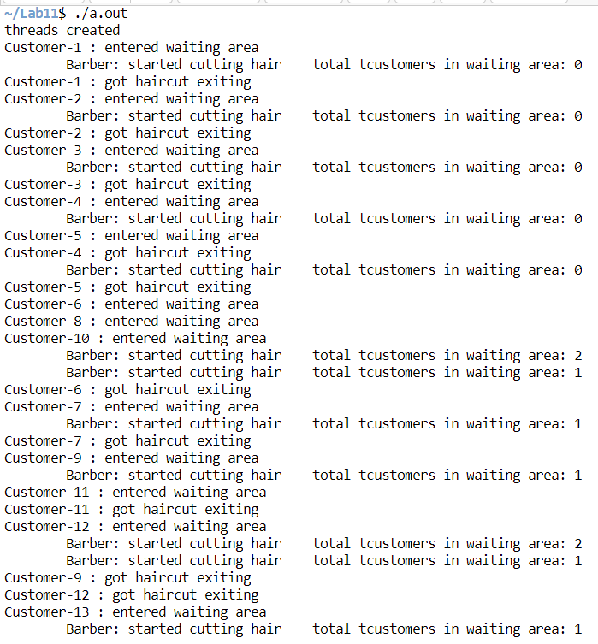

**Code-2:** writer have priority

#include <stdio.h>

#include <stdlib.h>

#include <pthread.h>

#include <semaphore.h>

#include <unistd.h>

#define P_COUNT 5

sem_t s_fork_set[P_COUNT],s_room;

void *Philosopher(void *arg){

int *phId=(int *)arg;

while(1){

sem_wait(&s_room);

printf("P-%d is thinking\n",*phId);

sem_wait(&s_fork_set[*phId-1]);

printf("\t\tP-%d : grabbed left fork\n",*phId);

sem_wait(&s_fork_set[(*phId)%P_COUNT]);

printf("\tP-%d : grabed both fork and is ready to eat\n",*phId);

sem_post(&s_fork_set[(*phId)%P_COUNT]);

printf("\t\tP-%d : relesed right\n",*phId);

sem_post(&s_fork_set[*phId-1]);

printf("\t\tP-%d : relesed both fork\n",*phId);

sem_post(&s_room);

sleep(1);

}

}

void main(){

pthread_t t_philosophers[P_COUNT];

int count1,ph_id[P_COUNT];

sem_init(&s_room,0,P_COUNT-1);

for(count1=0;count1<P_COUNT;count1++){

sem_init(&s_fork_set[count1],0,1);

}

printf("semaphores are ready\n");

//run

for(count1=0;count1<P_COUNT;count1++){

ph_id[count1]=count1+1;

pthread_create(&t_philosophers[count1],NULL,Philosopher,(void*)&ph_id[count1]);

}

//join

for(count1=0;count1<P_COUNT;count1++){

pthread_join(t_philosophers[count1],NULL);

}

}

**O/P**:

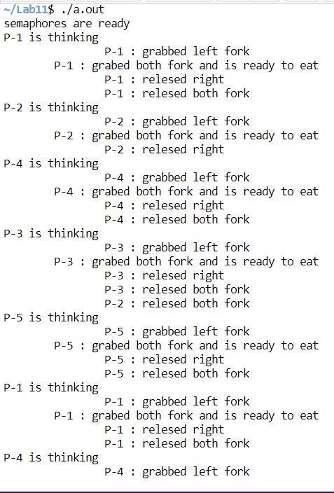

* **Some Exceptional conditions or errors**:
  + It may happen that threads are scheduled biasedly/unevenly by the kernel sometimes