

ISP392 PROJECT REPORT
Software Design Specification — Version 3.0

HEAVENSTAY WELLNESS RESORT MANAGEMENT SYSTEM (HSWRMS)
A Wellness Resort & Spa Management System
– Hanoi, Sep 2026 –

Table of Contents
Change Log 3
I. High Level Design 4
1. Software Architecture 4
1.1 Architecture and system scope 4
2. Package Diagram 6
2.1 Module responsibilities and dependencies 7
3. Database Design 7
II. Detailed Code Design 15
1. M1 Authentication and Sensitive Health Profile 15
2. M2 Retreat Package and Accommodation Booking 17
3. M3 Spa and Therapy Scheduling 19
4. M4 Dietary F&B Management 22
5. M5 Consolidated Checkout and Analytics 25
6. M6 System Administration and Permission Management 28
III. Other Design Specifications 30
1. Security and privacy 30
2. Interfaces, errors, and transaction boundaries 31
3. Lifecycle and concurrency 33
4. External integrations and background processing 34
5. Deployment, SQL Server and migration status 34
6. Requirements, API, service, data, and test traceability 35
7. Strategic decision register: Revision 1.1 39
8. Gaps and required evidence 40
Evidence index 41
9. Prior QA evidence and final status 41

Change Log
*A - Added M - Modified D - Deleted
Date | A* / M / D | In charge | Change Description
02 Nov 2026 | M | Not supplied | Final template restoration, source-grounded module diagrams, and evidence-status reconciliation.
03 Nov 2026 | M | Not supplied | Source-aligned architecture, UML package and domain ERD views; expanded M1-M6 class diagrams and sequential figure references.

I. High Level Design

1. Software Architecture
HSWRMS covers identity and sensitive health profiles (M1), retreat packages and accommodation booking (M2), spa/therapy scheduling (M3), dietary food service and inventory (M4), folio/invoice/payment/checkout (M5), and system administration/permissions (M6). This SDS documents source-backed design at the repository snapshot and separates it from target decisions and unverified operation.
Phase 0.1-F was a static technical evidence pass: 46 FR records, 152 route candidates, 43 service classes, 48 repository/entity/table records, 88 test classes and 737 annotated test methods were indexed. Nineteen FRs had partial direct controller/dependency candidates, 27 were unmapped, and zero complete FR-to-acceptance chains were established. Zero tests were run in that pass. These are inventory counts, not product-completeness measures.

1.1 Architecture and system scope
Backend source is a Java 17 / Spring Boot 3.3.4 modular monolith using Spring MVC, Spring Security, and Spring Data JPA/Hibernate. The React 19 / TypeScript / Vite client calls REST controllers; module packages are not independently deployed services. Shared security, errors, adapters, repositories, and scheduled work cross package boundaries. SQL Server is the intended database target; H2 appears in test configuration. No production topology, live SQL Server catalog, or provider operation was verified.
Figure 1 shows source layers and marks the SQL Server/provider relationships as targets, not deployed connections.
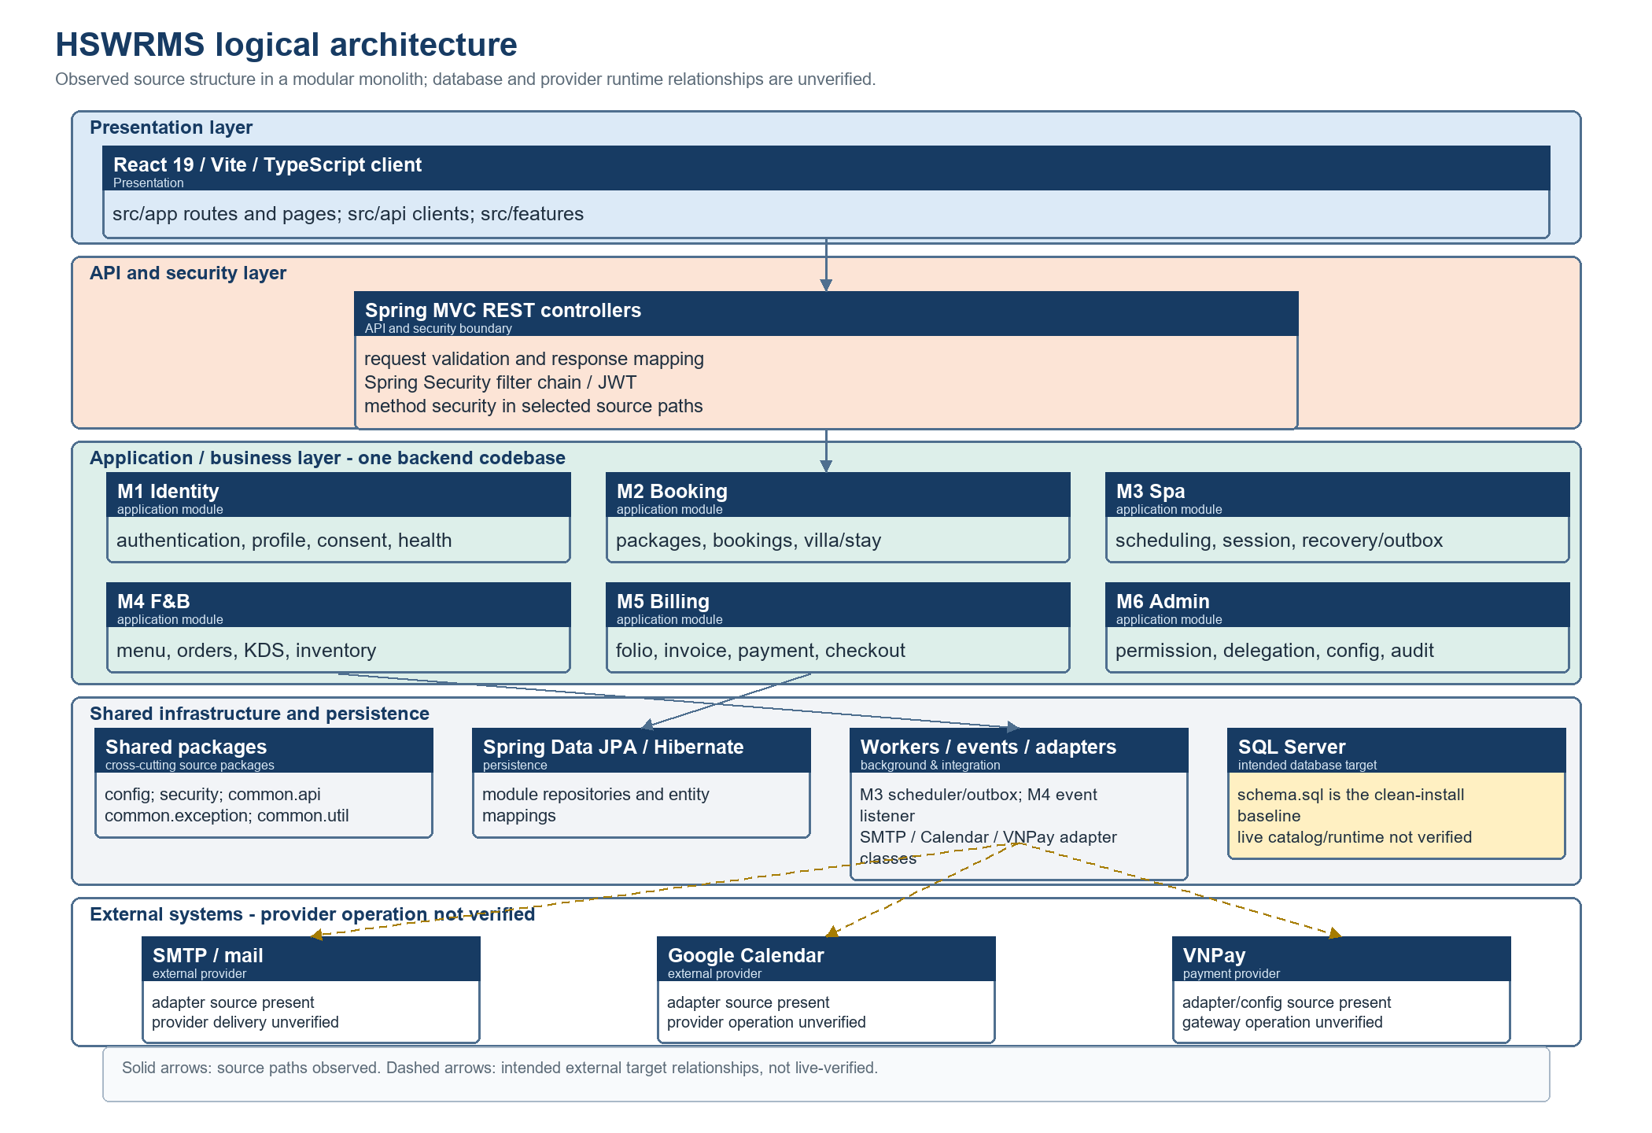
Figure 1. Source-aligned logical architecture. Package layers and six modules are observed in code; SQL Server/provider relationships are targets, not live-verified connections.
Architecture component responsibilities
Component | Responsibility |  | Main source evidence |  | Dependency / boundary
React 19 / Vite client | Renders route-oriented screens and calls backend APIs. |  | src/app, src/api, src/features |  | UI guards do not prove API authorization or complete screen integration.
Spring MVC and Security | Maps REST requests; JWT filter and selected method guards are source-backed. |  | config, security, module controllers |  | Complete route-level access behavior remains unverified.
M1-M6 modules | Own identity, booking, spa, F&B, billing and administration code paths. |  | m1identity through m6admin |  | One modular monolith; packages are not independently deployed services.
Shared packages | Provide cross-cutting configuration, security, response, exception and utility types. |  | config, security, common.api, common.exception, common.util |  | Shared dependencies do not imply module ownership.
Persistence | Repositories and entity mappings use Spring Data JPA/Hibernate. |  | module repository/entity packages |  | SQL Server is the intended target; live catalog and provider behavior are not verified.
Workers, events and adapters | Source includes M3 scheduling/outbox, M4 events and external adapters. |  | m3spa.scheduler/service; m4fnb.event/integration |  | Scheduler activation, SMTP, Calendar and VNPay operations are unverified.
Area |  | Source organization |  | Boundary interpretation
Frontend |  | src/app providers/router/guards; src/api and src/features; role-oriented pages |  | Routes/API clients do not prove operational screen integration. Frontend guards are not authorization.
Shared backend |  | config, security, common/errors, shared DTOs and ports/adapters |  | JWT filter and method security are source-backed; full route policy is not.
M1–M6 backend |  | m1identity, m2booking, m3spa, m4fnb, m5billing, m6admin |  | Package ownership is technical grouping, not approved data/write ownership.
Persistence |  | JPA entities/repositories and schema.sql; SQL Server profile |  | schema.sql is the clean-install baseline; live catalogs/constraints/indexes unverified.
Tests |  | backend/src/test and frontend test sources |  | Prior reports are historical evidence, not executed in this task.

2. Package Diagram
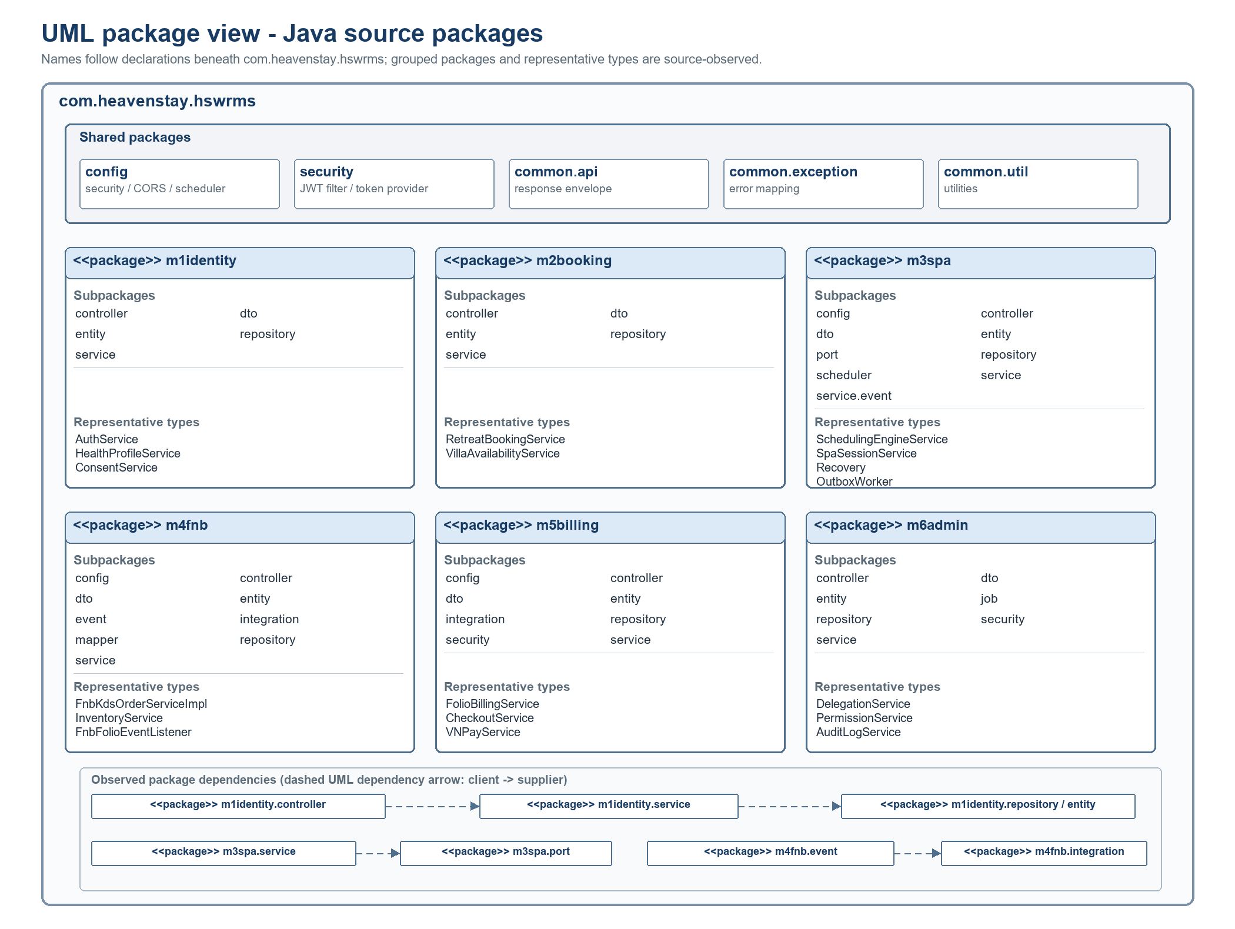
Figure 2. UML package structure beneath com.heavenstay.hswrms. Java package names and grouped subpackages are source-observed; Figure 3 separately shows cross-module calls and context reads.
Package description and representative types
Package | Observed subpackages | Representative source types | Responsibility / boundary
m1identity | controller, dto, entity, repository, service | AuthService; HealthProfileService; ConsentService | Identity, customer profile, consent and health data; module-local persistence.
m2booking | controller, dto, entity, repository, service | RetreatBookingService; VillaAvailabilityService; ReceptionistOperationService | Booking and physical-villa workflow; PaymentTransaction mapping conflict remains.
m3spa | config, controller, dto, entity, port, repository, scheduler, service, service.event | SchedulingEngineService; SpaSessionService; SessionRecoveryService; SpaDispatchOutboxWorker | Scheduling, lifecycle, recovery and provider ports; external delivery is unverified.
m4fnb | config, controller, dto, entity, event, integration, mapper, repository, service | FnbKdsOrderServiceImpl; MealOrderService; InventoryService; FnbFolioEventListener | Menu, order, KDS and inventory; direct + event M5 callers are distinct.
m5billing | config, controller, dto, entity, integration, repository, security, service | FolioBillingService; CheckoutService; VNPayService | Folio, invoice, payment and checkout; provider operation is unverified.
m6admin | controller, dto, entity, job, repository, security, service | PermissionService; DelegationService; BusinessParameterService; AuditLogService | Permission and administration; consumer coverage is incomplete.
shared | config; security; common.api; common.exception; common.util | JwtAuthenticationFilter; shared response/error types | Cross-cutting packages; not separate deployable services.
Within-module source layering includes controller-to-service and service-to-repository/entity dependencies; M3 also has port/scheduler/event packages and M4 has event/integration packages. Cross-module edges are shown separately in Figure 3.

2.1 Module responsibilities and dependencies
Module | Responsibility / technical owner | Observed dependency and limit
M1 | Identity, authentication, profile, consent and health projection. | Shared security, M2 customer/booking, M3/M4 minimized data use. Provider runtime and privacy approvals unverified.
M2 | Retreat package, booking, villa inventory and reception/check-in. | M1 identity; M3 stay adapter; M5 deposit/payment adjacency. M2 owns Booking/deposit rules by Rev 1.1; M5 owns PaymentTransaction.
M3 | Candidate scheduling, reservation, session/confirmation, recovery and outbox. | M1/M2 stay context; M5 charge adapter. No M3→M4 direct path found in reviewed scan; Calendar client absent.
M4 | Menu, meal order, KDS, recipe and inventory. | M1 dietary projection; M2 booking; M5 billing; M6 audit. Allergy, location and entitlement runtime remain unverified.
M5 | Folio, invoice, payment and checkout code paths. | Reads M1–M4 sources and M6 audit. M5-owned idempotent charge and PaymentTransaction are Rev 1.1 directions, not proof every path enforces them.
M6 | Permission catalog, role mapping, delegation, audit and configuration. | Shared backend security and module audit calls. Least-privilege, time-limited, auditable delegation is target direction; complete consumer mapping is pending.
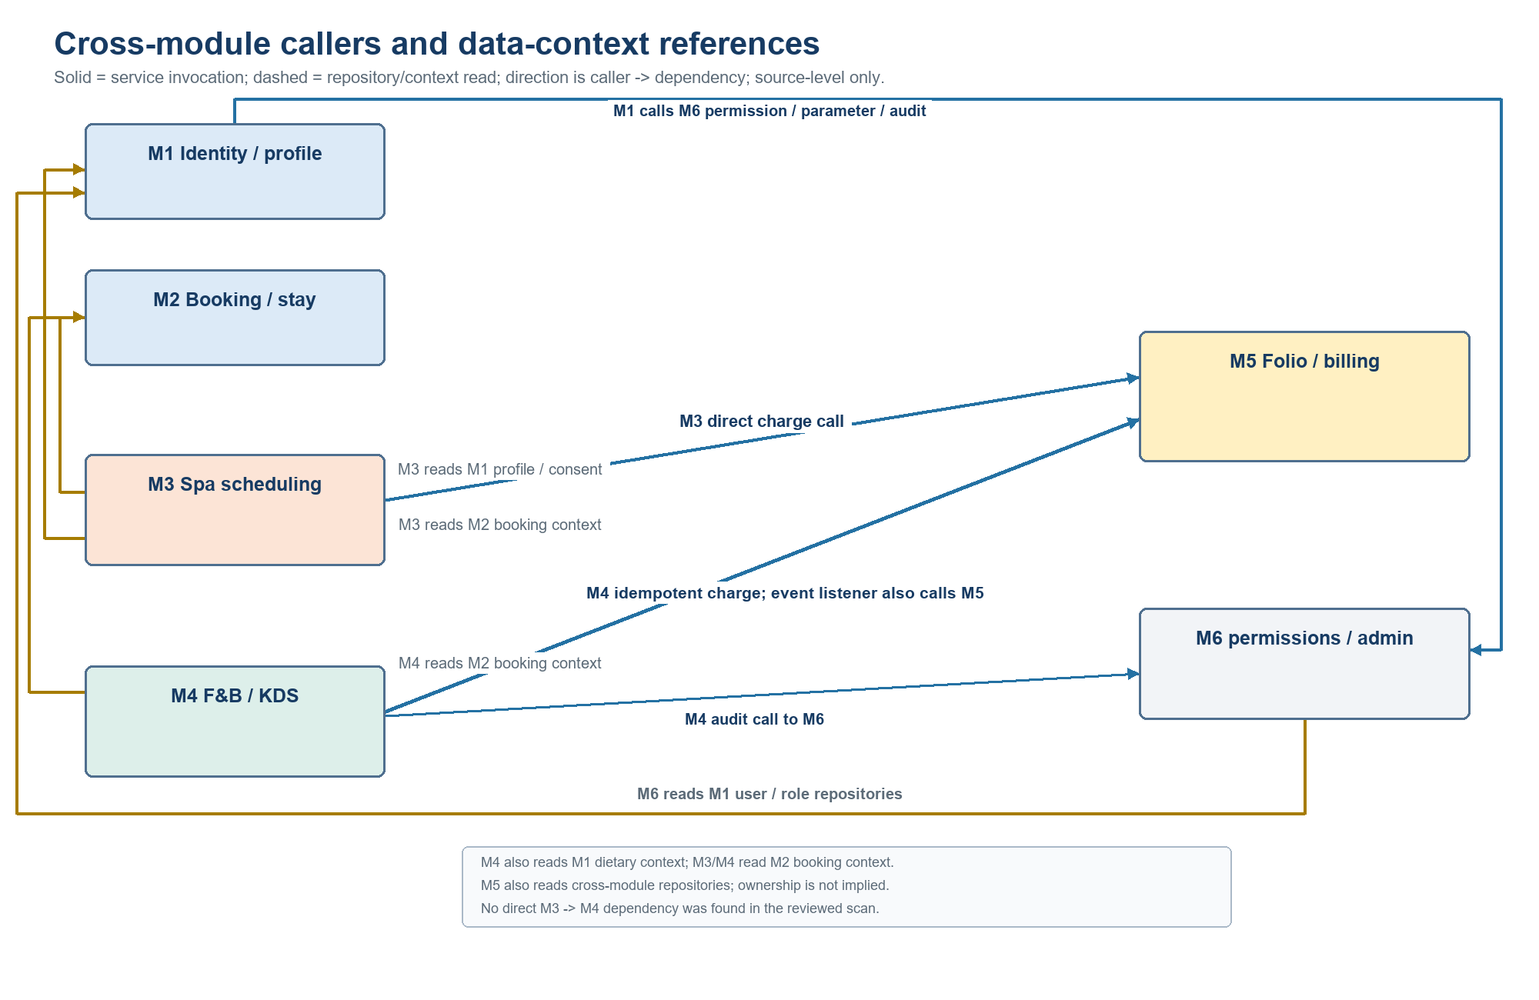
Figure 3. Cross-module caller and data-context dependencies. Solid arrows show observed service calls; dashed arrows show repository/context reads. M1 and M6 depend on one another through distinct calls; edges do not imply ownership or complete runtime contracts.

3. Database Design
Static schema review records 52 CREATE TABLE declarations and 52 unique names (50 unconditional and two guarded: SpaScheduleHistory and SpaDispatchOutbox). This describes inspected schema.sql source, not a live catalog or proof that migrations ran. Entity annotations, baseline DDL, migration files, and any deployed database are separate evidence layers.
Domain | Representative entities/tables | Integrity / ownership note
M1 | User, AuthIdentity, CustomerProfile, HealthProfile, ConsentRecord, allergy/diet, deletion request | Consent/retention policy and deployed privacy controls need evidence.
M2 | RetreatPackage, RetreatBooking, ResortZone, VillaCategory, PhysicalVilla, ResidenceRecord | Villa Category differs from Physical Villa; zone and allocation rules remain.
M3 | SpaSession, Therapist, TreatmentRoom, SpaTreatment, SpaScheduleHistory, SpaDispatchOutbox | Resource bundle: time + qualified therapist + compatible room. FK/index/locking state unverified.
M4 | MenuItem, Ingredient, MenuItemIngredient, IngredientBatch, MealOrder, MealOrderItem | Usable quantity/expiry/condition are guards; deployed behavior unverified.
M5 | Folio, FolioItem, Invoice, PaymentTransaction, adjustments | Folio is mutable; Invoice is a formal snapshot. OI-01 ownership risk remains in source.
M6 | Permission, RolePermission, SystemConfiguration, RightDelegation, AuditLog | Canonical contract and operational immutability/retention unverified.
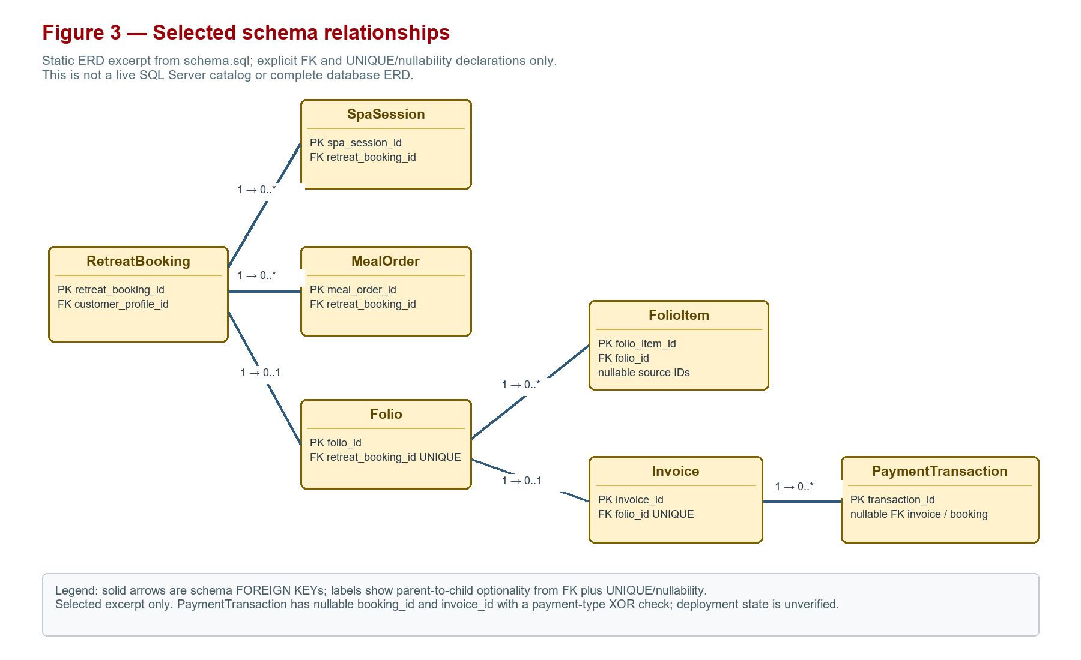
Figure 4. Selected cross-domain relationships declared in schema.sql; excerpt only, not a complete or deployed ERD.
Phase 0.1-F mapped 50 entity classes, 48 repository interfaces, and 110 relationship annotations. Figure 4 is a selected schema-level relationship excerpt, not a complete or deployed ERD. Source annotations or DDL establish only source-level mappings; live foreign keys, trust, cascades, indexes, nullability, SQL types, and SQL Server application remain unverified. See SDS_DATABASE_DICTIONARY_FINAL.md for the detailed static inventory.
Domain ERD views and selected table descriptions
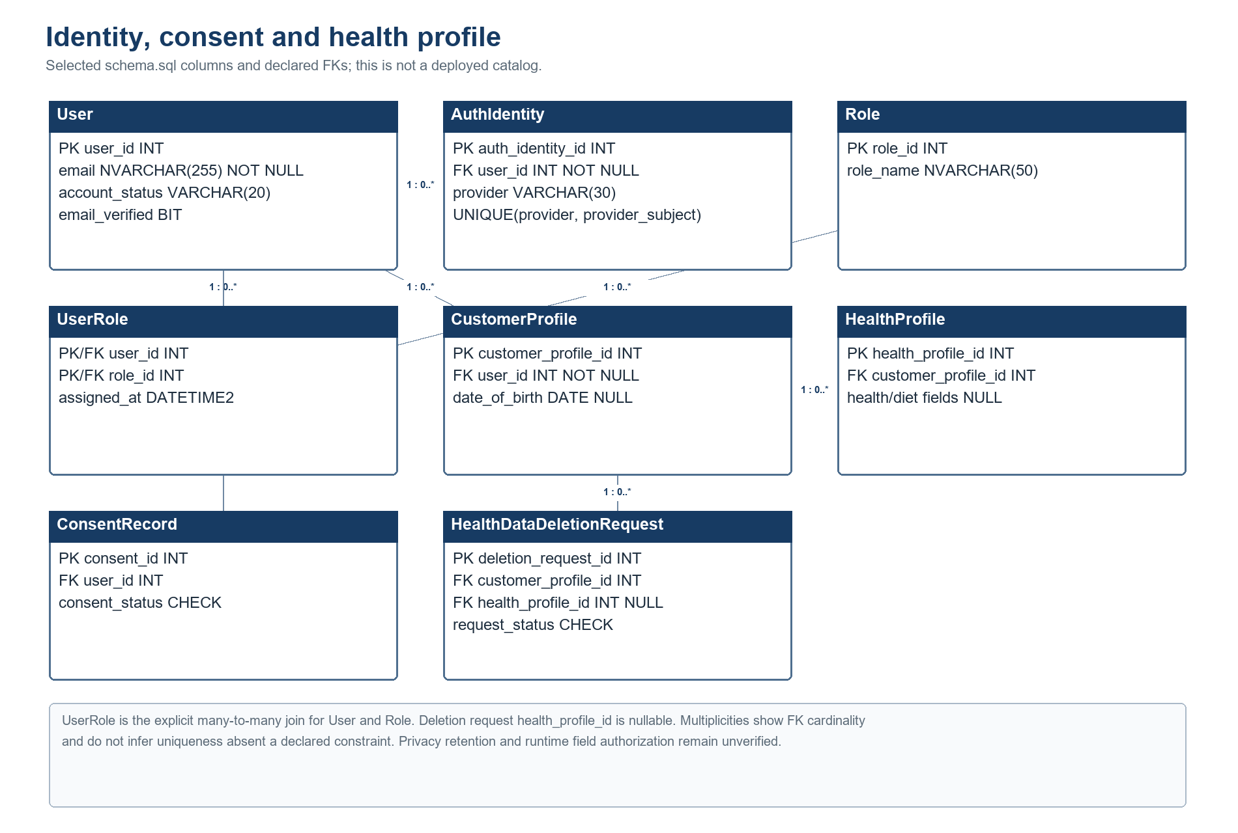
Figure 5. Identity, consent and health-profile ERD. Selected PK/FK fields and nullability are read from schema.sql; runtime catalog and privacy controls are unverified.
Selected columns and FK edges only; consult the existing static database dictionary for the full schema inventory. This figure describes source DDL, not live deployment.
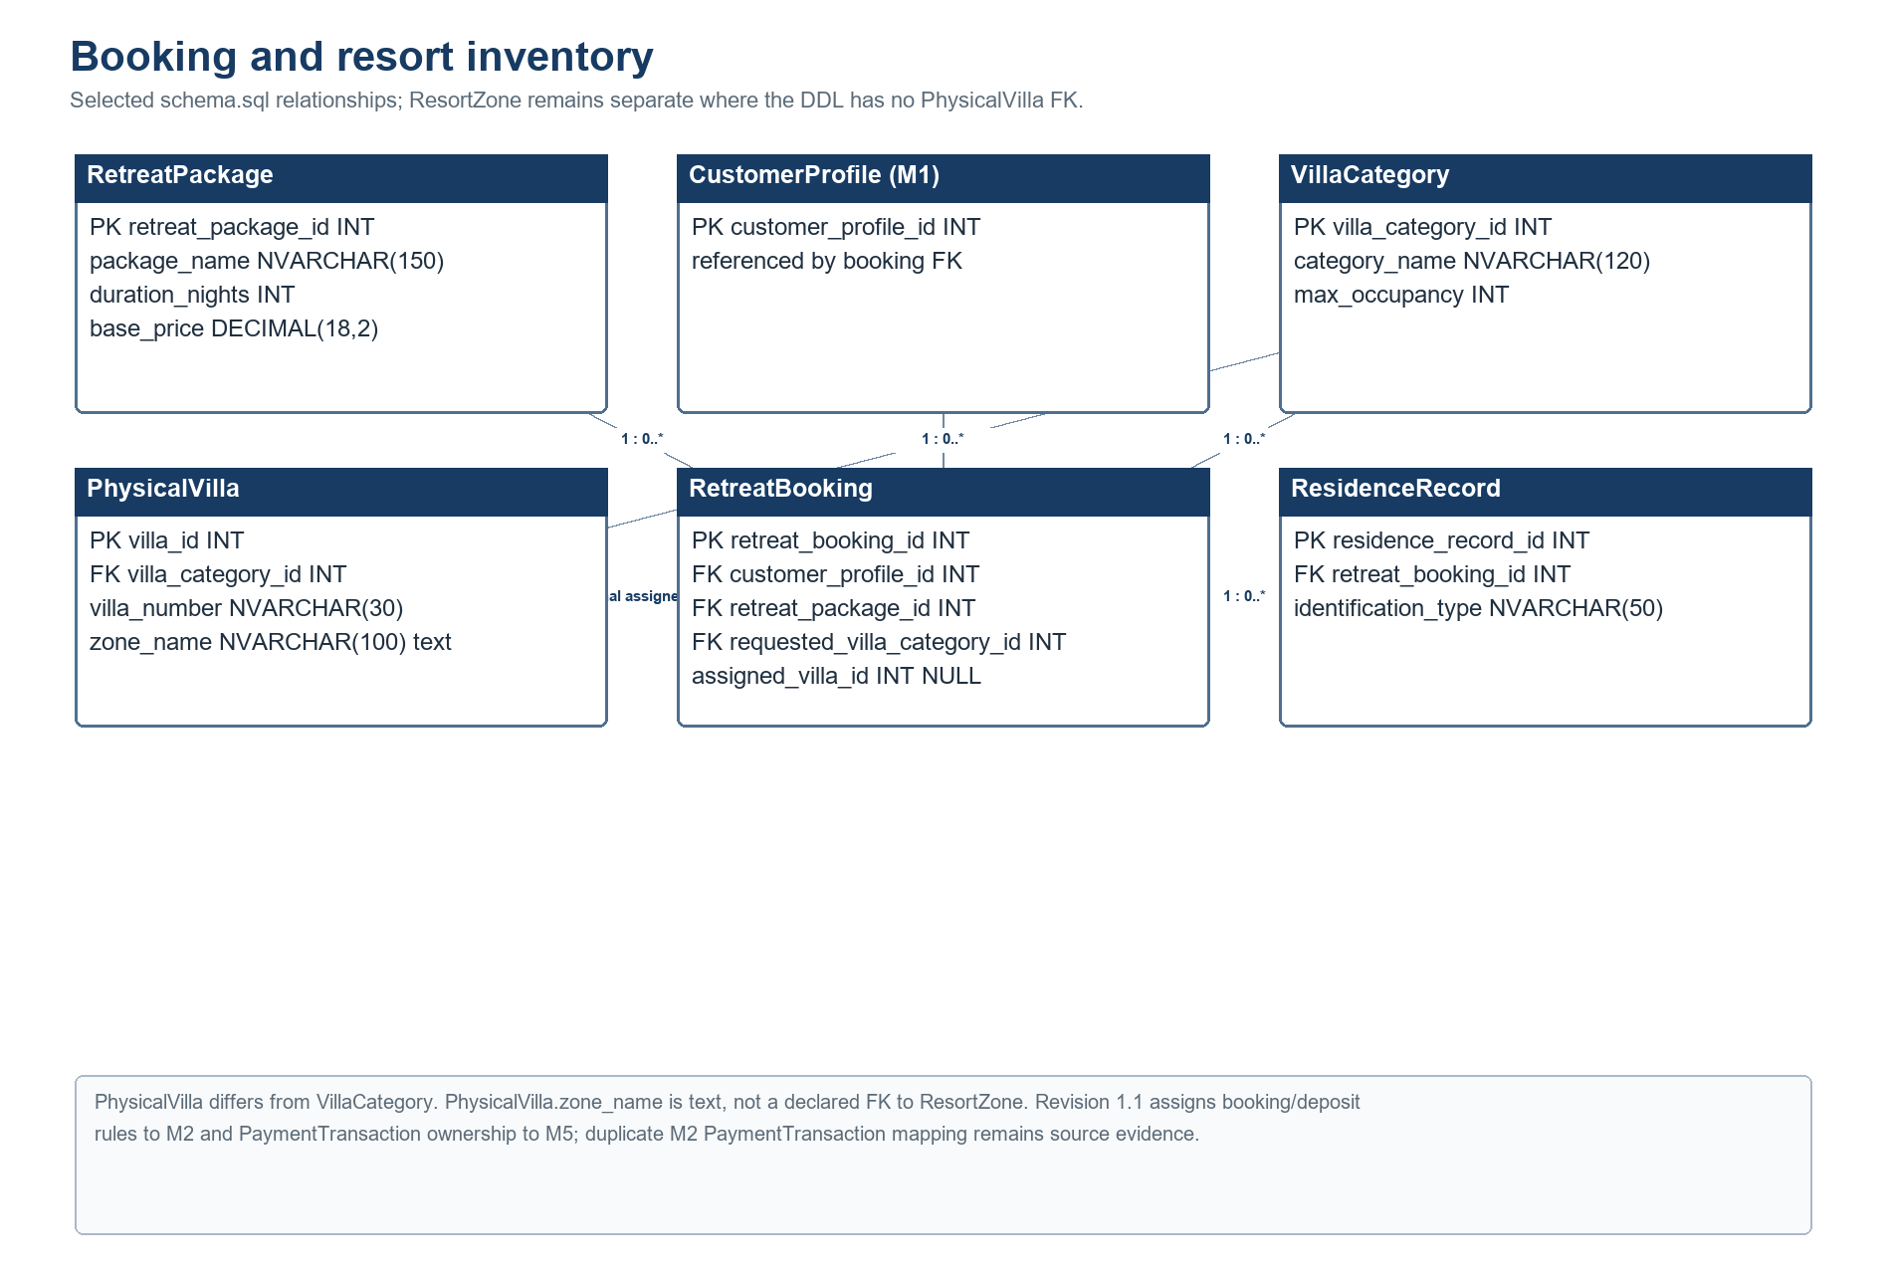
Figure 6. Booking and resort-inventory ERD. RetreatPackage, CustomerProfile and VillaCategory FKs are source-declared; ResortZone is not joined to PhysicalVilla by an inspected FK.
Selected columns and FK edges only; consult the existing static database dictionary for the full schema inventory. This figure describes source DDL, not live deployment.
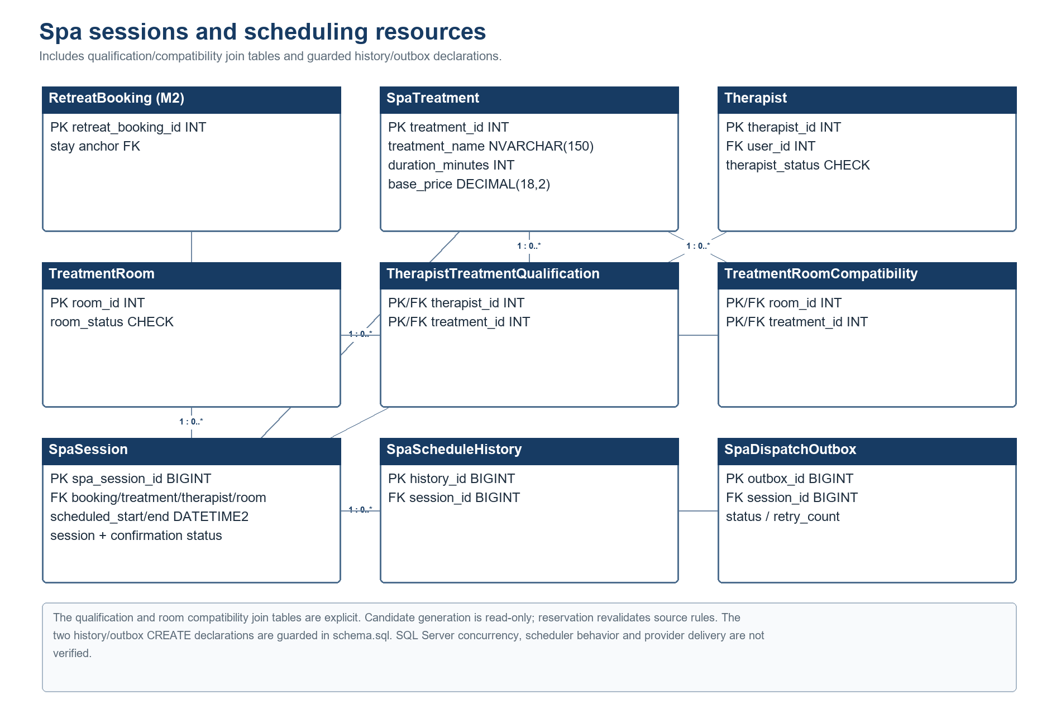
Figure 7. Spa scheduling ERD. Qualification and room compatibility use explicit join tables; history/outbox declarations are guarded in schema.sql.
Selected columns and FK edges only; consult the existing static database dictionary for the full schema inventory. This figure describes source DDL, not live deployment.
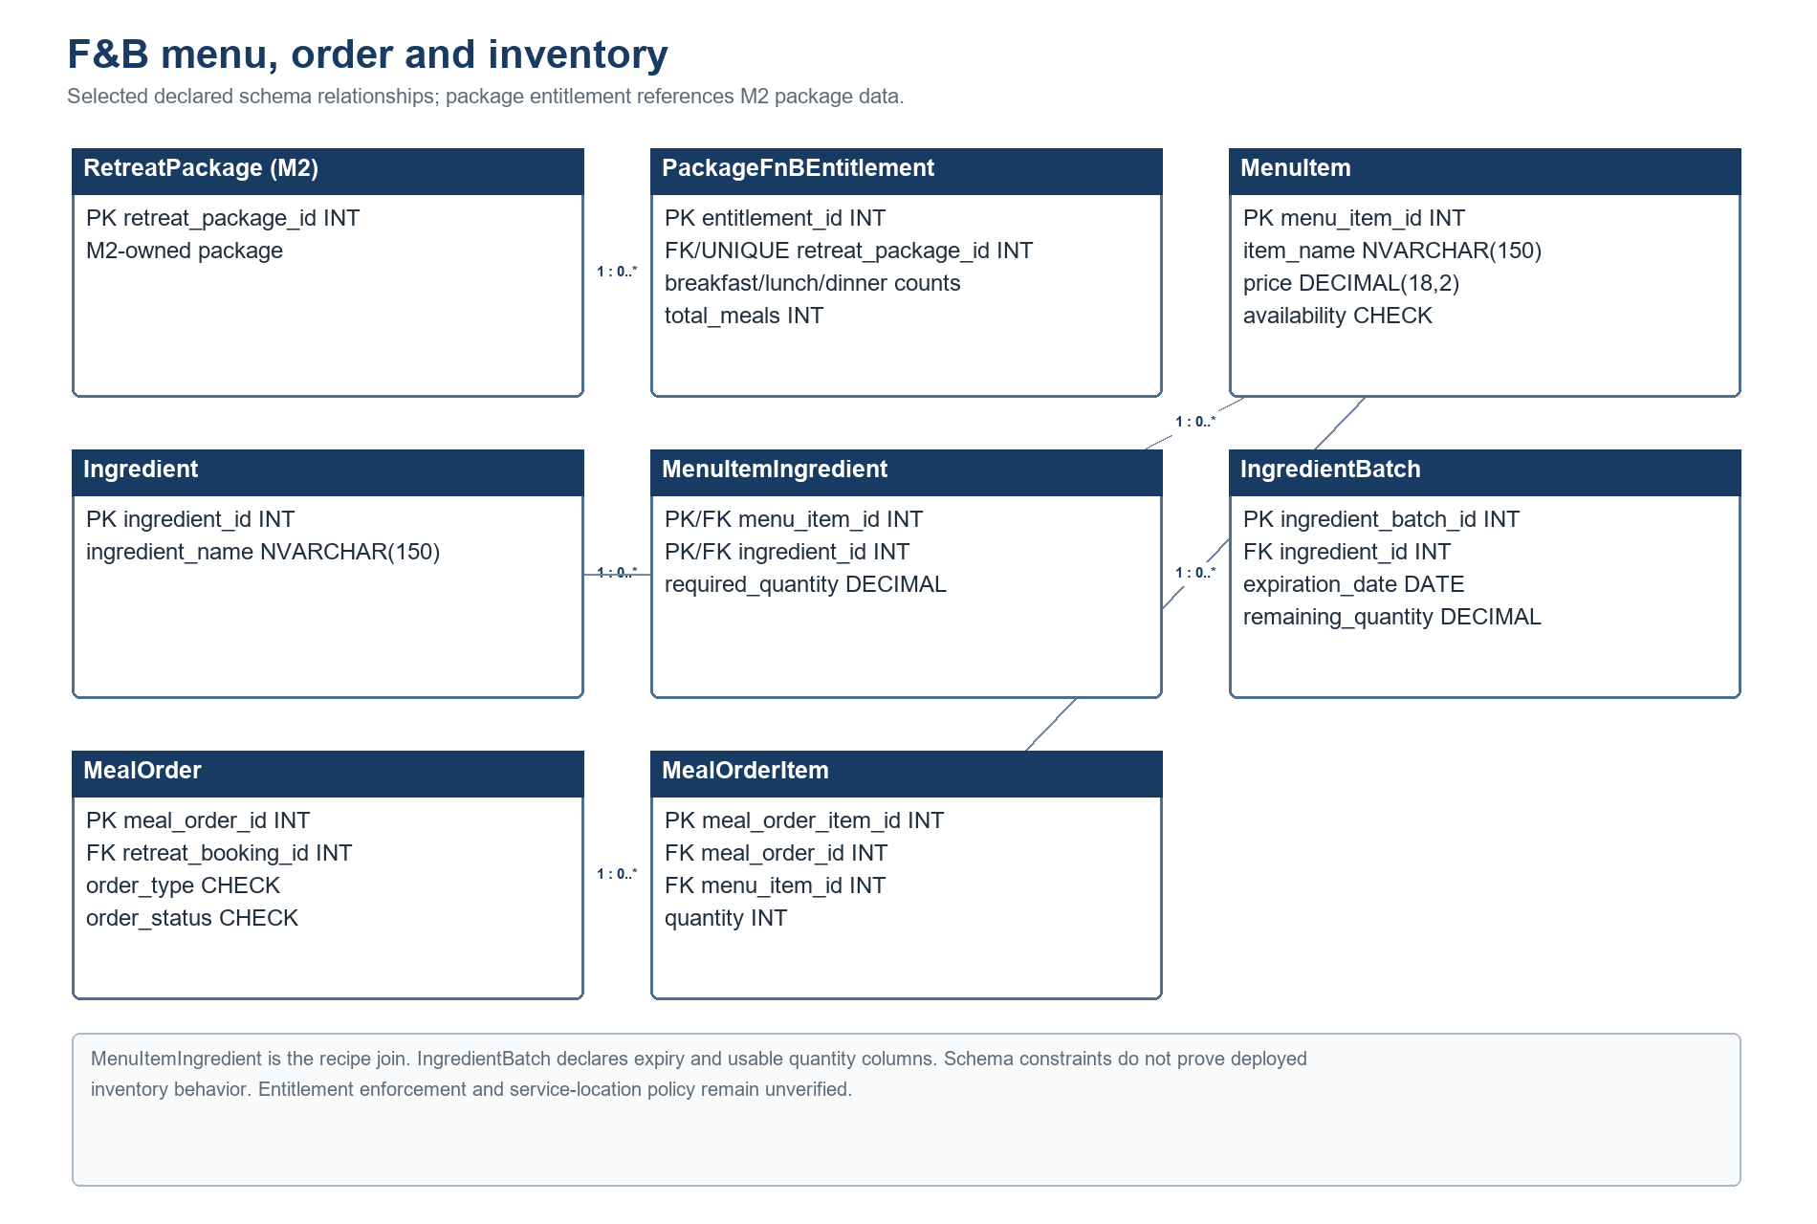
Figure 8. F&B menu, order and inventory ERD. Recipe ingredients and package entitlement constraints are source-declared; deployed enforcement is unverified.
Selected columns and FK edges only; consult the existing static database dictionary for the full schema inventory. This figure describes source DDL, not live deployment.
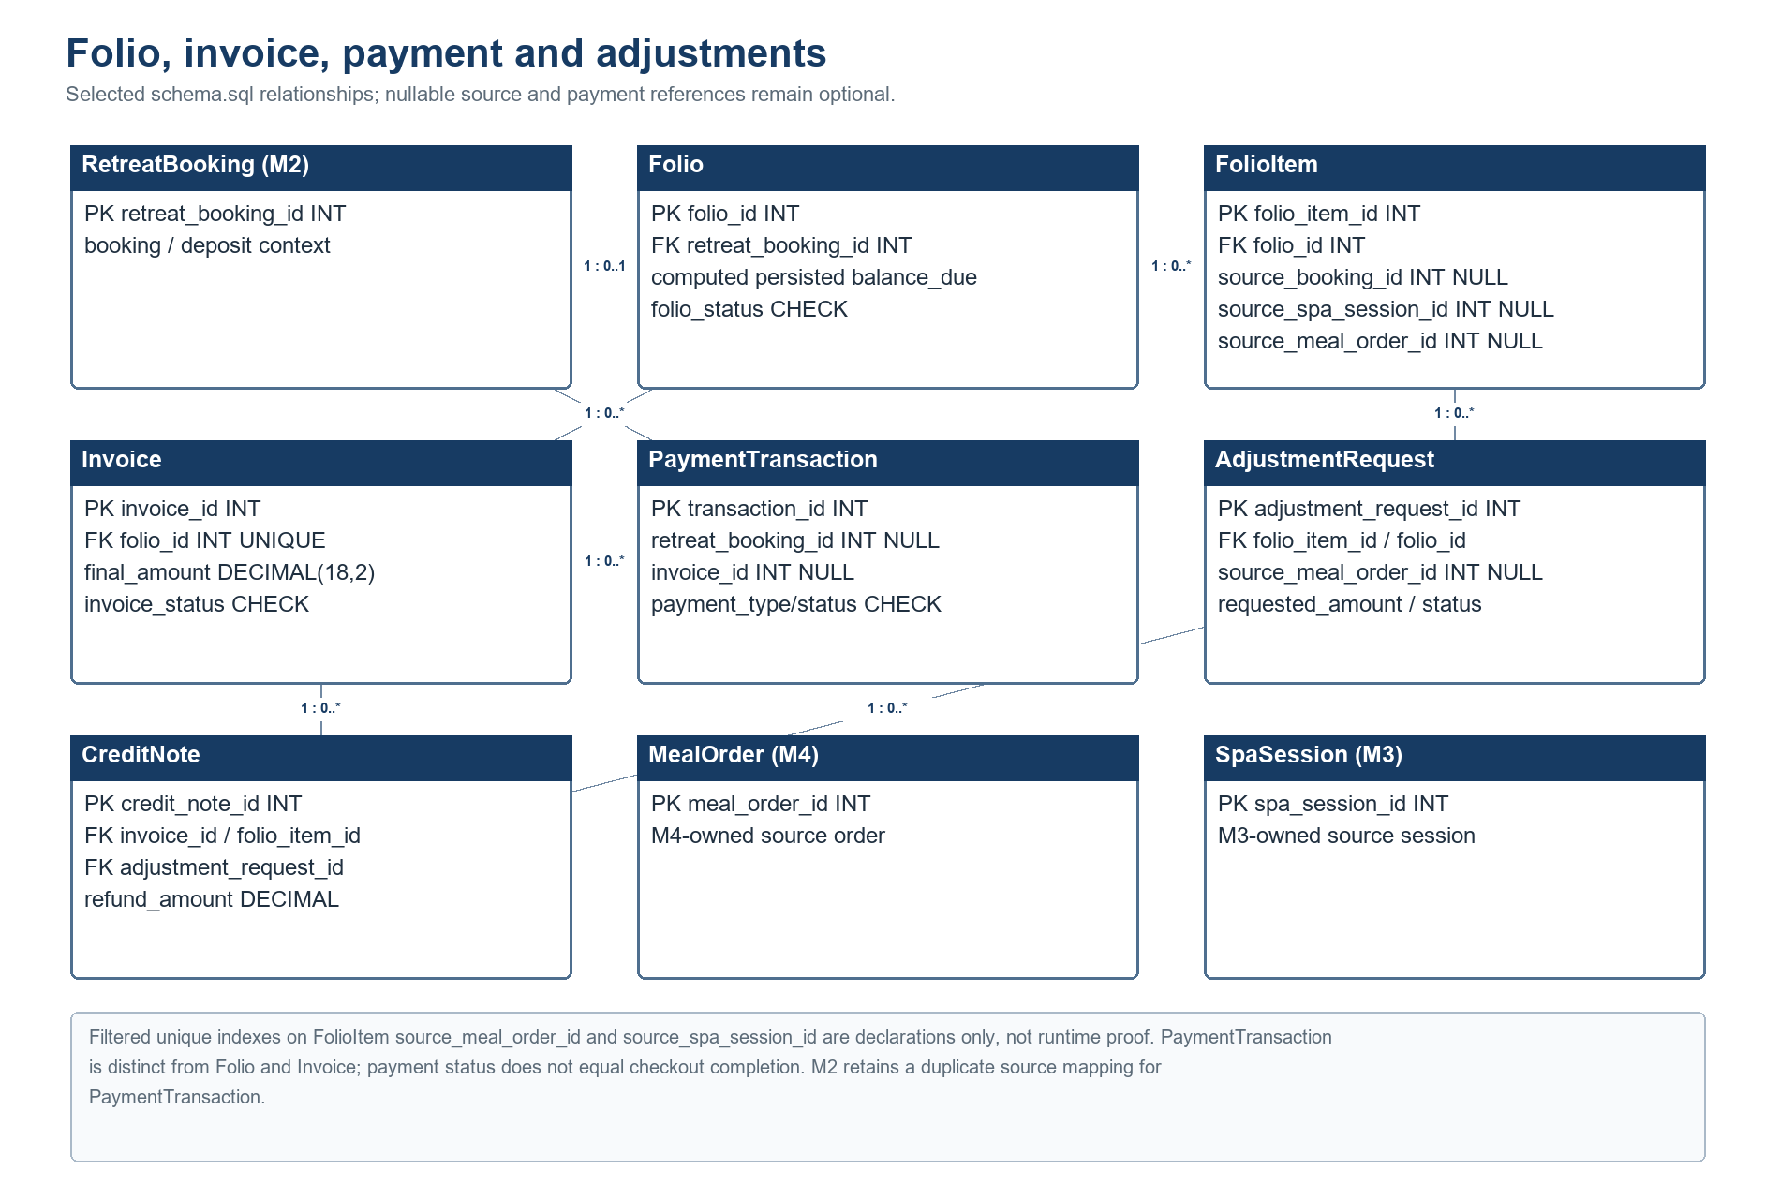
Figure 9. Billing ERD. Folio, FolioItem, Invoice, PaymentTransaction and source references remain separate; filtered unique indexes are schema declarations only.
Selected columns and FK edges only; consult the existing static database dictionary for the full schema inventory. This figure describes source DDL, not live deployment.
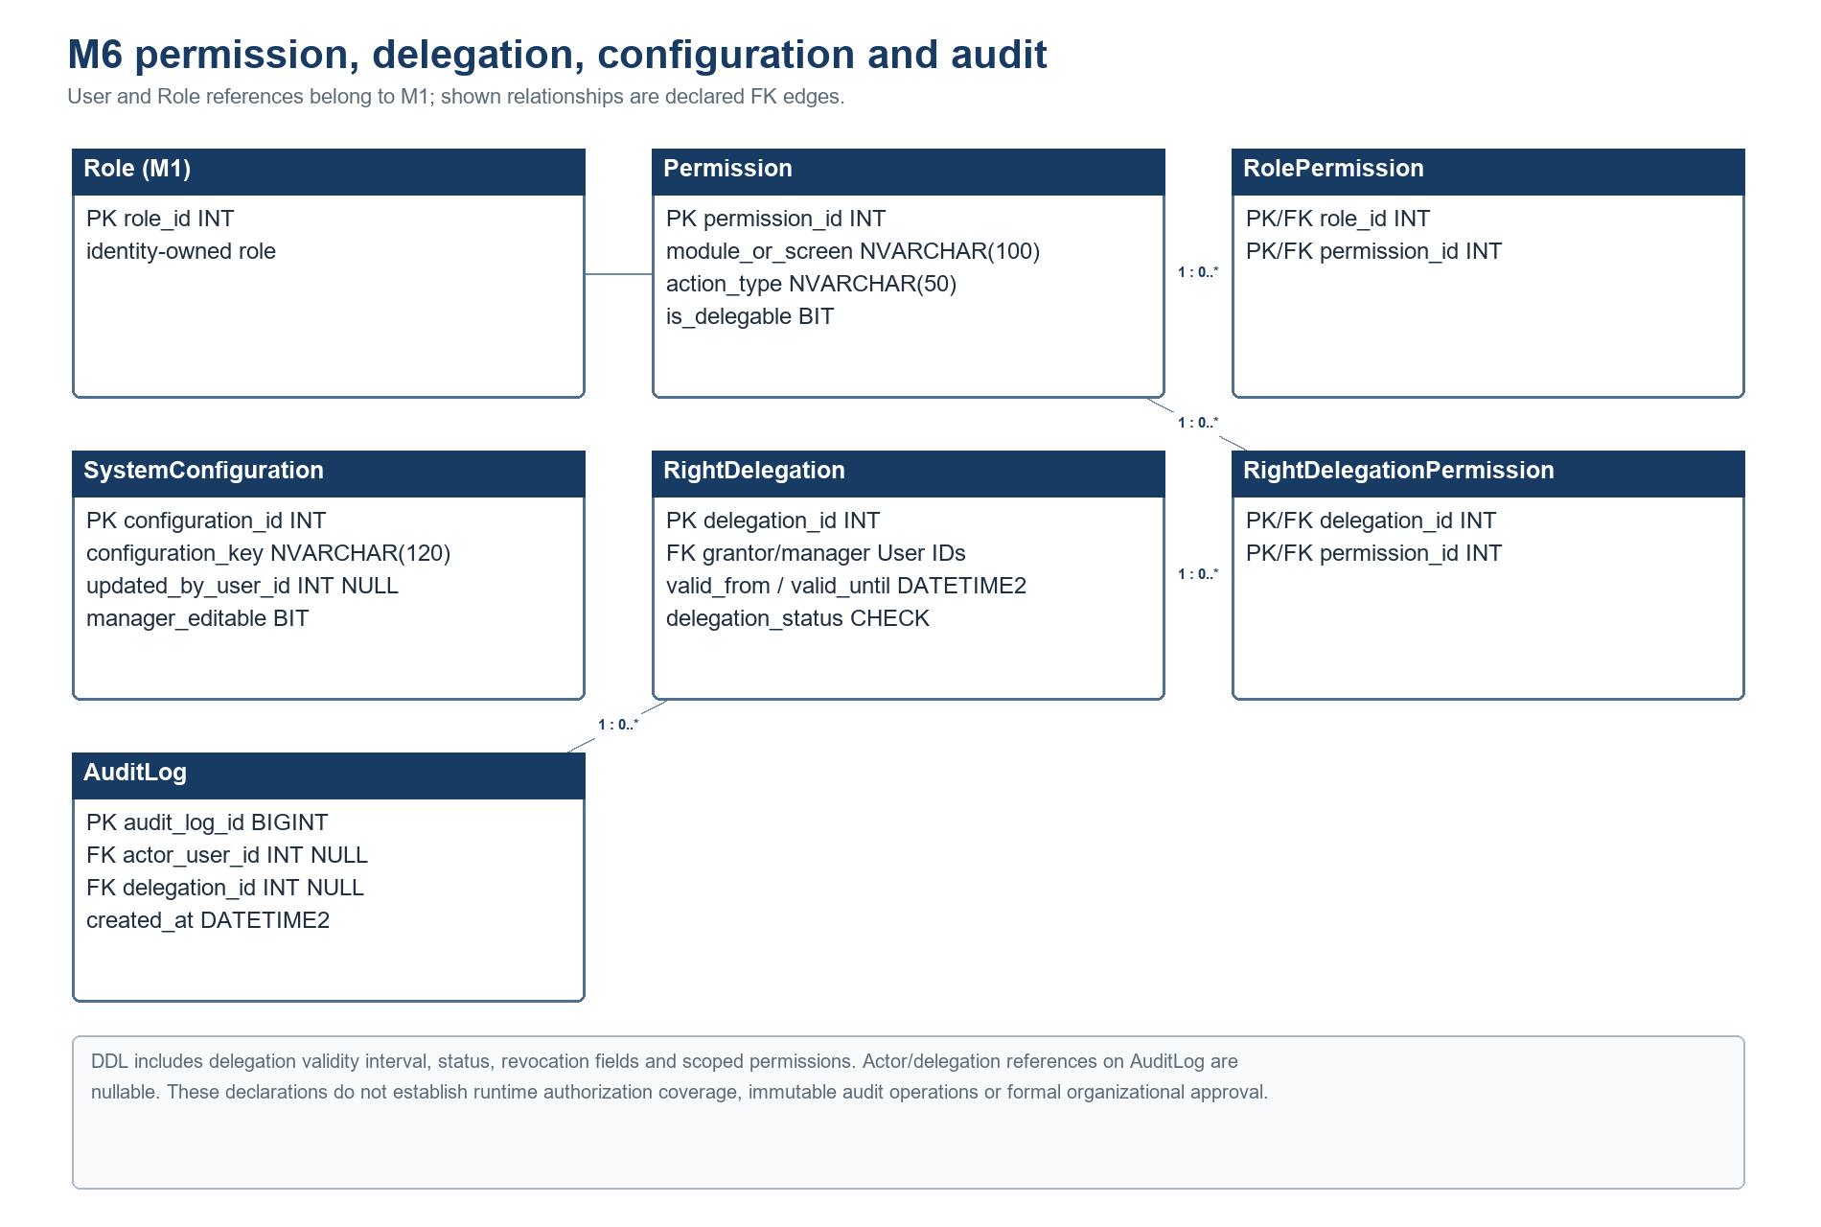
Figure 10. Administration and permission ERD. Role and User are M1 references; delegation scope and nullable audit references follow the DDL.
Selected columns and FK edges only; consult the existing static database dictionary for the full schema inventory. This figure describes source DDL, not live deployment.
Selected table descriptions and key constraints
Module | Representative tables | Important keys / constraints | Boundary / verification status
M1 Identity | User, AuthIdentity, UserRole, CustomerProfile, HealthProfile, ConsentRecord, HealthDataDeletionRequest | UserRole composite PK; AuthIdentity provider/subject unique; consent/deletion checks. | Health data and consent remain subject to privacy decisions; no production state claimed.
M2 Booking | RetreatPackage, ResortZone, VillaCategory, PhysicalVilla, RetreatBooking, ResidenceRecord | Booking FKs to package/customer/category; assigned villa nullable; villa category distinct from physical villa. | No schema FK from PhysicalVilla.zone_name to ResortZone.
M3 Spa | SpaSession, TherapistTreatmentQualification, TreatmentRoomCompatibility, SpaScheduleHistory, SpaDispatchOutbox | Resource FKs; composite qualification/compatibility PKs; guarded history/outbox declarations. | SQL Server locking and scheduler/provider runtime unverified.
M4 F&B | MenuItem, MenuItemIngredient, IngredientBatch, MealOrder, MealOrderItem, PackageFnBEntitlement | Recipe join composite PK; expiry/quantity checks; order type/status checks; one entitlement per package. | Inventory and entitlement deployed behavior unverified.
M5 Billing | Folio, FolioItem, Invoice, PaymentTransaction, AdjustmentRequest, CreditNote | Unique invoice-per-folio; nullable source/payment references; filtered unique source indexes; financial checks. | SQL Server index enforcement, gateway, payment and checkout runtime unverified.
M6 Admin | Permission, RolePermission, SystemConfiguration, RightDelegation, RightDelegationPermission, AuditLog | Composite role/delegation permission keys; bounded validity fields; nullable audit references. | DDL does not establish runtime enforcement, audit immutability, or formal approval.
The static baseline contains 52 CREATE TABLE declarations (50 unconditional and two guarded). Entity annotations and DDL are source evidence only and do not prove deployed SQL Server state.

II. Detailed Code Design
The following module descriptions synthesize Phase 0.1-F registers A01–H02, existing SDS V2 registers, and targeted static inspection of current working-tree source. The repository HEAD recorded in Document Control is fcd628eb32679f75fef385f1f656a07c83f1a5aa; the inspected working tree already contains pre-existing source changes. Those changes were read only and were not executed. Component and method statements are static observations; absent trace joins are not inferred.

1. M1 Authentication and Sensitive Health Profile
M1 handles identity/account flows, customer profile, consent and health. AuthController/AuthService, HealthProfileController/HealthProfileService, ConsentController/ConsentService and User/AuthIdentity/CustomerProfile/HealthProfile/ConsentRecord are source candidates.

Responsibilities and design constraints
• JWT filter/security chain and selected method guards exist. Backend authorization is authoritative; UI guards do not secure APIs. Full route-level 401/403 evidence is incomplete.
• Apply consent, retention and minimum-access principles. Therapist sees treatment-relevant health/safety context; F&B staff sees relevant allergy/dietary information; Receptionist must not have unrestricted health access.
• Health deletion may be deferred while an active/upcoming stay needs the data. Revision 1.1 does not specify retention periods or detailed consent semantics; do not invent them.
• Fail closed where ownership, consent or safety-critical data cannot be established. Exact error mapping and rollback evidence are endpoint-specific and incomplete.

Evidence status
PARTIAL — source exists; privacy retention, field-level approval, full trace and runtime access remain unverified.

Components and operations
AuthController/AuthService implement authentication entry points; HealthProfileController/HealthProfileService handle profile operations; ConsentController/ConsentService handle consent records. User, AuthIdentity, CustomerProfile, HealthProfile, and ConsentRecord remain separate source concepts. Shared SecurityConfig/JWT infrastructure authenticates requests; selected controllers/services consume the principal. This is not a complete route-to-data chain.

Interfaces, data access, and failure boundary
Identity/profile repositories are the persistence path in the source inventory. M3/M4 health projections must remain purpose-limited. Consent, retention, deletion scheduling, field-level authorization, and endpoint-by-endpoint 401/403/error behavior lack complete evidence. Fail closed when ownership, consent, or safety context is unknown; no retention period is specified.
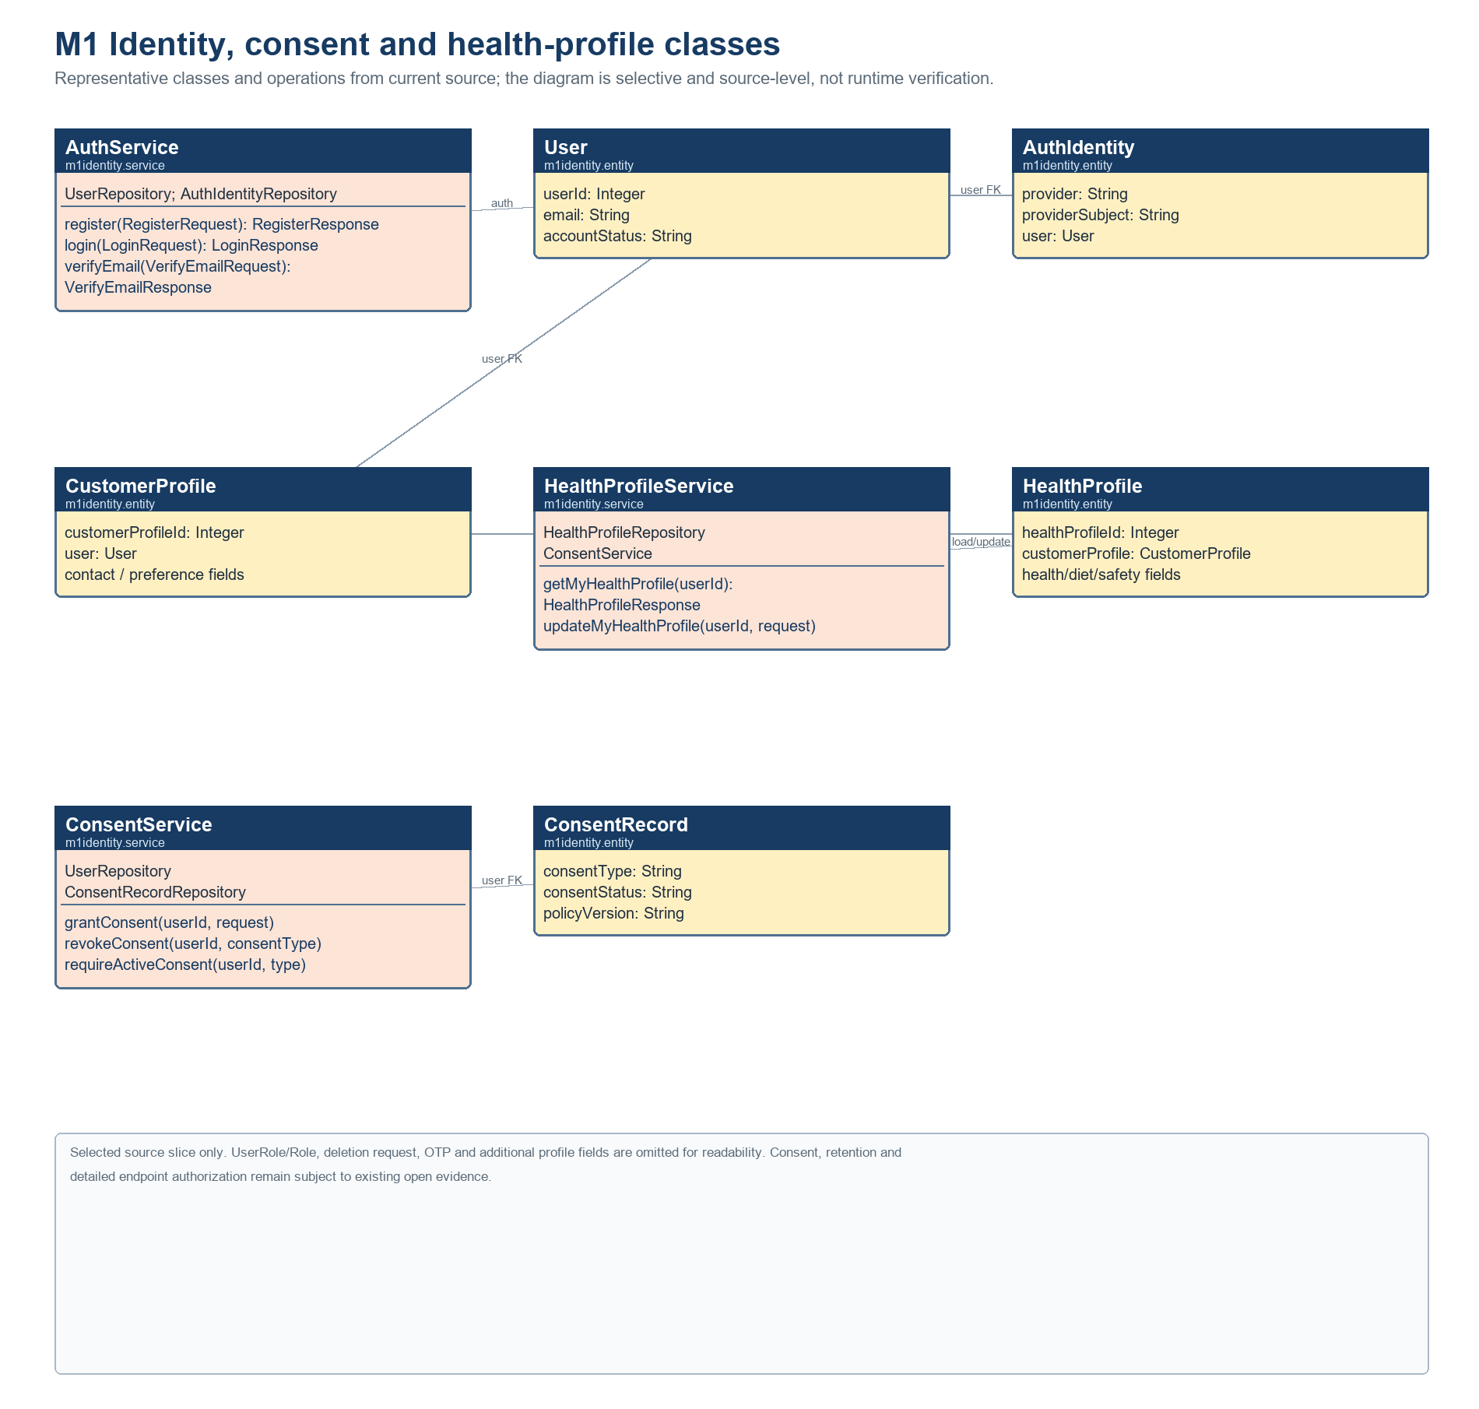
Figure 11. M1 identity, consent and health-profile classes. Selected fields and operations are source-level; privacy policy and deployed authorization remain unverified.
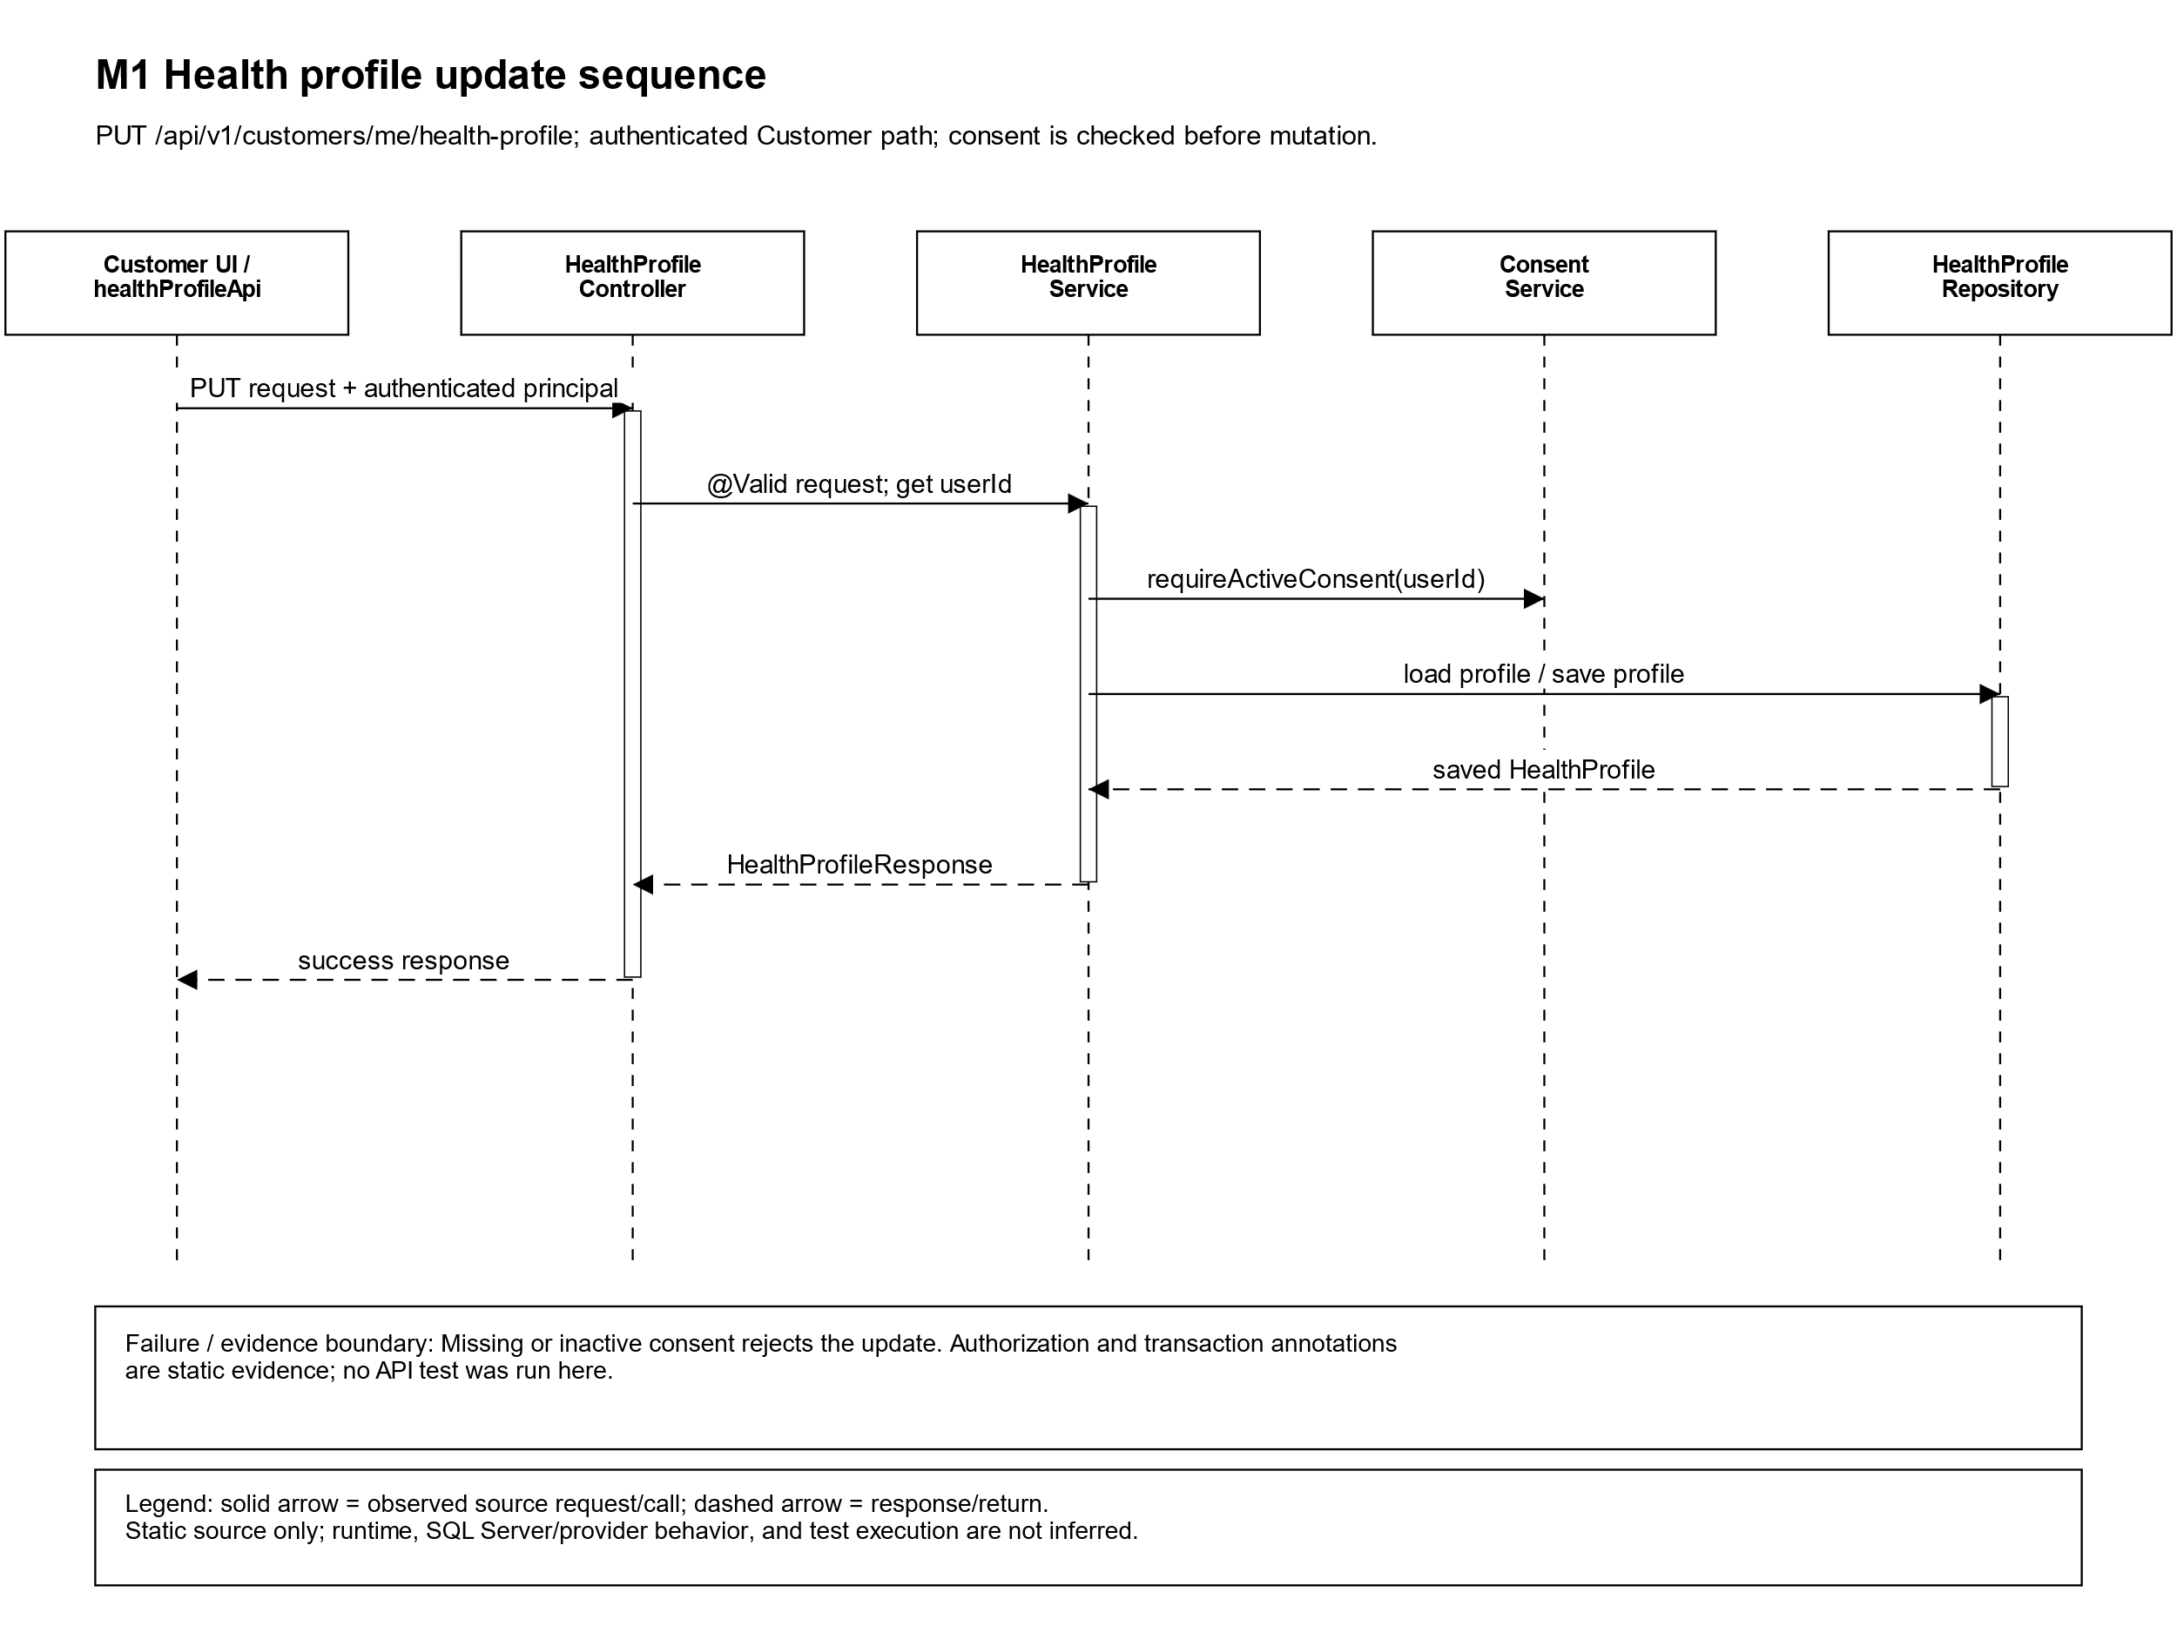
Figure 12. Customer health-profile read/update path; authorization and consent behavior are source-level evidence only. Selected path only; error and alternate branches are not exhaustive.

2. M2 Retreat Package and Accommodation Booking
M2 manages retreat packages, booking, villa inventory and reception workflows. RetreatBookingController/Service, VillaInventoryController and ReceptionistOperationController/Service are source-listed. A Villa Category is distinct from a Physical Villa.

Responsibilities and design constraints
• Revision 1.1 assigns Booking and deposit business rules to M2, while PaymentTransaction ownership is M5. Existing path compliance is not proven.
• Reception check-in source checks booking/villa conditions and records residence state; locking methods exist. SQL Server concurrency is unverified.
• ResortZone, VillaCategory and PhysicalVilla occur in source/schema. Do not infer zone allocation or package entitlements from entity shape.
• Role/actor checks occur in selected code; complete endpoint permissions, ownership rules and error responses need trace evidence.

Evidence status
PARTIAL — code paths exist; M2 rules, schema relationship, payment integration and SQL Server behavior remain incomplete.

Components and operations
RetreatBookingController/Service own booking-facing paths; ReceptionistOperationController delegates check-in and walk-in work to ReceptionistOperationService; VillaInventoryController exposes villa state. assignVillaAndCheckIn checks booking, physical-villa, and residence conditions, persists stay state, and records audit in the reviewed service path. VNPay deposit code is adjacent but does not settle OI-04.

Interfaces, data access, and failure boundary
The check-in controller maps AssignVillaRequest to BookingSummaryResponse; transaction and repository lock methods are visible in selected service paths. VillaCategory is distinct from PhysicalVilla and ResortZone is separately represented; names do not define allocation rules. SQL Server concurrency is unverified. Role and ownership review remains incomplete across routes.
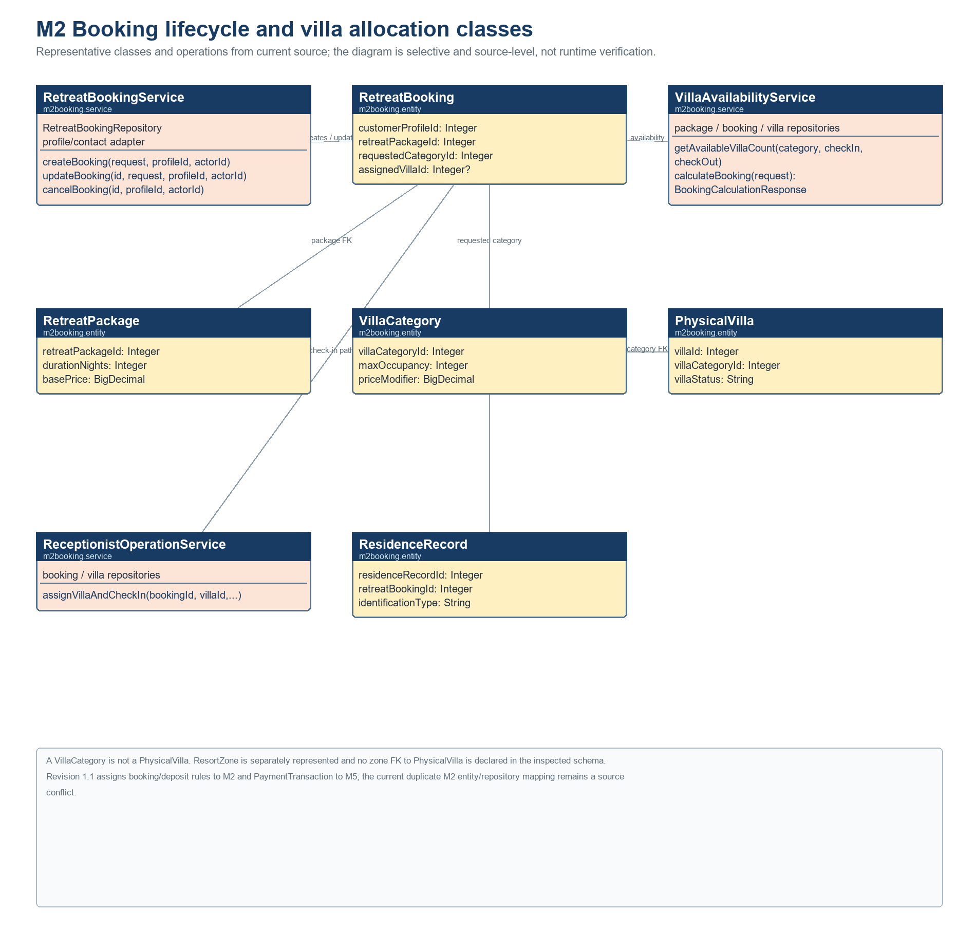
Figure 13. M2 booking lifecycle and villa allocation classes. Source-level relationships only; SQL Server concurrency and the M2/M5 PaymentTransaction ownership conflict remain open.
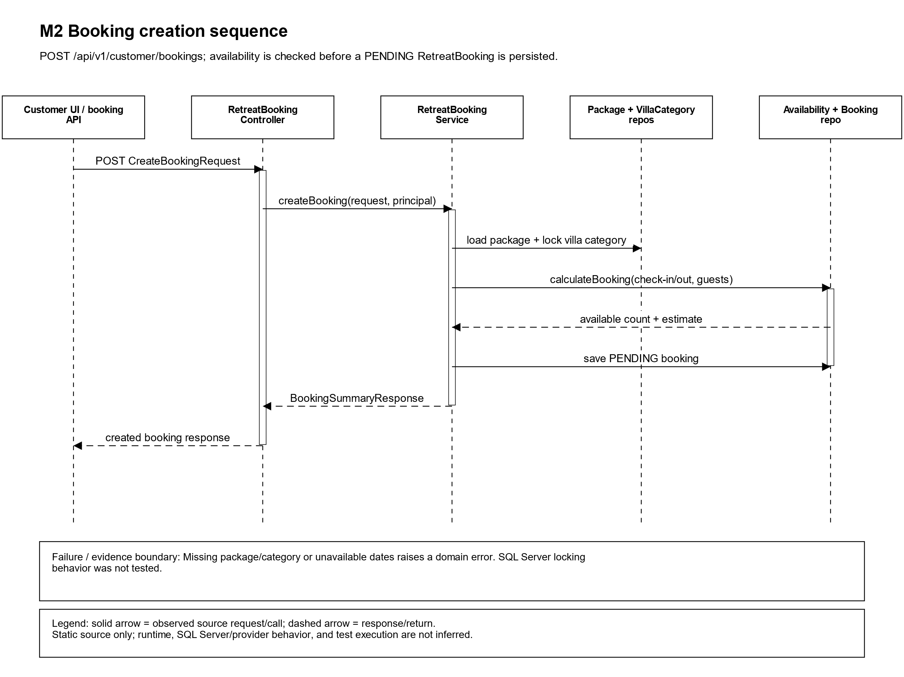
Figure 14. Booking creation path through availability calculation and persistence; SQL Server concurrency is unverified. Selected path only; error and alternate branches are not exhaustive.

3. M3 Spa and Therapy Scheduling
M3 scheduling treats candidate resource as an indivisible bundle: time slot, qualified Therapist/Instructor and compatible TreatmentRoom. Candidate generation is read-only; final reservation revalidates and reserves atomically. Components include SpaBookingController, SchedulingEngineService, SpaSessionService, SessionRecoveryService, SessionTimelineScheduler and SpaDispatchOutboxWorker.

Responsibilities and design constraints
• Resource conflict must not create partial reservation. Existing Customer session remains valid while browsing reschedule candidates; replacement is effective only after successful transactional replacement.
• Persisted statuses: SCHEDULED, RESCHEDULING, CANCELLED, COMPLETED, NO_SHOW. Separate confirmation states: PENDING, CONFIRMED, DECLINED, EXPIRED. Persisted IN_PROGRESS remains prohibited.
• Cross-customer recovery/swap requires explicit mutual consent (Rev 1.1). Existing mutual-consent workflow is PARTIAL; do not claim implemented.
• OI-02 Option B: five attempts total, delays 30s/1m/2m/4m. Ambiguous SMTP outcome must be reconciled, not blindly resent. Historical ADR reconciliation remains necessary.
• Calendar adapter lacks authenticated API client. M3→M5 adapter uses non-idempotent postFolioCharge and catches/logs exceptions; no durable retry is evidenced. M5 idempotent target contract is not yet enforced by this path.

Evidence status
PARTIAL — H2 evidence only; SQL Server locks, live SMTP/Calendar, OI-01 remediation and cross-customer consent remain unverified.

Components and operations
SpaBookingController.generateCandidates calls read-only SchedulingEngineService.generateCandidates; confirmReservation calls SpaSessionService.confirmReservation. SpaSessionService owns attendance confirmation, decline, cancellation, and reschedule paths. SessionRecoveryService and schedulers evaluate disrupted or due sessions; SpaDispatchOutboxWorker claims persisted work and delegates to email/calendar adapters. CustomerStayPort and health projection adapters read M2/M1 context; the billing adapter calls M5 directly.

Interfaces, data access, and failure boundary
GenerateCandidatesRequest requires treatmentId and preferredDate; ConfirmReservationRequest requires treatmentId, therapistId, roomId, start, and end and validates interval shape. Candidate generation does not reserve. Final reservation is transactional in source and revalidates/locks resources; SQL Server behavior remains unverified. Confirmation and session statuses are separate; IN_PROGRESS is not persisted. Current worker defaults are configurable, but scheduler, claims, SMTP outcome certainty, and Calendar delivery were not run. SPA billing still calls non-idempotent postFolioCharge, catches/logs failures, and shows no adapter-level durable retry (OI-01).
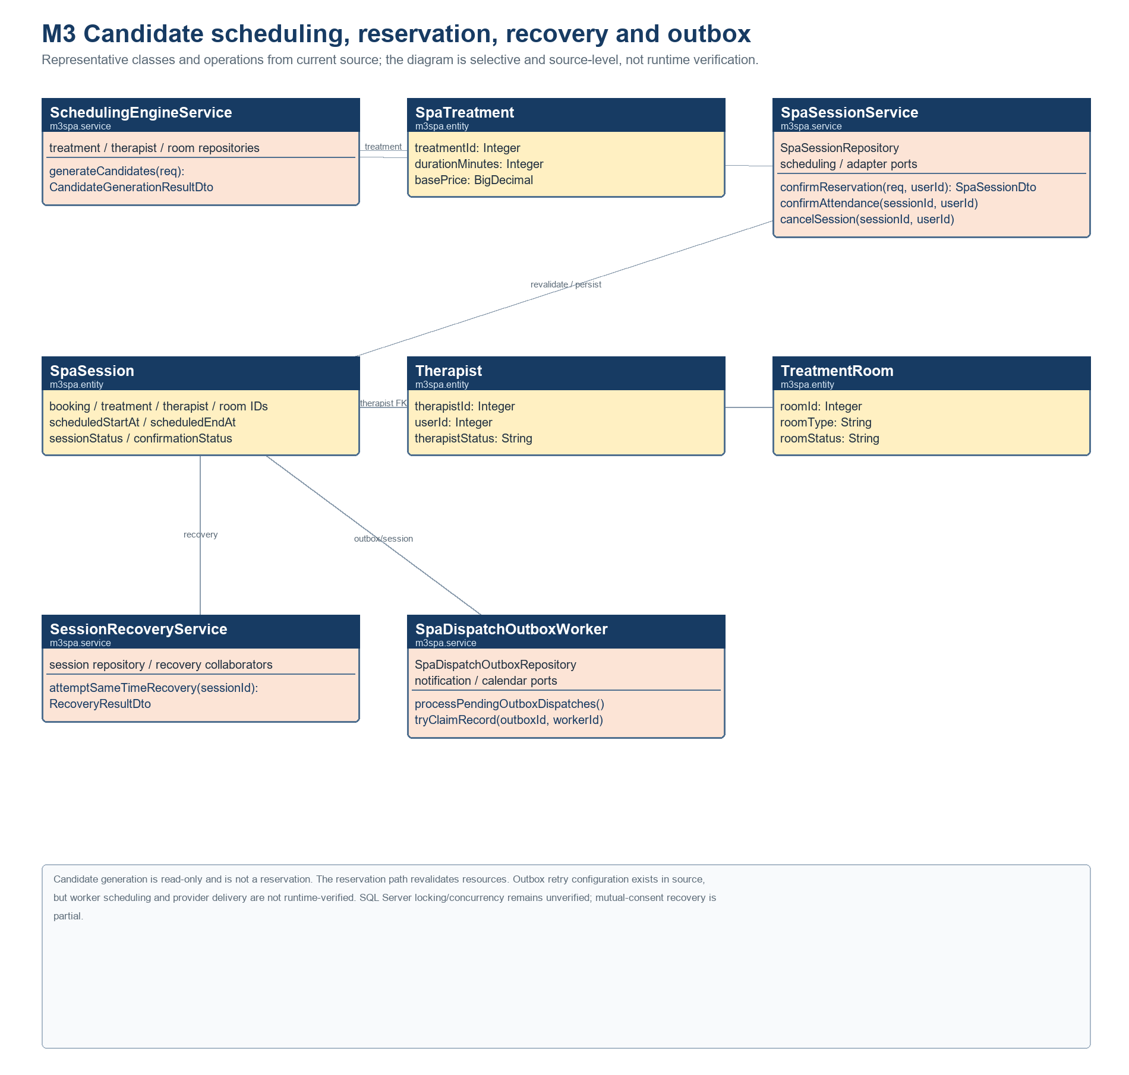
Figure 15. M3 candidate scheduling, reservation, recovery and outbox classes. Candidate generation is read-only; the reservation path revalidates resources. Runtime and SQL Server behavior remain unverified.
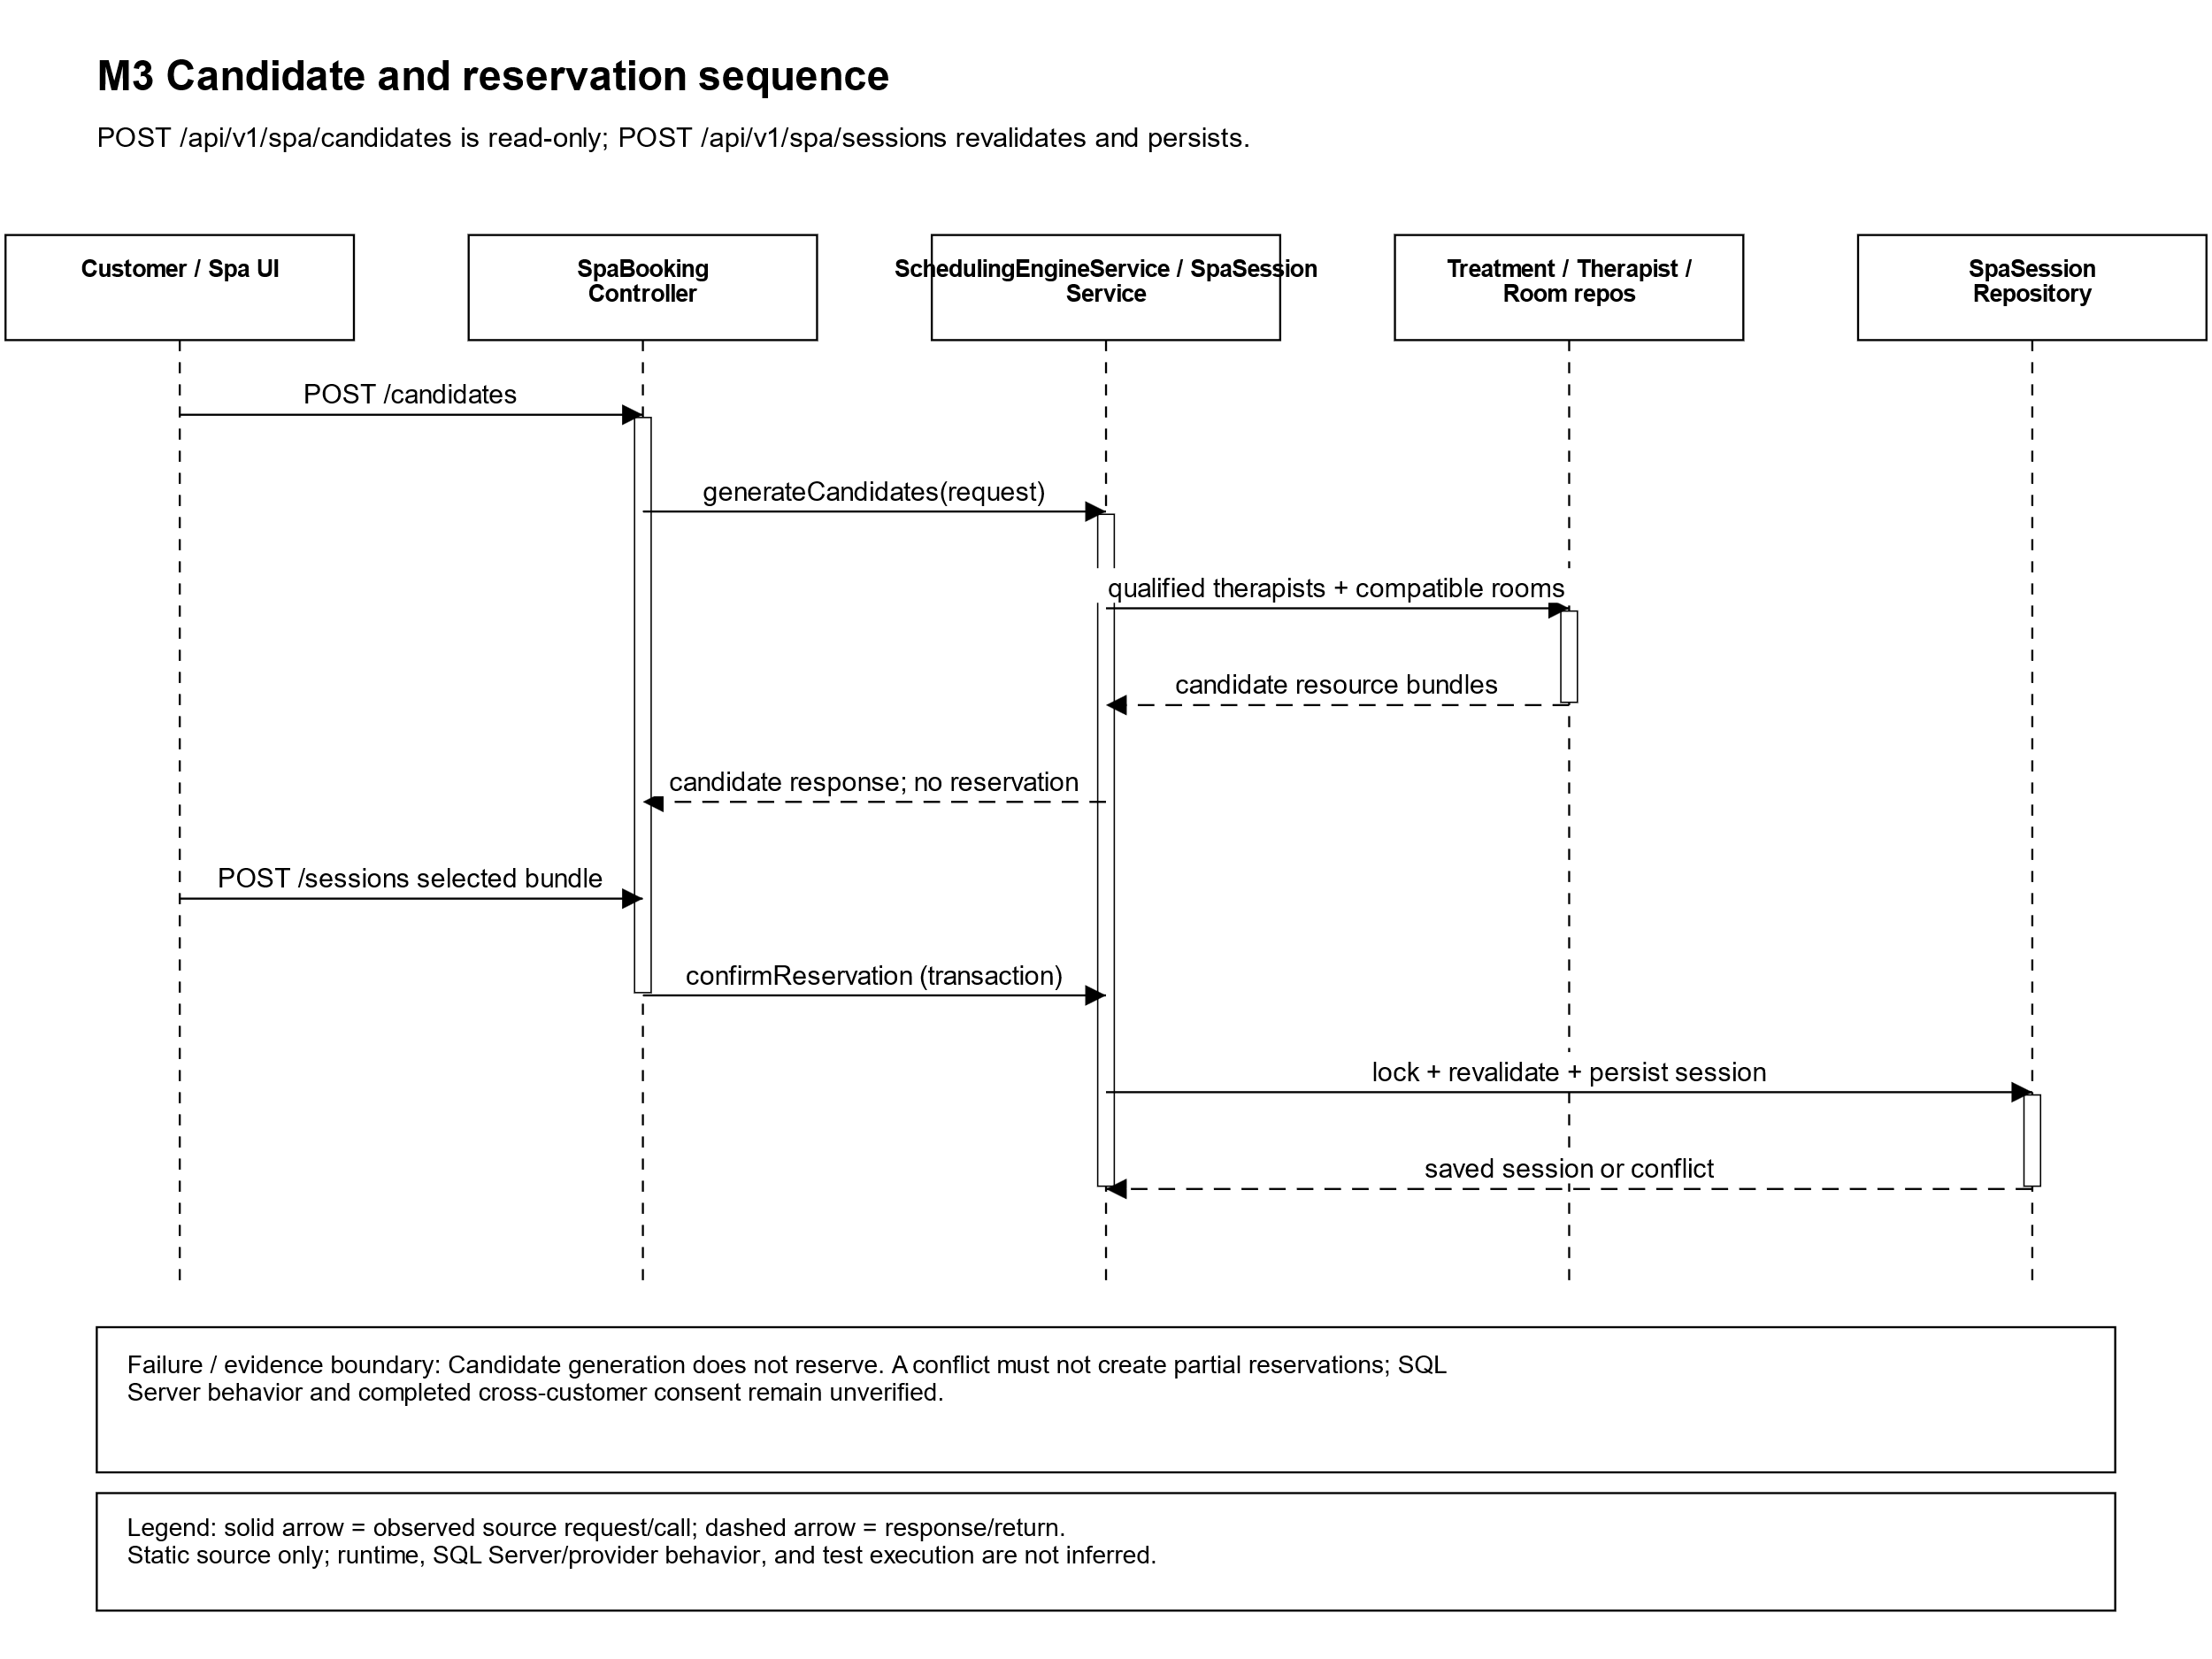
Figure 16. Read-only candidate generation followed by transactional reservation revalidation; SQL Server behavior is unverified. Selected path only; error and alternate branches are not exhaustive.

4. M4 Dietary F&B Management
M4 manages menu/order, KDS, recipe and ingredient inventory. Source components include MenuController, FnbKdsController, MenuService and FnbKdsOrderServiceImpl; entities include MealOrder/Item, MenuItem and IngredientBatch.

Responsibilities and design constraints
• Allergy suitability must fail closed. If suitability cannot be established, do not treat a meal as suitable; do not reduce this to a warning.
• Inventory must respect usable quantity, expiry and condition; reserve/deduct at the approved preparation transition, not an invented earlier state.
• G04 lists PENDING → PREPARING → READY → DELIVERED and CANCELLED. Full transition and authorization matrix is partial.
• Eligible A_LA_CARTE delivery calls M5 postFolioChargeIdempotent with sourceMealOrderId. Both service methods carry transactional annotations; runtime propagation and SQL Server concurrency were not tested.
• OI-06 uses explicit configurable service-location contract; OI-07 uses package-specific entitlement matrix with effective dates. These are target decisions; implementation/configuration evidence must be mapped.

Evidence status
PARTIAL — source and test files exist; location, entitlement, inventory and allergy runtime evidence remain incomplete.

Components and operations
MealOrderController exposes customer ordering and staff status updates. FnbKdsOrderServiceImpl places orders, checks booking context, reads the kitchen queue, locks an order during status change, rejects changes after DELIVERED/CANCELLED, and handles delivery/cancellation. DefaultBookingAndDietaryIntegrationService reads M2 booking and M1 customer/health data. IngredientBatch and menu/recipe entities support inventory; M6 audit calls are present in selected paths.

Interfaces, data access, and failure boundary
MealOrderController routes under /api/v1/fnb/orders call MealOrderService; its status endpoint uses UpdateOrderStatusRequest and returns KitchenOrderResponse. Source traces the FnbKdsController status route through MealOrderService.updateOrderStatus to FnbKdsOrderServiceImpl; eligible A_LA_CARTE delivery invokes M5 postFolioChargeIdempotent with sourceMealOrderId, which is passed into FolioItemEntity and queried by the duplicate-check repository. Both service methods are transactional in source, but runtime propagation and SQL Server races remain unverified. Allergy suitability must fail closed. The full actor/transition matrix, cross-bean propagation, and SQL Server races remain unverified; service-location and package-entitlement matrices remain target decisions.
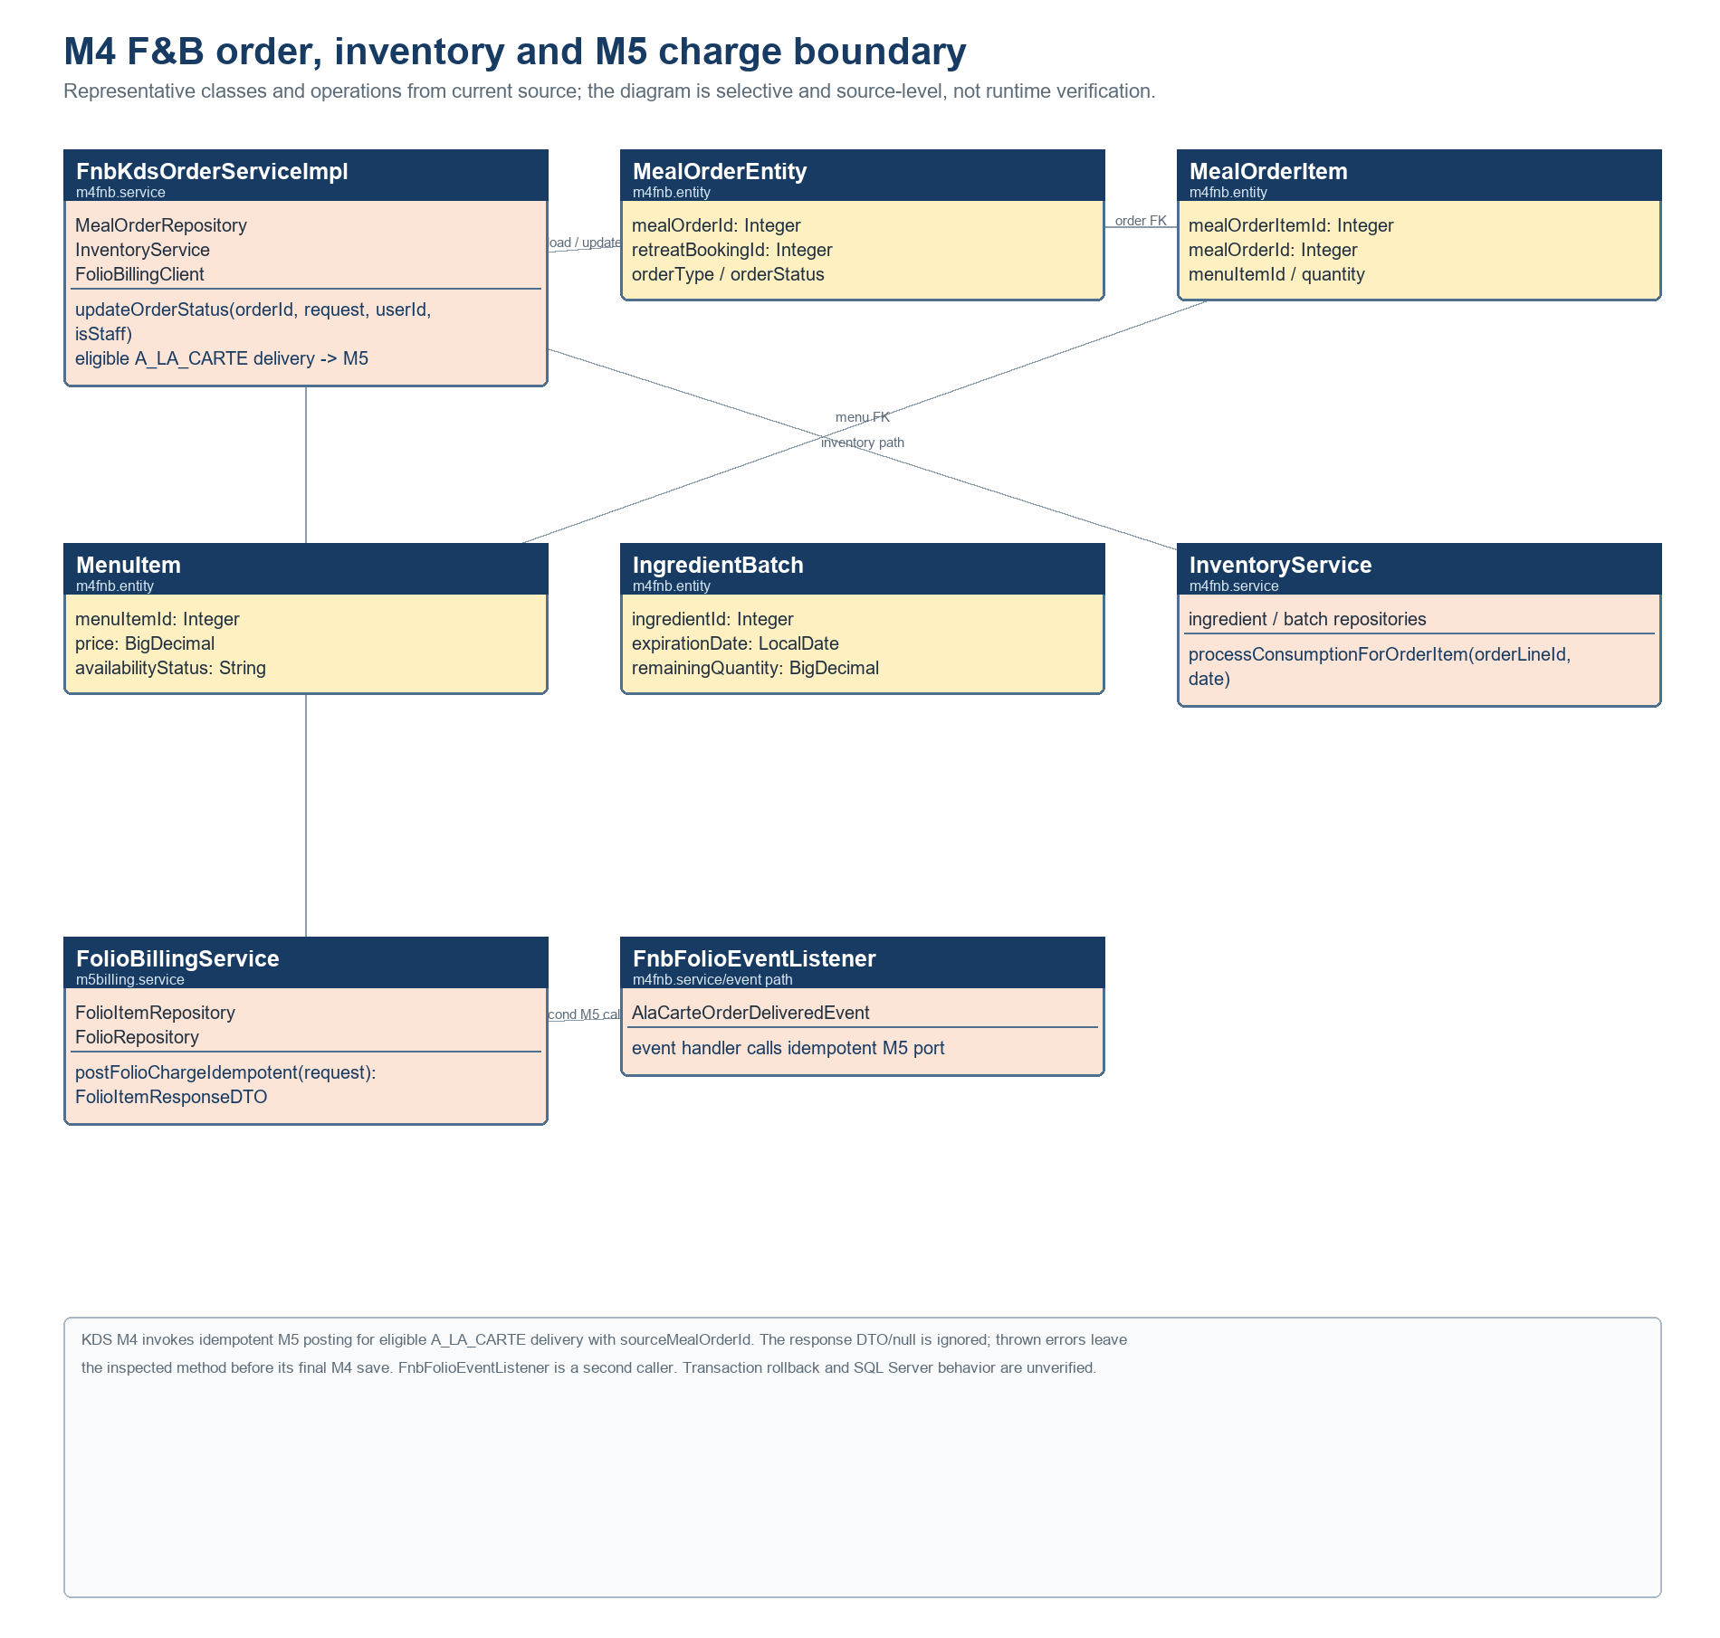
Figure 17. M4 order, inventory and M5 charge classes. The direct KDS caller and second event-listener caller are both shown; idempotency and transaction behavior are not runtime-verified.
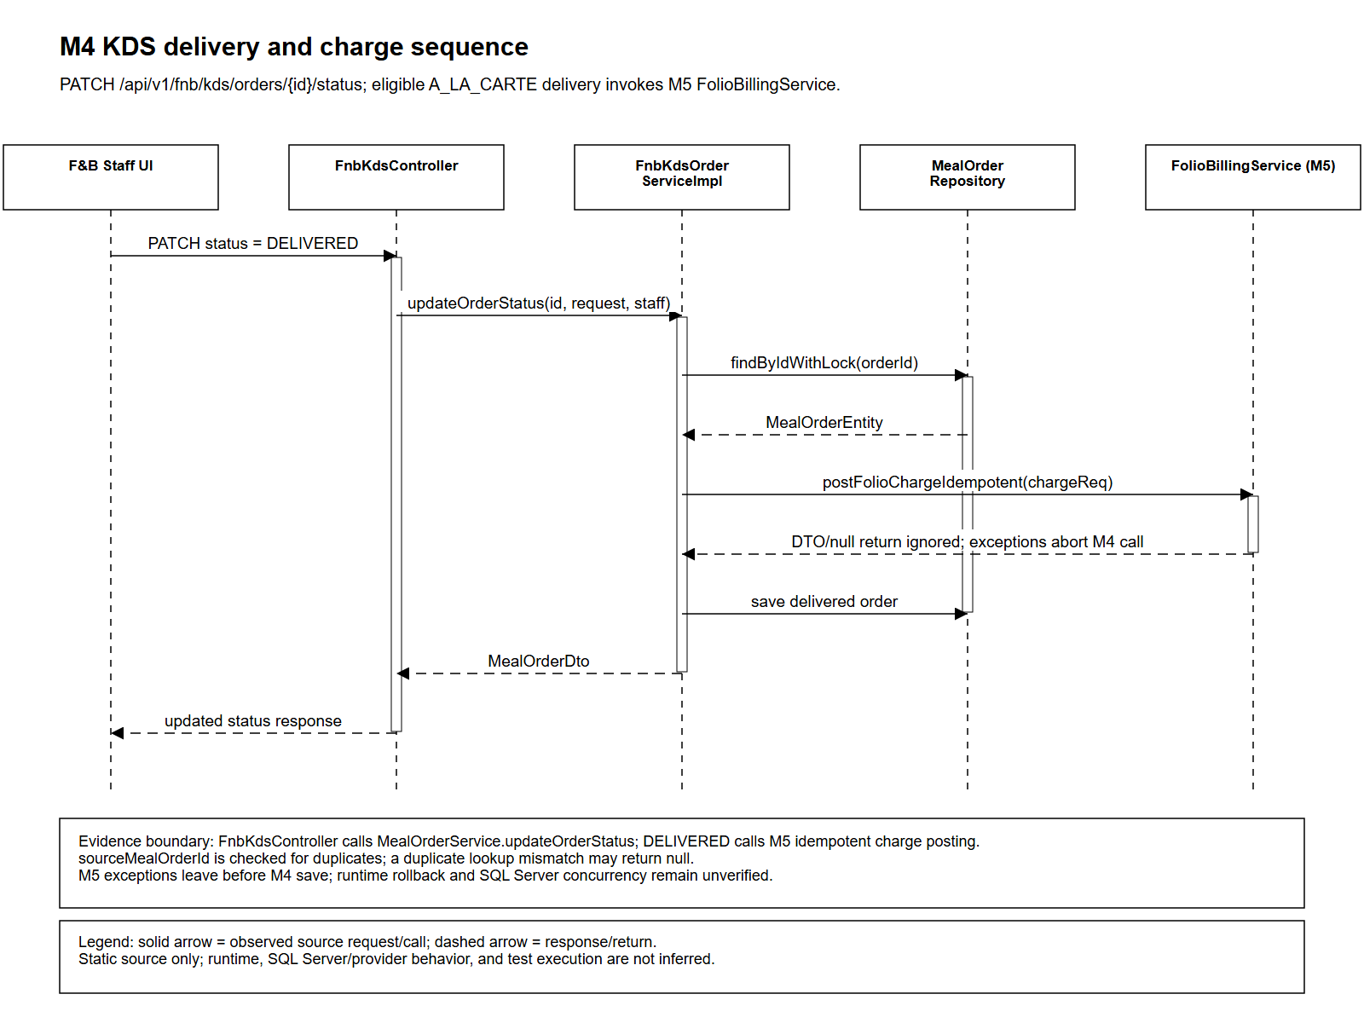
Figure 18. KDS delivery calls M5 for eligible A_LA_CARTE charges. Returned DTO or null is ignored; a thrown M5 exception exits before M4 status save. Runtime rollback and SQL Server behavior remain unverified. Selected path only; error and alternate branches are not exhaustive.

5. M5 Consolidated Checkout and Analytics
M5 contains Folio, Invoice, PaymentTransaction and checkout services. Revision 1.1 selects M5 ownership of PaymentTransaction and an M5-owned idempotent Folio posting contract. These target ownership directions do not prove every present code path conforms.

Responsibilities and design constraints
• Folio is a mutable running stay account; Invoice is a formal snapshot. A successful PaymentTransaction is not by itself proof of checkout completion: an asynchronous VNPay callback closes the stay only when the invoice becomes PAID and the billing guard passes; finalizeCheckout separately checks balance and guards.
• Checkout must block when unpaid/unresolved Spa or F&B charges remain. CheckoutService source locks/rechecks booking/folio and checks balance, but SQL Server locking and charge visibility are unverified.
• M3 adapter calls a non-idempotent M5 operation and catches/logs errors. M4 eligible delivered A_LA_CARTE uses an idempotent source order key. OI-01 risk remains until source changes and verification demonstrate M5 target contract across paths.
• VNPay is the only in-scope payment method; Cash/POS and other methods are deferred. No live VNPay verification. Refund, adjustment, settlement and reconciliation details need evidence; no policy is invented.

Evidence status
PARTIAL — target ownership selected; adapter gap, gateway runtime, refunds and SQL Server behavior remain.

Components and operations
FolioBillingService posts charges and creates invoice snapshots; CheckoutService.processPayment evaluates payment state, and finalizeCheckout validates outstanding amounts before stay close. The observed finalization path reads invoice details, locks Folio and RetreatBooking via repositories, sums successful PaymentTransaction values and final credit notes, then applies close state. VNPayService.createPaymentUrl persists a PENDING PaymentTransaction; verify-return processes the callback through confirmGatewayPayment. A successful callback can close the Folio and Booking when the Invoice becomes PAID and the billing guard passes. Runtime gateway behavior is unverified.

Interfaces, data access, and failure boundary
POST /api/v1/billing/charges calls non-idempotent postFolioCharge; postFolioChargeIdempotent is a separate source-key method used by M4 delivery. This does not prove the M3 path meets OI-01. PaymentRequestDTO source accepts a broader method vocabulary than the VNPay-only strategic scope; source validation does not prove deferred methods are operational or approved. Folio is mutable; Invoice is a snapshot. A successful PaymentTransaction is distinct from stay closure: the callback closes only on PAID invoice plus passing billing guard; finalize-checkout separately rejects remaining balance or billing-guard failures. SQL Server concurrency, callbacks, refunds, and reconciliation remain unverified.
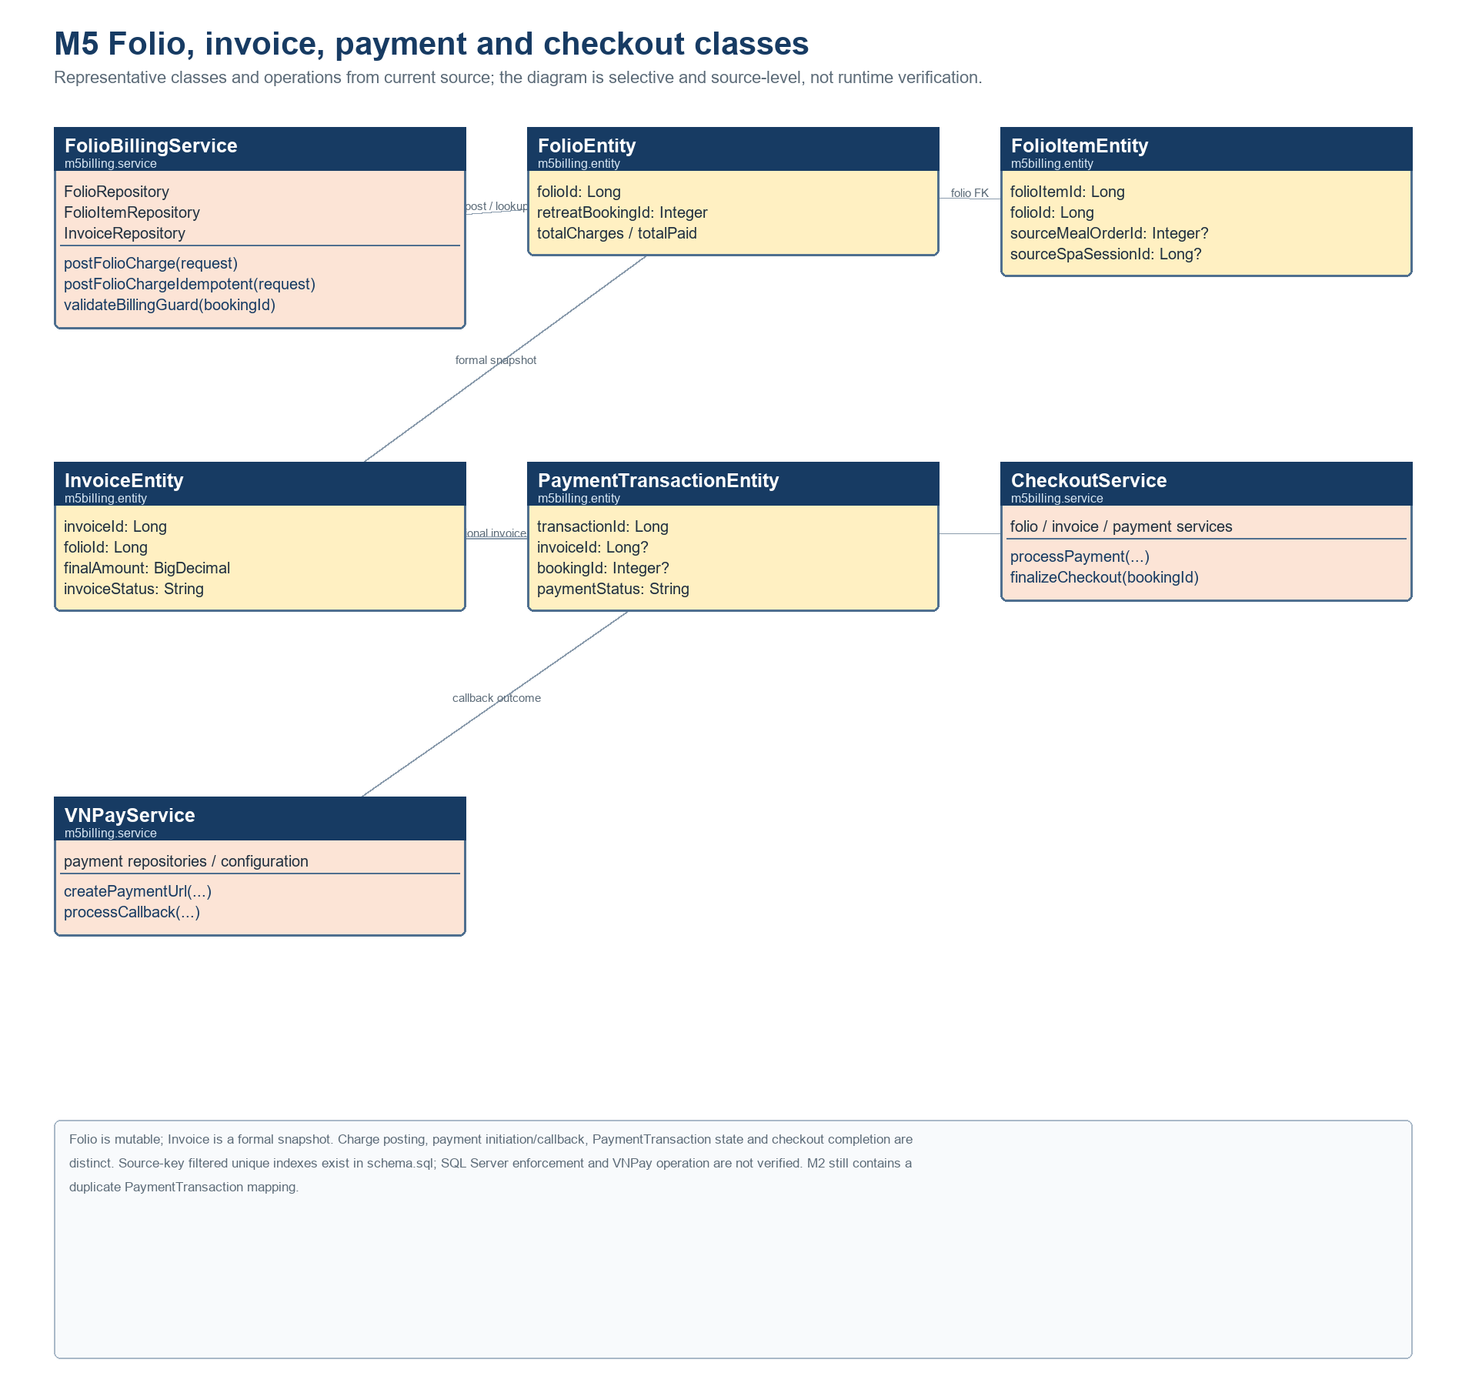
Figure 19. M5 folio, invoice, payment and checkout classes. Charge, payment, callback and checkout are separate source paths; SQL Server and VNPay behavior remain unverified.
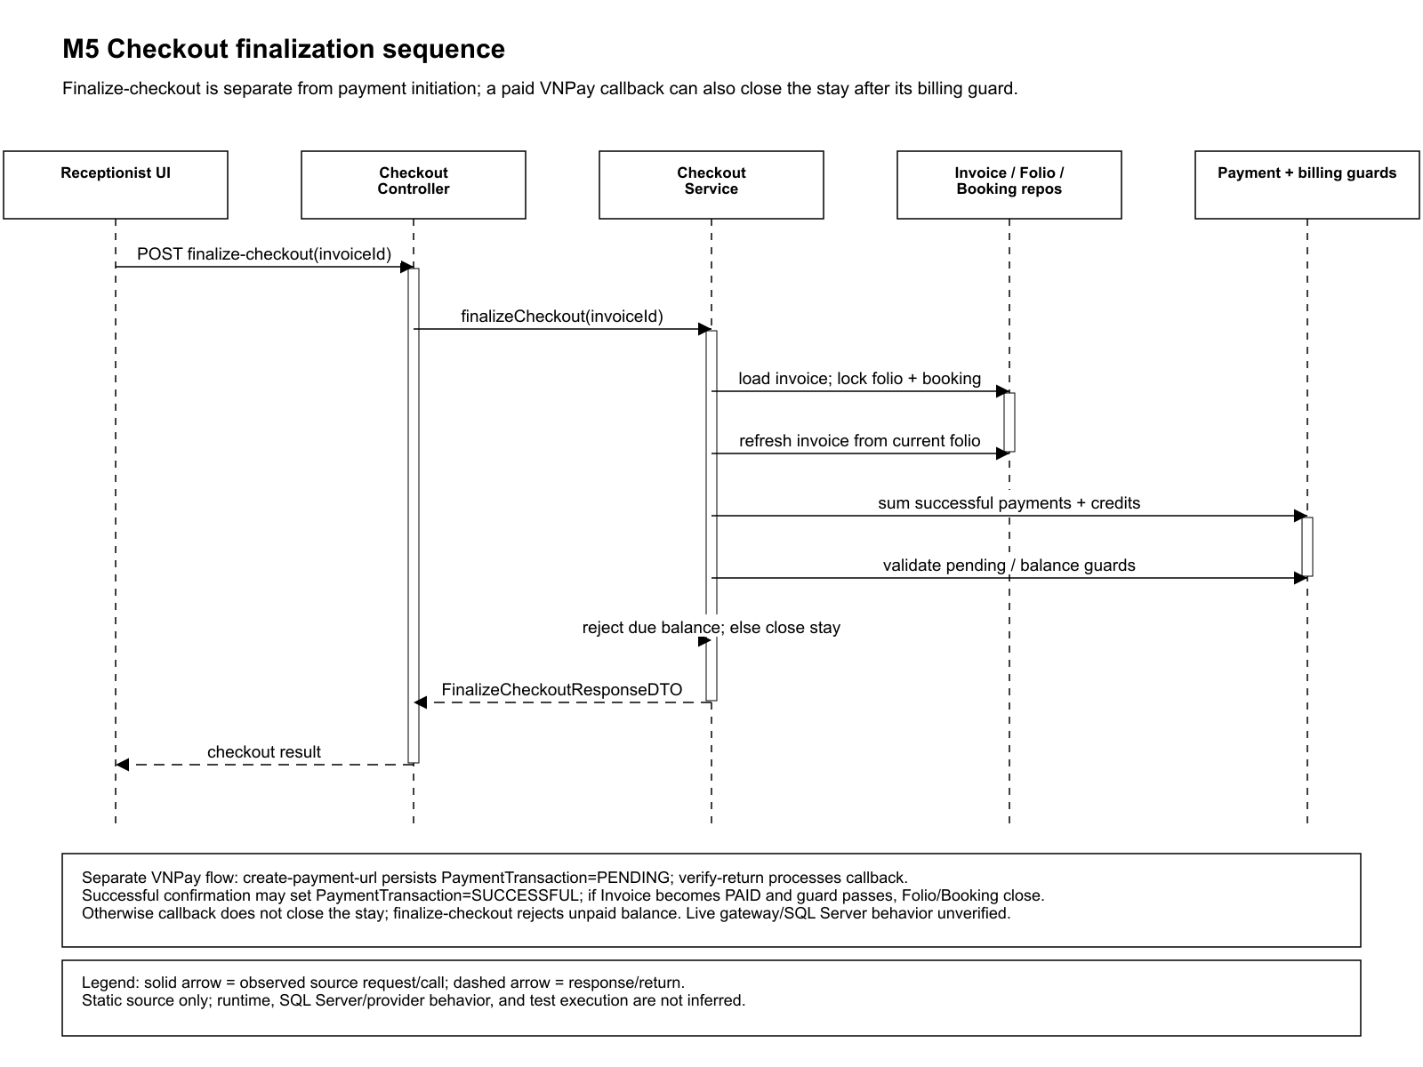
Figure 20. Invoice-owned finalization path plus separate VNPay callback outcome; a paid, guarded callback may close the stay. Live gateway and SQL Server behavior remain unverified. Selected path only; error and alternate branches are not exhaustive.

6. M6 System Administration and Permission Management
M6 includes permission catalog and role mapping, permission evaluation, staff, delegation, audit and system configuration. Static components include AdminPermissionController, AdminDelegationController, PermissionEvaluator and DelegationService.

Responsibilities and design constraints
• Backend authorization is authoritative; selected endpoints use permission guards, but full route coverage is incomplete.
• Delegation follows least privilege, is time-limited and auditable. Broad, indefinite or unaudited delegation is not an acceptable target.
• Canonical SystemConfiguration and RightDelegation API/data/UI contract is not established by the available evidence. Do not assume frontend shape is the canonical contract.
• Audit writes are present in selected paths. Retention, immutability, read access and operation are not runtime verified.

Evidence status
PARTIAL — source exists; contract, all-consumer coverage, policy values and formal security approval remain pending.

Components and operations
SecurityConfig enables method security; PermissionEvaluator delegates to PermissionService. AdminDelegationController applies S52 view/create/delete checks to list/create/revoke. DelegationService validates actor, Manager target, permission and time bounds, and records audit in selected create/revoke paths. SystemConfiguration and RightDelegation repositories back configuration/delegation areas, but canonical API/data/UI contracts are not established.
DelegationCreateRequest uses @Valid; create returns DelegationView and revoke returns updated DelegationView. Status refresh/revoke source exists, but scheduler invocation and all module consumers are not verified. Permission evaluation is intended to deny on failure; selected guards do not prove complete route coverage. Audit retention/immutability and policy values require security and organizational approval. Frontend guards do not replace backend authorization.
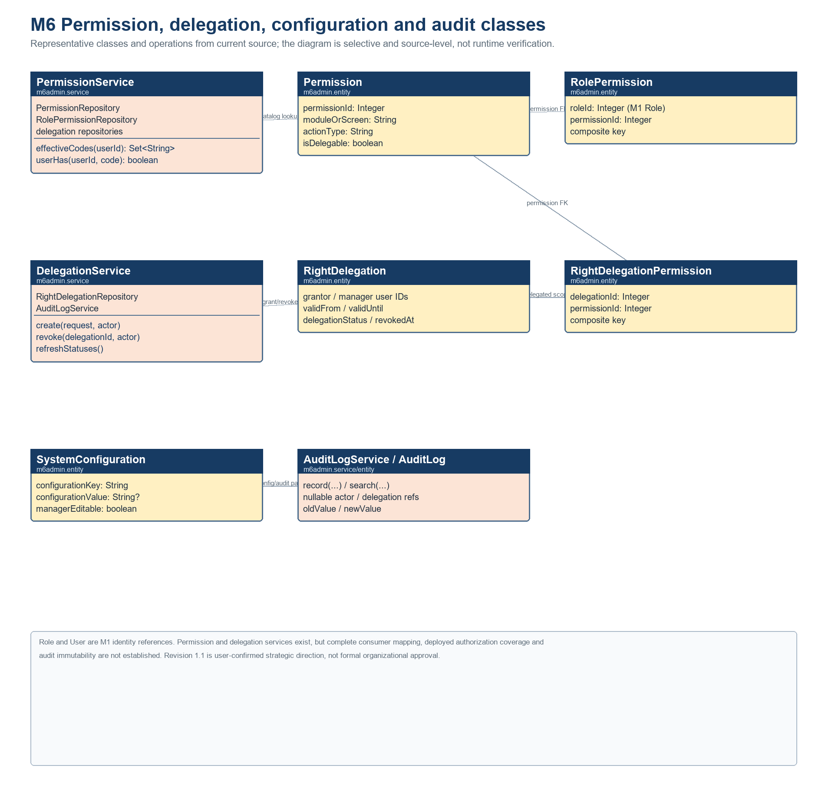
Figure 21. M6 permission, delegation, configuration and audit classes. Source structure only; complete consumer mapping, runtime authorization coverage and audit guarantees remain unverified.

Interfaces, data access, and failure boundary
AdminPermissionController/AdminDelegationController expose selected permission and delegation routes with @perm guards. M6 uses its permission, delegation and configuration repositories and reads M1 UserRepository/RoleRepository data; M1 calls M6 PermissionService.effectiveCodes and selected parameter/audit services. Delegation validation/access errors and selected audit writes are source-visible. Full route coverage, scheduler/runtime behavior and audit guarantees remain unverified.
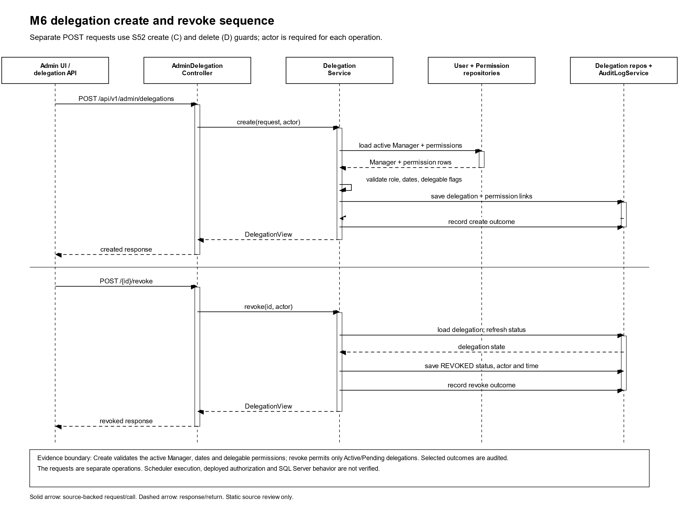
Figure 22. Delegation creation/revocation path; scheduler and deployed authorization are not runtime-verified. Selected path only; error and alternate branches are not exhaustive.

III. Other Design Specifications
Document status and evidence scope: Version 3.0. Verified implementation facts are limited to inspected repository source and static artifacts. Revision 1.1 records user-approved strategic directions, not formal organizational approvals. Proposed contracts, unverified runtime/deployment behavior, and unresolved gaps remain explicitly labelled. No tests, application, database, SQL Server, SMTP, Google Calendar, or VNPay were executed for this specification.

1. Security and privacy
• JWT authentication and backend role/permission checks are source-backed. Full effective-route coverage and deployed 401/403 outcomes are not established. Frontend guards provide presentation only.
• Apply least privilege, resource ownership checks for Customer/Therapist records, and minimum health-data projection. Health access remains purpose-scoped; exact field matrices need approved evidence.
• Consent, identity, profile and health are distinct concerns. Deletion can be deferred when active/upcoming stay needs data; no retention period or grace window is invented.
• Never include credentials or machine-specific values in specifications. Secret storage and operational identity controls require an approved deployment design.

2. Interfaces, errors, and transaction boundaries
REST controllers, module services, Spring Data repositories, selected ports/adapters and scheduled workers are visible in source. The 152 route candidates match handler/path annotations, but do not form a complete effective API contract. Authentication, composed routes, DTO validation, error mapping, UI callers, repository writes and tests are not joined for every route.
Boundary | Observed path | Failure/design treatment | Status or target
M2→M3 | DefaultCustomerStayAdapter reads M2 booking and M1 customer profile via read-only transaction/JDBC fallback. | Returns empty when context unavailable (fail closed); active bean and caller response unverified. | Static evidence; runtime pending.
M3→M5 | DefaultBillingAdapter calls non-idempotent postFolioCharge with session source; catches/logs. | Durable retry/idempotency not shown; reconciliation risk. | Target: M5-owned idempotent contract (OI-01); implementation gap.
M4→M5 | Eligible A_LA_CARTE calls postFolioChargeIdempotent with sourceMealOrderId. | Idempotent method/source check exists; transaction and SQL Server race untested. | Target owner M5; accounting ownership path still must be reconciled.
M1→M4 | Dietary integration reads health profile. | Fail closed where allergy suitability cannot be established; minimize projection. | Field-level runtime authorization pending.
M6→modules | Permission evaluator and selected @perm guards. | Deny on evaluation failure; all route consumers not mapped. | Least privilege target; coverage pending.
A proposed API error taxonomy is validation 400, authentication 401, authorization/ownership 403 (or non-disclosing not-found where approved), not-found 404, lifecycle/conflict 409, and dependency failure 5xx or safe domain error. This is a proposed consistency contract; exact endpoint behavior must be verified from controller advice and API tests. The selected interface table is a high-risk subset: it records declarations and visible calls, not 152 end-to-end contracts. Response, validation, exception, and security fields are marked unknown when not confirmed in inspected source.

Declared endpoint and handler | Request → response types | Visible access / validation | Service path and evidence limit
GET /api/v1/customers/me/health-profile  HealthProfileController.getMyHealthProfile | No request body → ApiResponse<HealthProfileResponse> | @PreAuthorize hasRole(CUSTOMER); identity from authenticated principal. | HealthProfileService.getMyHealthProfile; field-level access, error mapping, and runtime outcomes not verified.
POST /api/v1/spa/candidates  SpaBookingController.generateCandidates | GenerateCandidatesRequest → CandidateGenerationResultDto | SPA-role matcher in SecurityConfig; @Valid. No method @PreAuthorize visible. | SchedulingEngineService.generateCandidates; read-only. DTO validation failure responses and runtime contract not verified.
POST /api/v1/spa/sessions  SpaBookingController.confirmReservation | ConfirmReservationRequest → SpaSessionDto | SPA-role matcher; @Valid; principal passed to service. No method guard visible. | SpaSessionService.confirmReservation; transactional source path; rollback, error mapping, and SQL Server behavior not verified.
POST /api/v1/receptionist/check-in/{bookingId}/assign-villa  assignVillaAndCheckIn | AssignVillaRequest → BookingSummaryResponse | Receptionist route matcher; no controller method guard visible in inspected handler. | ReceptionistOperationService.assignVillaAndCheckIn; lock methods in source; error mapping and SQL Server behavior not verified.
PATCH /api/v1/fnb/orders/{orderId}/status  MealOrderController.updateOrderStatus | UpdateOrderStatusRequest → KitchenOrderResponse | @PreAuthorize FNB_STAFF / F&B STAFF; @Valid; status required. | MealOrderService.updateStatus. Link to FnbKdsOrderServiceImpl Folio posting remains unverified; transition errors/transaction behavior need reconciliation.
POST /api/v1/billing/charges  FolioBillingController.postFolioCharge | PostChargeRequestDTO → FolioItemResponseDTO | RECEPTIONIST/ADMIN @PreAuthorize; @Valid. | FolioBillingService.postFolioCharge; non-idempotent; OI-01 risk. Error mapping and durable retry not evidenced.
POST /api/v1/billing/invoices/{invoiceId}/pay  CheckoutController.processPayment | PaymentRequestDTO → PaymentResponseDTO | Staff roles or invoice-access evaluator; @Valid. | CheckoutService.processPayment; transaction in source; payment errors/callbacks and live gateway unverified.
POST /api/v1/billing/invoices/{invoiceId}/finalize-checkout  CheckoutController.finalizeCheckout | No body → FinalizeCheckoutResponseDTO | @PreAuthorize billingAccess.canFinalizeCheckout; effective outcomes not run. | CheckoutService.finalizeCheckout; locks Folio/Booking and checks amounts; response errors and SQL Server isolation unverified.
POST /api/v1/admin/delegations  AdminDelegationController.create | DelegationCreateRequest → DelegationView | @perm.has(S52,C); @Valid; CurrentActor principal. | DelegationService.create; validation/audit static; error mapping, all consumers, and policy approval not verified.
Figure 3 arrows point from caller to dependency: M3 reads M1/M2 context and calls M5; M4 reads M1/M2 context and calls M5/M6. M1 AuthController calls M6 PermissionService.effectiveCodes; M1 AccountLockoutService calls M6 BusinessParameterService and AuditLogService. M6 PermissionEvaluator and DelegationService read M1 UserRepository/RoleRepository data. No direct M3-to-M4 call was found in the reviewed scan.

3. Lifecycle and concurrency
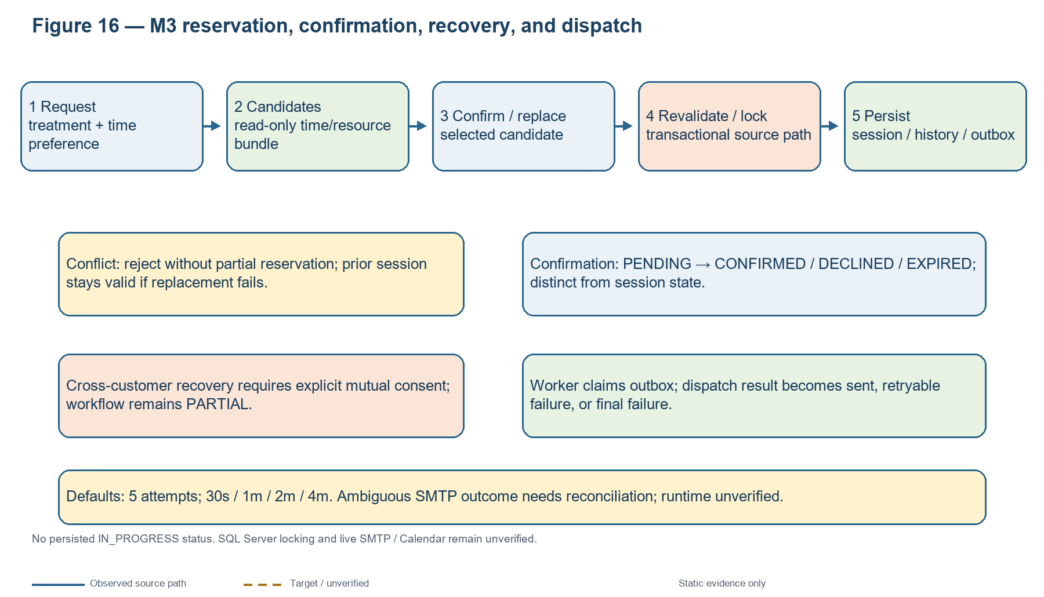
Figure 23. M3 reservation, confirmation, recovery, and dispatch. SQL Server and provider behavior remain unverified.
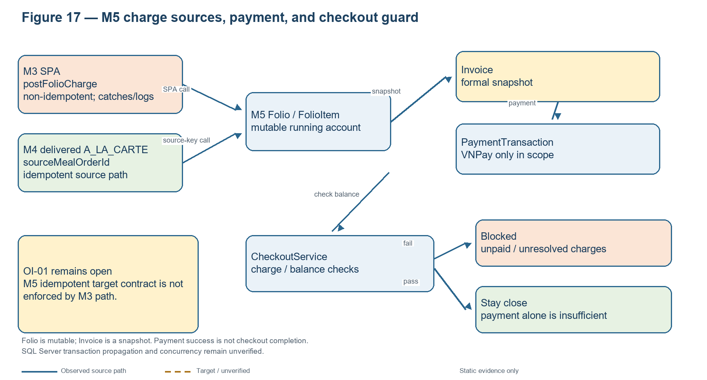
Figure 24. M5 charge and checkout paths. M3 and M4 adapter semantics differ; payment success is not checkout completion.
M3 search does not reserve; confirmation revalidates and locks the resource bundle. Keep original session while a replacement is pending and commit replacement atomically. Cross-customer recovery requires both parties’ explicit consent. Checkout must not omit delivered F&B charges. H2 cannot establish SQL Server locking, isolation, deadlocks, triggers or production scheduler timing.
Figure 23 expands the reservation and dispatch flow. Current working-tree defaults specify five total attempts and delays of 30 seconds, 1, 2, and 4 minutes. This is static configuration evidence, not worker-activation or delivery proof. Ambiguous SMTP outcomes require reconciliation. The SPA billing adapter still calls non-idempotent postFolioCharge and catches/logs failures.

4. External integrations and background processing
Integration / trigger | Direction and source behavior | Failure / retry evidence | Verification status
M3 Email / SMTP | M3 outbox worker → SMTP; reminder or schedule-change item. | Worker claims persisted item; current source has configurable attempts/delays and provider outcomes. Ambiguous send can be uncertain. | No live send, receipt, bounce, credentials, or provider outcome verified. Reconcile ambiguity; do not blindly resend.
M3 Google Calendar | M3 adapter/worker → Google Calendar for session create/update/cancel. | Outbox/adapter result handling is source-visible; authenticated client absent in reviewed evidence. | No live event operation or authenticated client verification.
VNPay | M2 deposit/M5 payment URL and callback paths ↔ VNPay. | Source/config and callback handling exist; payment success and stay closure are distinct. Runtime/idempotency details remain partial. | VNPay is the only in-scope method by Revision 1.1; no live gateway, settlement, or finance reconciliation evidence.
Schedulers / outbox / webhook | Scheduled M3 workers and payment callback handlers → database/provider boundaries. | 30-second dispatch sweep and 60-second recovery schedule are source declarations; operation depends on activation/configuration. | No activation, provider delivery, shutdown, or production timing verified.
VietQR source | Legacy/config or source endpoints may remain; not an approved payment method in current scope. | Source presence does not establish active operational scope. | Deferred/out of current strategic payment scope; no provider or settlement verification.

5. Deployment, SQL Server and migration status
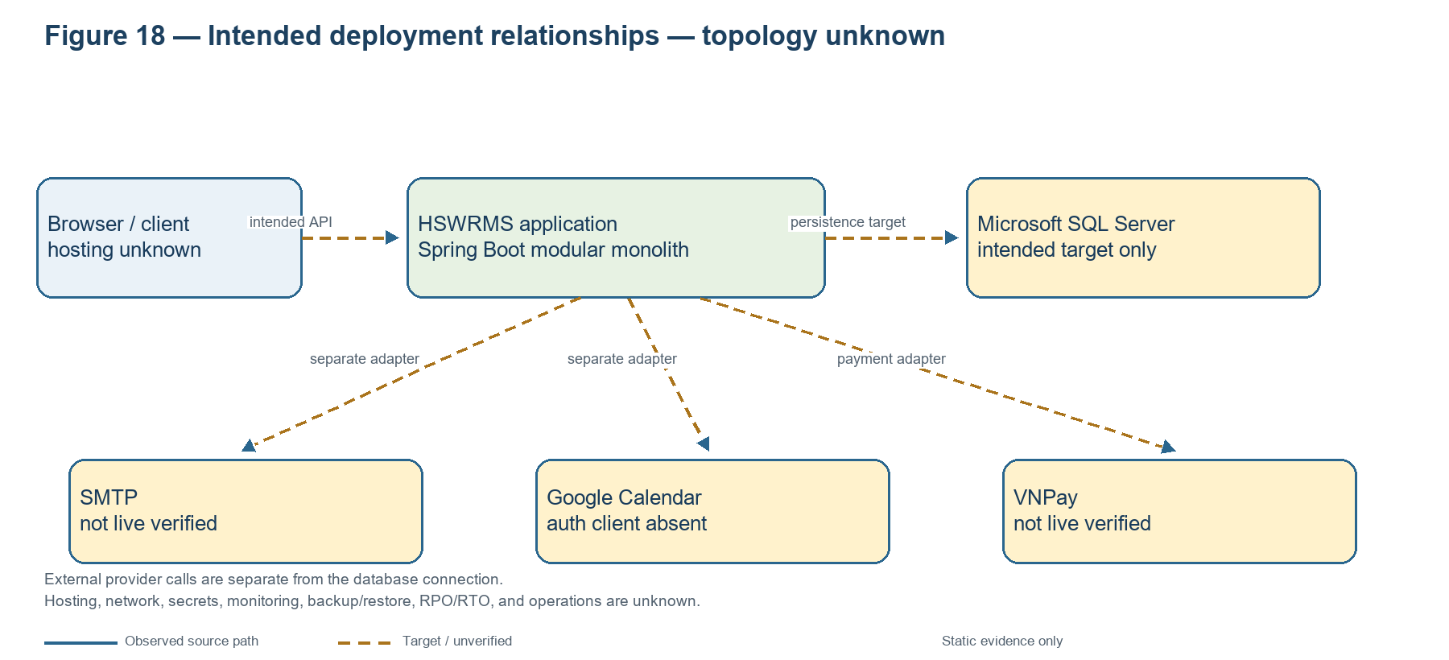
Figure 25. Intended deployment relationships. Hosting, topology, SQL Server, and provider operations remain unverified.
No approved topology, network segmentation, secret handling, health checks, logging/monitoring, backup/restore, RPO/RTO, certificate rotation, scaling or operations ownership was available. H2 is test evidence only and does not establish SQL Server behavior.
Figure 25 separates intended browser-to-application, application-to-database, and application-to-provider relationships. External providers are not shown as reached through SQL Server.
Static migration history includes duplicate V1_6 identifiers; V004/V2 namespace ambiguity; overlapping V003/V1_2/V1_3/V1_4 ownership; V011/V012/V015 M3 consolidation; V014/V017 trigger/payment overlap; destructive V1_5; and seed-like DML in V007. Filenames do not define an approved order. No migration ran and this SDS does not select an execution plan.
Migration question | SDS treatment | Evidence required
Duplicate V1_6; V004 vs V2 | No order inferred. | DBA-approved framework and unique ordered manifest.
V003 / V1_2 / V1_3 / V1_4 overlap | Potential duplicate/conflicting object ownership. | Baseline-to-file DDL diff and object-owner confirmation.
V011 / V012 / V015 | Potential M3 schema consolidation. | Dependency and data impact review plus SQL Server restore test.
V014 vs V017 | Payment/type/VietQR vs trigger/payment overlap. | Compare against canonical schema, trigger definitions and approved finance contract.
V1_5 destructive removal | Potential loss of duration-unit data. | Impact assessment and explicit approval before execution.
V007 seed-like DML | Do not treat seed content as schema migration. | Approved seed lifecycle and separated deployment artifact.

6. Requirements, API, service, data, and test traceability
Phase 0.1-F reports 46 FR records: 19 have partial direct controller/dependency candidates; 27 are not defensibly mapped; 0 complete FR-to-acceptance chains. The table reproduces each FR ID, summary and candidate API/status from A01. “Candidate” is not a verified implementation chain. Full records remain in SDS_REPOSITORY_AUDIT_PHASE_0_1_F_TECHNICAL_EVIDENCE/A01_FR_IMPLEMENTATION_TRACEABILITY.csv.
FR ID | Requirement | Module | API candidate | Evidence status
FR-M1-01 | Register Account | M1 | /api/v1/auth/register | Partial candidate
FR-M1-02 | Email OTP Verification | M1 | /api/v1/auth/verify-email | Partial candidate
FR-M1-03 | Email & Password Login | M1 | /api/v1/auth/login | Partial candidate
FR-M1-04 | Forgot & Reset Password | M1 | /api/v1/auth/forgot-password;/api/v1/auth/reset-password | Partial candidate
FR-M1-05 | Single Sign-On Authentication (Google & Facebook) | M1 | /api/v1/auth/register/sso;/api/v1/auth/sso/tickets/exchange;/api/v1/auth/sso/tickets/resolve;/api/v1/auth/sso/tickets/link | Partial candidate
FR-M1-06 | Account Settings Management | M1 | UNMAPPED | Not mapped
FR-M1-07 | Health & Dietary Profile Management | M1 | UNMAPPED | Not mapped
FR-M1-08 | Consent Management | M1 | /api/v1/customers/me/consents/{consentType}/revoke | Partial candidate
FR-M1-09 | Health Data Deletion Request & Retention Processing | M1 | UNMAPPED | Not mapped
FR-M2-01 | Browse Retreat Packages | M2 | UNMAPPED | Not mapped
FR-M2-02 | Book Retreat & Pay Deposit | M2 | UNMAPPED | Not mapped
FR-M2-03 | Perform Check-in & Assign Villa | M2 | UNMAPPED | Not mapped
FR-M2-04 | Manage Villa Status | M2 | /api/v1/villas/{villaNumber}/status | Partial candidate
FR-M2-05 | View Booking & Itinerary | M2 | /api/v1/customer/bookings/{id} | Partial candidate
FR-M2-06 | Create Walk-in Booking | M2 | /api/v1/receptionist/walk-in | Partial candidate
FR-M2-07 | Cancel Booking or Services | M2 | /api/v1/customer/bookings/{id}/cancel | Partial candidate
FR-M2-08 | Modify Booking or Services | M2 | /api/v1/customer/bookings/{id} | Partial candidate
FR-M3-01 | Submit Spa/Therapy Scheduling Request | M3 | /api/v1/spa/sessions | Partial candidate
FR-M3-02 | Generate & Select Valid Scheduling Candidates | M3 | /api/v1/spa/candidates | Partial candidate
FR-M3-03 | Revalidate & Atomically Reserve Selected Schedule | M3 | /api/v1/spa/sessions | Partial candidate
FR-M3-04 | Manage Reminder Timeline & Customer Confirmation | M3 | /api/v1/spa/sessions/{id}/confirm-attendance | Partial candidate
FR-M3-05 | Recover / Re-Match Disrupted Session | M3 | /api/v1/spa/sessions/{id}/decline-attendance | Partial candidate
FR-M3-06 | Receptionist-Initiated Extra Spa Booking | M3 | UNMAPPED | Not mapped
FR-M3-07 | View Assigned Schedule & Treatment Safety Health Profile | M3 | UNMAPPED | Not mapped
FR-M3-08 | Record Final Session Attendance & Outcome | M3 | /api/v1/spa/sessions/{id}/confirm-attendance | Partial candidate
FR-M4-01 | View Personalized Menu | M4 | UNMAPPED | Not mapped
FR--M4-02 | Pre-Select Daily Meal | M4 | UNMAPPED | Not mapped
FR--M4-03 | Order Extra A-lar-carte | M4 | /api/v1/fnb/customer/daily-meals;/api/v1/fnb/orders/daily-meals | Partial candidate
FR--M4-04 | Manage Ingredient Batch Information | M4 | UNMAPPED | Not mapped
FR--M4-05 | View Meal Preparation Dashboard | M4 | UNMAPPED | Not mapped
FR--M4-06 | Prepare Meal | M4 | UNMAPPED | Not mapped
FR- | [FR-] Update Meal Order Status 5. Module 5 - Consolidated Checkout & Analytics | UNRESOLVED | UNMAPPED | Not mapped
FR--M5-01 | Generate Consolidated Invoice & Manage Folio | M5 | UNMAPPED | Not mapped
FR--M5-02 | Process Final Payment & Settlement | M5 | UNMAPPED | Not mapped
FR--M5-03 | Finalize Stay & Automated Checkout | M5 | /api/v1/billing/invoices/{invoiceId}/finalize-checkout | Partial candidate
FR-M5-04 | View & Download E-Invoice | M5 | UNMAPPED | Not mapped
FR-M5-05 | Submit Customer Review & Rating | M5 | UNMAPPED | Not mapped
FR-M5-06 | View Operational & Revenue Analytics Dashboard | M5 | UNMAPPED | Not mapped
FR-M6-01 | Manage Staff Accounts & Role Assignment | M6 | UNMAPPED | Not mapped
FR-M6-02 | Manage Master Data | M6 | UNMAPPED | Not mapped
FR-M6-03 | Configure Business Parameters | M6 | UNMAPPED | Not mapped
FR-M6-04 | Toggle Feature Flags | M6 | UNMAPPED | Not mapped
FR-M6-05 | Configure Permission Matrix | M6 | UNMAPPED | Not mapped
FR-M6-06 | Delegate Limited Admin Rights to Manager | M6 | UNMAPPED | Not mapped
FR-M6-07 | View Sensitive-Data Audit Log | M6 | UNMAPPED | Not mapped
FR-M6-08 | View System Overview Dashboard | M6 | UNMAPPED | Not mapped
Original FR identifiers are retained exactly as recorded in A01, including malformed or unresolved source identifiers; no IDs were renumbered.
Trace-link statuses: route and call-site matches are direct static evidence, not requirement satisfaction; unresolved service/data joins are partial; test-method associations without approved FR linkage remain inferred; unmapped/conflicting identifiers stay raw. Phase 0.1-F records 0 direct approved test-to-FR/rule links, 0 tests run in that phase, and 0 complete FR-to-acceptance chains. Raw “FR-” remains unresolved.

Test-source evidence summary
Source group | Test classes | Annotated methods | Direct FR/rule link
SHARED | 13 | 79 | 0 direct; inferred links only
m1identity | 24 | 148 | 0 direct; inferred links only
m2booking | 8 | 58 | 0 direct; inferred links only
m3spa | 17 | 154 | 0 direct; inferred links only
m4fnb | 11 | 100 | 0 direct; inferred links only
m5billing | 6 | 135 | 0 direct; inferred links only
m6admin | 9 | 63 | 0 direct; inferred links only
Additional static crosswalks: B01–B05 route/call/auth/error; C01–C04 repository/entity/table/ownership; D01–D04 module boundaries; E01–E05 cross-module/failure; F01–F04 test source and acceptance gaps; G01–G05 architecture/data/state facts; H01–H02 technical gaps. No tests were run for this SDS.

7. Strategic decision register: Revision 1.1
Revision 1.1 (01 November 2026) is the latest user-confirmed strategic decision baseline used here. Its decisions are target direction, not implementation facts or formal organizational, finance, privacy, security, legal or operations approvals. Cross-check against Phase 0.1-E/F showed the following remaining gaps.
Decision | Strategic direction in Rev 1.1 | Implementation/evidence reconciliation | Status
PRJ-SRS | Option D: authoritative SRS baseline unresolved. | Phase 0.1-F also reports source authority unresolved; no version is called approved. | OPEN
OI-01 | M5 owns idempotent Folio posting contract. | M3 adapter still uses non-idempotent postFolioCharge and catches/logs; M4 has idempotent source key. Risk not remediated. | TARGET / GAP
OI-02 | Option B: one initial attempt plus four retries (five total), delayed 30s, 1m, 2m, 4m; reconcile ambiguous SMTP outcomes, do not blindly resend. | Prior decision register records this policy, but historical ADR-06 status remains open; implementation/provider semantics not fully verified. | PARTIAL / ADR CONFLICT
OI-03 | Staged rollout: Email → Bell/In-app → Push. | Email required; staged rollout is target only; later channels/runtime not verified. | TARGET
OI-04 | M5 owns PaymentTransaction; M2 owns Booking and deposit rules. | Code adjacency does not prove enforcement; transaction boundary and reconciliation remain to be mapped. | TARGET / PARTIAL
OI-05 | VNPay only; defer Cash/POS and other methods. | VNPay code exists; no live gateway. Do not represent other methods as current scope. | TARGET / RUNTIME GAP
OI-06 | Explicit configurable service-location contract. | Source/config ownership and field/value contract need mapping. | TARGET / PARTIAL
OI-07 | Package-specific entitlement matrix with effective dates. | No complete implementation/configuration evidence in Phase 0.1-F. | TARGET / GAP
OI-08 | Persisted IN_PROGRESS prohibited. | ADR-07 and M3 state evidence retain the prohibition. | DIRECTION / SOURCE BACKED
OI-09 | Confirmation lifecycle remains separate. | Current confirmation_status is separate; historical ADR reconciliation still required. | SOURCE / ADR CONFLICT
M1 | Consent, retention, minimum access; values/semantics not invented. | Project rules align; detailed retention/access matrix and org/privacy approval missing. | DIRECTION / OPEN VALUES
M2 | M2 owns Booking/deposit business rules. | Target ownership; verify all payment/deposit paths. | TARGET
M3 | Cross-customer recovery/swap needs explicit mutual consent. | Implementation report says workflow remains partial. | TARGET / GAP
M4 | Allergy suitability fails closed. | Project rule and source path exist; full runtime/edge coverage not demonstrated. | TARGET / PARTIAL
M5 | M5 owns PaymentTransaction/idempotent Folio contract; VNPay only. | Adapter risk and live gateway limitations remain. | TARGET / GAP
M6 | Delegation least privilege, time-limited, auditable. | Selected create/revoke source paths exist; full consumers and formal security approval not established. | TARGET / PARTIAL
Revision 1.1 expressly does not supersede technical evidence or resolve SRS authority. Where historical ADRs differ, this SDS records the conflict and does not rewrite repository history.

8. Gaps and required evidence
Gap | Current status | Evidence/action required
SRS authority and formal approvals | OPEN / NOT PROVIDED | Approve authoritative SRS version; record organization owner and signed/versioned approval separately from user strategic direction.
OI-01 implementation risk | OPEN — code mismatch | Update all M3/M4 posting paths to M5 idempotent contract only under implementation authorization; verify failure/retry/reconciliation and source identity.
OI-02 / OI-09 historical ADRs | CONFLICTING | Record superseding ADR/history; do not silently edit status.
M1 privacy and retention | PARTIAL | Privacy/security-approved data access, consent, retention and deletion matrix; no values inferred.
M2 configuration and ownership | PARTIAL | Booking/deposit, guest-count, zone/villa and package rule mapping plus tests and approval.
M3 mutual consent and runtime | PARTIAL / NOT VERIFIED | Mutual-consent workflow and evidence; SQL Server concurrency and provider behavior.
M4 allergy/location/entitlements | PARTIAL / NOT VERIFIED | Fail-closed tests and explicit service-location/package entitlement configuration.
M5 payments/refunds/SQL Server | PARTIAL / NOT VERIFIED | VNPay sandbox evidence; finance-owned refund/reconciliation decisions; SQL Server trigger/transaction check.
M6 contracts and consumers | PARTIAL | Canonical SystemConfiguration/RightDelegation contract; all protected endpoints/delegation consumers; security approval.
Database/migration history | NOT VERIFIED | DBA catalog, resolved baseline/sequence, test-copy restore and rollback evidence.
SMTP / Calendar / deployment | NOT VERIFIED | SMTP sandbox, authenticated Calendar client test, approved deployment/operations evidence.
Requirement/test trace | INCOMPLETE | Join each FR to authoritative use case/API/service/data/test and acceptance record. Phase 0.1-F has 0 complete chains.

Evidence index
Existing V2: 06_Reports/HSWRMS_Software_Design_Specification_V2_Final.docx and .pdf. Companion registers: SDS_SOURCE_TRACEABILITY_FINAL.md; SDS_REQUIREMENT_TRACEABILITY_FINAL.md; SDS_DATABASE_DICTIONARY_FINAL.md; SDS_API_INVENTORY_FINAL.md; SDS_MIGRATION_ANALYSIS_FINAL.md; SDS_DECISION_REGISTER_FINAL.md; SDS_DOCUMENTATION_GAP_REGISTER_FINAL.md; SDS_FINAL_QA_REPORT.md.
Phase 0.1-F package: SDS_REPOSITORY_AUDIT_PHASE_0_1_F_TECHNICAL_EVIDENCE/PHASE_0_1_F_FINAL_REPORT.md and registers A01–H02. Strategic baseline: Human Decision Disposition Revision 1.1 (HSWRMS_Human_Decision_Disposition_Revision_1.1.docx) (decision date 01 November 2026).

9. Prior QA evidence and final status
The existing V2 Final QA report states 19 PDF pages were rendered and visually reviewed, with 11 embedded PNG diagrams; it describes them as simplified, not complete class/ER/sequence models. Prior reports record M3 focused H2 results of 129 passed, full backend H2 results of 770 passed and 10 skipped, and 30/30 historical API scenarios. These are report-reported prior results, not rerun here. Phase 0.1-F says 0 tests ran in that pass. This final SDS task ran no tests, build, application, migration, DB operation or provider call.
Area | Status | Limit
Repository design | PARTIAL | Static source trace only; 27 FRs unmapped; 0 complete FR acceptance chains.
Requirement authority | NOT APPROVED | PRJ-SRS Option D remains unresolved.
SQL Server/migrations | NOT VERIFIED | No connection or migration; H2 does not prove SQL Server.
SMTP/Calendar/VNPay/Push | NOT VERIFIED | No live provider operation; Calendar client absent.
Deployment/operations | NOT VERIFIED | No approved topology, secrets/monitoring/restore plan.
Organizational acceptance/G0 | NOT PROVIDED | Revision 1.1 is user strategic direction only; no organizational signoff or G0 acceptance.
Conclusion: This repository-grounded specification separates static source facts, user-approved strategic direction, proposed contracts, conflicts, and unverified runtime or approval evidence. It is not organizationally approved or accepted. Every PARTIAL / NOT VERIFIED / OPEN state remains until named evidence is supplied.

