

ISP392 PROJECT REPORT
Software Requirement Specification
HEAVENSTAY WELLNESS RESORT MANAGEMENT SYSTEM
(HSWRMS)
A Wellness Resort & Spa Management System

- Hanoi, Sep 2026 -

Table of Contents
Table of Contents 2
Change Log 3
Definition and Acronyms 4
I. Overall Requirements 5
1. Context Diagram 5
2. Main Business Flow 7
2.1 Customer Onboarding & Wellness Profile Setup (BF-01) 7
Link Customer Onboarding & Wellness Profile Setup (BF-01) 9
2.2 Retreat Booking, Deposit & Check-In (BF-02) 9
2.3 Spa/Therapy Scheduling & Session Fulfillment (BF-03) 12
2.4 Personalized Dining & F&B Service Fulfillment (BF-04) 14
2.5 Consolidated Checkout, Payment & Customer Feedback (BF-05) 16
2.6 System Administration, Permission & Management Monitoring (BF-06) 18
3. Conceptual Data Model 20
3.1 Entity Relationship Diagram 20
3.2 Entity Descriptions 21
3.3 Data Business Rules: 27
4. User Requirements 32
4.1 Actors 32
4.2 Use Cases (UC) 33
4.3 Use Case Diagrams 39
4.3.1 Module 1 - Authentication & Sensitive Health Profile: (Sai) 40
4.3.2 Module 2 - Retreat Package & Accommodation Booking: 41
4.3.3 Module 3 - Spa & Therapy Scheduling: 42
4.3.4 Module 4 -Personalized Dining & F&B Service Fulfillment: 42
4.3.5 Module 5 - Consolidated Checkout & Analysis: 44
4.3.6 Module 6 - System Administration & Permission Management: 45
4.4 Permission Matrix 46
5. System Functionalities 46
5.1 Screen Flow 46
5.2 Screen List: 46
II. Functional Requirements: 51
1. Functional Requirements List: 51
1. Module 1 - Authentication & Sensitive Health Profile 51
2. Module 2 - Retreat Package & Accommodation Booking 58
3. Module 3 - Spa & Therapy Scheduling 62
4. Module 4 - Dietary F&B Management 68
5. Module 5 - Consolidated Checkout & Analytics 73
6. Module 6 - System Administration & Permission Management 79
2. Background Job Inventory 86
2.1 Unlock Expired Locked Accounts (JOB-01) 86
2.2 Clean Up Old Audit Log Entries (JOB-02) 86
3. External API Inventory 87
3.1 HTTP Method: URL pattern (API-ID) 87
3.2 VnPay Webhook (API-02) 87
3.3 SePay Webhook (API-03) 87
III. Requirement Appendix 87
1. Business Rules 87
2. System Messages 94
3. Other Requirements: 97
3.1. Background Job Requirements 97
3.2. External API Requirements 99
4. Open Items Requiring Team Confirmation 101

Change Log
Acronym / Term | Definition
AWRMS | Aurevia Wellness Resort Management System
SRS | Software Requirement Specification
PMS | Property Management System
RBAC | Role-Based Access Control
OTP | One-Time Password
SSO | Single Sign-On
F&B | Food & Beverage
API | Application Programming Interface
ERD | Entity Relationship Diagram
CRUD | Create, Read, Update, Delete
PII | Personally Identifiable Information
GWI | Global Wellness Institute
AHLEI | American Hotel & Lodging Educational Institute
UC | Use Case
BF | Business Flow
2D Lock | Atomic reservation of both an available Therapist and an available Treatment Room for one requested slot
Folio | Guest central account aggregating package, spa and F&B charges for checkout
VNPay | Confirmed payment gateway for deposit and final checkout payment

Date | A/M/D | In charge | Change Description
Sep 8, 2026 | A | Tất Đạt | Created SRS’s structure baseline from the project specification and current six-module plan.
Sep 12, 2026 | M | Tất Đạt | Renamed project to HeavenStay Wellness Resort Management System (HSWRMS).
Sep 12, 2026 | A | Phương Thảo | Added BF04_Personalized Dining & F&B Service Fulfillment(2.4)
Sep 12, 2026 | A | Tất Đạt | Added BF03_Spa/Therapy Scheduling & Session Fulfillment(2.3)
Sep 13, 2026 | A | Xuân Hòa | Added BF05_Consolidated Checkout, Payment & Customer Feedback(2.5)
Sep 13, 2026 | A | Đức Hoàng | Added BF01_Customer Onboarding & Wellness Profile Setup(2.1)
Sep 14, 2026 | A | Gia Đạt | Added BF02_Retreat Booking, Deposit & Check-In(2.2)
Sep 14, 2026 | A | Thành Vinh | Added BF06_Customer Onboarding & Wellness Profile Setup(2.6)
Sep 15, 2026 | A | Tất Đạt | Added HSWRMS Context Diagram(1.)
Sep 15, 2026 | A | Tất Đạt | Added M3 Spa Scheduling Use Case Diagram(4.3.3)
Sep 15, 2026 | A | Xuân Hòa | Added Module 5 - Consolidated Checkout & Analysis:(4.3.5)
Sep 15, 2026 | A | Phương Thảo | Add Module 4- Dietary F&B Management (4.3.4)
Sep 15, 2026 | A | Đức Hoàng | Add Module 1 - Authentication & Sensitive Health Profile (4.3.1)
Sep 16, 2026 | A | Gia Đạt | Add Module 2 - Retreat Package & Accommodation Booking (4.3.2)
Sep 16, 2026 | A | Thành Vinh | Add Module 6 - System Administration & Permission Management (4.3.6)
Sep 25, 2026 | A | Tất Đạt | Added the initial Master Screen Flow for HSWRMS, defining the navigation relationships among the official system screens and major role-based flows.
Sep 27, 2026 | M | Phương Thảo | Modified the Master Screen Flow and Screen List to refine screen naming, navigation links, and module-level screen organization based on the updated UI/UX structure.
Sep 27, 2026 | A | Phương Thảo | Added 3.1 Entity Relationship Diagram, establishing the initial Conceptual/Logical ERD for HSWRMS and defining the core entities and relationships across the six modules.
Sep 29, 2026 | A | Phương Thảo | Added 3.2 Entity Descriptions, documenting the purpose, key business attributes, business identity, and lifecycle/status of the entities defined in the Conceptual Data Model.
Sep 30, 2026 | M | Tất Đạt | Revised the Master Screen Flow to synchronize cross-module navigation, role-based screen transitions, and the latest screen structure before subsequent M3 business-flow updates.
Oct 2, 2026 | M | Tất Đạt | Revised 2.3 Spa/Therapy Scheduling & Session Fulfillment (BF-03) and 4.3.3 Module 3 - Spa & Therapy Scheduling (UC-M3) according to the latest BF-03 and approved M3 decisions, including system-driven scheduling, candidate selection, atomic resource reservation, recovery/re-matching, attendance confirmation, and Customer consent for time changes.
Oct 3, 2026 | A | Tất Đạt | Added M3-related Business Rules, System Messages, Background Job Requirements, and Calendar & Notification Services API Requirements.
Oct 4, 2026 | M | Tất Đạt | Revised 3.1 Entity Relationship Diagram and 3.2 Entity Descriptions to align entity structure, relationships, attributes, ownership, and lifecycle definitions with the updated HSWRMS business flows and latest module requirements.
Oct 4, 2026 | M | Tất Đạt | Consolidated Open Items Requiring Team Confirmation
Oct 5, 2026 | A | Tất Đạt | Added Section 3.3 Data Business Rules based on the finalized conceptual ERD and relational database schema, covering key data constraints and business rules across authentication, booking, Spa scheduling, F&B, billing, permissions, and audit.
Oct 6, 2026 | A | Thành Vinh | Added the initial Section 4.4 – Permission Matrix, defining role-based screen access, action permissions, sensitive-data access restrictions, Manager delegation rules, and core access-control principles for HSWRMS.
Oct , 2026 | M | Tất Đạt | Revised Section 4.4 – Permission Matrix, consolidating role-based access, sensitive-data restrictions, Manager delegation, RBAC rules, and traceability to align with the current HSWRMS requirements.

A = Added M = Modified D = Deleted

Definition and Acronyms

I. Overall Requirements

1. Context Diagram
HeavenStay Wellness Resort Management System (HSWRMS) is an integrated platform for wellness retreat booking, accommodation operations, spa/therapy scheduling, personalized nutrition, consolidated billing, analytics, and permission-controlled administration. It connects guests and resort staff with external payment, calendar, email, and identity services.

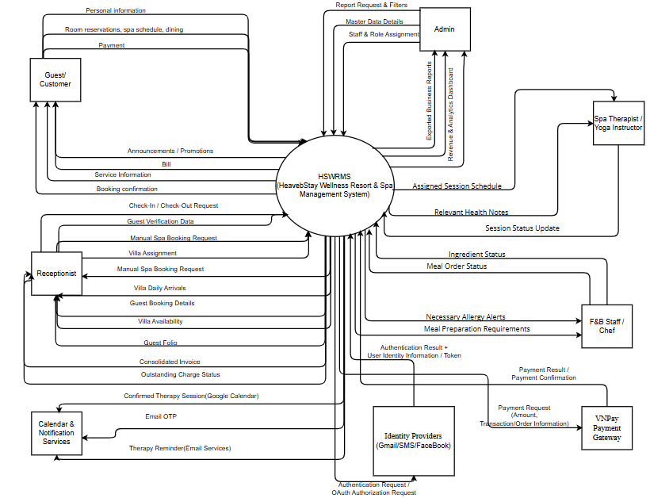

HSWRMS_Context_diagram
Figure 1. HSWRMS system context diagram
System boundary rationale. Guest, Receptionist, Therapist, F&B Staff/Chef, Admin and Manager are external human actors because they initiate or receive business interactions with HSWRMS . VNPay, Calendar & Notification Services, and Google/Facebook Identity Providers remain outside the system boundary because HSWRMS consumes their services rather than implementing those external platforms.

2. Main Business Flow

2.1 Customer Onboarding & Wellness Profile Setup (BF-01)
Primary Module: M1 - Authentication & Sensitive Health Profile
Primary Actors / Systems: Customer/User, HSWRMS, External Service
Trigger: A new Customer wants to create an account and use HSWRMS.
Flow Summary: Authentication: Guest registers or authenticates using Email/Password or supported Google/Facebook SSO, with external services supporting email verification, password recovery, and identity authentication.
Role Routing: After successful authentication, HSWRMS determines the user's authorized role and routes Customer or Staff users to the appropriate authorized area.
Customer Profile Management: Customers independently manage Account Settings and Health & Dietary Profile. Health, dietary, allergy, and consent information is recorded as part of the Health Profile process.
Health Data Deletion: Customers may submit a health-data deletion request from the Health Profile. If retention rules prevent immediate deletion due to an active or upcoming retreat, the request is deferred and may be cancelled while pending; after the retention condition ends, the system performs the defined deletion/anonymization process.
End Condition: The Customer has a verified account and a valid Dietary & Health Profile that can be securely used by authorized resort services.
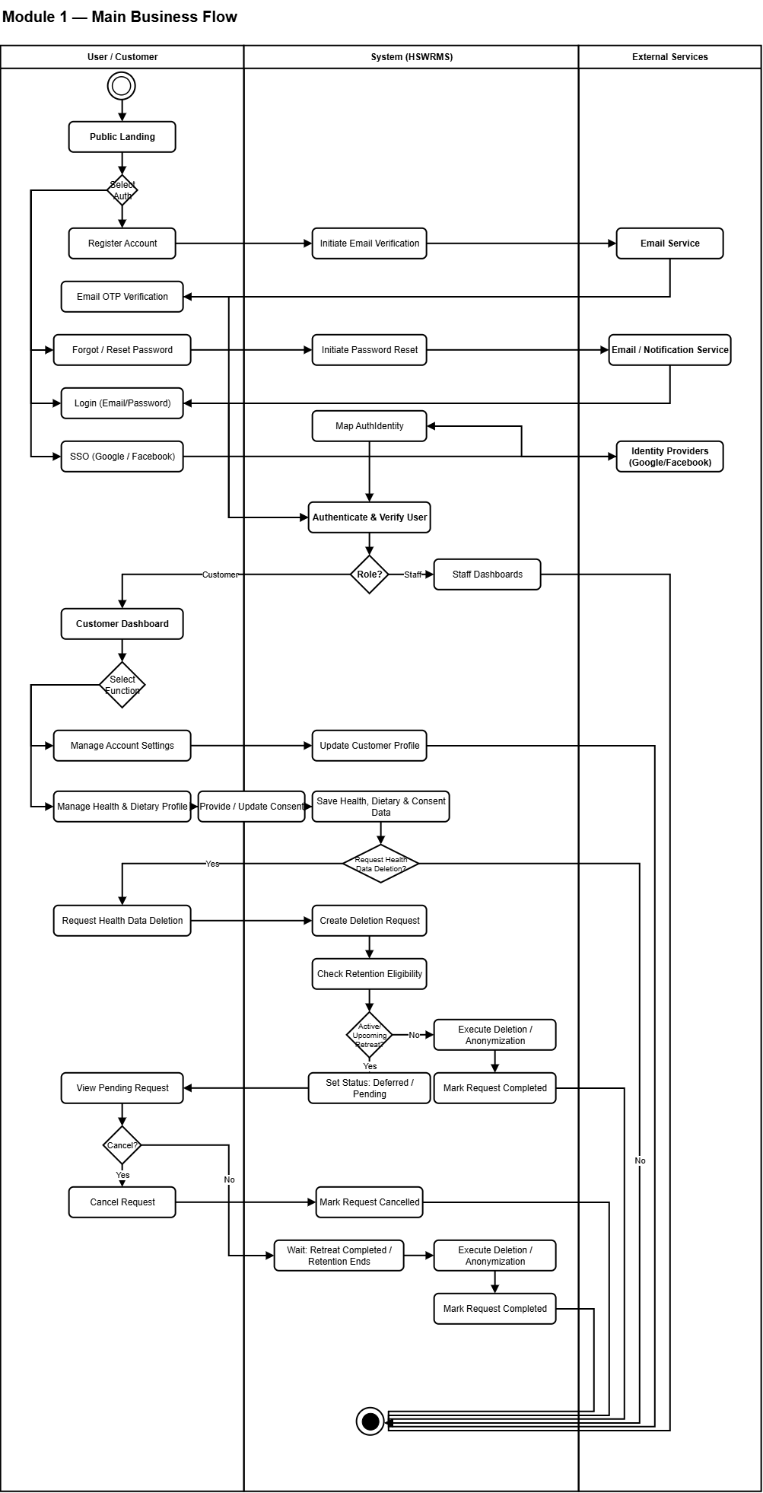

Link Customer Onboarding & Wellness Profile Setup (BF-01)

2.2 Retreat Booking, Deposit & Check-In (BF-02)
Primary Module: M2 - Retreat Package & Accommodation Booking
Primary Actors / Systems: Customer, Receptionist, HSWRMS, VNPay Payment Gateway
Trigger: An authenticated Customer wants to book a wellness retreat.
End Condition: The retreat booking is confirmed, required deposit is successfully paid, and the Customer is checked in with an assigned physical villa.
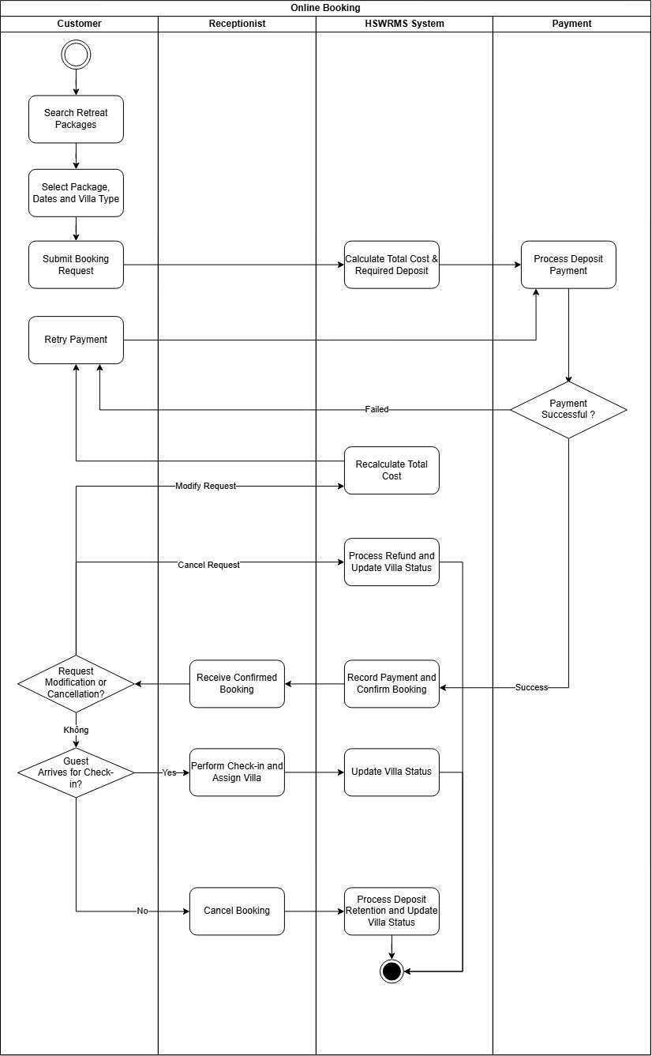
HSWRMS_Module2_MainFlow_OnlineBooking
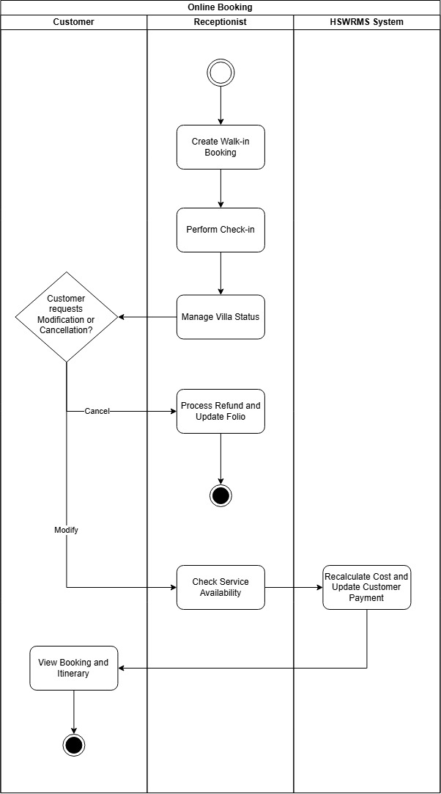
HSWRMS_Module2_MainFlow_OfflineBooking

2.3 Spa/Therapy Scheduling & Session Fulfillment (BF-03)
Primary Module: M3 - Spa & Therapy Scheduling (CORE)
Primary Actors / Systems: Customer, Receptionist, Spa Therapist / Yoga Instructor, HSWRMS, Calendar & Notification Services
Trigger: An authenticated Customer, or a Receptionist acting on behalf of an eligible Customer, requests a Spa/Therapy service.
Flow Summary: _HSWRMS validates Customer and service eligibility, then automatically generates suitable scheduling options combining a time slot, qualified Therapist/Yoga Instructor, and compatible Treatment Room. The Customer/Receptionist reviews and confirms the final option. Before confirmation, HSWRMS revalidates availability and reserves the Therapist and Treatment Room atomically. If no suitable option exists, the system automatically searches alternatives and may use Customer slot swapping as a final fallback with explicit consent from all affected Customers.
_For confirmed sessions, HSWRMS synchronizes calendar information and manages pre-session reminders and confirmation. A declined/expired confirmation or Therapist unavailability triggers automatic recovery and rescheduling. Any accepted schedule change is updated and communicated to the Customer.
_Before fulfillment, the Therapist/Yoga Instructor views the assigned schedule and required Treatment Safety Health Profile, performs the session, and records the final attendance outcome as Completed or No-Show.
End Condition: BF-03 ends through a single final path after HSWRMS records the final outcome and relevant scheduling/confirmation history. The outcome may be Rejected, Cancelled, Unable to Reschedule, Completed, or No-Show.
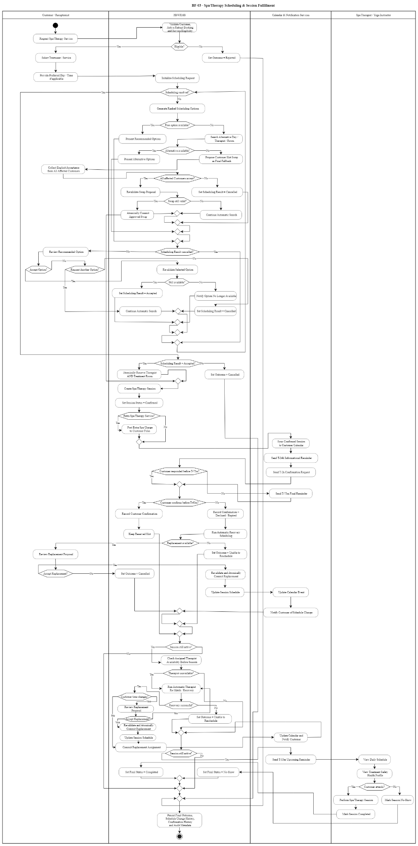
Link Spa/Therapy Scheduling & Session Fulfillment (BF-03)

2.4 Personalized Dining & F&B Service Fulfillment (BF-04)
Primary Module: M4 - Dietary F&B Management
Primary Actors / Systems: Customer, Chef / F&B Staff, HSWRMS(System)
Flow Summary:
- Chefs and F&B staff manage and verify ingredient details by batch. HSWRMS updates the availability status (Available/Unavailable) of dishes based on ingredient quantities, expiration dates, and stock conditions. When a customer accesses the menu, the system cross-references their allergy and dietary profile with dish availability to display a personalized menu of available options.
- The customer selects a daily meal or additional à la carte items and submits the order. The system generates a meal order, attaches relevant allergy and dietary information, and posts any à la carte charges to the customer's folio. Chefs and F&B staff receive the order, review necessary alerts, and prepare the dishes.
- During preparation, staff record the quantity of ingredients used to update remaining stock levels and—if necessary—adjust menu availability. Finally, staff update the order status (Preparing → Ready → Delivered), allowing the customer to track their meal plan and order status
Trigger: F&B Staff needs to check and update ingredient availability before meals are offered to Customers.
End Condition: The selected meal is prepared and fulfilled, the final meal order status is updated, and any applicable Extra A-la-carte charge is recorded in the Customer Folio, and ingredient usage is recorded to update the remaining quantity and menu availability.
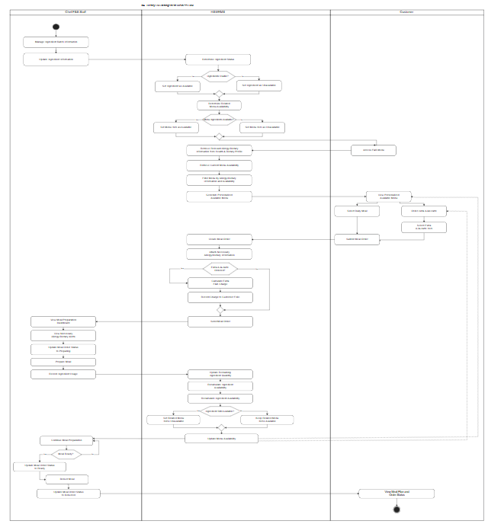

Link Personalized Dining & F&B Service Fulfillment

2.5 Consolidated Checkout, Payment & Customer Feedback (BF-05)
Primary Module: M5 - Consolidated Checkout & Analytics
Primary Actors / Systems: Customer, Receptionist, HSWRMS, VNPay Payment Gateway
Flow summary:
_ The process begins when a guest requests checkout and the Receptionist accesses the booking details. HSWRMS automatically queries and aggregates all outstanding balance data (Retreat package balance, incurred Spa charges, additional F&B orders, complimentary tours) and performs a status check on individual services. If any service is found to be incomplete (Pending status), the system displays an alert prompting the Receptionist to contact the relevant departments for finalization before generating the consolidated invoice for the guest.
_ Once the guest confirms the charges and selects a payment method, the system processes the transaction. For cash payments, the Receptionist collects the funds directly and confirms the transaction in the software. For online payments (Card/VNPay), HSWRMS sends a transaction request to the payment gateway; the guest scans a QR code or swipes their card, and the system automatically verifies the checksum and records the successful payment via the returned result (IPN Callback).
_ Immediately following a successful transaction, HSWRMS automatically executes a series of finalization tasks: updating the invoice status to "Paid," closing the booking record, changing the villa status to "Vacant / Needs Cleaning" (triggering a cleaning notification), and marking the stay as complete. Simultaneously, the system triggers the dispatch of an electronic invoice email containing a link to the invoice details. The workflow concludes when the guest accesses the link from the email to download the PDF invoice or submit a review, which the system stores for analysis on the dashboard.
Trigger: Customer requests to check out from the resort.
End Condition: All outstanding charges are settled, checkout is completed, villa status is updated, and the Customer may submit a review/rating.
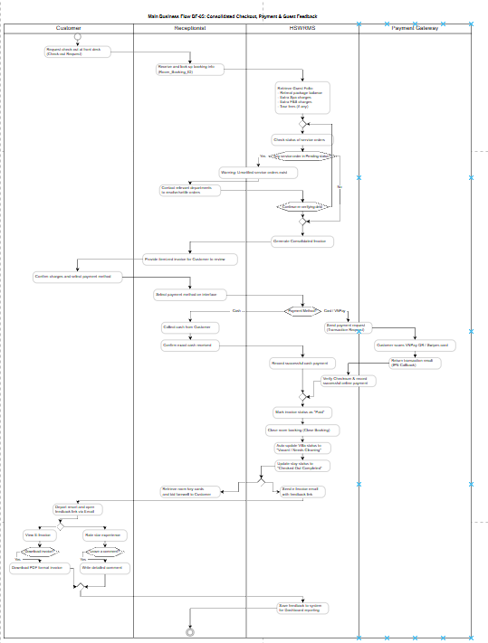

Link Consolidated Checkout, Payment & Customer Feedback (BF-05)
2.6 System Administration, Permission & Management Monitoring (BF-06)
Primary Module: M6 - System Administration & Permission Management
Primary Actors / Systems: Admin, Manager, HSWRMS
Flow Summary:
- Authentication & Access Control: The user initiates sign-in at the admin portal (UC80: Sign In & Authenticate). HSWRMS verifies credentials and checks permissions via the role/screen permission matrix (UC81: Configure Permission Matrix). If authentication or authorization fails, an access-denied message is returned and the session is terminated.
- Admin Operations Execution: Upon authorized entry, the System Administrator can perform system governance and operational configurations:
- Delegate limited administrative rights to managers (UC79).
- Configure the permission matrix and screen access rules (UC81).
- Manage staff accounts, credentials, and access levels (UC75).
- Maintain system master data and operational configuration records (UC76).
- Configure core business parameters and system-wide operational rules (UC77).
- Inspect sensitive-data audit logs regarding guest PII and health information (UC78).The system updates corresponding data stores, adjusts runtime configurations, and invokes the audit engine.
- Manager Execution, Monitoring & Analytics: An authorized Manager accesses managerial and operational functions:
- Execute designated scope-restricted administrative actions assigned via delegated rights (UC83).
- Access the System Overview Dashboard (UC84) and Operations Dashboard (UC71) to track real-time operational and performance metrics.
- Analyze hotel room occupancy rates (UC72) and spa therapist workload/utilization (UC73).
- Export operational, performance, and occupancy reports to Excel or PDF format (UC74).
- Audit Logging: Every administrative mutation, delegated privilege change, security event, and sensitive data access automatically triggers the audit engine to persist immutable logs (UC82: Write Security & Action Audit Log), available for compliance and security reviews (UC78).
Trigger: Admin or Manager signs in (UC80) to perform an authorized administrative, management, or analytical operation.
End Condition: Authorized configuration changes are applied and logged (UC82), or requested management dashboards/reports are displayed or exported (UC71–UC74, UC84) according to the user's role and permission level.

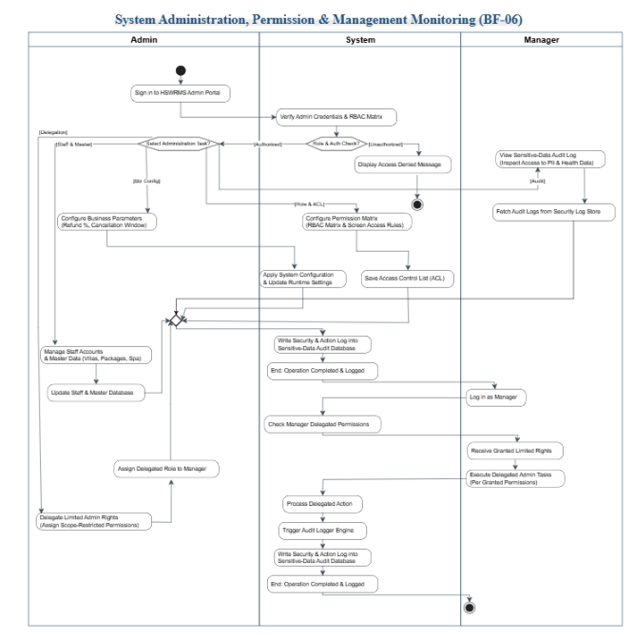Link System Administration, Permission & Management Monitoring (BF-06)

3. Conceptual Data Model

3.1 Entity Relationship Diagram
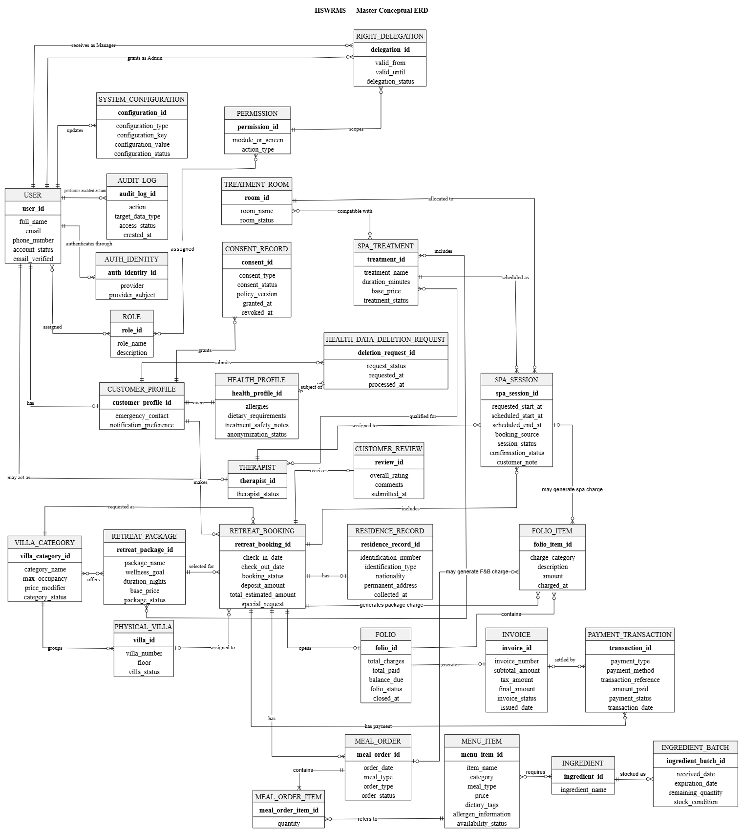
Link Conceptual ERD

3.2 Entity Descriptions
1. Entity: USER
Attribute | Value
user_id | Unique identifier of a user account in HSWRMS.
full_name | Full name of the user used for profile and display purposes.
email | Email address used for account identification, authentication, verification, and communication.
phone_number | User contact phone number.
account_status | Current account state, such as pending, active, inactive, or locked, according to account rules.
email_verified | Indicates whether the user's email address has been successfully verified.
2. Entity: AUTH_IDENTITY
Attribute | Value
auth_identity_id | Unique identifier of an external authentication identity linked to HSWRMS.
provider | External identity provider used for authentication, such as Google or Facebook.
provider_subject | Provider-specific unique subject identifier used to map the external identity to an HSWRMS user.
3. Entity: ROLE
Attribute | Value
role_id | Unique identifier of a system role.
role_name | Business role name used for authorization, such as Customer, Receptionist, Therapist, F&B Staff, Manager, or Admin.
description | Description of the role's business purpose and access scope.
4. Entity: CUSTOMER_PROFILE
Attribute | Value
customer_profile_id | Unique identifier of a Customer profile.
emergency_contact | Emergency contact information maintained for the Customer.
notification_preference | Customer preference for supported communication or notification channels.
5. Entity: CONSENT_RECORD
Attribute | Value
consent_id | Unique identifier of a consent record.
consent_type | Category of consent granted or withdrawn, such as consent for processing health-related information.
consent_status | Current consent state, indicating whether the applicable consent is granted, revoked, or otherwise inactive.
policy_version | Version of the privacy or consent policy accepted by the Customer.
granted_at | Date and time when the consent was granted.
revoked_at | Date and time when the consent was revoked, when applicable.
6. Entity: HEALTH_PROFILE
Attribute | Value
health_profile_id | Unique identifier of the Customer's health and dietary profile.
allergies | Customer allergy information used for safe service personalization and F&B suitability checks.
dietary_requirements | Dietary needs or restrictions used to personalize meal options.
treatment_safety_notes | Treatment-relevant health information needed to identify contraindications and deliver Spa/Therapy services safely.
anonymization_status | Indicates whether the health profile remains identifiable or has been anonymized according to the approved privacy process.
7. Entity: HEALTH_DATA_DELETION_REQUEST
Attribute | Value
deletion_request_id | Unique identifier of a Customer health-data deletion or anonymization request.
request_status | Current lifecycle state of the request, such as pending, deferred, completed, or cancelled.
requested_at | Date and time when the Customer submitted the request.
processed_at | Date and time when the request was executed or otherwise finalized, when applicable.
8. Entity: RETREAT_PACKAGE
Attribute | Value
retreat_package_id | Unique identifier of a retreat package.
package_name | Name of the wellness retreat package.
wellness_goal | Primary wellness objective or focus of the package.
duration_nights | Number of nights included in the retreat package.
base_price | Base price of the retreat package before applicable extras or adjustments.
package_status | Current availability or activation status of the package.
9. Entity: VILLA_CATEGORY
Attribute | Value
villa_category_id | Unique identifier of a villa category.
category_name | Business name of the villa category.
max_occupancy | Maximum number of occupants supported by the villa category.
price_modifier | Price adjustment associated with selecting this villa category.
category_status | Current availability or activation status of the villa category.
10. Entity: PHYSICAL_VILLA
Attribute | Value
villa_id | Unique identifier of an individual physical villa.
villa_number | Operational villa number or code used by resort staff.
floor | Floor or physical level where the villa is located, where applicable.
villa_status | Current operational state of the villa, such as available, occupied, maintenance, or another approved status.
11. Entity: RETREAT_BOOKING
Attribute | Value
retreat_booking_id | Unique identifier of a Customer retreat booking.
check_in_date | Planned or actual start date of the retreat stay.
check_out_date | Planned or actual end date of the retreat stay.
booking_status | Current booking lifecycle state, such as pending, confirmed, checked-in, cancelled, or completed.
deposit_amount | Deposit amount required or paid for the retreat booking.
total_estimated_amount | Estimated total value of the retreat booking before final consolidated charges are settled.
special_request | Customer request or note associated with the retreat booking.
12. Entity: RESIDENCE_RECORD
Attribute | Value
residence_record_id | Unique identifier of the residence/identity information collected during check-in.
identification_number | Identification document number provided for required residence records.
identification_type | Type of identification document provided by the Customer.
nationality | Nationality recorded for the required residence information.
permanent_address | Permanent address recorded during check-in where required.
collected_at | Date and time when the residence information was collected.
13. Entity: THERAPIST
Attribute | Value
therapist_id | Unique identifier of a Spa Therapist or Yoga Instructor represented in the scheduling domain.
therapist_status | Current operational availability/status of the Therapist or Instructor.
14. Entity: SPA_TREATMENT
Attribute | Value
treatment_id | Unique identifier of a Spa/Therapy service.
treatment_name | Name of the Spa/Therapy treatment.
duration_minutes | Standard duration of the treatment in minutes.
base_price | Base price used when the treatment is chargeable as an additional service.
treatment_status | Current availability or activation status of the treatment.
15. Entity: TREATMENT_ROOM
Attribute | Value
room_id | Unique identifier of a Treatment Room.
room_name | Operational name or code of the Treatment Room.
room_status | Current operational state of the room, such as available, occupied, maintenance, or inactive.
16. Entity: SPA_SESSION
Attribute | Value
spa_session_id | Unique identifier of a scheduled Spa/Therapy session.
requested_start_at | Customer-requested or preferred start time used as input to scheduling.
scheduled_start_at | Confirmed start time assigned to the session after scheduling.
scheduled_end_at | Confirmed end time calculated from the selected treatment duration and schedule.
booking_source | Source through which the Spa/Therapy request was initiated, such as Customer or Receptionist.
session_status | Business lifecycle state of the Spa session, separate from attendance confirmation; for example scheduled, rescheduling, cancelled, completed, or no-show.
confirmation_status | Customer pre-session attendance-confirmation state, such as pending, confirmed, declined, or expired.
customer_note | Customer-provided treatment request or note relevant to the session.
17. Entity: CUSTOMER_REVIEW
Attribute | Value
review_id | Unique identifier of a Customer review submitted for a completed retreat stay.
overall_rating | Overall rating given by the Customer for the completed retreat experience.
comments | Free-text feedback provided by the Customer.
submitted_at | Date and time when the review was submitted.
18. Entity: FOLIO_ITEM
Attribute | Value
folio_item_id | Unique identifier of an individual charge recorded in the Customer Folio.
charge_category | Business category of the charge, such as retreat package, extra Spa/Therapy, or extra F&B.
description | Human-readable description of the charge.
amount | Monetary amount of the folio charge.
charged_at | Date and time when the charge was posted to the Customer Folio.
19. Entity: FOLIO
Attribute | Value
folio_id | Unique identifier of the Customer's consolidated folio for a retreat stay.
total_charges | Total value of all charge items currently recorded in the folio.
total_paid | Total amount successfully paid against the folio.
balance_due | Outstanding amount remaining to be settled.
folio_status | Current folio state, such as open, partially paid, paid, or closed.
closed_at | Date and time when the folio was closed after applicable checkout requirements were completed.
20. Entity: INVOICE
Attribute | Value
invoice_id | Unique identifier of a consolidated invoice generated from a folio.
invoice_number | Business-facing invoice number used for display and reference.
subtotal_amount | Invoice amount before applicable tax or final adjustments.
tax_amount | Tax amount applied to the invoice, where applicable.
final_amount | Final amount payable on the invoice.
invoice_status | Current invoice lifecycle state, such as draft, issued, paid, or cancelled.
issued_date | Date on which the invoice was issued.
21. Entity: PAYMENT_TRANSACTION
Attribute | Value
transaction_id | Unique identifier of a deposit or final-payment transaction.
payment_type | Business purpose of the payment, such as retreat deposit or final checkout payment.
payment_method | Method used to make the payment, such as supported online payment or cash where applicable.
transaction_reference | External or internal payment reference used to trace the transaction.
amount_paid | Amount processed by the payment transaction.
payment_status | Current transaction result or state, such as pending, successful, or failed.
transaction_date | Date and time when the payment transaction was created or processed.
22. Entity: MEAL_ORDER
Attribute | Value
meal_order_id | Unique identifier of a Customer meal order.
order_date | Date associated with the meal selection or F&B order.
meal_type | Meal period or type, such as breakfast, lunch, or dinner, where applicable.
order_type | Type of order, distinguishing included daily meal selection from additional a-la-carte ordering.
order_status | Current preparation/fulfillment state of the order, such as pending, preparing, ready, delivered, or cancelled.
23. Entity: MEAL_ORDER_ITEM
Attribute | Value
meal_order_item_id | Unique identifier of an individual menu item entry within a meal order.
quantity | Quantity of the selected menu item included in the meal order.
24. Entity: MENU_ITEM
Attribute | Value
menu_item_id | Unique identifier of a food or beverage menu item.
item_name | Display name of the menu item.
category | Menu category used to group the item.
meal_type | Meal period or meal type for which the item is applicable.
price | Price charged when the menu item is ordered as an additional item.
dietary_tags | Dietary characteristics or tags used to support personalized menu filtering.
allergen_information | Allergen-related information used to compare the menu item with Customer allergy data.
availability_status | Indicates whether the menu item is currently available for ordering.
25. Entity: INGREDIENT
Attribute | Value
ingredient_id | Unique identifier of an ingredient used by one or more menu items.
ingredient_name | Business name of the ingredient.
26. Entity: INGREDIENT_BATCH
Attribute | Value
ingredient_batch_id | Unique identifier of a received inventory batch for an ingredient.
received_date | Date on which the ingredient batch was received.
expiration_date | Expiration date used to determine whether the batch remains usable.
remaining_quantity | Current quantity remaining in the ingredient batch.
stock_condition | Current stock/quality condition used together with quantity and expiration to determine ingredient usability.
27. Entity: PERMISSION
Attribute | Value
permission_id | Unique identifier of a permission definition.
module_or_screen | HSWRMS module or screen to which the permission applies.
action_type | Authorized action represented by the permission, such as view, create, update, configure, or another approved operation.
28. Entity: SYSTEM_CONFIGURATION
Attribute | Value
configuration_id | Unique identifier of a system configuration item.
configuration_type | Type/category of configuration, such as a business parameter or feature configuration.
configuration_key | Unique business key used to identify the configuration setting.
configuration_value | Current configured value used by HSWRMS behavior.
configuration_status | Current activation or applicability state of the configuration item.
29. Entity: RIGHT_DELEGATION
Attribute | Value
delegation_id | Unique identifier of a limited administrative-right delegation.
valid_from | Date and time from which the delegation becomes valid.
valid_until | Date and time until which the delegation remains valid.
delegation_status | Current delegation state, such as pending, active, expired, or revoked.
30. Entity: AUDIT_LOG
Attribute | Value
audit_log_id | Unique identifier of an audit record.
action | Auditable system or administrative action that was performed.
target_data_type | Type/category of data or system object affected or accessed by the audited action.
access_status | Result or access outcome associated with the audited event.
created_at | Date and time when the audit record was created.

3.3 Data Business Rules:

Rule | Description | Enforced On
1. Unique account email | Each HSWRMS user account must use a unique email address. A new account cannot be created with an email already registered in the system. | User.email
2. External identity uniqueness | Each external authentication identity must be uniquely identified by the combination of identity provider and provider subject. The same external identity cannot be linked to multiple HSWRMS accounts. | AuthIdentity.provider, AuthIdentity.provider_subject
3. One Customer Profile per User | A user may have at most one Customer Profile. Staff-only accounts are not required to have a Customer Profile. | User, CustomerProfile
4. Consent required for sensitive profile data | Health, allergy, dietary, and treatment-safety information must not be stored or maintained unless the required Customer consent is granted. | ConsentRecord, HealthProfile
5. Health-data deletion lifecycle | A health-data deletion request may be processed immediately only when no active or upcoming retreat requires the data. Otherwise, the request remains Pending/Deferred until eligible. A pending request may be cancelled before processing. | HealthDataDeletionRequest, HealthProfile, RetreatBooking
6. Valid retreat booking period | A retreat booking must have a check-out date later than its check-in date. | RetreatBooking.check_in_date, RetreatBooking.check_out_date
7. Package–villa eligibility | A Customer may request only a Villa Category that is offered by the selected Retreat Package. | RetreatPackage, VillaCategory, RetreatPackageVillaCategory, RetreatBooking
8. Physical villa assignment validity | A physical villa assigned to a retreat booking must belong to a valid Villa Category and must be operationally available for assignment. | PhysicalVilla, VillaCategory, RetreatBooking
9. One residence record per retreat booking | A retreat booking may have at most one residence-information record for check-in and stay reporting purposes. | RetreatBooking, ResidenceRecord
10. Package Spa eligibility | Spa/Therapy services treated as included services must belong to the selected Retreat Package. Services outside the package are treated as additional Spa services. | RetreatPackage, SpaTreatment, RetreatPackageSpaTreatment
11. Therapist qualification rule | A Therapist or Yoga Instructor may be assigned to a Spa Session only if they are qualified for the selected Spa Treatment. | Therapist, SpaTreatment, TherapistTreatmentQualification, SpaSession
12. Treatment-room compatibility rule | A Treatment Room may be assigned to a Spa Session only if the room is compatible with the selected Spa Treatment. | TreatmentRoom, SpaTreatment, TreatmentRoomCompatibility, SpaSession
13. No Spa resource double-booking | A Therapist and a Treatment Room must not be assigned to overlapping active Spa Sessions. Both resources must be available for the entire scheduled interval. | SpaSession, Therapist, TreatmentRoom
14. Spa resource assignment is atomic | A Spa Session is considered successfully scheduled only when both a qualified Therapist and a compatible Treatment Room are valid for the same time interval. Partial resource assignment must not be treated as a confirmed schedule. | SpaSession, Therapist, TreatmentRoom
15. Session status and attendance confirmation are separate | Spa Session lifecycle status and Customer attendance-confirmation status must be maintained independently. Confirmation must not be stored as a session lifecycle state. | SpaSession.session_status, SpaSession.confirmation_status
16. Ingredient-based menu availability | A Menu Item may be available only when the required ingredients have sufficient usable stock and are not expired or otherwise unsuitable. | MenuItem, Ingredient, IngredientBatch, MenuItemIngredient
17. Meal-order quantity validity | Each Meal Order Item must have a quantity greater than zero and must reference a valid Menu Item belonging to the corresponding Meal Order. | MealOrder, MealOrderItem, MenuItem
18. Personalized menu safety | Menu options presented to a Customer must consider the Customer's allergy and dietary information together with current Menu Item availability. | HealthProfile, MenuItem, MealOrder
19. One Folio per retreat booking | Each retreat booking has at most one consolidated Customer Folio used to aggregate Package, additional Spa, and additional F&B charges. | RetreatBooking, Folio
20. Valid Folio charge source | Every Folio Item must represent one valid charge source: Package, Spa, or F&B. A Folio Item must not simultaneously represent multiple charge sources. | FolioItem, RetreatBooking, SpaSession, MealOrder
21. No duplicate included-service charge | Services already included in the Retreat Package must not be charged again as additional Folio Items. Only eligible extra Spa or F&B services generate additional charges. | RetreatPackage, SpaSession, MealOrder, FolioItem
22. One consolidated invoice per Folio | A Customer Folio may generate at most one consolidated Invoice for final checkout settlement. | Folio, Invoice
23. Payment target consistency | A deposit payment must be associated with a Retreat Booking, while a final checkout payment must be associated with an Invoice. A single payment transaction must not target both at the same time. | PaymentTransaction, RetreatBooking, Invoice
24. Payment success does not complete checkout | A successful final payment does not by itself complete checkout. The applicable booking, folio, and villa operational states must also be finalized before checkout is considered complete. | PaymentTransaction, Invoice, Folio, RetreatBooking, PhysicalVilla
25. Review eligibility | A Customer Review may be submitted only for an eligible completed retreat stay, and each Retreat Booking may have at most one review. | CustomerReview, RetreatBooking
26. Role-based permission assignment | System permissions are assigned through roles. Users may access only the functions permitted by their assigned roles and any valid delegated permissions. | UserRole, Role, RolePermission, Permission
27. Limited administrative delegation | Administrative permissions may be delegated by an Admin to a Manager only for a defined scope and validity period. Expired or revoked delegations must not grant access. | RightDelegation, RightDelegationPermission, Permission, User
28. Audit traceability | Sensitive-data access and administrative actions that require auditing must generate an audit record containing the actor, action, target-data type, access result, and timestamp. | AuditLog, User
29. System configuration uniqueness | Each system configuration key must uniquely identify one configurable setting in HSWRMS. | SystemConfiguration.configuration_key
30. Non-negative monetary values | Prices, deposits, payments, charges, and invoice amounts must not contain negative values unless a separate approved refund mechanism explicitly represents the reversal. | RetreatPackage, SpaTreatment, MenuItem, RetreatBooking, FolioItem, Invoice, PaymentTransaction

4. User Requirements

4.1 Actors
# | Actor | Description
0 | Guest | Browses the public landing page, retreat packages, accommodation, spa, dining, and other promotional information.May start registration, sign-in, password recovery, or supported SSO authentication, but cannot access authenticated Customer functions until successfully authenticated.
1 | Registered User | An authenticated HSWRMS user with an active account. A Registered User may access common authenticated functions according to the permissions and role assigned to the account.
2 | Customer | An authenticated resort customer who manages account, health and dietary information; browses and books retreat packages; views booking and itinerary information; requests and confirms Spa/Therapy sessions; selects meals and orders additional F&B items; reviews folio and payment information; completes payment; and may submit a post-checkout review.
3 | Receptionist | Handles front-desk and stay operations, including daily arrivals, Customer verification, check-in/check-out, required residence information, villa assignment and villa status. The Receptionist may initiate or confirm Spa/Therapy bookings on behalf of a Customer and book extra Spa services, while therapist/room matching and scheduling remain system-driven. The Receptionist also supports folio and consolidated checkout operations.
4 | Spa Therapist / Yoga Instructor | Views assigned daily Spa/Therapy sessions and the Customer's Treatment Safety Health Profile required to identify contraindications and safely perform the assigned treatment. Unrelated administrative, residence, payment, and account-security information remains hidden.The Therapist/Yoga Instructor performs the assigned session and records the final attendance outcome as Completed or No-Show.
5 | F&B Staff / Chef | Manages meal-preparation operations;views aggregated meal requirements and Customer allergy/diet information required for food preparation; monitors ingredient/menu availability where permitted; prepares personalized meals and updates meal/order preparation status. Unrelated medical, identity, residence, or payment information is not exposed.
6 | Admin | Performs system-administration and governance functions, including staff-account administration, supported master data, business parameters, feature flags, permission configuration, limited administrative-right delegation, and sensitive-data audit monitoring. Admin capabilities remain subject to mandatory privacy, security, and business rules.
7 | Manager | Uses management dashboards, reports, and approved system-overview functions to monitor revenue, occupancy, therapist workload, and other aggregated operational information. Manager access is primarily read-only or restricted and does not include staff-account, role, or permission administration by default. Specific limited administrative capabilities may be delegated by Admin when explicitly authorized.
8 | VNPay Payment Gateway | External payment service used to process supported retreat deposit and final-payment transactions and return payment results to HSWRMS. A successful payment transaction does not by itself complete the resort checkout process.
9 | Calendar & Notification Services | External supporting services used by HSWRMS to synchronize confirmed Spa/Therapy sessions with Customer calendar events and deliver reminders, confirmation requests, OTPs, and schedule-change notifications where applicable. HSWRMS remains the source of truth for scheduling decisions and session status.

4.2 Use Cases (UC)
ID | Use Case | Feature | Use Case Description
UC01 | Register Account | M1 Authentication & Health Profile | Guest creates a new account by providing the required registration information.
UC02 | Verify Email | M1 | Guest verifies the registered email address using the verification process supported by the Email Service.
UC03 | Forgot / Reset Password | M1 | Registered user requests a password reset and establishes a new password through the supported recovery process. .
UC04 | Login (Email / Password) | M1 | Users authenticate using their registered email address and password to access authorized system functions. .
UC05 | Login with Google | M1 | Users authenticate through Google Identity Provider and access their authorized system functions using Google SSO. .
UC06 | Login with Facebook | M1 | Users authenticate through Facebook Identity Provider and access their authorized system functions using Facebook SSO.
UC07 | Manage Account Settings | M1 | Customer updates personal information, contact preferences, and account security settings through the Account Settings page.
UC08 | Manage Health & Dietary Profile | M1 | Customer records and maintains dietary, allergy, and physical treatment information relevant to the retreat experience
UC09 | Manage Consent | M1 | Customer reviews, provides, and withdraws consent for the collection and use of personal, health, dietary, and allergy information.
UC10 | Request Health Data Deletion | M1 | Customer requests deletion or anonymization of health and allergy data after retreat completion
UC11 | Browse Retreat Packages | M2 Booking & Accommodation | Guest browses packages and filters by wellness goal.
UC12 | Book Retreat & Pay Deposit | M2 | Guest selects package/dates/villa type and pays deposit via VNPay.
UC13 | Perform Check-in | M2 | Receptionist verifies Guest, collects required residence information, and assigns a physical villa.
UC14 | Manage Villa Status | M2 | Allows the reception staff to monitor and update the physical status of each villa (Vacant, Occupied, Under maintenance).
UC15 | View Booking & Itinerary | M2 | Guest views booking details and itinerary timeline.
UC16 | Create Walk-in Booking | M2 | The Receptionist checks villa availability and creates a retreat package/booking for a walk-in guest (a guest who has not booked in advance via the website).
UC17 | Cancel Booking | M2 | Customer or Receptionist cancels the entire retreat booking (including villa and packages) or specific individual services (e.g., cancelling a scheduled Spa service).
UC18 | Modify Booking or Services | M2 | Customer or Receptionist modifies the initial booking details (e.g., changing stay dates or villa type) or adjusts included/extra services (e.g., adding or removing Spa treatments and packages).
UC19 | Schedule Spa/Therapy  Session | M3 Spa Scheduling | Allows a Customer or Receptionist acting on behalf of a Customer to initiate a Spa/Therapy scheduling request. HSWRMS validates eligibility, generates suitable scheduling options, obtains final confirmation, reserves the required resources, creates the session, and synchronizes the confirmed schedule.
UC20 | Validate Customer &  Service Eligibility | M3 | Verifies that the authenticated Customer has a valid retreat/stay context and is eligible to use the selected included or additional Spa/Therapy service before scheduling proceeds.
UC21 | Generate Recommended  Slot Options | M3 | Generates and ranks suitable scheduling options based on the requested treatment, preferred date/time constraints, treatment duration, therapist qualification, Treatment Room compatibility, and current resource availability.
UC22 | Auto-Match Qualified Therapist & Compatible Treatment Room | M3 | Identifies valid scheduling combinations in which a qualified Therapist/Yoga Instructor and a compatible Treatment Room are both available for the same complete treatment interval.
UC23 | Confirm Recommended Schedule | M3 | Allows the Customer or Receptionist to review and confirm one of the system-recommended scheduling options before the resources are finally committed.
UC24 | Revalidate Selected  Schedule | M3 | Rechecks the selected time slot, Therapist, and Treatment Room immediately before reservation to prevent conflicts caused by availability changes occurring after the recommendation was generated.
UC25 | Atomically Reserve Therapist  & Treatment Room | M3 | Reserves the selected Therapist and Treatment Room as one atomic scheduling operation. The reservation is valid only when both resources can be committed for the same complete interval; a partial reservation is not accepted.
UC26 | Book Extra Spa/Therapy  Service | M3 | Allows a Receptionist to initiate an additional Spa/Therapy service for an eligible Customer. The extra service uses the same automated scheduling, matching, confirmation, and resource-reservation process as a normal Spa/Therapy session.
UC27 | Post Extra Spa Charge  to Customer Folio | M3 | Posts the charge for a confirmed additional Spa/Therapy service to the Customer Folio so that it can later be included in the consolidated invoice and checkout process.
UC28 | Manage Pre-Session  Confirmation | M3 | Manages the Customer confirmation lifecycle before a confirmed Spa/Therapy session, including reminder delivery, confirmation response, expiration, and the decision to keep the reserved slot or initiate recovery scheduling.
UC29 | Record Customer  Confirmation Response | M3 | Records whether the Customer explicitly confirms, declines, or fails to respond before the confirmation deadline. An expired confirmation is not treated as a No-Show; final attendance is recorded later by the Therapist/Yoga Instructor.
UC30 | Sync / Update Confirmed Session  to Customer Calendar | M3 | Sends confirmed or changed Spa/Therapy session information to the external Calendar & Notification Services so that the Customer's calendar event can be created, updated, or cancelled as required.
UC31 | Send Reminder &  Confirmation Request | M3 | Sends the scheduled pre-session notifications, including the informational reminder, primary confirmation request, final reminder when required, and upcoming-session reminder for confirmed sessions.
UC32 | Notify Customer of  Schedule Change | M3 | Notifies the affected Customer whenever a confirmed session's time, Therapist, Treatment Room, or other relevant scheduling information changes after recovery or approved rescheduling.
UC33 | Auto-Reschedule /  Re-Match Session | M3 | Automatically attempts to recover a session when confirmation is declined/expired, an assigned Therapist becomes unavailable, or another scheduling disruption occurs. The system prioritizes free same-day alternatives, alternative qualified resources, another suitable day, and finally a Customer slot swap when no free alternative exists.
UC34 | Propose Customer  Slot Swap | M3 | As a final fallback, proposes exchanging confirmed time slots between affected Customers when no suitable free alternative can be found. A proposed swap does not modify any confirmed schedule until all required Customer approvals are received and the resources are revalidated.
UC35 | Collect Explicit Consent  from All Affected Customers | M3 | Obtains explicit acceptance from every Customer whose confirmed schedule would change as part of a proposed slot swap. The swap may proceed only when all affected Customers accept; otherwise the existing schedules remain unchanged.
UC36 | View Daily Schedule &  Treatment Safety Health Profile | M3 | Allows a Spa Therapist/Yoga Instructor to view assigned sessions for the selected working day and access the Customer's complete treatment-safety health information required to identify contraindications and safely deliver the assigned treatment. Unrelated administrative, residence, payment, and account-security data remain hidden.
UC37 | Record Session Attendance  & Outcome | M3 | Allows the assigned Therapist/Yoga Instructor to record whether the Customer attended the session and to finalize the session outcome as Completed or No-Show after the scheduled treatment period.
UC38 | Manage Ingredient Batch Information | M4 Dietary F&B | Chef/F&B Staff manages ingredient information by batch, including food type, received date, expiration date, quantity, and stock condition.
UC39 | Update Ingredient Availability | M4 | Staff update the quantity, quality, and usage limits of raw materials in the system.
UC40 | Update Menu Availability | M4 | HSWRMS automatically updates the Available/Unavailable status of related menu items based on ingredient availability. This occurs after ingredient information is verified(after staff update ingredient information) and may be recalculated after ingredient usage during meal preparation.
UC41 | View Personalized Menu | M4 | Customer views available Daily Meal and Extra A-la-carte items. HSWRMS uses the Customer's allergy and dietary information together with current menu item availability to display suitable options.
UC42 | Pre-select Daily Meals | M4 | Customer selects daily meals from the personalized menu based on meal type and available suitable options.
UC43 | Order Extra A-la-carte Item | M4 | Customers can select and order additional available a-la-carte items suitable for their allergy/dietary profile. Applicable charges are added to the Customer Folio for items outside the Daily Meal or retreat package.
UC44 | Post Extra A-lar-carte to Customer Folio | M4 | HSWRMS calculates the charge for extra a-la-carte items and records the applicable F&B charge in the customer's folio for consolidated checkout.
UC45 | View Meal Order Status | M4 | Customers view their selected dishes, ordered a-la-carte items, and processing status.
UC46 | View Meal Preparation Dashboard | M4 | Chef/F&B staff view the list of meal orders requiring preparation, including meal type, dish, quantity, and status.
UC47 | View Necessary Allergy/Dietary Alerts | M4 | Staff view allergy or dietary alerts necessary for food preparation, not the full health profile.
UC48 | Prepare Meal | M4 | Chef/F&B Staff prepares the ordered meals according to the meal order and the necessary allergy/dietary information provided by HSWRMS.
UC49 | Record Ingredient Usage | M4 | Chef/F&B Staff records the quantities of ingredients used during meal preparation. HSWRMS updates the remaining ingredient quantities based on the recorded usage.
UC50 | Update Meal Order Status | M4 | Chef/F&B updates meal state from Preparing -> Ready->Delivered.
UC51 | Generate Consolidated Invoice | M5 Checkout & Analytics | Receptionist aggregates package, spa and F&B charges by Room_Booking_ID.
UC52 | Process Final Payment | M5 | The receptionist completes payment only after outstanding charges are cleared, then updates villa status.
UC53 | Check-Out | M5 | The receptionist triggers the final checkout process, automatically initiating invoice printing and system updates.
UC54 | Print Hard Copy Invoice | M5 | The system automatically prints a physical copy of the invoice.
UC55 | Send E-Invoice | M5 | The system automatically sends an electronic invoice to the customer's email.
UC56 | Send Review Form | M5 | The system automatically sends a feedback form link to the customer
UC57 | Update Villa Status to Needs Cleaning | M5 | The system automatically updates the room status to "Needs Cleaning" immediately after the payment transaction is completed.
UC58 | Select Payment Method | M5 | The system requires or allows the selection of a payment method for the invoice.
UC59 | Pay with Cash | M5 | Payment method: Cash payment directly at the counter.
UC60 | Pay with Card/VNPay | M5 | Electronic payment methods via card or the VNPay gateway.
UC61 | Confirm Final Invoice | M5 | The customer reviews and confirms the final charges before payment .
UC62 | View E-Invoice | M5 | The customer views the electronic invoice online .
UC63 | Download E-Invoice | M5 | The customer downloads the electronic invoice as a PDF file.
UC64 | Submit Rating | M5 | Guest submits a star rating after checkout
UC65 | Write Review | M5 | Guest writes detailed textual feedback about their stay
UC66 | View Dashboard | M5 | Manager accesses the main system analytics dashboard
UC67 | View Revenue Dashboard | M5 | Manager views the financial and revenue dashboard.
UC68 | Analyze Revenue by Category | M5 | Manager analyzes revenue broken down by Package, Spa, and F&B
UC69 | Filter Revenue Data | M5 | Manager filters revenue data by specific dates or criteria
UC70 | Export Revenue Reports to Excel/PDF | M5 | Manager exports financial revenue reports to Excel or PDF format.
UC71 | View Operations Dashboard | M5 | Manager views the operations and performance dashboard.
UC72 | Analyze Room Occupancy | M5 | Manager analyzes hotel room occupancy rates
UC73 | Analyze Therapist Workload | M5 | Manager analyzes the workload and utilization of spa therapists
UC74 | Export Operations Reports to Excel/PDF | M5 | Manager exports operational and occupancy reports to Excel or PDF format.
UC75 | Manage Staff Accounts | M6 | Admin manages staff accounts, including creating, updating, and managing staff access.
UC76 | Manage Master Data | M6 | Admin manages system master data and configuration data.
UC77 | Configure Business Parameters | M6 | Admin configures business parameters and system-wide operational settings.
UC78 | View Sensitive-Data Audit Log | M6 | Admin reviews logged access to sensitive information.
UC79 | Delegate Limited Admin Rights | M6 | Admin grants Manager a limited subset of administrative capabilities.
UC80 | Sign In & Authenticate | M6 | Admin and Manager sign in and authenticate to access authorized system functions.
UC81 | Configure Permission Matrix | M6 | Admin configures detailed permission rules by screen and role.
UC82 | Write Security & Action Audit Log | M6 | System records security-related events and administrative actions for auditing.
UC83 | Execute Delegated Admin Tasks | M6 | Manager executes administrative tasks within the limited permissions delegated by Admin.
UC84 | View System Overview Dashboard | M6 | Admin and Manager view a system-level operational overview according to granted access.

4.3 Use Case Diagrams
At the end of Week 2, the team maintains one use-case diagram per module and one consolidated system-wide use-case view. Detailed scenarios, preconditions, alternate flows, activity diagrams and screen flows are deferred to later iterations.

4.3.1 Module 1 - Authentication & Sensitive Health Profile: (Sai)
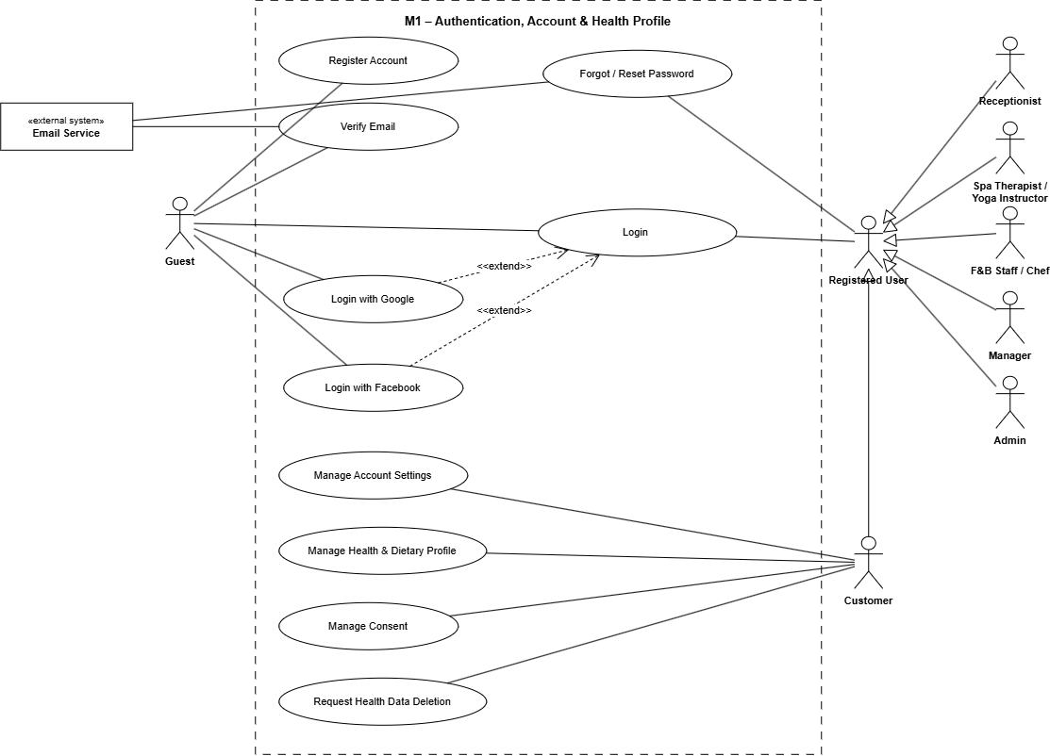

Figure 2. Module 1 Authentication, Account & Health Profile
Link Module 1 - Authentication,Account & Health Profile

4.3.2 Module 2 - Retreat Package & Accommodation Booking:
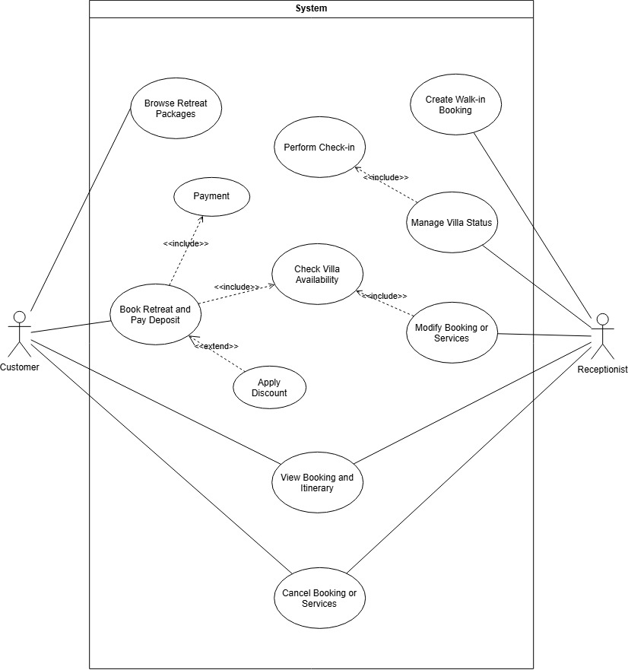

Link Module 2 - Retreat Package & Accommodation Booking
Figure 3. Module 2 Retreat Package & Accommodation Booking

4.3.3 Module 3 - Spa & Therapy Scheduling:
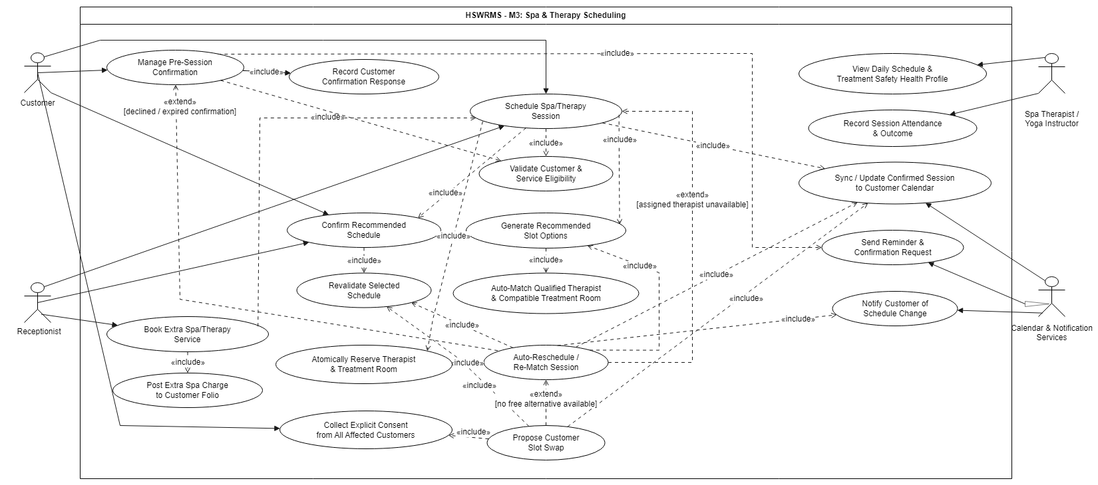
Link Module 3 - Spa & Therapy Scheduling

Figure 4. Module 3 Spa & Therapy Scheduling:

4.3.4 Module 4 -Personalized Dining & F&B Service Fulfillment:

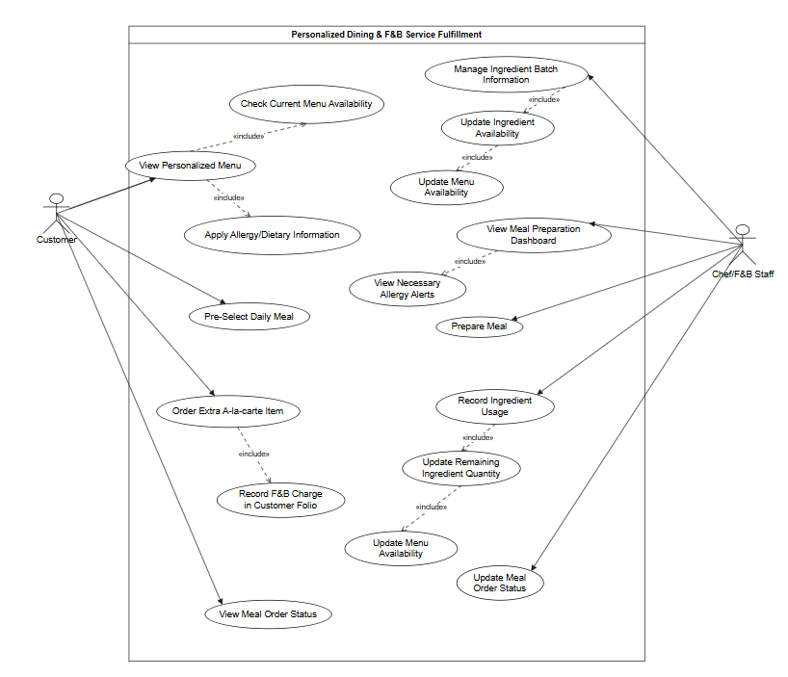

Link Personalized Dining & F&B Service Fulfillment

Figure 5. Module 4 Dietary F&B Management

4.3.5 Module 5 - Consolidated Checkout & Analysis:

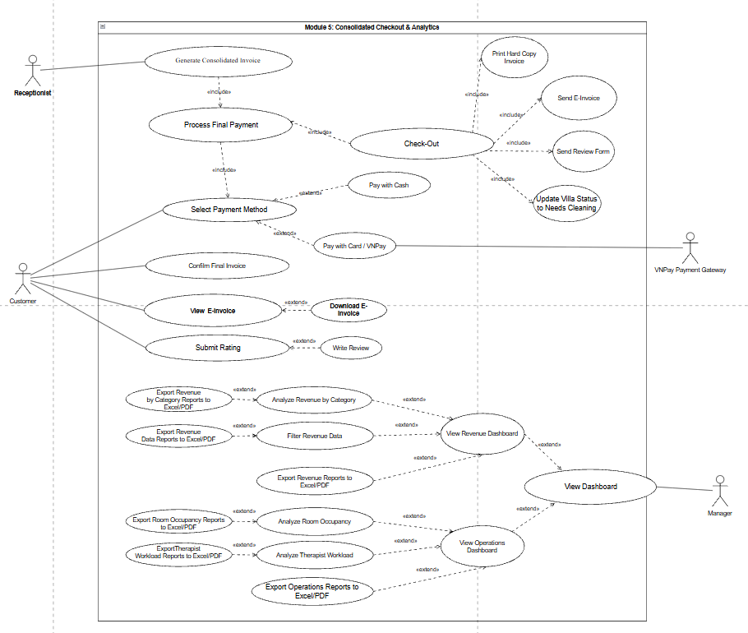
Link UC M5
Figure 6. Module 5 Consolidated Checkout & Analysis

4.3.6 Module 6 - System Administration & Permission Management:
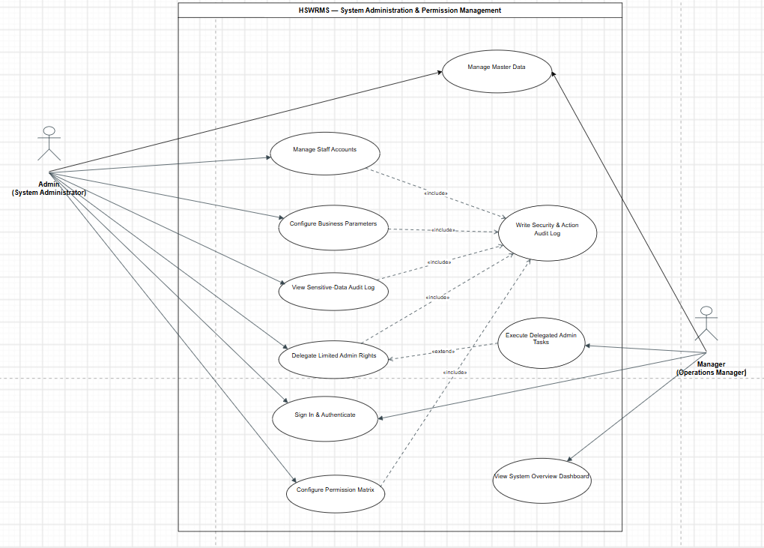
Link Module 6 - System Administration & Permission Management

Figure 7. Module 6 System Administration & Permission Management

4.4 Permission Matrix
This section defines the HSWRMS role-based access-control baseline, including screen access, permitted actions, data scope, sensitive-data visibility, and limited Manager delegation. It supports ROLE, PERMISSION, ROLE_PERMISSION, RIGHT_DELEGATION, the Permission Matrix (S52), and Limited Admin Rights Delegation (S53). External systems such as VNPay and Calendar & Notification Services are integration actors and do not receive user permissions.
4.4.1 Roles and Access Scope
Actor / Access State | Scope
Public / Unauthenticated | Public information, registration, login, password recovery, and public service browsing. This is an access state, not a persisted system role.
Customer | Own account/profile, bookings, Spa/Therapy sessions, meal orders, folio/invoice, and review.
Receptionist | Front-desk operations, booking support, check-in, residence information, villa assignment/status, Extra Spa initiation, folio, and checkout.
Spa Therapist / Yoga Instructor | Assigned Spa/Therapy sessions and the minimum treatment-safety information required for those sessions.
F&B Staff / Chef | Meal preparation, ingredient operations, and minimum food-related allergy/dietary information.
Manager | Primarily read-only operational/analytics access; limited additional rights only through a valid Admin delegation.
Admin | Staff administration, configuration, permissions, delegation, audit, and other authorized system-administration functions.
The access model follows least privilege and data minimization. A staff role receives only the data required for its assigned duties.
4.4.2 Permission and Scope Notation
Code | Action | Meaning
V | View | Read data.
C | Create | Create a new record.
U | Update | Modify data or business status.
D | Deactivate / Cancel | Soft-delete, deactivate, cancel, or  anonymize where permitted.
X | Execute | Perform a business action such as confirm, pay, check in, or approve.
E | Export | Export permitted reports/data.
G | Configure | Modify system configuration, permissions, ordelegation.

Qualifier | Meaning
Own | Only records belonging to the logged-in Customer/User.
Assigned | Only records assigned to the authenticated staff member.
Min | Data-minimized projection containing only fields necessary for the task.
Agg | Aggregated/anonymized data without unnecessary personal detail.
Del | Access exists only while a valid Admin delegation is active.

Restricted access must be enforced by backend authorization. Hiding a screen or UI control alone is not sufficient.
4.4.3 Screen Access Summary

Module / Screens | Access Summary
Common & M1 (S1-S12) | Public users access landing/authentication functions. Customer manages own profile, Health & Dietary Profile, and deletion request. Staff account administration is Admin-controlled; Manager access is limited to specifically delegated functions.
M2 (S13-S24) | Public users may browse retreat packages. Customer manages own booking journey. Receptionist supports booking/check-in, residence information, villa assignment, and operational villa status.
M3 (S25-S33) | Customer and Receptionist initiate Spa scheduling; HSWRMS generates valid candidates. Customer manages own  confirmation/recovery in S29. Receptionist initiates Extra Spa in S30. Therapist accesses S31-S33 only for assigned sessions and treatment-safety data.
M4 (S34-S40) | Customer accesses own personalized menu, meal selections, and orders. F&B Staff/Chef uses operational preparation screens and only food-relevant allergy/dietary information.
M5 (S41-S48) | Customer accesses own folio/invoice, payment result, and review. Receptionist performs settlement/checkout operations. Manager/Admin access authorized aggregated analytics.
M6 (S49-S55) | Admin controls configuration, permissions, delegation, and audit functions. Manager receives monitoring/reporting access and only specifically delegated administrative capabilities.

4.4.4 Sensitive-Data Access Rules
Data Category | Permitted Access
Full Health & Dietary Profile | Customer - own data only. Staff roles do not receive unrestricted access.
Treatment-Safety Health Information | Customer - own data; Therapist/Yoga Instructor - assigned session, minimized projection only.
Food Allergy / Dietary Information | Customer - own data; F&B Staff/Chef - minimized food-related projection only.
Residence / Identification Data | Receptionist - collection and operational access for the relevant stay;masked display after collection where applicable.
Booking / Package / Villa Information | Customer - own booking; Receptionist - operational booking context; management roles - aggregated/restricted information where permitted.
Folio / Invoice / Payment Information | Customer - own data; Receptionist - settlement operations; Manager/Admin - aggregated financial analytics unless another permission explicitly applies.
System Configuration / Permissions | Admin; Manager only for explicitly delegable configuration. Permission Matrix remains Admin-controlled.
Audit Log | Admin read-only operational access; Manager only where delegated and read-only. Audit records are not manually editable.

Administrative configuration rights do not automatically grant access to Customer health, residence, payment-card, or other sensitive operational data.
4.4.5 Manager Delegation
Manager does not inherit the Admin role. Additional permissions are temporary, scoped, and effective only while an approved delegation is active.
Capability | Delegable | Scope if Delegated
View Master Data | Yes | Read-only
View/update approved Business Parameters | Yes | Only listed parameters
View Sensitive-Data Audit Log | Yes | Read-only; no modification
Export Police Residency Declaration Report | Yes | Authorized and audited
View extended System Overview widgets | Yes | Only granted widgets
Manage Staff Accounts / Roles | No | Admin only
Modify Permission Matrix | No | Admin only
Create/revoke delegations | No | Admin only
Access unrestricted Health/Dietary/Residence data | No | Privacy rules still apply
Modify Audit Records | No | Not permitted for any role

4.4.6 Core Access-Control Rules
Rule | Principle | Requirement
AC-01 | Deny by Default | A role receives only permissions explicitly granted by ROLE_PERMISSION or a valid delegation.
AC-02 | Backend Enforcement | Every protected screen/API operation must validate role, permission, and object scope. UI hiding is not sufficient.
AC-03 | Own / Assigned Scope | Customers access only their own records; operational staff access only authorized or assigned records.
AC-04 | Data Minimization | Therapist, F&B Staff/Chef, and Receptionist receive only fields necessary for their duties.
AC-05 | Manager Least Privilege | Manager is primarily read-only; additional administrative access requires a valid delegation.
AC-06 | Administrative Privacy Boundary | Admin configuration privileges do not override health, residence, financial, or other privacy restrictions.
AC-07 | Protected Business Invariants | Permission/configuration changes cannot bypass M3 resource validation, checkout settlement guards, payment verification, or audit logging.
AC-08 | Payment vs Checkout Separation | Permission to process payment does not itself authorize checkout completion; business completion conditions must also be satisfied.
AC-09 | Auditability | Sensitive-data access, denied access, configuration/permission changes,  delegation changes, and exports must be auditable.
AC-10 | No Uncontrolled Hard Delete | Historical transactional and audit records areprotected from arbitrary hard deletion; only approved deactivation, anonymization, or retention processes apply.

4.4.7 Permission Model Traceability
Concept | Main Entity | Main Screen / Requirement
Roles / User-role assignment | ROLE, USER_ROLE | Staff Account Management
Permission definition | PERMISSION | S52 Permission Matrix
Role-to-permission mapping | ROLE_PERMISSION | S52 Permission Matrix
Temporary delegated rights | RIGHT_DELEGATION (+ related permissionmapping) | S53 Limited Admin Rights Delegation
Access evidence | AUDIT_LOG | S54 Sensitive Data Audit Log

5. System Functionalities

5.1 Screen Flow

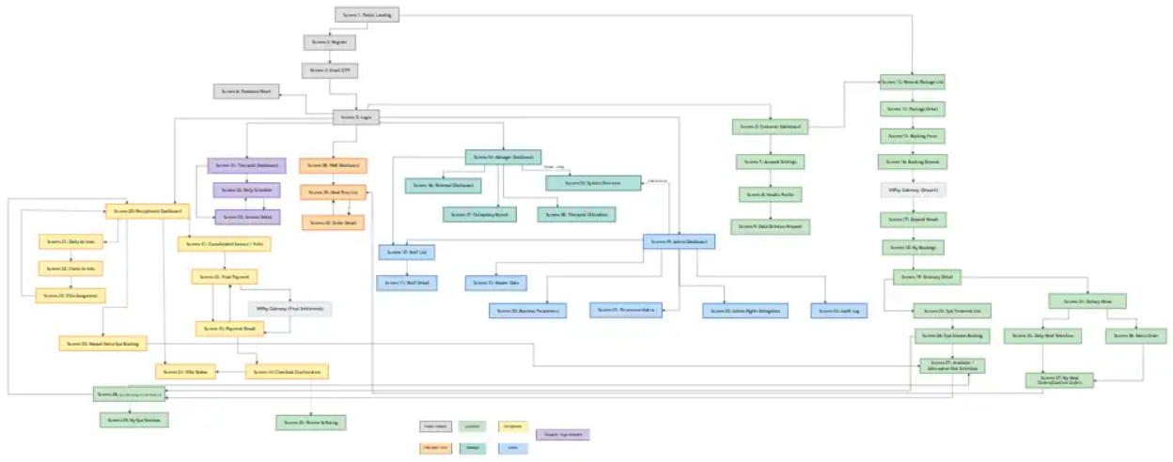
Link Master Screenflow

5.2 Screen List:
# | Screen Name | Feature | Description
1 | Public Landing | Common / M1-M2 | Public entry screen providing access to retreat packages, registration and login.
2 | Customer Dashboard | Common / Customer Shell [Derived] | Main post-login navigation screen for Customer, providing access to bookings, spa sessions, meals, profile and folio.
3 | Register | M1 – Authentication | Allows a new Customer to create an HSWRMS account using required personal and authentication information.
4 | Email OTP Verification | M1 – Authentication | Allows Customer to enter the OTP sent by email to verify the registered account.
5 | Login | M1 – Authentication | Allows users to sign in using email/password or initiate supported Google/Facebook SSO.
6 | Password Reset | M1 – Authentication [Derived] | Allows a user to request and set a new password when login credentials are forgotten.
7 | Account Settings | M1 – Authentication [Derived] | Allows an authenticated Customer to manage personal information, contact preferences, and account security settings, including password change.
8 | Health & Dietary Profile | M1 – Health Profile | Allows Customer to view, create and update allergy, dietary, and treatment-relevant health information and manage related consent preferences.
9 | Health Data Deletion Request | M1 – Health Profile | Allows Customer to request deletion or anonymization of eligible health and allergy data after retreat completion
10 | Staff Account List | M6 – System Administration | Allows Admin to view and search staff accounts and their assigned roles/status.
11 | Staff Account Detail | M6 – System Administration | Allows Admin to create, edit, assign roles to or deactivate a staff account.
12 | Master Data Management | M6 – System Administration | Allows Admin to manage master data such as Villa Categories, Spa Services and Retreat Packages.
13 | Retreat Package List | M2 – Retreat Booking | Displays available retreat packages and allows Customers to filter packages by wellness goal or relevant criteria.
14 | Retreat Package Detail | M2 – Retreat Booking | Displays package description, included services, duration, villa options and information required before booking.
15 | Retreat Booking Form | M2 – Retreat Booking | Allows customers to select retreat dates, package options and villa type and provide required booking information.
16 | Booking Summary & Deposit | M2 – Retreat Booking | Shows booking summary, deposit amount and payment information before redirecting the Customer to VNPay.
17 | Deposit Payment Result | M2 – Retreat Booking [Derived] | Displays the returned deposit payment result and confirmed booking information after VNPay processing.
18 | My Bookings | M2 – Booking Management | Displays the Customer's current and historical retreat bookings.
19 | Booking Detail & Itinerary | M2 – Booking Management | Displays booking status, retreat information, accommodation details and itinerary timeline.
20 | Receptionist Dashboard | M2 – Front Desk [Derived] | Main operational navigation screen for Receptionist, including arrivals, check-in, villa operations and checkout access.
21 | Daily Arrivals | M2 – Check-In | Displays Customers expected to arrive and allows Receptionist to open the relevant booking for check-in.
22 | Check-In & Residence Information | M2 – Check-In | Allows Receptionists to verify the Customer and collect required identification and residence information for check-in.
23 | Villa Assignment | M2 – Check-In | Allows Receptionist to assign an available physical villa to a confirmed booking during check-in.
24 | Villa Status Management | M2 – Accommodation Operations | Allows Receptionists to view and update operational villa status such as Available, Occupied or Maintenance.
25 | Spa Treatment List | M3 – Spa Scheduling | Displays Spa/Therapy services available to the Customer, including services included in the retreat package.
26 | Spa Session Booking | M3 – Spa Scheduling | Allows Customer to select a Spa/Therapy service, date and requested time slot. The system validates both Therapist and Treatment Room availability.
27 | Available / Alternative Slot Selection | M3 – Spa Scheduling | Displays available or alternative time slots when the originally requested Therapist and Treatment Room combination is unavailable.
28 | Spa Booking Confirmation | M3 – Spa Scheduling | Displays confirmed Spa/Therapy session information after both Therapist and Treatment Room have been successfully reserved.
29 | My Spa Sessions | M3 – Spa Scheduling [Derived] | Displays upcoming and historical Spa/Therapy sessions belonging to the Customer.
30 | Manual Extra Spa Booking | M3 – Extra Spa Service | Allows Receptionists to select a Customer and manually book an extra Spa/Therapy service, with the charge posted to the Customer Folio.
31 | Therapist Dashboard | M3 – Therapist Operations [Derived] | Main screen for Spa Therapist/Yoga Instructor showing assigned work and access to the daily schedule.
32 | Therapist Daily Schedule | M3 – Therapist Operations | Displays Spa/Therapy sessions assigned to the logged-in Therapist for the selected working day.
33 | Therapist Session Detail | M3 – Therapist Operations | Displays assigned session details and only treatment-relevant health notes; allows Therapist to mark the session Completed or No-Show.
34 | Dietary Menu | M4 – Dietary F&B | Displays meal options filtered according to the Customer's relevant allergy and dietary profile.
35 | Daily Meal Selection | M4 – Dietary F&B | Allows customers to pre-select meals for the applicable retreat day.
36 | Extra A-la-carte Order | M4 – Extra F&B | Allows Customers to select and order additional F&B items that are charged to the Customer Folio.
37 | My Meal Plan / Orders | M4 – Dietary F&B [Derived] | Allows customers to view selected daily meals and submit additional F&B orders.
38 | F&B Dashboard | M4 – F&B Operations  [Derived] | Main operational screen for Chef/F&B Staff providing access to daily meal preparation requirements.
39 | Daily Meal Prep List | M4 – F&B Operations | Displays aggregated meal orders and preparation workload for Chef/F&B Staff.
40 | Meal Order Detail | M4 – F&B Operations | Displays meal order details and only relevant allergy/dietary warnings; allows F&B Staff to update status from Preparing to Ready.
41 | Customer Folio & Consolidated Invoice | M5 – Checkout 1 | Displays consolidated Package, Spa and F&B charges for the selected stay and identifies any outstanding amount.
42 | Final Payment | M5 – Checkout 2 | Allows final payment to be initiated only when applicable charges have been consolidated and checkout requirements are satisfied.
43 | Final Payment Result | M5 – Checkout [Derived] | Displays the result returned from the payment process and indicates whether payment was successfully confirmed.
44 | Checkout Confirmation | M5 – Checkout | Displays successful checkout after payment is confirmed and the booking and villa operational statuses have been updated.
45 | Review & Rating | M5 – Customer Feedback | Allows customers to submit a rating and review for a completed retreat stay, either from HSWRMS or an emailed review link.
46 | Revenue Dashboard | M5 – Analytics | Allows Managers to view revenue information and breakdowns across Retreat Package, Spa and F&B services.
47 | Occupancy Report | M5 – Analytics | Allows Manager to view accommodation occupancy information and export permitted report data.
48 | Therapist Utilization Report | M5 – Analytics | Allows Manager to view Therapist utilization information and export permitted report data.
49 | Admin Dashboard | M6 – System Administration [Derived] | Main administration navigation screen for Admin, providing access to configuration, permissions, security and audit functions.
50 | Business Parameters | M6 – System Administration | Allows Admin to configure system business parameters such as cancellation windows, refund percentages and other configurable rules.
51 | Permission Matrix | M6 – Permission Management | Allows Admin to configure detailed role-to-screen and role-to-function access permissions.
52 | Limited Admin Rights Delegation | M6 – Permission Management | Allows Admin to grant or revoke a limited subset of administrative capabilities for Manager.
53 | Sensitive Data Audit Log | M6 – Audit & Security | Allows Admin to review logged access and sensitive-data related activities for security and accountability.
54 | Manager Dashboard | M6 – Management Monitoring [Derived] | Main navigation screen for Manager, providing access to authorized management dashboards, reports and system overview.
55 | System Overview Dashboard | M6 – System Monitoring | Displays a system-level operational overview to Admin or Manager according to granted permissions.

II. Functional Requirements:

1. Functional Requirements List:

1. Module 1 - Authentication & Sensitive Health Profile
1.1 Authentication
[FR-M1-01] Register Account
Purpose: Allow a Guest to create a new account using Email and Password.
Actor: Guest
Trigger: Guest submits registration information on the Register screen (S03).
Preconditions: Guest is not logged in.
Main Flow:
Guest enters email, phone number, and password on S03.
The system validates the input, checks email uniqueness, and creates a new User record with account_status = Pending and email_verified = false.
The system issues a new OTP, invalidates any previously issued unused OTP, and sends the OTP through the Email Service.
The system redirects the Guest to the Email OTP Verification screen (S04).
Alternative / Exception Flows:
Alt 1 (Invalid / Empty Input): The system displays the corresponding validation messages (MSG02, MSG08).
Alt 2 (Email Already Exists): The system rejects the registration request and informs the Guest that the email is already registered.
Alt 3 (Email Service Failure): The system informs the Guest that the verification email could not be sent and allows the Guest to request another OTP.
Postconditions: A new User record is created in an unverified state and a new OTP is issued.
Related Business Rules: GB-03, GB-04, GB-05
Related System Messages: MSG02, MSG08, MSG10
[FR-M1-02] Email OTP Verification
Purpose: Verify the user's email address using an OTP before activating the account.
Actor: Guest
Trigger: Guest submits an OTP on the Email OTP Verification screen (S04).
Preconditions: A User record exists and an OTP has been issued to the registered email.
Main Flow:
Guest enters the OTP on S04.
The system verifies the OTP for correctness, validity period, and unused status.
The system sets User.email_verified = true, changes User.account_status = Active, marks the OTP as used, authenticates the session, and performs post-login role routing.
Alternative / Exception Flows:
Alt 1 (Invalid, Expired, or Used OTP): The system displays MSG11 and allows the Guest to retry or request a new OTP.
Postconditions: User.email_verified = true and the account becomes active.
Related Business Rules: GB-04
Related System Messages: MSG11, MSG12
[FR-M1-03] Email & Password Login
Purpose: Authenticate users with Email/Password and route them to the appropriate authorized dashboard.
Actor: Guest, Registered User
Trigger: User submits login credentials on the Login screen (S05).
Preconditions: The User account exists and email_verified = true.
Main Flow:
User enters email and password on S05.
The system verifies the credentials against User.password_hash and checks User.account_status.
After successful authentication, the system retrieves the user's assigned roles and routes the User to the corresponding dashboard.
Customer → S02: Customer Dashboard
Receptionist → EXT S20: Receptionist Dashboard
Spa Therapist / Yoga Instructor → EXT S31: Therapist Dashboard
F&B Staff / Chef → EXT S38: F&B Dashboard
Manager → EXT S55: Manager Dashboard
Admin → EXT S49: Admin Dashboard
Alternative / Exception Flows:
Alt 1 (Invalid Credentials / Inactive Account): The system rejects the login request and displays MSG09.
Alt 2 (Email Not Verified): The system redirects the User to S04 to complete OTP verification.
Postconditions: An authenticated session is established and the User is routed to the appropriate authorized dashboard.
Related Business Rules: GB-04, GB-05, GB-07
Related System Messages: MSG09
[FR-M1-04] Forgot & Reset Password
Purpose: Allow a user to reset their password through a secure email-based verification process.
Actor: Registered User
Trigger: User selects "Forgot Password" on the Login screen (S05).
Preconditions: The User submits a validly formatted email address.
Main Flow:
User enters the registered email address on the Password Reset screen (S06).
The system processes the request and, when applicable, sends password reset instructions through the Email Service without revealing whether the email is registered.
User opens the reset link/token, enters a new password, and submits the reset request.
The system validates that the reset token is valid, unexpired, and unused; updates User.password_hash, invalidates the token, updates updated_at, and redirects the User to S05.
Alternative / Exception Flows:
Alt 1 (Invalid / Expired / Used Reset Token): The system rejects the password reset request and instructs the User to request a new reset link/token.
Postconditions: User.password_hash is securely updated and the reset token is invalidated.
Related Business Rules: GB-05
Related System Messages: MSG13
[FR-M1-05] Single Sign-On Authentication (Google & Facebook)
Purpose: Allow users to register or authenticate through Google or Facebook Identity Providers.
Actor: Guest
Trigger: User selects "Login with Google" or "Login with Facebook" on S03 or S05.
Preconditions: The selected external Identity Provider is available.
Main Flow:
User selects an SSO method on S03/S05 and authenticates with the selected External Provider.
The Provider returns an authentication response containing the external identity and email information.
The system validates the authentication response and callback state before using the returned identity data.
The system looks up AuthIdentity using provider and provider_subject.
Case 1 (AuthIdentity Exists): The system retrieves the linked user_id and signs the User in.
Case 2 (AuthIdentity Does Not Exist, Verified Email Matches Existing User): The system links the new AuthIdentity to the existing User rather than creating a duplicate User, then signs the User in.
Case 3 (AuthIdentity Does Not Exist, Verified Email Not Found): The system creates a new User and corresponding AuthIdentity.
The system routes the authenticated User to the appropriate dashboard based on the assigned role.
Alternative / Exception Flows:
Alt 1 (SSO Authentication Failure / Authorization Cancelled / Invalid Callback State): The system displays MSG18 and returns the User to S05.
Postconditions: The AuthIdentity is correctly linked to a User, and an authenticated session is established.
Related Business Rules: GB-06, GB-07
Related System Messages: MSG18
1.2 Account & Sensitive Health Profile
[FR-M1-06] Account Settings Management
Purpose: Allow customers to view and update their basic personal information and emergency contact information.
Actor: Customer
Trigger: Customer selects "Account Settings" from the Customer Dashboard (S02).
Preconditions: Customer is authenticated.
Main Flow:
The system displays the Account Settings screen (S07).
Customer views and updates applicable personal, emergency contact, and notification information stored in CustomerProfile.
The system validates the input, saves the changes to CustomerProfile, and updates updated_at.
Alternative / Exception Flows:
Alt 1 (Validation Failure): The system displays the corresponding field-level messages (MSG02, MSG08).
Postconditions: The CustomerProfile record is successfully updated.
Related Business Rules: GB-08
Related System Messages: MSG02, MSG08
[FR-M1-07] Health & Dietary Profile Management
Purpose: Allow customers to manage sensitive health, injury, allergy, and dietary information.
Actor: Customer
Trigger: Customer selects "Health & Dietary Profile" from S02 or S07.
Preconditions: Customer is authenticated and has a CustomerProfile.
Main Flow:
The system displays the Health & Dietary Profile screen (S08).
The system checks the customer's consent status in ConsentRecord.
If valid consent is not granted, the system prevents saving and displays MSG19, requiring the Customer to complete Consent Management.
Customer updates information in HealthProfile and the related FoodAllergy, DietaryRequirement, and TreatmentHealthNote records.
The system saves the changes and displays MSG14.
Alternative / Exception Flows:
Alt 1 (Consent Not Granted): The system rejects the save operation and displays MSG19.
Postconditions: Health and dietary information is stored only when valid consent is available.
Related Business Rules: GB-09
Related System Messages: MSG14, MSG19
[FR-M1-08] Consent Management
Purpose: Record and manage the customer's consent status for the processing of health data.
Actor: Customer
Trigger: Customer changes the consent settings on S08.
Preconditions: Customer is authenticated.
Main Flow:
The system displays the applicable privacy and consent options on S08.
Customer grants or revokes consent for health-data processing.
The system creates or updates ConsentRecord with the consent status, relevant timestamps, and policy_version.
Postconditions: ConsentRecord accurately reflects the customer's current consent status.
Related Business Rules: GB-09
Related System Messages: N/A
[FR-M1-09] Health Data Deletion Request & Retention Processing
Purpose: Accept health-data deletion requests and process them according to applicable retreat retention conditions.
Actor: Customer
Trigger: Customer submits a health-data deletion request on S09.
Preconditions: Customer is authenticated and has stored health data.
Main Flow:
Customer submits a health-data deletion request on S09.
The system creates a HealthDataDeletionRequest with status = Pending.
The system checks the applicable retreat status provided by Module 2.
Case A (No Active / Upcoming Retreat): The system performs Deletion / Anonymization [NEED CONFIRMATION: Hard Delete vs Anonymization] on HealthProfile and related records, sets status = Executed / Completed, and displays MSG15.
Case B (Active / Upcoming Retreat Exists): The system sets status = Deferred / Pending, displays MSG16, and waits until the applicable retreat/retention condition is satisfied before executing Deletion / Anonymization.
Alternative / Exception Flows:
Alt 1 (Cancel Pending Request): Customer selects "Cancel Request" while the request is Deferred / Pending. The system sets status = Cancelled, stops the pending deletion process, and displays MSG17.
Postconditions: The deletion request is either completed immediately or placed in a deferred state until the applicable retention condition is satisfied.
Related Business Rules: GB-10, GB-11
Related System Messages: MSG15, MSG16, MSG17.

2. Module 2 - Retreat Package & Accommodation Booking
[FR-M2-01] Browse Retreat Packages
Purpose: Allow a Guest to browse available Retreat Packages and filter them by wellness goals.
Actor: Guest / Customer
Trigger: Guest accesses the retreat package listing screen.
Preconditions: None.
Main Flow:
Guest navigates to the Retreat Packages screen.
The system retrieves and displays a list of active retreat packages.
Guest applies a "wellness goal" filter (e.g., Detox, Stress Relief).
The system filters the list and displays only the packages matching the selected criteria.
Guest selects a package to view its detailed description, included services, and base price.
Alternative / Exception Flows:
Alt 1 (No packages found): If no packages match the selected wellness goal, the system displays a friendly message and suggests resetting the filter.
Postconditions: Guest has viewed the package details and can proceed to booking.

[FR-M2-02] Book Retreat & Pay Deposit
Purpose: Enable Guests to securely book a retreat package, select stay dates and villa type, and pay the required deposit via VNPay.
Actor: Guest / Customer, VNPay Payment Gateway
Trigger: Guest clicks "Book Now" on a selected Retreat Package.
Preconditions: Guest is authenticated (logged in). The selected package and villa type are available for the chosen dates.
Main Flow:
Guest specifies check-in/check-out dates, number of guests, and preferred villa type.
The system validates availability and calculates the total estimated amount and the required deposit.
Guest confirms the booking details and proceeds to payment.
The system redirects the Guest to the VNPay Payment Gateway.
Guest completes the deposit payment.
VNPay sends an IPN callback to the system with the successful transaction result.
The system verifies the checksum, records the Payment_Transaction, updates the booking status to "Confirmed", and sends a confirmation email.
Alternative / Exception Flows:
Alt 1 (Payment Failed/Timeout): If VNPay returns a failure or the Guest cancels, the system logs the failed transaction, releases the temporarily held villa, and displays an error message prompting the Guest to retry.
Postconditions: A new Retreat_Booking record is created with a successfully paid deposit.
Related Business Rules: VNPay Payment checksum validation; Deposit requirement before confirmation.

[FR-M2-03] Perform Check-in & Assign Villa
Purpose: Verify Guest identity, collect mandatory residence information, and assign a specific physical villa upon arrival.
Actor: Receptionist
Trigger: Guest arrives at the front desk for check-in.
Preconditions: A confirmed Retreat Booking exists.
Main Flow:
Receptionist retrieves the Guest's confirmed booking using the booking reference or Guest name.
Receptionist verifies the Guest's identity documents.
Receptionist inputs/collects required residence-identification information (compliant with the Law on Residence 2020) into the Residence_Record.
Receptionist views available physical villas matching the booked category and assigns a specific Physical_Villa to the booking.
The system updates the booking status to "Checked-In" and updates the assigned villa's status to "Occupied".
Alternative / Exception Flows:
Alt 1 (Missing Health Profile): The system alerts the Receptionist if the Guest has not completed their Health & Dietary Profile. Receptionist requests the Guest to complete it before finalizing check-in.
Postconditions: Guest is checked in, Residence_Record is saved, and a Physical_Villa is assigned and marked as Occupied.
Related Business Rules: Law on Residence 2020 compliance (mandatory residence declaration).

[FR-M2-04] Manage Villa Status
Purpose: Allow reception staff to monitor and manually update the physical status of each villa to maintain accurate inventory and availability.
Actor: Receptionist
Trigger: A change in physical villa conditions (e.g., housekeeping completes cleaning, maintenance issue arises).
Preconditions: Receptionist is authenticated.
Main Flow:
Receptionist navigates to the Villa Status management screen.
The system displays a dashboard of all physical villas and their real-time statuses (Vacant, Occupied, Needs Cleaning, Under Maintenance).
Receptionist selects a specific villa and updates its status.
The system saves the new status and immediately updates availability calculations.
Postconditions: The Physical_Villa status is successfully updated.

[FR-M2-05] View Booking & Itinerary
Purpose: Allow Guests to view their current booking details and an integrated timeline of scheduled activities.
Actor: Guest / Customer
Trigger: Guest selects "My Bookings" or "Itinerary" from their dashboard.
Preconditions: Guest is authenticated and has an active or upcoming booking.
Main Flow:
Guest accesses the booking details screen.
The system retrieves the Retreat_Booking details, including dates, assigned villa, and package inclusions.
The system aggregates confirmed Spa sessions and F&B meal orders associated with the booking.
The system displays a chronological itinerary timeline for the duration of the stay.
Postconditions: Guest views their comprehensive schedule.

[FR-M2-06] Create Walk-in Booking
Purpose: Allow the Receptionist to create a direct retreat booking for walk-in guests who arrive without a prior online reservation.
Actor: Receptionist
Trigger: A walk-in guest requests a stay at the front desk.
Preconditions: Receptionist is authenticated.
Main Flow:
Receptionist searches for villa availability based on the guest's desired dates and wellness goals.
The system displays available packages and villas.
Receptionist selects the appropriate package and villa, then inputs the guest's basic information.
The system calculates the total cost and required deposit.
Receptionist collects the payment (via cash, POS, or VNPay QR) and submits the booking.
The system confirms the booking and generates a booking reference.
Alternative / Exception Flows:
Alt 1 (No availability): The system indicates no villas are available for the requested period.
Postconditions: A confirmed Walk-in Retreat Booking is created in the system.

[FR-M2-07] Cancel Booking or Services
Purpose: Allow Customer or Receptionist to cancel the entire retreat booking or specific individual services according to the cancellation policy.
Actor: Customer, Receptionist
Trigger: Actor requests to cancel a booking or a specific extra service.
Preconditions: A confirmed booking or scheduled service exists.
Main Flow:
Actor selects the booking or service and chooses the "Cancel" action.
The system validates the request against the Admin-configured cancellation window policy (from Module 6).
The system calculates any applicable refund percentage based on the policy.
The system presents the cancellation consequences (refund amount or penalty) for confirmation.
Actor confirms the cancellation.
The system updates the booking/service status to "Cancelled", releases the reserved villa/resources, and processes the refund to the Guest Folio or payment gateway.
Alternative / Exception Flows:
Alt 1 (Outside Cancellation Window): The system informs the Actor that cancellation is not permitted or will result in a 0% refund, requiring explicit acknowledgment before proceeding.
Postconditions: Booking/service is cancelled, resources are freed, and refund calculations are recorded.
Related Business Rules: System-configured cancellation window and refund percentage rules.

[FR-M2-08] Modify Booking or Services
Purpose: Allow Customer or Receptionist to change stay dates, villa types, or add/remove individual extra services (without changing the core retreat package).
Actor: Customer, Receptionist
Trigger: Actor requests to modify an active booking.
Preconditions: A confirmed booking exists.
Main Flow:
Actor selects the booking and chooses to modify stay dates, villa category, or individual services (e.g., adding an extra Spa session).
The system checks the availability of the newly requested dates, villa, or services.
The system recalculates the total estimated cost and determines if an additional deposit or charge is required.
Actor reviews the updated cost and confirms the modifications.
The system updates the Retreat_Booking details and posts any new charges to the Guest Folio.
Alternative / Exception Flows:
Alt 1 (Resource Unavailable): The system notifies the Actor that the newly requested dates or villa type are fully booked and prompts them to select alternatives.
Postconditions: Booking details are successfully modified and costs are updated.

3. Module 3 - Spa & Therapy Scheduling
Module 3 uses system-driven scheduling. Customer/Receptionist provides the treatment request and preferred time constraints; HSWRMS generates complete schedule candidates that combine a valid Time Slot, a Qualified Therapist/Yoga Instructor, and a Compatible Treatment Room. Final confirmation requires revalidation and atomic reservation of the required resources.
3.1 Scheduling Request & Candidate Generation
[FR-M3-01] Submit Spa/Therapy Scheduling Request
- Purpose: Allow a Customer, or a Receptionist acting on behalf of an eligible Customer, to submit a Spa/Therapy scheduling request without manually assigning treatment resources.
- Actor: Customer; Receptionist.
- Trigger: Customer selects a treatment from S25 and continues to S26, or Receptionist initiates an Extra Spa request from S30.
- Preconditions: The Customer is authenticated or is being served by an authorized Receptionist; an active/eligible retreat context exists; the selected service is available to the Customer.
- Main Flow:
  - The actor selects the Spa/Therapy treatment and provides the preferred date and preferred time/time window; an optional treatment note or supported flexibility preference may also be provided.
  - HSWRMS validates the Customer, active Retreat Booking/stay context, and whether the selected service is included or additional.
  - HSWRMS accepts the request only when the eligibility checks succeed and forwards the validated scheduling constraints to the candidate-generation process.
  - No Therapist or Treatment Room is manually selected by the Customer or Receptionist in the normal scheduling flow.
- Alternative / Exception Flows:
  - Alt 1 (Customer / Retreat Not Eligible): HSWRMS stops scheduling and displays M3-MSG-01.
  - Alt 2 (Invalid / Missing Scheduling Preference): HSWRMS keeps the request on S26/S30 and displays the applicable validation message.
- Postconditions: A valid scheduling request exists for candidate generation; no Therapist or Treatment Room has been reserved yet.
- Related Business Rules: GB-M3-01, GB-M3-02, GB-M3-03
- Related System Messages: M3-MSG-01
[FR-M3-02] Generate & Select Valid Scheduling Candidates
- Purpose: Generate and present complete scheduling options that are valid for the requested Spa/Therapy service.
- Actor: Customer; Receptionist.
- Trigger: A validated scheduling request is submitted from S26 or S30.
- Preconditions: The treatment duration and scheduling preferences are known and the Customer is eligible for the service.
- Main Flow:
  - HSWRMS identifies valid time intervals matching the scheduling request.
  - For each valid interval, HSWRMS identifies a Qualified Therapist/Yoga Instructor and a Compatible Treatment Room that are both available for the complete treatment interval.
  - HSWRMS rejects resource-conflicting combinations and creates complete candidates consisting of Time Slot + Qualified Therapist/Instructor + Compatible Treatment Room.
  - HSWRMS ranks/presents the available candidates on S27 as Recommended and/or Alternative options without exposing independent resource mix-and-match controls.
  - The actor selects one complete candidate and proceeds to S28 for final review and confirmation.
- Alternative / Exception Flows:
  - Alt 1 (No Valid Candidate for Current Preferences): HSWRMS displays M3-MSG-02 and allows the actor to revise scheduling preferences or review available alternatives.
  - Alt 2 (Candidate Becomes Stale Before Final Confirmation): S28 revalidation fails and the system returns the actor to the updated S27 alternative-selection state with M3-MSG-03.
- Postconditions: One complete candidate is selected for final revalidation; resources are not considered committed until FR-M3-03 succeeds.
- Related Business Rules: GB-M3-02, GB-M3-03, GB-M3-04
- Related System Messages: M3-MSG-02, M3-MSG-03
3.2 Schedule Confirmation & Atomic Reservation
[FR-M3-03] Revalidate & Atomically Reserve Selected Schedule
- Purpose: Prevent double-booking by revalidating and reserving the selected Therapist and Treatment Room as one atomic scheduling operation.
- Actor: Customer; Receptionist; HSWRMS.
- Trigger: The actor confirms the selected candidate on S28.
- Preconditions: A complete candidate has been selected on S27 and is ready for final confirmation.
- Main Flow:
  - HSWRMS revalidates the selected Time Slot, Therapist/Yoga Instructor, and Treatment Room immediately before commit.
  - HSWRMS attempts to reserve the Therapist and Treatment Room together for the same complete treatment interval.
  - Only when both required resources are reserved successfully does HSWRMS create/update the Spa Session as SCHEDULED.
  - HSWRMS initializes the separate attendance-confirmation lifecycle as PENDING for sessions that require pre-session confirmation.
  - HSWRMS records/sends the scheduled session to Calendar & Notification Services and displays M3-MSG-04.
  - For an Extra Spa service, HSWRMS records that the confirmed service is chargeable; the exact M3-to-M5 Folio posting mechanism remains subject to OI-01.
- Alternative / Exception Flows:
  - Alt 1 (Revalidation Failure): HSWRMS commits neither resource, displays M3-MSG-03, regenerates/loads valid alternatives, and returns the actor to S27.
  - Alt 2 (Calendar Synchronization Failure): The HSWRMS schedule remains the source of truth; the failed synchronization is recorded for later background processing and M3-MSG-15 is shown where appropriate.
- Postconditions: A successful session has valid committed resources and session_status = SCHEDULED; no partial resource reservation is accepted.
- Related Business Rules: GB-M3-04, GB-M3-05, GB-M3-13, GB-M3-15
- Related System Messages: M3-MSG-03, M3-MSG-04, M3-MSG-15
3.3 Pre-Session Reminder & Attendance Confirmation
[FR-M3-04] Manage Reminder Timeline & Customer Confirmation
- Purpose: Remind the Customer before the session and obtain an attendance response before the T-60m confirmation deadline.
- Actor: Customer; HSWRMS; Calendar & Notification Services.
- Trigger: A scheduled Spa/Therapy session approaches its start time.
- Preconditions: The session is SCHEDULED or CUSTOMER_CONFIRMED and has not been cancelled or finalized.
- Main Flow:
  - At T-24h, HSWRMS sends an informational reminder for the upcoming session.
  - At T-2h, HSWRMS sends the mandatory email confirmation request and exposes the attendance-confirmation action on S29.
  - If the Customer has not responded, HSWRMS sends a final confirmation reminder at T-75m.
  - The Customer may confirm/decline through the email action/link or directly on S29; both channels update the same persisted confirmation lifecycle.
  - If the Customer confirms before T-60m, HSWRMS records confirmation_status = CONFIRMED and session_status = CUSTOMER_CONFIRMED, then displays M3-MSG-06.
  - At T-60m, if no response has been recorded, HSWRMS records confirmation_status = EXPIRED, sets the session into RESCHEDULING, and invokes automated recovery.
  - At T-15m, HSWRMS sends the upcoming-session reminder for an applicable still-valid session.
- Alternative / Exception Flows:
  - Alt 1 (Customer Declines): HSWRMS records confirmation_status = DECLINED, sets session_status = RESCHEDULING, displays M3-MSG-07, and invokes FR-M3-05.
  - Alt 2 (Confirmation Expires): HSWRMS displays M3-MSG-08 and invokes FR-M3-05.
  - Alt 3 (Notification Provider Failure): The job records the failure without duplicating the confirmation state; retry/backoff policy remains OI-02.
- Postconditions: The confirmation lifecycle is persisted separately as PENDING, CONFIRMED, DECLINED, or EXPIRED; the Spa Session lifecycle is updated according to the approved M3 status model.
- Related Business Rules: GB-M3-09, GB-M3-10, GB-M3-11, GB-M3-14
- Related System Messages: M3-MSG-05, M3-MSG-06, M3-MSG-07, M3-MSG-08, M3-MSG-18, M3-MSG-19
3.4 Automated Recovery & Rescheduling
[FR-M3-05] Recover / Re-Match Disrupted Session
- Purpose: Recover a disrupted Spa/Therapy session using the least disruptive valid alternative while protecting Customer consent for schedule-time changes.
- Actor: HSWRMS; Customer.
- Trigger: The Customer declines or expires confirmation, an assigned Therapist/Room becomes unavailable, or a committed assignment becomes conflicted/invalid.
- Preconditions: A session exists and recovery is required; the session is not already COMPLETED, NO_SHOW, or permanently CANCELLED.
- Main Flow:
  - HSWRMS sets/maintains session_status = RESCHEDULING while recovery is in progress.
  - HSWRMS first searches for a valid replacement that preserves the current session time.
  - If only the Therapist and/or Treatment Room changes while the session time remains unchanged, HSWRMS may commit the valid replacement and notify the Customer with M3-MSG-09 without requesting time consent.
  - If the recovery candidate changes the Customer session time, HSWRMS presents a Schedule Change Proposal on S29 and does not commit the changed time until the Customer explicitly accepts it.
  - If no free valid alternative exists, HSWRMS may propose a Customer slot swap as the final fallback; the swap is committed only after all affected Customers explicitly consent and the resources are revalidated.
  - After an accepted recovery/reschedule, HSWRMS updates the session schedule, synchronizes the external calendar event, and notifies the Customer of the change.
- Alternative / Exception Flows:
  - Alt 1 (Customer Declines Proposed New Time): HSWRMS records the declined proposal, displays M3-MSG-12, and continues recovery where another valid option remains.
  - Alt 2 (Slot Swap Consent Incomplete / Rejected): The proposed swap is not committed and the original unaffected schedules remain unchanged.
  - Alt 3 (No Valid Recovery Can Be Confirmed): HSWRMS sets the session to CANCELLED and displays M3-MSG-14.
- Postconditions: The session is restored to a valid accepted schedule or is CANCELLED; all accepted schedule changes are reflected in HSWRMS and calendar/notification processing.
- Related Business Rules: GB-M3-06, GB-M3-07, GB-M3-08, GB-M3-13
- Related System Messages: M3-MSG-09, M3-MSG-10, M3-MSG-11, M3-MSG-12, M3-MSG-13, M3-MSG-14
3.5 Extra Spa Booking
[FR-M3-06] Receptionist-Initiated Extra Spa Booking
- Purpose: Allow Receptionist to initiate an additional Spa/Therapy service for an eligible Customer while keeping resource matching system-driven.
- Actor: Receptionist.
- Trigger: Receptionist selects Manual Extra Spa Booking from S20 and opens S30.
- Preconditions: The Customer has an active/eligible retreat context and is allowed to purchase/request the selected Extra Spa service.
- Main Flow:
  - Receptionist selects the Customer, active Retreat Booking, Extra Spa treatment, preferred date/time, and optional Customer note on S30.
  - HSWRMS validates eligibility and price/extra-service classification.
  - HSWRMS generates complete scheduling candidates using the same matching logic as FR-M3-02; Receptionist does not manually assign Therapist or Treatment Room.
  - Receptionist selects a complete candidate, reviews it, and confirms it through the same revalidation and atomic-reservation rules defined in FR-M3-03.
  - The confirmed Extra Spa service is marked for Folio charging; the exact cross-module posting mechanism remains OI-01.
- Alternative / Exception Flows:
  - Alt 1 (Customer / Extra Service Not Eligible): HSWRMS rejects the request and displays M3-MSG-01.
  - Alt 2 (No Valid Candidate): HSWRMS displays M3-MSG-02 and allows Receptionist to revise the requested time.
- Postconditions: An Extra Spa session is either scheduled through the normal M3 scheduling engine or no session is created; no manual resource assignment is committed.
- Related Business Rules: GB-M3-01, GB-M3-02, GB-M3-05, GB-M3-15
- Related System Messages: M3-MSG-01, M3-MSG-02, M3-MSG-04
3.6 Therapist Operations
[FR-M3-07] View Assigned Schedule & Treatment Safety Health Profile
- Purpose: Provide the assigned Therapist/Yoga Instructor with the schedule and the minimum treatment-relevant Customer health information required to deliver the service safely.
- Actor: Spa Therapist / Yoga Instructor.
- Trigger: Therapist opens S31, S32, or the assigned session detail on S33.
- Preconditions: Therapist is authenticated and the requested session is assigned to that Therapist/Yoga Instructor.
- Main Flow:
  - HSWRMS displays the Therapist dashboard and daily assigned sessions on S31/S32.
  - Therapist opens S33 for an assigned session.
  - HSWRMS displays treatment details, scheduled time, Treatment Room, Customer treatment request, treatment-specific contraindications, warnings, mobility considerations, and other Treatment Safety Health Profile information required for the assigned treatment.
  - HSWRMS hides unrelated health/medical information and unrelated account, residence, payment, and security data.
- Alternative / Exception Flows:
  - Alt 1 (Unauthorized / Unassigned Session): HSWRMS denies access to the session detail and protected health projection.
- Postconditions: Therapist can safely prepare for the assigned session without receiving unrestricted Sensitive Health Profile data.
- Related Business Rules: GB-M3-12
- Related System Messages: N/A
[FR-M3-08] Record Final Session Attendance & Outcome
- Purpose: Allow the assigned Therapist/Yoga Instructor to finalize the session outcome after the service period.
- Actor: Spa Therapist / Yoga Instructor.
- Trigger: Therapist finalizes the assigned session from S33.
- Preconditions: The session is assigned to the Therapist and has not already reached a final outcome.
- Main Flow:
  - If the treatment was delivered, Therapist marks the session COMPLETED and HSWRMS records session_status = COMPLETED.
  - If the Customer did not attend or arrived too late to be served, Therapist marks the session NO_SHOW and HSWRMS records session_status = NO_SHOW.
  - HSWRMS records the final outcome/history and updates the Therapist schedule view.
- Alternative / Exception Flows:
  - Alt 1 (Start Session / In-Progress UI): The current approved persisted session-status model does not define IN_PROGRESS; whether Start Session requires a future persisted state remains OI-08.
- Postconditions: The Spa Session has a final attendance outcome of COMPLETED or NO_SHOW.
- Related Business Rules: GB-M3-16
- Related System Messages: M3-MSG-16, M3-MSG-17

4. Module 4 - Dietary F&B Management
[FR-M4-01] View Personalized Menu
Purpose: Allow the Customer to view available Daily Meal and Extra A-la-carte items based on their allergy/dietary requirements and current menu availability.
Actor: Customer
Trigger: Customer accesses the Dietary Menu screen (S34).
Preconditions:
- Customer is logged in.
- Customer has an active retreat booking.
- Menu items are available in the system.
Main Flow:
- Customer accesses the Dietary Menu screen (S34).
- The system retrieves the Customer's relevant allergy and dietary information.
- The system retrieves the current availability status of menu items.
- The system filters or marks menu items according to the Customer's allergy/dietary requirements.
- The system displays the Personalized Available Menu, including Daily Meal and Extra A-la-carte items.
- Customer can select a suitable menu item.
Alternative / Exception Flows:
- Alt 1 (No Available Menu Item): The system informs the Customer that no suitable menu items are currently available.
- Alt 2 (Menu Item Unavailable): The system displays the item as unavailable and prevents the Customer from selecting it.
- Alt 3 (Allergy/Dietary Conflict): The system warns the Customer that the selected item may not be suitable for their allergy or dietary requirements.
Postconditions: Customer can view the personalized menu and select available suitable menu items.

[FR--M4-02] Pre-Select Daily Meal
Purpose: Allow the Customer to select daily meals from the Personalized Available Menu according to meal type and availability.
Actor: Customer
Trigger: Customer selects a Daily Meal from the Dietary Menu screen (S34).
Preconditions:
- Customer has an active retreat booking.
- Customer can access the Personalized Available Menu.
- Selected menu items are currently available.
Main Flow:
- Customer accesses the Dietary Menu screen (S34).
- Customer selects a Daily Meal based on the required meal type.
- The system verifies the selected menu item's current availability.
- The system verifies the selected item against the Customer's relevant allergy/dietary requirements.
- The system saves the Customer's daily meal selection.
- The system displays a confirmation that the selection has been saved.
Alternative / Exception Flows:
- Alt 1 (Item Becomes Unavailable): The system rejects the selection and informs the Customer to select another available item.
- Alt 2 (Allergy/Dietary Conflict): The system warns the Customer that the selected item may not be suitable.
- Alt 3 (No Meal Selected): The system requires the Customer to select at least one available meal item before submitting.
Postconditions: The selected Daily Meal is saved to the Customer's meal plan/order.
Related Business Rules: GB-
Related System Messages: MSG17,

[FR--M4-03] Order Extra A-lar-carte
Purpose: Allow the Customer to order additional A-la-carte items suitable for their allergy/dietary requirements.
Actor: Customer
Trigger: Customer selects an Extra A-la-carte item on the Dietary Menu screen (S34).
Preconditions:
- Customer has an active retreat booking.
- The selected A-la-carte item is currently available.
- The item is suitable for the Customer's relevant allergy/dietary requirements.
Main Flow:
- Customer accesses the Dietary Menu screen (S34).
- Customer selects an available Extra A-la-carte item.
- The system verifies the item's current availability.
- The system verifies the item's compatibility with the Customer's relevant allergy/dietary requirements.
- The system adds the selected item to the Customer's meal order.
- The system calculates the applicable A-la-carte charge.
- The system posts the applicable charge to the Customer Folio.
- The system displays the updated meal order.
Alternative / Exception Flows:
- Alt 1 (Item Becomes Unavailable): The system rejects the order and asks the Customer to select another available item.
- Alt 2 (Allergy/Dietary Conflict): The system prevents the Customer from selecting the item and displays an appropriate warning.
- Alt 3 (Charge Posting Failure): The system informs the Customer that the A-la-carte charge could not be added and does not complete the order.
Postconditions: The A-la-carte item is added to the Customer's meal order and the applicable charge is posted to the Customer Folio.
Related Business Rules: GB-
Related System Messages: MSG-

[FR--M4-04] Manage Ingredient Batch Information

Purpose: Allow Chef/F&B Staff to manage ingredient information by batch to support food preparation and menu availability.
Actor: Chef/F&B Staff
Trigger: Chef/F&B Staff accesses the F&B Dashboard (S38) and selects ingredient batch management.
Preconditions:
- Chef/F&B Staff is authenticated.
- Chef/F&B Staff has permission to manage ingredient information.
Main Flow:
- Chef/F&B Staff accesses the F&B Dashboard (S38).
- The system displays existing ingredient batch information.
- Chef/F&B Staff adds or updates ingredient batch information, including food type, received date, expiration date, quantity, and stock condition.
- The system validates the entered ingredient information.
- The system saves the ingredient batch information.
- The system updates ingredient availability based on the recorded information.
- The system updates the availability of affected menu items.
Alternative / Exception Flows:
- Alt 1 (Invalid Information): The system displays the corresponding validation message and requests correction.
- Alt 2 (Expired Batch): The system marks the ingredient batch as unavailable for use.
- Alt 3 (Insufficient Quantity): The system identifies insufficient ingredient quantity for affected menu items.
Postconditions: Ingredient batch information is stored and the availability of affected ingredients/menu items is updated.
Related Business Rules: GB-
Related System Messages:

[FR--M4-05] View Meal Preparation Dashboard

Purpose: Allow Chef/F&B Staff to view meal orders requiring preparation and their current status.
Actor: Chef/F&B Staff
Trigger: Chef/F&B Staff accesses the F&B Dashboard (S38).
Preconditions:
- Chef/F&B Staff is authenticated.
- Meal orders exist.
Main Flow:
- Chef/F&B Staff accesses the F&B Dashboard (S38).
- The system retrieves meal orders requiring preparation.
- The system displays relevant order information, including meal type, menu item, quantity, and order status.
- The system displays necessary allergy/dietary information for food preparation.
- Chef/F&B Staff selects a meal order to view its details on the Meal Order Detail screen (S40).
Alternative / Exception Flows:
- Alt 1 (No Pending Orders): The system displays that there are currently no meal orders requiring preparation.
Postconditions: Chef/F&B Staff can view and select meal orders for preparation.
Related Business Rules: GB-
Related System Messages: MSG

[FR--M4-06] Prepare Meal
Purpose: Allow Chef/F&B Staff to prepare ordered meals according to the meal order and necessary allergy/dietary information.
Actor: Chef/F&B Staff
Trigger: Chef/F&B Staff starts preparing a meal order.
Preconditions:
- A valid meal order exists.
- The meal order is ready for preparation.
- Necessary allergy/dietary information is available.
Main Flow:
- Chef/F&B Staff opens the Meal Order Detail screen (S40).
- The system displays the ordered menu items, quantities, and necessary allergy/dietary alerts.
- Chef/F&B Staff reviews the order and relevant alerts.
- Chef/F&B Staff prepares the meal according to the order.
- Chef/F&B Staff records the ingredient quantities used during preparation.
- The system updates the remaining ingredient quantities.
Alternative / Exception Flows:
- Alt 1 (Insufficient Ingredient Quantity): The system informs Chef/F&B Staff that the required ingredient quantity is insufficient.
- Alt 2 (Expired Ingredient): The system prevents the expired ingredient batch from being used.
Postconditions: The meal is prepared or ready for completion, and ingredient usage is recorded.
Related Business Rules: GB-
Related System Messages:

[FR-] Update Meal Order Status

5. Module 5 - Consolidated Checkout & Analytics

[FR--M5-01] Generate Consolidated Invoice & Manage Folio

Purpose: Allows the Receptionist to look up a guest's stay, aggregate all accrued charges (Retreat Package balance, extra Spa sessions, extra F&B orders, complimentary tours) from the Guest Folio, verify the completion status of all individual service orders, and generate a consolidated invoice for final billing.
Actor: Receptionist
Target Screen: S41 - Customer Folio & Consolidated Invoice (navigated from S20 - Receptionist Dashboard)
Trigger: Customer requests check-out at the front desk.
Preconditions:
- The Receptionist is authenticated and has front-desk/billing operational permissions.
- The Customer has an active stay record with status Retreat_Booking.booking_status = Checked-in.
Main Flow:
- The Receptionist looks up the booking details using the booking reference (Room_Booking_ID / retreat_booking_id) or physical villa number.
- The system retrieves the guest's Folio and all associated Folio_Item records to calculate itemized charges:
  - Remaining Retreat Package balance (Retreat package balance = base_price - deposit_amount).
  - Accrued Spa charges (Extra Spa charges).
  - Additional F&B charges (Extra F&B charges).
  - Optional tour items or incidental fees (if any).
- The system checks the execution status of all underlying service orders (Check status of service orders):
  - Spa/therapy sessions (Spa_Session.session_status).
  - F&B orders (Meal_Order.order_status).
- The system verifies that no service orders remain in an incomplete state (Pending or Preparing).
- The system generates the consolidated invoice (Generate Consolidated Invoice), automatically calculating the subtotal (subtotal), applicable tax (tax_amount), deducted deposit, and final balance due (balance_due).
- The system displays the consolidated invoice summary on screen S41, enabling the Receptionist to present an itemized bill for Customer review (Provide itemized invoice for Customer to review).
Alternative / Exception Flows:
- Alt 1 (Unsettled Service Orders Detected):
  - At Step 3, if any Spa session or meal order is still in Pending or Preparing status:
  - The system displays an operational warning on screen S41: "Warning: Unsettled service orders exist."
  - The Receptionist contacts the relevant department (Spa or Kitchen) to finalize or cancel the unfinished order (Contact relevant departments to resolve/settle orders).
  - Once the orders are cleared, the Receptionist clicks "Continue on verifying debt" to trigger a system re-scan.
  - The system refreshes line items and proceeds to Step 5 to generate the consolidated invoice.
- Alt 2 (Booking Record Not Found):
  - If the entered reference code is invalid or the guest is not checked in, the system displays MSG01 (No search results).
Postconditions: A new Invoice record is created in Draft status, ready for payment processing.
Related Business Rules: Mandatory billing settlement before room checkout; Folio charge consolidation.
Related System Messages: MSG01, MSG02, Unsettled service orders warning.

[FR--M5-02] Process Final Payment & Settlement

Purpose: Facilitates final balance settlement via direct Cash collection or online electronic payment gateway (Card / VNPay QR), verifying transaction validity prior to stay closure.
Actor: Receptionist, Customer, VNPay Payment Gateway (External)
Target Screen: S42 - Final Payment, S43 - Final Payment Result
Trigger: Customer confirms all itemized charges and selects a preferred payment method (Confirm charges, and select payment method).
Preconditions:
- A consolidated Invoice has been generated from [FR-21] with invoice_status = "Draft".
- The remaining outstanding balance balance_due >= 0.
Main Flow:
- The Receptionist selects the chosen payment method on the system interface (S42): Cash or Card / VNPay.
- Case A: Cash Payment
  - The Receptionist collects cash directly from the Customer (Collect cash from Customer).
  - The Receptionist confirms receipt on the screen (Confirm exact cash received).
  - The system records a successful transaction: creates a Payment_Transaction record with payment_type = Cash and payment_status = Successful (Record successful cash payment).
- Case B: Card / VNPay Payment
  - The system dispatches a transaction request (Send payment request / Transaction Request) to VNPay Payment Gateway.
  - The Customer scans the generated VietQR code or provides card details via the terminal (Customer scans VNPay QR / Swipes card).
  - VNPay processes the payment and transmits the result back via an IPN Callback (Return transaction result / IPN Callback).
  - The system validates the cryptographic checksum signature (Verify Checksum).
  - Upon successful verification, the system records the transaction (Record successful online payment), creates a Payment_Transaction with payment_status = Successful, and displays confirmation on S43.
- The system automatically triggers the post-settlement stay closure sequence (proceeds to [FR-23]).
Alternative / Exception Flows:
- Alt 1 (Payment Failed or Checksum Mismatch):
  - If VNPay returns an error code or the transaction times out, the system displays an error alert on screen S43 and logs Payment_Transaction.payment_status = Failed.
  - The Receptionist prompts the Customer to retry scanning or switch to Cash payment.
- Alt 2 (Zero Balance Due):
  - If all services were pre-paid with zero extra charges, the system bypasses payment execution and directly invokes stay finalization.
Postconditions: Outstanding balance is fully settled; a valid Payment_Transaction audit record is stored.
Related Business Rules: VNPay HMAC-SHA512 checksum validation; GBR payment settlement.
Related System Messages: MSG09, Payment success notification.

[FR--M5-03] Finalize Stay & Automated Checkout

Purpose: Automatically executes a unified sequence of finalization tasks upon successful payment: marks invoice as paid, releases villa to cleaning status, completes booking, and dispatches electronic invoices with feedback invitations.
Actor: Receptionist, HSWRMS (System Automation)
Target Screen: S44 - Checkout Confirmation
Trigger: The system records a successful transaction confirmation from [FR-22].
Preconditions: The final Payment_Transaction record has payment_status = Successful.
Main Flow:
- The system updates the invoice state: Invoice.invoice_status = "Paid".
- The system closes the guest spending account: Folio.folio_status = "Closed".
- The system completes the stay reservation: Retreat_Booking.booking_status = "Closed" / "Completed" (Close room booking).
- The system automatically updates villa operational availability: Physical_Villa.villa_status = "Vacant / Needs Cleaning". A housekeeping task notification is automatically triggered.
- The system sets the overall stay status: Stay status = "Checked Out / Completed".
- The system executes concurrent handoff actions:
  - Automated Workflow: Dispatches an official electronic invoice email containing a PDF download link and a feedback link (Send e-Invoice email with feedback link).
  - Front-Desk Workflow: Displays the checkout completion screen (S44), prompting the Receptionist to collect physical room keys and conclude guest departure (Retrieve room key cards and bid farewell to Customer).
Postconditions: The stay record is finalized, villa status transitions to cleaning queue, and customer receipt emails are delivered.
Related Business Rules: Mandatory billing settlement before room checkout; Automatic Villa status transition to "Needs Cleaning".
Related System Messages: Checkout completion notification.

[FR-M5-04] View & Download E-Invoice

Purpose: Enables departed guests to review their itemized electronic invoice online and download a formal PDF copy via the authenticated link received in their checkout email.
Actor: Customer
Target Screen: Online E-Invoice Portal / Web Browser
Trigger: Customer opens the electronic invoice link provided in the checkout confirmation email (Depart resort and open feedback/invoice link via Email).
Preconditions: The checkout workflow is completed, and the invoice status is marked as Paid.
Main Flow:
- The Customer clicks the emailed URL to access the electronic invoice view (View E-Invoice).
- The system renders the itemized billing details, including resort credentials, guest information, villa number, categorized item breakdowns (Retreat Package, Spa, F&B), transaction reference IDs, and tax breakdowns.
- The Customer clicks the download option (Download Invoice? -> Yes).
- The system dynamically generates and downloads an immutable, formal PDF copy (Download PDF formal invoice) to the guest's local device.
Alternative Flows:
- Customer views the invoice details online without initiating PDF generation.
Postconditions: Customer acquires a formal, tax-compliant invoice document.
Related Business Rules: Invoice immutability post-settlement.

[FR-M5-05] Submit Customer Review & Rating

Purpose: Collects categorical ratings and qualitative feedback from verified guests following checkout, feeding the analytics dashboard for service quality optimization.
Actor: Customer
Target Screen: S45 - Review & Rating
Trigger: Customer clicks the feedback survey link in the checkout email or accesses it via their completed booking history.
Preconditions: The booking status is verified as Completed.
Main Flow:
- The Customer navigates to the review form (S45).
- The Customer rates their overall stay experience (Rate stay experience) using a 1-to-5 star scale across dedicated categories:
  - Overall rating (rating_overall).
  - Villa & Accommodation rating (rating_room).
  - Spa & Therapy service rating (rating_spa).
  - Food & Beverage experience rating (rating_fnb).
- The Customer opts to provide detailed text commentary (Leave a comment? -> Yes).
- The Customer enters qualitative feedback into the text area (Write detailed comment).
- The Customer submits the review form.
- The system validates the inputs, creates a Customer_Review entity tied to the retreat_booking_id, and stores the record (Save feedback to system for Dashboard reporting).
- The system displays an appreciation message and concludes the BF-05 business process.
Alternative / Exception Flows:
- Alt 1 (Numerical Rating Only):
  - If the Customer declines to add text feedback (Leave a comment? -> No), the system saves the star ratings without text notes.
- Alt 2 (Missing Required Star Rating):
  - If mandatory fields (e.g., overall rating) are left blank, the system prompts validation error MSG02: The * field is required.
- Alt 3 (Text Exceeds Character Limit):
  - If comment text exceeds the allowed threshold (1,000 characters), the system flags MSG08: Exceed max length.
Postconditions: Feedback data is persisted and immediately available for managerial analytics.
Related Business Rules: One review per completed booking; Review eligibility validation.
Related System Messages: MSG02, MSG08, Feedback submission confirmation.

[FR-M5-06] View Operational & Revenue Analytics Dashboard

Purpose: Provides executive and management personnel with interactive visualizations and quantitative summaries of financial revenue, occupancy trends, and guest satisfaction metrics derived from checkout settlements.
Actor: Manager, Admin
Target Screen: S46 - Revenue Dashboard, S55 - Manager Dashboard
Trigger: Manager opens the Analytics / Dashboard menu option.
Preconditions: The user is logged in with Manager or Admin role permissions.
Main Flow:
- The Manager opens the Revenue Dashboard (S46).
- The analytics engine aggregates data from Invoice, Folio_Item, Payment_Transaction, and Customer_Review tables:
  - Gross realized revenue filtered by date range.
  - Revenue breakdown by operational sector: Retreat Packages, Spa Sessions, and F&B Orders.
  - Real-time satisfaction KPIs calculated from recent Customer_Review records.
- The Manager applies date range filters or selects the Export function.
- The system compiles and exports operational datasets into Excel (.xlsx) or PDF format.
Postconditions: Management metrics are rendered or downloaded.

6. Module 6 - System Administration & Permission Management
[FR-M6-01] Manage Staff Accounts & Role Assignment
Purpose: Allows the Admin to search staff accounts, create or edit a staff account, assign a role, and activate/deactivate the account so that every staff member holds only the role needed for their duties.
Actor: Admin Target Screen: S10 - Staff Account List, S11 - Staff Account Detail (navigated from S49 - Admin Dashboard)
Trigger: Admin selects "Staff Accounts" on the Admin Dashboard. Preconditions:
- The Admin is authenticated and holds the Admin role.
- Roles (Receptionist, Therapist / Yoga Instructor, F&B Staff / Chef, Manager) exist in the Role table.
Main Flow:
1. The Admin opens S10. The system lists staff accounts with name, email, role and status (Active / Inactive / Locked).
2. The Admin searches or filters by name, email, role or status.
3. The Admin selects "Create Staff Account" or an existing account and opens S11.
4. The Admin enters or edits full name, email, phone, and assigns one role (UserRole).
5. The Admin clicks "Save".
6. The system validates the inputs (required fields, unique email, valid role).
7. The system saves the User and UserRole records and displays a success toast.
8. The system writes an AUDIT_LOG record (action = Create/Update Staff Account, target_data_type = User, access_status = Success).
Alternative / Exception Flows:
- Alt 1 (No Search Result): The system displays MSG01 (No search results).
- Alt 2 (Missing Required Field): The system displays MSG02: The * field is required.
- Alt 3 (Text Exceeds Maximum Length): The system displays MSG08: Exceed max length.
- Alt 4 (Duplicate Email): The system rejects the save and displays an inline duplicate-email error. [PROPOSED] M6-MSG-01.
- Alt 5 (Deactivate Account): The Admin sets status = Inactive. The system confirms via dialog, blocks future sign-in for that account (MSG09 on login attempt) and logs the action. Historical records are retained.
- Alt 6 (Self-Lockout Protection): The Admin cannot deactivate their own account or remove their own Admin role. [PROPOSED] M6-MSG-02.
Postconditions: Staff account and role assignment are stored and audited.
Related Business Rules: Role-based permission assignment (Data Rule 26); Unique account email; Audit traceability (Data Rule 28); BR-06 Manager Least Privilege.

Related System Messages: MSG01, MSG02, MSG08, MSG09, M6-MSG-01, M6-MSG-02.
[FR-M6-02] Manage Master Data
Purpose: Allows the Admin to maintain master data used across modules: Villa Categories, Spa
Services / Treatments and Retreat Packages.

Actor: Admin Target Screen: S12 - Master Data Management
Trigger: Admin selects "Master Data" on the Admin Dashboard.
Preconditions: The Admin is authenticated and has master-data permission in the Permission Matrix.

Main Flow:
- The Admin opens S12 and selects a data group (Villa Categories, Spa Services, Retreat Packages).
- The system displays the current records of that group with price/duration and status.
- The Admin selects "Add", or edits/deactivates an existing record.
- The Admin enters the required fields (name, description, price, duration/capacity, status).
- The Admin clicks "Save".6.
- The system validates the input (required fields, non-negative monetary values).
- The system saves the record and displays MSG03 (update) or MSG04 (add).
- The system writes an audit record.
Alternative / Exception Flows:
Alt 1 (Invalid Input): The system displays MSG02 / MSG08 and does not save.
Alt 2 (Negative Price): The system rejects the value (Data Rule 30). [PROPOSED] M6-MSG-03.
Alt 3 (Record Already Referenced): If a record is used by existing bookings or sessions, it can be deactivated but not deleted; existing bookings are unaffected.
Postconditions: Updated master data is available to Module 2, 3 and 4 for new transactions only.
Related Business Rules: Non-negative monetary values; Audit traceability.
Related System Messages: MSG02, MSG03, MSG04, MSG08, M6-MSG-03.
[FR-M6-03] Configure Business Parameters
Purpose: Allows the Admin to configure approved business parameters (cancellation window, refund percentage and other configurable rules) without code changes.
Actor: Admin (or Manager when the delegated right is active, see FR-M6-06) Target Screen: S50 - Business Parameters
Trigger: Admin selects "Business Parameters" on the Admin Dashboard. Preconditions:
- The user is authenticated with Admin role, or holds a valid delegation covering "Configure Business Parameters".
- Parameters exist as SYSTEM_CONFIGURATION records with configuration_type = Business Parameter.
Main Flow:
- The user opens S50. The system lists parameters (key, current value, unit, last updated, status).
- The user selects a parameter and edits its value (e.g., cancellation_window_hours, refund_percentage).
- The user clicks "Save".
- The system validates the value (required, numeric type, allowed range, e.g., refund percentage 0-100).
- The system displays the change summary (old value -> new value) for confirmation.
- The user confirms.
- The system updates configuration_value, applies the new value to subsequent transactions, and displays a success toast.
- The system writes an audit record (actor, parameter key, old/new value, timestamp).
Alternative / Exception Flows:
- Alt 1 (Missing Value): MSG02.
- Alt 2 (Value Out of Allowed Range / Wrong Type): The system rejects the value and shows an inline range message. [PROPOSED] M6-MSG-04.
- Alt 3 (Cancel Confirmation): No change is persisted.
Postconditions: Parameter is updated and audited. Existing bookings/refunds already processed are not recalculated.
Related Business Rules: System configuration uniqueness (Data Rule 29); parameters referenced by FR-M2-07 (Cancel Booking) and FR-M2-08 (Modify Booking); Audit traceability.
Related System Messages: MSG02, MSG03, M6-MSG-04.
[FR-M6-04] Configure Permission Matrix
Purpose: Allows the Admin to configure detailed role-to-screen and role-to-function permissions so each role accesses only what its duties require.
Actor: Admin Target Screen: S52 - Permission Matrix Trigger: Admin selects "Permission Matrix" on the Admin Dashboard.
Preconditions: The Admin is authenticated; ROLE and PERMISSION records exist.
Main Flow:
- The Admin opens S51. The system displays a matrix: rows = permissions (module/screen + action type: view, create, update, configure, export), columns = roles.
- The Admin ticks or unticks permission cells for a role.
- The Admin clicks "Save".
- The system validates the change set against protected rules (see Alt 1, Alt 2).
- The system displays a diff summary and requests confirmation.
- The Admin confirms.
- The system updates RolePermission; the new permissions apply on the next request/session of the affected users.
- The system writes an audit record (role, permission, granted/revoked).
Alternative / Exception Flows:
Alt 1 (Sensitive-Data Rule Violation): The system blocks changes that would break data minimization: Receptionist cannot be granted unrestricted health/diet data; Therapist cannot be granted health data beyond treatment-relevant scope or for non-assigned customers; F&B Staff/Chef cannot be granted data beyond allergy/dietary information. [PROPOSED] M6-MSG-06.
Alt 2 (Admin Lockout): The Admin role always retains S49-S53 permissions; these cells are locked.
Alt 3 (Manager Over-Privilege): Admin-only permissions (S50-S52 configuration, staff accounts) cannot be assigned directly to the Manager role; they can only be delegated via FR-M6-06.
Alt 4 (Unauthorized Access at Runtime): A user who opens a screen without permission is shown an access-denied page and the attempt is logged.
Alt 5 (Reset): The Admin can reset a role's unsaved edits to the last saved matrix.

Postconditions: Permission matrix is updated and audited; access is enforced in backend authorization, not only in the UI.
Related Business Rules: BR-03 Data Minimization & RBAC; BR-06 Manager Least Privilege; Role-based permission assignment (Data Rule 26).
Related System Messages: MSG03, M6-MSG-06.
[FR-M6-05] Delegate Limited Admin Rights to Manager
Purpose: Allows the Admin to grant or revoke a limited, time-bound subset of administrative capabilities to a Manager without granting full Admin authority.

Actor: Admin (grants/revokes), Manager (receives and uses) Target Screen: S52 - Limited Admin Rights Delegation
Trigger: Admin selects "Rights Delegation" on the Admin Dashboard. Preconditions:
- The Admin is authenticated.
- The target user has an Active account with the Manager role.
Main Flow:
- The Admin opens S52. The system lists current and past delegations (Manager, rights, valid_from, valid_until, status).
- The Admin clicks "New Delegation" and selects the Manager.
- The Admin selects the delegable rights from an approved list (e.g., view/edit Business Parameters within limits, view Audit Log summary, export reports) and sets valid_from and valid_until.
- The Admin clicks "Save".
- The system validates: Manager role, selected rights are delegable, valid_until is after valid_from.
- The system creates RIGHT_DELEGATION (status = Active, or Pending if valid_from is in the future) and its permission links.
- The system displays a success toast and notifies the Manager.
- The system writes an audit record.
Alternative / Exception Flows:
- Alt 1 (Revoke): The Admin selects "Revoke" on an Active/Pending delegation and confirms. The system sets status = Revoked; access is removed immediately; the action is audited.
- Alt 2 (Expiry): When valid_until passes, the delegation status becomes Expired automatically and no longer grants access.
- Alt 3 (Non-Delegable Right): Rights such as role/permission editing, staff account management, delegation, and unrestricted sensitive-data access cannot be delegated. [PROPOSED] M6-MSG-06.
- Alt 4 (Invalid Validity Period): The system rejects valid_until <= valid_from. [PROPOSED] M6-MSG-07.
- Alt 5 (Missing Required Field): MSG02.
Manager Usage: While active, the Manager sees only the delegated menu items; every action is audited with the delegation reference.
Postconditions: Delegation record is stored; Manager gains only the delegated scope during the validity period. Related
Business Rules: BR-06 Manager Least Privilege; Limited administrative delegation (Data Rule 27); Audit traceability. Related
System Messages: MSG02, MSG03, MSG04, M6-MSG-06, M6-MSG-07.

[FR-M6-06] View Sensitive-Data Audit Log
Purpose: Allows the Admin to review logged sensitive-data access events and administrative changes for governance, accountability and troubleshooting.
Actor: Admin Target Screen: S53 - Sensitive Data Audit Log
Trigger: Admin selects "Audit Log" on the Admin Dashboard. Preconditions: The Admin is authenticated. Audit records exist in AUDIT_LOG.
Main Flow:
- The Admin opens S54. The system lists audit records newest first: timestamp (created_at), actor, role, action, target_data_type, access_status (Success / Denied).
- The Admin applies filters: date range, actor, role, action, data type (e.g., Health Profile, Residence ID, Payment, Configuration), access status.
- The Admin selects a record to view details (reference IDs and masked data only).
- The Admin optionally selects "Export" to download the filtered log (CSV/PDF) [PROPOSED].
- The system records the Admin's own audit-log access as an audit event.
Alternative / Exception Flows:
- Alt 1 (No Result): MSG01.
- Alt 2 (Invalid Date Range): The system prompts the Admin to correct the range. [PROPOSED] M6-MSG-09.
- Alt 3 (Unauthorized User): Non-Admin users (including Manager unless a delegation includes audit viewing) are denied and the attempt is logged.
Postconditions: Audit data is displayed/exported. Audit records are read-only and immutable; no edit or delete is offered. Old records are removed only by the retention job (JOB-02), never manually.
Related Business Rules: Audit traceability (Data Rule 28); BR-03 Data Minimization (the log shows who accessed what, never the raw health/PII content); BR-05 Residence Data Protection.
Related System Messages: MSG01, M6-MSG-09.
[FR-M6-07] View System Overview Dashboard
Purpose: Provides the Admin and authorized Manager with a system-level overview of operations and management indicators, and a navigation entry to permitted functions.
Actor: Admin, Manager Target Screen: S49 - Admin Dashboard, S54 - Manager Dashboard, S55 - System Overview Dashboard
Trigger: The Admin or Manager signs in, or selects "System Overview". Preconditions: The user is authenticated with Admin or Manager role; the Manager sees only widgets covered by the permission matrix and any active delegation.
Main Flow:
- The system authenticates the user and checks the permission matrix; unauthorized users are denied.
- The system routes the Admin to S49 or the Manager to S54, showing only permitted navigation.
- The user opens S55.
- The system aggregates indicators permitted for the user's scope:
- Occupancy and villa status summary (Vacant, Occupied, Needs Cleaning).
- Today's arrivals/departures and in-house Customers.
- Spa utilization and pending service orders.
- Revenue summary and review-rating KPI (linked to S46-S48).
- Admin-only: active feature flags, active delegations, recent audit events, failed-access count.
- The user applies a date range or refresh.
- The user optionally exports permitted data, including the Police Residency Declaration Report (daily residence declaration for foreign/domestic Customers), embedded as an export action on S56.
Alternative / Exception Flows:
Alt 1 (No Data for Range): MSG01.
Alt 2 (Widget Not Permitted): The widget is hidden; direct URL access shows access-denied and is logged.
Alt 3 (Residence Export Without Right): Only roles with the residence-report permission can export; the export is audited.
Postconditions: Indicators are displayed or exported according to the user's permission level.
Related Business Rules: BR-05 Residence Data Protection; BR-06 Manager Least Privilege (Manager is read-only monitoring); Audit traceability.
Related System Messages: MSG01.

2. Background Job Inventory

2.1 Unlock Expired Locked Accounts (JOB-01)
Trigger: Scheduled — every 15 minutes
Purpose: Automatically unlocks accounts that were locked after failed sign-in attempts, once the lockout duration has elapsed
Processing steps:
- Find all accounts with status = Locked where the lockout timestamp is more than 10 minutes ago.
- For each account found: reset the failed sign-in count to zero, set status back to Active.
- Log the number of accounts unlocked in this run.
Failure behavior:
Scenario | System behavior
Database unreachable | Job retries up to 3 times with 30-second intervals. If still failing, logs a critical error. Accounts remain locked until the next successful run.
No locked accounts found | Job completes immediately with no action — this is normal and expected.

2.2 Clean Up Old Audit Log Entries (JOB-02)
Trigger: Scheduled — daily at 2:00 AM
Purpose: Removes audit log entries older than the configured retention period to prevent unbounded database growth.
Processing steps:
- Determine the configured log retention period (default: 90 days).
- Find all audit log entries with a timestamp older than the retention threshold.
- Delete the old entries in batches of up to 5,000 records per run — to avoid locking the database for an extended period.
- If records remain after one batch, schedule the next batch to run 5 minutes later rather than deleting everything at once.
- Log the total number of entries deleted and the number of batches processed.
Failure behavior:
Scenario | System behavior
Database timeout during delete | Current batch rolled back. Job logs a warning. Tries again at the next scheduled time. No data corruption.
Retention period not configured | Job uses default of 90 days and logs a warning that the setting was not found.

3. External API Inventory

3.1 HTTP Method: URL pattern (API-ID)
URL | HTTP method: URL pattern
Purpose | Purpose in one plain-language sentence
Caller | Who the caller is (which external system)
Auth | Authentication requirement (yes/no + type)

3.2 VnPay Webhook (API-02)
URL | POST: /api/v1/commerce/payment/webhook/vnpay
Purpose | Receives payment confirmation (IPN) from VNPay; triggers access grant creation
Caller | VNPay payment gateway
Auth | HMAC-SHA512 signature validation

3.3 SePay Webhook (API-03)
URL | POST: /api/v1/commerce/payment/webhook/sepay
Purpose | Receives payment confirmation from SePay; triggers access grant creation
Caller | SePay payment gateway
Auth | HMAC signature validation

III. Requirement Appendix

1. Business Rules

GBR-ID | Rule Statement | Applies To | Rationale | Enforced By
GB-M1-01 | Email Uniqueness: Email addresses stored in the User table must be unique system-wide. Registration with an existing email is rejected. | User registration; User.email | Prevents duplicate accounts and ensures unambiguous user identification. | Database uniqueness constraint and API validation.
GB-M1-02 | Mandatory Email Verification: Accounts registered through Email/Password must complete OTP verification (email_verified = true) before activation and login. | Registration; Email OTP verification; Login | Verifies email ownership and prevents unverified account access. | Authentication controller and login status validation.
GB-M1-03 | Password Storage Security: Passwords must be securely hashed before storage. Plaintext passwords must never be stored or logged. | User.password_hash; Password reset | Protects user credentials from unauthorized exposure. | Authentication service and security controls.
GB-M1-04 | SSO Identity Mapping & Same-Email Merge: Google/Facebook identities must be mapped using provider and provider_subject. When a verified external email matches an existing User.email, the system shall link the external AuthIdentity to the existing User instead of creating a duplicate User | AuthIdentity; User; Google/Facebook SSO | Maintains a single internal user identity and prevents duplicate accounts. | Identity mapping service.
GB-M1-05 | Post-Login Role Routing: After successful authentication, the system shall evaluate assigned UserRole records and route the User to the dashboard designated for the assigned role. | Post-login routing; UserRole; Role; dashboard screens | Enforces role-based access boundaries after authentication. | Post-login routing component.
GB-M1-06 | Customer Profile Relationship: A User record may be linked to at most one CustomerProfile (1 to 0..1). Staff accounts do not require a CustomerProfile. | User; CustomerProfile | Separates account credentials from customer-specific profile information. | Database relational constraints.
GB-M1-07 | Sensitive Health Consent Requirement: Health & Dietary Profile data shall not be saved unless the required consent is granted in ConsentRecord. | HealthProfile; FoodAllergy; DietaryRequirement; TreatmentHealthNote; ConsentRecord | Protects sensitive health data and enforces the consent requirement. | Health Profile controller.
GB-M1-08 | Health Data Deletion Retention Eligibility: Deletion requests shall be executed immediately when no active/upcoming retreat exists. When an active/upcoming retreat exists, the request shall remain Deferred / Pending until the applicable retention condition is satisfied. | HealthDataDeletionRequest; health data; retreat status | Balances data-deletion requests with operational retention requirements during a retreat. | Deletion request workflow.
GB-M1-09 | Pending Deletion Request Cancellation: A customer may cancel a health-data deletion request while it remains in Deferred / Pending status, changing the request to Cancelled. | HealthDataDeletionRequest; deletion request UI | Allows customers to revoke a pending deletion request before execution. | Deletion request controller.
GB-M1-10 | Data Minimization / RBAC: Chef/F&B Staff may access only the customer's food allergy and dietary information required for meal preparation. Unrelated health and medical information must not be exposed. | Customer allergy information; dietary requirements; meal preparation data; staff permissions; protected health data views. | Protects sensitive customer health information and enforces the data-minimization principle by exposing only information necessary for safe food preparation. | The system automatically enforce through RBAC permission SQL queries Controller and protected data view
GB-M4-01 | Ingredient-Based Menu Availability: A menu item may be marked Available only when its required ingredients meet the required quantity, expiration, and stock-condition criteria. HSWRMS must automatically mark affected menu items as Unavailable when required ingredients are insufficient, expired, or unusable. | Ingredient batch; quantity; expiration date; stock condition; menu item availability. | Ensures customers can select only menu items that can currently be prepared safely and sufficiently. | The system automatically checks ingredient availability after ingredient information is updated and recalculates affected menu item availability when ingredient quantities change during meal preparation.
GB-M3-01 | Scheduling Eligibility Gate: HSWRMS shall validate the Customer and active/eligible retreat/service context before Spa/Therapy scheduling proceeds. | M3 scheduling request; S25/S26/S30; Retreat Booking | Prevents invalid or out-of-scope Spa/Therapy requests from entering resource scheduling. | M3 scheduling service and eligibility validation.
GB-M3-02 | System-Driven Complete Candidate: The Customer/Receptionist supplies treatment and preferred time constraints; HSWRMS generates complete candidates. A candidate is selected as one indivisible Time Slot + Qualified Therapist/Instructor + Compatible Treatment Room option. | S26; S27; S30; scheduling engine | Prevents manual resource mix-and-match and keeps scheduling decisions consistent. | M3 candidate-generation and UI flow.
GB-M3-03 | Qualification & Compatibility: A candidate is valid only when the assigned Therapist/Yoga Instructor is qualified for the selected treatment and the Treatment Room is compatible and available for the complete treatment interval. | Therapist qualification; Treatment Room; Spa Treatment; candidate generation | Ensures service safety and resource feasibility. | Scheduling validation and resource-availability checks.
GB-M3-04 | Final Revalidation: Immediately before confirmation/commit, HSWRMS shall revalidate the selected Time Slot, Therapist/Instructor, and Treatment Room. | S28; Spa Session creation/rescheduling | Prevents stale recommendations from causing double-booking or invalid assignments. | M3 scheduling transaction/service.
GB-M3-05 | Atomic Resource Reservation: Therapist and Treatment Room shall be reserved as one atomic scheduling operation. If either resource cannot be committed, neither resource is treated as successfully reserved. | Spa Session; Therapist; Treatment Room | Prevents partial reservation and double-booking. | Transactional scheduling service / database transaction boundary.
GB-M3-06 | Least-Disruptive Recovery: Automated recovery shall prefer a valid alternative that preserves the current session time before considering a Customer time change; slot swap is used only as the final fallback. | RESCHEDULING; automated recovery | Minimizes disruption to Customers and operational schedules. | Recovery / re-matching service.
GB-M3-07 | Customer Consent for Time Change: A recovery proposal that changes the Customer session time shall not be committed until the affected Customer explicitly accepts the proposed time. | S29; recovery/rescheduling | Protects the Customer from unilateral schedule-time changes. | Recovery workflow and consent state.
GB-M3-08 | All-Affected Consent for Slot Swap: A proposed Customer slot swap shall be committed only after every affected Customer explicitly consents and required resources are revalidated. | Last-resort slot swap; S29 | Prevents one Customer approval from changing another Customer schedule without consent. | Swap orchestration / consent workflow.
GB-M3-09 | Reminder & Confirmation Timeline: Applicable sessions shall follow the approved checkpoints T-24h informational reminder, T-2h confirmation request, T-75m final reminder when still pending, T-60m confirmation deadline, and T-15m upcoming-session reminder. | Session reminders; attendance confirmation | Defines one consistent pre-session timing policy. | Background jobs and notification service.
GB-M3-10 | Unified Confirmation State Across Channels: Email confirmation actions and S29 confirmation actions shall update the same persisted confirmation lifecycle; confirmation shall not be duplicated by channel. | Email confirmation; S29; confirmation persistence | Prevents contradictory attendance responses. | Confirmation service and persistence layer.
GB-M3-11 | Separate Session & Confirmation Lifecycles: SPA_SESSION.session_status shall use SCHEDULED, CUSTOMER_CONFIRMED, RESCHEDULING, CANCELLED, COMPLETED, or NO_SHOW. Attendance confirmation shall be persisted separately as PENDING, CONFIRMED, DECLINED, or EXPIRED. | SPA_SESSION; confirmation persistence | Separates scheduling lifecycle from pre-session response state and supports reminder/recovery logic. | M3 domain model and persistence.
GB-M3-12 | Treatment-Safety Data Minimization: Therapist/Yoga Instructor may access only the Treatment Safety Health Profile relevant to the assigned session; unrestricted Sensitive Health Profile and unrelated account/residence/payment data shall not be exposed. | S31-S33; health-data projection; RBAC | Protects sensitive Customer data while providing information needed for safe treatment. | RBAC, protected query/view, session-detail API.
GB-M3-13 | HSWRMS Scheduling Source of Truth & Calendar Sync: HSWRMS remains authoritative for session scheduling. Calendar & Notification Services shall be synchronized for scheduled/confirmed session creation, accepted rescheduling, and cancellation as applicable. | Calendar synchronization; Spa Session | Keeps external calendar information consistent without delegating scheduling authority. | Calendar integration service.
GB-M3-14 | Background Job Idempotency & Eligibility: Reminder/deadline/calendar jobs shall be safe to run more than once, shall skip ineligible/final/cancelled sessions as applicable, and shall not create duplicate reminders or contradictory state transitions. | M3 background jobs | Prevents duplicated side effects and stale scheduled work. | Background job handlers and execution guards.
GB-M3-15 | Extra Spa Module Boundary: Extra Spa/Therapy scheduling belongs to M3 and uses the same system-driven candidate, revalidation, and atomic-reservation rules. Consolidated Folio/payment/checkout remains M5; the exact M3-to-M5 charge-posting mechanism is OI-01. | S30; M3/M5 integration | Preserves module ownership while allowing Extra Spa charges to reach the Customer Folio. | M3 scheduling plus agreed cross-module integration.
GB-M3-16 | Final Attendance Outcome: The assigned Therapist/Yoga Instructor records the final session outcome as COMPLETED or NO_SHOW. IN_PROGRESS is not an approved persisted status unless separately approved under OI-08. | S33; SPA_SESSION.session_status | Keeps final attendance recording authoritative and aligned with the approved state model. | Therapist session-detail workflow.
GB-M6-01 | Staff Account & Self-Lockout Guard: Each staff member shall only hold the specific role required for their assigned duties. The Admin cannot deactivate their own account or remove their own Admin role | FR-M6-01; S10, S11; USER, USER_ROLE | Enforces the principle of least privilege and prevents the permanent loss of highest administrative access. | Staff Account Service & API Validation Controller.
GB-M6-02 | Master Data Integrity & Price Constraint: Master data prices must be non-negative values (>= 0). If a record is actively referenced by existing bookings or sessions, it may only be deactivated (status = Inactive), not physically deleted. | FR-M6-02; S12; RETREAT_PACKAGE, SPA_TREATMENT, VILLA_CATEGORY | Ensures financial data consistency and protects historical transactional reporting. | Master Data Service & Database Foreign Key Constraints.
GB-M6-03 | Business Parameter Range & Non-Retroactivity: Parameter values must strictly adhere to expected data types and permitted ranges (e.g., refund percentage 0–100). Updated parameter values only apply to future transactions and shall not retroactively recalculate completed transactions. | FR-M6-03; S50; SYSTEM_CONFIGURATION | Prevents logical calculation conflicts in cancellation/modification workflows and preserves historical financial records. | System Configuration Validator & Business Rule Service.
GB-M6-04 | Sensitive Data Minimization in Matrix: The permission matrix must not grant sensitive data access beyond operational necessity: Receptionist cannot access unrestricted health/dietary data; Therapist can only access treatment safety notes for assigned sessions; F&B staff can only access food allergy/dietary tags. | FR-M6-04; S51; PERMISSION, ROLE_PERMISSION | Complies with legal regulations on personal data protection (Decree 13/2023) and privacy minimization principles. | Permission Matrix Engine & Authorization Filter.
GB-M6-05 | Limited Delegation Scope: Administrative capabilities may only be delegated to an active user holding the Manager role, where valid_until must be strictly later than valid_from. Core admin rights (staff account management, permission matrix editing, sensitive PII access) must never be delegated. | FR-M6-05; S52; RIGHT_DELEGATION | Prevents privilege escalation and maintains clear administrative boundaries. | Delegation Service & Authorization Middleware.
GB-M6-06 | Immutable Audit Log Trail: Audit log records (AUDIT_LOG) are strictly read-only and immutable; no manual modification or deletion is permitted. Details display reference identifiers and masked sensitive data only, with purging performed strictly via scheduled cleanup job (JOB-02). | FR-M6-06; S53; AUDIT_LOG | Guarantees audit integrity, transparency, and accountability for security compliance. | Database Read-Only Access & Audit Logging Service.
GB-M6-07 | System Overview Role-Scoped Visibility: The System Overview Dashboard only aggregates and displays operational indicators, widgets, and export options (such as the Police Residency Declaration Report) permitted for the logged-in user's role and active delegation scope. | FR-M6-07; S49, S54, S55; Dashboard Widgets | Ensures residency data protection and maintains distinct operational visibility between Admin and Manager. | Dashboard Aggregation Controller & Export Policy Guard.

2. System Messages

# | Message code | Message Type | Context | Content
1 | M1-MSG-01 | In line | There is not any search result | No search results.
2 | M1-MSG-02 | In red, under the text box | Input-required fields are empty | The * field is required.
3 | M1-MSG-03 | Toast message | Updating asset(s) information successfully | Update asset(s) successfully.
4 | M1-MSG-04 | Toast message | Adding new asset successfully | Add asset successfully.
5 | M1-MSG-05 | Toast message | Confirming email of asset hand-over is sent successfully | A confirmation email has been sent to {email_address}.
6 | M1-MSG-06 | In red, under the text box | Input value length > max length | Exceed max length of {max_length}.
7 | M1-MSG-07 | In line | Username or password is not correct when clicking sign-in | Incorrrect user name or password. Please check again.
8 | M1-MSG-08 | Toast message | Registration verification email sent successfully | A verification code has been sent to {email_address}.
9 | M1-MSG-09 | In red, under the text box | Invalid, expired, or reused OTP verification code | Invalid or expired verification code. Please check again.
10 | M1-MSG-10 | Toast message | Email verification completed successfully | Email verified successfully. Your account is now active.
11 | M1-MSG-11 | Toast message | Password reset request processed | If the email is associated with an account, password reset instructions have been sent to {email_address}.
12 | M1-MSG-12 | Toast message | Health & Dietary Profile updated successfully | Health and dietary profile updated successfully.
13 | M1-MSG-12 | Toast message | Health data deletion request processed immediately | Health data deletion request processed successfully.
14 | M1-MSG-13 | Toast message/Alert | Health data deletion request deferred due to retreat | Your deletion request is recorded. Due to an active or upcoming retreat, deletion is deferred until the applicable retention condition is satisfied.
15 | M1-MSG-14 | Toast message | Pending health data deletion request cancelled | Health data deletion request cancelled successfully.
16 | M1-MSG-15 | Toast message | External SSO authentication failure | External authentication failed. Please try again or use email login.
17 | M1-MSG-16 | Toast message/Alert | Consent required before saving health profile | Consent is required before saving your Health & Dietary Profile. Please accept the consent terms.
18 | M4-MSG-01 | Toast message/Alert | Required ingredient stock is insufficient for the selected Menu Item or meal preparation quantity. | Insufficient ingredient stock for {menu_item}. Please review inventory availability.
19 | M3-MSG-01 | Inline / Alert | Customer/Retreat/service eligibility validation fails | This Spa/Therapy service is not available for the current Customer retreat context.
20 | M3-MSG-02 | Inline / Empty state | No valid candidate exists for current scheduling preferences | No valid schedule is available for the selected preferences. Please choose another time or review available alternatives.
21 | M3-MSG-03 | Alert / Banner | Selected candidate becomes invalid/unavailable during final revalidation | This schedule is no longer available. Updated alternatives are shown for you to review.
22 | M3-MSG-04 | Toast / Success | Atomic reservation succeeds and Spa Session is scheduled | Spa/Therapy session scheduled successfully.
23 | M3-MSG-05 | Email + S29 banner | Attendance confirmation request is active before the T-60m deadline | Please confirm your attendance before {confirmation_deadline}.
24 | M3-MSG-06 | Toast / Success | Customer confirms attendance | Attendance confirmed successfully.
25 | M3-MSG-07 | Alert / Status | Customer declines attendance confirmation | You declined this session. HSWRMS is searching for a valid alternative.
26 | M3-MSG-08 | Alert / Status | Attendance confirmation reaches T-60m without response | The confirmation deadline has passed. HSWRMS is searching for a valid alternative.
27 | M3-MSG-09 | Banner / Notification | Recovery changes Therapist/Room but preserves the same session time | Your treatment assignment was updated. Your scheduled session time remains unchanged.
28 | M3-MSG-10 | S29 proposal panel | Recovery requires a different session time | A new session time is available. Please review and accept or decline the proposed schedule.
29 | M3-MSG-11 | Toast / Success | Customer accepts the proposed new time | The new session time has been accepted.
30 | M3-MSG-12 | Toast / Status | Customer declines the proposed new time | The proposed session time was declined. HSWRMS will continue recovery where another valid option is available.
31 | M3-MSG-13 | S29 consent panel | Last-resort Customer slot swap requires consent | This recovery requires a schedule swap. The change will only be committed after all affected Customers consent.
32 | M3-MSG-14 | Alert | No valid recovery schedule can be confirmed | No valid recovery schedule could be confirmed. The Spa/Therapy session has been cancelled.
33 | M3-MSG-15 | Warning / Toast | External calendar synchronization fails | Calendar synchronization is temporarily unavailable. Your HSWRMS session remains recorded.
34 | M3-MSG-16 | Toast / Success | Therapist records final outcome COMPLETED | Session marked Completed.
35 | M3-MSG-17 | Toast / Status | Therapist records final outcome NO_SHOW | Session marked No-Show.
36 | M3-MSG-18 | Email / Informational | T-24h informational reminder | Reminder: Your Spa/Therapy session is scheduled for {session_datetime}.
37 | M3-MSG-19 | Email / Informational | T-15m upcoming-session reminder | Your Spa/Therapy session starts in 15 minutes at {session_location}.
38 | M6-MSG-01 | Inline / Error | Duplicate email entered during staff account creation or update | Email is already registered by another account.
39 | M6-MSG-02 | Alert / Dialog | Admin attempts to deactivate their own account or remove their own Admin role | You cannot deactivate your own account or remove your Admin role.
40 | M6-MSG-03 | Inline / Error | Negative price value entered in master data management | Price must be a non-negative value.
41 | M6-MSG-04 | Inline / Error | Business parameter value is outside the permitted numerical range | Value is outside the allowed range.
42 | M6-MSG-05 | Alert / Toast | Permission matrix modification violates sensitive data minimization rules | Permission update rejected: Violates sensitive data minimization rules.
43 | M6-MSG-06 | Alert / Toast | Admin attempts to delegate a non-delegable administrative capability | The selected permission cannot be delegated.
44 | M6-MSG-07 | Inline / Error | Delegation end date/time is prior to or equal to effective start date/time | Expiration time must be later than effective start time.
45 | M6-MSG-08 | Inline / Alert | Filter start date is later than end date in audit log search | Invalid date range. Start date must be prior to end date.

3. Other Requirements:

3.1. Background Job Requirements
The following M3 background jobs support the approved reminder/confirmation timeline and calendar synchronization. Exact retry count and backoff are intentionally not specified until OI-02 is resolved.
3.1.1 M3-JOB-01 - T-24h Informational Reminder
Trigger: Scheduled when an eligible session reaches approximately T-24h before scheduled_start_at.
Purpose: Provide advance notice of the upcoming Spa/Therapy session.
Processing steps:
1. Select sessions that are still valid and have not reached a final/cancelled state.
2. Check whether the T-24h informational reminder was already delivered/recorded for the session.
3. Send the informational reminder through the mandatory email channel and record the delivery attempt/result.
4. Do not alter attendance confirmation status.
Failure behavior: Provider/time-out/temporary failures shall be recorded without duplicating business state. Exact retry count and backoff remain OI-02; the next execution must remain idempotent and re-check current session eligibility before applying side effects.
3.1.2 M3-JOB-02 - T-2h Attendance Confirmation Request
Trigger: Scheduled when an eligible session reaches approximately T-2h before scheduled_start_at.
Purpose: Request explicit attendance confirmation from the Customer before the T-60m deadline.
Processing steps:
1. Verify that the session remains eligible for confirmation and has not been cancelled/finalized.
2. If confirmation is not already CONFIRMED/DECLINED/EXPIRED, ensure confirmation_status is PENDING.
3. Send the mandatory confirmation-request email containing a Confirm/Decline action or link back to HSWRMS.
4. Expose the same pending confirmation state on S29 without creating a separate confirmation record.
Failure behavior: Provider/time-out/temporary failures shall be recorded without duplicating business state. Exact retry count and backoff remain OI-02; the next execution must remain idempotent and re-check current session eligibility before applying side effects.
3.1.3 M3-JOB-03 - T-75m Final Confirmation Reminder
Trigger: Scheduled when an eligible session reaches approximately T-75m before scheduled_start_at.
Purpose: Send a final reminder only when the Customer has not yet responded to the confirmation request.
Processing steps:
1. Re-read the persisted confirmation state before sending.
2. Skip the job when confirmation_status is CONFIRMED, DECLINED, or EXPIRED.
3. Send the final confirmation reminder by email and record the delivery attempt/result.
4. Do not extend or change the T-60m deadline.
Failure behavior: Provider/time-out/temporary failures shall be recorded without duplicating business state. Exact retry count and backoff remain OI-02; the next execution must remain idempotent and re-check current session eligibility before applying side effects.
3.1.4 M3-JOB-04 - T-60m Confirmation Deadline Evaluation
Trigger: Scheduled when the session reaches the T-60m response deadline.
Purpose: Close unanswered confirmation requests and initiate recovery scheduling.
Processing steps:
1. Re-read session and confirmation state at execution time.
2. If confirmation_status is still PENDING, change it to EXPIRED.
3. Set/transition the Spa Session into RESCHEDULING according to the approved M3 state model.
4. Invoke the automated recovery/re-matching workflow.
5. Skip sessions already confirmed, declined, cancelled, completed, or no-show as applicable.
Failure behavior: Provider/time-out/temporary failures shall be recorded without duplicating business state. Exact retry count and backoff remain OI-02; the next execution must remain idempotent and re-check current session eligibility before applying side effects.
3.1.5 M3-JOB-05 - T-15m Upcoming-Session Reminder
Trigger: Scheduled when an applicable valid session reaches approximately T-15m before scheduled_start_at.
Purpose: Remind the Customer that the session is about to begin.
Processing steps:
1. Verify the session remains valid and is not cancelled/finalized/rescheduling to a different uncommitted time.
2. Send the upcoming-session reminder through the mandatory email channel.
3. Record the delivery attempt/result and avoid duplicate sends.
Failure behavior: Provider/time-out/temporary failures shall be recorded without duplicating business state. Exact retry count and backoff remain OI-02; the next execution must remain idempotent and re-check current session eligibility before applying side effects.
3.1.6 M3-JOB-06 - Calendar Synchronization Processing
Trigger: Event-triggered/background processing after a session is scheduled, an accepted reschedule is committed, or a session is cancelled.
Purpose: Create/update/cancel the corresponding external calendar event while keeping HSWRMS as the scheduling source of truth.
Processing steps:
1. Read the latest authoritative Spa Session schedule/status from HSWRMS.
2. Determine whether the external event requires create, update, or cancellation.
3. Send the synchronization request through Calendar & Notification Services.
4. Record external event identifier/synchronization result where available.
5. Process the operation idempotently so repeated execution does not create duplicate calendar events.
Failure behavior: Provider/time-out/temporary failures shall be recorded without duplicating business state. Exact retry count and backoff remain OI-02; the next execution must remain idempotent and re-check current session eligibility before applying side effects.

3.2. External API Requirements
3.2.1 Email Service API
- Purpose: Send registration OTPs and password-reset instructions to users by email.
- Direction: System → External Service
- Data Exchanged:
  - Sent: Recipient email, email template identifier, OTP or reset token, expiration information.
  - Received: Message dispatch status and relevant delivery/error information.
- Authentication / Protocol: Secure service authentication over HTTPS/TLS.
- Failure Handling & Edge Cases:
  - Issuing a new OTP invalidates previously issued unused OTPs.
  - The system shall handle timeout and temporary email-service failures and allow the user to retry the request.
  - Appropriate rate limiting shall be applied to OTP requests to prevent abuse.
- Security Consideration: Passwords and sensitive health data must not be sent through email.
- Related FR: FR-01, FR-02, FR-04
3.2.2 Google Identity Provider API
- Purpose: Authenticate users through Google SSO and obtain the verified external subject identity used for account mapping.
- Direction: System ↔ External Provider
- Data Exchanged:
  - Sent: Authorization request parameters and authorization code.
  - Received: Validated identity information including provider_subject (sub) and verified email.
- Authentication / Protocol: OAuth 2.0 / OpenID Connect.
- Failure Handling & Edge Cases:
  - The system shall handle user cancellation, invalid or expired authorization responses, and invalid callback state and return the user to S05 with MSG18.
  - When the verified external email matches an existing User.email, the system shall link the new AuthIdentity to that User instead of creating a duplicate User.
- Security Consideration: The system shall validate the authentication response, token integrity, callback state, and configured redirect destination before creating or linking an identity.
- Related FR: FR-05
3.2.3 Facebook Identity Provider API
- Purpose: Authenticate users through Facebook SSO and obtain the verified external subject identity used for account mapping.
- Direction: System ↔ External Provider
- Data Exchanged:
  - Sent: Authorization request parameters and authorization code.
  - Received: Validated identity information including provider_subject and verified email, where available.
- Authentication / Protocol: OAuth 2.0 / Facebook Login / Graph API.
- Failure Handling & Edge Cases:
  - The system shall handle authorization cancellation, invalid or expired authentication responses, and temporary connection failures and return the user to S05 with MSG18.
  - When the verified external email matches an existing User.email, the system shall link the new AuthIdentity to that User instead of creating a duplicate User.
- Security Consideration: Authentication data shall be exchanged and validated over secure HTTPS/TLS communication.
- Related FR: FR-05
3.2.4 VNPay Payment Gateway API
Purpose: Process online deposit payments for retreat package bookings and final checkout settlements for resort stays via the VNPay gateway.
Direction: System $↔$ External Service (VNPay Gateway)
Data Exchanged:
- Sent: Merchant terminal code (vnp_TmnCode), order amount, transaction reference (vnp_TxnRef), order description, client IP address, return URL, and cryptographic checksum (vnp_SecureHash).
- Received: Transaction status/response code, VNPay transaction reference number, bank code, payment timestamp, and signed checksum response for integrity verification.
Authentication / Protocol: Secure service authentication over HTTPS/TLS using HMAC-SHA512 checksum signatures.
Failure Handling & Edge Cases:
- Checksum mismatch on callback immediately invalidates the payment confirmation, triggers an audit alert, and rejects the settlement.
- Duplicate IPN callback notifications are handled idempotently to prevent double-charging or repeated folio closing.
- In the event of network timeouts or payment failure, the booking or invoice status remains unchanged, allowing the customer to re-initiate payment or select an alternative payment method.
Security Consideration: Merchant secret keys must remain protected on the backend server and must never be exposed to the client browser or included in frontend code.
Related FR: FR-07, FR-22, FR-23
3.2.5 Calendar Synchronization API (M3-API-01)
Purpose: Synchronize HSWRMS Spa/Therapy session creation, accepted schedule changes, and cancellations with an external calendar capability provided through Calendar & Notification Services.
Direction: HSWRMS -> External Service, with provider response returned to HSWRMS.
Data Exchanged: Sent: HSWRMS session reference, Customer/calendar target information as required by the provider, treatment/session title, start/end date-time, location/Treatment Room summary as permitted, and operation type (create/update/cancel). Received: external event identifier, synchronization result/status, and provider error information when applicable.
Authentication / Protocol: Provider-specific secure service authentication over HTTPS/TLS. Exact provider endpoint and credential mechanism are implementation-specific and are not fixed by this SRS section.
Failure Handling & Edge Cases: HSWRMS remains the scheduling source of truth. A calendar failure must not convert a valid HSWRMS booking into a failed booking. Failed/temporary synchronization is recorded for background processing; exact retry/backoff remains OI-02. Repeated operations must be idempotent and must not create duplicate external events.
Related FR: FR-M3-03, FR-M3-05
3.2.6 Reminder / Confirmation Email API (M3-API-02)
Purpose: Deliver mandatory M3 email reminders, confirmation requests, final reminders, upcoming-session reminders, and accepted schedule-change notifications through Calendar & Notification Services / an equivalent email delivery capability.
Direction: HSWRMS -> External Service.
Data Exchanged: Sent: recipient email, notification template/event type, session date-time and permitted session summary, confirmation deadline where applicable, and the HSWRMS Confirm/Decline action/link for T-2h and T-75m confirmation messages. Received: dispatch/delivery result and provider error information where available.
Authentication / Protocol: Provider-specific secure service authentication over HTTPS/TLS. The provider remains generic in the current SRS; no Google Calendar or fixed email vendor is assumed.
Failure Handling & Edge Cases: Email is the mandatory confirmed channel. The delivery integration must not create a separate confirmation record; email actions and S29 update the same persisted confirmation lifecycle. Exact provider retry count/backoff remains OI-02. Full in-app Bell/Push delivery remains OI-03.
Related FR: FR-M3-04, FR-M3-05

4. Open Items Requiring Team Confirmation
The following decisions remain intentionally unresolved. They shall not be silently inferred in implementation or treated as approved business rules until the team confirms them.
OI-ID | Topic / Affected Modules | Issue | Decision Required / Current Position
OI-01 | M3/M4 -> M5 Folio charge posting | Extra Spa and Extra A-la-carte charges must reach the Customer Folio, but ownership of the write path is not finalized. | Decide whether M3/M4 insert FOLIO_ITEM directly or call an internal M5-owned service/API. Current position: scheduling/order modules identify the charge; M5 owns consolidated Folio/payment/checkout behavior.
OI-02 | M3 Background Job retry/backoff | Calendar/notification jobs are required to be idempotent, but exact retry count, delay, and backoff strategy are not approved. | Confirm maximum attempts, retry intervals/backoff, and final FAILED handling for temporary provider errors.
OI-03 | M3 In-app reminder/confirmation channel | Email is mandatory and S29 supports direct confirmation while logged in; full Bell/Push in-app notification delivery is not yet approved. | Confirm whether in-app notification/bell becomes an official delivery channel in addition to Email.
OI-04 | M2 <-> M5 Payment Transaction ownership | Deposit is processed in M2 while final payment/checkout is M5. Shared transaction ownership is not finalized. | Decide whether M5 owns one PAYMENT_TRANSACTION model for both Deposit and Final Payment (with payment_type) or M2 keeps a separate deposit-transaction model.
OI-05 | M5 Supported payment methods | Project scope confirms VNPay, while some M5 flow wording also mentions Receptionist cash collection. | Confirm whether Payment_Method officially supports VNPAY + CASH or only VNPay/online payment.
OI-06 | M2 <-> M4 F&B service location | Retreat packages include daily meals, but the approved service location is not finalized. | Confirm restaurant-only service vs optional delivery to the assigned Villa. If Villa delivery is approved, confirm the required M4-to-current-villa reference.
OI-07 | M2 <-> M4 Menu restriction by Retreat Package | M4 filters meals for allergy/dietary suitability, but package-specific hard menu restrictions are not finalized. | Confirm whether a Retreat Package limits the selectable menu catalogue (for example, Detox-only menu) or whether all suitable menu items remain selectable.
OI-08 | M3 Start Session / IN_PROGRESS state | Current Therapist prototype contains Start Session / In Progress concepts, but the approved persisted SPA_SESSION statuses do not include IN_PROGRESS. | Confirm whether IN_PROGRESS will be added to the official domain model later or Start Session remains a non-persisted operational UI action. Until confirmed, do not add IN_PROGRESS as a persisted status.
OI-09 | M3 Confirmation persistence representation in Logical ERD | Attendance confirmation must be persisted separately from session_status, with PENDING/CONFIRMED/DECLINED/EXPIRED, but the exact logical data representation has not been finalized in the current Master ERD. | Confirm whether the confirmation lifecycle is represented by a dedicated SESSION_CONFIRMATION entity or another explicitly modeled persisted structure/fields, while preserving separation from SPA_SESSION.session_status.

3.2 Entity Descriptions
1. Entities: User
Field | Value
Purpose | Stores user accounts used to authenticate and access HSWRMS.
Key business  attributes | user_id, full name, email, phone number, account status, and email verification status.
Business identity | A unique user account identified by user_id.
Status / lifecycle | Created during registration or supported SSO onboarding; becomes active after required verification and may later be deactivated or locked according to account status.

2. Entities: Auth_Identity
Field | Value
Purpose | Represents an external authentication identity linked to a user account, such as Google or Facebook.
Key business  attributes | auth_identity_id, provider, and provider subject.
Business identity | A unique external authentication identity identified by auth_identity_id; provider and provider subject distinguish the external account.
Status / lifecycle | Created when an external identity is linked and retained while that identity remains associated with the HSWRMS user.

3. Entities: Role
Field | Value
Purpose | Defines business roles used to control authorized access to HSWRMS functions.
Key business  attributes | role_id, role name, and description.
Business identity | A unique role identified by role_id.
Status / lifecycle | Defined and maintained as part of access-control administration; user assignments may change without changing the role definition.

4. Entities: Customer_Profile
Field | Value
Purpose | Stores Customer-specific profile information that is separate from authentication data.
Key business  attributes | customer_profile_id, emergency contact, and notification preference.
Business identity | A unique Customer profile identified by customer_profile_id.
Status / lifecycle | Created when a Customer profile is established and updated as Customer contact or notification preferences change.

5. Entities: Consent_Record
Field | Value
Purpose | Records Customer consent for the collection and processing of personal, health, dietary, and related sensitive information.
Key business  attributes | consent_id, consent type, consent status, policy version, granted date, and revoked date.
Business identity | A unique consent record identified by consent_id.
Status / lifecycle | Created when consent is recorded and updated when the Customer grants, changes, or revokes that consent.

6. Entities: Health_Profile
Field | Value
Purpose | Stores the Customer's health and dietary information used for safe wellness-service personalization.
Key business  attributes | health_profile_id, allergies, dietary requirements, treatment-safety notes, and anonymization status.
Business identity | A unique health profile identified by health_profile_id.
Status / lifecycle | Created and maintained during the Customer relationship; may later be anonymized according to approved privacy and retention rules.

7. Entities: Health_Data_Deletion_Request
Field | Value
Purpose | Represents a Customer request to delete or anonymize eligible health-related information.
Key business  attributes | deletion_request_id, request status, requested date, and processed date.
Business identity | A unique health-data deletion request identified by deletion_request_id.
Status / lifecycle | Submitted as pending; may be deferred while an active or upcoming retreat requires retention, cancelled while still pending, or processed when deletion/anonymization becomes eligible.

8. Entities: Retreat_Package
Field | Value
Purpose | Defines wellness retreat packages offered by the resort, including the stay concept and services made available through the package.
Key business  attributes | retreat_package_id, package name, wellness goal, duration in nights, base price, and package status.
Business identity | A unique retreat package identified by retreat_package_id.
Status / lifecycle | Defined and maintained as an available or unavailable package according to package status.

9. Entities: Villa_Category
Field | Value
Purpose | Defines categories of villas that may be offered by retreat packages and selected during booking.
Key business  attributes | villa_category_id, category name, maximum occupancy, price modifier, and category status.
Business identity | A unique villa category identified by villa_category_id.
Status / lifecycle | Maintained as accommodation master data and made available or unavailable according to category status.

10. Entities: Physical_Villa
Field | Value
Purpose | Represents an individual physical villa assigned to a Customer's retreat booking during resort operations.
Key business  attributes | villa_id, villa number, floor, and villa status.
Business identity | A unique physical villa identified by villa_id.
Status / lifecycle | Moves through operational states such as available, occupied, maintenance, and other approved villa-status values.

11. Entities: Retreat_Booking
Field | Value
Purpose | Represents a Customer's retreat reservation and provides the stay context used by accommodation, Spa, F&B, folio, payment, and review processes.
Key business  attributes | retreat_booking_id, check-in date, check-out date, booking status, deposit amount, total estimated amount, and special request.
Business identity | A unique retreat booking identified by retreat_booking_id.
Status / lifecycle | Typically progresses from pending to confirmed and checked-in, then to completed; cancellation may occur according to booking rules.

12. Entities: Residence_Record
Field | Value
Purpose | Stores identification and residence information collected as part of the Customer check-in process.
Key business  attributes | residence_record_id, identification number, identification type, nationality, permanent address, and collection date.
Business identity | A unique residence record identified by residence_record_id.
Status / lifecycle | Created when required residence information is collected and retained according to applicable operational and data-management rules.

13. Entities: Therapist
Field | Value
Purpose | Represents staff members qualified to provide Spa/Therapy or Yoga services and to receive system-assigned sessions.
Key business  attributes | therapist_id and therapist status.
Business identity | A unique Therapist/Yoga Instructor profile identified by therapist_id.
Status / lifecycle | Maintained according to the therapist's operational status, such as active, inactive, or suspended.

14. Entities: Spa_Treatment
Field | Value
Purpose | Defines Spa/Therapy services that may be included in retreat packages or requested as additional services.
Key business  attributes | treatment_id, treatment name, duration in minutes, base price, and treatment status.
Business identity | A unique Spa/Therapy service identified by treatment_id.
Status / lifecycle | Defined and made available or unavailable according to treatment status.

15. Entities: Treatment_Room
Field | Value
Purpose | Represents physical rooms that can be matched to compatible Spa/Therapy treatments and allocated to scheduled sessions.
Key business  attributes | room_id, room name, and room status.
Business identity | A unique Treatment Room identified by room_id.
Status / lifecycle | Maintained according to room availability and operational status, such as available, occupied, maintenance, or inactive.

16. Entities: Spa_Session
Field | Value
Purpose | Represents a scheduled Spa/Therapy session created from an eligible retreat context and a system-matched treatment, qualified Therapist, compatible Treatment Room, and time interval.
Key business  attributes | spa_session_id, requested start time, scheduled start time, scheduled end time, booking source, session status, confirmation status, and Customer note.
Business identity | A unique Spa/Therapy session identified by spa_session_id.
Status / lifecycle | Session lifecycle is tracked separately from attendance confirmation. A session may be scheduled, rescheduled, cancelled, completed, or marked no-show; confirmation may independently be pending, confirmed, declined, or expired.

17. Entities: Menu_Item
Field | Value
Purpose | Defines food and beverage items that can be offered to Customers based on availability, dietary tags, and allergen information.
Key business  attributes | menu_item_id, item name, category, meal type, price, dietary tags, allergen information, and availability status.
Business identity | A unique menu item identified by menu_item_id.
Status / lifecycle | Available or unavailable according to menu and ingredient availability conditions.

18. Entities: Ingredient
Field | Value
Purpose | Represents an ingredient required by one or more menu items.
Key business  attributes | ingredient_id and ingredient name.
Business identity | A unique ingredient identified by ingredient_id.
Status / lifecycle | Defined as part of the resort's food-preparation data and retained while used by menu items or inventory batches.

19. Entities: Ingredient_Batch
Field | Value
Purpose | Represents a received stock batch of an ingredient used to determine current food-preparation availability.
Key business  attributes | ingredient_batch_id, received date, expiration date, remaining quantity, and stock condition.
Business identity | A unique ingredient batch identified by ingredient_batch_id.
Status / lifecycle | Created when a batch is received and subsequently becomes available, depleted, expired, or otherwise unusable according to quantity, expiration, and stock condition.

20. Entities: Meal_Order
Field | Value
Purpose | Represents a Customer meal selection or additional F&B order associated with a retreat stay.
Key business  attributes | meal_order_id, order date, meal type, order type, and order status.
Business identity | A unique meal order identified by meal_order_id.
Status / lifecycle | Typically progresses through operational preparation states such as pending, preparing, ready, and delivered, with cancellation where applicable.

21. Entities: Meal_Order_Item
Field | Value
Purpose | Represents an individual menu item and quantity contained in a meal order.
Key business  attributes | meal_order_item_id and quantity.
Business identity | A unique meal-order item identified by meal_order_item_id.
Status / lifecycle | Created as part of a meal order and follows the lifecycle of that order.

22. Entities: Folio
Field | Value
Purpose | Represents the Customer's consolidated account for charges and payments associated with a retreat stay.
Key business  attributes | folio_id, total charges, total paid, balance due, folio status, and closed date.
Business identity | A unique folio identified by folio_id.
Status / lifecycle | Open while charges are being accumulated; may become partially paid or paid and is closed only after checkout requirements are satisfied.

23. Entities: Folio_Item
Field | Value
Purpose | Represents an individual charge recorded in the Customer Folio, including package, eligible Spa, and eligible F&B charges.
Key business  attributes | folio_item_id, charge category, description, amount, and charged date.
Business identity | A unique folio charge item identified by folio_item_id.
Status / lifecycle | Created when a billable charge is posted to the folio and retained as part of the consolidated billing history.

24. Entities: Invoice
Field | Value
Purpose | Represents the consolidated invoice generated from a Customer Folio during checkout.
Key business  attributes | invoice_id, invoice number, subtotal amount, tax amount, final amount, invoice status, and issued date.
Business identity | A unique invoice identified by invoice_id.
Status / lifecycle | Created from the folio, issued for final settlement, and subsequently paid or cancelled according to checkout/payment outcome.

25. Entities: Payment_Transaction
Field | Value
Purpose | Represents a deposit or final-payment transaction processed for the Customer's retreat stay.
Key business  attributes | transaction_id, payment type, payment method, transaction reference, amount paid, payment status, and transaction date.
Business identity | A unique payment transaction identified by transaction_id.
Status / lifecycle | Created as pending and subsequently recorded as successful or failed; later payment-status changes may occur according to supported payment rules.

26. Entities: Customer_Review
Field | Value
Purpose | Stores Customer feedback submitted for a completed retreat booking after checkout.
Key business  attributes | review_id, overall rating, comments, and submitted date.
Business identity | A unique Customer review identified by review_id.
Status / lifecycle | Created after an eligible completed retreat stay when the Customer submits feedback and then retained as historical review data.

27. Entities: Permission
Field | Value
Purpose | Defines an authorized action that may be assigned to roles or included in a limited administrative-right delegation.
Key business  attributes | permission_id, module or screen, and action type.
Business identity | A unique permission definition identified by permission_id.
Status / lifecycle | Defined and updated as HSWRMS access-control rules evolve.

28. Entities: Right_Delegation
Field | Value
Purpose | Represents a time-bounded delegation of selected administrative permissions from an Admin to an authorized Manager.
Key business  attributes | delegation_id, valid-from date, valid-until date, and delegation status.
Business identity | A unique delegation identified by delegation_id.
Status / lifecycle | Created for a defined validity period and may become active, expire, or be revoked according to delegation status and dates.

29. Entities: System_Configuration
Field | Value
Purpose | Represents configurable system settings, including business parameters and feature-level configuration used to control HSWRMS behavior.
Key business  attributes | configuration_id, configuration type, configuration key, configuration value, and configuration status.
Business identity | A unique system configuration item identified by configuration_id.
Status / lifecycle | Created and updated through authorized administration; applicability or activation is controlled by configuration status.

30. Entities: Audit_Log
Field | Value
Purpose | Records auditable system access and administrative actions for security monitoring and traceability.
Key business  attributes | audit_log_id, action, target data type, access status, and created date.
Business identity | A unique audit record identified by audit_log_id.
Status / lifecycle | Created when an auditable access or administrative action occurs and retained as historical audit data according to the applicable retention policy.

