2.1.1 Calendars viewing

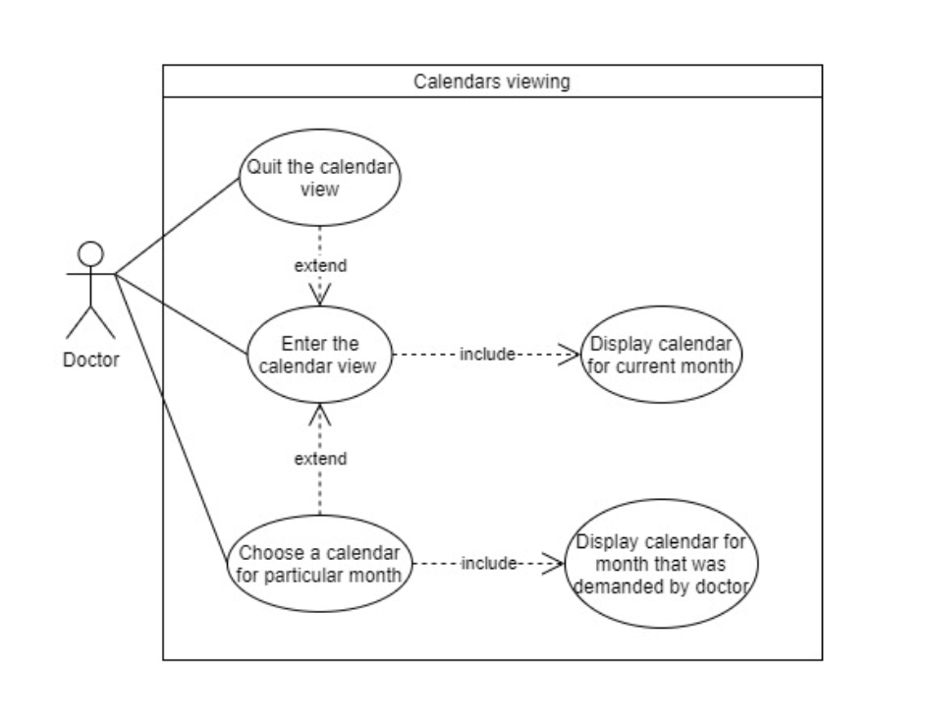

|  |  |
| --- | --- |
| Name | Calendars viewing |
| ID | cv_1.1 |
| Description | Logged in doctor has the possibility to view monthly calendars. |
| Author | Aleksandra Michalak |
| Actor | Doctor |
| Start conditions | Doctor has to be logged in |
| Finish conditions | N/A |
| Input data | N/A |
| Output data | N/A |
| Scenarios | Main:   1. Doctor enters the calendars view 2. System displays calendar for current month 3. Doctor uses a button to check a calendar for next month 4. System displays calendar for next month 5. Doctor quits the calendar view |
| Notices |  |

2.1.2 Calendar's details viewing

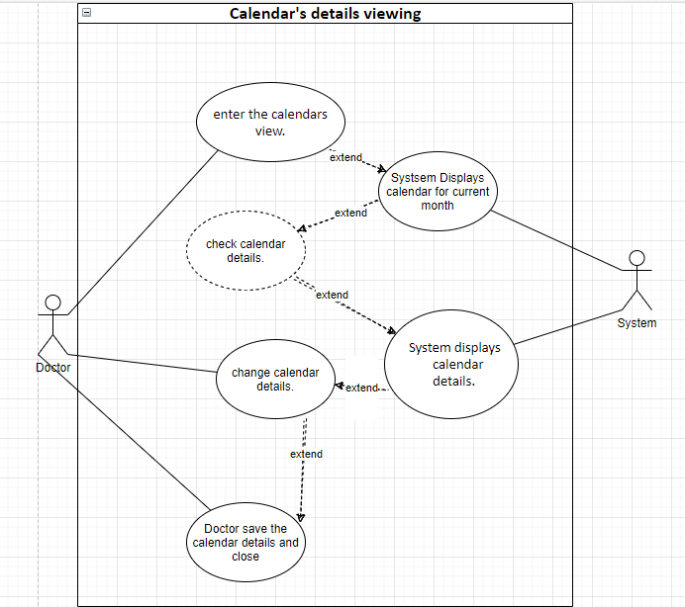

|  |  |
| --- | --- |
| Name | Calendar's details viewing |
| ID | cdv_1.1 |
| Description | Logged in doctor has the possibility to view monthly calendars details. |
| Author | Kacper Kowalski |
| Actor | Doctor |
| Start conditions | Doctor has to be logged in |
| Finish conditions | N/A |
| Input data | N/A |
| Output data | N/A |
| Scenarios | Main:   1. Doctor enters the calendars view. 2. System displays calendar for current month. 3. Doctor uses a button to check a calendar details. 4. System displays calendar details. 5. Doctor change calendar details. 6. Doctor save the calendar details. |
| Notices |  |

2.1.3.1 Manual creation of the calendar

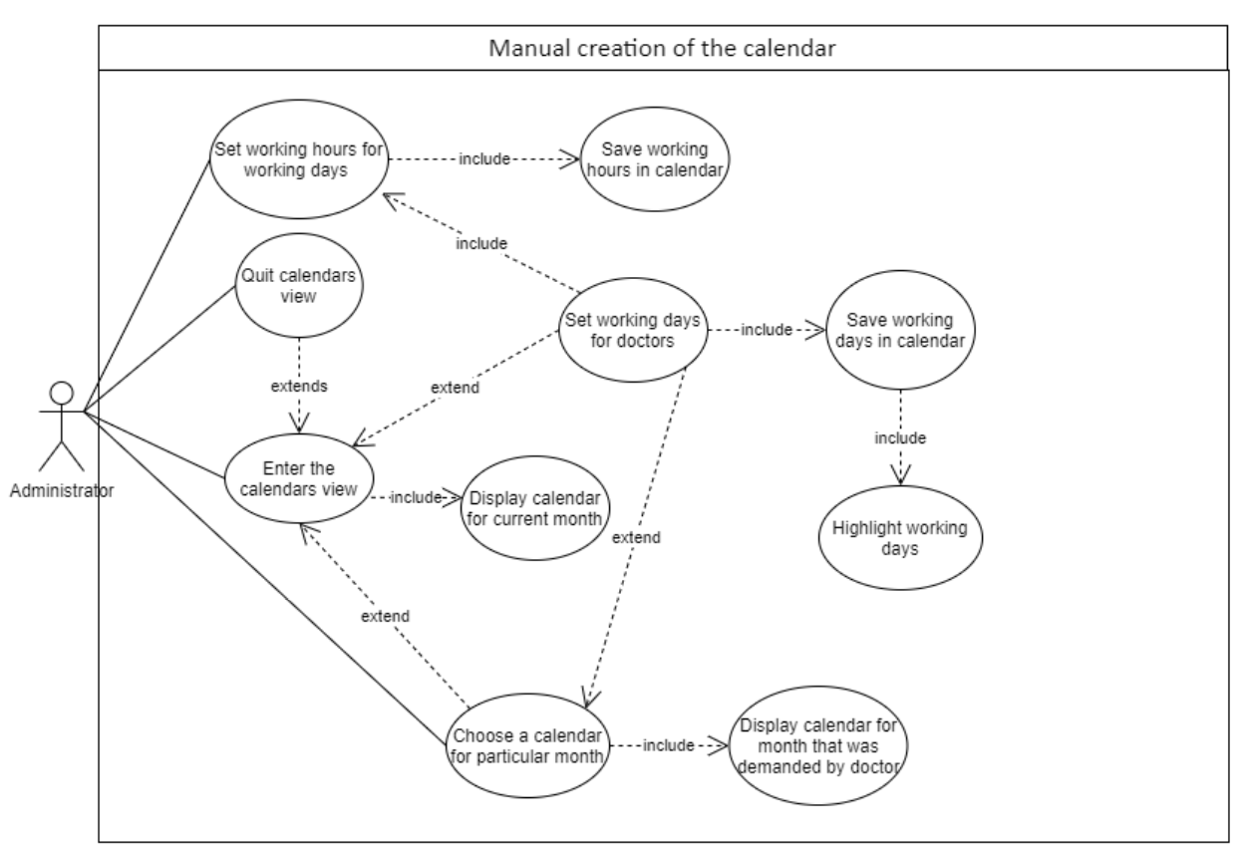

|  |  |
| --- | --- |
| Name | Manual creation of the calendar |
| ID | ncca_1.1 |
| Description | Administrator of the system can set working days and hours for doctor |
| Author | Aleksandra Michalak |
| Actor | Administrator |
| Start conditions | Administrator has to be logged in |
| Finish conditions | Calendar contains working days and working hours |
| Input data | N/A |
| Output data | N/A |
| Scenarios | Main:   1. Administrator enters the calendars view 2. System displays calendar for current month 3. Administrator uses button to choose a calendar for next month 4. System displays a calendar for next month 5. Administrator sets working days for doctor 6. System highlights working days in calendar 7. Administrator sets working hours for working days by using a designated for that button 8. System saves working hours in calendar 9. Administrator quits the calendars view |
| Notices |  |

2.1.3.2 Automatic creation based on already existing calendar

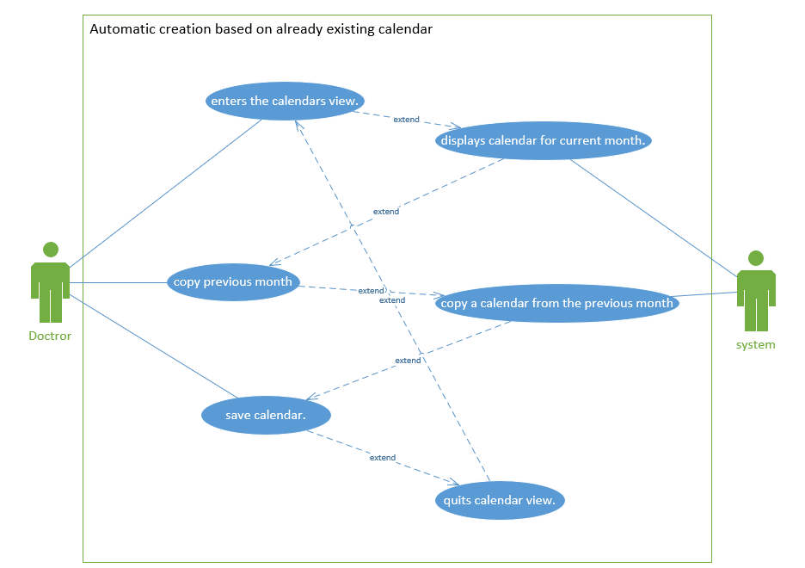

|  |  |
| --- | --- |
| Name | Automatic creation based on already existing calendar |
| ID | acbaec_1.1 |
| Description | The doctor is able to copy the calendar of the previous month |
| Author | Kacper Kowalski |
| Actor | Doctor |
| Start conditions | Doctor has to be logged in |
| Finish conditions | The previous month's calendar was copied |
| Input data | N/A |
| Output data | N/A |
| Scenarios | Main:   1. Doctor enters the calendars view. 2. System displays calendar for current month. 3. Doctor presses button to copy previous month . 4. System copy a calendar from the previous month. 5. Doctor presses button to save calendar. 6. Doctor quits calendar view. |
| Notices |  |

2.1.4.1 New term

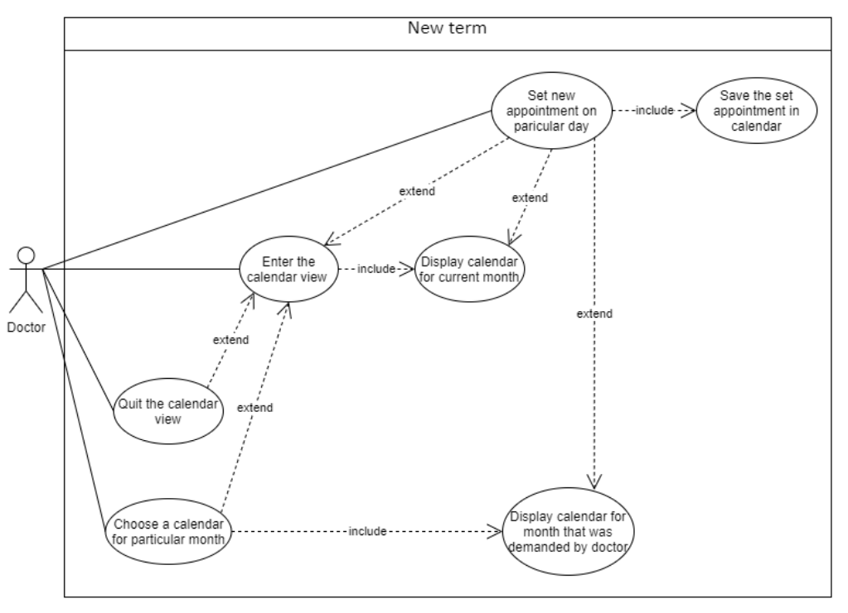

|  |  |
| --- | --- |
| Name | New term |
| ID | eoc_1.1 |
| Description | Logged in doctor has the possibility to add a new term to a calendar |
| Author | Aleksandra Michalak |
| Actor | Doctor |
| Start conditions | Doctor has to be logged in |
| Finish conditions | New term is added to calendar |
| Input data | N/A |
| Output data | N/A |
| Scenarios | Main:   1. Doctor enters the calendar view 2. System displays calendar for current month 3. Doctor chooses a day 4. Doctor adds an appointment by using a designated button 5. System saves the term in calendar 6. Doctor quits calendar view |
| Notices |  |

2.1.4.2 Term change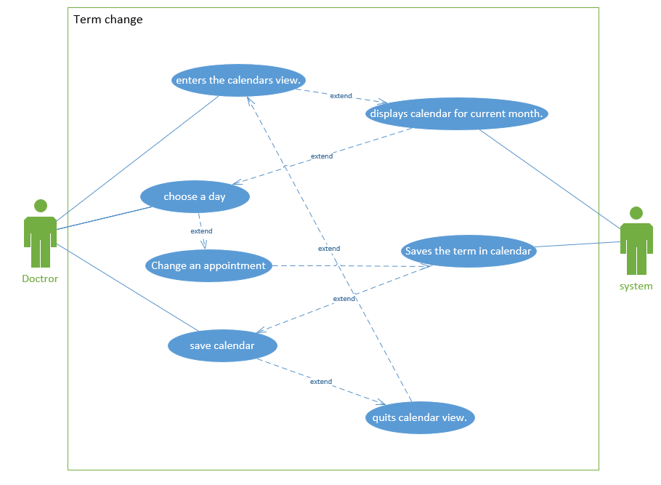

|  |  |
| --- | --- |
| Name | Term change |
| ID | TC_1.1 |
| Description | Logged in doctor has the possibility to change a term in a calendar |
| Author | Kacper Kowalski |
| Actor | Doctor |
| Start conditions | Doctor has to be logged in |
| Finish conditions | Term is changed in calendar |
| Input data | N/A |
| Output data | N/A |
| Scenarios | Main:   1. Doctor enters the calendar view. 2. System displays calendar for current month. 3. Doctor chooses a day . 4. Doctor change an appointment by using a designated button. 5. System saves the term in calendar. 6. Doctor quits calendar view. |
| Notices |  |

2.1.4.3 Term cancellation

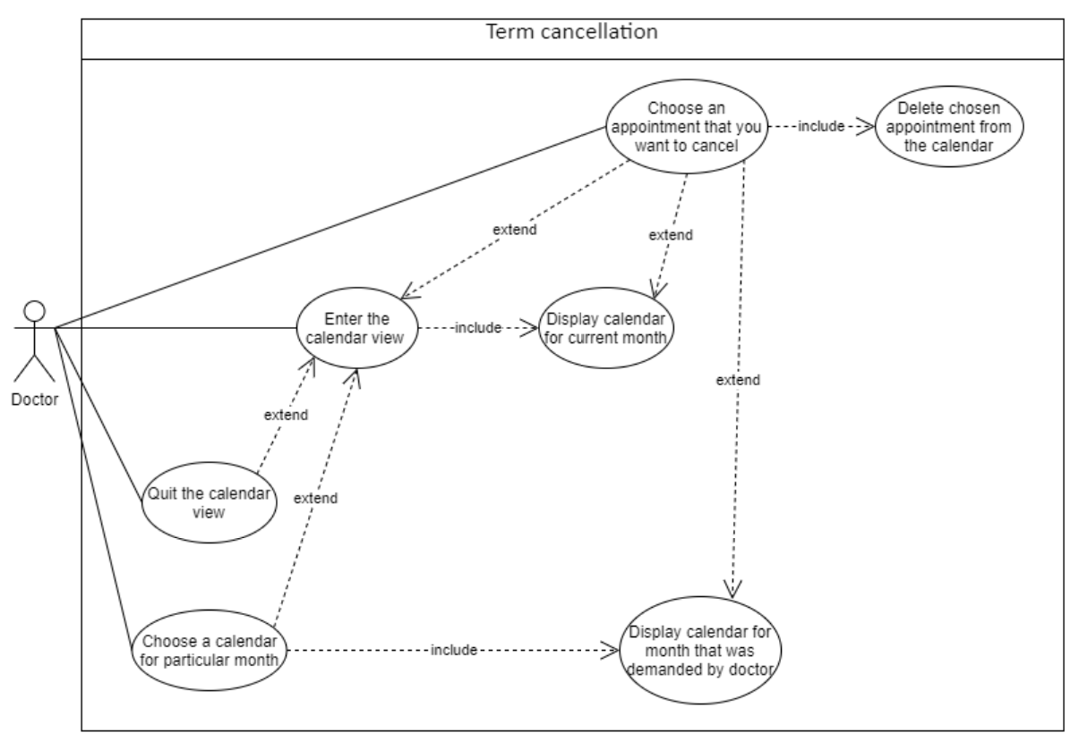

|  |  |
| --- | --- |
| Name | Term cancellation |
| ID | eoc_1.3 |
| Description | Logged in doctor has the possibility to add a new term to a calendar |
| Author | Aleksandra Michalak |
| Actor | Doctor |
| Start conditions | Doctor has to be logged in |
| Finish conditions | Term from calendar is cancelled |
| Input data | N/A |
| Output data | N/A |
| Scenarios | Main:   1. Doctor enter the calendar view 2. System displays calendar for ongoing month 3. Doctor chooses a day that contains booked appointments 4. Doctor clicks on a designated for term cancellation button 5. System displays booked appointments for the particular day 6. Doctors chooses the appointment that should be cancelled 7. System cancels that particular term 8. Doctor quits the calendar view |
| Notices |  |