**PATHWAY**

* Damanvir Singh
* Munib Syed

Year 12

Gungahlin College

ACT

A project submitted to

Young ICT Explorers

30/07/2015

Please answer to the best of your abilities all of the below questions?

1. ABSTRACT – *max 150 words*

Provide a short summary telling us about your project and what you hoped to achieve?

Our project is an indoor navigation system/application, with the possible addition of an Indoor Positioning System (IPS) using Wi-Fi triangulation. We hope to create a user-friendly web-based app that will work in a variety of indoor environments, giving the user short directions to their goal destination. Since this is a web-app, it will be available on all platforms including OSX, Windows, IOS, Android, etc.

In order for the main application to work, we need to provide it with map data (floor plans), which will then be read and processed, so the map data can work with the application. The project delves into areas of computer vision, and OpenCV has been used to make portions of this task more achievable. We hope to achieve an efficient, scalable algorithm that can work universally as long as sufficient map data is provided, that can recognize and avoid as many obstacle types as possible.

2. INTRODUCTION – *max 50 words*

What inspired the idea for your project?

We came across Dijkstra's algorithm for one of our assessments and were fascinated by its use and extensibility. We wanted to create an indoor navigation application using Dijkstra’s algorithm. Knowing that map data is needed for this application, we need to create another application to automatically read building floor maps.

3. PROBLEM STATEMENT – *max 50 words*

Explain the problem you are trying to solve with your project?

The issue of quickly navigating large indoor environments, such as a school or office building. Users can find efficient ways to reach one point to another. The main problem that we are addressing is the issue of not being able to navigate a large, unfamiliar building.

* Design and Features – *max 75 words*  
  Tell us about the design and some of the features of your project?

There are two parts to the application. First part is getting map data which is done through the user providing a floor plan of the building, which is then read, processed by OpenCV and then imported into the main application which then allows users to navigate inside the building.

Features:

* Indoor navigation.
* Calculating optimal/near-optimal paths.
* Floor plan reading and processing.
* IPS (if included) using Wi-Fi triangulation.
* Universal application (works inside any building).
* Web application (works on most platforms).
* Challenges Designing and Building this Project *– max 75 words*  
  what challenges did you have when designing and building your project?
* Computer vision/image analysis. Corner detection requires difficult maths such as image gradient analysis, which is simplified through the use of OpenCV.
* Algorithm Efficiency/Scalability. Avoiding intractability.
* Detecting and ignoring obstacles on a floor plan, for a wide variety of different-shaped obstacles.
* Keeping it user-friendly, as much of it has to be automated as possible.
* Harris Corner Detection algorithm does not work well with jagged lines.
* Lack of knowledge in networking and triangulation which are needed to build an IPS.

4. CONCLUSION – *max 50 words*

Does your project do what you set out to achieve?

The project is not yet completed, however the prototypes we have tested demonstrate the capacity to reach our final goal comfortably.

5. TECHNOLOGIES USED

List the programs and technologies used?

* OpenCV
* Python
* Python Packages (NumPy, Matplotlib and others)
* Flask
* Leaflet (mapping library)
* HTML
* CSS
* JavaScript/jQuery
* Google Docs (for cooperative work)

*If an IPS is implemented, the following technologies would be used: Wi-Fi routers, Netsh

APPENDIX A  
Insert images or screenshots or links to your project if published online (eg: Youtube video) in this section in support of your submission

The image below is a screenshot of the prototype of our web application for indoor navigation.

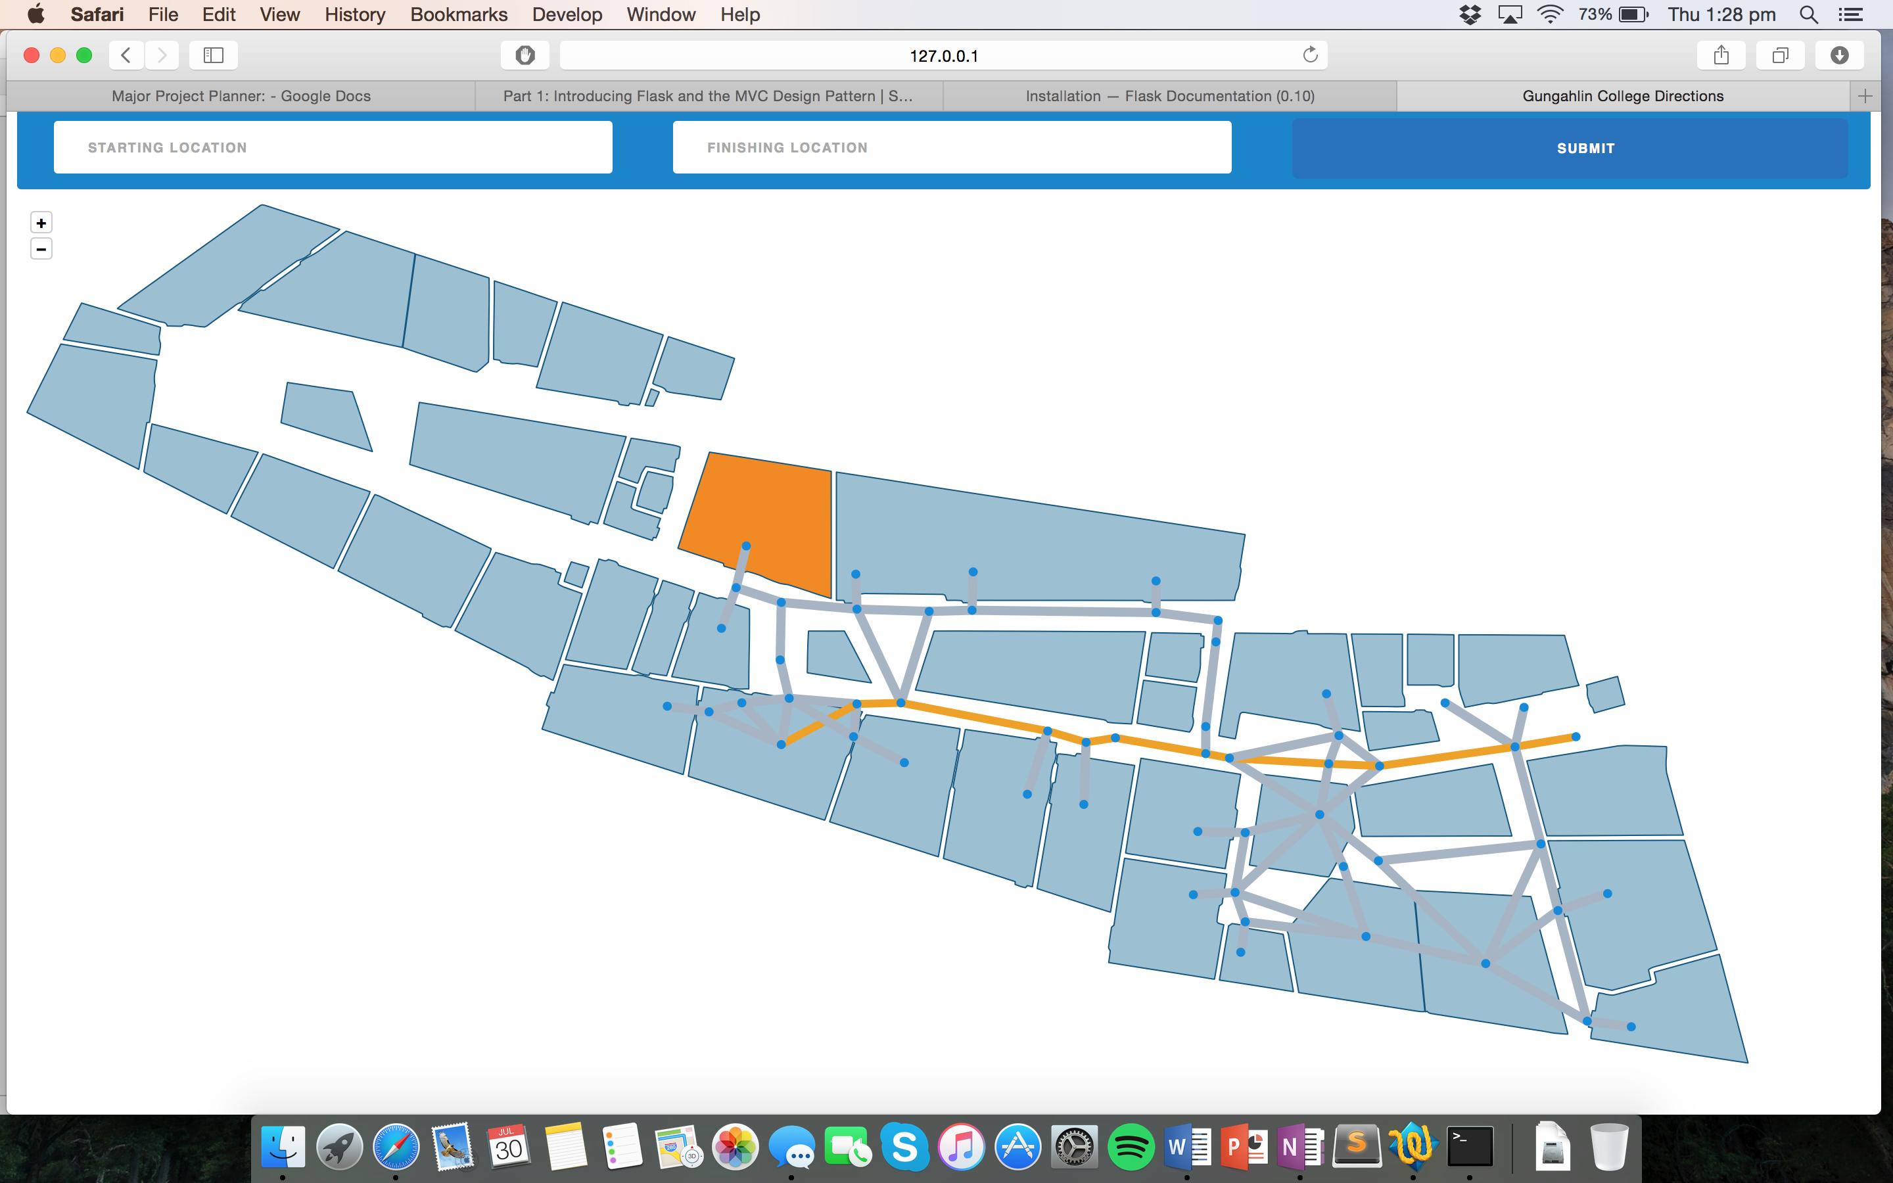

The image below is a screenshot of OpenCV demonstrating Harris Corner Detection algorithm.

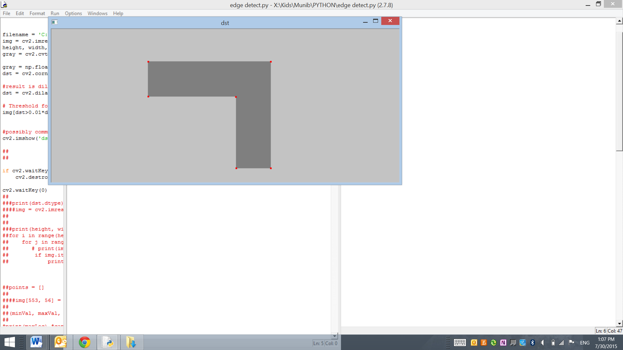

APPENDIX B

Insert samples of program code here (if applicable)

The image below is a code snippet of the Dijkstra’s algorithm in Python.

