Preprocessing

# Questions to Answer:

1. UCSFFSL File: Analyzing timestamps using VISCODE and calculating visitation durations
   1. How are the visitations aligned with each participant
   2. What is the average duration between baseline and follow up visits?
   3. How to handle large gaps between visits?
2. Participant Mapping: Mapping participants with age, baseline symptoms and other sociodemographic features
   1. Do participants with insomnia show distinct demographic profiles compared to those without symptoms?
3. Transition analysis: Plotting alluvial plots, visualizing the transitions between stages during uniform visit points.
   1. Are certain diagnoses more likely to progress or remain stable?
   2. Can we ensure uniform visit points?
4. Cognitive scores: Incorporating cognitive psychometric scores into the analysis.
   1. 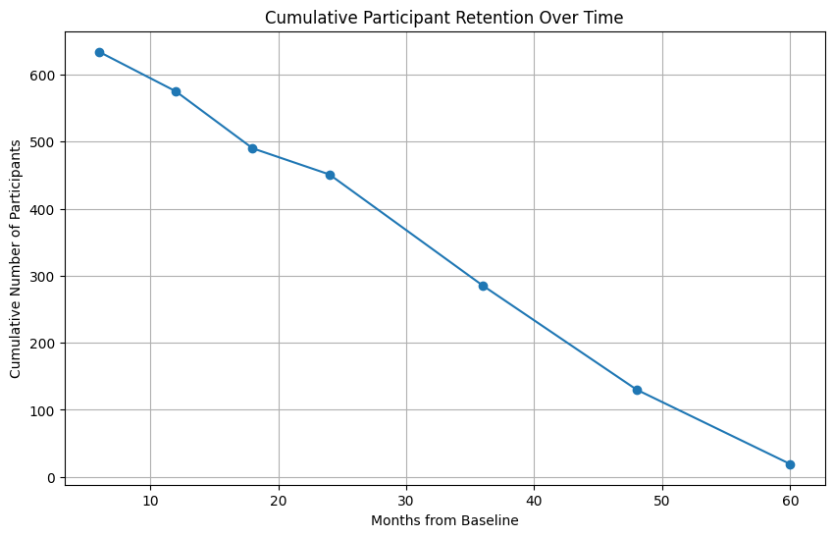Finding relationship between sleep disturbances, sociodemographic factors and psychometric tests.

# Results:

* Cumulative participant counts with available sleep-related NPIQ data across different time points.
* 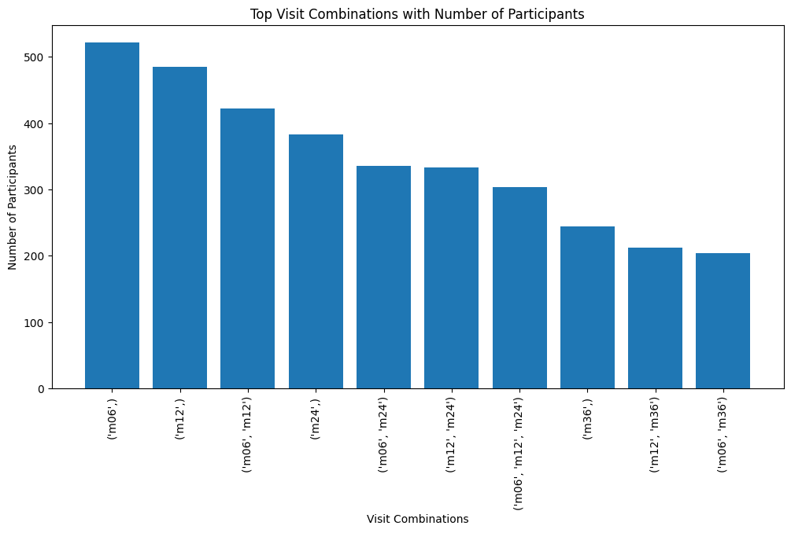A decline in count is expected as the longitudinal count decreases.
* Merged UCSFFSL and ADNIMERGE based on RID and VISCODE.
* Removed participants with missing DX_bl and DX.
* Extracted Month values and mapped it with VISCODE.
* The above plot gives the count of participants with the longitudinal study.

| **Visit Combination** | **AD → AD** | **AD → MCI** | **CN → AD** | **CN → CN** | **CN → MCI** | **LMCI → AD** | **LMCI → CN** | **LMCI → MCI** |
| --- | --- | --- | --- | --- | --- | --- | --- | --- |
| **m06** | 104 | 2 | 2 | 163 | 14 | 94 | 11 | 240 |
| **m12** | 86 | 2 | 2 | 156 | 15 | 97 | 9 | 225 |
| **m06, m12** | 77 | 2 | 2 | 141 | 14 | 83 | 9 | 192 |
| **m24** | 62 | 3 | 2 | 139 | 14 | 83 | 7 | 166 |
| **m06, m24** | 55 | 2 | 2 | 122 | 13 | 71 | 7 | 152 |
| **m12, m24** | 49 | 2 | 2 | 128 | 14 | 74 | 6 | 145 |
| **m06, m12, m24** | 46 | 2 | 2 | 118 | 13 | 66 | 6 | 133 |
| **m36** | 0 | 0 | 2 | 114 | 13 | 62 | 9 | 113 |
| **m12, m36** | 0 | 0 | 2 | 100 | 13 | 49 | 8 | 104 |
| **m06, m36** | 0 | 0 | 2 | 96 | 12 | 47 | 9 | 102 |

* The above table is the Diagnosis transition from baseline to the current DX of that time point.
* 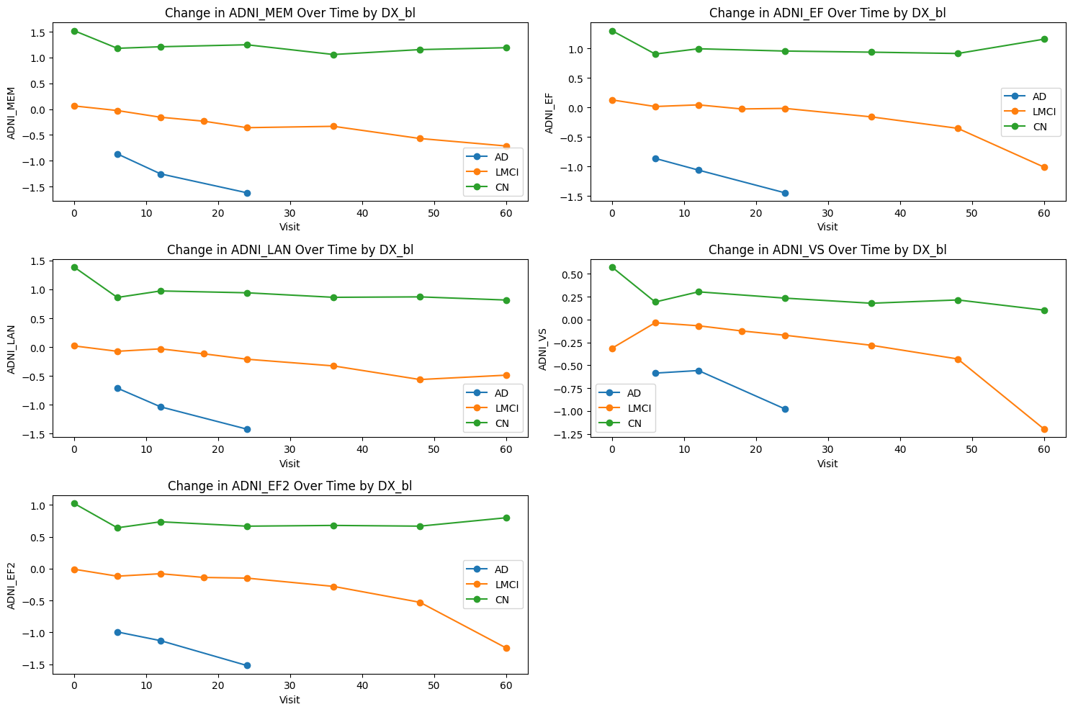This suggests, taking the Visit combination (m06, m12 and m24) would be ideal.
* 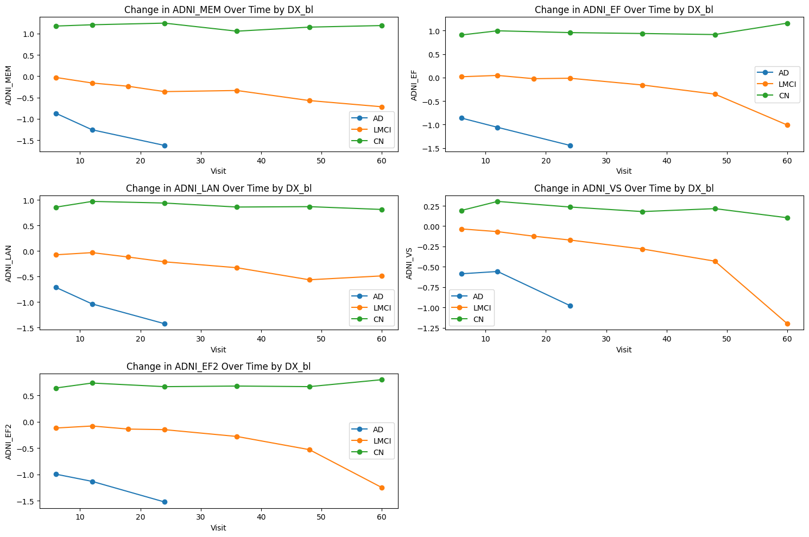Psychometric tests (Memory, executive function, language and visuospatial) were combined with ADNIMERGE to see the trend on different Diagnosis groups with respective to the Visit points.(with baseline being bl)
* The above plot was the same as before except here the baseline is m06.

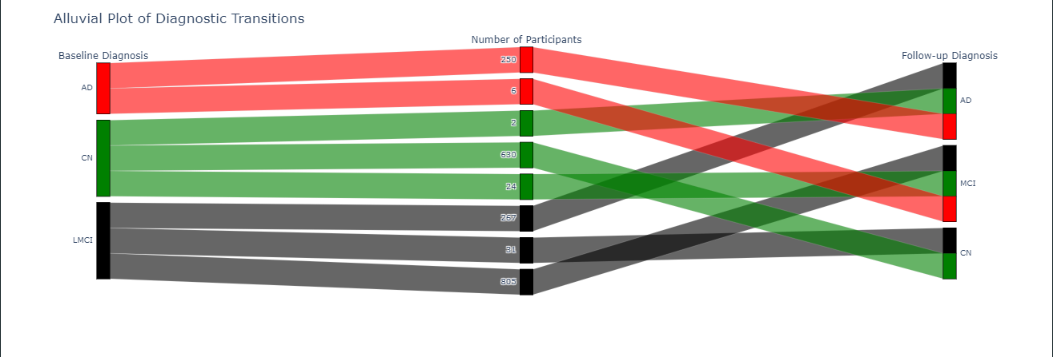

* Overall Alluvial plot accounting for transitions (All values).

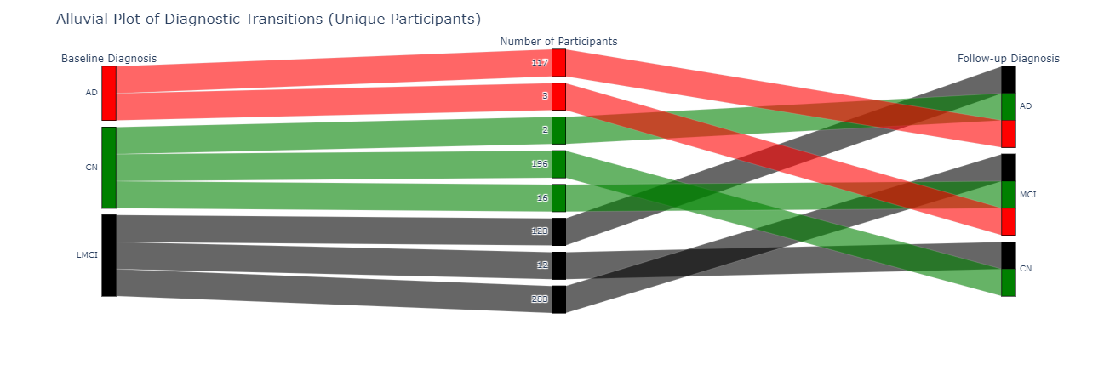

* Alluvial plot accounting for transitions (Unique participants)
* 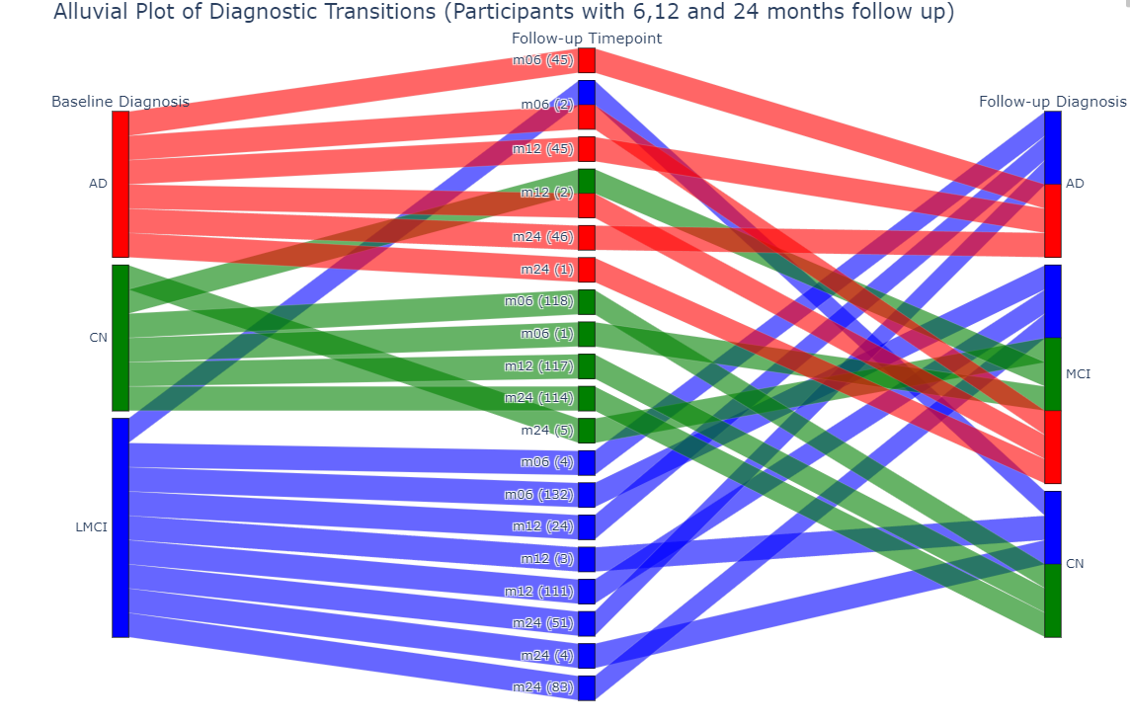Alluvial plot for transitions (taking only time points: m06, m12 and m24) [Unique participants : 304]
* RIDs with multiple changes in DX: [ 873, 293, 294, 887, 906, 325, 839, 835, 204, 1010, 1007, 214, 1057, 1054, 187, 952, 941, 249, 978, 443, 429, 507, 568, 649, 729, 725, 722, 752, 675, 658, 390, 708, 702, 388, 1247, 77, 112, 1240, 108, 1217, 1213, 1282, 1427, 57, 1299, 42, 54, 141, 1121, 1135, 1066] (Total count: 51)
  + Participants with multiple changes in the DX (changing in intermediate visits).

* 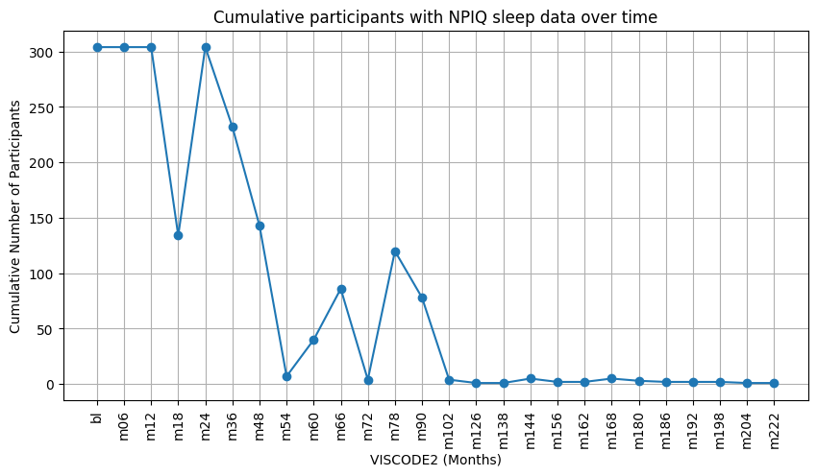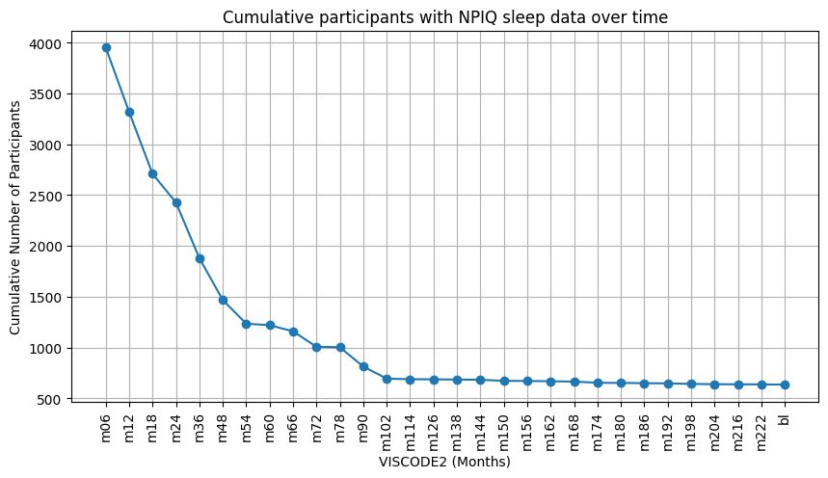Number of participants with available sleep-related NPIQ data across different time points (longitudinal).
* Cumulative participants (for those 304 unique participants)
  + The graph contains unexpected drops in participants during certain time points.

From NPIQ data, NPIKSEV was taken: severity scores (0: mild, 1: moderate, 2: severe)

For those 304 participants the split was, mild: 270, moderate: 33 and severe: 1.

* 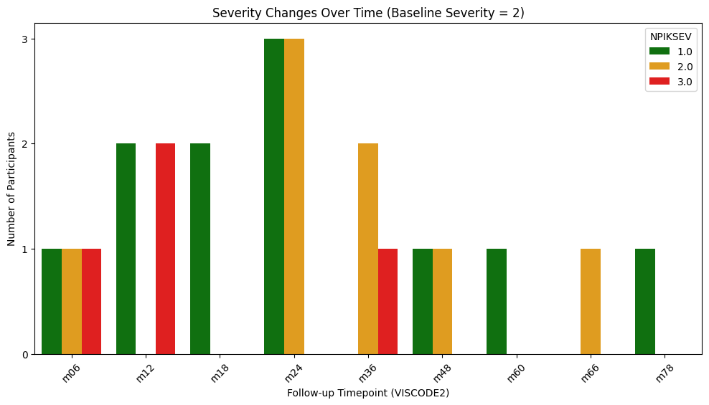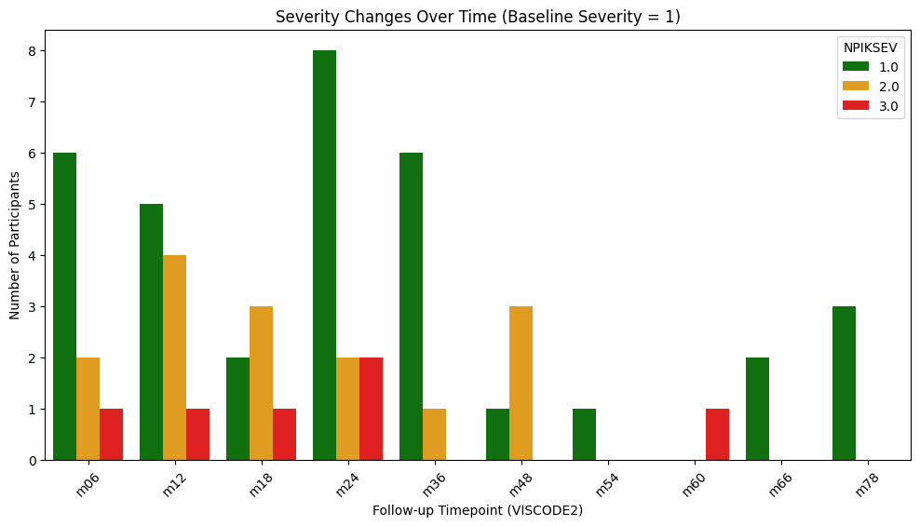Changes of NPIK severity for people with moderate severity during baseline
* Changes of NPIK severity for people with severe severity during baseline