Meets

Create a meet

Version <1.0>

Revision History

|  |  |  |  |
| --- | --- | --- | --- |
| **Date** | **Version** | **Description** | **Author** |
| 01/11/2016 | 1.0 | Initial fill up | Luca Carotenuto |
|  |  |  |  |
|  |  |  |  |
|  |  |  |  |

Table of Contents

1. Use-Case Name 4

1.1 Brief Description 4

2. Flow of Events 4

2.1 Basic Flow 4

2.2 Alternative Flows 4

2.2.1 < First Alternative Flow > 4

2.2.2 < Second Alternative Flow > 5

3. Special Requirements 5

3.1 < First Special Requirement > 5

4. Preconditions 5

4.1 < Precondition One > 5

5. Postconditions 5

5.1 < Postcondition One > 5

6. Extension Points 5

6.1 <Name of Extension Point> 5

Create a meet

# Use-Case Name

## Brief Description

This use case enables a user that is logged in to the system to create a new meet. In this process the user has to fill out the required form fields that are necessary to create a new meet. Only in the case of valid input a new meet is stored in the system.

# Flow of Events

## Basic Flow

Activity diagram:

C:\Users\D064880\Downloads\activity_create_meet.png

Mockup:



Feature File:

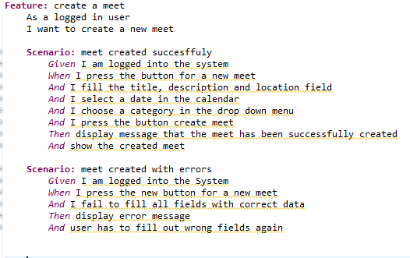

# Special Requirements

n/a

# Preconditions

The user that tries to create a new meet must be logged in to the system.

# Postconditions

After the process creating a new meet, the meet is stored in the database and is ready to be viewed not only by the creator but by every other user. After successful completion people can join the meet, leave the meet and comment on the meet.

# Extension Points

n/a