Meets

Register

Version 1.0

Revision History

|  |  |  |  |
| --- | --- | --- | --- |
| **Date** | **Version** | **Description** | **Author** |
| 01/11/2016 | 1.0 | Initial fill up | Luca Carotenuto |
|  |  |  |  |
|  |  |  |  |
|  |  |  |  |

Table of Contents

1. Use-Case Name 4

1.1 Brief Description 4

2. Flow of Events 4

2.1 Basic Flow 4

3. Special Requirements 6

4. Preconditions 6

5. Postconditions 6

6. Extension Points 6

Register

# Use-Case Name

## Brief Description

This use case enables the guest user to create a new account for the meets platform. In this process he has to fill out the required form fields to complete a successful registration to the system.

# Flow of Events

## Basic Flow

Activity diagram:

C:\Users\D064880\Downloads\activity_register (1).png

Mockup: 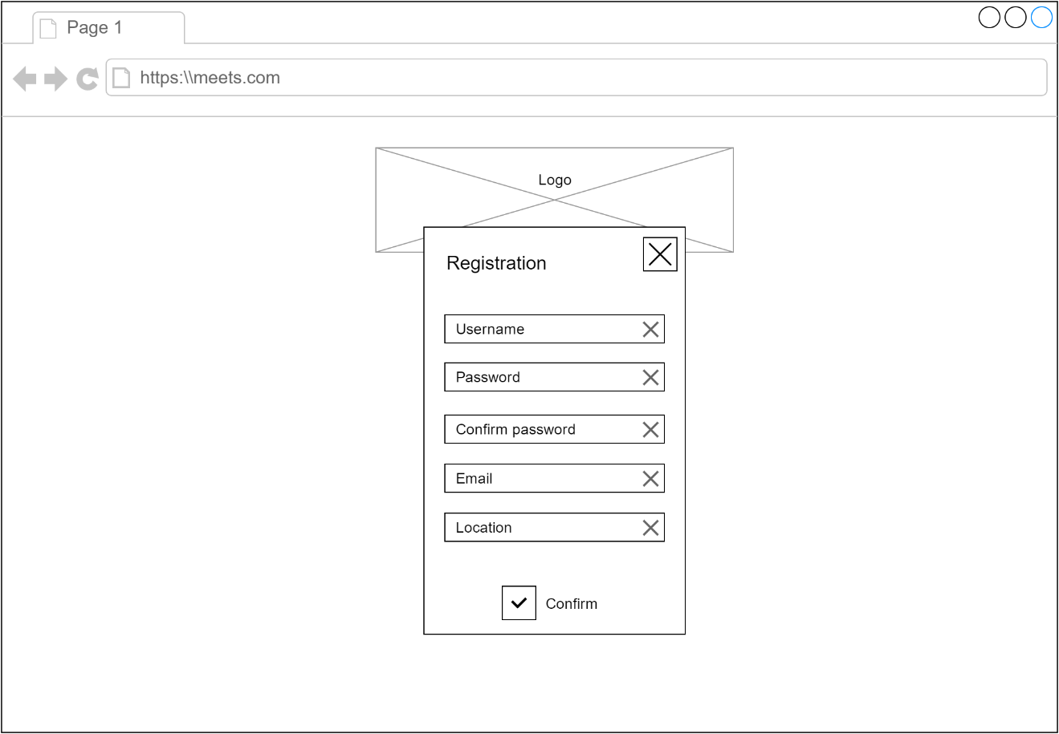

Feature File:

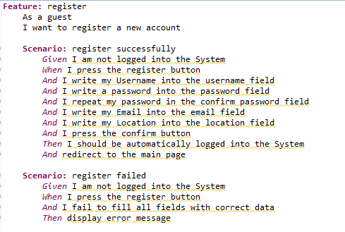

# Special Requirements

n/a

# Preconditions

The user that tries to register must be logged out of the system.

# Postconditions

After the process of the user registering to the system, there is a new user stored in the database and ready for use. That means the user can log into his account immediately.

# Extension Points

n/a