1-3-3:

When K = 4, there are 745 correctly classified instances among 1000 instances. After setting the K equals to 999, the amount of the correctly classified instances decreases to 700 among 1000 instances. The changing of the K value means using K nearest neighbor(s) for classification. After changing the K value to 999, the classifier will classify all of the instances into one class, the type of the class is the most frequency class. According to the Weka summary, the relative absolute error up to 99.9578 %. Using too many nearest neighbors for classification lead the classification result under-fitting.

=== Confusion Matrix ===

a b <-- classified as

700 0 | a = good

300 0 | b = bad

2-4-4

After changed the value of the weight 0,1,2, the best weight was founded after 5 loop times loop executed. The train accuracy reached 0.79 and the test accuracy reached 0,82.

The best weight found is

Weight 0 = 0.000

Weight 1 = 1.000

Weight 2 = 1.000

The code is changed to

1. lw0 = -1:0.5:1;
2. lw1 = -1:0.5:1;
3. lw2 = -1:0.5:1;

The iteration graph:

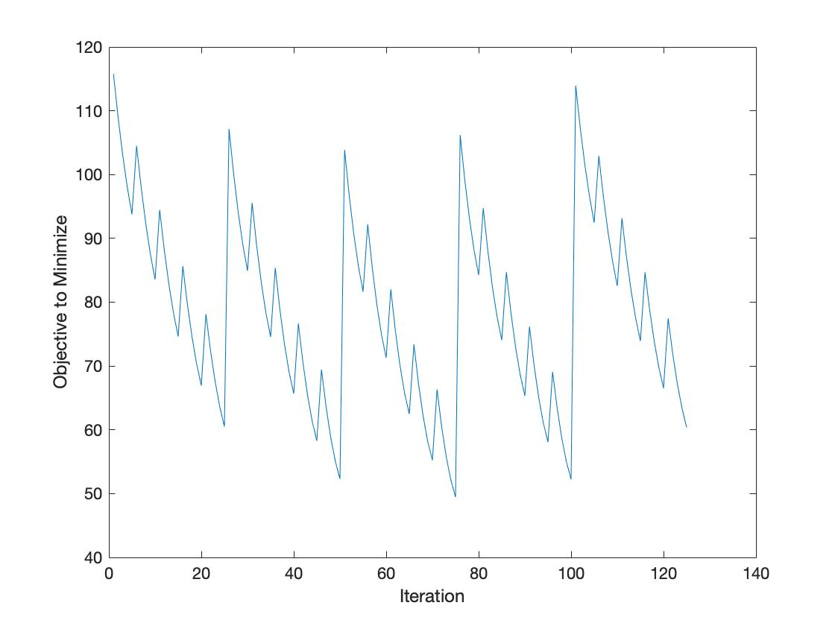

2-5-1-2

The original likelihood is 81.6513. After update the weights to move in the direction of the gradient, the new likelihood is 45.3826. The new train accuracy is 0.76.

The weight is

Weight 0 = 0.066543178776321

Weight 1 = 1.222607395813489

Weight 2 = 1.677419405413738

Updating the weights to move in the direction of the gradient in MATLAB:

1. step = 0.1;
2. w = w-step\*dllh;

2-6-4