Part 2

Task 1

According to

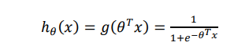

The code changes to

1. output = 1./(1+exp(-z));

The figure shows

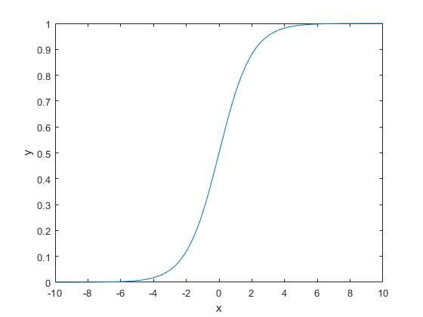

Task 2

Plot the data

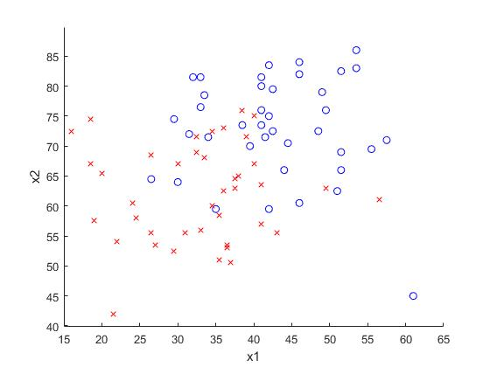

Normalized the data

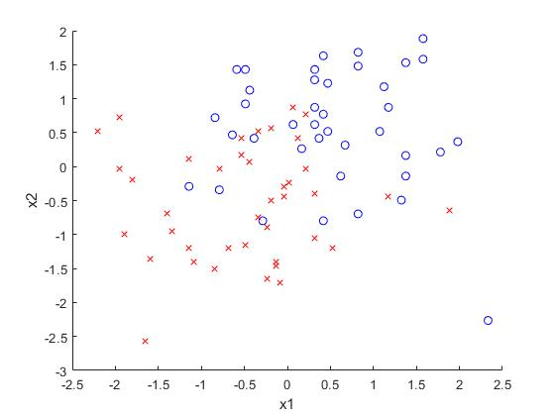

The new figure shows that the

1.1

Task 3

**function** result**=**calculate_hypothesis**(**X**,**theta**,**training_example**)**

hypothesis **=** 0.0**;**

%%%%%%%%%%%%%%%%%%%%%%%%

%Calculate the hypothesis for the i-th training example in X.

**[**y **,** x**]** **=** size**(**theta**);**

**for** i **=**1 **:** x

hypothesis **=** hypothesis **+** X**(**training_example**,** i**)\*** theta**(**i**);**

**end**

%%%%%%%%%%%%%%%%%%%%%%%%

result**=**sigmoid**(**hypothesis**);**

**end**

%END OF FUNCTION

Task 4

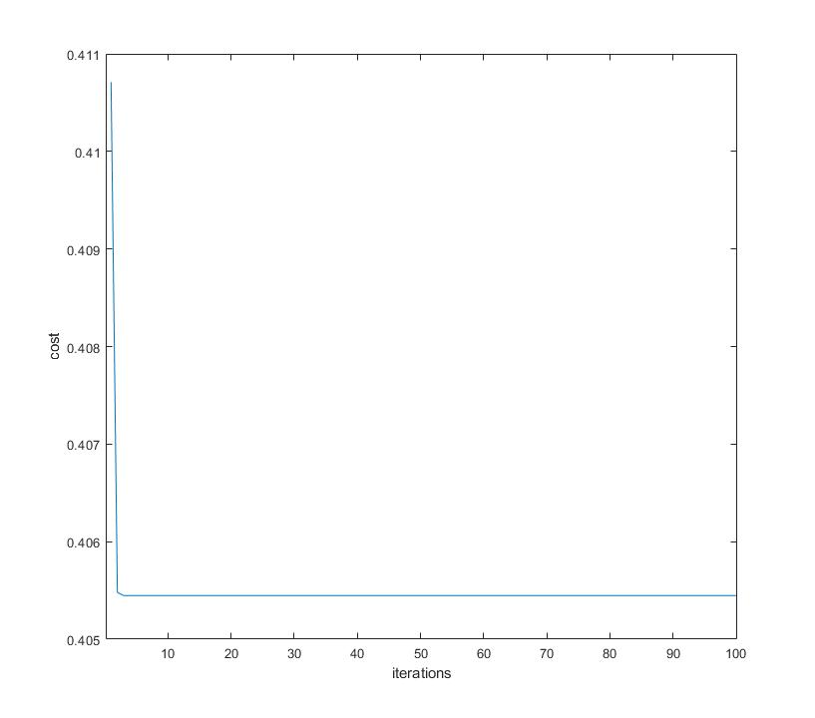

Final error:0.40545

1.2

Task 5