

**COMP 3710 - 3**

**Applied Artificial Intelligence (3,1,0)**

**Fall 2017**

**Seminar/Lab 4**

**Genetic Algorithms**

**Instructor:** Mahnhoon Lee

**Student Name:** ZHENYU WANG

**Student Number:**  T00059541

[2,4,7,3,1,8,6,5]

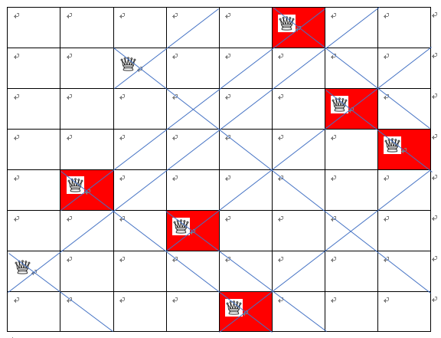

The number of conflicts: 4

The fitness value is (28-4) = 24;

[1,2,3,4,5,6,7,8,]

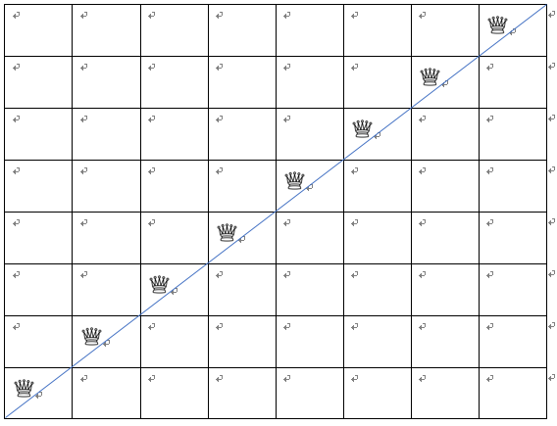

The number of conflicts: 7+6+5+4+3+2+1 = 28

The fitness value is (28-28) = 0;

[2,4,1,4,5,1,2,4]

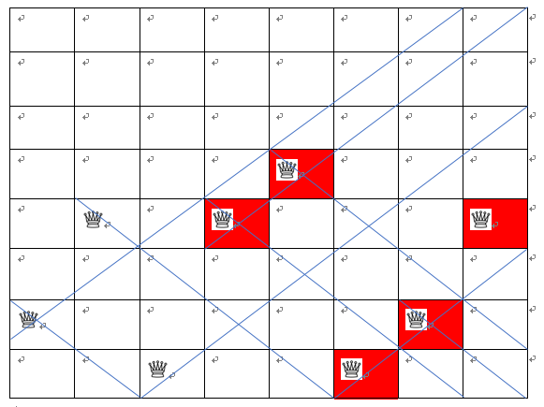

The number of conflicts: 7

The fitness value is (28-7) = 21;

[2,3,4,5,2,3,1,3]

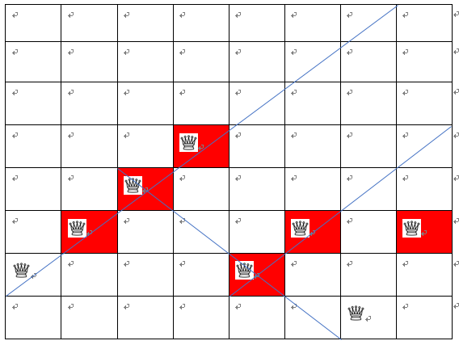

The number of conflicts: 13

The fitness value is (28-13) = 15;

24+0+21+15 = 60

|  |  |  |
| --- | --- | --- |
| Individuals | Fitness values | Fitness ratios (%) |
| [2 4 7 3 1 8 6 5] | 24 | 24/60 = 0.4= 40% |
| [2 4 1 4 5 1 2 4] | 21 | 21/60 =0.35 = 35% |
| [2 3 4 5 2 3 1 3] | 15 | 15/60 = 0.25 = 25% |
| [1 2 3 4 5 6 7 8] | 0 | 0/60 = 0 |

40%, 35%, 25%, 0(drop)

From above, construct a list – [ 0, 40, 75(40+35), 100(75+25)]

* + - * With the above example, if *r* <= 40, then the first one is selected
      * else if *r* <= 75, then the second one is selected
      * else if *r* <= 100, then the third one is selected

|  |  |  |  |  |  |  |  |  |
| --- | --- | --- | --- | --- | --- | --- | --- | --- |
| *r* | Selected individuals | New individuals | *m* | *v* | *p* | | Mutated individuals | |
| 32.32696917027824 | [2 4 7 3 1 8 6 5] | [2,4,7,3,5,1,2,4] [2,4,1,4,1,8,6,5] [2,4,7,3,2,3,1,3]  [2,3,4,5,1,8,6,5] | 3671  4  89 | 4  1  6  8 | | 5  3  7  6 | | [2,4,7,3,5,1,2,4] [2,4,1,4,1,8,6,5] [2,4,7,3,2,7,1,3] [2,3,4,5,1,8,6,5] | |

|  |  |  |
| --- | --- | --- |
| Individuals | Fitness values | Fitness ratios (%) |
| [2,4,1,4,1,8,6,5] | 28-4=24 | 24/90=26.7% |
| [2,4,7,3,5,1,2,4] | 28-5=23 | 23/(23+24+23+20)=25.6% |
| [2,4,7,3,2,7,1,3] | 28-5=23 | 23/90=25.6% |
| [2,3,4,5,1,8,6,5] | 28-8=20 | 20/90=22.2% |

26.7%, 25.6%, 25.6%, 22.2%

From above, construct a list – [ 0, 26.7,52.3 ,77.9,100.1]

* + - * With the above example, if *r* <= 26.7, then the first one is selected
      * else if *r* <= 52.3, then the second one is selected
      * else if *r* <= 77.9, then the third one is selected
      * else, the last one is selected.

|  |  |  |  |  |  |  |  |
| --- | --- | --- | --- | --- | --- | --- | --- |
| *r* | Selected individuals | New individuals | *m* | *v* | | *p* | Mutated individuals |
| 51.769515533005794 | [2,4,7,3,5,1,2,4] | [2,4,1,4,5,1,2,4]  [2,4,7,3,1,8,6,5]  [2,4,7,3,5,1,2,4]  [2,4,7,3,2,7,1,3] | 76  61  24  8 | 4  1  5  3 | 4  5  3  8 | | [2,4,1,4,5,1,2,4]  [2,4,7,3,1,8,6,5]  [2,4,7,3,5,1,2,4]  [2,4,8,3,2,7,1,3] |

|  |  |  |
| --- | --- | --- |
| Individuals | Fitness values | Fitness ratios (%) |
| [2,4,7,3,1,8,6,5] | 28-3=25 | 25/92=27.2% |
| [2,4,7,3,5,1,2,4] | 28-5=23 | 23/92=25% |
| [2,4,8,3,2,7,1,3] | 28-5=23 | 23/92=25% |
| [2,4,1,4,5,1,2,4] | 28-7=21 | 21/(21+25+23+23)=22.8% |

27.2%,25%,25%,22.8%

From above, construct a list – [ 0, 27.2,52.5 ,77.2,100]

* + - * With the above example, if *r* <= 27.2, then the first one is selected
      * else if *r* <= 52.5, then the second one is selected
      * else if *r* <= 77.2, then the third one is selected
      * else, the last one is selected.

|  |  |  |  |  |  |  |  |
| --- | --- | --- | --- | --- | --- | --- | --- |
| *r* | Selected individuals | New individuals | *m* | *v* | | *p* | Mutated individuals |
| 24.78430255049242 | [2,4,7,3,1,8,6,5] | [2,4,7,3,5,1,2,4]  [2,4,7,3,1,8,6,5]  [2,4,7,3,2,7,1,3]  [2,4,8,3,1,8,6,5] | 17  51  45  35 | 2  7  2  6 | 5  8  5  3 | | [2,5,7,3,5,1,2,4]  [2,4,7,3,1,8,6,5]  [2,4,7,3,2,7,1,3]  [2,4,8,3,1,8,6,5] |