1. Design a fuzzy controller for an air conditioning system in a room.

Negative Medium (NM)

Negative Small (NS)

Zero (ZE)

Positive Small (PS)

Positive Medium (PM)

Domain for Theta (room temperature): [18, 40]

Domain for dTheta (temperature difference): [-5, 5]

Domain for Current: [0, 10]

Fuzzy Set for Theta:

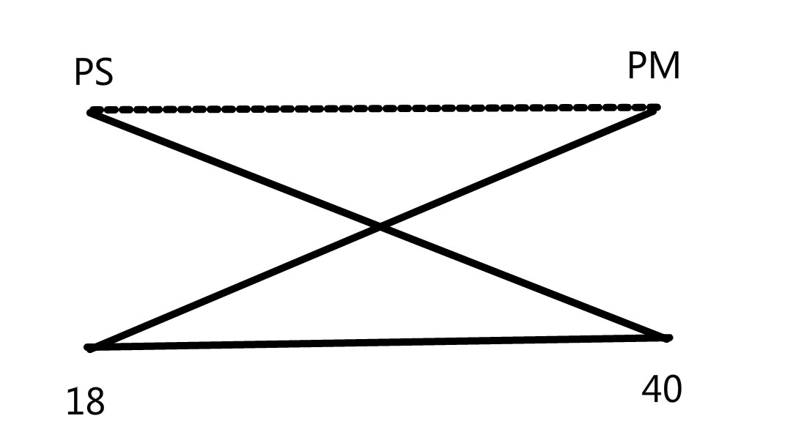

Fuzzy Set for dTheta:

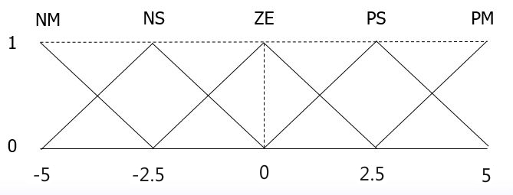

Fuzzy Set for Current:

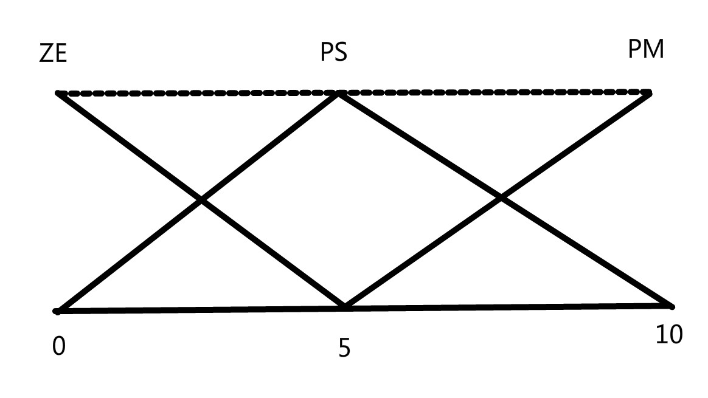

* If Theta is PS and dTheta is NS then Current is PS
* If Theta is PS and dTheta is ZE then Current is PS
* If Theta is PS and dTheta is NM then Current is PS
* If Theta is PS and dTheta is PS then Current is PS
* If Theta is PS and dTheta is PM then Current is PS
* If Theta is PM and dTheta is NM then Current is PM
* If Theta is PM and dTheta is NS then Current is PM
* If Theta is PM and dTheta is ZE then Current is PM
* If Theta is PM and dTheta is PS then Current is PM
* If Theta is PM and dTheta is PM then Current is PM

|  |  |  |  |
| --- | --- | --- | --- |
|  | Theta | | |
|  |  | PS | PM |
| NM | PS | PM |
| dtheta | NS | PS | PM |
|  | ZE | PS | PM |
| PS | PS | PM |
| PM | PS | PM |