1. Design a fuzzy controller for an air conditioning system in a room.

Negative Medium (NM)

Negative Small (NS)

Zero (ZE)

Positive Small (PS)

Positive Medium (PM)

Domain for Theta (room temperature): [18, 40]

Domain for dTheta (temperature difference): [-5, 5]

Domain for Current: [0, 10]

Fuzzy Set for Theta:

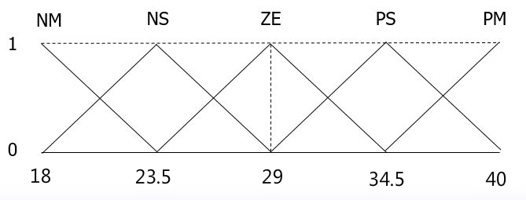

Fuzzy Set for dTheta:

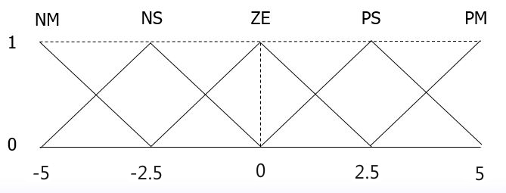

Fuzzy Set for Current:

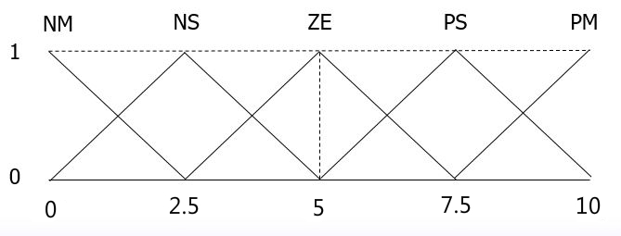

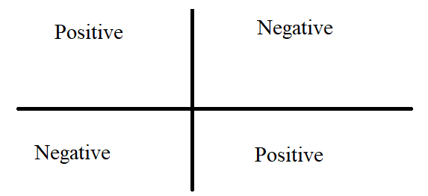

* If Theta is NM and dTheta is ZE then Current is PM
* If Theta is NS and dTheta is ZE then Current is PS
* If Theta is NS and dTheta is PS then Current is ZE
* If Theta is PS and dTheta is NS then Current is ZE
* If Theta is PS and dTheta is ZE then Current is NS
* If Theta is PM and dTheta is ZE then Current is NM
* If Theta is ZE and dTheta is NM then Current is PM
* If Theta is ZE and dTheta is NS then Current is PS
* If Theta is ZE and dTheta is ZE then Current is ZE
* If Theta is ZE and dTheta is PS then Current is NS
* If Theta is ZE and dTheta is PM then Current is NM

|  |  |  |  |  |  |
| --- | --- | --- | --- | --- | --- |
|  | Theta | | | | |
|  |  | NM | NS | ZE | PS |
| NM |  |  | PM |  |
| dtheta | NS |  |  | PS | ZE |
|  | ZE | PM | PS | ZE | NS |
| PS |  | ZE | NS |  |
| PM |  |  | NM |  |

1. Exercise

a

b

0

p

d

q

c

When p is given, how to compute q?

q = 2(p-a)/(b-a) How?

When c is given, how to compute d?

???

(a+b)/2

1

0

d

c

b

a

a

When d is given, how to compute c?

c = a + d(b-a)/2 How?

How to compute the area of the trapezoid of (a, d, d, b)?

Area = d(b-c) How?