Seth Hutcheson

REPORT PROJECT 1

For this assignment I decided to recreate Snake, a classic game I played a lot when I was little. However, snake in and of itself isn't the world’s most complicated game. While the game is initially a very vanilla take on snake, after collecting a few ‘apples’ the game shows it’s true colors. A second purple snake starts off on a single pixel until it is moved. Once moved, a purple snake initially equal to the original snake moves independently of that first snake using WASD. The food, instead of switching between red and black, now switches between black and purple. Eating your snake’s corresponding color increases the length while decreasing the length of the other snake. Each snake has its own score, though that is merely for fun. If either snake loses all of its length, the game is over and it resets. The player (or players) can choose to act against one another or see if they can go for the highest combined score possible.

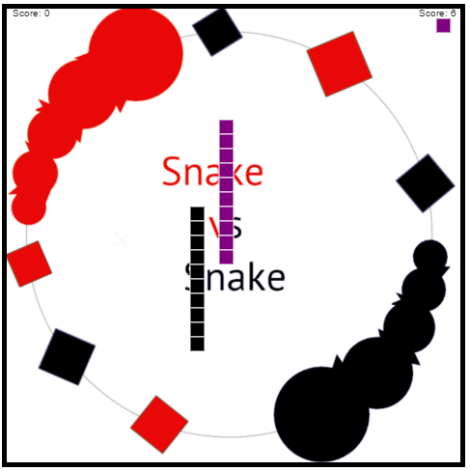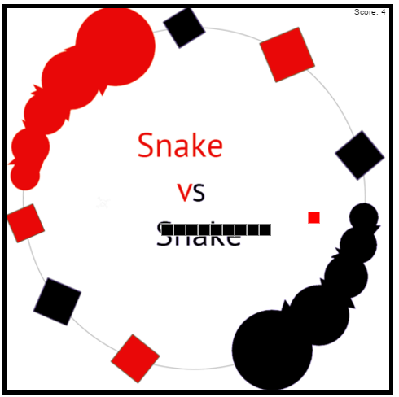

The three main graphical objects are the two snakes and the apples they eat. Each snake is just an array of points that are scaled by 15 pixels to create the larger cells seen in the game. The apples are a similar structure, just limited to a single point as opposed to an array. When they’re eaten a new one is made. The snakes animated by key events, with the arrows keys and WASD keys moving each snake separately. As the keys are it, it tells the game how to increment the head of the snake. Once its next position is set, the array is updated to reflect that movement. If an apple is eaten during movement, the tail position is noted, another point inserted into the arrow, and the movement continues as normal.

For new players, the game runs automatically, and will reset when either snake hits the boundaries of the canvas. However, the game also ends if either snake loses all of its length, or if the black snake hits itself. The purple snake is purposely allowed to move through itself and the black snake in order to facilitate a challenge. If both snakes died when colliding it would limit the amount of aggression the purple player could take when trying to win, as opposed to cooperating.