EvonyToolKit 1.0.0.8C Guide
- Basic Setup
  - Download EvonyToolKit
  - Install EvonyToolKit
  - Setting up EvonyToolKit & Adding Accounts
  - Start your bots!
- Each Page Explained.

1.Download EvonyToolKit
First you need to download EvonyToolKit so you can install it on your Windows PC.

To do this go to https://drive.google.com/file/d/0B3dDpJZ7DlpDckIwZXFKZzBBR3c/view?usp=sharing

Click the blue download button


A download should start called EvonyToolKit1.0.0.8C.exe
2.Install EvonyToolKit
Once EvonyToolKit is done downloading you are ready to install it.

Navigate to where you downloaded EvonyToolKit1.0.0.8C.exe and launch the file

You will be prompted for a password which is “EvonyToolKit1008C” without quotes.

After typing in the password and hitting enter you should see a window like:
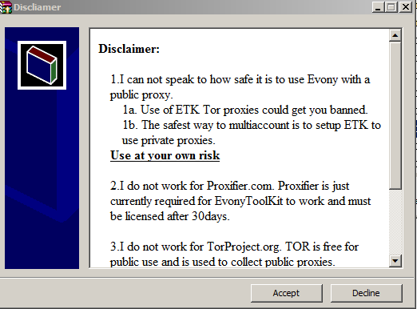
Please read through the disclaimer and if you wish to use EvonyToolKit hit “Accept”.

A second window should pop up which looks like:
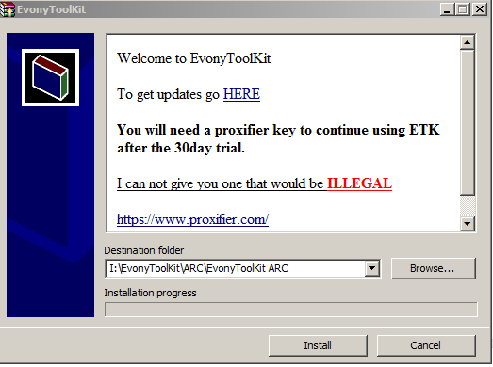
In the Destination Folder area put where you would like EvonyToolKit to install to. You can likewise use the “Browse” button to find a location for it. If you use browse I suggest using the new folder option to create a new folder for EvonyToolKit.

Once you have a path to install EvonyToolKit to in the Destination Folder box hit install and EvonyToolKit will start extracting all of its files.

The EvonyToolKit GUI will automaticly start and you can move on to the next step of setting up EvonyToolKit.

3.Setting up EvonyToolKit & Adding Accounts
When you first run EvonyToolKit it will make shortcuts on your desktop in the EvonyToolKit folder so you can easily launch EvonyToolKit in the future.

Now you need to add the accounts you wish to run through EvonyToolKit to the launcher. You do this by clicking the “Add Account” button as seen below.
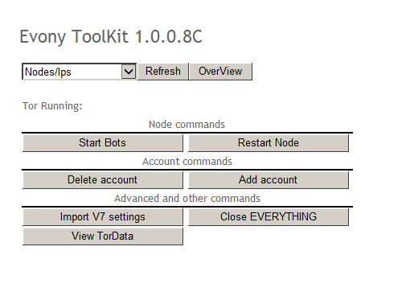

Once you hit the “Add Account” button you should see a page like:
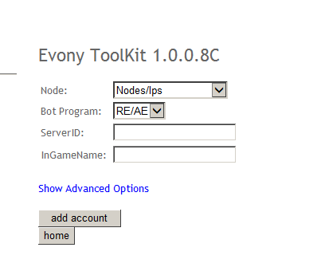
First you need to select your “Node” in the “Nodes/Ips” drop down. Each node starting with Node1 - Node30 represents a new IP Address which can be used to run more bots.

So for this example I will select “Node1” or our first new IP Address to add a bot to.
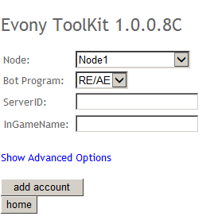

No for the “Bot Program” I will leave it on “RE/AE” though the other option is to use “YAEB” an alternative to RE/AE.

“ServerID” is which server you play on. For example “NA10” (without quotes) would be a server.

“InGameName” is the name of the account. For example an account name could be “EvonyToolKit” (without quotes).

Note that none of this info is every sent to me and is used to create a unique indentification in which you can store settings for that bot.

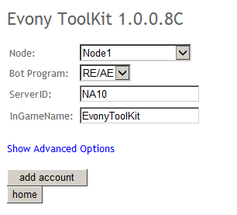

Now if you click the blue “Show Advanced Options” you will see a few more things you can do with EvonyToolKit.

None of these advanced settings have to be set. But I shall go over them briefly.
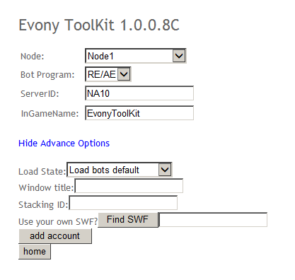
“Load State” is how you would like EvonyToolKit to launch the bot when it loads it. There are three options which are:
- “Load bots default”
  - This loads the bot in the default window mode.
- “Load bots minimized”
  - This will load the bot as a minimized window. Thus showing up in your taskbar.
- “Load bots maximized”
  - This will load the bot with the window maximized.
- “Load bots hidden”
  - This option allows you to load the bot as a hidden window so it doesn’t take up any room on your taskbar and is not visiable to users.

“Window title” is the title you wish to show up at the top of the bot window.
For example if I were to make Window title equal to “Testingstuffstuff” (without quotes) it would look like below:
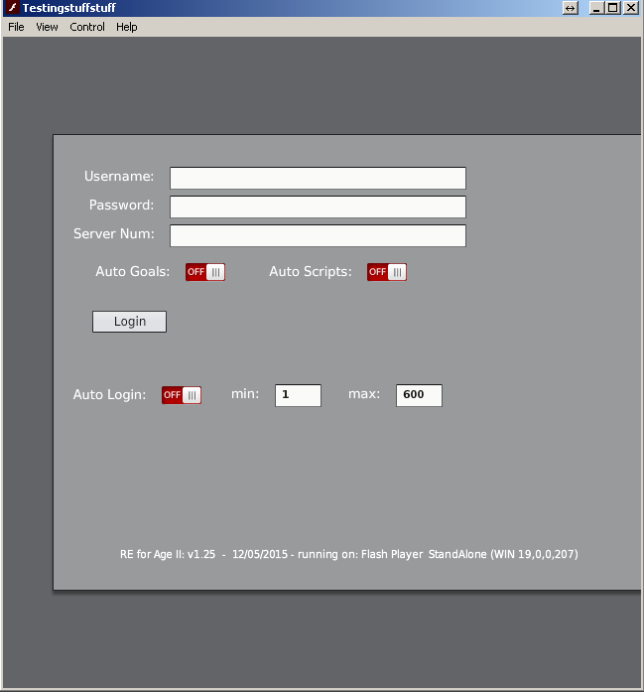

“Stacking ID” is used to stack the bots together on your taskbar. If two EvonyToolKit launched bots have the same “Stacking ID” they will stack together on the task bar like below:
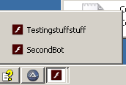

The “Find SWF” button allows you to load a bot that is already setup (Autoevony2.swf) and use it with a new IP Address. This can be handy if you already have alts setup and just wish to send them out a new IP Address.
Once you have filled out the settings, remember you don’t have to fill out any of the advanced options, hit the “Add Account” button.

You should now see in red text above the node box saying it added the account like below.
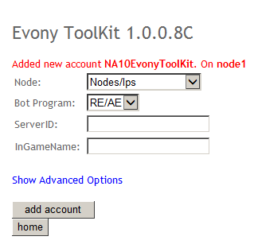

Repeat the above steps for each account you would like to run through the EvonyToolKit proxy system.

Once you are done click the “Home” button to return to the main EvonyToolKit page.

4.Start your bots!
Setting up the bots is really the hardest part. Now you all you have to do is start them!

From the Home page select the node you wish to start from the Nodes/Ips drop down and hit the “Start bots” button.
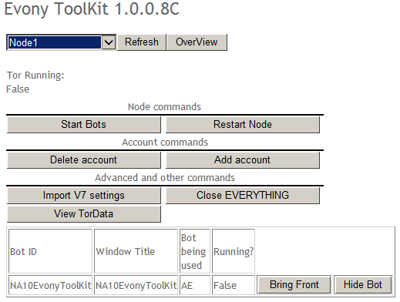

If this is your first time running EvonyToolKit you will be asked if you wish to run Proxifier in demo mode. Note the demo only lasts for 30days after which time you will have to get a key.

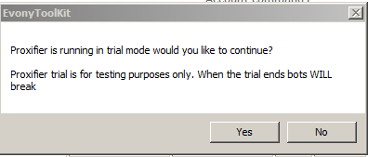

Hit yes if you wish to use Proxifier in demo mode.

Hit no if you wish to enter a key for proxifer so it runs forever and ever and ever

In this example I shall hit “No” if you hit “Yes” just scroll past this part.

After hitting yes you should see a window like below.
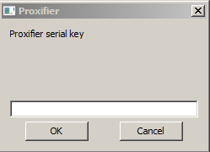

Enter your proxifier key and hit ok.

If you chose to use Proxifier in Trial mode you may have to hit continue on Proxifier for it work. Its been so long since I used it under trial mode that I can’t take a screenshot.

Now a box should of popped up letting you know that Tor is trying to connect as seen below.
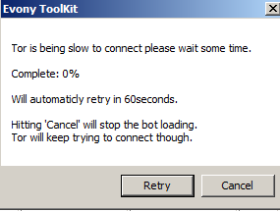
You can leave the window up and as said above it will retry every 60seconds tell tor is connected.

You may also hit “Retry” to see if tor is connected instantly. If you hit “Cancel” it will stop trying to load the bots will continue to connect to Tor.

If you don’t hit “Cancel” after Tor is connect it should load a bot window like below

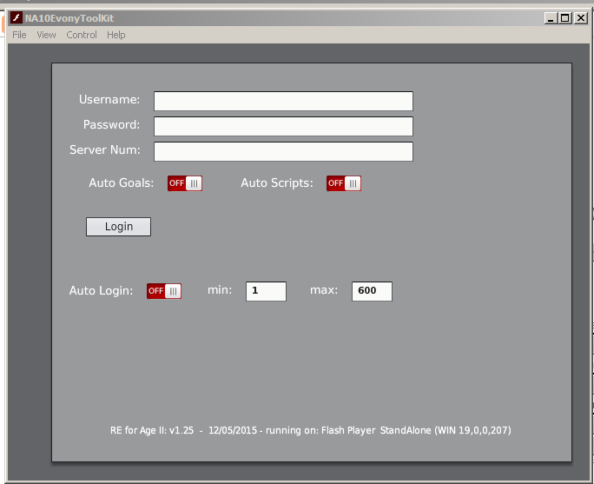

That bot is now using a free proxy provided by Tor (https://www.torproject.org/).

