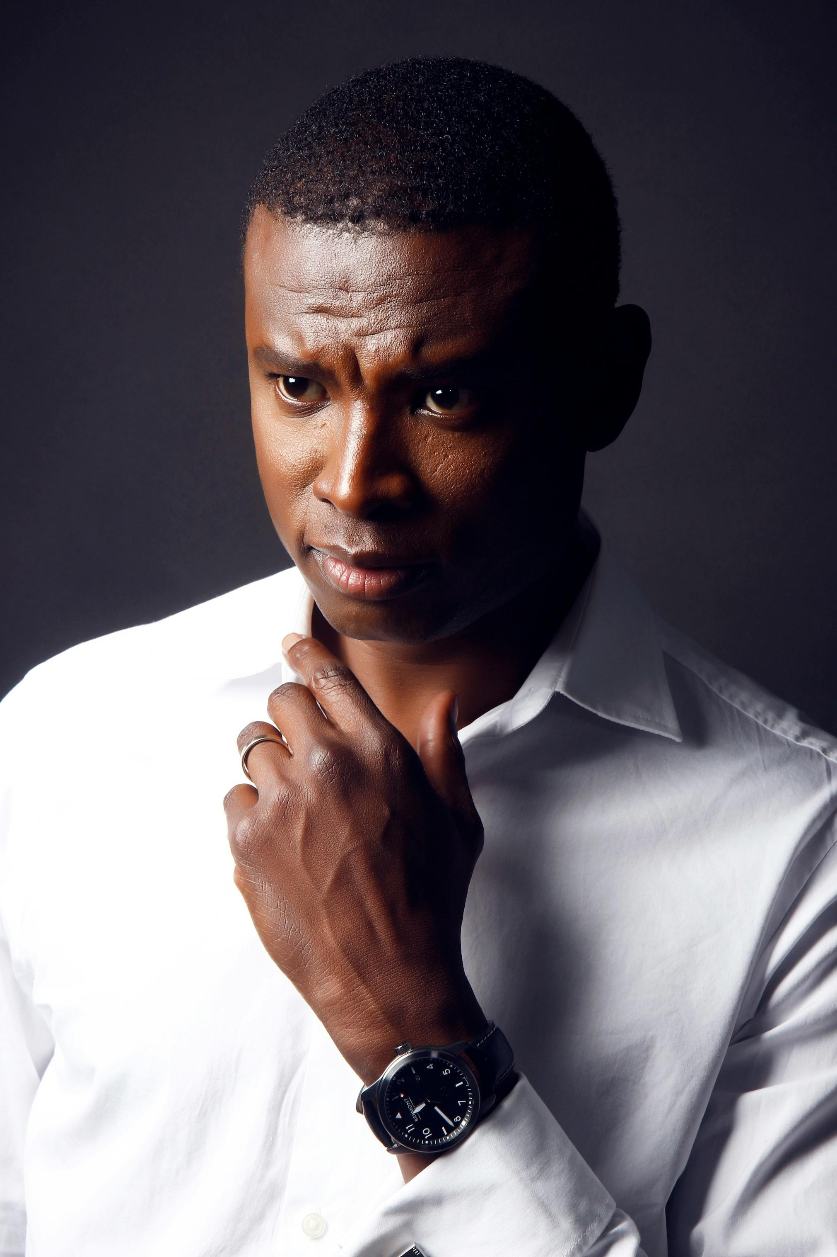

"/Users/davontehoward/Desktop/Learning - Python/.venv/bin/python" "/Users/davontehoward/Desktop/Learning - Python/cv_app.py" | "/Users/davontehoward/Desktop/Learning - Python/.venv/bin/python" "/Users/davontehoward/Desktop/Learning - Python/cv_app.py" | "/Users/davontehoward/Desktop/Learning - Python/.venv/bin/python" "/Users/davontehoward/Desktop/Learning - Python/cv_app.py"

# About Me

"/Users/davontehoward/Desktop/Learning - Python/.venv/bin/python" "/Users/davontehoward/Desktop/Learning - Python/cv_app.py"

# Work Experience

**"/Users/davontehoward/Desktop/Learning - Python/.venv/bin/python" "/Users/davontehoward/Desktop/Learning - Python/cv_app.py"** *"/Users/davontehoward/Desktop/Learning - Python/.venv/bin/python" "/Users/davontehoward/Desktop/Learning - Python/cv_app.py"-"/Users/davontehoward/Desktop/Learning - Python/.venv/bin/python" "/Users/davontehoward/Desktop/Learning - Python/cv_app.py"*"/Users/davontehoward/Desktop/Learning - Python/.venv/bin/python" "/Users/davontehoward/Desktop/Learning - Python/cv_app.py"

# Skills

* "/Users/davontehoward/Desktop/Learning - Python/.venv/bin/python" "/Users/davontehoward/Desktop/Learning - Python/cv_app.py"