**STUDY GUIDE**

**EXAM 8**

**PART 1**

**Population Growth Models, Carrying Capacity, Community Interactions**

**NGSS**

**Presentations in the Locker:**

* Hierarchy
* Population Dynamics
* Communities

**Owl Book Chapters:**

* 19.2 Introduction to Ecology
* 20 Populations
* 21 Community Ecology

Ch 19 – Climate affects biosphere, levels of organization (population, community etc), biotic/abiotic factors, response to changing environment, resources, habitat vs. niche

Ch 20 – Population Density, Dispersion, What changes population size? (Birth rate vs. death rate vs. life expectancy), population growth rate models: exponential growth model, logistical growth model (takes into account limiting factors which creates a carrying capacity)

Ch 21 – Community-Level Ecology: Predator-Prey, parasite-host, mutualism, commensalism, Community Stability, Succession after a disturbance (primary vs. secondary), Pioneer Species, Climax Community

**POPULATIONS AND COMMUNITIES**

1. **Survivorship curves**

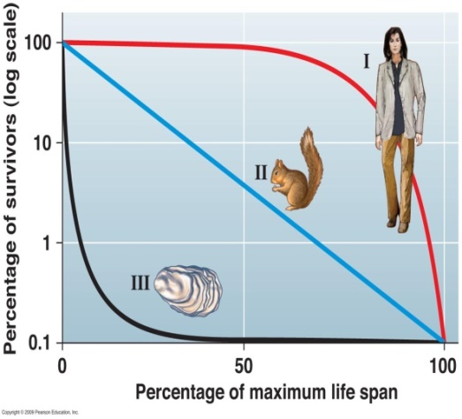

1. **Maximum Reproductive Capacity**
2. **Population Dispersal Patterns**

* **Random**
* **Clumped**
* **Uniform (Evenly Spaced)**

1. **POPULATION GROWTH MODELS:** 
   * **(Be able to describe why the growth rate is changing the way it is)**
   * EXPONENTIAL GROWTH MODEL
   * LOGISTIC GROWTH MODEL

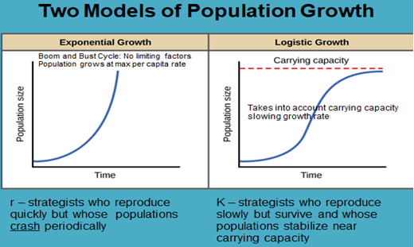

1. **r-strategy vs. K-strategy and which uses which growth model**
   * Insects use r-strategy and have a boom and bust cycle
   * Primates such as monkeys and gorillas use K-strategy and live near carrying capacity
2. Factors affecting carrying capacity (Includes **analysis** of exponential & logistic growth **graphs**)

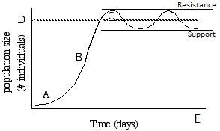

1. Be able to analyze the figure above to identify and describe:
   * Factors that affect the **growth rate** of the population (slope of the graph)
     + Birth Rate
     + Death Rate
     + Per capita growth rate
     + Average growth rate
     + Relative Growth Rates at the lettered locations along the line
2. **Carrying Capacity** and factors that affect population growth:
   * **Limiting Factors resist population growth**
   * **Reduced limiting factors supports population growth**
     + **Characterize limiting factors into two groups:**
       1. **Density Dependent Limiting Factors**
       2. **Density Independent Limiting Factors**
3. **Density Dependent** Limiting Factors
   * Predation/Herbivory (top-down control)
   * Competition
     + Intraspecific is the most intense (same niche) (Population level)
     + Interspecific depends on niche overlap (Ecosystem level)
     + Limited resources
       1. Examples:
       2. Terrestrial Animals: Food, Territory
       3. Terrestrial Plants: Soil Nutrients, Light
       4. Aquatic Organisms: position in a tidepool or on a reef
   * Disease
   * Parasitism
   * Territoriality
4. **Density Independent** Limiting Factors
   * Adverse effects of climate a and weather
   * Humans causing habitat destruction
   * Collisions with human vehicles e.g. cars hitting mountain lions in California
   * Pollution affecting the habitat and increasing the death rate or lowering the birth rate
5. Be able to identify how the **slope of the line** (steepness) relates to the “Birth rate”, “Death rate” and “Population Growth Rate”

**Identify and apply:**

1. The relationship between population size & **genetic diversity**

**Science Practice: Use mathematics appropriately**

**(Note: We are NOT using derivatives. The “d” in the formula should be read as “a change in”; such as “a change in population size” divided by “a change in time”.)**

**Exponential Growth Equation:**



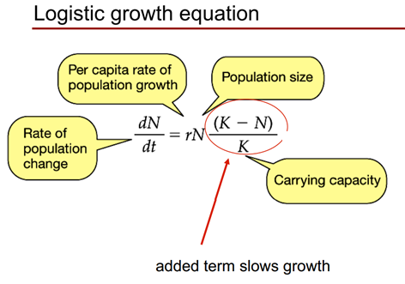

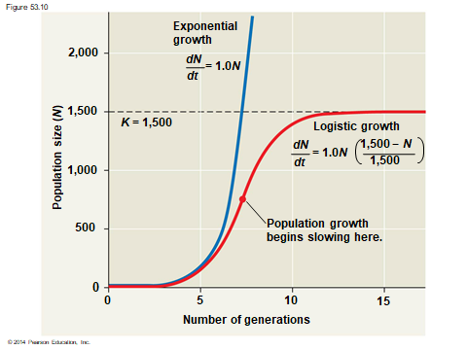

**Community Level Interactions:**

1. **Analyze graphs** showing population size changes when **predator and prey** populations interact.

Predator-Prey Interactions

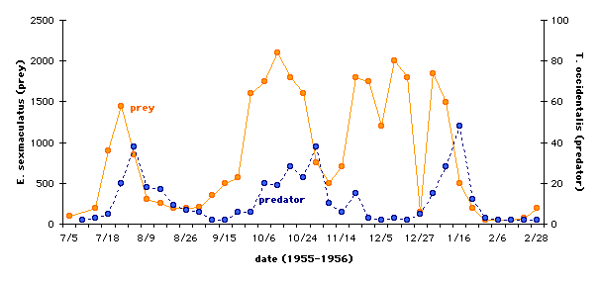

**Types of Community-Level Interactions:**

* Predator-Prey
* Herbivore-Plant
* Parasite-Host

**The interactions may be:**

* Competitive
  + Predator-Predator: Competing for the animal food source
  + Herbivore-Herbivore: Competing for the same plant source
* Cooperative
  + Mutualistic
  + Commensalistic

**Ecosystem-Level Interactions include abiotic factors in addition to the biotic factors.**

1. **Abiotic Factors** (Physical Non-living things):

Be able to apply the concepts from the figure below to novel (never before seen) situations. Use the figure below to analyze how abiotic factors such as **temperature, pH, dissolved salt level (salinity),** or **dissolved oxygen level** affect **population sizes**.

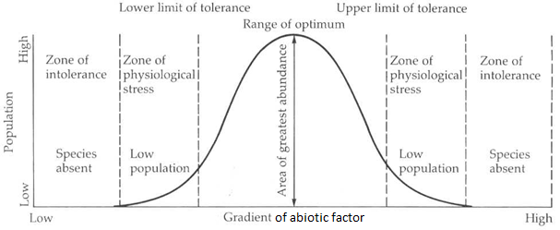

**PART 2**

**POPULATIONS EVOLVE: Natural Selection & Adaptations**

***NGSS***

**Presentations in the Locker:**

* Evolution 1 Natural Selection and Genetic Drift
* Evolution 2 The Peppered Moth

**Owl Book Chapters:**

* 15 Evolution: Evidence and Theory
* 16.1-16.2 The Evolution of Populations (16.3 Speciation is on Exam 9)

**Class Activities:**

* **Beadfish Lab**
* **HHMI Case Studies:**
  + **How the Finch got its Beak**
  + **Allele Frequencies in Rock Pocket Mouse Populations**
  + **Look Who’s Coming for Dinner; Selection by Predation**

1. **Charles Darwin** made two bold **CLAIMS** that are the basis for the **Scientific Theory of Evolution**:

* Claim #1: All life on Earth is related and descended from one or just a few original types.
* Claim #2: Species evolve from existing species that were different from their present day form.
* Be able to describe the meaning of a “Scientific Theory”.

1. Know a little about where Darwin traveled on the H.M.S. Beagle and what he learned on his multi-year journey.

* Darwin DID NOT invent evolution!
* Darwin DID NOT come up with the idea of evolution!
* Darwin is famous because he is the first person to **explain** how evolution works! (natural selection)

1. Describe how Darwin’s observations of **tortoises** and **finches** on the **Galapagos Islands helped him to develop his scientific theory of evolution by means of natural selection.**
2. **Principles of Evolution by Natural Selection**
   1. Genetic & Trait **variation** exists within a **population**
   2. Populations have the ability to produce more individuals than the environment can support
   3. **Overpopulation** leads to competition for limited resources
   4. Competition leads to **selection**. Those individuals born with traits that increase their chances of **survival** and/or increase their **reproductive success** rate pass on their successful genes through reproduction more frequently than those individuals born with traits that are not well adapted to the **environment**.
   5. As a result of **differential survival and reproduction**, individuals with successful traits accumulate in the population and the **population is now better adapted to meet the demands of the current environment**. (both the living and non-living environment)

**Review Meiosis and Genetics because they are the source of variation**

1. **Natural Selection acts on trait (phenotypic) variation**
   * Within species, all individuals are at least slightly different. This is called **variation**.
   * The differences between individuals comes from differences in their DNA
   * The **variation in DNA** stems from completely random processes:
     + Random mutations (the source of all NEW versions of a gene: alleles)
     + Sexual Reproduction:
       - Random **crossing-over** during meiosis (the formation of sperm/egg)
       - Random **independent assortment** during meiosis (the formation of sperm/egg)
       - **Random fertilization** (the Punnett Squares are used to illustrate this)
   * **Evolution** is the **change in genetic variation** in a **population** over time
     + Changes in genetic variation are measured by looking for changes in ALLELE FREQUENCIES of that population’s **gene pool** over time
2. **Natural Selection** acts on **variations** (differences) in traits (**phenotype**) within a population

* Individuals who are better suited to their environment will survive and reproduce more often
* Natural selection is the only mechanism of evolution that helps a population to become better **adapted** to its environment.
* Natural Selection is the only known form of “Adaptive Evolution”, which leads to populations that are better adapted or suited to successful survival and reproduction in their current environment.
* An individual’s survival depends on the variation(s) they have
  + A beneficial variation can arise through the methods discussed above.
  + Beneficial genetic variations will be passed on to the next generation (Heredity)
* The variations **already exist** in the population (resulting from mutations, meiosis, random fertilization)
  + Natural Selection did not create the variation
  + The environment did not create the variation
* Natural Selection works directly on an individual’s traits (phenotype), not genotype
  + The physical ability of the organism is what matters most
  + Recessive genes that cause disease will not be selected against in heterozygous carriers (Dd) because the dominant gene produces enough functional protein that the person is healthy. There is no selective pressure against a healthy person! There is no selective pressure against recessive lethal alleles “hidden” in healthy “carriers”.
  + Lethal recessive alleles only show up in homozygous recessive individuals. (dd)
* If an individual has a baby before a lethal genetic disorder kills, then the gene that causes the genetic disorder is not selected against. You could say, “The gene has escaped natural selection.” Or “There is no selection against that individual.”
* **Heterozygote Advantage:** Sometimes there is a survival advantage for individuals who are heterozygous (Dd) for a particular trait. Examples are people who are heterozygous for cystic fibrosis may have a survival advantage when exposed to the cholera bacteria. (Remember the Case Study we did in class)

**Relate Extinction & Variation**

1. **Genetic variation within a species is necessary** for the long-term survival of the species

* **Environments** (living & non-living) are constantly changing
* Variation gives the opportunity for at least some individuals to be able to survive in the new environmental conditions
* If the environment changes too fast, or if no individuals happen to have traits that are well suited to the new environment, **extinction** occurs.
* (**Extinction** is when all individuals of a species have died and that species is gone forever)
* On a frequency diagram (trait histogram) the wideness relates to the degree of variance:
  + Wide base of the graph = lots of trait variation (beneficial)
  + Narrow base of the graph = less trait variation (species is at risk of extinction if environment changes)

1. Natural Selection alters variation within a population
   * **Stabilizing Selection:** reduces variation by selecting against the extreme traits (on both sides of the x-axis of the graph)
   * **Directional Selection** (selects against one side of the graph)
   * **Divergent Selection** (AKA Disruptive Selection) : Selection against the middle of the graph). Selects against an average trait that is not specialized. Causes the population to have two noticeably different traits. Traits on the left side will be common and traits on the right side will be common, but intermediate (average) traits will be less common.
2. **Construct and/or Interpret Histograms:**

* Continuous data grouped into “bins” that cover a range
* Trait Variation (phenotype) goes on the X-axis
* Number of individuals in the population at that time with that variant goes on the Y-axis
* Read these figures vertically.
* The **trait range** is the width of the bottom of the graph. The larger the trait **range**, the larger the amount of trait **variation** in that population.

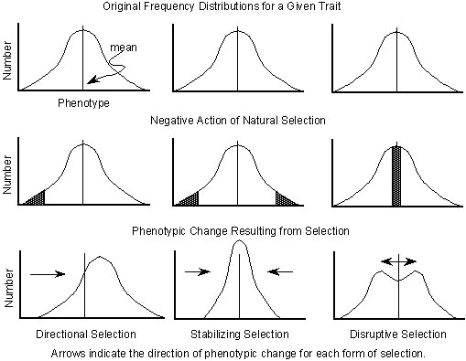

1. Be able to **analyze** a histogram for:
   * Increases in population size
   * Be able to **analyze** a histogram for changes in trait distribution
   * Be able to **analyze** a histogram to identify the range of trait variation
   * Be able to **analyze** a histogram to identify when the trait variation has increased, remained the same, or decreased.
2. Be able to **justify** how an increase or decrease in variation (trait or genetic variation) may affect species chances of survival vs. extinction.

**Vocabulary used on the test:**

**All of the topics and vocabulary on the study guide and the words/phrases below:**

Diversity of species

Mass extinction

Niche

Genetic variation

Trait variation

Lethal allele

Allele frequency

Inherited trait

Genotype

Phenotype

Environment

Genetic Mutation

Gene pool

Scientific theory

Survival of the fittest – common way of explaining Natural Selection

Descent with modification - what Darwin called “evolution”

Microevolution = changes in allele frequencies (small changes in a population vs. becoming a new species)

**Acquired trait** is one you get during your lifetime vs. **inherited trait** you are born with

Dominant allele (D)

Recessive allele (d)

|  |  |  |
| --- | --- | --- |
| **Genotype (Two alleles)** | **Phenotype (Physical Traits)** | **If the allele causes a disorder** |
| DD | Shows the dominant trait | Has a dominant disorder.  Does not have a recessive disorder. |
| Dd | Shows the dominant trait | Has a dominant disorder.  Does not have a recessive disorder, but can pass the gene to offspring.  In some cases, having one copy of the recessive allele provides a survival advantage. (Heterozygote Advantage)  (Remember how individuals who are heterozygous for cystic fibrosis do not get as severe diarrhea when exposed to cholera) |
| Dd | Shows the recessive trait | Does not have a dominant disorder.  Has a recessive disorder. |

**SOCIAL INTERACTIONS AND GROUP BEHAVIOR: (LS2.D)**

* YouTube: Battle at Kruger if you want to watch it again.
* BATTLE AT KRUGER (stimulus)
* Refer to your “Battle at Kruger” graphic organizer and relate group behavior to positive selection to increase chances of survival

**HONORS BIOLOGY EXTENSION:**

1. **HARDY-WEINBERG EQUILIBRIUM**
   1. Know the Hardy-Weinberg Conditions
2. Causes of microevolution that do NOT help the population to become better *adapted* to its environment:
3. **Genetic Drift** (big effect on small populations)
   * Random chance of death by natural disaster like a fire or flood **(bottleneck effect)**
   * Tends to reduce genetic variation
   * Colonization of a new habitat or niche by random individuals **(founder effect)**
4. **Gene Flow –** Migration of individuals (and their alleles) out of or into the population.
   * Tends to increase diversity because the immigrants may add new alleles
5. **HARDY-WEINBERG EQUATIONS**
   1. Know how to use the Hardy-Weinberg Equations to make predictions
   2. You will be provided with the equations on the test

