**Date: 12-02-2021**

**Hashing with Chaining**

**Done By :** Rohit Karunakaran **Roll no:** 58

**Aim:** Implementation of Hash table with chaining as the collition

**Data Structure Used:** Hash table

**Algorithm for Inserting an element (insert)**

**Input:** Element to be inserted, v. The hash table to which the element is inserted HT, and the hash function h(v)

**Output:** The element inserted in the hash table

**Data Structure:** Hash table

**Steps:**

Step 1: Start

Step 2:key = h(v)

Step 3: new = GetNode(Node)

Step 4: new→data = v

Step 5: new →next =NULL

Step 6: if(HT[key]!=NULL) then

Step 4: HT[key] = new

Step 7: else

Step 1: ptr = HT[key]

Step 2: while(ptr→next != NULL) do

Step 1: ptr = ptr→ next

Step 3: EndWhile

Step 4: ptr →next = new

Step 8: endif

Step 9: Stop

**Program Code:**

/***********************************

* Implementiong of Hashing with

* chaining

* Done By: Rohit Karunakaran

* ********************************/

#include<stdio.h>

#include<stdlib.h>

#define SIZE 10

typedef struct hash_node{

int data;

struct hash_node *next;

} node;

void insert(node ***ht, int e){

int pos = e%SIZE;

node **hash_table = *ht;

node *new_node = (node*)malloc(sizeof(node));

if(new_node !=NULL){

new_node->data = e;

new_node->next=NULL;

if(hash_table[pos]==NULL){

hash_table[pos] = new_node;

}

else{

node *ptr = hash_table[pos];

while(ptr->next!=NULL)ptr = ptr->next;

ptr->next=new_node;

}

}

}

void show_the_hash_table(node **ht){

int i;

for(i=0;i<SIZE;i++){

node *ptr = ht[i];

if(ptr!=NULL){

while(ptr->next!=NULL){

printf("%d -> ",ptr->data);

ptr = ptr->next;

}

printf("%d\n",ptr->data);

}

}

}

int main(){

node **hash_table=(node**)calloc(sizeof(node),SIZE);

int RUN=1;

int elem;

int c;

while(RUN){

printf("\nMENU\n");

printf("1.Insert to hash table\n");

printf("2.Display the hash table\n");

printf("3.Exit\n");

printf("Enter yout choice: ");

scanf("%d",&c);

switch(c){

case 1:

printf("Enter the element you want to enter : ");

scanf("%d",&elem);

insert(&hash_table, elem);

break;

case 2:

printf("The hash table is : \n");

show_the_hash_table(hash_table);

break;

case 3:

RUN=0;

break;

}

}

return 0;

}

**Result:**

The program was successfully compiled and the required output was obtained.

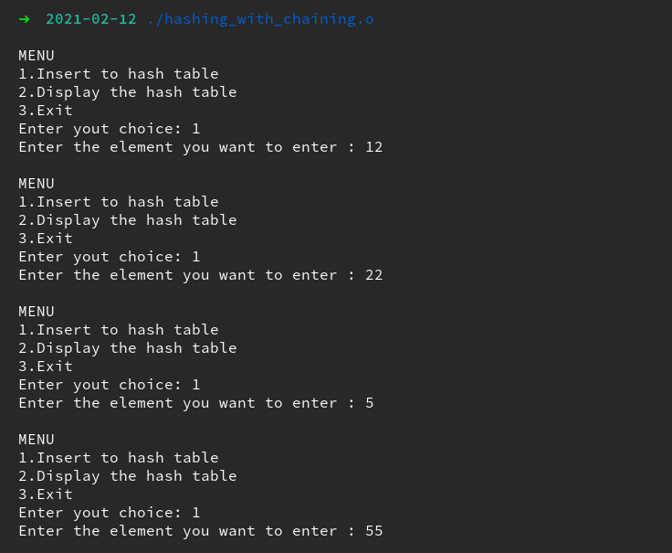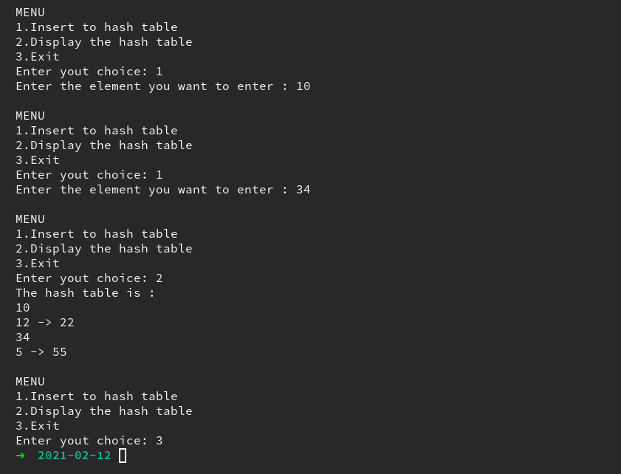**Sample input output:**

**Date: 12-02-2021**

**Hashing with Linear Probing**

**Done By :** Rohit Karunakaran **Roll no:** 58

**Aim:** Implementation of Hash table with linear probing as the collition resolution method

**Data Structure Used:** Hash table

**Algorithm for Inserting an element (insert)**

**Input:** Element to be inserted, v. The hash table to which the element is inserted HT with the hash function h(v)

**Output:** The element inserted in the hash table

**Data Structure:** Hash table

**Steps:**

Step 1: Start

Step 2:key = h(v)

Step 3: new = GetNode(Node)

Step 4: new→value = v

Step 6: if(HT[key]!=NULL) then

Step 4: HT[key] = new

Step 7: else

Step 1: new_key = key+1

Step 2: while(new_key!=key and HT[new_key]!=NULL) do

Step 1: new_key = new_key+1

Step 3: EndWhile

Step 4: if(new_key == key) then

Step 1: Print “Insertion not possible”

Step 2: Exit

Step 5: else

HT[new_key] = new

Step 6: endif

Step 8: endif

Step 9: Stop

**Program Code:**

/*************************************

* Hashing with linear probing as the

* collision resolution method

*

* Done By: Rohit Karunakaran

************************************/

#include<stdio.h>

#include<stdlib.h>

#define SIZE 10

void insert(int ***hash_table, int e,int i){

if(i<=SIZE){

int pos = (e%SIZE+i)%SIZE;

int **ht = *hash_table;

if(ht[pos]==NULL){

int* node = (int*) malloc(sizeof(int));

*node = e;

ht[pos] = node;

}

else{

insert(hash_table,e,i+1);

}

}

else{

printf("INSERTION NOT POSSIBLE!!!!!!\nThe Hash Table is full\n");

return;

}

}

void show_the_hash_table(int **ht){

int i;

for(i=0;i<SIZE;i++){

int *ptr = ht[i];

if(ptr!=NULL){

printf("(%d) - %d\n",i,*ptr);

}

}

}

int main(){

int **hash_table=(int**)calloc(sizeof(int*),SIZE);

int RUN=1;

int elem;

int c;

while(RUN){

printf("\nMENU\n");

printf("1.Insert to hash table\n");

printf("2.Display the hash table\n");

printf("3.Exit\n");

printf("Enter yout choice: ");

scanf("%d",&c);

switch(c){

case 1:

printf("Enter the element you want to enter : ");

scanf("%d",&elem);

insert(&hash_table, elem,0);

break;

case 2:

printf("The hash table is : \n");

show_the_hash_table(hash_table);

break;

case 3:

RUN=0;

break;

}

}

for(int i = 0; i<SIZE;i++){

free(*(hash_table+i));

}

free(hash_table);

return 0;

}

**Result:**

The program is successfully compiled and the required output is obtained

**Sample input output:**

