Experiment 5
Scheduling Algorithms

Done By: Rohit Karunakaran
Roll No: 58
Date Of Submission: 16-06-2021

First Come First Serve Scheduling (FCFS)

#include<stdio.h>
#include<stdlib.h>
#define MAX_PROCESS 2

typedef struct {
int arrival_time;
int burst_time;
int p_num;
int comp;
} proc;

typedef struct{
proc** list ;
int size;
int cap;
} proc_list;

typedef struct {
int p_id;
int tat;
int wt;
} proc_summ;

proc_list *
create_process()
{
proc_list* p_list = (proc_list *) malloc(sizeof(proc_list));
p_list->size = 0;
p_list->cap = MAX_PROCESS;

p_list->list = (proc**)malloc(sizeof(proc)*p_list->cap);

int RUN=1;
int i=0;
int c;

while(RUN)
{
proc *p = (proc*)malloc(sizeof(proc));
printf("Enter the Arrival time of proc P%d : ",i);
scanf("%d",&p->arrival_time);
printf("Enter the Burst time of proc P%d : ",i);
scanf("%d",&p->burst_time);
p->p_num = i;
p->comp = 0;

p_list->list[i] = p;

i++;
p_list->size = i;

printf("Is there anymore Processes? (N for no): ");
getc(stdin);
c = getc(stdin);
if(c == 'n' || c == 'N'){
RUN=0;
break;
}

if(! i < p_list -> cap){
p_list -> cap = p_list->cap*2;
p_list->list= (proc**) realloc(p_list->list, sizeof(proc)*p_list->cap);
}
}

return p_list;
}

void
show_process(proc_list *procs)
{
printf("\n");
printf("=======================================\n");
printf(" Processes \n");
printf("=======================================\n");
printf("Process BT AT\n");
for(unsigned int i=0;i<procs->size; i++){
printf("P%d %d %d\n",
procs->list[i]->p_num,
procs->list[i]->burst_time,
procs->list[i]->arrival_time);
}
printf("=======================================\n");

}

void
sort ( proc** list, int s) {
for(int i=0 ; i<s; i++){
for (int j=0 ;j<=s-i-1 ;j++){
if(list[j]->arrival_time > list[j+1]->arrival_time){
proc *temp = list[j];
list[j] = list[j+1];
list[j+1] = temp;
}
}
}
}

void
show_result(proc_summ * psum, proc_list *procs)
{
if (psum == NULL) return;
int n = procs->size;
printf("\n");
printf("==============================================\n");
printf(" Excecution Summary \n");
printf("==============================================\n");
printf("Process BT AT TAT WT \n");
int wt_sum = 0;
int tat_sum = 0;
for(unsigned int i=0;i<procs->size; i++){
printf("P%d %d %d %d %d \n",
procs->list[i]->p_num,
procs->list[i]->burst_time,
procs->list[i]->arrival_time,
psum[i].tat,
psum[i].wt);
wt_sum += psum[i].wt;
tat_sum += psum[i].tat;

}
printf("==============================================\n");

float average_wt = (float)wt_sum / n;
float average_tat = (float)tat_sum / n;

printf("\nAverage Turnaround time = %.2f\nAverage Waiting time = %.2f\n",average_tat,average_wt);
}

proc_summ *
fcfs(proc_list *procs)
{
if ( procs->size > 0 ){

int n = procs->size;
proc_summ *ps = (proc_summ*) malloc (sizeof (proc_summ)*n);

int time = 0;

//Sort the process using their arrival time.
sort(procs->list, n-1);
//show_process(procs);

time = procs -> list[0]->arrival_time;

for (int i = 0 ; i < n; ){
if (time >= procs->list[i] -> arrival_time){
time = time + procs->list[i]->burst_time;
ps[i].p_id = procs->list[i] -> p_num;
ps[i].tat = time - procs -> list[i] -> arrival_time;
ps[i].wt = ps[i].tat - procs -> list[i] -> burst_time;
i++;
}
else{
time++;
}
}

return ps;
}
return NULL;

}

void
main()
{
proc_list *s = create_process();
show_process(s);
proc_summ *psum = fcfs(s);
show_result(psum, s);
}

Screen Shots:

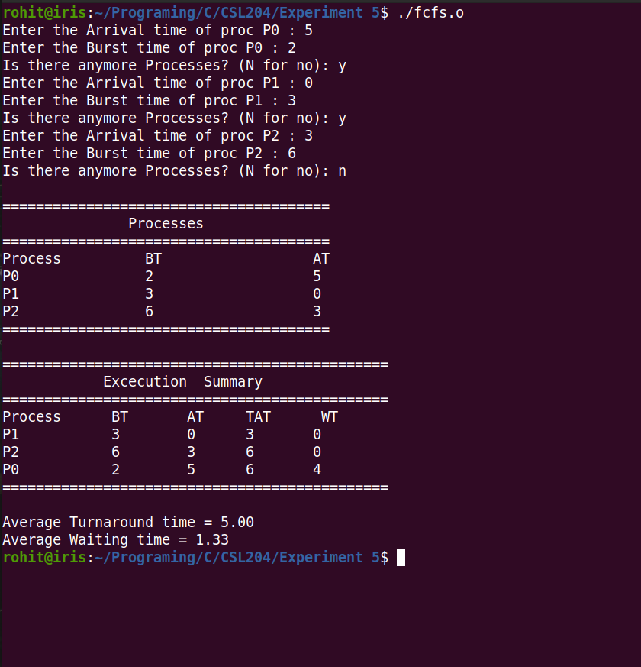
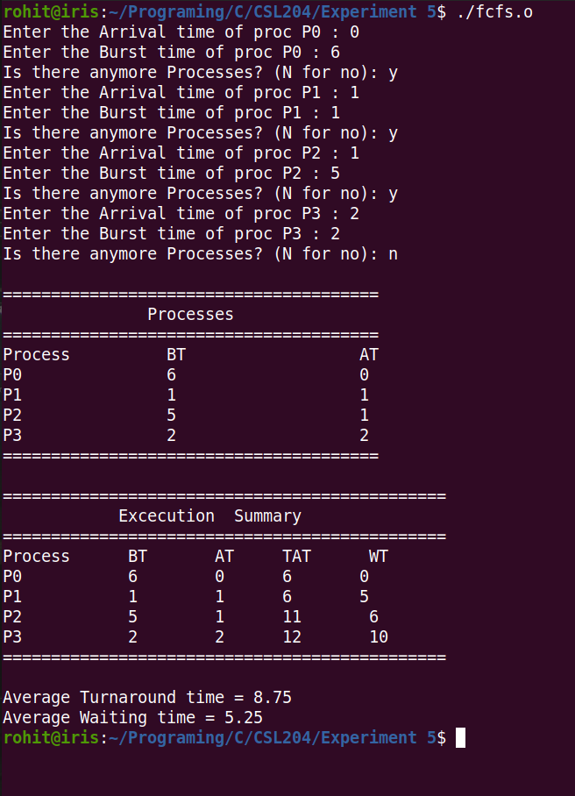
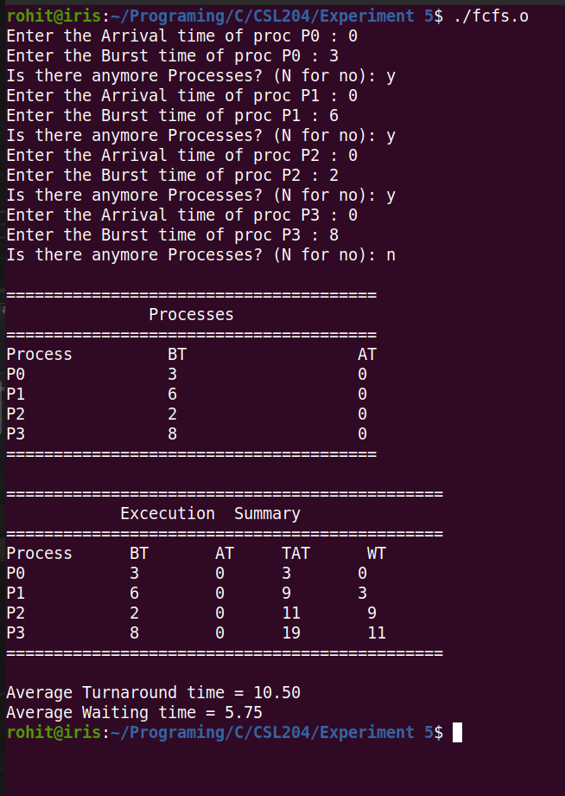

Priority Scheduling

#include<stdio.h>
#include<stdlib.h>
#define MAX_PROCESS 2

typedef struct {
int arrival_time;
int burst_time;
int p_num;
int pr;
int comp;
} proc;

typedef struct{
proc** list ;
int size;
int cap;
} proc_list;

typedef struct {
int p_id;
int tat;
int wt;
} proc_summ;

proc_list *
create_process()
{
proc_list* p_list = (proc_list *) malloc(sizeof(proc_list));
p_list->size = 0;
p_list->cap = MAX_PROCESS;

p_list->list = (proc**)malloc(sizeof(proc)*p_list->cap);

int RUN=1;
int i=0;
int c;

while(RUN)
{
proc *p = (proc*)malloc(sizeof(proc));
printf("Enter the Arrival time of proc P%d : ",i);
scanf("%d",&p->arrival_time);
printf("Enter the Burst time of proc P%d : ",i);
scanf("%d",&p->burst_time);
printf("Enter the Priority of proc P%d : ",i);
scanf("%d",&p->pr);
p->p_num = i;
p->comp = 0;

p_list->list[i] = p;

i++;
p_list->size = i;

printf("Is there anymore Processes? (N for no): ");
getc(stdin);
c = getc(stdin);
if(c == 'n' || c == 'N'){
RUN=0;
break;
}

if(! i < p_list -> cap){
p_list -> cap = p_list->cap*2;
p_list->list= (proc**) realloc(p_list->list, sizeof(proc)*p_list->cap);
}
}

return p_list;
}

void
show_process(proc_list *procs)
{
printf("\n");
printf("========================================\n");
printf(" Processes \n");
printf("========================================\n");
printf("Process BT AT Prioriy\n");
for(unsigned int i=0;i<procs->size; i++){
printf("P%d %d %d %d\n",
procs->list[i]->p_num,
procs->list[i]->burst_time,
procs->list[i]->arrival_time,
procs->list[i]->pr);
}
printf("=======================================\n");

}

void
sort_at ( proc** list, int s)
{
for(int i=0 ; i<s; i++){
for (int j=0 ;j<=s-i-1 ;j++){
if(list[j]->arrival_time > list[j+1]->arrival_time){
proc *temp = list[j];
list[j] = list[j+1];
list[j+1] = temp;
}
}
}
}

int
get_process(proc_list *procs, int time)
{
int n = procs -> size;
proc **list = procs -> list;

int i=0;
int smallest_pos = -1;
while( i<n ){
if(list[i] -> comp == 0 && list[i] -> arrival_time <= time)
smallest_pos = i;
i++;
}

if (smallest_pos == -1 ){
printf("No Process to be excecuted at time %d\n", time);
return -1;
}

for ( i=0; i < n; i++){

if( time >= list[i] -> arrival_time && list[i]->comp != 1){
if (smallest_pos >= 0 && list[i] -> pr < list[smallest_pos] -> pr){
smallest_pos = i;
}
}
}

return smallest_pos;
}

void
show_result(proc_summ * psum, proc_list *procs)
{
int n = procs->size;
printf("\n");
printf("=======================================================\n");
printf(" Processes Summary \n");
printf("=======================================================\n");
printf("Process BT AT Prio. TAT WT \n");
int wt_sum = 0;
int tat_sum = 0;
for(unsigned int i=0;i<procs->size; i++){

int pos = procs->list[i]->p_num;
printf("P%d %d %d %d %d %d \n",
procs->list[i]->p_num,
procs->list[i]->burst_time,
procs->list[i]->arrival_time,
procs->list[i]->pr,
psum[pos].tat,
psum[pos].wt);
wt_sum += psum[pos].wt;
tat_sum += psum[pos].tat;

}
printf("==============================================\n");

float average_wt = (float)wt_sum / n;
float average_tat = (float)tat_sum / n;

printf("\nAverage Turnaround time = %.2f\nAverage Waiting time = %.2f\n",average_tat,average_wt);
}

proc_summ *
priority(proc_list *procs)
{
if ( procs->size > 0 ){

int n = procs->size;
proc_summ *ps = (proc_summ*) malloc (sizeof (proc_summ)*n);

int time = 0;

//Sort the process using their arrival time.
sort_at(procs->list, n-1);
//show_process(procs);

//time = procs -> list[get_process(procs,time)] -> arrival_time;

for (int i = 0 ; i < n; ){
int p_index = get_process(procs, time);
if( p_index != -1 ){
printf("Exccuting process..... %d\n",procs->list[p_index] -> p_num);

int pos = procs->list[p_index]-> p_num;

time += procs->list[p_index]->burst_time;

ps[pos].p_id = pos;
ps[pos].tat = time - procs -> list[p_index] -> arrival_time;
ps[pos].wt = ps[pos].tat - procs -> list[p_index] -> burst_time;

procs -> list[p_index] -> comp = 1;
i++;
}
else{
time++;
if(time>1024){
printf("Time Limit Exceeded\n");
return NULL;
}
}

}

return ps;
}
return NULL;

}

void
main()
{
proc_list *s = create_process();
show_process(s);
proc_summ *psum = priority(s);
show_result(psum, s);
}

Screenshots:

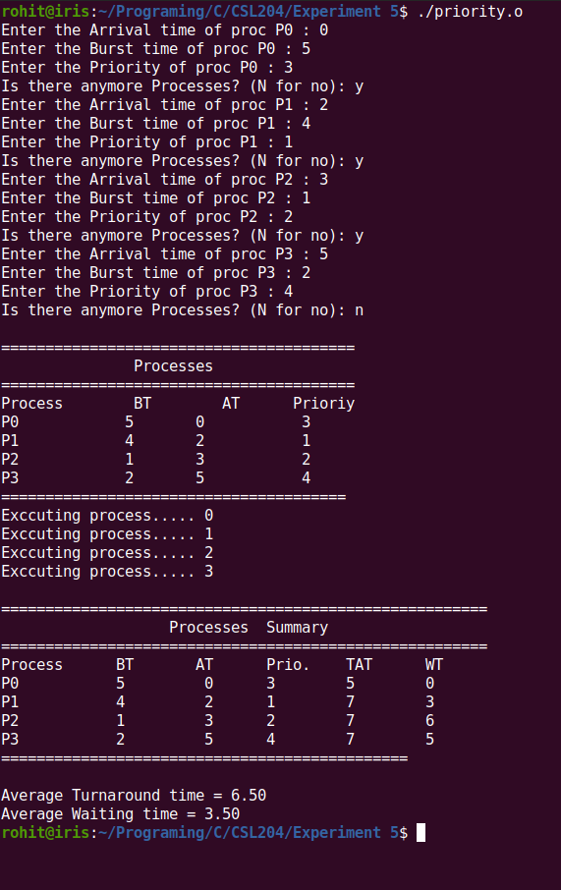
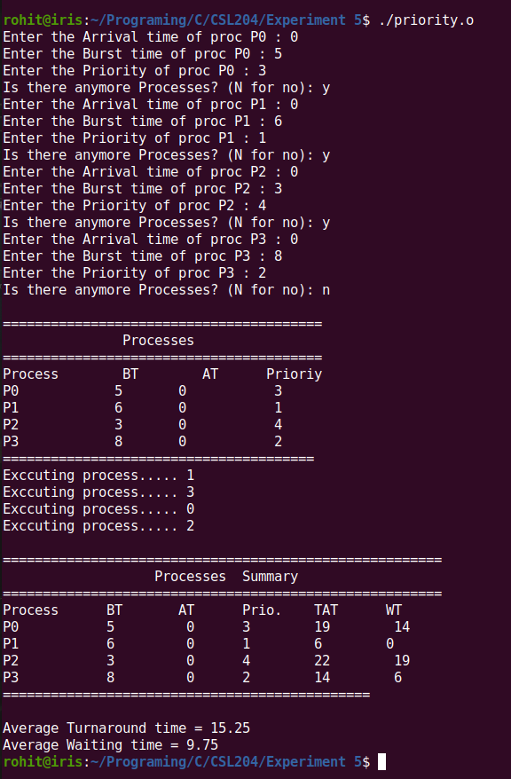
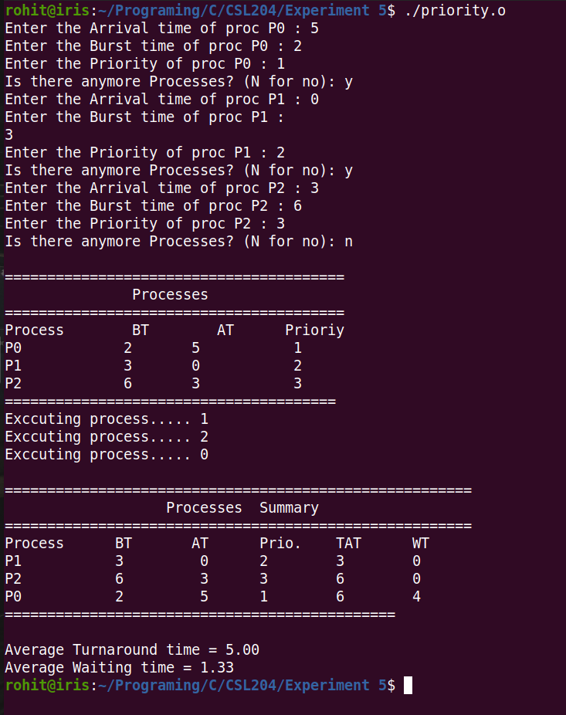

Shortest Job First Scheduling (SJFS)

#include<stdio.h>
#include<stdlib.h>
#define MAX_PROCESS 2

typedef struct {
int arrival_time;
int burst_time;
int p_num;
int comp;
} proc;

typedef struct{
proc** list ;
int size;
int cap;
} proc_list;

typedef struct {
int p_id;
int tat;
int wt;
} proc_summ;

proc_list *
create_process()
{
proc_list* p_list = (proc_list *) malloc(sizeof(proc_list));
p_list->size = 0;
p_list->cap = MAX_PROCESS;

p_list->list = (proc**)malloc(sizeof(proc)*p_list->cap);

int RUN=1;
int i=0;
int c;

while(RUN)
{
proc *p = (proc*)malloc(sizeof(proc));
printf("Enter the Arrival time of proc P%d : ",i);
scanf("%d",&p->arrival_time);
printf("Enter the Burst time of proc P%d : ",i);
scanf("%d",&p->burst_time);
p->p_num = i;
p->comp = 0;

p_list->list[i] = p;

i++;
p_list->size = i;

printf("Is there anymore Processes? (N for no): ");
getc(stdin);
c = getc(stdin);
if(c == 'n' || c == 'N'){
RUN=0;
break;
}

if(! i < p_list -> cap){
p_list -> cap = p_list->cap*2;
p_list->list= (proc**) realloc(p_list->list, sizeof(proc)*p_list->cap);
}
}

return p_list;
}

void
show_process(proc_list *procs)
{
printf("\n");
printf("=======================================\n");
printf(" Processes \n");
printf("=======================================\n");
printf("Process BT AT\n");
for(unsigned int i=0;i<procs->size; i++){
printf("P%d %d %d\n",
procs->list[i]->p_num,
procs->list[i]->burst_time,
procs->list[i]->arrival_time);
}
printf("=======================================\n");

}

void
sort_at ( proc** list, int s)
{
for(int i=0 ; i<s; i++){
for (int j=0 ;j<=s-i-1 ;j++){
if(list[j]->arrival_time > list[j+1]->arrival_time){
proc *temp = list[j];
list[j] = list[j+1];
list[j+1] = temp;
}
}
}
}

int
get_process(proc_list *procs, int time)
{
int n = procs -> size;
proc **list = procs -> list;

int i=0;
int smallest_pos = -1;
while( i<n ){
if(list[i] -> comp == 0 && list[i] -> arrival_time <= time)
smallest_pos = i;
i++;
}

if (smallest_pos == -1 ){
printf("No Process to be excecuted at time %d\n", time);
return -1;
}

for ( i=0; i < n; i++){

if( time >= list[i] -> arrival_time && list[i]->comp != 1){
if (smallest_pos >= 0 && list[i] -> burst_time < list[smallest_pos] -> burst_time){
smallest_pos = i;
}
}
}

return smallest_pos;
}

void
show_result(proc_summ * psum, proc_list *procs)
{
int n = procs->size;
printf("\n");
printf("==============================================\n");
printf(" Processes Summary \n");
printf("==============================================\n");
printf("Process BT AT TAT WT \n");
int wt_sum = 0;
int tat_sum = 0;
for(unsigned int i=0;i<procs->size; i++){

int pos = procs->list[i]->p_num;
printf("P%d %d %d %d %d \n",
procs->list[i]->p_num,
procs->list[i]->burst_time,
procs->list[i]->arrival_time,
psum[pos].tat,
psum[pos].wt);
wt_sum += psum[pos].wt;
tat_sum += psum[pos].tat;

}
printf("==============================================\n");

float average_wt = (float)wt_sum / n;
float average_tat = (float)tat_sum / n;

printf("\nAverage Turnaround time = %.2f\nAverage Waiting time = %.2f\n",average_tat,average_wt);
}

proc_summ *
sjfs(proc_list *procs)
{
if ( procs->size > 0 ){

int n = procs->size;
proc_summ *ps = (proc_summ*) malloc (sizeof (proc_summ)*n);

int time = 0;

//Sort the process using their arrival time.
sort_at(procs->list, n-1);
//show_process(procs);

//time = procs -> list[get_process(procs,time)] -> arrival_time;

for (int i = 0 ; i < n; ){
int p_index = get_process(procs, time);
if( p_index != -1 ){
int pos = procs->list[p_index]-> p_num;
printf("Exccuting process..... P%d\n",pos);

time += procs->list[p_index]->burst_time;

ps[pos].p_id = pos;
ps[pos].tat = time - procs -> list[p_index] -> arrival_time;
ps[pos].wt = ps[pos].tat - procs -> list[p_index] -> burst_time;

procs -> list[p_index] -> comp = 1;
i++;
}
else{
time++;
if(time>1024){
printf("Time Limit Exceeded\n");
return NULL;
}
}

}

return ps;
}
return NULL;

}

void
main()
{
proc_list *s = create_process();
show_process(s);
proc_summ *psum = sjfs(s);
show_result(psum, s);
}

Screenshots

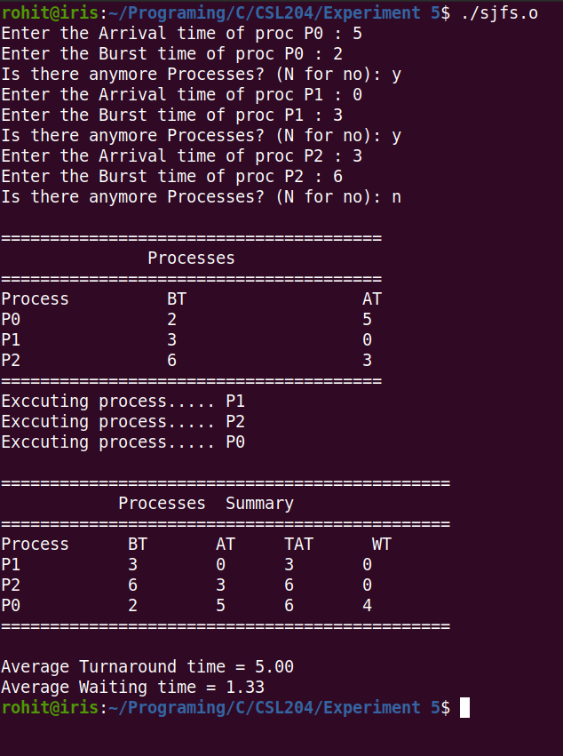
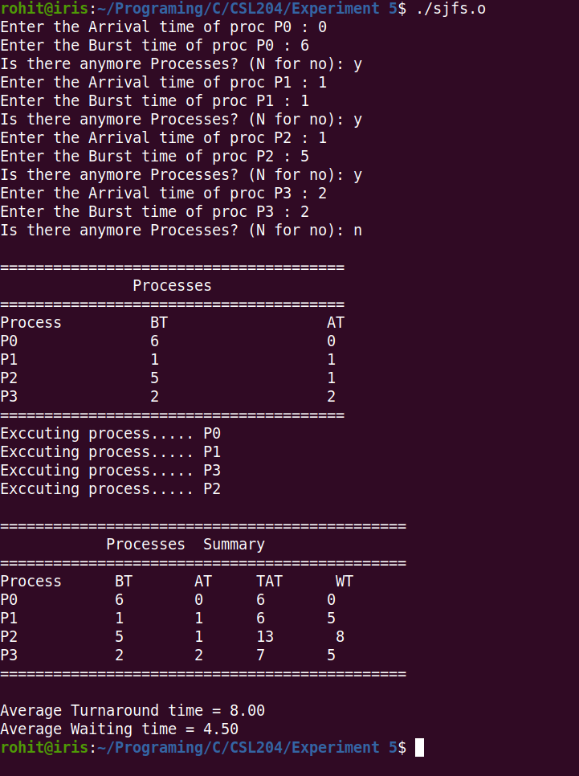
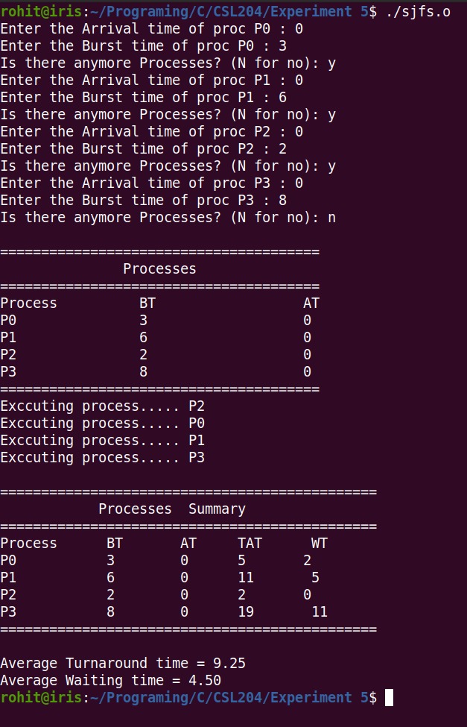

Round Robin Scheduling

#include<stdio.h>
#include<stdlib.h>
#define MAX_PROCESS 10

typedef struct {
int arrival_time;
int burst_time;
int rem_time;
int p_num;
int comp;
} proc;

typedef struct{
proc** list ;
int size;
int cap;
} proc_list;

typedef struct {
int p_id;
int tat;
int wt;
} proc_summ;

proc_list *
create_process()
{
proc_list* p_list = (proc_list *) malloc(sizeof(proc_list));
p_list->size = 0;
p_list->cap = MAX_PROCESS;

p_list->list = (proc**)malloc(sizeof(proc)*p_list->cap);

int RUN=1;
int i=0;
int c;

while(RUN)
{
proc *p = (proc*)malloc(sizeof(proc));
printf("Enter the Arrival time of process P%d : ",i);
scanf("%d",&p->arrival_time);
printf("Enter the Burst time of proc P%d : ",i);
scanf("%d",&p->burst_time);
p->rem_time = p->burst_time;
p->p_num = i;
p->comp = 0;

p_list->list[i] = p;

i++;
p_list->size = i;

printf("Is there anymore Processes? (N for no): ");
getc(stdin);
c = getc(stdin);
if(c == 'n' || c == 'N'){
RUN=0;
break;
}

if(! i < p_list -> cap){
p_list -> cap = p_list->cap*2;
p_list->list= (proc**) realloc(p_list->list, sizeof(proc)*p_list->cap);
}
}

return p_list;
}

void
show_process(proc_list *procs)
{
printf("\n");
printf("=======================================\n");
printf(" Processes \n");
printf("=======================================\n");
printf("Process BT AT\n");
for(unsigned int i=0;i<procs->size; i++){
printf("P%d %d %d\n",
procs->list[i]->p_num,
procs->list[i]->burst_time,
procs->list[i]->arrival_time);
}
printf("=======================================\n");

}

void
sort_at ( proc** list, int s)
{
for(int i=0 ; i<s; i++){
for (int j=0 ;j<=s-i-1 ;j++){
if(list[j]->arrival_time > list[j+1]->arrival_time){
proc *temp = list[j];
list[j] = list[j+1];
list[j+1] = temp;
}
}
}
}

void
show_result(proc_summ * psum, proc_list *procs)
{
if (psum == NULL){
printf("Process summary cant be null ERROR!!!!!\n");
return;
}

int n = procs->size;
printf("\n");
printf("==============================================\n");
printf(" Processes Summary \n");
printf("==============================================\n");
printf("Process BT AT TAT WT \n");
int wt_sum = 0;
int tat_sum = 0;
for(unsigned int i=0;i<procs->size; i++){

int pos = procs->list[i]->p_num;
printf("P%d %d %d %d %d \n",
procs->list[i]->p_num,
procs->list[i]->burst_time,
procs->list[i]->arrival_time,
psum[pos].tat,
psum[pos].wt);
wt_sum += psum[pos].wt;
tat_sum += psum[pos].tat;

}
printf("==============================================\n");

float average_wt = (float)wt_sum / n;
float average_tat = (float)tat_sum / n;

printf("\nAverage Turnaround time = %.2f\nAverage Waiting time = %.2f\n",average_tat,average_wt);
}

proc_summ *
round_robin(proc_list *procs, int time_q)
{
if ( procs->size > 0 ){

int n = procs->size;
int time = 0; // Time in ms
int proc_comp = 0; // Number of process completed

// Stores the summary of all the process.
proc_summ *ps = (proc_summ*) malloc (sizeof (proc_summ)*n);

//Sort the process using their arrival time.
sort_at(procs->list, n-1);

while ( proc_comp < n ) {
//Execute this loop until all the process is completed

int idle = 1;
//Update the ready queue, ie, add any process that is not completed.
for( int i =0 ; i< n; i++){
proc *p = procs -> list[i];
if ( p -> comp != 1 && time >= p-> arrival_time ){
// add the process to the ready queue
if (idle) idle = 0;
int ex_time = p->rem_time > time_q? time_q : p->rem_time ;
int index = p->p_num;
printf("Executing Process ... P%d for %dms\n", index, ex_time);

time += ex_time;
p->rem_time -= ex_time;
if (p -> rem_time == 0){
p->comp = 1;
ps[ index ] . tat = time - p -> arrival_time;
ps[ index ] . wt = ps[ index ] . tat - p-> burst_time;
proc_comp += 1;
}
}
}
if (idle){
time++;
}

if(time > 1024){
printf("Time Limit exceeded");
return NULL;
}
// Execute the process in the ready queue
}
return ps;
}
return NULL;

}

void
main()
{
proc_list *s = create_process();
printf("Enter the time Quantum for round robin: ");
int tq;
scanf("%d", &tq);
show_process(s);
proc_summ *psum = round_robin(s,tq);
show_result(psum, s);
}

Screenshots:
