Experiment 7

Memory Allocation Methods

Done By: Rohit Karunakaran
Roll No: 58
Date Of Submission: 18-08-2021

Program Code:
// Memory allocation methods
// Done By: Rohit Karunakaran
#include<stdio.h>
#include<stdlib.h>
#include<limits.h>

int* getList(int numElem, char fmtStr[]){
/*Function for reciving numElem integers and returning the array*/
/*fmtStr: the format string to be displayed while reciving the characters*/
int *list = (int*) malloc(sizeof(int)*numElem);
for (int i=0;i<numElem; i++){
printf(fmtStr,i);
scanf("%d",list + i);
}
return list;
}

void printMemParts(int* list, int numElem){
/* Displays the memory blocks like this:
* |---------|--------|
* | Block 1 | Block2 |
* |---------|--------|
* */
char top[] = "|----------";
char end[] = "|----------|";

for(int i=0;i<numElem; i++){
if(i< numElem-1){
printf("%s",top);
}else{
printf("%s",end);
}
}
printf("\n|");

for (int i=0; i<numElem; i++){
printf("%8dKB|",list[i]);
}
printf("\n");

for(int i=0;i<numElem-1; i++){
printf("%s",top);
}
printf("%s",end);
printf("\n");
}

void show_alloc(int* memList, int mnum, int* procList, int pnum, int*alloc_list){
/* Displays the processes allocated within each memory block
* |----------|---------|
* | Block1| Block 2|
* |----------|---------|
* | P1(45KB)| P0(30KB)|
* |----------|---------|
* */
char start[] = "|--------------";
char end[] = "|--------------|";
char str[30]; // This contains the string Pn(xKB) where n is the process number and x is the size of the process
int not_fit[pnum];
int k=0;
int total=0;
int used=0;

// Print initial |----- and |-----|
for(int i=0;i<mnum-1; i++){
printf("%s",start);
}
printf("%s",end);
printf("\n");

// Print The memory block values
printf("|");
for (int i=0;i<mnum; i++){
sprintf(str,"%dKB",memList[i]); // Integer to string converstion
printf("%14s|",str);
}
printf("\n");

// Next set of dashes
for(int i=0;i<mnum-1; i++){
printf("%s",start);
}
printf("%s",end);
printf("\n|");

// Print the Process and the size allocated
for (int i=0; i<mnum; i++){
if(alloc_list[i] != -1){
sprintf(str,"%s%d(%dKB)","P",alloc_list[i],procList[alloc_list[i]]); // Get the formatted string in str
printf("%14s|",str);
used += procList[alloc_list[i]];
}
else{
printf("%14s|","NULL");
}
total += memList[i];
}
printf("\n");

// Final set of dashes
for(int i=0;i<mnum-1; i++){
printf("%s",start);
}
printf("%s",end);
printf("\n");

// Find process that didn't fit
for (int i=0; i<pnum; i++){
int j = 0;
for (;j<mnum;j++){
if(alloc_list[j] == i){
break;
}
}
if (j==mnum){
not_fit[k] = i;
k++;
}
}
printf("\nProcess not allocated: ");
for(int i=0;i<k-1;i++){
printf("P%d(%dKB), ",not_fit[i],procList[not_fit[i]]);
}
if (k!=0)
printf("P%d(%dKB)\n",not_fit[k-1],procList[not_fit[k-1]]); // Print the last unallocated process as it doesnt require “,”
else
printf("NIL\n"); // k==0 then all the process fit

// Some stats (Optional)
printf("\n---- Algorithm Stats -----");
printf("\nTotal memory space: %dKB\n",total);
printf("Memory space used: %dKB\n",used);
printf("Memory space free: %dKB\n",total-used);
float precent_free = (float)(total-used) / total * 100.0;
printf("Precentage free: %.2f%%\n",precent_free);

}

int* first_fit(int* procList, int pnum, int* memList, int mnum){
int i,j;
int* alloc_list = (int*)malloc(sizeof(int)*mnum); // will contain the i-1th process in the j-1th location // -1 if there is no process
// alloc_list provieds 1-1 mapping with the memList
// initialise alloc_list to -1 i.e. they are unallocated
for (i=0;i<mnum;i++){
alloc_list[i] = -1;
}

for (i = 0; i< pnum ; i++){
//Find a place that fits for the i th process
for (j =0; j< mnum ; j++){
if (alloc_list[j] == -1 && memList[j] >= procList[i]){ // Process fits if the seat is big enough and not taked
alloc_list[j] = i;
break;
}
}
}
return alloc_list;
}

int* best_fit(int* procList,int pnum, int*memList, int mnum){
int i,j;
int* alloc_list = (int*)malloc(sizeof(int)*mnum);
for (i=0;i<mnum;i++){
alloc_list[i] = -1;
}

int space;
int pos;
for(i=0;i<pnum;i++){
space =INT_MAX;
pos = -1;
for(j=0;j<mnum; j++){
int diff = memList[j] - procList[i]; // The space remaining in the memory block if the process is allocated
if(diff>=0 && diff < space && alloc_list[j]==-1){ //The block is elible for allocation if diff greater than 0 and less than previously calculated diff and the block is not allocated
space = diff;
pos = j;
}
}
if (pos != -1){ // if pos is -1 then there is no eligible block
alloc_list[pos] = i;
}
}
return alloc_list;
}

int* worst_fit(int* procList,int pnum, int*memList, int mnum){
int i,j;
int* alloc_list = (int*)malloc(sizeof(int)*mnum);
for (i=0;i<mnum;i++){
alloc_list[i] = -1;
}

int greatest;
int pos;
for(i=0;i<pnum;i++){
greatest = -1;
pos = -1;
for (j=0;j<mnum ; j++){
if (memList[j]>=procList[i] && greatest < memList[j] && alloc_list[j] == -1){ // find the greatest unallocated space and return it
greatest = memList[j];
pos = j;
}
}

/* No need to calculate diff in worst fit
for(j=0;j<mnum; j++){
int diff = memList[j] - procList[i];
if(diff>=0 && diff > greatest && alloc_list[j]==-1){
greatest = diff;
pos = j;
}
}*/

if (pos != -1){
alloc_list[pos] = i;
}
}
return alloc_list;
}

int main(){
int n,p;
printf("Enter the number of Memory Partions: ");
scanf("%d",&n);
int *mem_blocks = getList(n,"Enter size of Memory Partition M%d (in KB): ");
printf("Enter the number of Processes: ");
scanf("%d",&p);
int *proc_list = getList(p,"Enter the memory required by process P%d: ");
int *alloc_list;

printf("\n\nThe Memory Locations recived are:\n");
printMemParts(mem_blocks, n);

printf("\n\n====================== FIRST FIT ======================\n");
alloc_list = first_fit(proc_list,p,mem_blocks,n);
show_alloc(mem_blocks, n, proc_list, p, alloc_list);
free(alloc_list);

printf("\n\n====================== BEST FIT ======================\n");
alloc_list = best_fit(proc_list,p,mem_blocks,n);
show_alloc(mem_blocks, n, proc_list, p, alloc_list);
free(alloc_list);

printf("\n\n====================== WORST FIT ======================\n");
alloc_list = worst_fit(proc_list,p,mem_blocks,n);
show_alloc(mem_blocks, n, proc_list, p, alloc_list);
free(alloc_list);

free(mem_blocks);
free(proc_list);
return 0;
}

Screenshots:

Sample Input 1
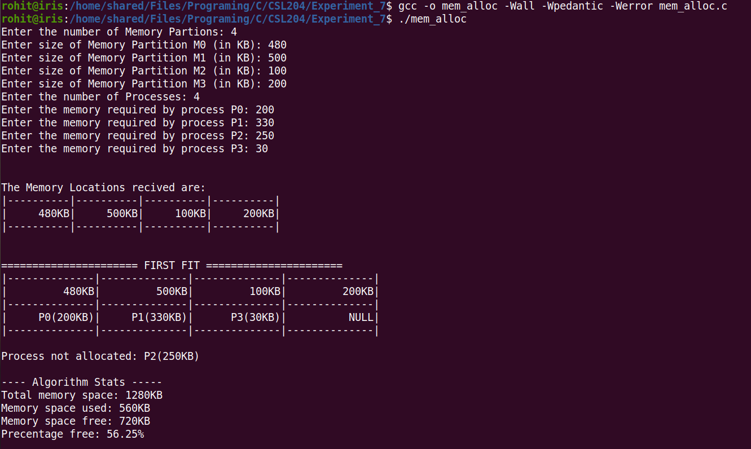
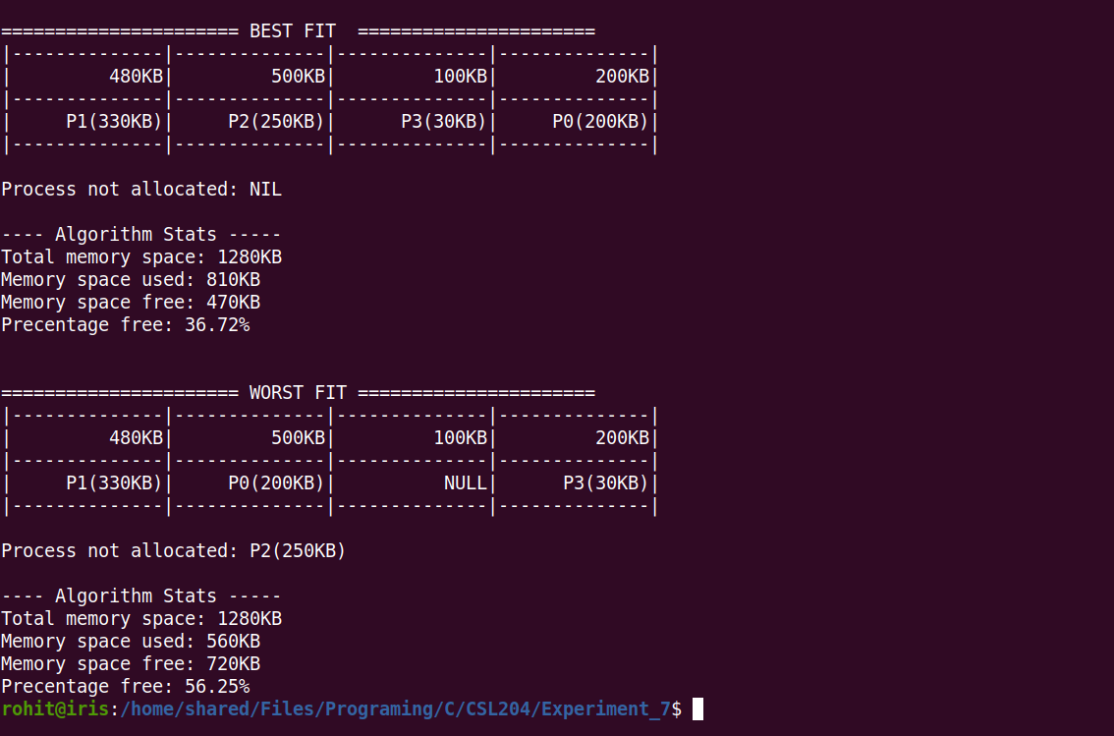

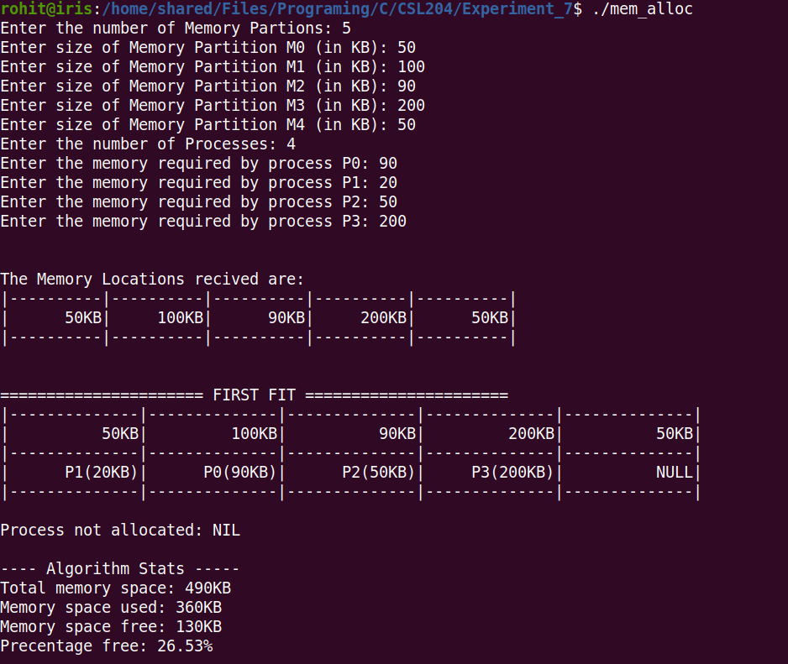
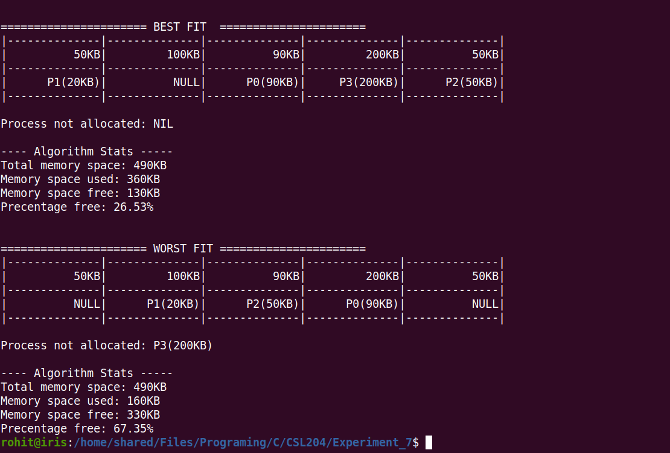
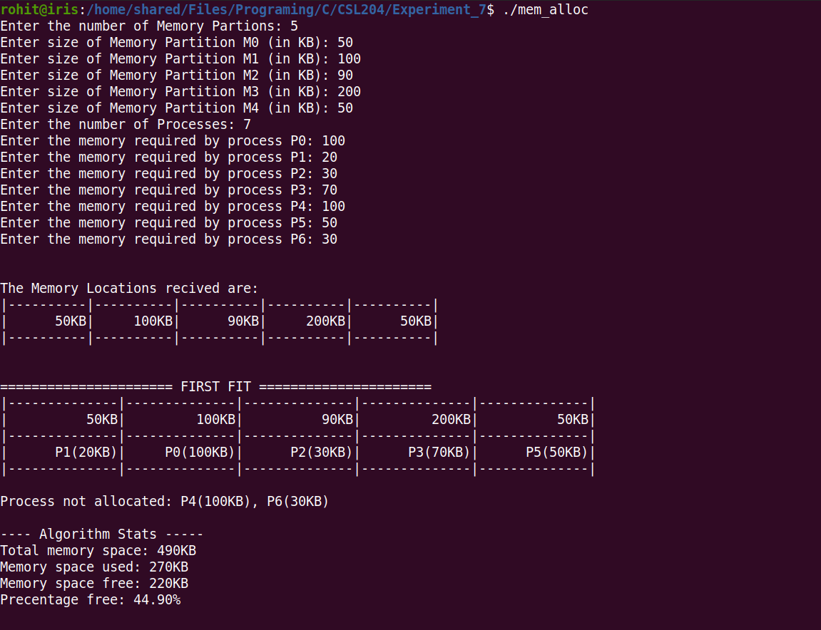
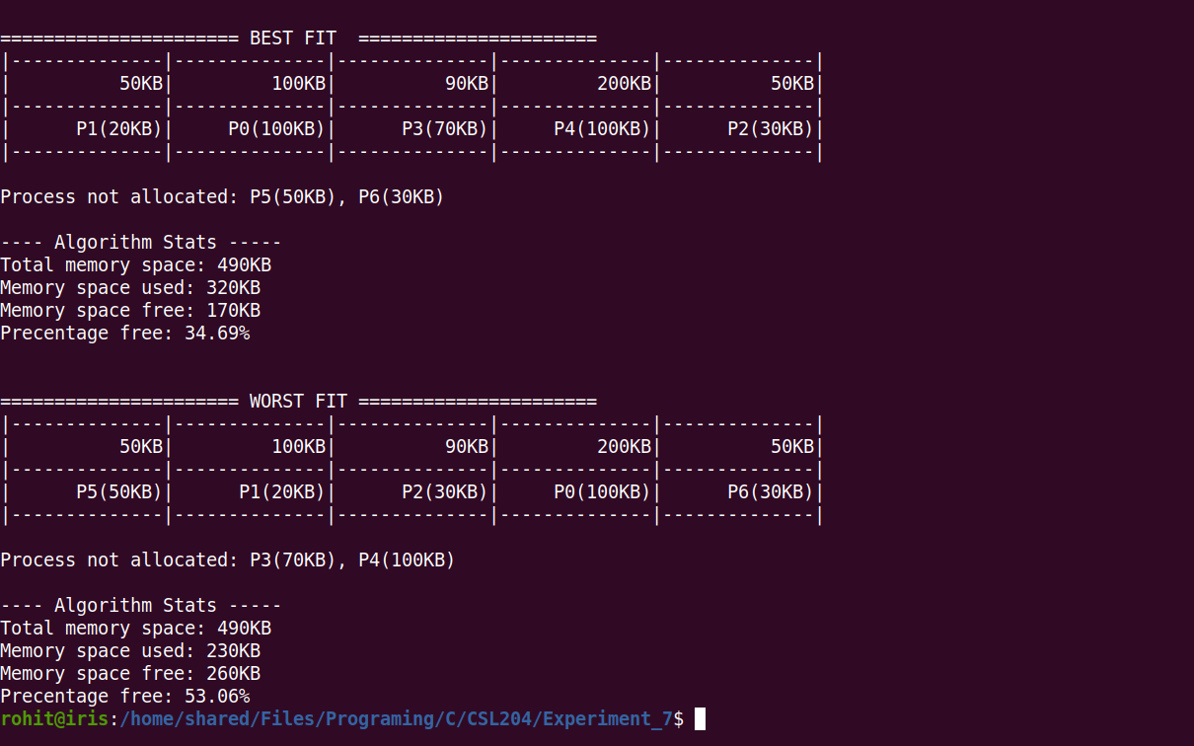
Sample input 2 Sample Input 3

