Experiment 8

System Calls

Done By: Rohit Karunakaran
Roll No: 58
Date Of Submission: 15-09-2021

1. Program to accept the limiting value ‘n’as input and generate the Fibonacci sequence of n numbers using the child process while the parent process generate the first n prime numbers

Program Code:
#include<stdio.h>
#include<stdlib.h>
#include<unistd.h>
#include<sys/wait.h>

int* fibonacci(int n){
if(n<0) return NULL;
int* fib = (int *)malloc (sizeof(int)*n);
fib[0] = 0;
if(n>0){
fib[1] = 1;
int f3;
for(int i = 2; i<n; i++){
f3 = fib[i-1]+fib[i-2];
fib[i] = f3;
}
}
return fib;
}

int* n_primes(int n){
if(n<0) return NULL;
int* prime = (int *) malloc(sizeof(int)*n);
prime[0] = 2;
int i = 3;
int k = 1;
while(k<n){
int j;
for( j = 2; j<=i/2; j++){
if(i%j == 0) break;
}
if(!(j<=i/2))
prime[k++] = i;
i++;
}
return prime;
}

void print_arr(int* arr,int n){
printf("Process %d of parent %d : ", (int)getpid(), (int)getppid());
for(int i=0;i<n;i++){
if(i==n-1)
printf("%d ",arr[i]);
else
printf("%d, ",arr[i]);
}
printf("\n");

}

int main(){
int n;
pid_t parentid = getpid();
printf("%d is the main process id\n", getpid());
printf("Enter the value of n: ");
scanf("%d",&n);
int cpid = (int)fork();
if(cpid == 0 ){
int* fib_arr = fibonacci(n);
printf("First %d Fibonacci : ",n);
print_arr(fib_arr, n);
exit(0);
}
int* primes = n_primes(n);
printf("First %d Primes : ",n);
print_arr(primes,n);
wait(NULL);
return 0;

}

Screenshots:
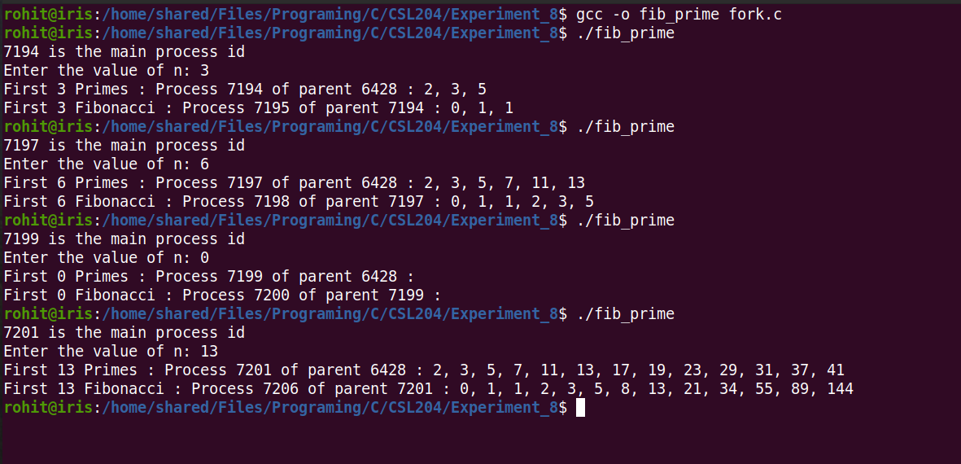

2. Generate an N level hierarchy of processes and also display the parent id of
process.

Program Code:
#include<stdlib.h>
#include<unistd.h>
#include<stdio.h>
#include<wait.h>

int main(){
int n ;
int i = 0;
int p = 0;
int ch = 0;
printf("Enter the number of process to be created: ");
scanf("%d", &n);

for(i =0; i<n ; i++){
p++;
if(ch == 0){
printf("Line %d: Process id: %d, Parent id: %d \n",p,getpid(),getppid());
ch = fork();
}else{
break;
}
}
wait(NULL);
return 0;
}

Screenshots:
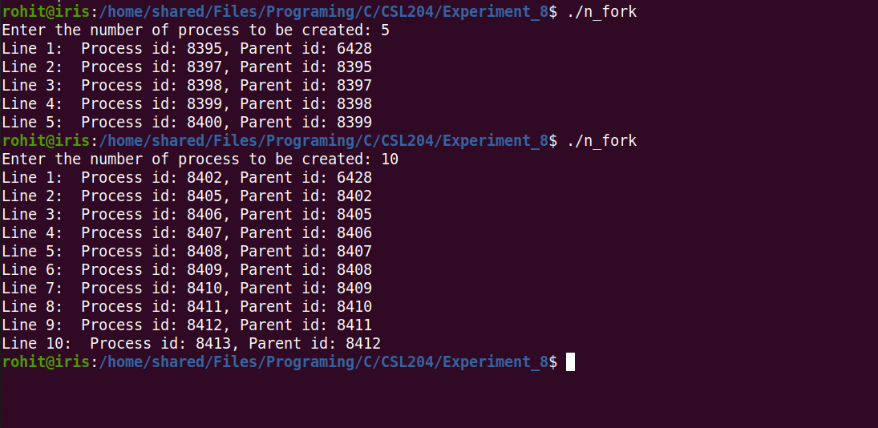
3.

Program Code:
#include<stdio.h>
#include<unistd.h>
#include<stdlib.h>

int main(){
printf("In process A, pid: %d\n",getpid());
int b_id = fork();
if(b_id == 0){ // create B
printf("In process B pid: %d, Parent pid: %d\n",getpid(),getppid());
int d_id = fork();
if(d_id == 0){
printf("In process D, pid: %d, Parent pid: %d\n",getpid(),getppid());
int h_id = fork();
if(h_id == 0){
printf("In process H, pid: %d, Parent pid: %d\n",getpid(),getppid());
int i_id = fork();
if(i_id == 0){
printf("In process I, pid: %d, Parent pid: %d\n",getpid(),getppid());
}
}
}
else{
int e_id = fork();
if(e_id == 0){
printf("In process E, pid: %d, Parent pid: %d\n",getpid(),getppid());

}else{
int f_id = fork();
if(f_id == 0){
printf("In process F, pid: %d, Parent pid: %d\n",getpid(),getppid());

}
}
}
}else{
int c_id = fork();
if(c_id == 0){ // Create C
printf("In process C pid: %d, Parent pid: %d\n",getpid(),getppid());
int g_id = fork();
if(g_id == 0){ // Create G
printf("In process G pid: %d, Parent pid: %d\n",getpid(),getppid());
}
}
}
wait(NULL);
return 0;
}

Screenshots:
