Program Code:

#include<stdio.h>
#include<stdlib.h>
#include<limits.h>

int *get_page_string(int n){
int *ps = (int*)malloc(sizeof(int)*n);
int prev = (int) ' ';
int num;
for(int i=0; i<n;i++){
scanf("%d",ps+i);
}
return ps;
}

void show_page_frame(int* pf, int fr, int p){
// p is the index in page string where the fault occured.
char start[] = "|-----";
char end[] = "|-----|";
int n = fr<p ? fr: p;

printf("\n");
for(int i=0; i<fr; i++){
if(i!= fr-1)
printf("%s", start);
else
printf("%s\n", end);
}
for(int i=0;i<fr;i++){
if(i<=n){
printf("|%5d",pf[i]);
}
else
printf("|%5s"," ");
}
printf("|\n");
for(int i=0; i<fr; i++){
if(i!= fr-1)
printf("%s", start);
else
printf("%s\n", end);
}
}

int fifo(int *ps, int n, int fr){
int first_in = 0, fault = 0, fl=0,j,l,i;

int *page_frame = (int*) malloc(sizeof(int)*fr);

for(j=0;j<fr;j++) page_frame[j] = -1;

for(i = 0; i< n; i++){
int fflag = 1; // assume page fault occures
if(fr>fl){ // page frame is not filled
for(j=0;j<fl;j++){
if(page_frame[j]==ps[i]){
fflag = 0;
break;
}
}
if(fflag){
page_frame[fl] = ps[i];
fault++;
show_page_frame(page_frame,fr,fl);
fl++;
}
}
else{
for(j=0;j<fr;j++){
if(page_frame[j]==ps[i]){
fflag=0;
break;
}
}
if (fflag){
//int pos = get_lru_index(ps,n, page_frame, fr, i);
page_frame[first_in] = ps[i];
first_in = (first_in+1)%fr;
fault++;
show_page_frame(page_frame,fr,i);
}
}
}

free(page_frame);
return fault;
}

int get_lru_index(int* ps, int n,int* pf, int fr, int i){
int j,k=0,l=0;
int pos=0;
int matched[fr];
for(j=0; j<fr; j++) matched[j] = 0;
for(j=i-1; j >= 0 && k < fr; j--){ //iterate until all the elements in the frame string are found
for(l=0; l<fr; l++){
if(ps[j] == pf[l] && !matched[l]){ // check if the page is in the page frame
//printf("Matched %d at %d\n",pf[l],j);
pos = l; //Position of the page to be replaced.
k++;
matched[l] = 1;
break;
}
}
}
//printf("\nPostion = %d\n",pos);
return pos;
}

int lru(int *ps, int n, int fr){
int i,j,fault = 0,fl=0;
int *page_frame = (int*) malloc (sizeof(int)*fr);
for(j=0;j<fr;j++) page_frame[j] = -1;

for(i = 0; i< n; i++){
int fflag = 1; // assume page fault occures
if(fr>fl){ // page frame is not filled
for(j=0;j<i;j++){
if(page_frame[j]==ps[i]){
fflag = 0;
break;
}
}
if(fflag){
page_frame[fl] = ps[i];
fault++;
show_page_frame(page_frame,fr,fl);
fl++;
}
}
else{
for(j=0;j<fr;j++){
if(page_frame[j]==ps[i]){
fflag=0;
break;
}
}
if (fflag){
int pos = get_lru_index(ps,n, page_frame, fr, i);
page_frame[pos] = ps[i];
fault++;
show_page_frame(page_frame,fr,i);
}
}
}

free(page_frame);
return fault;
}

int get_lfu_index(int* ps, int n, int* pf, int fr, int i, int* freq_array){
int pos = -1;
int min = INT_MAX;

for(int j=0; j<fr; j++){
if( freq_array[j] < min){
min = freq_array[j];
//printf("Min freq: %d of %d\n",pf[j],min);
pos = j;
}
}

return pos;
}

int lfu(int* ps, int n, int fr){
int i,j,k,fault = 0,fl = 0;
int *page_frame = (int*)malloc(sizeof(int)*fr);
int *freq_arr = (int*)malloc (sizeof(int)*fr); for(int i = 0;i<fr;i++) freq_arr[i]=0;

for(i=0;i<fr;i++) page_frame[i] = -1;
for(i=0;i<n;i++){ // Iterate through the page string
int fflag = 1 ; // Assume that a fault had occured.
if(fr>fl){ // There is still some free space in the page frame
for(j=0;j<fr;j++){
if(ps[i]==page_frame[j]){
fflag = 0; // The page in question is in the page frame.
freq_arr[j] = freq_arr[j]+1;
break;
}
}
if(fflag){ // If the page is not found.
page_frame[fl] = ps[i];
freq_arr[fl] = 1;
fault++;
show_page_frame(page_frame,fr,fl);
fl++;
}
}
else{ // Page frame is full
for(j=0;j<fr;j++){
if(ps[i]==page_frame[j]){
fflag = 0; // The page in question is in the page frame.
freq_arr[j] = freq_arr[j]+1;
break;
}
}
if(fflag){
int pos = get_lfu_index(ps,n,page_frame, fr, i,freq_arr);
for(int p=pos; p<fr; p++){
page_frame[p] = page_frame[p+1];
freq_arr[p] = freq_arr[p+1];
}
page_frame[fr-1] = ps[i];
freq_arr[fr-1] = 1;
fault++;
show_page_frame(page_frame,fr,i);
}
}
}

free(freq_arr);
free(page_frame);
return fault;

}

int main(){
int n,frames;
printf("Enter the length of page string: ");
scanf("%d",&n);
printf("Enter the page string: ");

int *page_string = get_page_string(n);
printf("Enter the frame size: ");
scanf("%d",&frames);

int fifo_f = fifo(page_string,n,frames);
printf("Number of page fault in fifo: %d\n",fifo_f);

int lru_f = lru(page_string,n,frames);
printf("Number of page fault in lru: %d\n",lru_f);

int lfu_f = lfu(page_string,n,frames);
printf("Number of page fault in lfu: %d\n",lfu_f);

free (page_string);
return 0;
}

Screenshots
Input 1:
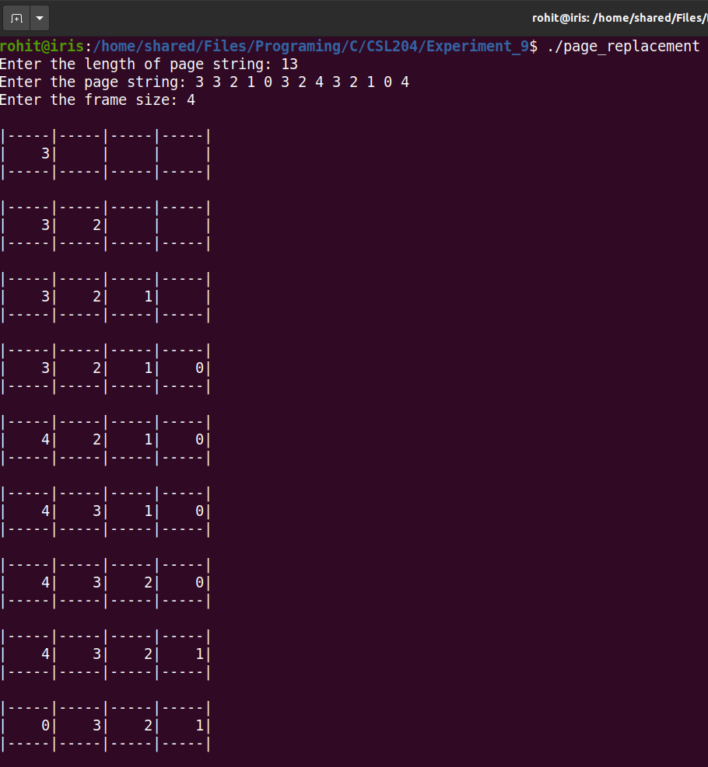
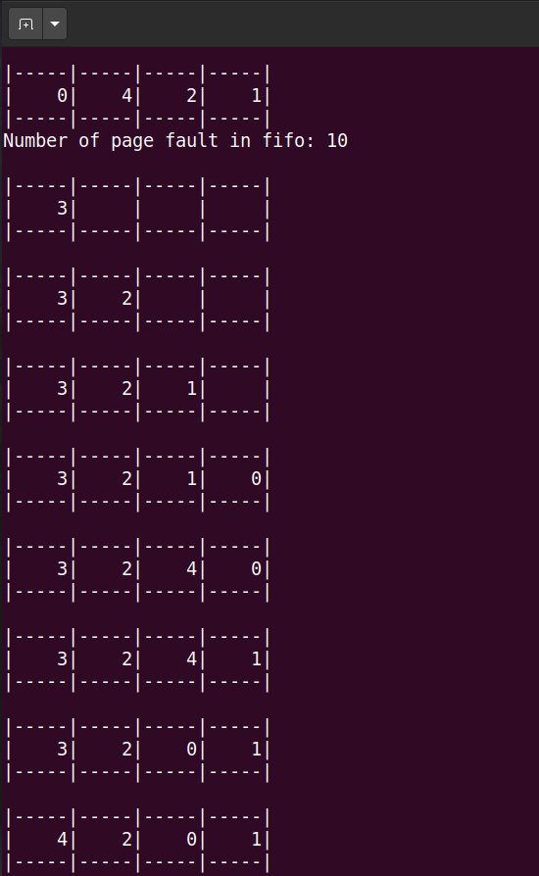
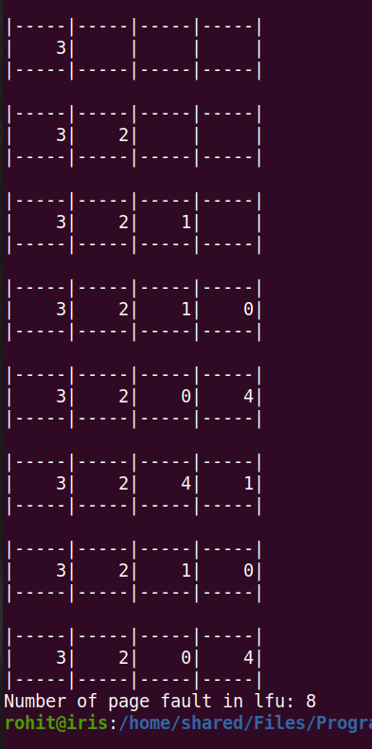

Input 2:
