https://luxome.com/products/weighted-blanket-cover?variant=13370891436101

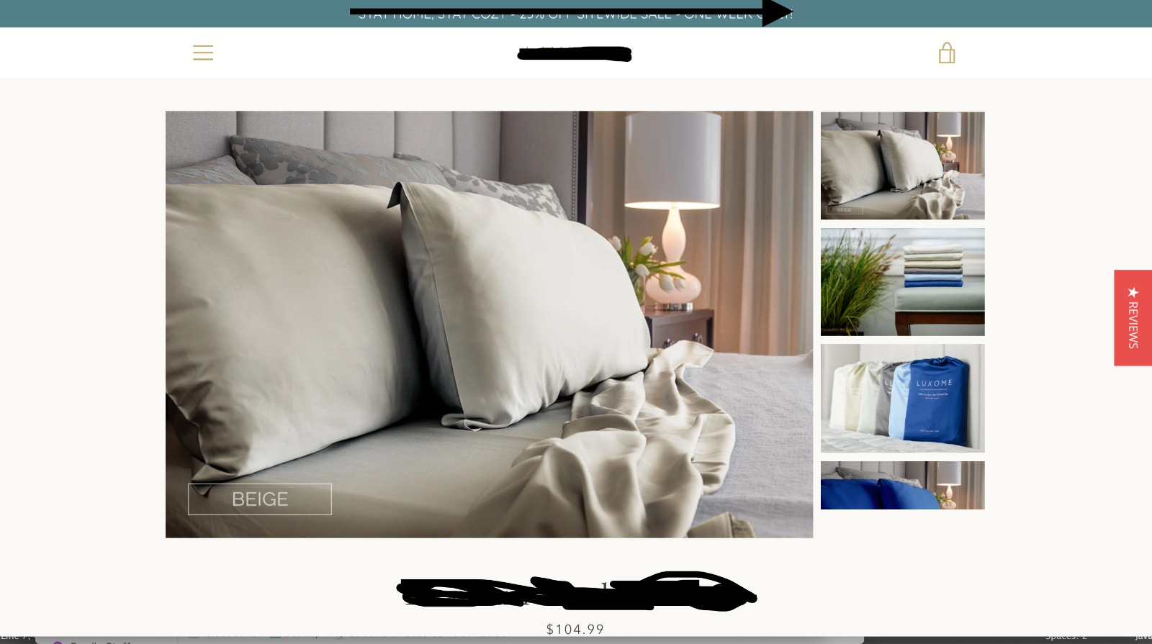
For those interested here is the frontend assignment. Mimic the look of this page as closely as possible.

You must complete the mobile version as well.

Those dots represent a working carousel on mobile
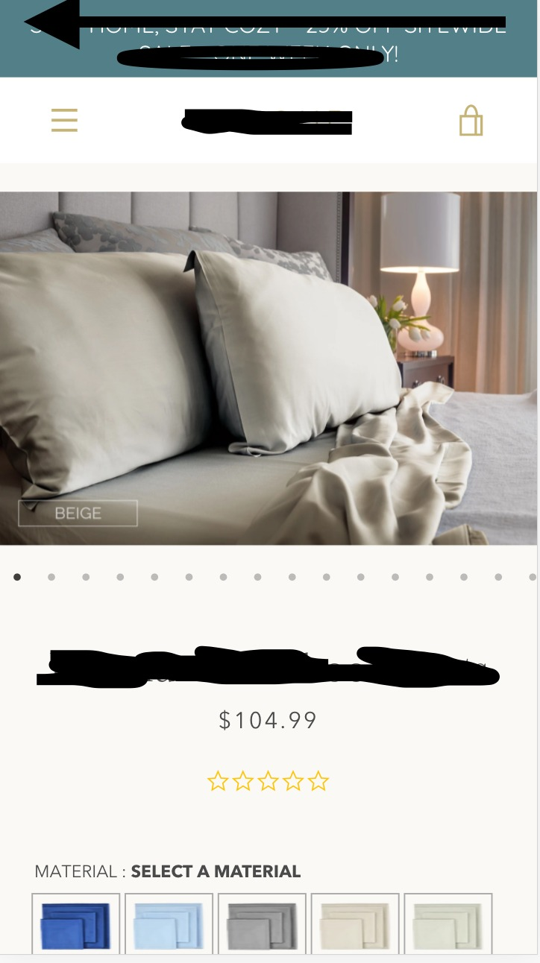
background: rgb(82, 127, 136)
color white

