MILESTONE UPDATE
Windows 11 Domain Client Deployment
Document date | 2026-07-21
Technical checkpoint | 2026-07-20
Project stage | Phase 1 - Identity and Foundational Networking
Publication status | READY - validated evidence and public-safe screenshots available

Milestone Snapshot
Accepted clients | WIN11-HR01 and WIN11-SALES01
DHCP leases | 10.50.10.100 and 10.50.10.101
Identity validation | HR and Sales domain-user sign-ins completed
Authorization validation | Expected department and printer groups confirmed
Directory validation | Both computer objects enabled in the custom Workstations OU

Copy-Ready LinkedIn Post
I have reached another Phase 1 milestone in my Northstar MSP IT Support lab: two Windows 11 Pro endpoints have now completed an end-to-end Active Directory onboarding and acceptance workflow.
I deployed WIN11-HR01 and WIN11-SALES01 on an isolated VMware network and validated that each endpoint:
- Received a unique DHCP lease from DC01
- Used DC01 for internal DNS and the corp.northstar.test suffix
- Located the writable Domain Controller before joining the Domain
- Joined corp.northstar.test and established a trusted computer identity
- Completed sign-in with a fictional department user
- Received only the intended department and printer security groups
- Refreshed user policy and processed RSOP data from DC01
- Appeared as an enabled AD computer object in the custom Workstations OU
The Sales deployment also gave me a practical troubleshooting lesson. I initially used the intended workstation name as the local OOBE username. I corrected the build by separating the device identity (WIN11-SALES01) from the local recovery identity (LocalAdmin), then repeated the network and Domain checks before proceeding.
The most important lesson was that Domain Join is not a single checkbox. It depends on a working chain of DHCP, DNS, Domain Controller discovery, computer trust, OU placement, user authentication, authorization, and policy validation.
Next: build WIN11-REMOTE01, place it in the Laptops OU, and validate an approved remote worker's department, printer, and VPN security groups.
#ITSupport #ActiveDirectory #WindowsServer #PowerShell #HelpDesk #MSP #HomeLab #LearningInPublic

Screenshot 1: HR Domain Join and Secure Channel
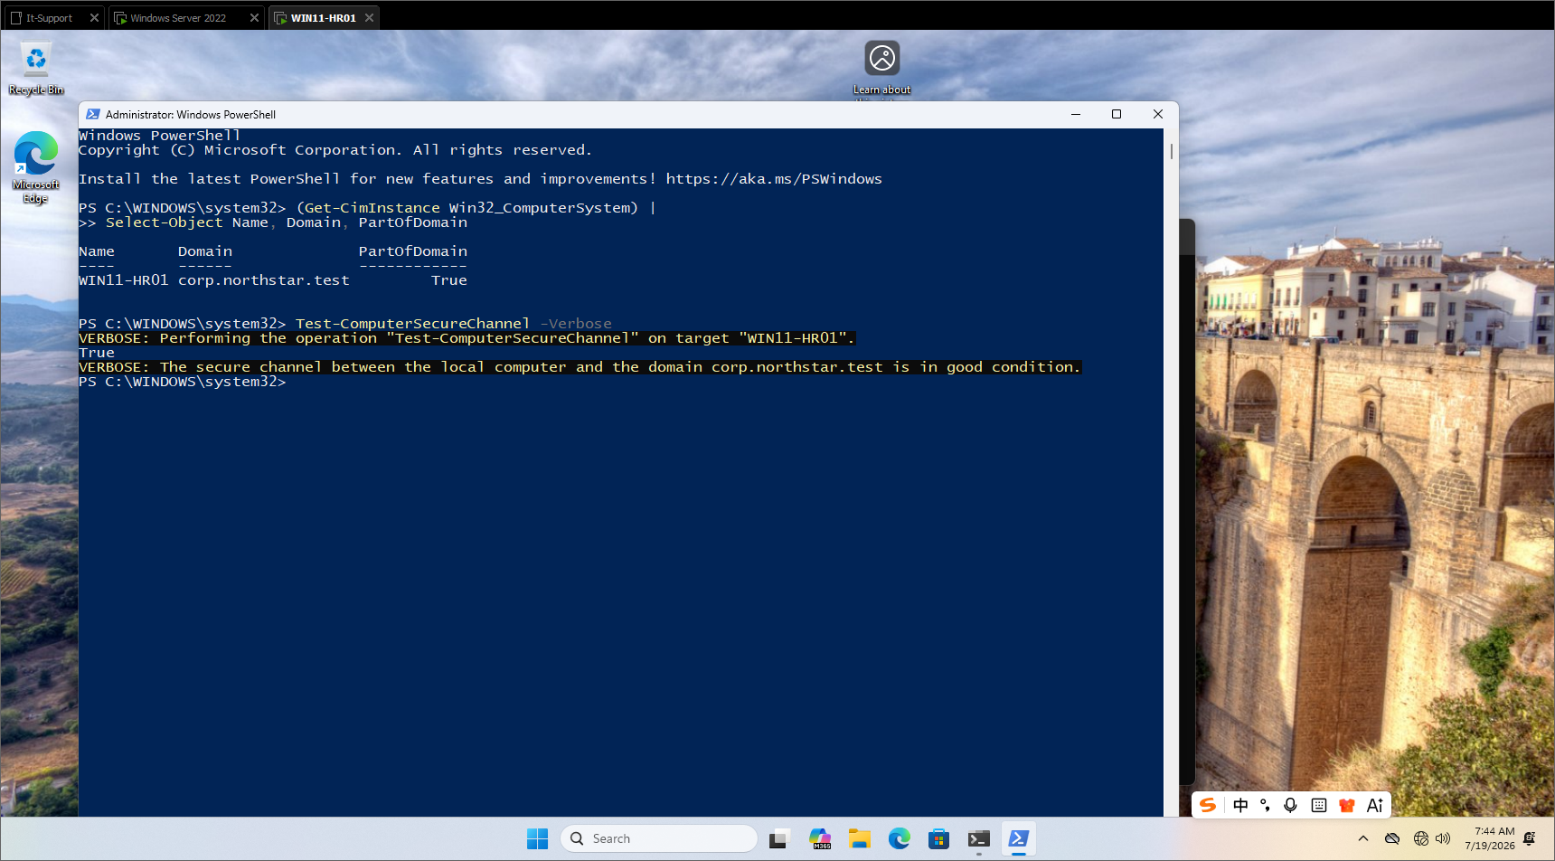
WIN11-HR01 reports Domain membership and a healthy secure channel with corp.northstar.test.

Screenshot 2: Sales DHCP and DNS Validation
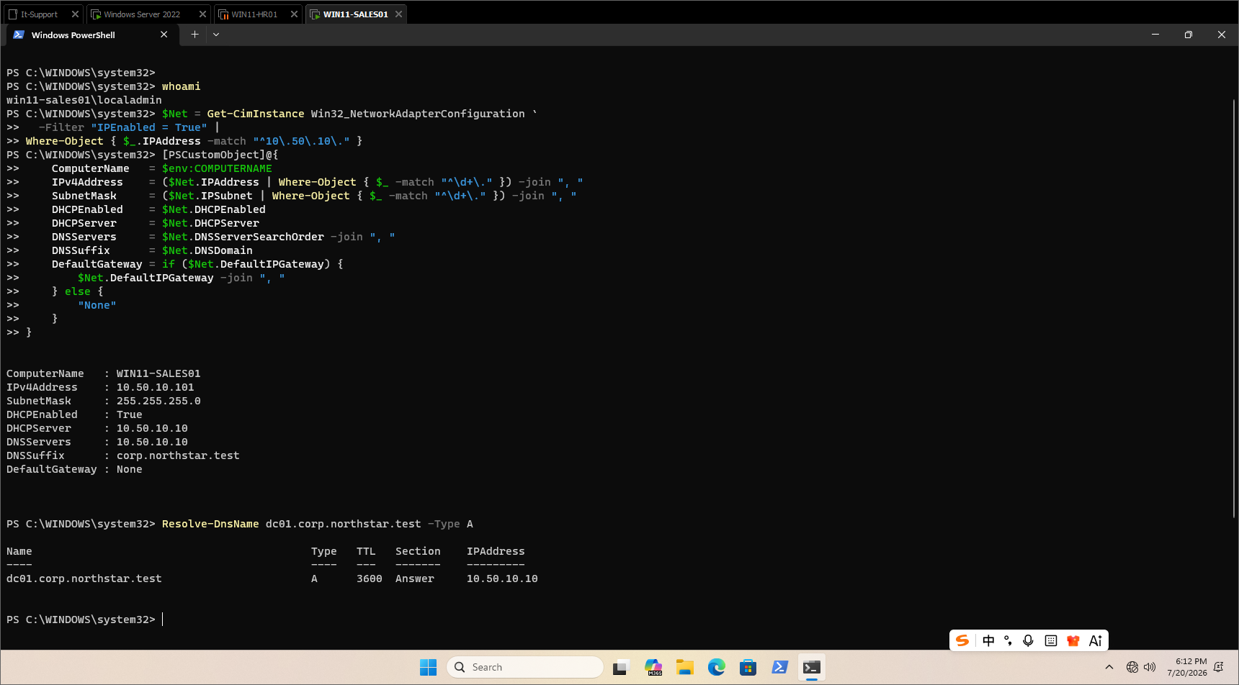
WIN11-SALES01 receives an independent DHCP lease and uses DC01 for internal DNS and name resolution.

Screenshot 3: Sales Identity, Groups, and Policy Refresh
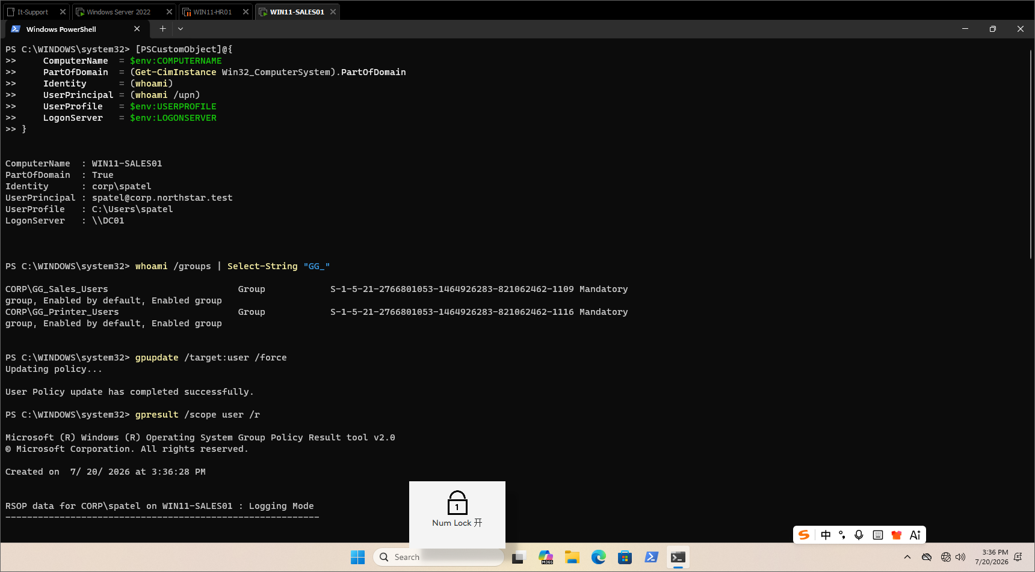
The fictional Sales user signs in through DC01 with the intended Sales and Printer group token and a successful policy refresh.

Screenshot 4: Active Directory Computer Objects
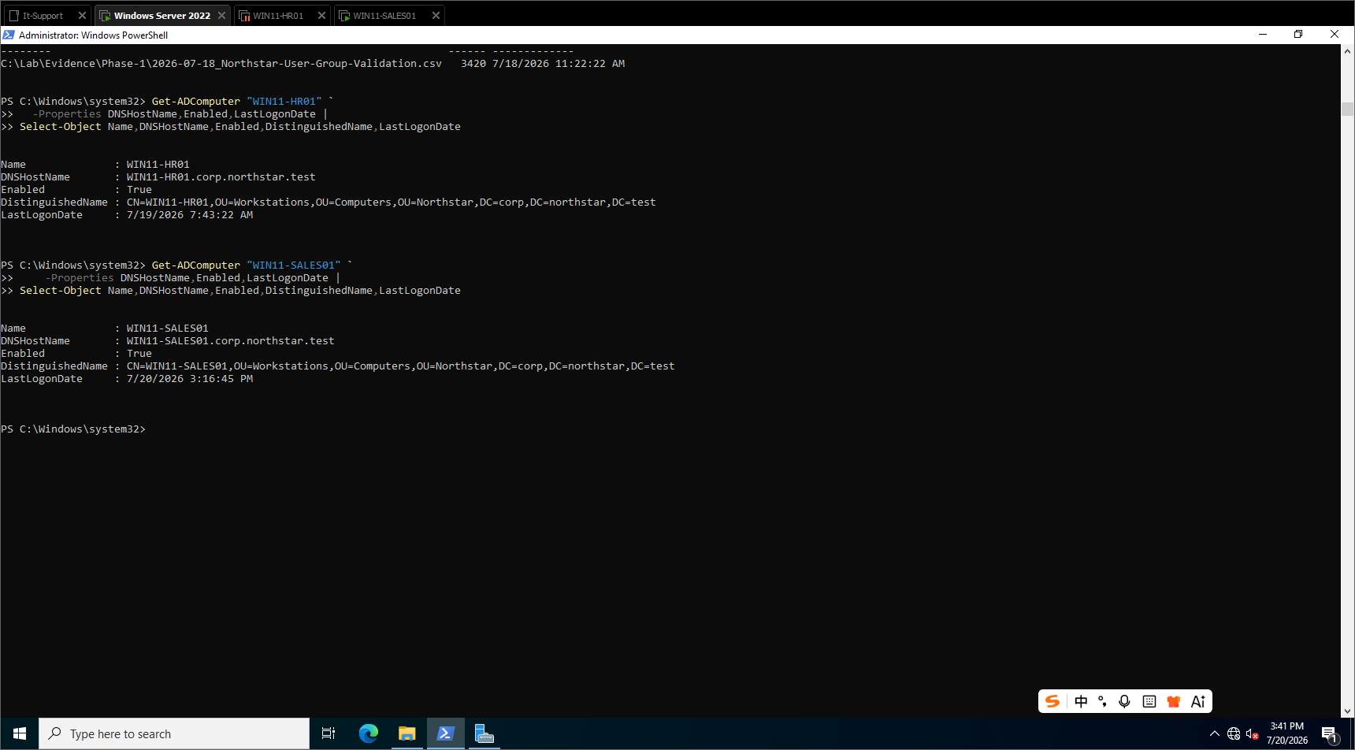
DC01 confirms both accepted Windows 11 computer objects are enabled and located in the custom Workstations OU.

Publication Decisions
LinkedIn image order | HR secure channel; Sales network; Sales identity and groups; AD computer objects
GitHub milestone | progress/2026-07-21-windows-client-deployment-milestone.md
Privacy check | Passed: fictional identities only; no passwords, tokens, MAC addresses, DUIDs, or public IPs
Claims check | Passed: the post describes only completed and validated work
Next milestone | WIN11-REMOTE01 in the Laptops OU with VPN-group validation

Final Posting Checklist
- Use the copy-ready post without adding unvalidated claims.
- Upload the four approved screenshots in the listed order.
- Confirm the GitHub Desktop change list before committing and pushing.
- Keep WIN11-REMOTE01 described as the next milestone, not completed work.

