MILESTONE UPDATE
Active Directory Identity Provisioning
Document date | 2026-07-18
Project stage | Phase 1 - Identity and Foundational Networking
Publication status | READY - validated evidence and public-safe screenshots available
Case association | Milestone only; not counted as one of the 30 support Cases

Milestone Snapshot
Identity objects | 20 fictional AD users; 20 enabled; zero disabled
Organization | 16 manager relationships; four top-level department managers
Authorization intent | 47 validated memberships across 10 Global Security groups
Audit evidence | Sanitized 20-row user-to-group validation CSV exported

Copy-Ready LinkedIn Post
Milestone update from my Northstar MSP IT Support lab: I moved Phase 1 from an empty Active Directory structure to a validated 20-user identity environment for a fictional professional services client.
What I completed:
• Provisioned 20 fictional users from a validated CSV source
• Placed users across HR, Finance, Sales, and Operations with a verified 4/4/6/6 distribution
• Assigned 16 employee-to-manager relationships, leaving four department managers as top-level users
• Applied 47 memberships across 10 Global Security groups
• Limited VPN membership to the three approved remote workers
• Required all 20 users to change their temporary password at first sign-in
• Exported a sanitized user-to-group validation report for audit evidence
I also worked through a useful troubleshooting moment: all 20 user objects were created with the correct attributes but remained disabled. I isolated the issue to the password and enablement stage, reset a compliant temporary password through a SecureString, enabled every account, and then verified the result directly from Active Directory.
Final validation:
20 total users | 20 enabled | 0 disabled
16 manager relationships | 4 top-level managers
47 expected memberships | 47 actual | 0 missing | 0 unexpected
The biggest lesson: automation is not complete when a command returns Success. A reliable workflow validates source data, checks for collisions, rehearses changes with -WhatIf, applies changes safely, and queries the directory again afterward.
Next milestone: deploy WIN11-HR01 and validate DHCP, internal DNS, Domain Join, first domain sign-in, and Group Policy processing.
#ITSupport #ActiveDirectory #WindowsServer #PowerShell #HelpDesk #MSP #HomeLab #LearningInPublic

Screenshot 1: Account State Validation
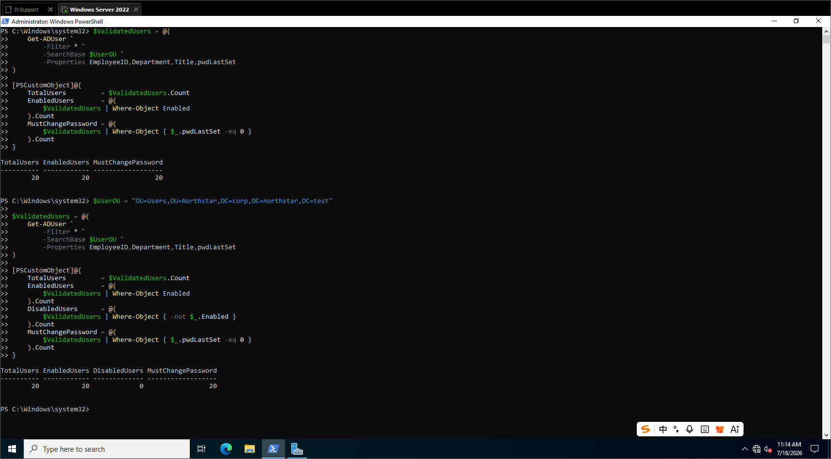
Fresh AD queries confirm 20 total users, 20 enabled users, zero disabled users, and 20 first-logon password changes.

Screenshot 2: Manager Relationship Validation
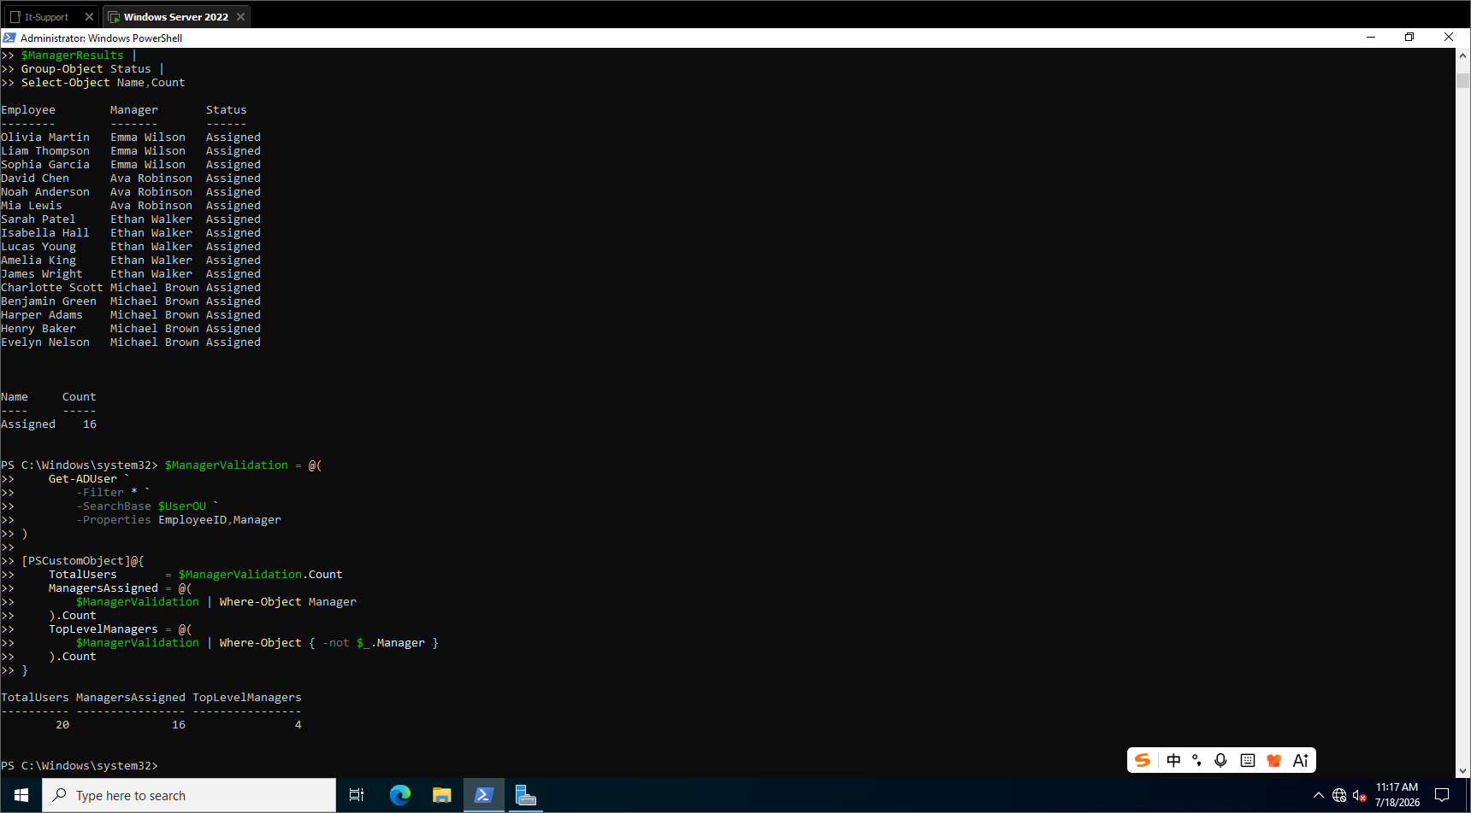
All 16 employee-to-manager relationships were assigned and validated, with four department managers left at the top level.

Screenshot 3: Security Group Validation
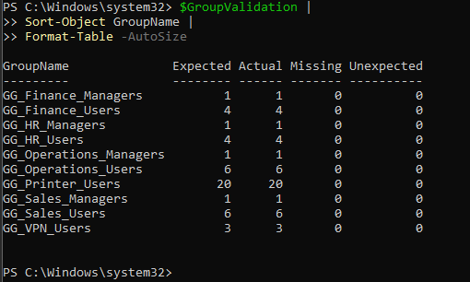
Every one of the 10 Global Security groups matches its expected membership count with zero missing or unexpected users.

Copy-Ready GitHub Update Summary
Documented and validated the Northstar Phase 1 identity-provisioning milestone: 20 fictional AD users across four department OUs, 16 manager relationships, 47 memberships across 10 Global Security groups, a repaired disabled-account condition, and a sanitized user-to-group audit export. The next milestone is deploying WIN11-HR01 and validating the end-to-end client service chain.

Publication Decisions
LinkedIn image order | Account validation; manager validation; per-group membership validation
GitHub evidence | Include the same three screenshots plus the 47/47 aggregate result and the sanitized CSV report
Privacy check | Passed: fictional identities only; no passwords, tokens, public IPs, MAC addresses, or personal data
Next milestone | WIN11-HR01 DHCP, DNS, Domain Join, domain sign-in, and Group Policy validation

Final Posting Checklist
- GitHub repository status matches the LinkedIn milestone.
- All images are readable and approved for public use.
- The post describes only completed and validated work.
- The sanitized audit CSV contains no credentials or real personal information.

