**FLS / RUBIA / Chr 5 Cline SUMMARY April 2020**

**SUMMARY**

* David’s cline analysis identified Chr 5 region, close to FLS gene, that shows a cline centred at the HZ
* Analysis of F2s suggests linkage to colour phenotype – MAGENTA

Flowers paler for Allele 1 from A.m.striatum

Flowers stronger.deeper magenta for Allele 2 from A.m.pseudomajus

* FLS is differentially expressed in petals: Low in pseudo vs HIGH in striatum
* Hypothesis: FLS diverts common substrates into flavonols, so reducing the flux into anthocyanins

**Literature Supporting Hypothesis** eg.

* Luo et al. (2006) Disequilibrium of Flavonol Synthase and Dihydroflavonol-4-Reductase Expression Associated Tightly to White vs. Red Color Flower Formation in Plants. Fronteris in Plant Science
* Aida et al. (2000) Copigmentation gives bluer ﬂowers on transgenic torenia plants with the antisense dihydroﬂavonol-4-reductase gene. Plant Science 160;49-56

**Phenotype**

Looked at an F2 of pseudo x striatum from HZ allopatrics - Total Genotyped for FLS/fls = 157

Numbers

Allele1 vs 2 Background Geno Result

5 vs 10 FLA/FLA SULF/sulf : no obvious yellow difference

2 vs 2 fla/fla SULF/sulf : no obvious yellow difference

2 vs 5 fla/fla sulf/sulf : no obvious yellow difference – hint of allele 2 stronger?

but low numbers

8 vs 10 FLA/ - sulf/sulf : no obvious yellow difference

14 vs 15 ros/ros : no obvious magenta difference

8 vs 7 ROS/ROS : **YES** obvious magenta difference of allele 2 (pseudo)

STRONGER than allele 1 (striatum)

16 vs 25 ROS/ros : **YES** obvious magenta difference of allele 2 (pseudo)

STRONGER than allele 1 (striatum) – but exceptions

**DATA**: see – ‘**J109_Genotype_DATA_Apr2020/xlsx’**

**Photos** of Clear Different Examples:

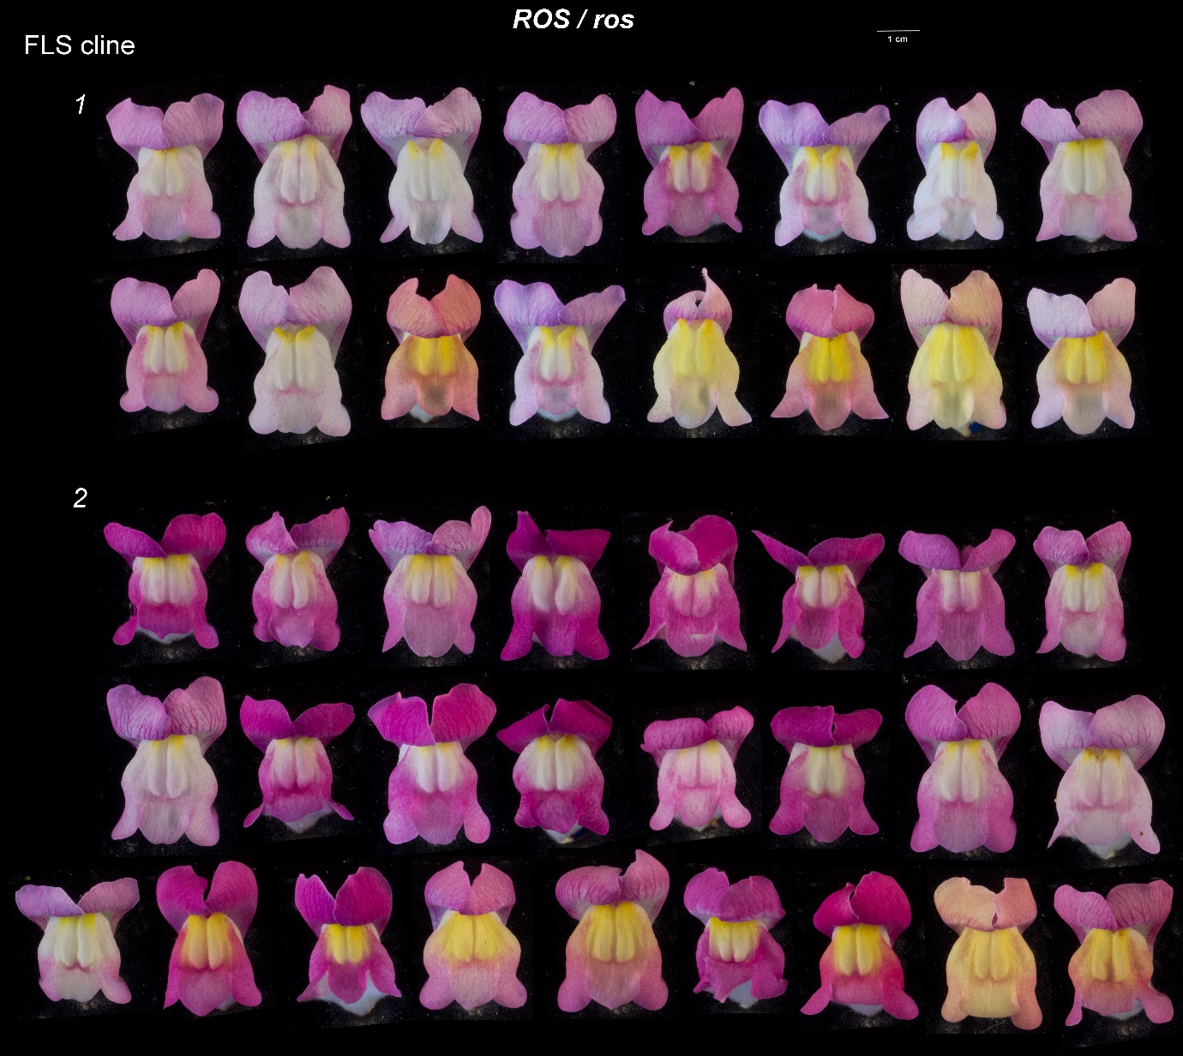

**Genetics:**

Seed collected from Hybrid Zone Individuals- J1428 – magenta (Ventola)

(see Antspec/Matt – for coorodinates) J1324 – yellow (Molina)

Seed grown and plants selected –

* V163-36 came from – J1428 allopatric magenta Ventola capsule 2
* V206-40 came from – J1324 allopatric yellow Molina capsule 5

Cross of - V163-36 x V206-40 gave F1 family Y132

Intercross of various F1s was made to get enough seed for J109

J109 came from - Y132-1 x Y132-5

J109-a came from - Y132-3 x Y132-4

J109-b came from - Y132-3 x Y132-5

J109-R came from - Y132-3 x Y132-4

Note:

* Y132-5 carried both an FLS alelle showing AFLP (compared to other pseudo or striatum) and also carried FLA-recombinant

**Additional Notes**

A rough map of region used in the analysis;

NB generated from v2 data – i will update to v3 which gives very small chnages i think

**Materials & Methods**