**Different environmental cues induce distinct gene expression profiles in a migratory butterfly**

Shipilina, D.1,*, Höök, L.1, Näsvall, K.1,2, Talla, V.1, Palahí i Torres, A.1, Parkes, E.1, Vila, R.3, Talavera, G.4, Backström, N.1

1Evolutionary Biology Program, Department of Ecology and Genetics (IEG), Uppsala University, Norbyvägen 18D, SE-752 36 Uppsala, Sweden

2Current affiliation

3Institut de Biologia Evolutiva (CSIC-Univ. Pompeu Fabra), Passeig Martim de la Barceloneta 37-49, 08003 Barcelona, Spain

4Institut Botànic de Barcelona (IBB), CSIC-Ajuntament de Barcelona, Passeig del Migdia s/n, 08038 Barcelona, Spain

* Corresponding author. Full contact details.

Running head:

Environmental impact on gene expression in a migratory butterfly

Emails:

Daria Shipilina

Lars Höök

Karin Näsvall

Venkat Talla

Aleix Palahí i Torres

Elenia Parkes

Roger Villa

Gerard Talavera

Niclas Backström

## Abstract

Migration is a complex behavior that involves the synchronization of a multitude of physiological and behavioral processes in response to environmental cues. Here, we used the painted lady butterfly (*Vanessa cardui*) as a model to characterize gene expression variation in response to environmental cues associated with host plant availability both during larval development and after emergence of adults. Assessment of the response to host plant availability in adult female butterflies revealed significant modifications in gene expression, particularly within hormonal pathways (ecdysone oxidase and juvenile hormone esterase). We therefore hypothesize that tuning of the ecdysone pathway may play a crucial role in the timing of migration and reproduction in adult female painted lady butterflies. In addition, our analysis revealed significant enrichment of genes associated with lipid, carbohydrate, and vitamin biosynthesis, as well as metabolism of pathogens and the immune response. Our expression contrasts in larvae showed that differences in both crowding and host plant availability during development resulted in significant changes in gene expression patterns, particularly pronounced at the instar V larval stage. Genes involved in development, reproduction, and metabolism were significantly differentially expressed in response to both crowding and food availability. In summary, our results offer novel insights into how environmental cues affect expression profiles in migratory insects in general and highlight candidate genes which may underpin the migratory syndrome in the painted lady butterfly in particular.

## Introduction

Animals are recurrently facing challenges to optimize the allocation of energy and time and the individual decisions about such trade-offs can have considerable downstream consequences on both survival and reproductive output (REF). Migration is a widely adopted behavioral response to seasonal shifts in the environment, essentially allowing migratory organisms to avoid temporary unfavorable environmental conditions [(Aidley, 1981)](https://www.zotero.org/google-docs/?Rt71g4). Migratory movements have been characterized in detail in many different groups of organisms, however vertebrates in general have traditionally received most of the attention while the understanding of e.g. insect migration is limited to a few model species [(Chowdhury et al., 2021; Dingle, 1978, 2001; Johnson, 1963)](https://www.zotero.org/google-docs/?Zw6HUl). Recent advances in tracking migratory behaviors in insects, for example via pollen metabarcoding and isotope analysis (REFS), have revealed WHAT? Migratory behaviour is a facultative trait, imposing that phenotypic plasticity is exhibited as a decision to start migratory movement in response to environmental cues. Therefore, one of the crucial aspects for understanding the genetic basis of migration is pinpointing gene regulatory networks leading to initiation of the migratory syndrome as a response to the environment [(Harringmeyer et al., 2021; Liedvogel et al., 2011)](https://www.zotero.org/google-docs/?GhEdnt). While environmental cues arguably play a vital role in triggering behavioral switches, the underlying mechanisms of the processing and responses on the molecular level have only been studied in a few migratory insects, for example the migratory locust (*Locusta migratoria*) and the monarch butterfly (*Danaus plexippus*) [(Kang et al., 2004; Merlin et al., 2020; Zhu et al., 2009)](https://www.zotero.org/google-docs/?118pMn).)

Following acquisition of environmental signals, migratory insects commonly face a situation where trade-offs between alternative resource allocations [(Guerra, 2011; Hanski et al., 2006; Tigreros & Davidowitz, 2019)](https://www.zotero.org/google-docs/?5kACVl) and physiological responses [(Bhaumik & Kunte, 2018; Tigreros & Davidowitz, 2019)](https://www.zotero.org/google-docs/?hA4YbD) are needed. The key trade-off characterizing the migratory syndrome in insects is termed the oogenesis-flight syndrome and refers to the delayed investment in reproduction in favor of migration [(Johnson, 1963; Rankin et al., 1986)](https://www.zotero.org/google-docs/?vvI8U6). Different migratory insect species exhibit significant variation in their migration traits, physiological and behavioral integration and degree of strength of exhibiting the oogenesis-flight syndrome. It varies from complete reproductive arrest during migration in for example the boll weevil [(Rankin et al., 1994)](https://www.zotero.org/google-docs/?ymTUMd) and the beet webworm [(Y. X. Cheng et al., 2012)](https://www.zotero.org/google-docs/?7n0R98), to expression of the syndrome in certain generations like in the monarch butterfly [(Malcolm et al., 2018)](https://www.zotero.org/google-docs/?J1lg3G), to a complete lack of reproductive arrest in some species where females can migrate with fertilized and developed eggs [(Tigreros & Davidowitz, 2019)](https://www.zotero.org/google-docs/?eMe9QS). Therefore, more detailed investigations are needed to enhance our understanding of this complex phenomenon. Empirical observations of the oogenesis-flight syndrome comes predominantly from phenotypic observations [(Oliveira et al., 2006; Rankin et al., 1986)](https://www.zotero.org/google-docs/?KDF6Iu), and while physiological and behavioral changes have been described in some detail, characterization of the genetic underpinnings of the trade-offs have predominantly been focused on reproductive arrest [(Green & Kronforst, 2019; Herman, 1981)](https://www.zotero.org/google-docs/?JJkD6I). Moreover, the specific environmental cues that can trigger this trade-off need to be characterized in more detail.

Accurate perception of environmental cues is essential for the expression of the migratory syndrome, both in adult individuals and during ontogenesis [(Angelo & Jr., 1984)](https://www.zotero.org/google-docs/?h1u66N). In particular, two environmental cues perceived during development have been shown to be associated with variation in propensity to migrate; rearing density and periodic starvation. A higher larval density for example can lead to increased competition and predominant investment in migration, likely as a strategy to disperse from areas where competition with conspecifics is high [(Bauerfeind & Fischer, 2005)](https://www.zotero.org/google-docs/?7EYKXf). The desert locust (*Schistocerca gregaria*) is a notable example of this phenomenon, exhibiting a density-dependent phase polyphenism that triggers a transition from a benign, solitary phase to a more gregarious, highly migratory phase [(Gasking Butler & Innes, 1936; Kang et al., 2004)](https://www.zotero.org/google-docs/?2VEVcW). In Lepidoptera, larval density-dependent migration has also been observed in the fall armyworm (*Spodoptera frugiperda*) [(S. Wang et al., 2023)](https://www.zotero.org/google-docs/?joyVeP), and larval density has been associated with outbreaks in the agricultural pest, beet webworm (*Loxostege sticticalis*) [(Y. X. Cheng et al., 2012)](https://www.zotero.org/google-docs/?aGrfmw). Food availability and quality has also been linked to the oogenesis-flight syndrome in insects, where limited resources during development predominantly manifest in reduced body size, fat storage, fecundity and investment in reproduction. Resource availability therefore should have a major influence on migration capacity/propensity and, hence, the trade-off between reproduction and migration [(Bauerfeind & Fischer, 2005; Boggs & Freeman, 2005; Chen & Ruberson, 2008; Niitepõld, 2019)](https://www.zotero.org/google-docs/?xgl8cN).

The painted lady butterfly (*Vanessa cardui*) is an emerging model species for studying the genomic basis of multigenerational long-distance migration [(García‐Berro et al., 2023; Lohse et al., 2021; Shipilina et al., 2022; Stefanescu et al., 2013)](https://www.zotero.org/google-docs/?NKBhQq). In addition to performing the longest individual migratory flight distances of any Lepidoptera [(Suchan et al., 2019, Reich, in prep)](https://www.zotero.org/google-docs/?5VzvMG), *V. cardui* is completely lacking diapause, which highlights the recurrent balance between reproduction and migration as a key adaptation in the species. The oogenesis-flight syndrome is well pronounced in *V.cardui* [(Stefanescu et al., 2021)](https://www.zotero.org/google-docs/?TAUNa2), but considerable inter-individual differences in migration distance and propensity have been observed ([Reich, in prep](https://www.zotero.org/google-docs/?3GkEYg)). Recently developed genomic resources (Shipilina et al. 2022, DtoL assembly, etc) have now made it possible to investigate the genetic underpinnings of migratory behavior in the species in more detail. Up until now, however, very few attempts have been made to characterize the components of the migratory syndrome and its dependence on environmental cues. Spearheading work using methylation and chromatin accessibility data have pinpointed candidate pathways that likely are involved in sensory perception of environmental cues [(Boman et al., 2023; Näsvall et al., 2023)](https://www.zotero.org/google-docs/?kHwQRw), but analyses that investigate potential associations with transcription profiles of specific genes or gene categories have not been performed.

Genetic regulation of migratory behavior is most likely exceptionally complex and it is therefore advantageous to conduct separate experiments addressing reading of various environmental cues. Here, we make a first attempt to investigate the transcriptomic response to different environmental cues that can be associated with investment in reproduction or migration in butterflies. The main aims were to i) characterize transcriptomic responses to different environmental cues in both adult females and across developmental stages, ii) identify developmental time points at which the environmental cue triggers a difference in gene expression, iii) identify candidate genes that might be involved in the trade-off between reproduction and migration.

## Methods

### *Experimental setup*

Painted lady (*Vanessa cardui*) butterfly females were collected in Catalonia, Spain, and individually housed in cages for egg laying at 23°C under an 18:6-hour light:dark regime. The butterflies were provided with host plants (*Malva sylvestris*) for egg laying and a 10% sugar water solution as a food source. The F1 offspring were raised individually with *ad libitum* access to food plants (*M. sylvestris*) in 23°C and a 18:6 h light:dark regime and subsequently divided into experimental groups where environmental conditions were controlled (Figure 1).

Two separate experiments were carried out to analyze the transcriptomic response to different environmental cues. The first experiment was designed to investigate the potential influence of the presence or absence of the host plants for egg laying on gene expression profiles in adult females during a critical stage in the trade-off between dispersal and reproduction (Figure 1B). The second experiment was designed to characterize the potential effects of larval density and food availability on gene expression profiles during development (larval instars III and V and pupae) and after emergence (imagines) (Figure 1B).

#### *Host plant availability effects on gene expression profiles in adult females*

Newly emerged adult F1 females were marked individually and released into one of two large cages (80 x 80 x 50 cm), both containing 10 free-flying males. One cage contained an abundance of host plants (9 15*15 cm pots with *M. sylvestris*), while the other cage lacked host plants (Figure 1A). Both experimental groups were provided with 10% sugar water as a food source, and the temperature and light regime was the same as for rearing larvae (23°C and an 18:6-hour light-dark regime). In the morning five days after emergence, when the predisposition to either mate or migrate in general has been established [(Stefanescu et al., 2021)](https://www.zotero.org/google-docs/?RIKhVn), the females were collected and snap frozen in liquid nitrogen. For each respective treatment group, we collected 9-10 females for gene expression profiling.

#### *Crowding and food availability effects on expression profiles across developmental stages*

In the second experiment, five newly mated F1 females were placed in individual cages containing *M. sylvestris* for egg laying. The eggs (F2) laid by each female were collected and divided into three treatment groups (Figure 1): LDAL (low density, *ad libitum* food), HDAL (high density, *ad libitum* food), and HDLI (high density, limited food) (Figure 1B). In the LD (low-density) condition, larvae were individually reared in 1 l flasks, while in the HD (high-density) treatment, 10 larvae were kept together in a single 1 l flask. Both density treatment groups had *ad libitum* access to food (*M. sylvestris*), which was replaced daily. In the LI (limited resource) treatment group, the food was replaced every other day, creating a mild starvation regime. Individuals in this treatment group were reared in groups of 10 (high density). This set-up allowed us to contrast treatments with different food availabilities (HDAL versus HDLI) and larval rearing densities (HDAL versus LDAL) separately (Figure 1).

Samples were collected at four developmental stages: larva (instar III and instar V), pupa, and imago. Larvae were harvested on the day they entered the respective larval stage, pupae were sexed and collected one day after pupation, and adults were harvested in the morning on the day of emergence. Prior to RNA extraction, individuals were snap frozen in liquid nitrogen and stored at -80°C. Note that larvae could not be sexed and these cohorts therefore can constitute a mix of males and females. Pupae and adults were sexed and divided into sex-specific cohorts. For each treatment and cohort, the samples represent one offspring from each of the five different F1 females (Figure 1).

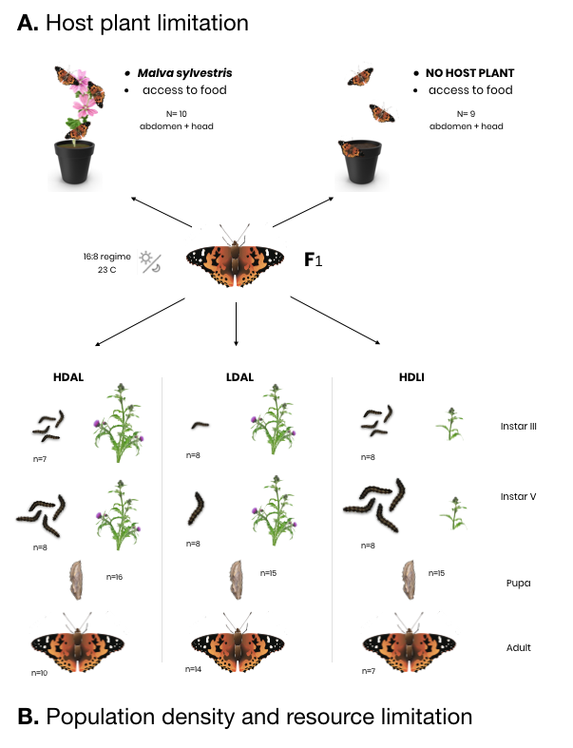

Figure 1. Setup of the two experiments conducted on offspring of wild-caught *Vanessa cardui* females (in the center). Numbers of individuals sampled in the study are provided for each treatment and cohort, respectively. A) The host plant availability experiment, where recently emerged females were divided in two experimental groups with or without access to *Malva sylvestris* for egg laying, respectively. B) The setup of the larval crowding and food availability experiment for different developmental stages. Here, F2 offspring from five different F1 females were divided into three cohorts where the environmental conditions varied. HDAL = high density (10 larvae / flask) and *ad libitum* food, LDAL = low density (1 larva / flask) and *ad libitum* food, HDLI = low density (1 larva / flask) and limited food (fed every other day).

### RNA extraction and sequencing

Two types of tissues were used for RNA extractions; heads (including antennae) and abdomens (the 6th - 8th body segments). The number of samples for each treatment / cohort are provided in Figure 1 and Supplementary Table 1). Tissues were homogenized using a micro-pestle in guanidine-isothiocyanate lysis buffer, followed by mixing with QiaShredder (Manufacturer?). RNA extractions were performed using the RNeasy Mini Kit (Qiagen) following the recommended guidelines by the manufacturer. RNA integrity and fragment lengths were assessed using 1% agarose gel electrophoresis, followed by measurements of the concentration using NanoDrop (ThermoFisher) and Qubit (ThermoFisher). Sequencing libraries were prepared using the Illumina TruSeq Stranded mRNA polyA selection kit and sequenced by the National Genomics Infrastructure (NGI) in Stockholm. Sequencing was conducted on two lanes of one S4 flow cell on the NovaSeq S6000 platform, generating 150 bp paired-end reads.

### Differential expression analysis

For all steps of the read processing, from adapter filtering to read mapping and transcript quantification, the Nextflow nf-core [(Di Tommaso et al., 2017; Ewels et al., 2020)](https://www.zotero.org/google-docs/?I2Ua7L) pipeline rnaseq v3.8.1 was applied [(Harshil Patel et al., 2023)](https://www.zotero.org/google-docs/?rFNGUf). In brief, raw sequencing reads were trimmed using Trim Galore! v0.6.7, utilizing Cutadapt v.3.4 [(Martin, 2011)](https://www.zotero.org/google-docs/?Qqc9wR). STAR v2.7.10a [(Dobin et al., 2013)](https://www.zotero.org/google-docs/?S4dji8) was used for mapping the reads to a previously published genome assembly [(Lohse et al., 2021)](https://www.zotero.org/google-docs/?BYM9IK). Read quantification was carried out using salmon v1.5.2 [(Patro et al., 2017)](https://www.zotero.org/google-docs/?sq4C4L), and gene expression levels were measured in transcripts per million reads (TPM) values. Differential expression analyses were conducted in R v.4.2.1 using DESeq2 v1.28.0 [(Love et al., 2014)](https://www.zotero.org/google-docs/?HBXluJ).

To assess differential expression between the cohorts of adult individuals with or without access to host plants for egg laying, we employed the Wald test within the DESeq2 framework. Our experimental design incorporated the correction for potential family effects, with treatment as the primary variable (~family+treatment). Due to incomplete family assignment for some samples, we utilized PCA analysis of mapped reads to recover the missing assignments. We applied the same Wald test for differential expression analysis in adult individuals subjected to environmental stressors: food limitation and larval crowding. Here, we also accounted for the potential effect of sex since both males and females were used in the analysis (~family+sex+treatment).

DIfferential gene expression across developmental stages were assessed using the likelihood ratio test mode of DESeq2 (model = "LRT''). This test compared the fit of a full model (~family + devstage + treatment + treatment:devstage) with a reduced model that excluded the interactive effect between the treatment and developmental stage ("devstage") variables. This analysis aimed to evaluate whether the effect of the treatment on gene expression differed across developmental stages. The same model was applied to both head and abdomen tissues, and the analysis included the treatments food availability (HDAL versus HDLI) and rearing density (HDAL versus LDAL).

For further analysis, candidate genes were selected based on the criteria of an adjusted p-value < 0.05 and a log fold change > 2. The GeneOverlap package [(Li Shen, 2017)](https://www.zotero.org/google-docs/?9Rx8W3) was used to assess the significance of overlaps between candidate gene sets in different tissues. Since tests using LRT typically result in larger gene sets, clusterProfiler [(Wu et al., 2021)](https://www.zotero.org/google-docs/?NnbrOl) was applied to identify functional clusters within all sets of candidate genes across the four ontogenetic stages, using parameters (consensusCluster = TRUE, groupDifference = 2) on rlog-transformed data. In the case of the head tissue, where 745 candidate genes were identified, more stringent clusterization parameters were employed with a group difference of 3. Functional information for differentially expressed genes was collected both by using previous annotations (REF) and by BLAST searches [(Altschul et al., 1990)](https://www.zotero.org/google-docs/?tTF2Bc).

To assess if certain functional categories were overrepresented in the gene-sets with significant differential expression, we conducted two types of enrichment analyses, Gene Ontology (GO) terms and KEGG pathways, utilizing previously obtained functional annotations [(Shipilina et al., 2022)](https://www.zotero.org/google-docs/?SK69mq). Enrichment analysis of GO terms was performed using the TopGO package [(Adrian Alexa, 2017)](https://www.zotero.org/google-docs/?44ZT9W), employing the "weight01" algorithm, with a focus on the biological processes category. Significantly enriched terms (p < 0.01) were further examined, visualized, and analyzed. The enrichment analysis of KEGG terms was performed using the enricher module of clusterProfiler (REF).

All analyses and visualizations were performed in R (RStudio version v.4.2.1) and composite figures were made in Adobe Illustrator 23.0.4.

## Results

#### *Gene expression patterns in response to host plant availability in adult females*

In order to get a better understanding of how the presence or absence of host plants for egg laying affects transcriptional response in recently emerged female imagines, we analyzed gene expression in head and abdomen tissues (Figure 2). The rationale behind choosing those particular tissues were that signaling cascades should be initiated in the head based on sensory perception of the environmental cues and that this may manifest in temporal differences in investment in reproduction and migration which might be picked up by gene expression differences in the abdomen (where the gonads are located). In total, 10 individuals were analyzed for head tissue (five for each treatment) and 9 individuals for abdomen tissue (five and four individuals from the treatments with and without access to host plants for egg laying, respectively). In the head, we found that 82 genes were significantly differentially expressed (p < 0.05 after FDR adjustment) between treatment groups. Of those, 34 genes (0.3% of all genes) had higher and 44 had lower expression (0.4%) in the treatment with access to host plants compared to the treatment without host plants (Figure 2A). In the abdomen, the corresponding numbers were 89 differentially expressed genes; 45 (0.4%) with higher and 26 (0.2%) with lower expression in the treatment with access to host plants (Figure 2B).

To get more detailed information about the functions of differentially expressed genes in adult females with and without access to host plants for egg laying, we focused on genes with a fold change difference > 5 and a FDR-adjusted p-value < 0.01 ~~-log10(p-value) higher than 10~~ (Figure 2 A, B). We found that significantly differentially expressed genes encompassed a diverse range of functional categories, including immune genes (*gloverin, attacin, cytochrome p450, PGRP*), metabolic genes (*lipase*), and genes involved in endoskeleton formation (*cuticle protein*) (Figure 2). Of particular interest was the *ecdysone oxidase* gene, which exhibited a remarkable ~20-fold higher expression in in both head and abdomen in the individuals that had access to host plants for egg laying (Figure 2A and 2B). A list of the significantly differentially expressed genes in both tissues for adult females is provided in Supplementary Material 1.

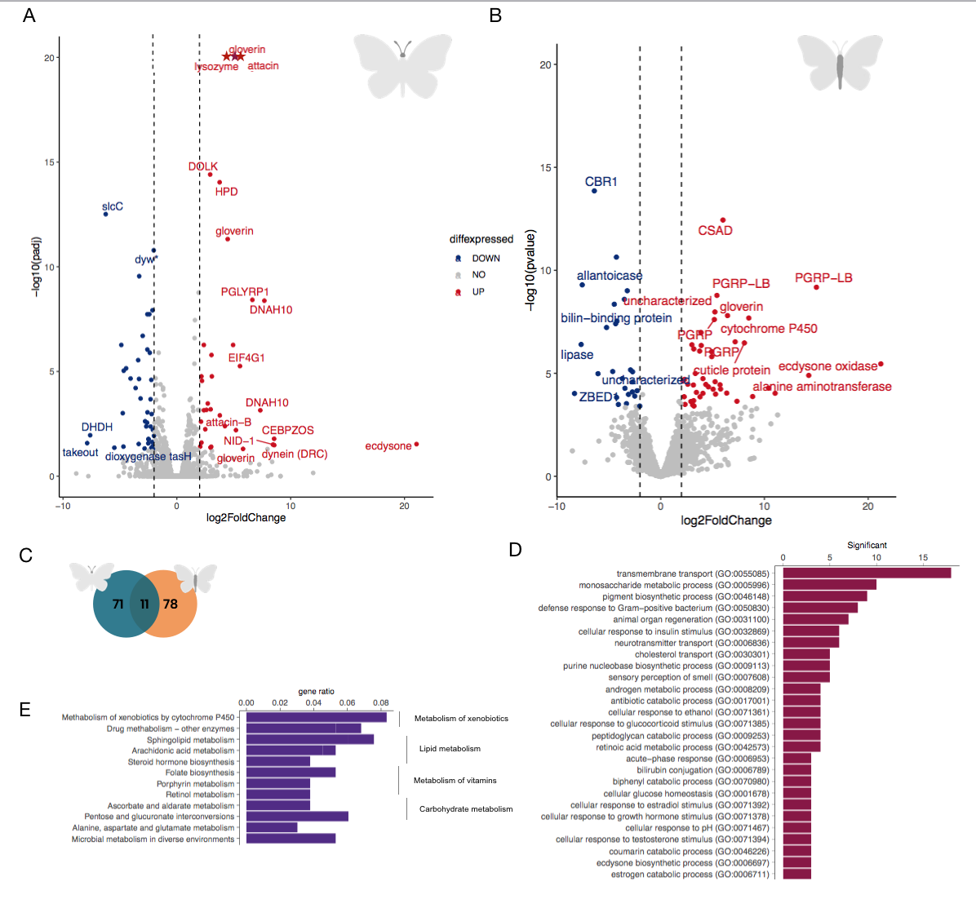

Figure 2. Volcano plots illustrating the relative levels of gene expression in the head (A) and abdomen (B) of adult females (x-axis; log2 fold change) in the two treatment groups with and without access to host plants for egg laying. Genes with a fold change difference > 2 and FDR-adjusted p-value < 0.05 are depicted in red (significantly higher expression in the treatment with host plants) and blue (significantly higher expression in the treatment without host plants), respectively, while non-significant genes are illustrated by grey dots. C) Venn diagram showing the number of overlapping and unique differentially expressed genes between the two tissues (head = green, abdomen = orange). D) Bar plot showing the counts of the enriched gene ontologies for the significantly differentially expressed genes (FDR-adjusted p < 0.01) between the treatment groups for both tissues combined. E) Bar plot illustrating the gene ratios for significantly differentially expressed genes with enriched functions for KEGG pathways for both tissues combined. The higher hierarchical grouping is displayed to the right.

Among the genes that were differentially expressed between the adult female treatment groups, 11 genes were found in both tissues (Figure 2C). To gain further insights into the associations between differentially expressed genes and functional categories, we combined the results from both tissues and assessed if any GO-terms were enriched. Significantly overrepresented GOterms encompassed transmembrane transport, various metabolic processes (including ecdysone biosynthesis), and defense response (Figure 2D). Consistent with this finding, the analysis of overrepresented KEGG pathways revealed enrichment of different metabolic pathways, in particular lipid, carbohydrate, vitamin, and xenobiotic metabolism (Figure 2E).

#### *Gene expression variation associated with food availability during development*

To complement the analysis in adult females, we focused on investigating differential gene expression across developmental stages in experimental cohorts exposed to environments that varied in food availability and rearing density. Again, we focused on the head and abdomen for the same reasons as indicated above. For the contrast between experimental groups with differences in food availability during development (HDAL versus HDLI), the likelihood ratio tests revealed 745 and 321 significantly differentially expressed (FDR-adjusted p-value < 0.05) in the head and abdomen, respectively. Notably, the two sets of genes with differential expression in the two respective tissues demonstrated a high degree of overlap (Jaccard index = 0.1, p-value = 9.6*10-30; Figure 3A). To gain a better understanding of which stages that contributed most to the overall differences in expression patterns between the treatment groups, we performed a clustering analysis which groups genes based on the expression patterns across developmental stages, facilitating the identification of genes with similar profiles and potential functional relationships. In head tissue, the most prominent cluster comprised 123 genes (16.5% of the differentially expressed genes in this tissue; Figure 3B). The majority of expression differences within this cluster were observed in instar III larvae. Similarly, in the abdominal tissue, 149 genes (46.4% of the differentially expressed genes) formed a distinct cluster. Genes within this cluster predominantly showed differential expression in instar V larvae (Figure 3C).

The GO term analysis for differentially expressed genes in head tissue revealed both a general enrichment of functions related to metabolic processes and regulation, and more specifically also enrichment of functions associated with epithelial cell development, sarcomere organization, angiogenesis regulation and blood coagulation (Figure 3D). Differentially expressed genes in abdominal tissue were predominantly associated with reproductive processes, and neural and immune cell development (Figure 3E). In addition, a joint KEGG pathway analysis of both tissues unveiled that functions associated with ribosome biogenesis and metabolism were overrepresented (Supplementary Table X).

The expression trajectories across developmental stages show that the influence of the environmental differences on gene expression differences between experimental groups in general appears to diminish at the pupal and adult stages. In order to investigate how environmental cues experienced during development are manifested in recently emerged imagines in more detail, we compared differences in gene expression between adult individuals that had experienced different environmental conditions during development specifically (Figure 3 F,G). In head tissue, only six genes showed significantly differential expression; *Tret1, odorant receptor, UDP-glucosyltransferase, esterase and zinc-finger MYM* (Figure/Table/SI?). In the abdominal tissue, X genes were found to be differentially expressed genes between treatment groups. Among the most prominent outliers were *cuticle protein, gloverin, glutamine synthetase, tektin, clavesin, gooseberry-neuro, orcokinin* and *tyrosine* (Figure/Table/SI?).

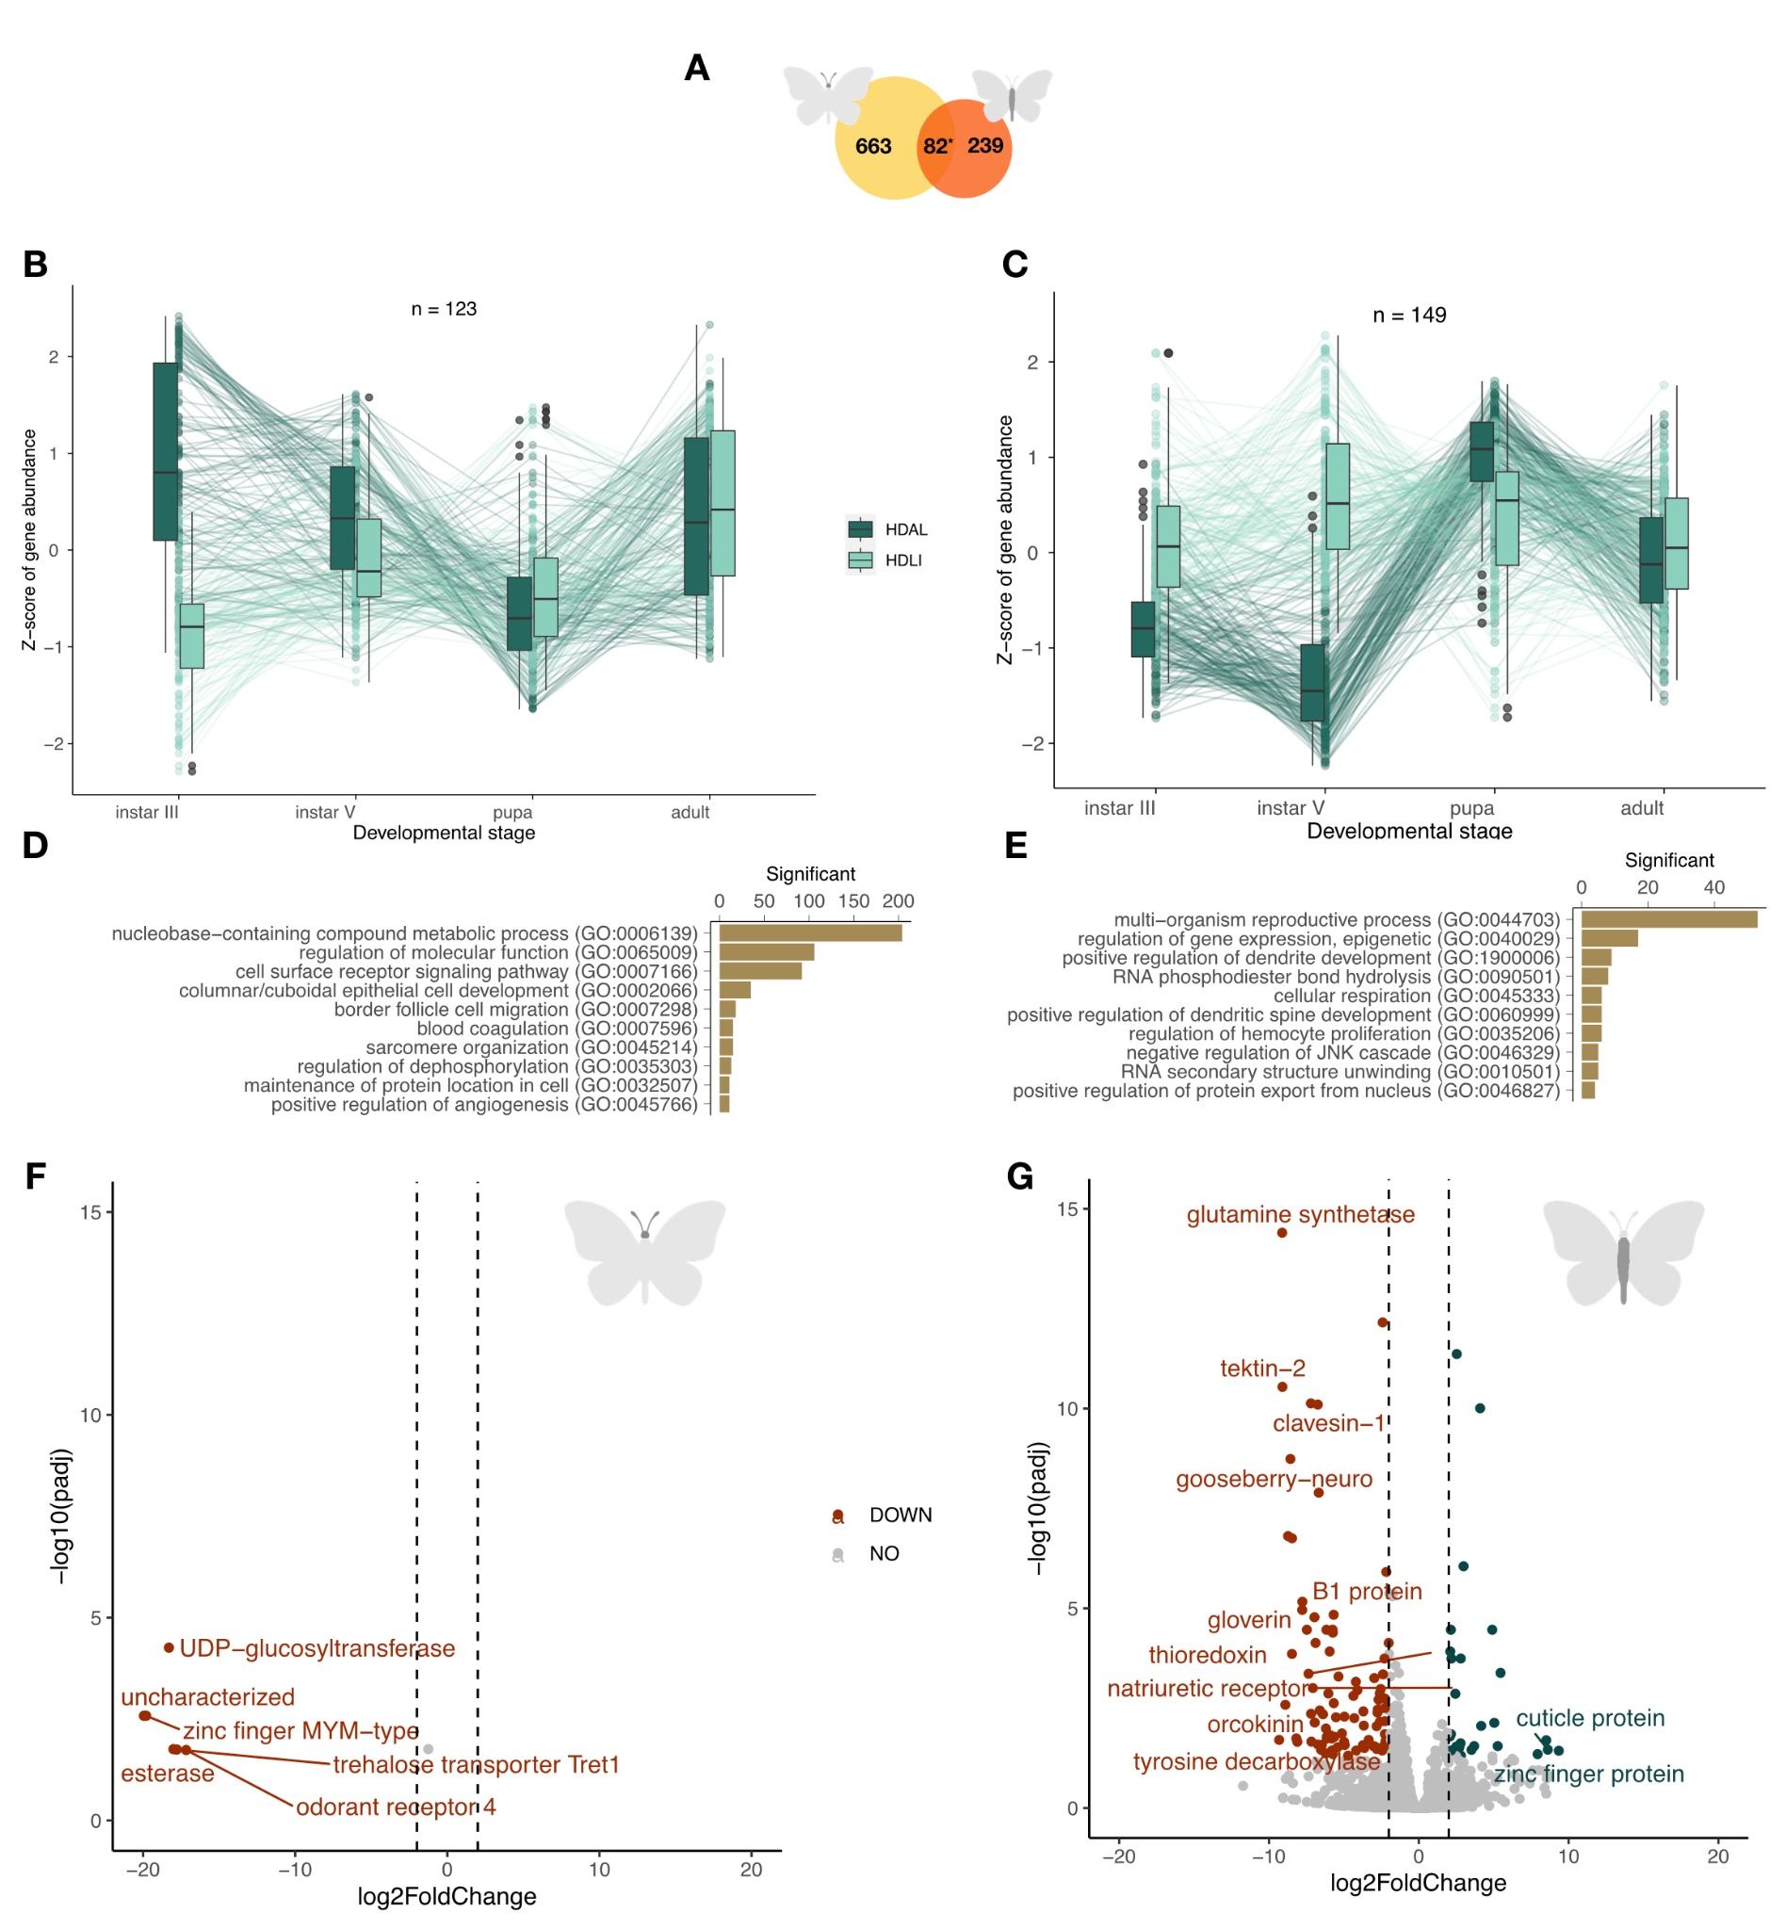

Figure 3. A summary of the results from the comparison between experimental groups with access to different levels of food plants during development. A) A Venn diagram showing the number of differentially expressed genes in each respective tissue (left = head, right = abdomen) and the number of genes with significant different expression in both tissues (center). The star indicates that the number of overlapping genes was significantly higher than expected by chance. B and C) Box plots showing the temporal patterns of differential expression across ontogenetic stages in head B) and abdomen C). Outliers are indicated with circles, temporal trends of gene expression levels for specific genes are illustrated with lines. D and E) The top 10 most significantly overrepresented GO terms (p < 0.01) for differentially expressed genes in head D) and abdomen E), respectively. F and G) Volcano plots showing the relative levels of gene expression in the adult individuals for head F) and abdomen G). Significantly differentially expressed genes (FDR-adjusted p-value < 0.05) with a log fold change difference < |2| are shown in red (significantly lower expression in the treatment where larvae had access to unlimited food [HDAL] than in the treatment where larvae got fed every other day [HDLI]) and teal (significantly higher expression in the treatment where larvae had access to unlimited food [HDAL] than in the treatment where larvae got fed every other day [HDLI]), respectively.

#### *Gene expression variation associated with rearing density during development*

To complement the analysis of gene expression variation associated with food plant availability during development, we also compared treatment groups that were reared at different densities (10 larvae versus 1 larva per flask, HDAL versus LDAL). In this comparison, we found a large number of genes differentially expressed in both head (222 genes) and abdomen (372). There was also a significant overlap between the tissues, i.e. a higher proportion of genes were differentially expressed in both tissues than expected by chance (Jaccard Index = 0.2, p-value = 1.2*10-80; Figure 4A).

To investigate the temporal trajectories of differences in expression patterns between treatment groups during development, we again performed a clustering analysis based on the expression patterns across the different developmental stages. In head tissue, the two main clusters contained 143 (38.4% of the differentially expressed genes in this tissue; Figure 4B) and 69 (18.5%; Supplementary Figure X) genes, respectively. Visual inspection clearly showed that expression differences in instar III and V larvae were driving the overall patterns within these clusters (Figure 4B, Supplementary Figure X). In the abdominal tissue, 83 genes (37.4% of the differentially expressed genes in this tissue) formed a distinct cluster (Figure 4C). Again, this cluster was mainly distinguished by considerable differences in gene expression in the larval stages (Figure 4C).

The gene ontology enrichment analysis of functional roles of differentially expressed genes in these clusters revealed that the most enriched functional category was regulation of filopodia assembly in head (Figure 4D). We also found enrichment of ontology terms related to sperm maturation, ephrin signaling, and several other functional categories (Figure 4D, Supplementary Table X). In abdomen, there was a significant enrichment of GO terms associated with reproductive processes, including functions such as egg formation, egg laying, and mating development (Figure 4E). In addition, there were several enriched terms associated with signal transduction like ephrin signaling, Ras signal transduction (involved in cell growth, division, and differentiation), Notch signaling (associated with neurogenesis) and JNK signaling (regulation of ubiquitin-dependent processes).

Analogous to the analysis based on food plant availability, we compared differences in gene expression between recently emerged females that had experienced different levels of crowding during development (Figure 4 F,G). In this comparison, six genes were significantly differentially expressed in head tissue, of which functional information was available for five (Figure 4F). We found that two copies of the *SUMO ligase* and a *trehalose transporter* were significantly higher expressed in the low density (LDAL) than in the high density treatment group (HDAL). The genes *pickpocket* and *NADH dehydrogenase* in contrast, had significantly higher expression in the HDAL than in the LDAL treatment group. In the abdominal tissue, the *peptidoglycan recognition protein (PGRP)*, *chitinase*, *hemocytin*, D-*arabinitol*, and *NCAM* had significantly higher expression in the LDAL than in the HDAL treatment group, while no genes with known functions had higher expression in HDAL.

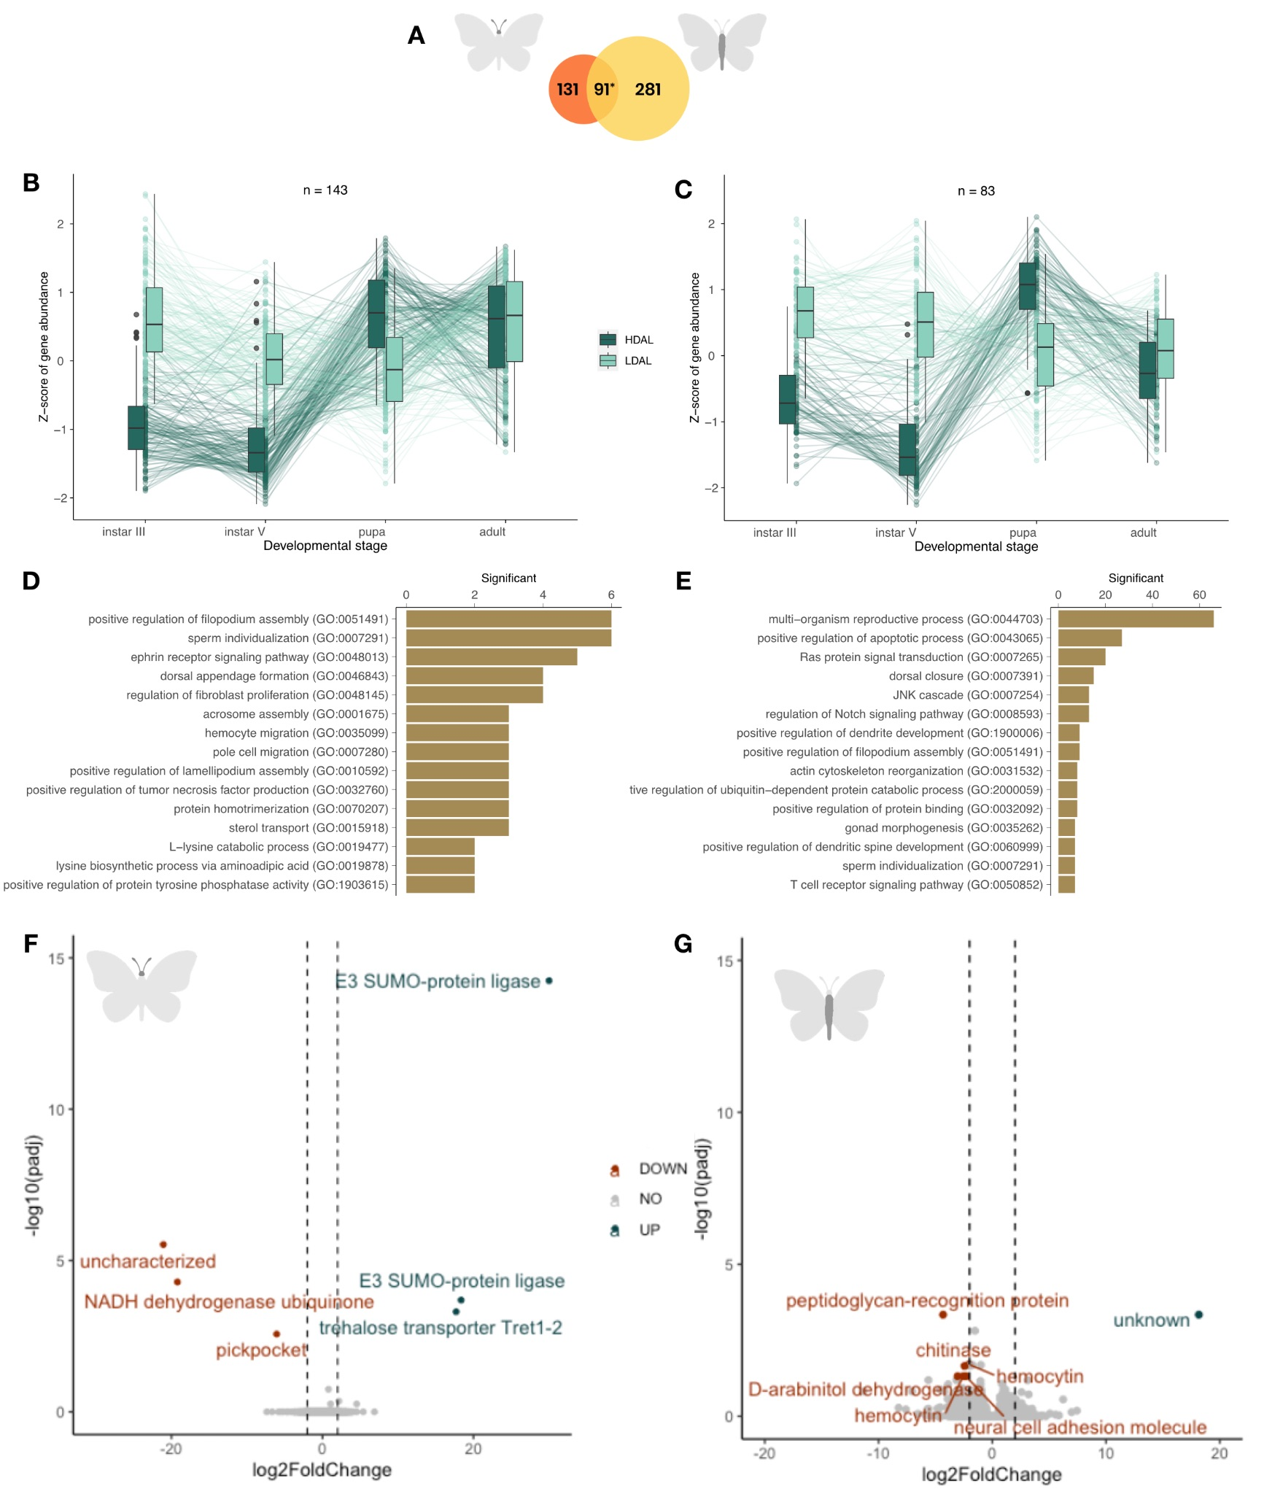

Figure 4. A summary of the results from the comparison between experimental groups which were reared at different densities during development. A) A Venn diagram showing the number of differentially expressed genes in each respective tissue (left = head, right = abdomen) and the number of genes with significant different expression in both tissues (center). The star indicates that the number of overlapping genes was significantly higher than expected by chance. B and C) Box plots showing the temporal patterns of differential expression across ontogenetic stages in head B) and abdomen C). Outliers are indicated with circles, temporal trends of gene expression levels for specific genes are illustrated with lines. D and E) The top 10 most significantly overrepresented GO terms (p < 0.01) for differentially expressed genes in head D) and abdomen E), respectively. F and G) Volcano plots showing the relative levels of gene expression in the adult female individuals for head F) and abdomen G). Significantly differentially expressed genes (FDR-adjusted p-value < 0.05) with a log fold change difference < |2| are shown in red (significantly lower expression in the treatment group where larvae were reared at high density [HDAL] than in the treatment where larvae were reared individually [LDAL]) and teal (significantly higher expression in the treatment where larvae were reared at high density [HDAL] than in the treatment where larvae were reared individually [LDAL), respectively.

## Discussion

*Transcriptomic response to availability of host plants for egg laying in adult female butterflies*

The ability of individuals to rapidly switch between migration and reproduction is a key adaptation for migratory insects in general [(Johnson, 1963; Rankin et al., 1986; Rankin & Burchsted, 1992)](https://www.zotero.org/google-docs/?L0sFME), and for long-distance migrants in particular - for example during fall migration of female monarch butterflies [(Malcolm et al., 2018)](https://www.zotero.org/google-docs/?hxxJTL). In the Monarch butterfly, one of the most extensively studied species, recurrent generations have different needs for resource allocation between flight/dispersal and reproduction (REF). This variation persists irrespective of the presence or absence of the oogenesis-flight syndrome in its classical definition, emphasizing the need for investigating the molecular mechanisms underpinning this trade-off. One important environmental trigger for the initiation (or termination) of migratory behavior is the presence and abundance of host plants for egg laying and as a food resource for developing larvae[(Stefanescu et al., 2021)](https://www.zotero.org/google-docs/?ujybtg)*.*

Our results from the analysis of gene expression variation associated with availability of host plants for egg laying in adult female *V. cardui* underscore the importance of hormonal regulation for the plastic response to host plant abundance – i.e. we found significant changes in expression of multiple genes regulating developmental hormones. Here, *ecdysone oxidase* stood out with its manyfold difference in expression level between experimental groups for both head and abdominal tissue. *Ecdysone oxidase* is a steroid hormone which is crucial for numerous biological processes in metamorphic insects during major developmental transitions, not the least maturation of terminal oocytes and control of oviposition [(D. Cheng et al., 2018; Niwa & Niwa, 2014; Robbins et al., 1968; Swevers & Iatrou, 2003)](https://www.zotero.org/google-docs/?xADbmx). *Ecdysone oxidase* also plays a critical role by converting ecdysone to 3-dehydroecdysone, which triggers a a pathway crucial for the synthesis of active ecdysteroids and facilitates a rapid feedback loop controlling the synthesis of the ecdysone-like hormones [(C.-F. Wang et al., 2018)](https://www.zotero.org/google-docs/?R8KVTI). We propose that the increased expression of *ecdysone oxidase* when host plants for egg laying are available is a crucial factor enabling a rapid response to this cue [(D. Cheng et al., 2018; C.-F. Wang et al., 2018)](https://www.zotero.org/google-docs/?c6QqBn). The orchestration of this process likely involves coregulation of multiple genes discovered as differentially expressed here, which likely are part of the same pathway [(Dubrovsky, 2005)](https://www.zotero.org/google-docs/?aEqKcs). These genes include the JHE (which controls expression of juvenile hormone) [(Dubrovsky, 2005; Herman, 1981; Leyria et al., 2022)](https://www.zotero.org/google-docs/?46aOgU), the *daywake* and *takeout* genes (which are juvenile hormone binding proteins), *nrf-6* (a neuropeptide and hormone receptor) [(Zinke et al., 2002)](https://www.zotero.org/google-docs/?8BttzN), and *cytochrome P450* (which has been shown to control ecdysone biosynthesis) [(Namiki et al., 2005)](https://www.zotero.org/google-docs/?broken=NEis1m). In *V. cardui*, chromatin accessibility profiling has demonstrated that *JHE* is upregulated in adult female butterflies with access to host plants for egg laying(Nasvall, 2023) and *JH* has been shown to be involved in the trade-off between reproduction and flight in other migratory species – for example in the monarch butterfly where *JH* expression is associated with reproductive diapause and migratory behavior [(Green & Kronforst, 2019; Herman, 1981; Herman & Tatar, 2001; Qiu et al., 2023)](https://www.zotero.org/google-docs/?do2d0v). Moreover, *JH* was overexpressed in actively migrating hoverflies in comparison to sedentary individuals [(Doyle et al., 2022)](https://www.zotero.org/google-docs/?broken=DezIKf). Taken together, our observations corroborate that the *ecdysone pathway* and the regulation of *juvenile hormone* play pivotal roles in the plastic responses to environmental cues in insects in general [(Leyria et al., 2022; Qiu et al., 2023)](https://www.zotero.org/google-docs/?jud2D0), and that they therefore may constitute key components in the trade-off between migration and reproduction.

In addition to the activation of hormonal regulation, our results revealed that several immune responses and metabolic processes were differentially affected in adult females exposed to environments with and without host plants for egg laying. Both the fine-tuning of the regulation of immune genes and metabolic processes have been indicated to be crucial for the migration syndrome in general ([Doyle et al., 2022](https://www.zotero.org/google-docs/?broken=laYtMr)). Insects lack self-immunity via antibody production [(Bangham et al., 2006; H. Jiang et al., 2010)](https://www.zotero.org/google-docs/?VNENxz) (Lemaitre et al. 1997; Iwanaga and Lee 2005), and instead depend on cellular responses to neutralize pathogens and a differentially activated immune response can be a plastic response of importance in the trade-off between reproduction and dispersal [(Rankin & Burchsted, 1992)](https://www.zotero.org/google-docs/?tP5O1u). Our results indicate that a diverse range of immune reactions are linked to the environmental cues encountered by adult females. For example, multiple peptidoglycan-recognition proteins (*PGRPs*) – molecules that guide recognition of various pathogens [(Bangham et al., 2006; Tong et al., 2022)](https://www.zotero.org/google-docs/?Zfx1sv) and initiate the TOLL-signaling pathway and induce production of antimicrobial peptides - such as attacin [(Buonocore et al., 2021)](https://www.zotero.org/google-docs/?qqr380), gloverin [(Xu et al., 2015)](https://www.zotero.org/google-docs/?8nlXqD), lysozyme [(In Seok & Yoe, 2005)](https://www.zotero.org/google-docs/?UWv54l), and cecropin [(Kim et al., 2015; Lee et al., 2015; M. Wang et al., 2021)](https://www.zotero.org/google-docs/?dKCMYH) were differentially expressed between the treatment groups. We can of course not link the specific expression patterns of these genes directly to certain behaviors, but immune gene evolution has been shown to be dynamic in migratory species in general (REF) and may be of particular importance in *V. cardui* where several immune genes are uniquely present in multi-copy arrays [(Shipilina et al., 2022)](https://www.zotero.org/google-docs/?xDyvku). In addition to immune response adjustments, efficient utilization of energy is obviously of ultimate importance in migratory species. In insects, fat serves as the most efficient source for storage of energy [(Arrese & Soulages, 2010; Beenakkers et al., 1981)](https://www.zotero.org/google-docs/?2cgl8c) and lipids are indeed the main fuel for flight (REF). Corroborating that pathways involved in metabolism have critical roles in resource allocation trade-offs [(Bhaumik & Kunte, 2020; Brower et al., 2006)](https://www.zotero.org/google-docs/?EF9LJM), we found that host plant availability variation resulted in differential expression of multiple genes associated with lipid and carbohydrate metabolism, for example lipases and XXXX [(Jones et al., 2015)](https://www.zotero.org/google-docs/?Ug79mx).

In summary, our results from the analysis of adult females highlight the central role of hormonal regulation in the response to different environmental cues in butterflies. Although our data and approaches do not allow us to establish a causative association between host plant availability and investment in reproduction or migration *per se*, the gene expression analysis revealed a set of candidate genes that can be used to investigate the molecular underpinnings of the reproduction-migration trade-off in more detail. The next step will be to target key genes in the regulatory pathways detected here, with a particular focus on the ecdysone pathway. It should be noted that the trade-off between reproduction and migration in adult butterflies is likely not exclusively dictated by environmental cues encountered after emergence. Previous investigations have shown that environmental conditions experienced during development can impact this decision. In the next steps, we therefore continue by exploring how differences in food plant availability and crowding affect the expression profiles across ontogenetic shifts, from larvae to imagines.

*Effects on gene expression by differences in food plant availability and rearing density during development*

Both crowding and food resource availability have been shown to impact the development and morphology of migratory insects in general [(Applebaum & Heifetz, 1999; Bauerfeind & Fischer, 2005; Bhavanam & Trewick, 2022; S. Wang et al., 2023; F. Yang et al., 2015)](https://www.zotero.org/google-docs/?coMm2R), and to affect the flight response norms and migration propensity specifically [(Bhavanam & Trewick, 2022)](https://www.zotero.org/google-docs/?vWgmh6). Here we analyzed how gene expression varied across developmental stages in experimental cohorts exposed to differences in crowding and food plant availability in *V.cardui*. Our experimental setup enabled us to assess the individual effects of both rearing density and food availability and gain understanding of their potential combined influence, as the treatment groups were partly overlapping.

Environmental stress induced significant differences in gene expression in both periodic starvation and larval crowding experiments. Notably, transcriptomic signatures revealed developmental alterations, affecting pathways in nearly all organ systems (Figures 2 D,E and 3 D,E). For instance, candidate genes were associated with ontology terms such as epithelial cell and dendrite development, sarcomere organization, angiogenesis, and hemocyte proliferation. It was previously shown that individuals experiencing starvation stress often exhibit delayed development [(Chen & Ruberson, 2008)](https://www.zotero.org/google-docs/?xDYbuY), may extend their larval stages, and as a consequence face reduction of the body size [(Bauerfeind & Fischer, 2005; Boggs & Freeman, 2005; Chen & Ruberson, 2008; Niitepõld, 2019; Niitepõld & Boggs, 2022; F. Yang et al., 2015)](https://www.zotero.org/google-docs/?Nzv8bZ). In *Vanessa cardui* in particular food limitation it is shown to be associated with developmental delay in pupation and subsequent adult emergence [(Kelly & Debinski, 1999)](https://www.zotero.org/google-docs/?Cnqk2h). Similarly a close link is established between larval density and developmental processes [(Applebaum & Heifetz, 1999; Bauerfeind & Fischer, 2005; Bhavanam & Trewick, 2022; Plazio et al., 2020; S. Wang et al., 2023; F. Yang et al., 2015)](https://www.zotero.org/google-docs/?D94zPT). Overall, our observations are in agreement with multitude of evidence in Lepidoptera [(reviewed in Boggs & Freeman, 2005)](https://www.zotero.org/google-docs/?4tE68V), underscore molecular basis of developmental alteration and suggest a strong link between environmental stress and developmental plasticity.

Another common observation in response to both environmental stressors is alternation of metabolism, observed both during developmental stages and resulting expression in adults. More than 200 differentially expressed genes in starvation treatment are associated with the compound metabolic process. In adults we see down regulation of trehalose (blood-sugar) transporter (Tret1) responsible for fat transport [(Kikawada et al., 2007)](https://www.zotero.org/google-docs/?broken=MAGuz4) and clavesin, known to bind small lipophilic molecules [(Smith & Briscoe, 2015)](https://www.zotero.org/google-docs/?broken=lht0F2). TRET1 is a key gene involved in transporting trehalose (insect blood sugar) synthesized in the fat body into the hemolymph [(Kikawada et al., 2007)](https://www.zotero.org/google-docs/?broken=Ad6TS5). Among other candidate genes differentially expressed in adults exclusively are metabolic genes NADH dehydrogenase and several chitinases (chitin metabolism).

While showing some common features differential expression in two experiments showed some noticeable specificities. Noticeably, food limitation treatment appeared to specifically affect neural development. For example we observed downregulation of gooseberry-neuro (GsbN) transcription factor responsible for central nervous system development [(Bonneaud et al., 2017)](https://www.zotero.org/google-docs/?frLIV1), glutamine synthetase glial neurotransmitter recycling protein [(Brunet Avalos et al., 2019; Huang et al., 2015)](https://www.zotero.org/google-docs/?6mr2H5) and neuropeptide orcokinin [(Tanaka, 2016)](https://www.zotero.org/google-docs/?N2VJ8K). In addition or as a consequence of neural development alteration, two candidate genes pointed to activation of environmental sensing in adult individuals, which have not experienced food stress as larva. Odorant receptor 4 and esterase (odorant degrading protein) [(Godoy et al., 2021)](https://www.zotero.org/google-docs/?vFJ6yo) are responsible for processing of olfactory signals in insects, which can be crucial to the successful mating of insects, locating of host plants for oviposition and food sources. Neural development and sensing are of particular importance for migratory insect development as it can largely influence plasticity of the environmental response in adults [(Zhang et al., 2019)](https://www.zotero.org/google-docs/?0mihtd).

Similarly a close link is established between larval density and developmental processes [(Applebaum & Heifetz, 1999; Bauerfeind & Fischer, 2005; Bhavanam & Trewick, 2022; Plazio et al., 2020; S. Wang et al., 2023; F. Yang et al., 2015)](https://www.zotero.org/google-docs/?D94zPT). The larval density experiment triggered differential expression of genes that are related to development in general and development of reproductive system in particular, as illustrated by specific gene ontology terms, such as sperm individualization and gonad morphogenesis. Interestingly, some Lepidoptera such as *Plodia interpunctella*, and *Mythimna separata* increase their sperm production in response to crowding [(Gage, 1995; He & Miyata, 1997)](https://www.zotero.org/google-docs/?2juA7Y). Another specificity of transcriptomic response to larval crowding is an increased signal of changes in programmed cell death: differential expression of E3-type small ubiquitin-like modifier (SUMO) [(Enserink, 2015)](https://www.zotero.org/google-docs/?3q3BfT), enrichment of genes in JNK, Ras signaling pathways [(Lehembre et al., 2000; Ureña et al., 2016)](https://www.zotero.org/google-docs/?vQFqPY). Programmed cell death is a crucial process for insect development, since metamorphic stages involve multiple self-destructive mechanisms [(Tettamanti & Casartelli, 2019)](https://www.zotero.org/google-docs/?722FBv).

​

Since the analysis spanned multiple developmental stages, from larval instar III to recently emerged imagines, we also gained insights into the temporal variation in gene expression and identified critical developmental periods where the effect was particularly pronounced. In the experiment where we investigated the effects of larval crowding, we noted that the most pronounced difference in gene expression between experimental groups was in larval instar V. This is the last larval stage of *V. cardui* and represents a crucial developmental point in the life cycle of insects [(Truman & Riddiford, 2019; C.-H. Yang et al., 2016)](https://www.zotero.org/google-docs/?lt8aCg), since it provides the last opportunity to respond to environmental cues before metamorphosis. In general, the last larval stage is accompanied by rapid growth and considerable physiological changes and environmental shifts during this time period can have particular importance for plastic responses [(Mirth et al., 2021)](https://www.zotero.org/google-docs/?OYEYoR).

## Conclusions

We provided new insights into the complex response to environmental cues and connected them to the migratory syndrome in highly migratory butterflies. Signatures consistent with the oogenesis-flight syndrome were observed in a host plant experiment, which aimed to initiate the trade-off between migration and reproduction. This highlighted the crucial role of hormonal regulation in this response. We examined the early predisposition for migratory plasticity by subjecting larvae to different environmental cues, such as food abundance and larval crowding. This experiment allowed us to closely examine the timing of the environmental cue perception and track this process throughout development. We obtained the first glimpse of the timing of such a response and identified the peak of the response during the last larval stage, indicating its importance in developmental regulation and metabolism. Furthermore, this led us to identify genes and pathways that jointly contribute to the migratory syndrome.

## Data access

RNA-seq data are available at the European Nucleotide Archive under XXXXXXXX. Scripts are available on GitHub in the following repository: XXXXX.

## Acknowledgements

This work was funded by a research grant from the Swedish Research Council FORMAS (grant # 2019-00670) and The Swedish Collegium for Advanced Science (Natural Sciences Programme, Knut and Alice Wallenberg Foundation, Postdoc funding for DS). RV was supported by Grant PID2022-139689NB-I00 funded by MCIN/AEI/ 10.13039/501100011033 and by ERDF A way of making Europe, and by Departament de Recerca i Universitats de la Generalitat de Catalunya grant 2021 SCR 00420. GT was supported by grants PID2020-117739GA-I00 MCIN / AEI / 10.13039/501100011033 and WW1-300R-18 (National Geographic Society); and by grant LINKA20399 from the CSIC iLink program to NB, CB and GT. The authors acknowledge support from the National Genomics Infrastructure in Stockholm funded by Science for Life Laboratory, the Knut and Alice Wallenberg Foundation and the Swedish Research Council, and SNIC/Uppsala Multidisciplinary Center for Advanced Computational Science for assistance with massively parallel sequencing and access to the UPPMAX computational infrastructure. The computations were enabled by resources provided by the National Academic Infrastructure for Supercomputing in Sweden (NAISS) and the Swedish National Infrastructure for Computing (SNIC) in Uppsala, partially funded by the Swedish Research Council through grant agreements no. 2022-06725 and no. 2018-05973. We thank Jesper Boman and all members of the Backström lab for helpful discussions.

## Bibliography

[Adrian Alexa, J. R. (2017). *TopGO* [Computer software]. Bioconductor. https://doi.org/10.18129/B9.BIOC.TOPGO](https://www.zotero.org/google-docs/?DlmmvW)

[Aidley, D. J. (Ed.). (1981). *Animal migration*. Cambridge University Press.](https://www.zotero.org/google-docs/?DlmmvW)

[Altschul, S. F., Gish, W., Miller, W., Myers, E. W., & Lipman, D. J. (1990). Basic Local Alignment Search Tool. *Journal of Molecular Biology*, *215*(3), 403–410. https://doi.org/10.1016/S0022-2836(05)80360-2](https://www.zotero.org/google-docs/?DlmmvW)

[Angelo, M. J., & Jr., F. S. (1984). Body Building by Insects: Trade-Offs in Resource Allocation with Particular Reference to Migratory Species. *The Florida Entomologist*, *67*(1), 22. https://doi.org/10.2307/3494102](https://www.zotero.org/google-docs/?DlmmvW)

[Applebaum, S. W., & Heifetz, Y. (1999). DENSITY-DEPENDENT PHYSIOLOGICAL PHASE IN INSECTS. *Annual Review of Entomology*, *44*(1), 317–341. https://doi.org/10.1146/annurev.ento.44.1.317](https://www.zotero.org/google-docs/?DlmmvW)

[Arrese, E. L., & Soulages, J. L. (2010). Insect Fat Body: Energy, Metabolism, and Regulation. *Annual Review of Entomology*, *55*(1), 207–225. https://doi.org/10.1146/annurev-ento-112408-085356](https://www.zotero.org/google-docs/?DlmmvW)

[Bangham, J., Jiggins, F., & Lemaitre, B. (2006). Insect Immunity: The Post-Genomic Era. *Immunity*, *25*(1), 1–5. https://doi.org/10.1016/j.immuni.2006.07.002](https://www.zotero.org/google-docs/?DlmmvW)

[Bauerfeind, S. S., & Fischer, K. (2005). Effects of food stress and density in different life stages on reproduction in a butterfly. *Oikos*, *111*(3), 514–524. https://doi.org/10.1111/j.0030-1299.2005.13888.x](https://www.zotero.org/google-docs/?DlmmvW)

[Beenakkers, A. M. T., Van Der Horst, D. J., & Van Marrewijk, W. J. A. (1981). Role of Lipids in Energy Metabolism. In R. G. H. Downer (Ed.), *Energy Metabolism in Insects* (pp. 53–100). Springer US. https://doi.org/10.1007/978-1-4615-9221-1_3](https://www.zotero.org/google-docs/?DlmmvW)

[Bhaumik, V., & Kunte, K. (2018). Female butterflies modulate investment in reproduction and flight in response to monsoon-driven migrations. *Oikos*, *127*(2), 285–296. https://doi.org/10.1111/oik.04593](https://www.zotero.org/google-docs/?DlmmvW)

[Bhaumik, V., & Kunte, K. (2020). Dispersal and migration have contrasting effects on butterfly flight morphology and reproduction. *Biology Letters*, *16*(8), 20200393. https://doi.org/10.1098/rsbl.2020.0393](https://www.zotero.org/google-docs/?DlmmvW)

[Bhavanam, S., & Trewick, S. A. (2022). Effects of population density on adult morphology and life-history traits of female Mediterranean flour moth, Ephestia kuehniella (Lepidoptera: Pyralidae). *European Journal of Entomology*, *119*, 191–200. https://doi.org/10.14411/eje.2022.021](https://www.zotero.org/google-docs/?DlmmvW)

[Boggs, C. L., & Freeman, K. D. (2005). Larval food limitation in butterflies: Effects on adult resource allocation and fitness. *Oecologia*, *144*(3), 353–361. https://doi.org/10.1007/s00442-005-0076-6](https://www.zotero.org/google-docs/?DlmmvW)

[Boman, J., Zhu, Y., Höök, L., Vila, R., Talavera, G., & Backström, N. (2023). Environmental stress during larval development induces DNA methylation shifts in the migratory painted lady butterfly ( *Vanessa cardui* ). *Molecular Ecology*, *32*(13), 3513–3523. https://doi.org/10.1111/mec.16957](https://www.zotero.org/google-docs/?DlmmvW)

[Bonneaud, N., Layalle, S., Colomb, S., Jourdan, C., Ghysen, A., Severac, D., Dantec, C., Nègre, N., & Maschat, F. (2017). Control of nerve cord formation by Engrailed and Gooseberry-Neuro: A multi-step, coordinated process. *Developmental Biology*, *432*(2), 273–285. https://doi.org/10.1016/j.ydbio.2017.10.018](https://www.zotero.org/google-docs/?DlmmvW)

[Brower, L. P., Fink, L. S., & Walford, P. (2006). Fueling the Fall Migration of the Monarch Butterfly. *Integrative and Comparative Biology*, *46*(6), 1123–1142. https://doi.org/10.1093/icb/icl029](https://www.zotero.org/google-docs/?DlmmvW)

[Brunet Avalos, C., Maier, G. L., Bruggmann, R., & Sprecher, S. G. (2019). Single cell transcriptome atlas of the Drosophila larval brain. *ELife*, *8*, e50354. https://doi.org/10.7554/eLife.50354](https://www.zotero.org/google-docs/?DlmmvW)

[Buonocore, F., Fausto, A. M., Della Pelle, G., Roncevic, T., Gerdol, M., & Picchietti, S. (2021). Attacins: A Promising Class of Insect Antimicrobial Peptides. *Antibiotics*, *10*(2), 212. https://doi.org/10.3390/antibiotics10020212](https://www.zotero.org/google-docs/?DlmmvW)

[Chen, Y., & Ruberson, J. R. (2008). Starvation Effects on Larval Development of Beet Armyworm (Lepidoptera: Noctuidae). *Journal of Entomological Science*, *43*(2), 247–253. https://doi.org/10.18474/0749-8004-43.2.247](https://www.zotero.org/google-docs/?DlmmvW)

[Cheng, D., Cheng, T., Yang, X., Zhang, Q., Fu, J., Feng, T., Gong, J., & Xia, Q. (2018). The Genome-Wide Transcriptional Regulatory Landscape of Ecdysone in the Silkworm. *Epigenetics & Chromatin*, *11*(1), 48. https://doi.org/10.1186/s13072-018-0216-y](https://www.zotero.org/google-docs/?DlmmvW)

[Cheng, Y. X., Luo, L. Z., Jiang, X. F., & Sappington, T. W. (2012). Synchronized Oviposition Triggered by Migratory Flight Intensifies Larval Outbreaks of Beet Webworm. *PLoS ONE*, *7*(2), e31562. https://doi.org/10.1371/journal.pone.0031562](https://www.zotero.org/google-docs/?DlmmvW)

[Chowdhury, S., Fuller, R. A., Dingle, H., Chapman, J. W., & Zalucki, M. P. (2021). Migration in Butterflies: A Global Overview. *Biological Reviews*, *96*(4), 1462–1483. https://doi.org/10.1111/brv.12714](https://www.zotero.org/google-docs/?DlmmvW)

[Di Tommaso, P., Chatzou, M., Floden, E. W., Barja, P. P., Palumbo, E., & Notredame, C. (2017). Nextflow enables reproducible computational workflows. *Nature Biotechnology*, *35*(4), 316–319. https://doi.org/10.1038/nbt.3820](https://www.zotero.org/google-docs/?DlmmvW)

[Dingle, H. (Ed.). (1978). *Evolution of Insect Migration and Diapause*. Springer US. https://doi.org/10.1007/978-1-4615-6941-1](https://www.zotero.org/google-docs/?DlmmvW)

[Dingle, H. (2001). The evolution of migratory syndromes in insects. In I. P. Woiwood, D. R. Reynolds, & C. D. Thomas (Eds.), *Insect movement: Mechanisms and consequences. Proceedings of the Royal Entomological Society’s 20th Symposium, London, UK, September 1999* (1st ed., pp. 159–181). CABI Publishing. https://doi.org/10.1079/9780851994567.0159](https://www.zotero.org/google-docs/?DlmmvW)

[Dobin, A., Davis, C. A., Schlesinger, F., Drenkow, J., Zaleski, C., Jha, S., Batut, P., Chaisson, M., & Gingeras, T. R. (2013). STAR: Ultrafast universal RNA-seq aligner. *Bioinformatics*, *29*(1), 15–21. https://doi.org/10.1093/bioinformatics/bts635](https://www.zotero.org/google-docs/?DlmmvW)

[Dubrovsky, E. (2005). Hormonal cross talk in insect development. *Trends in Endocrinology and Metabolism*, *16*(1), 6–11. https://doi.org/10.1016/j.tem.2004.11.003](https://www.zotero.org/google-docs/?DlmmvW)

[Enserink, J. M. (2015). Sumo and the cellular stress response. *Cell Division*, *10*(1), 4. https://doi.org/10.1186/s13008-015-0010-1](https://www.zotero.org/google-docs/?DlmmvW)

[Ewels, P. A., Peltzer, A., Fillinger, S., Patel, H., Alneberg, J., Wilm, A., Garcia, M. U., Di Tommaso, P., & Nahnsen, S. (2020). The nf-core framework for community-curated bioinformatics pipelines. *Nature Biotechnology*, *38*(3), 276–278. https://doi.org/10.1038/s41587-020-0439-x](https://www.zotero.org/google-docs/?DlmmvW)

[Gage, M. J. G. (1995). Continuous variation in reproductive strategy as an adaptive response to population density in the moth *Plodia interpunctella*. *Proceedings of the Royal Society of London. Series B: Biological Sciences*, *261*(1360), 25–30. https://doi.org/10.1098/rspb.1995.0112](https://www.zotero.org/google-docs/?DlmmvW)

[García‐Berro, A., Talla, V., Vila, R., Wai, H. K., Shipilina, D., Chan, K. G., Pierce, N. E., Backström, N., & Talavera, G. (2023). Migratory behaviour is positively associated with genetic diversity in butterflies. *Molecular Ecology*, *32*(3), 560–574. https://doi.org/10.1111/mec.16770](https://www.zotero.org/google-docs/?DlmmvW)

[Gasking Butler, C., & Innes, J. M. (1936). A comparison of the rate of metabolic activity in the solitary and migratory phases of *Locusta migratoria*. *Proceedings of the Royal Society of London. Series B - Biological Sciences*, *119*(814), 296–304. https://doi.org/10.1098/rspb.1936.0011](https://www.zotero.org/google-docs/?DlmmvW)

[Godoy, R., Machuca, J., Venthur, H., Quiroz, A., & Mutis, A. (2021). An Overview of Antennal Esterases in Lepidoptera. *Frontiers in Physiology*, *12*, 643281. https://doi.org/10.3389/fphys.2021.643281](https://www.zotero.org/google-docs/?DlmmvW)

[Green, D. A., & Kronforst, M. R. (2019). Monarch butterflies use an environmentally sensitive, internal timer to control overwintering dynamics. *Molecular Ecology*, *28*(16), 3642–3655. https://doi.org/10.1111/mec.15178](https://www.zotero.org/google-docs/?DlmmvW)

[Guerra, P. A. (2011). Evaluating the life-history trade-off between dispersal capability and reproduction in wing dimorphic insects: A meta-analysis. *Biological Reviews*, *86*(4), 813–835. https://doi.org/10.1111/j.1469-185X.2010.00172.x](https://www.zotero.org/google-docs/?DlmmvW)

[Hanski, I., Saastamoinen, M., & Ovaskainen, O. (2006). Dispersal-related life-history trade-offs in a butterfly metapopulation. *Journal of Animal Ecology*, *75*(1), 91–100. https://doi.org/10.1111/j.1365-2656.2005.01024.x](https://www.zotero.org/google-docs/?DlmmvW)

[Harringmeyer, O. S., Woolfolk, M. L., & Hoekstra, H. E. (2021). Fishing for the genetic basis of migratory behavior. *Cell*, *184*(2), 303–305. https://doi.org/10.1016/j.cell.2020.12.037](https://www.zotero.org/google-docs/?DlmmvW)

[Harshil Patel, Ewels, P., Peltzer, A., Botvinnik, O., Sturm, G., Moreno, D., Pranathi Vemuri, Garcia, M. U., Silviamorins, Pantano, L., Binzer-Panchal, M., Nf-Core Bot, Syme, R., Zepper, M., Kelly, G., Hanssen, F., Yates, J. A. F., Cheshire, C., Rfenouil, … Di Tommaso, P. (2023). *nf-core/rnaseq: Nf-core/rnaseq v3.12.0 - Osmium Octopus* (3.12.0) [Computer software]. Zenodo. https://doi.org/10.5281/ZENODO.1400710](https://www.zotero.org/google-docs/?DlmmvW)

[He, Y., & Miyata, T. (1997). Variations in sperm number in relation to larval crowding and spermatophore size in the armyworm, *Pseudaletia separata*. *Ecological Entomology*, *22*(1), 41–46. https://doi.org/10.1046/j.1365-2311.1997.00030.x](https://www.zotero.org/google-docs/?DlmmvW)

[Herman, W. S. (1981). STUDIES ON THE ADULT REPRODUCTIVE DIAPAUSE OF THE MONARCH BUTTERFLY, *DANAUS PLEXIPPUS*. *The Biological Bulletin*, *160*(1), 89–106. https://doi.org/10.2307/1540903](https://www.zotero.org/google-docs/?DlmmvW)

[Herman, W. S., & Tatar, M. (2001). Juvenile hormone regulation of longevity in the migratory monarch butterfly. *Proceedings of the Royal Society of London. Series B: Biological Sciences*, *268*(1485), 2509–2514. https://doi.org/10.1098/rspb.2001.1765](https://www.zotero.org/google-docs/?DlmmvW)

[Huang, Y., Ng, F. S., & Jackson, F. R. (2015). Comparison of Larval and Adult *Drosophila* Astrocytes Reveals Stage-Specific Gene Expression Profiles. *G3 Genes|Genomes|Genetics*, *5*(4), 551–558. https://doi.org/10.1534/g3.114.016162](https://www.zotero.org/google-docs/?DlmmvW)

[In Seok, B., & Yoe, S. M. (2005). Purification and cDNA Cloning of Lysozyme II from Cabbage Butterfly, Artogeia rapae Larvae. *Entomological Research*, *35*(4), 207–211. https://doi.org/10.1111/j.1748-5967.2005.tb00161.x](https://www.zotero.org/google-docs/?DlmmvW)

[Jiang, H., Vilcinskas, A., & Kanost, M. R. (2010). Immunity in Lepidopteran Insects. In K. Söderhäll (Ed.), *Invertebrate Immunity* (Vol. 708, pp. 181–204). Springer US. https://doi.org/10.1007/978-1-4419-8059-5_10](https://www.zotero.org/google-docs/?DlmmvW)

[Jiang, T., Ma, L., Liu, X.-Y., Xiao, H.-J., & Zhang, W.-N. (2019). Effects of starvation on respiratory metabolism and energy metabolism in the cotton bollworm Helicoverpa armigera (Hübner) (Lepidoptera: Noctuidae). *Journal of Insect Physiology*, *119*, 103951. https://doi.org/10.1016/j.jinsphys.2019.103951](https://www.zotero.org/google-docs/?DlmmvW)

[Johnson, C. G. (1963). Physiological Factors in Insect Migration by Flight. *Nature*, *198*(4879), 423–427. https://doi.org/10.1038/198423a0](https://www.zotero.org/google-docs/?DlmmvW)

[Jones, C. M., Papanicolaou, A., Mironidis, G. K., Vontas, J., Yang, Y., Lim, K. S., Oakeshott, J. G., Bass, C., & Chapman, J. W. (2015). Genomewide transcriptional signatures of migratory flight activity in a globally invasive insect pest. *Molecular Ecology*, *24*(19), 4901–4911. https://doi.org/10.1111/mec.13362](https://www.zotero.org/google-docs/?DlmmvW)

[Kang, L., Chen, X., Zhou, Y., Liu, B., Zheng, W., Li, R., Wang, J., & Yu, J. (2004). The Analysis of Large-Scale Gene Expression Correlated to the Phase Changes of the Migratory Locust. *Proceedings of the National Academy of Sciences*, *101*(51), 17611–17615. https://doi.org/10.1073/pnas.0407753101](https://www.zotero.org/google-docs/?DlmmvW)

[Kelly, L., & Debinski, D. M. (1999). Effects of Larval Food-limitation on Vanessa cardui Linnaeus (Lepidoptera: Nymphalidae). *The American Midland Naturalist*, *141*(2), 315–322. https://doi.org/10.1674/0003-0031(1999)141[0315:EOLFLO]2.0.CO;2](https://www.zotero.org/google-docs/?DlmmvW)

[Kim, S.-R., Choi, K.-H., Kim, S.-W., Hwang, J.-S., Goo, T.-W., & Kim, I. (2015). Molecular cloning of a novel cecropin-like peptide gene from the swallowtail butterfly, Papilio xuthus. *International Journal of Industrial Entomology*, *31*(2), 79–84. https://doi.org/10.7852/IJIE.2015.31.2.79](https://www.zotero.org/google-docs/?DlmmvW)

[Lee, E., Shin, A., & Kim, Y. (2015). ANTI-INFLAMMATORY ACTIVITIES OF CECROPIN A AND ITS MECHANISM OF ACTION: Anti-Inflammatory Activities of Cecropin A. *Archives of Insect Biochemistry and Physiology*, *88*(1), 31–44. https://doi.org/10.1002/arch.21193](https://www.zotero.org/google-docs/?DlmmvW)

[Lehembre, F., Badenhorst, P., Müller, S., Travers, A., Schweisguth, F., & Dejean, A. (2000). Covalent Modification of the Transcriptional Repressor Tramtrack by the Ubiquitin-Related Protein Smt3 in *Drosophila* Flies. *Molecular and Cellular Biology*, *20*(3), 1072–1082. https://doi.org/10.1128/MCB.20.3.1072-1082.2000](https://www.zotero.org/google-docs/?DlmmvW)

[Leyria, J., Benrabaa, S., Nouzova, M., Noriega, F. G., Tose, L. V., Fernandez-Lima, F., Orchard, I., & Lange, A. B. (2022). Crosstalk between Nutrition, Insulin, Juvenile Hormone, and Ecdysteroid Signaling in the Classical Insect Model, Rhodnius prolixus. *International Journal of Molecular Sciences*, *24*(1), 7. https://doi.org/10.3390/ijms24010007](https://www.zotero.org/google-docs/?DlmmvW)

[Li Shen, M. S. <Shenli S. C. (2017). *GeneOverlap* [Computer software]. Bioconductor. https://doi.org/10.18129/B9.BIOC.GENEOVERLAP](https://www.zotero.org/google-docs/?DlmmvW)

[Liedvogel, M., Åkesson, S., & Bensch, S. (2011). The Genetics of Migration on the Move. *Trends in Ecology & Evolution*, *26*(11), 561–569. https://doi.org/10.1016/j.tree.2011.07.009](https://www.zotero.org/google-docs/?DlmmvW)

[Lohse, K., Wright, C., Talavera, G., García-Berro, A., Darwin Tree of Life Barcoding collective, Wellcome Sanger Institute Tree of Life programme, Wellcome Sanger Institute Scientific Operations: DNA Pipelines collective, Tree of Life Core Informatics collective, & Darwin Tree of Life Consortium. (2021). The genome sequence of the painted lady, Vanessa cardui Linnaeus 1758. *Wellcome Open Research*, *6*, 324. https://doi.org/10.12688/wellcomeopenres.17358.1](https://www.zotero.org/google-docs/?DlmmvW)

[Love, M. I., Huber, W., & Anders, S. (2014). Moderated estimation of fold change and dispersion for RNA-seq data with DESeq2. *Genome Biology*, *15*(12), 550. https://doi.org/10.1186/s13059-014-0550-8](https://www.zotero.org/google-docs/?DlmmvW)

[Malcolm, S. B., Vargas, N. R., Rowe, L., Stevens, J., Armagost, J. E., & Johnson, A. C. (2018). Sequential Partial Migration Across Monarch Generations in Michigan. *Animal Migration*, *5*(1), 104–114. https://doi.org/10.1515/ami-2018-0007](https://www.zotero.org/google-docs/?DlmmvW)

[Martin, M. (2011). Cutadapt removes adapter sequences from high-throughput sequencing reads. *EMBnet.Journal*, *17*(1), 10. https://doi.org/10.14806/ej.17.1.200](https://www.zotero.org/google-docs/?DlmmvW)

[Merlin, C., Iiams, S. E., & Lugena, A. B. (2020). Monarch Butterfly Migration Moving into the Genetic Era. *Trends in Genetics*, *36*(9), 689–701. https://doi.org/10.1016/j.tig.2020.06.011](https://www.zotero.org/google-docs/?DlmmvW)

[Mirth, C. K., Saunders, T. E., & Amourda, C. (2021). Growing Up in a Changing World: Environmental Regulation of Development in Insects. *Annual Review of Entomology*, *66*(1), 81–99. https://doi.org/10.1146/annurev-ento-041620-083838](https://www.zotero.org/google-docs/?DlmmvW)

[Näsvall, K., Shipilina, D., Vila, R., Talavera, G., & Backstrom, N. (2023). *Resource availability affects activity profiles of regulatory elements in a long-distance butterfly migrant* [Preprint]. Preprints. https://doi.org/10.22541/au.167827909.99815237/v1](https://www.zotero.org/google-docs/?DlmmvW)

[Niitepõld, K. (2019). Effects of flight and food stress on energetics, reproduction, and lifespan in the butterfly Melitaea cinxia. *Oecologia*, *191*(2), 271–283. https://doi.org/10.1007/s00442-019-04489-8](https://www.zotero.org/google-docs/?DlmmvW)

[Niitepõld, K., & Boggs, C. L. (2022). Carry‐over effects of larval food stress on adult energetics and life history in a nectar‐feeding butterfly. *Ecological Entomology*, *47*(3), 391–399. https://doi.org/10.1111/een.13124](https://www.zotero.org/google-docs/?DlmmvW)

[Niwa, R., & Niwa, Y. S. (2014). Enzymes for ecdysteroid biosynthesis: Their biological functions in insects and beyond. *Bioscience, Biotechnology, and Biochemistry*, *78*(8), 1283–1292. https://doi.org/10.1080/09168451.2014.942250](https://www.zotero.org/google-docs/?DlmmvW)

[Oliveira, G. A., Baptista, D. L., Guimarães-Motta, H., Almeida, I. C., Masuda, H., & Atella, G. C. (2006). Flight-oogenesis syndrome in a blood-sucking bug: Biochemical aspects of lipid metabolism. *Archives of Insect Biochemistry and Physiology*, *62*(4), 164–175. https://doi.org/10.1002/arch.20132](https://www.zotero.org/google-docs/?DlmmvW)

[Patro, R., Duggal, G., Love, M. I., Irizarry, R. A., & Kingsford, C. (2017). Salmon provides fast and bias-aware quantification of transcript expression. *Nature Methods*, *14*(4), 417–419. https://doi.org/10.1038/nmeth.4197](https://www.zotero.org/google-docs/?DlmmvW)

[Plazio, E., Margol, T., & Nowicki, P. (2020). Intersexual differences in density‐dependent dispersal and their evolutionary drivers. *Journal of Evolutionary Biology*, *33*(10), 1495–1506. https://doi.org/10.1111/jeb.13688](https://www.zotero.org/google-docs/?DlmmvW)

[Qiu, J., Dai, T., Luo, C., Cui, W., Liu, K., Li, J., Sima, Y., & Xu, S. (2023). Circadian clock regulates developmental time through ecdysone and juvenile hormones in *Bombyx mori*. *Insect Molecular Biology*, imb.12835. https://doi.org/10.1111/imb.12835](https://www.zotero.org/google-docs/?DlmmvW)

[Rankin, M. A., & Burchsted, J. C. A. (1992). The Cost of Migration in Insects. *Annual Review of Entomology*, *37*(1), 533–559. https://doi.org/10.1146/annurev.en.37.010192.002533](https://www.zotero.org/google-docs/?DlmmvW)

[Rankin, M. A., Hampton, E. N., & Summy, K. R. (1994). Investigations of the oogenesis-flight syndrome inAnthonomus grandis (Coleoptera: Curculionidae) using tethered flight tests. *Journal of Insect Behavior*, *7*(6), 795–810. https://doi.org/10.1007/BF01997127](https://www.zotero.org/google-docs/?DlmmvW)

[Rankin, M. A., McAnelly, M. L., & Bodenhamer, J. E. (1986). The Oogenesis-Flight Syndrome Revisited. In W. Danthanarayana (Ed.), *Insect Flight* (pp. 27–48). Springer Berlin Heidelberg. https://doi.org/10.1007/978-3-642-71155-8_3](https://www.zotero.org/google-docs/?DlmmvW)

[Robbins, W. E., Kaplanis, J. N., Thompson, M. J., Shortino, T. J., Cohen, C. F., & Joyner, S. C. (1968). Ecdysones and Analogs: Effects on Development and Reproduction of Insects. *Science*, *161*(3846), 1158–1160. https://doi.org/10.1126/science.161.3846.1158](https://www.zotero.org/google-docs/?DlmmvW)

[Shipilina, D., Näsvall, K., Höök, L., Vila, R., Talavera, G., & Backström, N. (2022). Linkage mapping and genome annotation give novel insights into gene family expansions and regional recombination rate variation in the painted lady (Vanessa cardui) butterfly. *Genomics*, *114*(6), 110481. https://doi.org/10.1016/j.ygeno.2022.110481](https://www.zotero.org/google-docs/?DlmmvW)

[Stefanescu, C., Páramo, F., Åkesson, S., Alarcón, M., Ávila, A., Brereton, T., Carnicer, J., Cassar, L. F., Fox, R., Heliölä, J., Hill, J. K., Hirneisen, N., Kjellén, N., Kühn, E., Kuussaari, M., Leskinen, M., Liechti, F., Musche, M., Regan, E. C., … Chapman, J. W. (2013). Multi-Generational Long-Distance Migration of Insects: Studying the Painted Lady Butterfly in the Western Palaearctic. *Ecography*, *36*(4), 474–486. https://doi.org/10.1111/j.1600-0587.2012.07738.x](https://www.zotero.org/google-docs/?DlmmvW)

[Stefanescu, C., Ubach, A., & Wiklund, C. (2021). Timing of Mating, Reproductive Status and Resource Availability in Relation to Migration in the Painted Lady Butterfly. *Animal Behaviour*, *172*, 145–153. https://doi.org/10.1016/j.anbehav.2020.12.013](https://www.zotero.org/google-docs/?DlmmvW)

[Suchan, T., Talavera, G., Sáez, L., Ronikier, M., & Vila, R. (2019). Pollen metabarcoding as a tool for tracking long‐distance insect migrations. *Molecular Ecology Resources*, *19*(1), 149–162. https://doi.org/10.1111/1755-0998.12948](https://www.zotero.org/google-docs/?DlmmvW)

[Swevers, L., & Iatrou, K. (2003). The ecdysone regulatory cascade and ovarian development in lepidopteran insects: Insights from the silkmoth paradigm. *Insect Biochemistry and Molecular Biology*, *33*(12), 1285–1297. https://doi.org/10.1016/j.ibmb.2003.06.012](https://www.zotero.org/google-docs/?DlmmvW)

[Tanaka, Y. (2016). Orcokinins. In *Handbook of Hormones* (pp. 440-e68-5). Elsevier. https://doi.org/10.1016/B978-0-12-801028-0.00068-4](https://www.zotero.org/google-docs/?DlmmvW)

[Tettamanti, G., & Casartelli, M. (2019). Cell death during complete metamorphosis. *Philosophical Transactions of the Royal Society B: Biological Sciences*, *374*(1783), 20190065. https://doi.org/10.1098/rstb.2019.0065](https://www.zotero.org/google-docs/?DlmmvW)

[Tigreros, N., & Davidowitz, G. (2019). Flight-fecundity tradeoffs in wing-monomorphic insects. In *Advances in Insect Physiology* (Vol. 56, pp. 1–41). Academic Press Inc. https://doi.org/10.1016/bs.aiip.2019.02.001](https://www.zotero.org/google-docs/?DlmmvW)

[Tong, D., Zhang, L., Wu, N., Xie, D., Fang, G., Coates, B. S., Sappington, T. W., Liu, Y., Cheng, Y., Xia, J., Jiang, X., & Zhan, S. (2022). The oriental armyworm genome yields insights into the long-distance migration of noctuid moths. *Cell Reports*, *41*(12), 111843. https://doi.org/10.1016/j.celrep.2022.111843](https://www.zotero.org/google-docs/?DlmmvW)

[Truman, J. W., & Riddiford, L. M. (2019). The evolution of insect metamorphosis: A developmental and endocrine view. *Philosophical Transactions of the Royal Society B: Biological Sciences*, *374*(1783), 20190070. https://doi.org/10.1098/rstb.2019.0070](https://www.zotero.org/google-docs/?DlmmvW)

[Ureña, E., Pirone, L., Chafino, S., Pérez, C., Sutherland, J. D., Lang, V., Rodriguez, M. S., Lopitz-Otsoa, F., Blanco, F. J., Barrio, R., & Martín, D. (2016). Evolution of SUMO Function and Chain Formation in Insects. *Molecular Biology and Evolution*, *33*(2), 568–584. https://doi.org/10.1093/molbev/msv242](https://www.zotero.org/google-docs/?DlmmvW)

[Wang, C.-F., Zhang, Z., & Sun, W. (2018). Ecdysone oxidase and 3-dehydroecdysone-3β-reductase contribute to the synthesis of ecdysone during early embryonic development of the silkworm. *International Journal of Biological Sciences*, *14*(11), 1472–1482. https://doi.org/10.7150/ijbs.26227](https://www.zotero.org/google-docs/?DlmmvW)

[Wang, M., Zhou, Z., Li, S., Zhu, W., & Hu, X. (2021). Identification and Characterization of Antimicrobial Peptides From Butterflies: An Integrated Bioinformatics and Experimental Study. *Frontiers in Microbiology*, *12*, 720381. https://doi.org/10.3389/fmicb.2021.720381](https://www.zotero.org/google-docs/?DlmmvW)

[Wang, S., Yang, H., Hu, Y., Zhang, C., & Fan, D. (2023). Multi-Omics Reveals the Effect of Population Density on the Phenotype, Transcriptome and Metabolome of Mythimna separata. *Insects*, *14*(1), 68. https://doi.org/10.3390/insects14010068](https://www.zotero.org/google-docs/?DlmmvW)

[Wu, T., Hu, E., Xu, S., Chen, M., Guo, P., Dai, Z., Feng, T., Zhou, L., Tang, W., Zhan, L., Fu, X., Liu, S., Bo, X., & Yu, G. (2021). clusterProfiler 4.0: A universal enrichment tool for interpreting omics data. *The Innovation*, *2*(3), 100141. https://doi.org/10.1016/j.xinn.2021.100141](https://www.zotero.org/google-docs/?DlmmvW)

[Xu, X. X., Jin, F. L., Wang, Y. S., Freed, S., Hu, Q. B., & Ren, S. X. (2015). Molecular cloning and characterization of gloverin from the diamondback moth, Plutella xylostella L. and its interaction with bacterial membranes. *World Journal of Microbiology and Biotechnology*, *31*(10), 1529–1541. https://doi.org/10.1007/s11274-015-1901-7](https://www.zotero.org/google-docs/?DlmmvW)

[Yang, C.-H., Yang, P.-C., Li, J., Yang, F., & Zhang, A.-B. (2016). Transcriptome Characterization of Dendrolimus punctatus and Expression Profiles at Different Developmental Stages. *PLOS ONE*, *11*(8), e0161667. https://doi.org/10.1371/journal.pone.0161667](https://www.zotero.org/google-docs/?DlmmvW)

[Yang, F., Hu, G., Shi, J. J., & Zhai, B. P. (2015). Effects of larval density and food stress on life-history traits of *Cnaphalocrocis medinalis* (Lepidoptera: Pyralidae). *Journal of Applied Entomology*, *139*(5), 370–380. https://doi.org/10.1111/jen.12179](https://www.zotero.org/google-docs/?DlmmvW)

[Zhang, D.-W., Xiao, Z.-J., Zeng, B.-P., Li, K., & Tang, Y.-L. (2019). Insect Behavior and Physiological Adaptation Mechanisms Under Starvation Stress. *Frontiers in Physiology*, *10*, 163. https://doi.org/10.3389/fphys.2019.00163](https://www.zotero.org/google-docs/?DlmmvW)

[Zhu, H., Gegear, R. J., Casselman, A., Kanginakudru, S., & Reppert, S. M. (2009). Defining Behavioral and Molecular Differences between Summer and Migratory Monarch Butterflies. *BMC Biology*, *7*(1), 14. https://doi.org/10.1186/1741-7007-7-14](https://www.zotero.org/google-docs/?DlmmvW)

[Zinke, I., Schütz, C. S., Katzenberger, J. D., Bauer, M., & Pankratz, M. J. (2002). Nutrient control of gene expression in Drosophila: Microarray analysis of starvation and sugar-dependent response. *The EMBO Journal*, *21*(22), 6162–6173. https://doi.org/10.1093/emboj/cdf600](https://www.zotero.org/google-docs/?DlmmvW)

Supplementary Table 1

|  |  |  |  |  |
| --- | --- | --- | --- | --- |
| treatment | Stage instar 3 | Instar V | pupae | adult |
| Host Plant | male/female | male/female | male/female | male/female |
| Larval crowding | male/female | male/female | male/female | male/female |
| Starvation | male/female | male/female | male/female | male/female |

Supplementary table 1. Number of samples

**Table S1**: Sequencing and sample information. RNA-seq reads are provided in million reads.

|  |  |  |  |  |  |
| --- | --- | --- | --- | --- | --- |
| **Sample** | **Family** | **Treatment** | **BS-seq reads** | **Median coverage mapped BS-seq reads** | **RNA-seq reads** |
| LDAL-X1 | X1 | LDAL | 171.4 | 26.0 | 70.7 |
| LDAL-X3 | X3 | LDAL | 86.5 | 12.0 | 62.1 |
| LDAL-X18 | X18 | LDAL | 51.7 | 9.0 | 91.6 |
| HDAL-X1 | X1 | HDAL | 125.0 | 19.0 | 88.6 |
| HDAL-X3 | X3 | HDAL | 152.2 | 28.0 | 86.8 |
| HDAL-X18 | X18 | HDAL | 72.8 | 11.0 | 81.1 |
| HDLI-X1 | X1 | HDLI | 163.4 | 28.0 | NA * |
| HDLI-X3 | X3 | HDLI | 71.7 | 12.0 | 60.4 |
| HDLI-X18 | X18 | HDLI | 81.3 | 13.0 | 62.3 |

**\*** RNA extraction of sufficient quality failed for this sample

**Table S2**: Genes with more than four DMRs in the CDS in the HDAL-HDLI comparison.

Functional information from gene annotation (ref), GeneCards and/or Flybase.

|  |  |  |
| --- | --- | --- |
| **Number of DMRs** | **Gene** | **Gene function** |
| 7 | ? | Chromatin organization modifier domain |
| 6 | Rigor mortis /GEMIN5 | Involved in flight behavior; molting cycle; and response to ecdysone. This gene encodes a WD repeat protein that is a component of the survival of motor neurons (SMN) complex. The SMN complex plays a critical role in mRNA splicing through the assembly of spliceosomal small nuclear ribonucleoproteins (snRNPs), and may also mediate the assembly and transport of other classes of ribonucleoprotein. |
| 5 | FUCA1 | Alpha-L-fucosidase |
| 4 | Fibrillarin | Predicted to enable RNA binding activity; histone-glutamine methyltransferase activity; and rRNA methyltransferase activity. |

**Table S3**: Top 25 GO analysis of DE genes in the host plant comparison for the biological process category .

|  |  |  |  |  |  |
| --- | --- | --- | --- | --- | --- |
| **GO.ID** | **Term** | **Annotated** | **Significant DE** | **Expected** | **Adjusted *p*** |
| GO:0006614 | SRP-dependent cotranslational protein targeting to membrane | 55 | 7 | 0.13 | 3.86 * 10-7 |
| GO:0000184 | Nuclear-transcribed mRNA catabolic process, nonsense-mediated decay | 86 | 7 | 0.21 | 4.86 * 10-6 |
| GO:0002181 | Cytoplasmic translation | 113 | 7 | 0.27 | 2.24 * 10-5 |
| GO:0006413 | Translational initiation | 138 | 7 | 0.33 | 6.78 * 10-5 |

**Table S4**: KEGG analysis of DE genes in the host plant comparison for the biological process category.

|  |  |  |  |  |  |
| --- | --- | --- | --- | --- | --- |
| **GO.ID** | **Term** | **Annotated** | **Significant DE** | **Expected** | **Adjusted *p*** |
| GO:0006614 | SRP-dependent cotranslational protein targeting to membrane | 55 | 7 | 0.13 | 3.86 * 10-7 |
| GO:0000184 | Nuclear-transcribed mRNA catabolic process, nonsense-mediated decay | 86 | 7 | 0.21 | 4.86 * 10-6 |
| GO:0002181 | Cytoplasmic translation | 113 | 7 | 0.27 | 2.24 * 10-5 |
| GO:0006413 | Translational initiation | 138 | 7 | 0.33 | 6.78 * 10-5 |