O R I G I N A L A R T I C L E

Gene expression responses to environmental cues shed light on components of the migratory syndrome in butterﬂies

**Daria Shipilina1* | Lars Höök1 | Karin Näsvall1† | Venkat Talla1 | Aleix Palahí1 | Elenia Parkes1 | Roger Vila2 | Gerard Talavera3 | Niclas Backström1**

1 Evolutionary Biology Program, Department of Ecology and Genetics (IEG), Uppsala University, Norbyvägen 18D,

Migration is a complex behavior involving the synchronisa- tion of many physiological and behavioral processes. Envi- ronmental cues must thus be interpreted to make decisions regarding resource allocation between, for example, migra- tion or reproduction. In butterﬂies, the lack of host plants to sustain a new generation may indicate the need to mi- grate. Here, we used the painted lady butterﬂy (*Vanessa cardui*) as a model to characterize gene expression varia- tion in response to host plant availability. Assessment of the response to host plant availability in adult female but- terﬂies revealed signiﬁcant modiﬁcations in gene expres- sion, particularly within hormonal pathways (ecdysone ox- idase and juvenile hormone esterase). We therefore hy- pothesize that tuning the ecdysone pathway may play a crucial role in regulating the timing of migration and repro- duction in adult female painted lady butterﬂies. In addition, our analysis revealed signiﬁcant enrichment of genes asso- ciated with lipid, carbohydrate, and vitamin biosynthesis, as well as the immune response. As environmental acquisition occurs throughout the life cycle, we also tracked gene ex- pression responses to two other environmental cues across

SE-752 36 Uppsala, Sweden

2 Institut de Biologia Evolutiva (CSIC-Univ. Pompeu Fabra), Passeig Martim de la Barceloneta 37-49, 08003 Barcelona, Spain

3 Institut Botànic de Barcelona (IBB), CSIC-CMCNB, Passeig del Migdia s/n, 08038 Barcelona, Spain

**Correspondence**

Evolutionary Biology Program, Department of Ecology and Genetics (IEG), Uppsala University, Norbyvägen 18D, SE-752 36 Uppsala, Sweden

Email: [daria.shipilina@ebc.uu.se](mailto:daria.shipilina@ebc.uu.se)

**Present address**

† Wellcome Genome Campus, Hinxton, Cambridgeshire, CB10 1SA, UK

**Funding information**

1

18

19

20

2

Shipilina et al.

21

major developmental stages. Diﬀerences in both larval crowd- ing and host plant availability during development resulted in signiﬁcant changes in the expression of genes involved in development, reproduction and metabolism, particularly at the instar V larval stage. In summary, our results oﬀer novel insights into how environmental cues aﬀect expression pro- ﬁles in migratory insects and highlight candidate genes that may underpin the migratory syndrome in the painted lady butterﬂy.

**K E Y W O R D S**

butterﬂy migration, environmental cues, migratory syndrome, gene expression, *Vanessa cardui*

22

23

24

25

26

27

28

29

30

31

32

33

34 **1** | **INTRODUCTION**

35 Animals are recurrently facing challenges to optimize resource allocation and individual decisions can have consider-

36 able downstream consequences on both survival and reproductive output (1,2). Migration is one example of a be-

37 havioral response to seasonal shifts in the environment, essentially allowing migratory organisms to avoid temporary

38 unfavorable environmental conditions (3,4). Migratory movements have been characterized in detail in many diﬀerent

39 groups of organisms, however vertebrates have traditionally received most of the attention, while the understanding

40 of invertebrate migration is limited to a few model species (5–7). Recent advances in tracking migratory movements

41 in insects, for example via pollen metabarcoding and isotope-based geolocation of natal origins (e.g. 8–10), have

42 revealed that they are capable of traversing remarkable distances. Migratory behavior is a complex trait involving

43 decisions in initiating, maintaining and terminating migratory movements. Phenotypic plasticity in response to envi-

44 ronmental cues is critical for making optimal decisions. Therefore, one of the crucial aspects for understanding the

45 genetic basis of migration is pinpointing gene regulatory networks leading to the initiation of the migratory syndrome

46 as a response to the environment (11). While environmental cues play a vital role in triggering behavioral switches, the

47 underlying mechanisms of their interpretation and processing, as well as the responses on the molecular level, have

48 only been studied in a few migratory insects e.g., the migratory locust *(Locusta migratoria)* and the monarch butterﬂy

49 *(Danaus plexippus)* (12,13).

50 Upon sensing environmental cues, migratory insects commonly face scenarios demanding trade-oﬀs between

51 alternative resource allocations and physiological responses (14–16). The key trade-oﬀ characterizing the migratory

52 syndrome, or the initial impulse to migrate, in insects is termed the oogenesis-ﬂight syndrome and refers to the delayed

53 investment in reproduction in favor of migration (17,18). Diﬀerent migratory insect species exhibit signiﬁcant variation

54 in their physiological and behavioral integration of the oogenesis-ﬂight syndrome. The syndrome varies from complete

55 reproductive arrest during migration in for example the boll weevil (19) and the beet webworm (20), to the expression

56 of the syndrome in certain generations like in the monarch butterﬂy (21), to an absence of reproductive arrest in

57 several species, for example in the beet armyworm (22) and the codling moth (23), where females can migrate with

58 fertilized and developed eggs (reviewed in 16). Most of the evidence for the oogenesis-ﬂight syndrome is primarily

59 based on phenotypic observations (18,24) and, while physiological and behavioral changes have been described in

60 some detail, characterization of the genetic underpinnings of the trade-oﬀs have predominantly been focused on

61 reproductive arrest (25,26). Therefore, more detailed investigations are needed to enhance our understanding of this

62 complex phenomenon.

63 Accurate perception of environmental cues is essential for the expression of the migratory syndrome, both in

64 adult individuals and during ontogenesis (27). Among others, two environmental cues perceived during development

65 have been shown to be associated with variation in propensity to migrate: rearing density and periodic starvation.

66 High density during early developmental stages, for example, can lead to a predominant investment in migration,

67 likely as a strategy to disperse from areas where competition with conspeciﬁcs is high. The desert locust *(Schistocerca*

68 *gregaria)* is a notable example of this phenomenon, exhibiting a density-dependent phase polyphenism that triggers

69 a transition from a benign, solitary phase to a more gregarious, highly migratory phase (12,28,29). In Lepidoptera,

70 density-dependent migration has also been observed in the fall armyworm *Spodoptera frugiperda*; (30), and larval

71 density has been associated with outbreaks in the agricultural pest, beet webworm *(Loxostege sticticalis* (20)). Food

72 availability and quality has also been linked to the oogenesis-ﬂight syndrome in insects, where limited resources during

73 development predominantly manifest in reduced body size, fat storage, fecundity and investment in reproduction.

74 Food availability should therefore have a major inﬂuence on migration capacity/propensity and, hence, the trade-oﬀ

75 between reproduction and migration (31–33).

76 The painted lady butterﬂy *(Vanessa cardui)* is an emerging model species for studying the genomic basis of multi-

77 generational long-distance migration (34–36). In addition to performing the longest individual migratory ﬂight dis-

78 tances of any Lepidoptera (8,37–39), *V. cardui* is completely lacking diapause, which highlights the recurrent balance

79 between reproduction and migration as a key adaptation in the species. Delayed onset of reproduction suggestive of

80 an oogenesis-ﬂight syndrome has been observed in *V. cardui* (40), but evidences are mixed (41) and considerable inter-

81 individual diﬀerences in migration distance have been observed (10). Recently developed genomic resources (35,36)

82 make it possible to investigate the genetic underpinnings of migratory behavior in this species. Until now, however,

83 very few attempts have been made to characterize the components of the migratory syndrome and its dependence on

84 environmental cues. Spearheading work using methylation and chromatin accessibility data has pinpointed candidate

85 pathways that are likely involved in sensory perception of environmental cues (42,43), but analyses that investigate

86 potential associations with transcription proﬁles of speciﬁc genes or gene categories have not been performed.

87 Given the complex nature of genetic regulation underlying the migratory behavior, it is advantageous to conduct

88 separate experiments targeting various environmental cues. Here, we make a ﬁrst attempt to investigate the tran-

89 scriptomic response to two environmental cues that can be associated with investment in reproduction or migration

90 in butterﬂies: larval density and host plant availability for egg laying and as a food source. The main aims were to i)

91 characterize transcriptomic responses to these environmental cues across developmental stages and in adult females,

92 ii) identify developmental time points at which the environmental cues trigger a diﬀerence in gene expression, iii)

93 identify candidate genes that might be involved in the trade-oﬀ between reproduction and migration.

94 **2** | **MATERIALS AND METHODS**

95 **2.1** | **Experimental setup**

96 Painted lady *(Vanessa cardui)* butterﬂy females were collected in Catalonia, Spain, and individually housed in cages

97 for egg laying at 23°C under an 18:6-hour light:dark regime. The butterﬂies were provided with host plants *(Malva*

98 *sylvestris)* for egg laying and a 10% sugar water solution as a food source. The F1 oﬀspring were raised individually

99 with *ad libitum* access to food plants *(M. sylvestris)*, and were subsequently divided into experimental groups under

100 controlled environmental conditions (Figure 1).

101 Two separate experiments were carried out to analyze the transcriptomic response to diﬀerent environmental

102 cues. The ﬁrst experiment was designed to investigate the potential inﬂuence of the presence or absence of the host

103 plants for egg laying on gene expression proﬁles in adult females (Figure 1A). The second experiment was designed to

104 characterize the eﬀects of larval density and food availability on gene expression proﬁles during development (larval

105 instars III and V, and pupae) and after emergence (imagines, both sexes) (Figure 1B).

# 106 2.2 | Host plant availability eﬀects on gene expression proﬁles in adult females

107 Twenty newly emerged adult F1 females were marked individually and released into one of two large cages (80 x 80 x

108 50 cm), 10 in each cage. One cage contained an abundance of host plants (nine 15 x 15 cm pots with *M. sylvestris*) for

109 egg laying, while the other cage lacked host plants (Figure 1A) and both cages contained 10 free-ﬂying males. Both

110 experimental groups were provided with 10% sugar water as adult food, and the temperature and light regime were

111 the same as for rearing larvae (23°C and an 18:6-hour light-dark regime). In the morning ﬁve days after emergence,

112 around the expected time for ﬁrst mating / reproductive maturity (40,41), ﬁve females from each respective treatment

113 group were snap frozen in liquid nitrogen.

# 114 2.3 | Crowding and food availability eﬀects on expression proﬁles across developmental

115 **stages**

116 In the second experiment, ﬁve newly mated F1 females were placed in individual cages containing *M. sylvestris* for egg

117 laying. The eggs (F2) laid by each female were collected and divided into three treatment groups (Figure 1): LDAL (low

118 density, *ad libitum* food), HDAL (high density, *ad libitum* food), and HDLI (high density, limited food) (Figure 1B). In the

119 LD (low-density) condition, larvae were individually reared in 1-liter ﬂasks, while in the HD (high-density) treatment,

120 10 larvae were kept together in a single 1-liter ﬂask. Both density treatment groups had *ad libitum* access to food *(M.*

121 *sylvestris)*, which was replaced daily. In the LI (limited resource) treatment group, the food was replaced every other

122 day, creating a mild starvation regime. Individuals in this treatment group were reared in groups of 10 (high density).

123 This setup allowed us to contrast treatments with diﬀerent food availabilities (HDAL versus HDLI) and larval rearing

124 densities (HDAL versus LDAL) separately (Figure 1).

125 Samples were collected at four developmental stages: larva (instar III and instar V), pupa, and adult. Larvae

126 were harvested on the day they entered the respective larval stage, pupae were sexed and collected one day after

127 pupation, and adults were harvested in the morning on the day of emergence. Prior to RNA extraction, individuals

128 were snap frozen in liquid nitrogen and stored at -80°C. Note that larvae of this species cannot be easily sexed, and

129 these cohorts therefore can constitute a mix of males and females. Pupae and adults were sexed and divided into

130 sex-speciﬁc cohorts. For each treatment and cohort, one individual among the oﬀspring of each of the ﬁve diﬀerent

131 F1 females was selected for sequencing (Figure 1).

# 132 2.4 | RNA extraction and sequencing

133 Two types of tissues were used for RNA extractions; heads (including antennae) and abdomens (the 6th - 8th body

134 segments). The number of samples for each treatment/cohort are provided in Figure 1 and Supplementary Table

135 1). Tissues were homogenized using a micro-pestle in guanidine-isothiocyanate lysis buﬀer, followed by mixing with

136 QiaShredder (Qiagen). RNA extractions were performed using the RNeasy Mini Kit (Qiagen) following the recom-

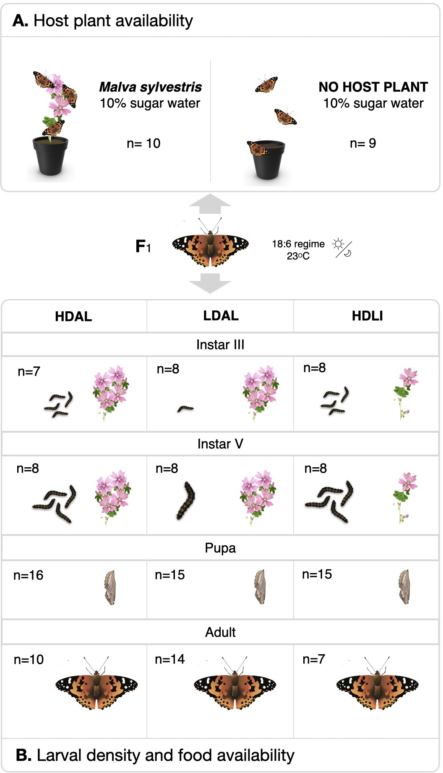

F I G U R E 1 Setup of the two experiments conducted on oﬀspring of wild-caught *Vanessa cardui* females (F1 in the center). Numbers of sequenced individuals are provided for each treatment and cohort. A) The host plant availability experiment, where recently emerged females were divided in two experimental groups with or without access to *Malva sylvestris* for egg laying. B) The setup of the larval density and food availability experiment for diﬀerent developmental stages. Here, F2 oﬀspring from ﬁve diﬀerent F1 females were divided into three cohorts where the environmental conditions varied. HDAL = high density (10 larvae / ﬂask) and *ad libitum* food, LDAL = low density (1 larva / ﬂask) and *ad libitum* food, HDLI = low density (1 larva / ﬂask) and limited food (fed every other day).

137 mended guidelines by the manufacturer. RNA integrity and fragment lengths were assessed using 1% agarose gel

138 electrophoresis, followed by measurements of the concentration using NanoDrop (ThermoFisher) and Qubit (Ther-

139 moFisher). Sequencing libraries were prepared using the Illumina TruSeq Stranded mRNA polyA selection kit and

140 sequenced by the National Genomics Infrastructure (NGI) in Stockholm. Sequencing was conducted on two lanes of

141 one S4 ﬂow cell on the NovaSeq S6000 platform, generating 150 bp paired-end reads.

# 142 2.5 | Diﬀerential expression analysis

143 For all steps of the read processing, from adapter ﬁltering to read mapping and transcript quantiﬁcation, the Nextﬂow

144 nf-core (44) pipeline rnaseq v3.8.1 was applied (45). In brief, raw sequencing reads were trimmed using Cutadapt

145 v.3.4 (46) as implemented Trim Galore! v0.6.7. STAR v2.7.10a (47) was used for mapping the reads to a previously

146 published genome assembly (36). Read quantiﬁcation was carried out using salmon v1.5.2 (48), and gene expression

147 levels were measured in transcripts per million reads (TPM) values. Diﬀerential expression analyses were conducted

148 in R v4.2.1 using DESeq2 v1.28.0 (49).

149 To assess diﬀerential expression between the cohorts of adult individuals with or without access to host plants

150 for egg laying, we employed the Wald test in the DESeq2. Our experimental design incorporated the correction for

151 potential family eﬀects, with treatment as the primary variable (~family+treatment). Due to incomplete family assign-

152 ment for some samples, we utilized PCA analysis to recover the missing assignments. Additionally, we applied the

153 Wald test for diﬀerential expression analysis in adult individuals subjected to environmental stressors: food limitation

154 and larval crowding. Here, we also accounted for the potential eﬀect of sex since both males and females were used

155 in the analysis (~family+sex+treatment).

156 Diﬀerential gene expression across developmental stages was assessed using the likelihood ratio test mode of

157 DESeq2 (model = "LRT"), which allows for analysis of time course experiments. This test compared the ﬁt of a full

158 model (~family+devstage+treatment+treatment:devstage) with a reduced model that excluded the interactive eﬀect

159 between the treatment and developmental stage ("devstage") variables. This analysis aimed to evaluate whether the

160 eﬀect of the treatment on gene expression diﬀered across developmental stages. The same model was applied to

161 both head and abdomen tissues, and the analysis included the treatments food availability (HDAL versus HDLI) and

162 rearing density (HDAL versus LDAL).

163 For further analysis, candidate genes were selected based on the criteria of an adjusted *p*-value < 0.05 (Benjamini

164 and Hochberg to control FDR) and a log2 (fold change) > 2. The GeneOverlap package (50) was used to assess

165 the signiﬁcance of overlaps between candidate gene sets in diﬀerent tissues. Since tests using LRT typically result

166 in larger gene sets, clusterProﬁler v3.17 (51) was applied to identify functional clusters within all sets of candidate

167 genes across the four ontogenetic stages, using parameters (consensusCluster = TRUE, groupDiﬀerence = 2) on *r* log-

168 transformed data. Regularized log (*r* log) transformation was used for stabilizing variance and normalizing the count

169 data. In the case of the head tissue, where 745 candidate genes were identiﬁed, more stringent clustering parameters

170 were employed with a group diﬀerence of 3. Functional information for diﬀerentially expressed genes was collected

171 both by using previous annotations (35,36) and by BLAST searches against the entire nucleotide database (52). Data

172 was summarized in corresponding supplementary tables, when two annotations were available the one from the most

173 similar ortholog was chosen.

174 To assess if certain functional categories were overrepresented in the gene sets with signiﬁcant diﬀerential ex-

175 pression, we conducted two types of enrichment analyses, Gene Ontology (GO) terms and KEGG pathways, utilizing

176 previously obtained functional annotations. Enrichment analysis of GO terms (biological processes category) was per-

177 formed using the TopGO package (53), employing the "weight01" algorithm, with a signiﬁcance threshold of p < 0.01.

178 The enrichment analysis of KEGG terms was performed using the enricher module of clusterProﬁler (51).

179 **3** | **RESULTS**

# 180 3.1 | Gene expression patterns in response to host plant availability in adult females

181 To understand how the presence or absence of host plants for egg laying aﬀects transcriptional responses in recently

182 emerged female imagines, we analyzed gene expression in head and abdominal tissues (Figure 2). The rationale behind

183 choosing those particular tissues was that signaling cascades should be initiated in the head based on sensory percep-

184 tion of the environmental cues and that this may manifest in temporal diﬀerences in investment in reproduction and

185 migration, which might be picked up by gene expression diﬀerences in the abdomen (where the gonads are located).

186 In total, abdominal tissue was analysed in 10 individuals (ﬁve for each treatment) and head tissue in 9 individuals (ﬁve

187 and four individuals from the treatments with and without access to host plants for egg laying, respectively). In the

188 head, we found that 88 genes were signiﬁcantly diﬀerentially expressed (p < 0.05 after FDR adjustment) between

189 treatment groups. Of those, 34 genes (0.3% of all genes analysed) had higher and 44 had lower expression (0.4%) in

190 the treatment with access to host plants compared to the treatment without host plants (Figure 2A). In the abdomen,

191 the corresponding numbers were 70 diﬀerentially expressed genes; 44 (0.4%) with higher and 26 (0.2%) with lower

192 expression in the treatment with access to host plants (Figure 2B). A list of the top signiﬁcantly diﬀerentially expressed

193 genes (p < 0.01) and their putative functions is provided in Supplementary Table 2.

194 We found that signiﬁcantly diﬀerentially expressed genes encompassed a diverse range of functional categories

195 (Figure 2A, B), including immune genes (gloverin, attacin, cytochrome p450, peptidoglycan recognition proteins),

196 metabolic genes (lipase), and genes involved in endoskeleton formation (cuticle protein) (Figure 2, Supplementary

197 Table 2). Of particular interest was the ecdysone oxidase gene, which exhibited a remarkable change in expression

198 in both head and abdomen in the individuals that had access to host plants for egg laying (Figure 2A, B; Note that

199 DESeq2 may sometimes exaggerate outliers (54)).

200 Among the genes that were diﬀerentially expressed between the adult female treatment groups, 11 genes were

201 found in both tissues (Figure 2C). To gain further insights into the associations between functions of diﬀerentially

202 expressed genes and increase statistical power, we combined the results from both tissues for GO term enrichment

203 test. Signiﬁcantly overrepresented GO terms encompassed transmembrane transport, various metabolic processes

204 (including ecdysone biosynthesis), and defense response (Figure 2D, Supplementary Table 3). Consistent with this

205 ﬁnding, the analysis of overrepresented KEGG pathways revealed enrichment of diﬀerent metabolic pathways, in

206 particular lipid, carbohydrate, vitamin, and xenobiotic metabolism (Figure 2E, Supplementary Table 4).

# 207 3.2 | Gene expression variation associated with food availability during development

208 To complement the analysis in adult females, we focused on investigating diﬀerential gene expression across devel-

209 opmental stages in experimental cohorts exposed to environments that varied in food availability and rearing density.

210 Again, we focused on the head and abdomen for the same reasons as indicated above. For the contrast between

211 experimental groups with diﬀerences in food availability during development (HDAL versus HDLI), the likelihood ra-

212 tio tests revealed 745 and 321 signiﬁcantly diﬀerentially expressed genes (FDR-adjusted p-value < 0.05) in the head

213 and abdomen, respectively. Notably, the two sets of genes with diﬀerential expression in the two respective tissues

214 demonstrated a high degree of overlap (Jaccard index = 0.1, *p*-value = 9.6 × 10−30; Figure 3A). To check which stages

215 contributed the most to the overall diﬀerences in expression patterns between treatment groups, we performed a

216 clustering analysis which groups genes based on the expression patterns across developmental stages, facilitating the

217 identiﬁcation of genes with similar proﬁles and potential functional relationships. In head tissue, the most prominent

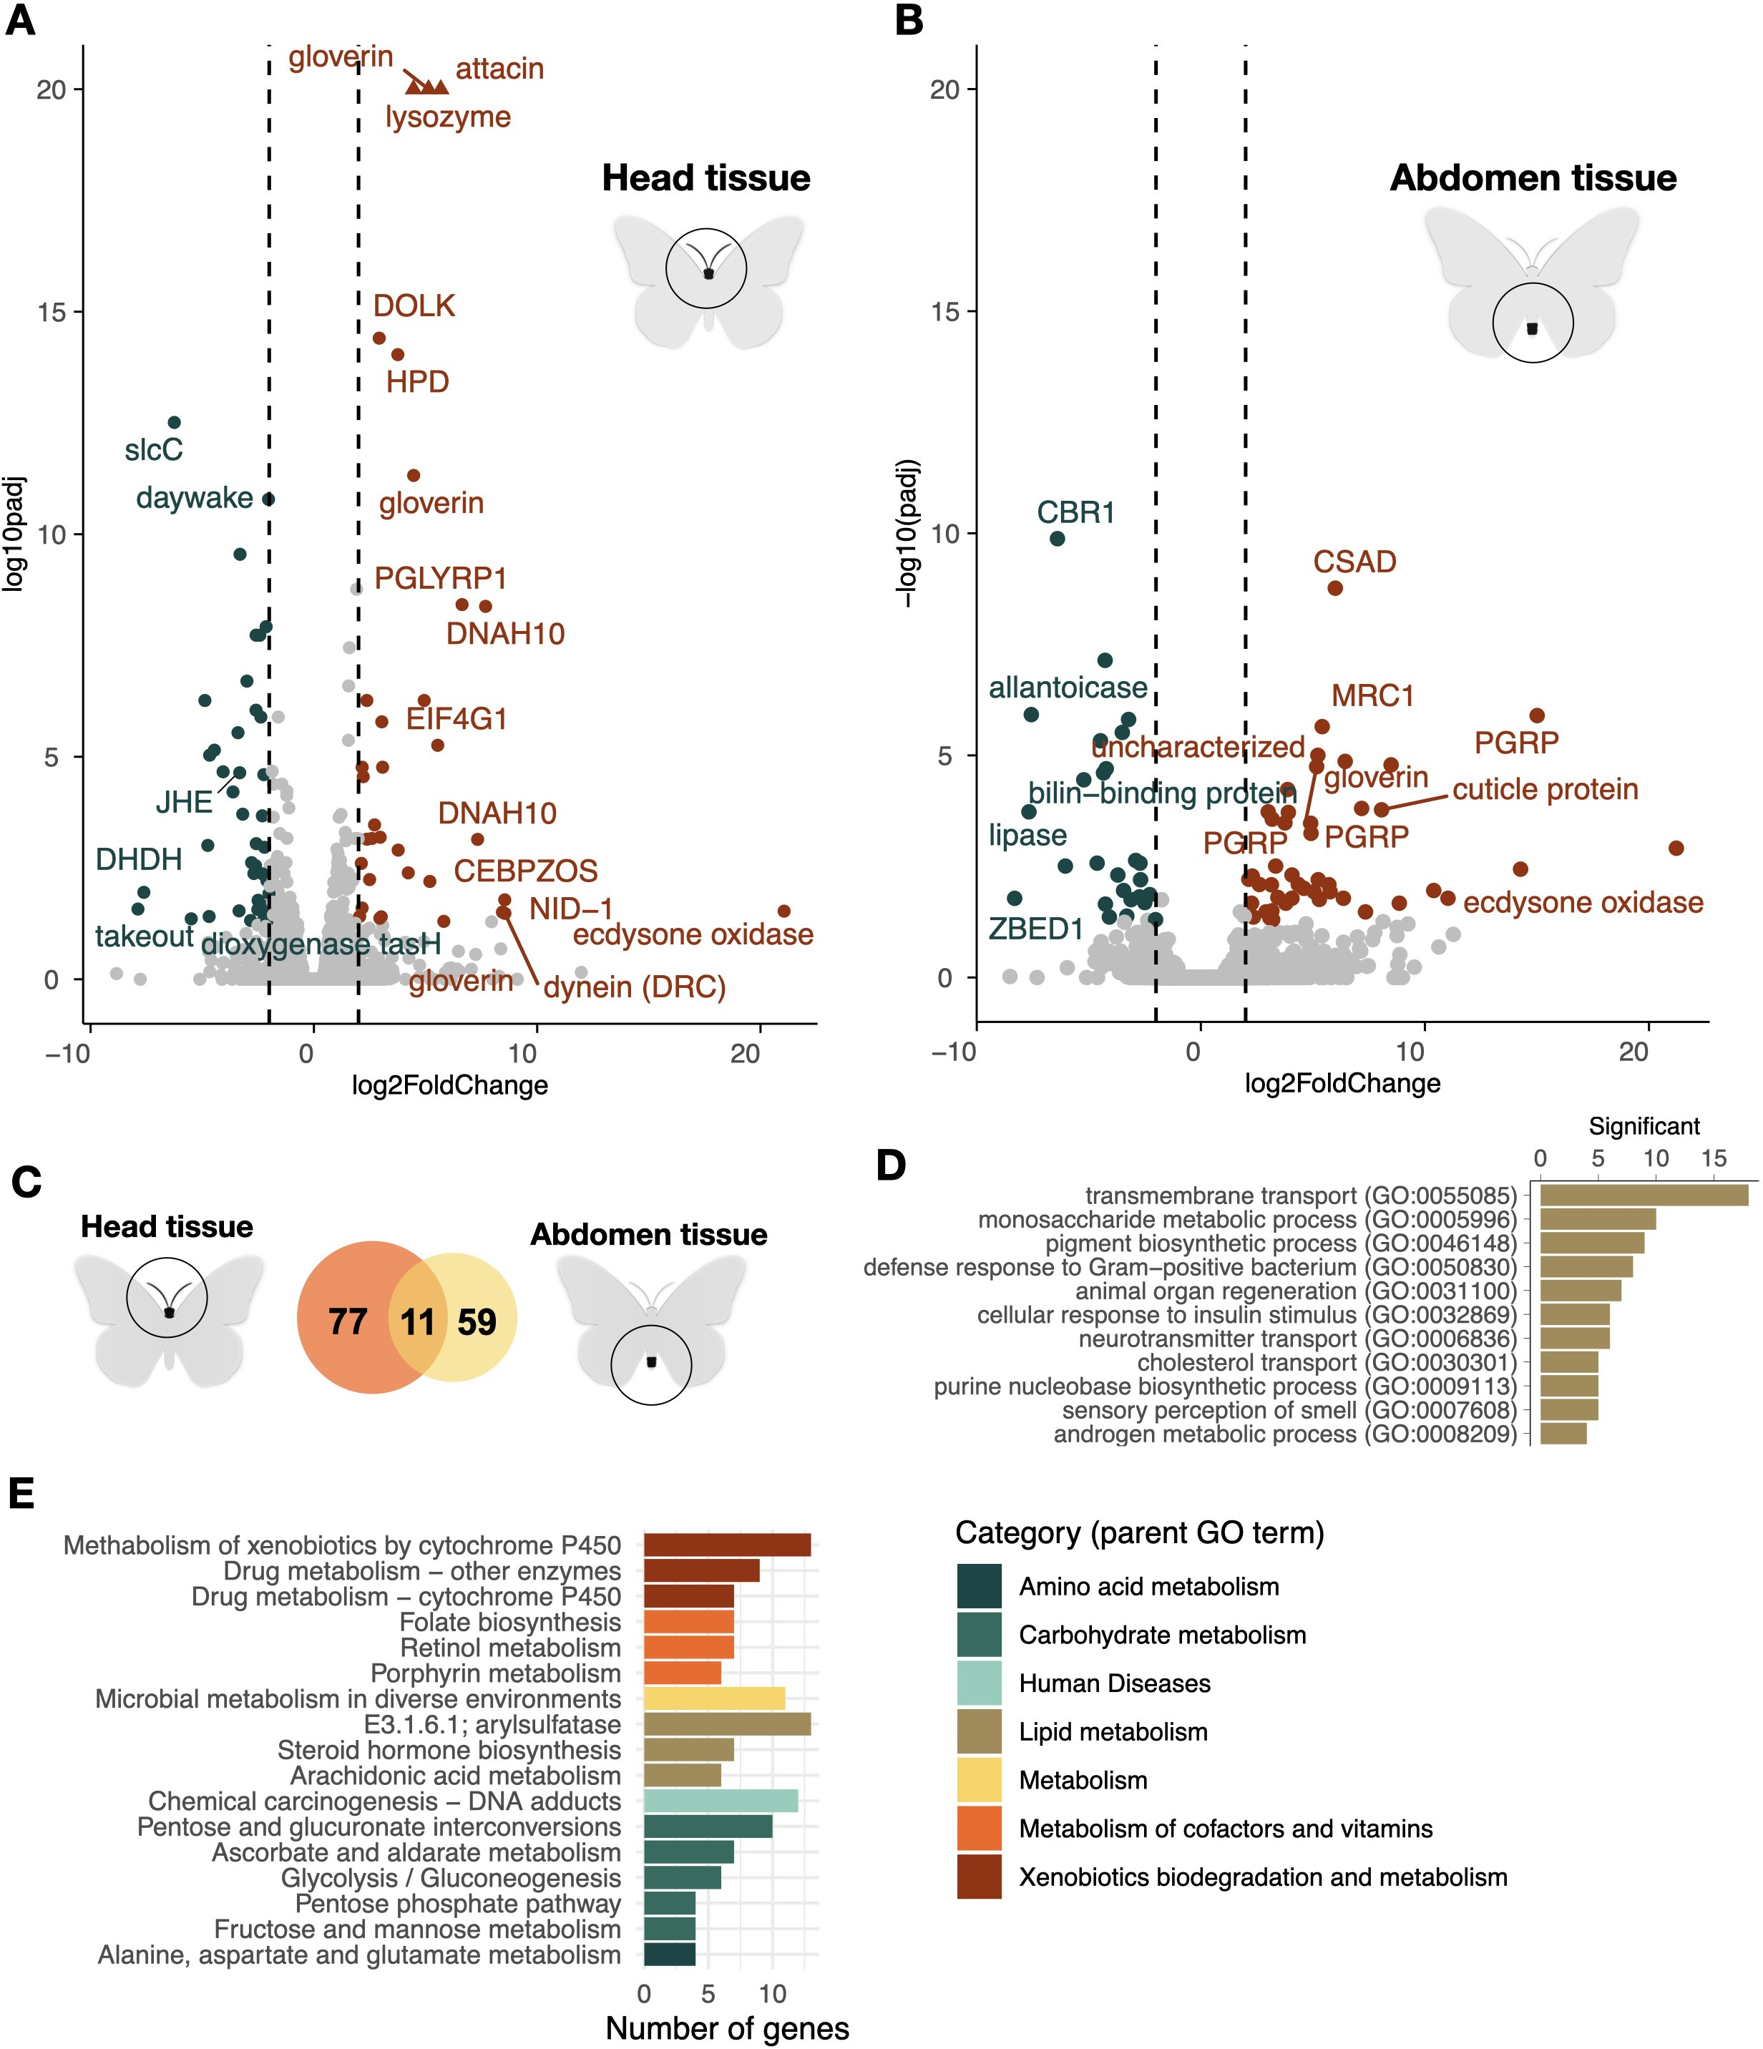

F I G U R E 2 Volcano plots illustrating the relative levels of gene expression in the head (A) and abdomen (B) of adult females (x-axis; log2 fold change) in the two treatment groups with and without access to host plants for egg laying. Genes with a fold change diﬀerence > |2| and FDR-adjusted *p*-value < 0.05 are depicted in dark orange (signiﬁcantly higher expression in the treatment with host plants) and teal (signiﬁcantly higher expression in the treatment without host plants), respectively, while non-signiﬁcant genes are illustrated by grey dots. Only selected outlier gene names are shown. Outlier genes with log2 fold change values exceeding y-limit are shown by triangles, exact values provided in the supplement. (C) Venn diagram showing the number of overlapping and unique diﬀerentially expressed genes between the two tissues (head = orange, abdomen = yellow). (D) Bar plot showing the counts of the enriched (FDR-adjusted *p* < 0.01) gene ontologies for the signiﬁcantly diﬀerentially expressed genes between the treatment groups for both tissues combined. (E) Bar plot illustrating the numbers of signiﬁcantly diﬀerentially expressed genes enriched for KEGG pathways, both tissues combined. The higher hierarchical grouping is indicated by bar colors (legend to the right).

218 cluster comprised 123 genes (16.5% of the diﬀerentially expressed genes in this tissue; Figure 3B). The majority of

219 expression diﬀerences within this cluster were observed in instar III larvae. Similarly, in the abdominal tissue, 149

220 genes (46.4% of the diﬀerentially expressed genes) formed a distinct cluster. Genes within this cluster predominantly

221 showed diﬀerential expression in instar V larvae (Figure 3C).

222 The GO term analysis for diﬀerentially expressed genes in head tissue revealed both a general enrichment of

223 functions related to metabolic processes and regulation and more speciﬁcally enrichment of functions associated

224 with epithelial cell development, sarcomere organization, angiogenesis regulation and blood coagulation (Figure 3D,

225 Supplementary Table 5). Diﬀerentially expressed genes in abdominal tissue were predominantly associated with re-

226 productive processes, and neural and immune cell development (Figure 3E, Supplementary Table 6). In addition, a

227 joint KEGG pathway analysis of both tissues unveiled that functions associated with ribosome biogenesis (ko03008)

228 and aﬂatoxin biosynthesis (ko00254) were overrepresented.

229 The expression trajectories across developmental stages show that the inﬂuence of the environmental factors

230 on gene expression diﬀerences between experimental groups, in general, appears to diminish at the pupal and adult

231 stages. To investigate how environmental cues experienced during development are manifested in recently emerged

232 imagines in more detail, we compared diﬀerences in gene expression between adult individuals that had experienced

233 diﬀerent environmental conditions during development speciﬁcally (Figure 3 F, G). In head tissue, only six genes (p <

234 0.05) showed signiﬁcantly diﬀerential expression; *Tret1*, odorant receptor, UDP-glucosyltransferase, esterase and zinc-

235 ﬁnger MYM (Supplementary Table 7). These genes were downregulated in response to limited food treatment. In the

236 abdominal tissue, 189 (p < 0.05) genes were found to be diﬀerentially expressed between treatment groups. Among

237 the most prominent outliers were cuticle protein (upregulated in response to limited food source), gloverin, glutamine

238 synthetase, tektin, clavesin, gooseberry-neuro, orcokinin and tyrosine (downregulated in response to limited food

239 source) (outliers are listed in Supplementary Table 7).

# 240 3.3 | Gene expression variation associated with rearing density during development

241 To complement the analysis of gene expression variation associated with food plant availability during development,

242 we also compared treatment groups that were reared at diﬀerent densities (10 larvae versus 1 larva per ﬂask, HDAL

243 versus LDAL). In this comparison, we found a large number of genes diﬀerentially expressed in both the head (222

244 genes) and abdomen (372). There was also signiﬁcant overlap between the tissues, i.e. a higher proportion of genes

245 were diﬀerentially expressed in both tissues than expected by chance (Jaccard Index = 0.2, p-value = 1.2 × 10−80;

246 Figure 4A).

247 To investigate the temporal trajectories of diﬀerences in expression patterns between treatment groups during

248 development, we again performed a clustering analysis based on the expression patterns across the diﬀerent devel-

249 opmental stages. In head tissue, the two main clusters contained 143 (38.4% of the diﬀerentially expressed genes in

250 this tissue; Figure 4B) and 69 (18.5%; Supplementary Figure 1) genes, respectively. Visual inspection clearly showed

251 that expression diﬀerences in instar III and V larvae were driving the overall patterns within these clusters (Figure 4B).

252 In the abdominal tissue, 83 genes (37.4% of the diﬀerentially expressed genes in this tissue) formed a distinct cluster

253 (Figure 4C). Again, this cluster was mainly distinguished by considerable diﬀerences in gene expression in the larval

254 stages (Figure 4C).

255 The gene ontology enrichment analysis of functional roles of diﬀerentially expressed genes in these clusters

256 revealed that the most enriched functional category was regulation of ﬁlopodia assembly in the head (Figure 4D).

257 We also found an enrichment of ontology terms related to sperm maturation, ephrin signaling, and several other

258 functional categories (Figure 4D, Supplementary Table 8). In the abdomen, there was a signiﬁcant enrichment of

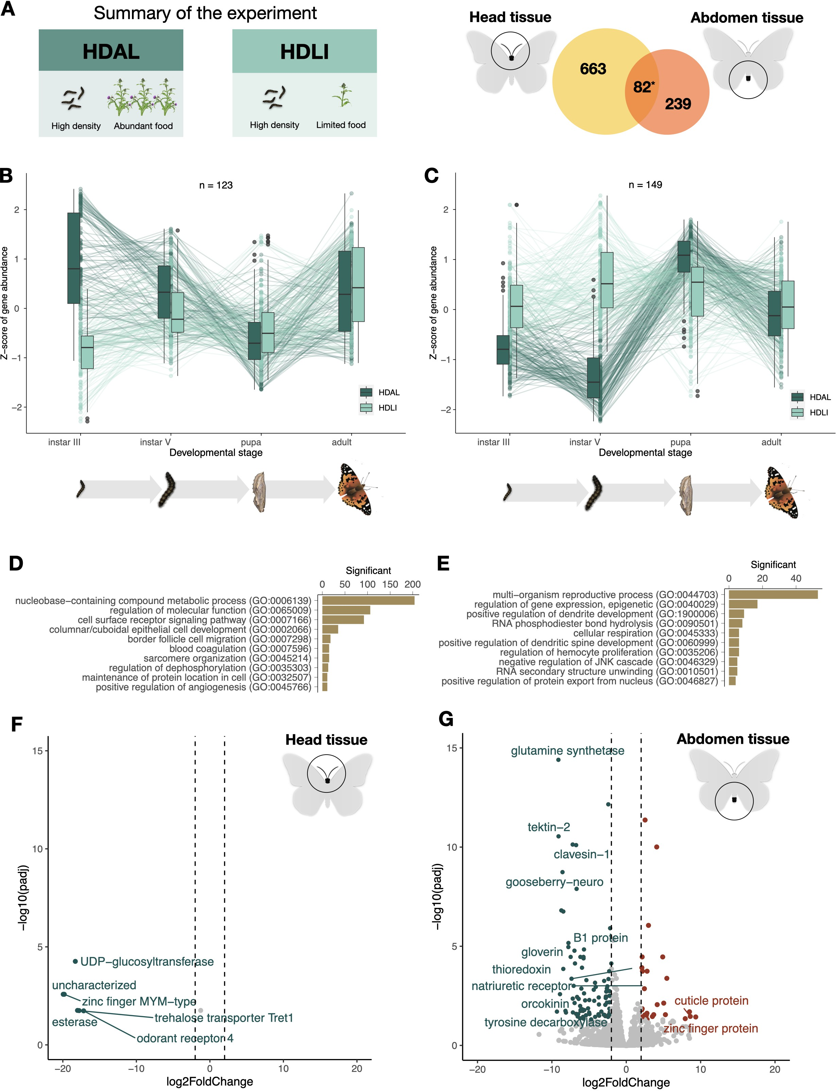

F I G U R E 3 A summary of the results from the comparison between experimental groups with access to diﬀerent amounts of food plants during development. (A) Summary of the experiment and a Venn diagram showing the number of diﬀerentially expressed genes in each respective tissue (left = head, right = abdomen) and the number of genes diﬀerentially expressed in both tissues (center). The star indicates that the number of overlapping genes was signiﬁcantly higher than expected by chance. (B) and (C) Box plots showing the temporal patterns of diﬀerential expression across ontogenetic stages in the head (B) and abdomen (C). Outliers are indicated with circles, and temporal trends of gene expression levels for speciﬁc genes are illustrated with lines. (D) and (E) The top 10 most signiﬁcantly overrepresented GO terms (p < 0.01) for diﬀerentially expressed genes in the head (D) and abdomen (E).

(F) and (G) Volcano plots showing the relative levels of gene expression in the adult individuals for the head (F) and abdomen (G). Genes that are signiﬁcantly diﬀerentially expressed and meet the threshold (FDR-adjusted *p*-value

< 0.05, log2 fold change diﬀerence < |2|) are highlighted. Dark orange marks genes that are upregulated in adults in the food limitation treatment [HDLI], while teal spots mark genes that are upregulated in the treatment where larvae had access to unlimited food [HDAL].

259 GO terms associated with reproductive processes, including functions such as egg formation, egg laying, and mating

260 development (Figure 4E, Supplementary Table 9). In addition, there were several enriched terms associated with signal

261 transduction like ephrin signaling, Ras signal transduction (involved in cell growth, division, and diﬀerentiation), Notch

262 signaling (associated with neurogenesis) and JNK signaling (regulation of ubiquitin-dependent processes).

263 Analogous to the analysis based on food plant availability, we compared diﬀerences in gene expression between

264 recently emerged females that had experienced diﬀerent levels of crowding during development (Figure 4 F, G, Sup-

265 plementary Table 10). In this comparison, six genes showed signiﬁcant diﬀerences in expression level in head tissue,

266 of which functional information was available for ﬁve (Figure 4F). We found that two copies of the SUMO ligase and

267 a trehalose transporter were signiﬁcantly higher expressed in the low density (LDAL) compared to the high density

268 treatment group (HDAL). The genes pickpocket and NADH dehydrogenase, in contrast, had a signiﬁcantly higher

269 expression in the HDAL than in the LDAL treatment group. In the abdominal tissue, the peptidoglycan recognition

270 protein (*PGRP*), chitinase, hemocytin, D-arabinitol, and *NCAM* were signiﬁcantly overexpressed in the LDAL treatment

271 group compared to HDAL, while no genes with known functions had higher expression in HDAL.

272 **4** | **DISCUSSION**

# 273 4.1 | Transcriptomic response to availability of host plants in adult female butterﬂies

274 The ability of individuals to switch between migration and reproduction is a key adaptation for migratory insects

275 in general, and for long-distance migrants in particular (17–19). This capability can also be considered part of the

276 migratory syndrome, which includes a suite of traits that facilitate migration (55). This study addresses the need

277 to investigate the molecular mechanisms underlying the migration-reproduction trade-oﬀ, focusing on one of the

278 environmental triggers for initiating or terminating migratory behavior in butterﬂies—the presence and abundance of

279 host plants for egg-laying (40,56). We identiﬁed three major functional categories of genes activated in response to

280 this treatment: hormonal regulation, metabolic regulation, and immunity. Below, we discuss these categories in detail

281 and their connections to reproduction and migration.

282 Hormonal regulation has been shown to be important in controlling reproductive and migratory physiology and

283 having a central role in the trade-oﬀ between reproduction and migration in butterﬂies (57). Similarly, our results

284 from the analysis of gene expression variation associated with host plant availability for egg laying in adult females *V.*

285 *cardui* underscore the importance of hormonal regulation for the plastic response to host plant abundance – i.e. we

286 found signiﬁcant changes in the expression of multiple genes regulating developmental hormones. Here, ecdysone

287 oxidase stood out with a striking diﬀerence in expression level between experimental groups. Ecdysone is a steroid

288 hormone crucial for numerous biological processes in metamorphic insects during major developmental transitions,

289 including the maturation of oocytes and control of oviposition (58–60). Ecdysone oxidase in turn regulates the levels

290 of active ecdysone by converting it to 3-dehydroecdysone and vice versa, thereby controlling the availability of active

291 hormones through a rapid feedback mechanism. We propose that increased expression of ecdysone oxidase, triggered

292 by the availability of host plants, modulates these hormone levels, enhancing reproductive investment (61).

293 Beyond ecdysone, other hormonal regulation pathways like juvenile hormone (JH) signiﬁcantly contribute to the

294 reproductive-migratory trade-oﬀ, as seen in monarch butterﬂies (25,62). Additionally, genes involved in JH synthesis

295 were notably overexpressed in migrating hoverﬂies compared to sedentary ones (68). Similar patterns were observed

296 in our study with genes such as juvenile hormone esterase (*JHE*; regulation of juvenile hormone levels; (62,64), and

297 daywake and takeout genes (encoding juvenile hormone binding proteins), *nrf-6* (neuropeptide and hormone receptor),

298 and cytochrome-P450 (control of ecdysone biosynthesis; (65)), suggesting a complex interplay of gene regulation and

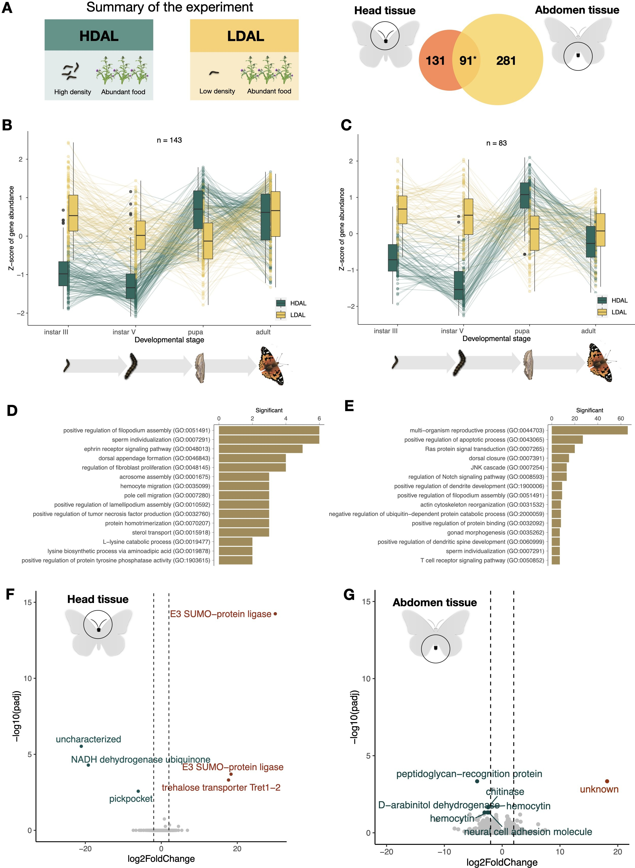

F I G U R E 4 A summary of the results from the comparison between experimental groups, which were reared at diﬀerent densities during development. (A) Summary of the experiment and a Venn diagram showing the number of diﬀerentially expressed genes in each respective tissue (left = head, right = abdomen) and the number of genes with signiﬁcantly diﬀerent expression in both tissues (center). The star indicates that the number of overlapping genes was signiﬁcantly higher than expected by chance. (B) and (C) Box plots showing the temporal patterns of diﬀerential expression across ontogenetic stages in the head (B) and abdomen (C). Outliers are indicated with circles, and temporal trends of gene expression levels for speciﬁc genes are illustrated with lines. (D) and (E) The top 10 most signiﬁcantly overrepresented GO terms (p < 0.01) for diﬀerentially expressed genes in the head (D) and abdomen (E), respectively. (F) and (G) Volcano plots showing the relative levels of gene expression in the adult female individuals for the head (F) and abdomen (G). Genes that are signiﬁcantly diﬀerentially expressed and meet the threshold

(FDR-adjusted *p*-value < 0.05, log2 fold change diﬀerence < |2|) are highlighted. Dark orange marks genes that are upregulated in adults in low density treatment [LDAL], while teal spots mark genes that are upregulated in the treatment where larvae had access to unlimited food [HDAL].

299 hormonal crosstalk crucial for adapting to environmental cues. We have also shown previously, using chromatin

300 accessibility proﬁling, that *JHE* likely is upregulated in adult female butterﬂies with access to host plants for egg

301 laying (43). Taken together, our observations corroborate that the ecdysone pathway and the regulation of juvenile

302 hormone play pivotal roles in the plastic responses to environmental cues in insects in general (66,67) and that they

303 may constitute key components in the trade-oﬀ between migration and reproduction in butterﬂies in particular.

304 The role of immunity in migratory syndrome is multifaceted, suggesting energy may be redirected from immune

305 functions to aid migration or enhanced in response to varied pathogens (68,69). Our study revealed a strong immune

306 response in adult females exposed to environments without host plants, evidenced by a large number of upregulated

307 genes. Functional data from a diverse range of candidate genes identiﬁed in our study, allows us to speculate on the

308 exact pathways of this response. Notably, multiple peptidoglycan-recognition proteins (*PGRP*s) may guide the recog-

309 nition of various pathogens (70), initiating the TOLL-signaling pathway and leading to the production of antimicrobial

310 peptides such as attacin (71), gloverin (72), lysozyme (73), and cecropin (74). Although we cannot establish causality

311 between expression diﬀerences of immune genes and investment in reproduction or migration, immune gene evo-

312 lution has been shown to be dynamic in migratory species in general (68) and may be of particular importance in V.

313 cardui where several immune genes are uniquely present in multi-copy arrays (35).

314 In addition to immune response adjustments, eﬃcient utilization of energy is of ultimate importance in migratory

315 species. In insects, fat serves as the most eﬃcient source for storage of energy (75,76) and lipids are indeed the main

316 fuel for ﬂight (77). Corroborating that, we observed that pathways associated with metabolism have critical roles in

317 resource allocation trade-oﬀs (71), we found that host plant availability variation resulted in diﬀerential expression of

318 multiple genes associated with lipid and carbohydrate metabolism, for example, dihydrodiol dehydrogenase (*DHDH*)

319 and dolihol kinase (*DOLK*) genes (79).

320 Our study highlights the central role of hormonal regulation, metabolism, and immunity in butterﬂies’ response to

321 host plant availability. Although our data and approaches do not allow us to establish a causative association between

322 host plant availability and investment in reproduction or migration per se, the gene expression analysis revealed a set

323 of candidate genes that can be used to investigate the molecular underpinnings of the reproduction-migration trade-

324 oﬀ in more detail. These ﬁndings may extend beyond the classical oogenesis-ﬂight syndrome, suggesting broader

325 applicability in understanding synchronization between reproduction and migration. The next step will be to target

326 key genes in the regulatory pathways detected here, with a particular focus on the ecdysone pathway. It should be

327 noted that the trade-oﬀ between reproduction and migration in adult butterﬂies is likely not exclusively dictated by

328 environmental cues encountered after emergence. As a complementary step, we therefore explored how diﬀerences

329 in food plant availability and crowding aﬀect the expression proﬁles across ontogenetic stages, from larvae to imagines.

# 330 4.2 | Eﬀects on gene expression by diﬀerences in food plant availability and rearing

331 **density during development**

332 Both crowding and food resource availability have been shown to impact the timing of development and morphology

333 of migratory insects, which in turn directly aﬀect the ﬂight response norms and migration propensity (80,81). Insect

334 individuals experiencing starvation in general exhibit delayed development (33), prolonged larval stages and reduced

335 body sizes (81), and these eﬀects have also previously been observed in *V. cardui* (82). Similarly, negative associations

336 between larval density and developmental rates have been established (28). This evidence arises from direct measure-

337 ment of resulting phenotypic traits, while molecular mechanisms involved in the responses are less studied (but see

338 e.g. 30). In our study, transcriptomic signatures of the response to periodic starvation and larval crowding conﬁrmed

339 diﬀerences in the activation of developmental genes and pathways in multiple organ systems. Diﬀerentially expressed

340 genes were associated with ontology terms such as epithelial cell and dendrite development, sarcomere organization,

341 angiogenesis, and hemocyte proliferation.

342 Gene expression proﬁles suggest that the food limitation treatment appeared to speciﬁcally aﬀect neural devel-

343 opment. Neural development and sensing are of particular importance for migratory insects, as they can largely inﬂu-

344 ence the plasticity of the response to perceived environmental cues in adults (81). In our experiment, two candidate

345 genes—odorant receptor 4 and esterase (odorant degrading protein)—were activated in adult individuals who had not

346 experienced food stress as larvae, suggesting enhanced environmental sensing (84). Conversely, the downregulation

347 of the gooseberry-neuro (*GsbN*) transcription factor suggests alterations in central nervous system development (85).

348 We therefore consider these particular genes as key candidates for further investigation of how environmental cues

349 are translated into behavioral responses.

350 The larval density experiment triggered diﬀerential expression of genes related development of reproductive sys-

351 tems, which is illustrated by ontology terms such as sperm individualization and gonad morphogenesis. Early changes

352 in reproductive functions are particularly noteworthy in the context of the trade-oﬀ between reproduction and migra-

353 tion in the adult stage, a topic previously discussed in relation to the host plant experiment. These results underscore

354 the role of the male reproductive system as well. Our result is in line with observations in other lepidopterans, such

355 as that *Plodia interpunctella*, and *Mythimna separata*, which have been shown to have increased sperm production in

356 response to crowding (86).

357 Alterations in metabolism at the molecular level appear to be a consistent response to all environmental cues

358 tested in this study, as evidenced by the earlier-mentioned responses to host-plant presence in adult females, and

359 the impacts of crowding and food scarcity across developmental stages and in adults. Notably, in the context of the

360 starvation treatment, we identiﬁed over 200 diﬀerentially expressed genes associated with the ’compound metabolic

361 process’. On the individual gene level, we observed diﬀerential expression of the trehalose transporter (*Tret1*) in

362 adults who experienced starvation during development. Trehalose is the primary sugar found in insect hemolymph,

363 synthesized in the fat body and subsequently distributed by transporters (87). Alteration of expression of *Tret1* was

364 also directly linked to active migration in insects (63). Among other candidate genes diﬀerentially expressed in the

365 density experiment were the metabolic genes NADH dehydrogenase and several chitinases (86).

366 Since the analysis spanned multiple developmental stages, from larval instar III to recently emerged imagines, we

367 gained insights into the temporal variation in gene expression and identiﬁed critical developmental periods where

368 the eﬀect was particularly pronounced. Notably, the most signiﬁcant gene expression diﬀerences occurred during

369 the larval stages in both experiments, especially in larval instar V—the ﬁnal stage for *V. cardui* and a critical time

370 point for responding to environmental cues before metamorphosis (89). Our ﬁndings highlight genes associated with

371 programmed cell death, such as E3-type small ubiquitin-like modiﬁer (*SUMO*) (90), and show enrichment in the JNK

372 and Ras signaling pathways, essential for the tissue remodeling required during metamorphosis (91). In general, the

373 last larval stage is accompanied by considerable physiological changes and environmental shifts during this period can

374 therefore have particular importance for plastic responses (92).

375 **5** | **CONCLUSIONS**

376 In a host plant experiment designed to trigger the trade-oﬀ between migration and reproduction, we observed sig-

377 natures of gene expression consistent with those expected for the oogenesis-ﬂight syndrome and highlighted the

378 crucial role of hormonal regulation. By subjecting larvae to diﬀerent environmental cues, food abundance and larval

379 crowding, we examined the early predisposition for migratory plasticity. This approach allowed us to closely track the

380 timing of cue perception throughout development. Our ﬁndings revealed the peak of this response during the last

381 larval stage, emphasizing the role of the genes involved in developmental regulation and metabolism. Furthermore,

382 this led us to identify candidate genes and pathways that jointly contribute to the migratory syndrome.

# 383 DATA AVAILABILITY AND BENEFIT-SHARING

384 Raw sequence data (RNA-seq) are available at the European Nucleotide Archive under XXXXXXXX. The scripts used

385 to generate the analyses presented in the paper are archived on GitHub in the following repository:

386 https://github.com/orgs/EBC-butterﬂy-genomics-team.

387 The beneﬁt arising from the utilization of genetic resources in this study is provided through the sharing of the

388 analysis scripts and code, which are freely available and accessible to the research community, consistent with appli-

389 cable international and national regulations.

# 390 AUTHOR CONTRIBUTIONS

391 NB contributed to the conception and design of the study. Lab work was performed by EP and LH with assistance

392 from KN and AP. Formal analysis and visualization were performed by DS with assistance from VT. DS and NB wrote

393 the manuscript. GT provided samples. NB supervised the study. Funding acquisition was handled by NB, GT, and RV.

394 All authors reviewed and approved the ﬁnal manuscript.

# 395 CONFLICT OF INTEREST DISCLOSURE

396 The authors declare that they have no conﬂicts of interest.

397 **ACKNOWLEDGEMENTS**

398 Acknowledgments This work was funded by a research grant from the Swedish Research Council FORMAS (grant #

399 2019-00670 to N.B.) and The Swedish Collegium for Advanced Science (Natural Sciences Programme, Knut and Alice

400 Wallenberg Foundation, Postdoc funding for D.S.). R.V. was supported by grant PID2022-139689NB-I00 (MICIU/

401 AEI/ 10.13039/501100011033 and ERDF, EU) and by grant 2021-SGR-00420 (Departament de Recerca i Univer-

402 sitats, Generalitat de Catalunya). G.T. was supported by grants PID2020-117739GA-I00 MCIN / AEI / 10.13039/

403 501100011033, LINKA20399 from the CSIC iLink program and 2021-SGR-01334 (Departament de Recerca i Uni-

404 versitats, Generalitat de Catalunya). The authors acknowledge support from the National Genomics Infrastructure

405 in Stockholm funded by Science for Life Laboratory, the Knut and Alice Wallenberg Foundation and the Swedish Re-

406 search Council, and SNIC/Uppsala Multidisciplinary Center for Advanced Computational Science for assistance with

407 massively parallel sequencing and access to the UPPMAX computational infrastructure. The computations were en-

408 abled by resources provided by the National Academic Infrastructure for Supercomputing in Sweden (NAISS) and the

409 Swedish National Infrastructure for Computing (SNIC) in Uppsala, partially funded by the Swedish Research Council

410 through grant agreements no. 2022-06725 and no. 2018-05973. We thank Jesper Boman and all members of the

411 Backström lab for helpful discussions.

412 **Bibliography**

413 **1.** Bell, A. M. (2023). The evolution of decision-making mechanisms under competing demands. Trends in Ecology

414 & Evolution.

415 **2.** Stearns, S. C. (1989). Trade-oﬀs in life-history evolution. Functional Ecology, 3(3), 259.

416 **3.** Aidley, D. J. (Ed.). (1981). Animal migration. Cambridge: Cambridge University Press. (Seminar series).

417 **4.** Williams, C. B. (1958). Insect migration. London: Collins. (New Naturalist; vol. xiii).

418 **5.** Williams, C. B. (1930). The migration of butterﬂies. Edinburgh: Oliver & Boyd. (Biological Monographs and

419 Manuals; vol. 8).

420 **6.** Satterﬁeld, D. A., Sillett, T. S., Chapman, J. W., Altizer, S., & Marra, P. P. (2020). Seasonal insect migrations: massive,

421 inﬂuential, and overlooked. Frontiers in Ecology and the Environment.

422 **7.** Dingle, H. (2014). Migration: The biology of life on the move. Oxford: Oxford University Press.

423 **8.** Suchan, T., Talavera, G., Sáez, L., Ronikier, M., & Vila, R. (2019). Pollen metabarcoding as a tool for tracking long-

424 distance insect migrations. Molecular Ecology Resources, 19(1), 149–162.

425 **9.** Jia, X., Liu, S., Zheng, H., Li, B., Qi, Q., Wei, L., et al. (2015). Non-uniqueness of factors constraint on the codon

426 usage in *Bombyx mori*. BMC Genomics, 16(1), 356.

427 **10.** Reich, M., Shipilina, D., Talla, V., Bahleman, F., Kébé, K., Berger, J., et al. (2023). Isotope geolocation and population

428 genomics in *Vanessa cardui*: Short- and long-distance migrants are genetically undiﬀerentiated. Preprint bioarxiv.

429 **11.** Liedvogel, M., Åkesson, S., & Bensch, S. (2011). The genetics of migration on the move. Trends in Ecology &

430 Evolution, 26(11), 561–569.

431 **12.** Kang, L., Chen, X., Zhou, Y., Liu, B., Zheng, W., Li, R., et al. (2004). The analysis of large-scale gene expression cor-

432 related to the phase changes of the migratory locust. Proceedings of the National Academy of Sciences, 101(51),

433 17611–17615.

434 **13.** Merlin, C., & Liedvogel, M. (2019). The genetics and epigenetics of animal migration and orientation: Birds,

435 butterﬂies and beyond. Journal of Experimental Biology, 222(1, SI).

436 **14.** Guerra, P. A. (2011). Evaluating the life-history trade-oﬀ between dispersal capability and reproduction in wing

437 dimorphic insects: A meta-analysis. Biological Reviews, 86(4), 813–835.

438 **15.** Hanski, I., Saastamoinen, M., & Ovaskainen, O. (2006). Dispersal-related life-history trade-oﬀs in a butterﬂy

439 metapopulation. Journal of Animal Ecology, 75(1), 91–100.

440 **16.** Tigreros, N., & Davidowitz, G. (2019). Flight-fecundity tradeoﬀs in wing-monomorphic insects. Advances in

441 Insect Physiology, 56, 1–41.

442 **17.** Johnson, C. G. (1963). Physiological factors in insect migration by ﬂight. Nature, 198(4879), 423–427.

443 **18.** Rankin, M. A., McAnelly, M. L., & Bodenhamer, J. E. (1986). The oogenesis-ﬂight syndrome revisited. In: Dantha-

444 narayana W, editor. Insect ﬂight. Berlin, Heidelberg: Springer Berlin Heidelberg. p. 27–48. (Proceedings in Life

445 Sciences).

446 **19.** Rankin, M. A., Hampton, E. N., & Summy, K. R. (1994). Investigations of the oogenesis-ﬂight syndrome in *Anthono-*

447 *mus grandis* (Coleoptera: Curculionidae) using tethered ﬂight tests. Journal of Insect Behavior, 7(6), 795–810.

448 **20.** Cheng, Y. X., Luo, L. Z., Jiang, X. F., & Sappington, T. W. (2012). Synchronized oviposition triggered by migratory

449 ﬂight intensiﬁes larval outbreaks of beet webworm. PLoS ONE, 7(2), e31562.

450 **21.** Malcolm, S. B., Vargas, N. R., Rowe, L., Stevens, J., Armagost, J. E., & Johnson, A. C. (2018). Sequential partial

451 migration across monarch generations in Michigan. Animal Migration, 5(1), 104–114.

452 **22.** Han, L. Z., Gu, H. N., Zhai, B. P., & Zhang, X. X. (2008). Reproduction-ﬂight relationship in the beet armyworm,

453 *Spodoptera exigua* (Lepidoptera: Noctuidae). Environmental Entomology, 37(2), 374–381.

454 **23.** Gu, H., Hughes, J., & Dorn, S. (2006). Trade-oﬀ between mobility and ﬁtness in *Cydia pomonella* L. (Lepidoptera:

455 Tortricidae). Ecological Entomology, 31(1), 68–74.

456 **24.** Oliveira, G. A., Baptista, D. L., Guimarães-Motta, H., Almeida, I. C., Masuda, H., & Atella, G. C. (2006). Flight-

457 oogenesis syndrome in a blood-sucking bug: Biochemical aspects of lipid metabolism. Archives of Insect Bio-

458 chemistry and Physiology, 62(4), 164–175.

459 **25.** Green, D. A., & Kronforst, M. R. (2019). Monarch butterﬂies use an environmentally sensitive, internal timer to

460 control overwintering dynamics. Molecular Ecology, 28(16), 3642–3655.

461 **26.** Herman, W. S. (1981). Studies on the adult reproductive diapause of the monarch butterﬂy, *Danaus plexippus*.

462 Biological Bulletin, 160(1), 89–106.

463 **27.** Angelo, M. J., & Slansky, F. Jr. (1984). Body building by insects: Trade-oﬀs in resource allocation with particular

464 reference to migratory species. Florida Entomologist, 67(1), 22.

465 **28.** Butler, C. G., & Innes, J. M. (1936). A comparison of the rate of metabolic activity in the solitary and migratory

466 phases of *Locusta migratoria*. Proceedings of the Royal Society of London Series B - Biological Sciences, 119(814),

467 296–304.

468 **29.** Wang, S., Yang, H., Hu, Y., Zhang, C., & Fan, D. (2023). Multi-omics reveals the eﬀect of population density on

469 the phenotype, transcriptome and metabolome of *Mythimna separata*. Insects, 14(1), 68.

470 **30.** Boggs, C. L., & Freeman, K. D. (2005). Larval food limitation in butterﬂies: Eﬀects on adult resource allocation

471 and ﬁtness. Oecologia, 144(3), 353–361.

472 **31.** Niitepõld, K. (2019). Eﬀects of ﬂight and food stress on energetics, reproduction, and lifespan in the butterﬂy

473 *Melitaea cinxia*. Oecologia, 191(2), 271–283.

474 **32.** Chen, Y., & Ruberson, J. R. (2008). Starvation eﬀects on larval development of beet armyworm (Lepidoptera:

475 Noctuidae). Journal of Entomological Science, 43(2), 247–253.

476 **33.** García-Berro, A., Talla, V., Vila, R., Wai, H. K., Shipilina, D., Chan, K. G., et al. (2023). Migratory behaviour is

477 positively associated with genetic diversity in butterﬂies. Molecular Ecology, 32(3), 560–574.

478 **34.** Shipilina, D., Näsvall, K., Höök, L., Vila, R., Talavera, G., & Backström, N. (2022). Linkage mapping and genome

479 annotation give novel insights into gene family expansions and regional recombination rate variation in the painted

480 lady (*Vanessa cardui*) butterﬂy. Genomics, 114(6), 110481.

481 **35.** Lohse, K., Wright, C., Talavera, G., García-Berro, A., Darwin Tree of Life Barcoding collective, Wellcome Sanger

482 Institute Tree of Life programme, et al. (2021). The genome sequence of the painted lady, *Vanessa cardui* Linnaeus

483 1758. Wellcome Open Research, 6, 324.

484 **36.** Talavera, G., & Vila, R. (2016). Discovery of mass migration and breeding of the painted lady butterﬂy *Vanessa*

485 *cardui* in the Sub-Sahara: the Europe-Africa migration revisited. Biological Journal of the Linnean Society.

486 **37.** Talavera, G., Bataille, C., Benyamini, D., Gascoigne-Pees, M., & Vila, R. (2018). Round-trip across the Sahara:

487 Afrotropical painted lady butterﬂies recolonize the Mediterranean in early spring. Biology Letters, 14(6).

488 **38.** Stefanescu, C., Puig-Montserrat, X., Samraoui, B., Izquierdo, R., Ubach, A., & Arrizabalaga, A. (2017). Back to

489 Africa: autumn migration of the painted lady butterﬂy *Vanessa cardui* is timed to coincide with an increase in

490 resource availability: Autumn migration of Vanessa cardui. Ecol Entomol. 42(6):737–47

491 **39.** Stefanescu, C., Puig-Montserrat, X., Samraoui, B., Izquierdo, R., Ubach, A., & Arrizabalaga, A. (2017). Back to

492 Africa: Autumn migration of the painted lady butterﬂy *Vanessa cardui* is timed to coincide with an increase in

493 resource availability. Ecological Entomology, 42(6), 737–747.

494 **40.** Stefanescu, C., Ubach, A., & Wiklund, C. (2021). Timing of mating, reproductive status and resource availability

495 in relation to migration in the painted lady butterﬂy. Animal Behaviour, 172, 145–153.

496 **41.** Wiklund, C., & Friberg, M. (2022). Testing the migration syndrome: Comparative fecundity of migratory and

497 non-migratory nymphaline butterﬂies. Ecological Entomology, 47(6), 1061–1067.

498 **42.** Boman, J., Zhu, Y., Höök, L., Vila, R., Talavera, G., & Backström, N. (2023). Environmental stress during larval

499 development induces DNA methylation shifts in the migratory painted lady butterﬂy (*Vanessa cardui*). Molecular

500 Ecology, 32(13), 3513–3523.

501 **43.** Näsvall, K., Shipilina, D., Vila, R., Talavera, G., & Backström, N. (2023). Resource availability aﬀects activity proﬁles

502 of regulatory elements in a long-distance butterﬂy migrant. Preprints Authorea.

503 **44.** Ewels, P. A., Peltzer, A., Fillinger, S., Patel, H., Alneberg, J., Wilm, A., et al. (2020). The nf-core framework for

504 community-curated bioinformatics pipelines. Nature Biotechnology, 38(3), 276–278.

505 **45.** Harshil, P., Ewels, P., Peltzer, A., Botvinnik, O., Sturm, G., Moreno, D., et al. (2023). nf-core/rnaseq: nf-core/rnaseq

506 v3.12.0 - Osmium Octopus. Zenodo. Available from: https://zenodo.org/record/1400710

507 **46.** Martin, M. (2011). Cutadapt removes adapter sequences from high-throughput sequencing reads. EMBnet.journal,

508 17(1), 10.

509 **47.** Dobin, A., Davis, C. A., Schlesinger, F., Drenkow, J., Zaleski, C., Jha, S., et al. (2013). STAR: ultrafast universal

510 RNA-seq aligner. Bioinformatics, 29(1), 15–21.

511 **48.** Patro, R., Duggal, G., Love, M. I., Irizarry, R. A., & Kingsford, C. (2017). Salmon provides fast and bias-aware

512 quantiﬁcation of transcript expression. Nature Methods, 14(4), 417–419.

513 **49.** Love, M. I., Huber, W., & Anders, S. (2014). Moderated estimation of fold change and dispersion for RNA-seq

514 data with DESeq2. Genome Biology, 15(12), 550.

515 **50.** Shen, L. S. (2017). GeneOverlap. Bioconductor. Available from: https://bioconductor.org/packages/GeneOverlap

516 **51.** Wu, T., Hu, E., Xu, S., Chen, M., Guo, P., Dai, Z., et al. (2021). clusterProﬁler 4.0: A universal enrichment tool for

517 interpreting omics data. The Innovation, 2(3), 100141.

518 **52.** Altschul, S. F., Gish, W., Miller, W., Myers, E. W., & Lipman, D. J. (1990). Basic local alignment search tool. Journal

519 of Molecular Biology, 215(3), 403–410.

520 **53.** Alexa, A., & Rahnenfuhrer, J. (2021). topGO: Enrichment analysis for gene ontology. Bioconductor version: Re-

521 lease (3.13). Available from: https://bioconductor.org/packages/topGO

522 **54.** Li, Y., Ge, X., Peng, F., Li, W., & Li, J. J. (2022). Exaggerated false positives by popular diﬀerential expression

523 methods when analyzing human population samples. Genome Biology, 23(1), 79.

524 **55.** Dingle, H. (2001). The evolution of migratory syndromes in insects. In: Woiwood, I. P., Reynolds, D. R., & Thomas,

525 C. D., editors. Insect movement: mechanisms and consequences. Proceedings of the Royal Entomological Soci-

526 ety’s 20th Symposium, London, UK, September 1999. 1st ed. UK: CABI Publishing. p. 159–181. Available from:

527 <http://www.cabidigitallibrary.org/doi/10.1079/9780851994567.0159>

528 **56.** Gamberale-Stille, G., Söderlind, L., Janz, N., & Nylin, S. (2014). Host plant choice in the comma butterﬂy-larval

529 choosiness may ameliorate eﬀects of indiscriminate oviposition. Insect Science, 21(4), 499–506.

530 **57.** Rankin, M. A. (1991). Endocrine eﬀects on migration. American Zoologist, 31(1), 217–230.

531 **58.** Niwa, R., & Niwa, Y. S. (2014). Enzymes for ecdysteroid biosynthesis: Their biological functions in insects and

532 beyond. Bioscience, Biotechnology, and Biochemistry, 78(8), 1283–1292.

533 **59.** Robbins, W. E., Kaplanis, J. N., Thompson, M. J., Shortino, T. J., Cohen, C. F., & Joyner, S. C. (1968). Ecdysones

534 and analogs: Eﬀects on development and reproduction of insects. Science, 161(3846), 1158–1160.

535 **60.** Swevers, L., & Iatrou, K. (2003). The ecdysone regulatory cascade and ovarian development in lepidopteran

536 insects: Insights from the silkmoth paradigm. Insect Biochemistry and Molecular Biology, 33(12), 1285–1297.

537 **61.** Cheng, D., Cheng, T., Yang, X., Zhang, Q., Fu, J., & Feng, T. (2018). The genome-wide transcriptional regulatory

538 landscape of ecdysone in the silkworm. Epigenetics & Chromatin, 11(1), 48.

539 **62.** Herman, W. S., & Tatar, M. (2001). Juvenile hormone regulation of longevity in the migratory monarch butterﬂy.

540 Proceedings of the Royal Society of London. Series B: Biological Sciences, 268(1485), 2509–2514.

541 **63.** Doyle, T., Jimenez-Guri, E., Hawkes, W. L. S., Massy, R., Mantica, F., Permanyer, J., et al. (2022). Genome-wide

542 transcriptomic changes reveal the genetic pathways involved in insect migration. Molecular Ecology, 31(16),

543 4332–4350.

544 **64.** Zhang, L., Cheng, L., Chapman, J. W., Sappington, T. W., Liu, J., Cheng, Y., et al. (2020). Juvenile hormone

545 regulates the shift from migrants to residents in adult oriental armyworm, *Mythimna separata*. Scientiﬁc Reports,

546 10(1), 11626.

547 **65.** Namiki, T., Niwa, R., Sakudoh, T., Shirai, K., Takeuchi, H., & Kataoka, H. (2005). Cytochrome P450 CYP307A1/Spook:

548 A regulator for ecdysone synthesis in insects. Biochemical and Biophysical Research Communications, 337(1),

549 367–374.

550 **66.** Dingle, H., & Winchell, R. (1997). Juvenile hormone as a mediator of plasticity in insect life histories. Archives of

551 Insect Biochemistry and Physiology, 35(4), 359–373.

552 **67.** Lafuente, E., & Beldade, P. (2019). Genomics of developmental plasticity in animals. Frontiers in Genetics, 10(JUL),

553 1–18.

554 **68.** O’Connor, E. A., Cornwallis, C. K., Hasselquist, D., Nilsson, J. Å., & Westerdahl, H. (2018). The evolution of

555 immunity in relation to colonization and migration. Nature Ecology & Evolution, 2(5), 841–849.

556 **69.** Shaw, A. K., Levet, M., & Binning, S. A. (2023). A uniﬁed evolutionary framework for understanding parasite

557 infection and host migratory behaviour. Ecology Letters, 26(11), 1987–2002.

558 **70.** Tong, D., Zhang, L., Wu, N., Xie, D., Fang, G., Coates, B. S., et al. (2022). The oriental armyworm genome yields

559 insights into the long-distance migration of noctuid moths. Cell Reports, 41(12), 111843.

560 **71.** Buonocore, F., Fausto, A. M., Della Pelle, G., Roncevic, T., Gerdol, M., & Picchietti, S. (2021). Attacins: A promising

561 class of insect antimicrobial peptides. Antibiotics, 10(2), 212.

562 **72.** Xu, X. X., Jin, F. L., Wang, Y. S., Freed, S., Hu, Q. B., & Ren, S. X. (2015). Molecular cloning and characterization

563 of gloverin from the diamondback moth, *Plutella xylostella* L. and its interaction with bacterial membrane. World

564 Journal of Microbiology and Biotechnology, 31(10), 1529–1541.

565 **73.** In Seok, B., & Yoe, S. M. (2005). Puriﬁcation and cDNA cloning of lysozyme II from cabbage butterﬂy, Artogeia

566 rapae larvae. Entomological Research, 35(4), 207–211.

567 **74.** Lee, E., Shin, A., & Kim, Y. (2015). Anti-inﬂammatory activities of cecropin A and its mechanism of action. Archives

568 of Insect Biochemistry and Physiology, 88(1), 31–44.

569 **75.** Arrese, E. L., & Soulages, J. L. (2010). Insect fat body: Energy, metabolism, and regulation. Annual Review of

570 Entomology, 55(1), 207–225.

571 **76.** Beenakkers, A. M. T., Van Der Horst, D. J., & Van Marrewijk, W. J. A. (1981). Role of lipids in energy metabolism.

572 In: Downer, R. G. H., editor. Energy metabolism in insects. Boston, MA: Springer US. p. 53–100. Available from:

573 <http://link.springer.com/10.1007/978-1-4615-9221-1_3>

574 **77.** Brower, L. P., Fink, L. S., & Walford, P. (2006). Fueling the fall migration of the monarch butterﬂy. Integrative and

575 Comparative Biology, 46(6), 1123–1142.

576 **78.** Bhaumik, V., & Kunte, K. (2018). Female butterﬂies modulate investment in reproduction and ﬂight in response

577 to monsoon-driven migrations. Oikos, 127(2), 285–296.

578 **79.** Jones, C. M., Papanicolaou, A., Mironidis, G. K., Vontas, J., Yang, Y., Lim, K. S., et al. (2015). Genome-wide

579 transcriptional signatures of migratory ﬂight activity in a globally invasive insect pest. Molecular Ecology, 24(19),

580 4901–4911.

581 **80.** Bhavanam, S., & Trewick, S. A. (2022). Eﬀects of population density on adult morphology and life-history traits of

582 female Mediterranean ﬂour moth, *Ephestia kuehniella* (Lepidoptera: Pyralidae). European Journal of Entomology,

583 119, 191–200.

584 **81.** Zhang, D. W., Xiao, Z. J., Zeng, B. P., & Li, K., Tang, Y. L. (2019). Insect behavior and physiological adaptation

585 mechanisms under starvation stress. Frontiers in Physiology, 10, 163.

586 **82.** Kelly, L., & Debinski, D. M. (1999). Eﬀects of larval food-limitation on *Vanessa cardui* Linnaeus (Lepidoptera:

587 Nymphalidae). American Midland Naturalist, 141(2), 315–322.

588 **83.** Bauerfeind, S. S., & Fischer, K. (2005). Eﬀects of food stress and density in diﬀerent life stages on reproduction

589 in a butterﬂy. Oikos, 111(3), 514–528.

590 **84.** Godoy, R., Machuca, J., Venthur, H., Quiroz, A., & Mutis, A. (2021). An overview of antennal esterases in Lepi-

591 doptera. Frontiers in Physiology, 12, 643281.

592 **85.** Bonneaud, N., Layalle, S., Colomb, S., Jourdan, C., Ghysen, A., Severac, D., et al. (2017). Control of nerve cord for-

593 mation by Engrailed and Gooseberry-Neuro: A multi-step, coordinated process. Developmental Biology, 432(2),

594 273–285.

595 **86.** Gage, M. J. G. (1995). Continuous variation in reproductive strategy as an adaptive response to population den-

596 sity in the moth *Plodia interpunctella*. Proceedings of the Royal Society of London Series B: Biological Sciences,

597 261(1360), 25–30.

598 **87.** Kikawada, T., Saito, A., Kanamori, Y., Nakahara, Y., Iwata, K., & Tanaka, D., et al. (2007). Trehalose transporter 1,

599 a facilitated and high-capacity trehalose transporter, allows exogenous trehalose uptake into cells. Proceedings

600 of the National Academy of Sciences, 104(28), 11585–11590.

601 **88.** Morimoto, J., Wenzel, M., Derous, D., Henry, Y., & Colinet, H. (2022). The transcriptomic signature of responses

602 to larval crowding in *Drosophila melanogaster*. Insect Science, 29(6), 1744-7917.

603 **89.** Truman, J. W., & Riddiford, L. M. (2019). The evolution of insect metamorphosis: A developmental and endocrine

604 view. Philosophical Transactions of the Royal Society B: Biological Sciences, 374(1783), 20190070.

605 **90.** Enserink, J. M. (2015). Sumo and the cellular stress response. Cell Division, 10(1), 4.

606 **91.** Tettamanti, G., & Casartelli, M. (2019). Cell death during complete metamorphosis. Philosophical Transactions of

607 the Royal Society B: Biological Sciences, 374(1783), 20190065.

608 **92.** Mirth, C. K., Saunders, T. E., & Amourda, C. (2021). Growing up in a changing world: Environmental regulation of

609 development in insects. Annual Review of Entomology, 66(1), 81–99.