Release Notes
Discount Toronto Canada

Document Details
Description | Release Notes
Document Version | 1.0
Author | Suraj
Release Date | 14th March’2019
SPR Number | 80412

Table of Contents

Assumption 2
Objective 2
Technical Information 2

Assumption
Testing is done on local environment.
Objective
Vehicle swaps on VEH transaction table

Technical Information
Version Date : 14th March’2019
Version Name : Discount Toronto
MFF
Rpweb10
PAGES:
NewCreateCheckOut_Quick.html
Script:
NA

Pre-Requisite
- Create Agreement
- Modify Agreement
- Swap Agreement

Step1:Create Agreement
Menu path->1st tab->Create->New Agreement
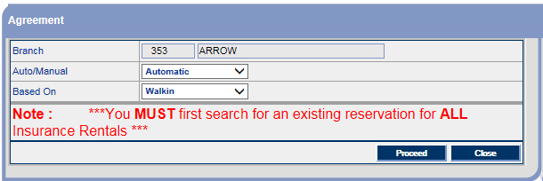
-Click on proceed button.
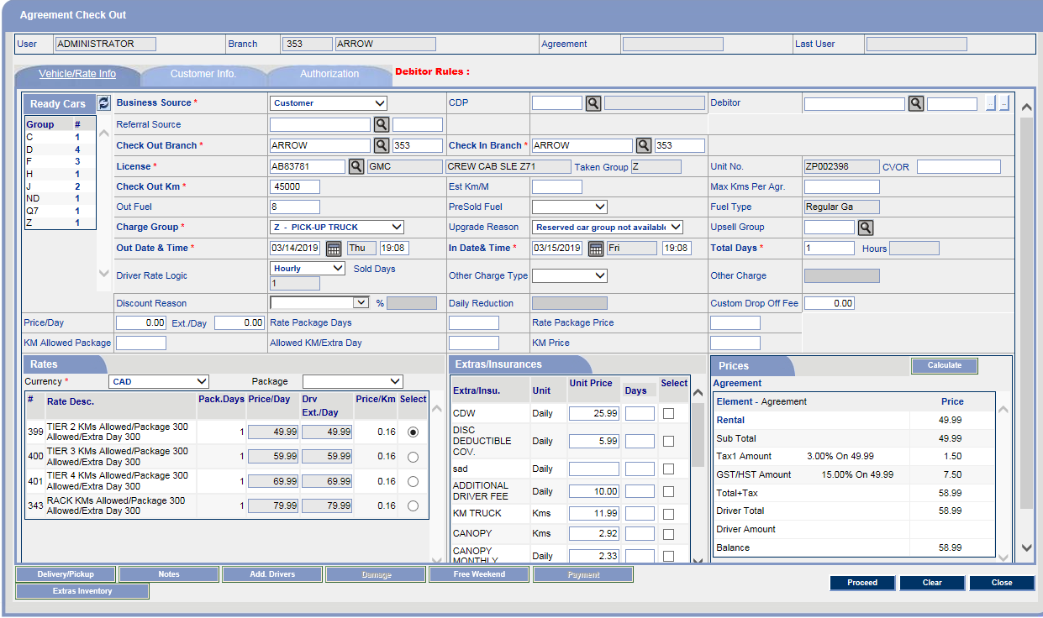
-Fill all Details and click on proceed button.
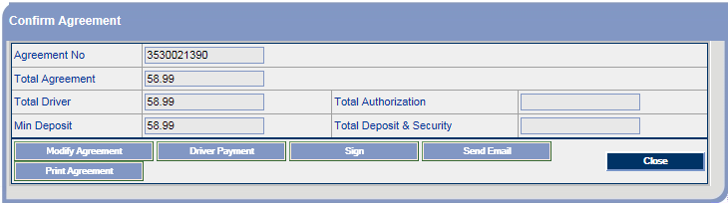
-Agreement has been Created with number 3530021390.
Agreement QA
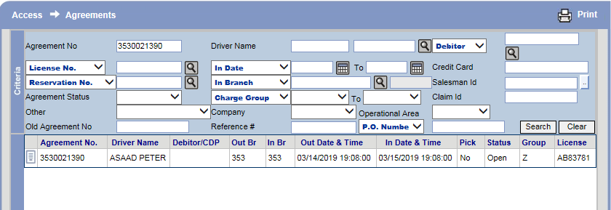
-User can see Created Agreement.

Step2:Vehicle Transaction
Menu path->1st tab->Access->Fleet Inventory
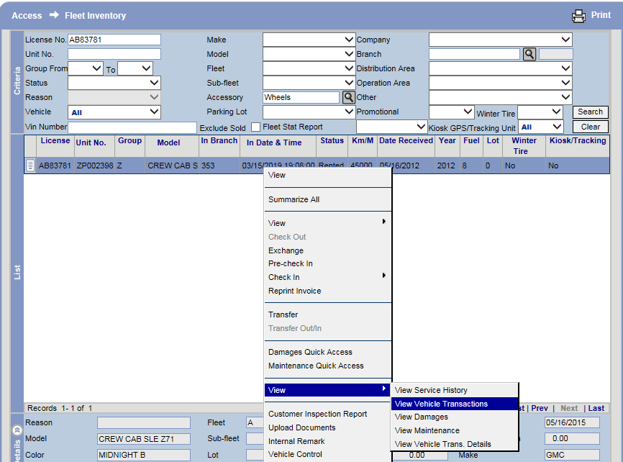
-Right click on Fleet Inventory and select View Vehicle Transaction option.
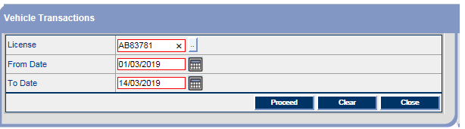
-Click on Proceed button.
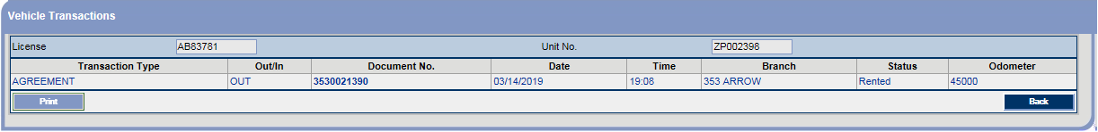
-Vehicle Transaction is showing correctly.

Step3:Modify Agreement
Menu path->1st tab->Access->Agreement
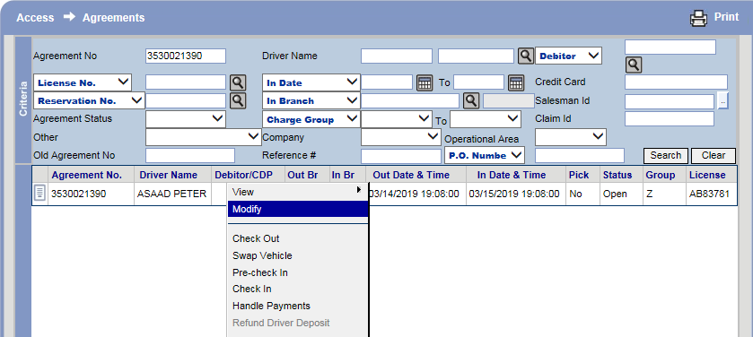
-Right click on Agreement and select Modify option.
1st modify screen is showing
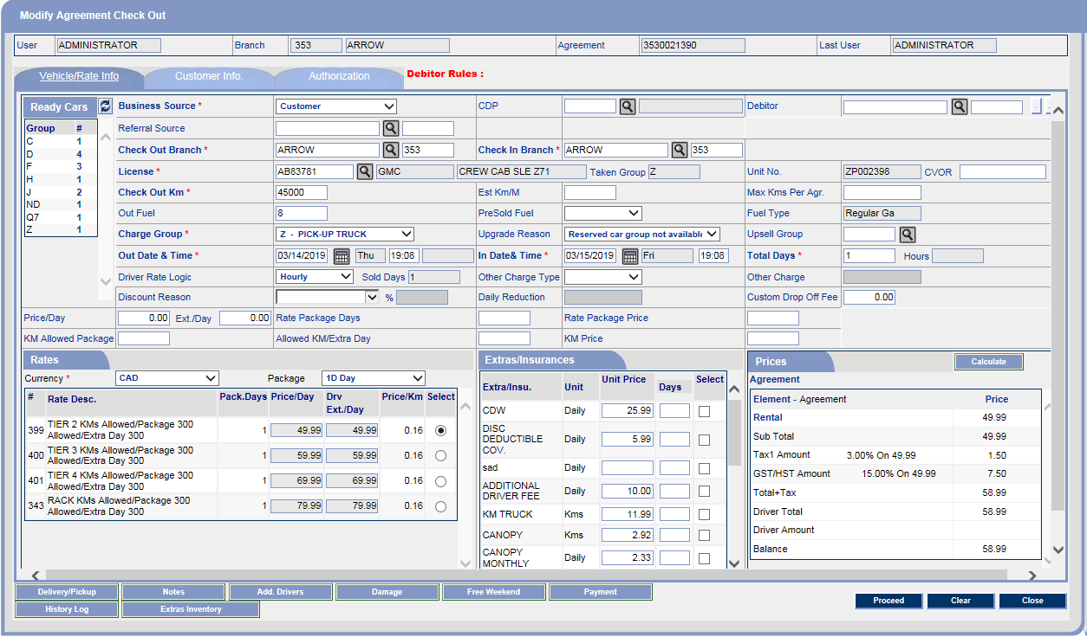

2nd modify screen is showing
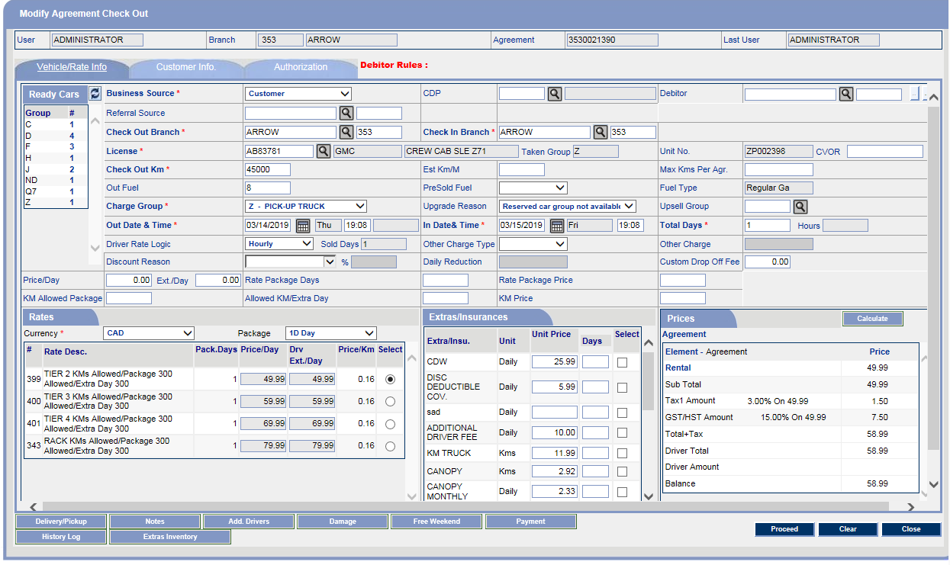
Step4:Swap vehicle
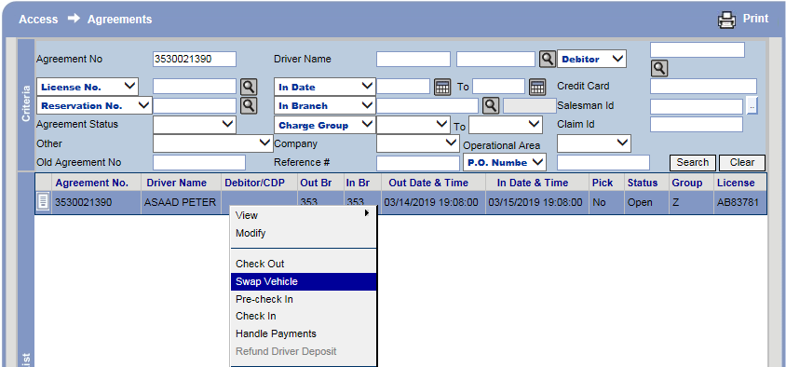
-Right click on Agreement and select Swap Vehicle option.
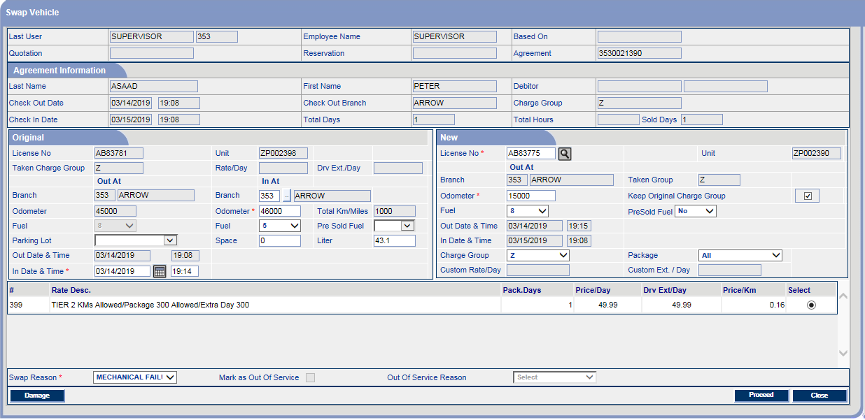
-Fill all Details and click on proceed button.
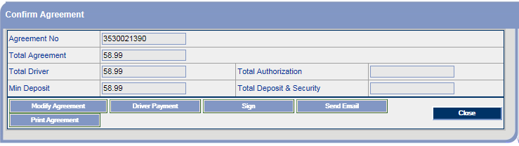
-Confirm screen is showing.

Step5:Modify Agreement Screen
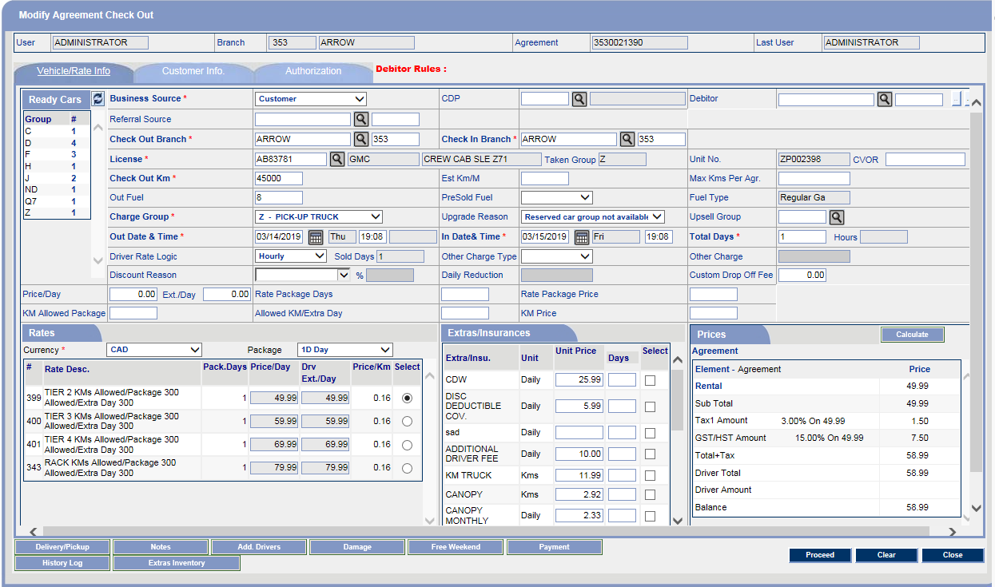
-Click on proceed button.
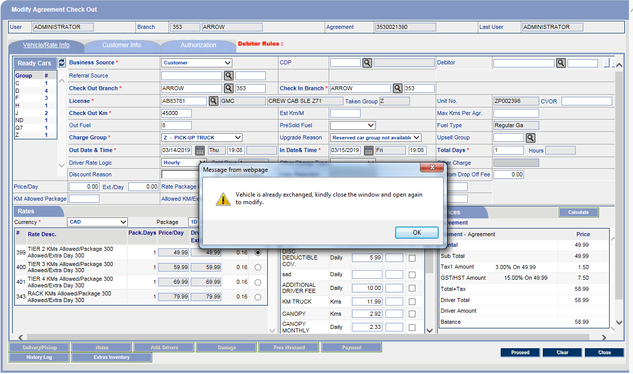
-Vehicle Exchange message is showing.

Step6:Modify Agreement
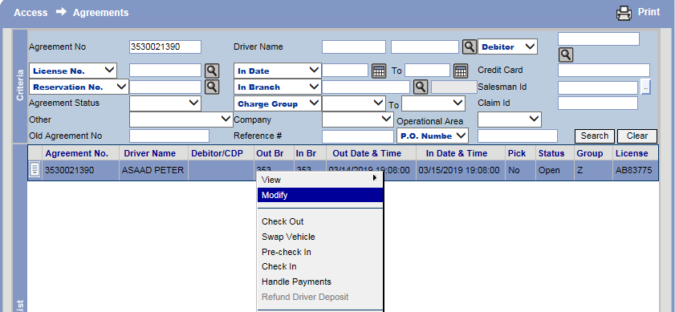
-Right click on Agreement and select modify option.
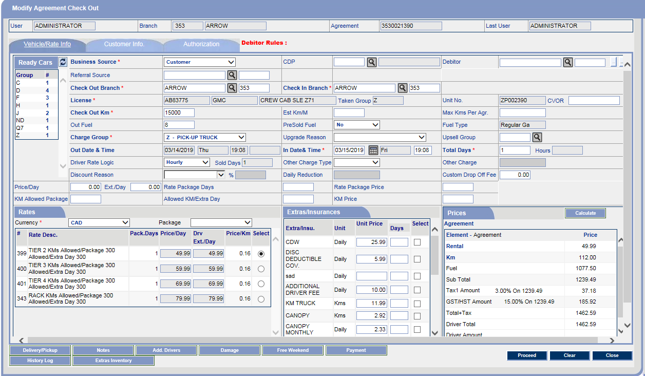
-at Modify screen swap vehicle is showing.
-Click on proceed button.
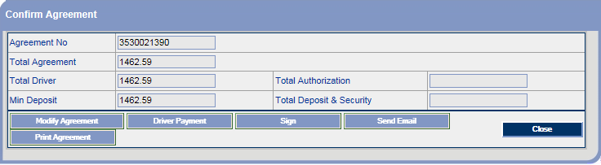
-Agreement has been Modified.

Step7:Vehicle Transaction
1st Vehicle
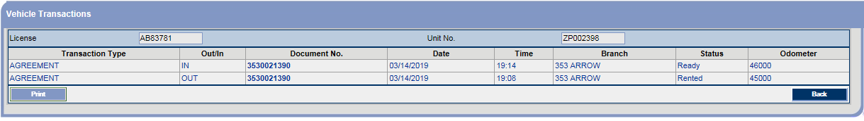
-Vehicle transaction is showing correctly.
2nd Vehicle
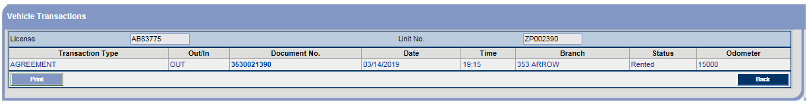
-Vehicle transaction is showing correctly.

************************ End of Document ********************************

