Functional Design of:
79733-Avis India- Consolidate Invoice Feature Phase 2
For RentPro XL

Document Details
Service Call Number | SPR # 72257
Description | Consolidate Invoice Feature Phase 2
Customer | Avis India
Author | Kranti Wanawe
Creation Date | 6th March 2019
Date Last Updated | 6th March 2019
Status | To be approved
Document History
Mod by | Date | Summary of Change | Status
Kranti | 06/03/2019 | Modification Document Preparation | Completed

This document is not to be considered as a functional programming description. Its only purpose is to describe the required functionality. RTB and/or CarPro Systems International have the right to (re)design the required program in any desired way as long as the requested and described functionality is achieved.

Table of Contents
Description/Objectives 3
Present Functionality 4
Proposed Solution 4

Description/Objectives

Dear team.
Further to enhancement in consolidate, we require consolidate invocie over a GST state,
• CarPro will provide functionality to create consolidate invoice under state level and we can add further filer at branch level to handle individual billing for cities like Mumbai and Pune.
• A state will have a default branch for Tax groups, for e.g. Maharashtra and U.P. have more than one branches so we have to set default branch for tax groups if a single invoice required at state level.
• Here sales will be distributed as per GL code structure in their respective Hubs.
• All the calculations will be handled by CarPro team and CarPro will responsible for plotting data in Accpac bridge server for all locations in merged state.
• Individual Agreements reference will no more available in Accpac for consolidated invoices.

Present Functionality
As per the current functionality ,Consolidate Invoices are generated by grouping with Out Location.

Proposed Solution
Please confirm the below points.
- New Field will be added in State Setup as ‘Consolidate Invoice Branch’ where user will select the branch from the state.
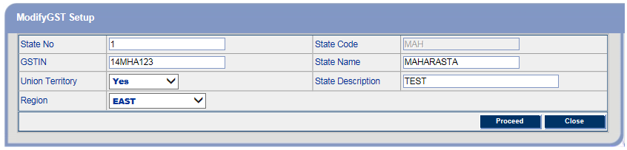
- New field will be added in City Setup as ‘Consolidate Invoice Branch’ where user will select the branch from the City.
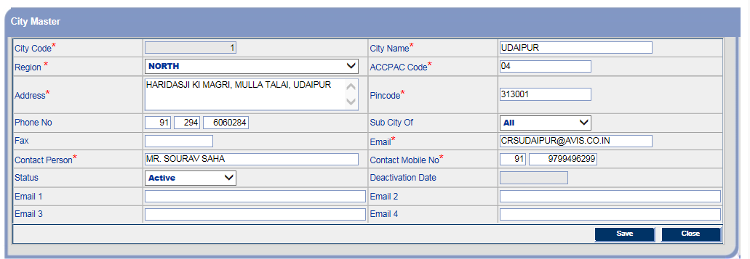
- When Creating Consolidate Invoice , below new fields will be added in search criteria
- Invoice By: This will be a combo with 2 values” 1.State 2. City. Default will be ‘State’
- State: This will be enabled only if ‘State’ is selected in field Invoice By .
This will be a combo box with all State names values.This field Will be mandatory.
- City: This will be enabled only if ‘City’ is selected in field Invoice By .
This will be a combo box with all City names values.This field Will be mandatory.

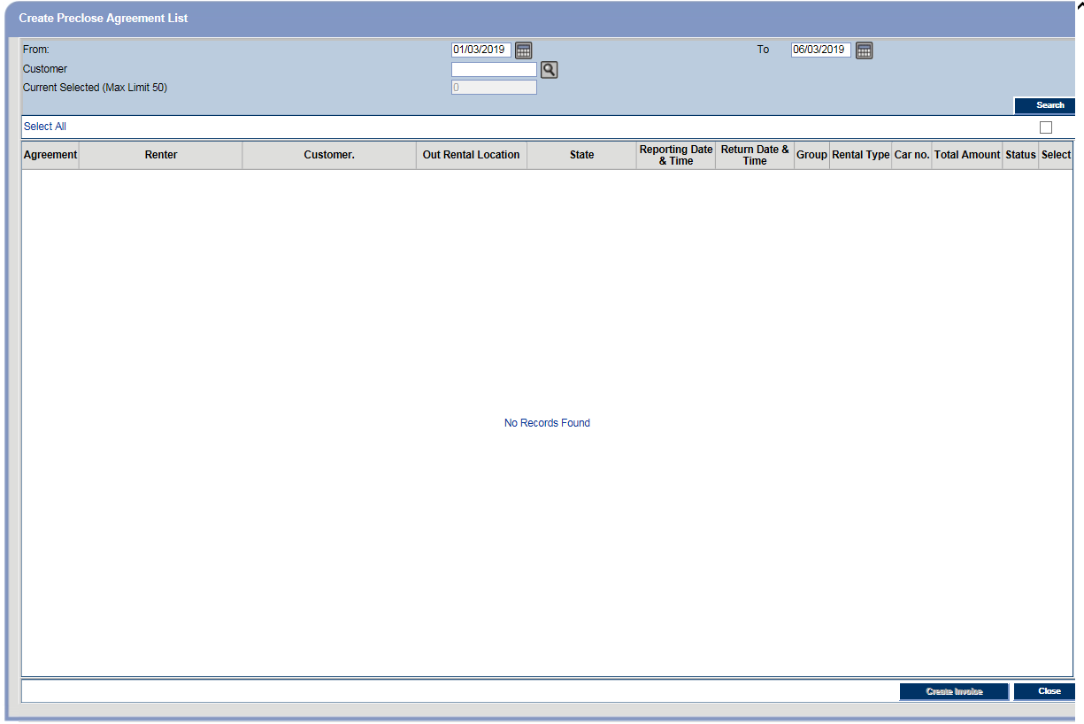
- If Invoice By=’State’ and state is selected then:
- When clicked on search , the agreements with Out Rental locations of the selected State will be loaded.
- After selecting agreements and clicked on Create Invoice:Agreements will be grouped by State (Currently they are grouped by Out Rental Location) and regardless of the Company of last vehicles on agreement (Currently we group agreements by Company of Last Vehicles on agreements (0 or 1)). Rest criteria will be same as current.
- Tax Invoice Number and Invoice Branch will taken from ‘Consolidate Invoice Branch’ from State.
- Flag of Invoice By will be saved for each Invoice as it will be used for Consolidate Invoice Print.
- If Invoice By=’City’ and City is selected then:
- When clicked on search , the agreements with Out Rental locations of the selected City will be loaded.
- After selecting agreements and clicked on Create Invoice:Agreements will be grouped by City (Currently they are grouped by Out Rental Location) and regardless of the Company of last vehicles on agreement (Currently we group agreements by Company of Last Vehicles on agreements (0 or 1)). Rest criteria will be same as current.
- Tax Invoice Number and Invoice Branch will taken from ‘Consolidate Invoice Branch’ from City.
- Flag of Invoice By will be saved for each Invoice as it will be used for Consolidate Invoice Print.

- Currently maximum 50 agreements are allowed for selection of consolidate.Now the maximum limit will be saved in ‘Default_Control’ and it will be used.
- On Consolidate Invoice Print,Rental Location name and Address will be Printed from ‘Invoice Branch’
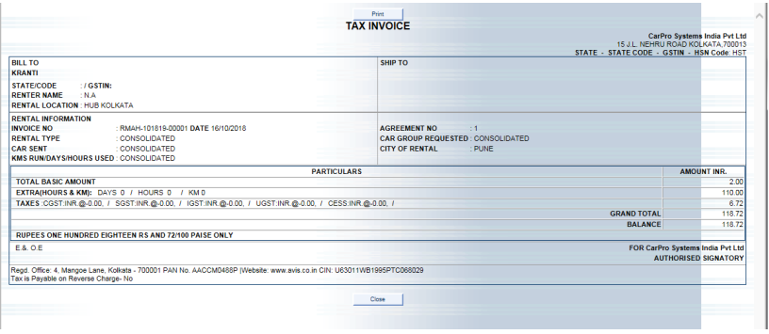
- On Consolidate Invoice create/Cancel, currently below window is shown for print which shows separate line for each agreement
- Now only 1 Line will be shown for 1 consolidate, columns will be ‘Tax Invoice Number’, ‘Combination Invoice’, ‘Total Amount’.
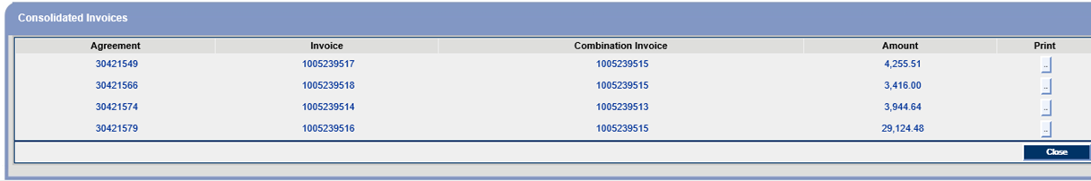
- For Accounting Export , for Consolidate Invoices currently Entries are grouped by 1 Combination Number.
- Now, Entries will be grouped by Combination Number+ Out Location+(Own/Hired Vehicles- which means 1 group will be for own vehicles and another for hired(company=0) vehicles) of agreements. Example if for 1 Consolidate number, there are 5 invoices with out location 101 (out of which vehicles on 2 invoices are own and 3 are hired)and 3 invoices with out location 202 (out of which vehicles on 1 invoices are own and 2 are hired) then 1 Entry for sum of rental of the out location 101 and own vehicles invoices for this location will be passed , 1 Entry for sum of rental of the out location 101 and hired vehicles invoices for this location will be passed, 1 Entry for sum of rental of the out location 202 and own vehicles invoices for this location will be passed and 1 Entry for sum of rental of the out location 202and hired vehicles invoices for this location will be passed.
Kindly Confirm and let us know!!!

