**Requirements for test application**

**Contents**

**1. General part 1**

1.1. Husband 1

1.2. Wife 1

1.3. Children 1

**2. Business Rules 2**

**3. Sketches** **2**

**1. General part**

**Scope:** Test application is purposed for collecting information about families, i.e. Husband, Wife and Children. –--**(What will be the name of our application?)**

**R 1001** Each family’s information (called ‘family database’) should be contained within 1 file, which can be saved with empty fields.

**R1001.1** Several applications should be able to be launched simultaneously. –-- **(Which exactly applications should be run?)**

**R 1002** When starting the Application the window should contain menu with three hinted standard buttons (New Database, Open Database, Save Database) and General tab should be enabled (**see Sketch 1**).

**R 1002.1** These “New, Open, Save” buttons should be eligible also for other three tabs: Husband, Wife, Children. Button Save should be disabled until the user clicks on New (Open) button.

**R 1003** To create a new family database the user should click on New button. The user might fill in Description (see **BR 1002**) of a family and select Date of marriage using Calendar (see **BR 1001**). --- **(Where should the description be placed? What is the Calendar app? Should it run with our application? The requirement is not correct by atomicity)**

**R 1004** To open an existing database the user should click on Open button, select from a dialog form and click on OK

**R 1004.1** If the user is editing new (or opened) database and then clicks on New (or Open) button the application should propose to Save the current database (changes). --- **(What if you click the Open button and the application does not find the databases, what action should the application take?)**

**R1005** To save a current database the user should click on Save button.

**R1005.1** The saved database name should be displayed in the top of application’s screen. ---**(Blurred indication. Where exactly should this field be located?)**

**R1005.2** If opened database is not edited yet, the Save button should be disabled.

**R1005.3** If the user saves database under the name which already exists in the path, the application should send the alert message if the user really wants to replace the existing file.

***1.1. Husband***

**R 2001** To fill in the information about a husband the user should click on Husband tab (see **Sketch 2**)

**R 2001.1** The following attributes of Husband might be filled in: First Name, Middle Name, Last Name (see **BR 1003**), Birth Day (**BR 1001**).

**R 200.2** The field Age is blank by default. The field age shouldn’t be editable. It should be calculated by application as soon as Birth Day is filled in.

***1.2. Wife***

The Wife screen has the same interface and logic as Husband screen does. --- **(It is not a complete requirement, you need more information and a screen of this field. There is an incorrect name, the word "wife" is written with a small letter)**

***1.3. Children***

**R 4001** To fill in the information about children the user should click on Children tab (see **Sketch 3**).

**R 4002** The table (2 rows and 3 columns) with children should be empty in a new database. These 3 columns should have names “Name” and “Height” consequently. ---**(The field “Name” is not correct, it must consist of several fields such as “First Name”, “Middle Name”, “Last Name”. The field “Height” is not correct)**

**R 4002.1** The cells in the table are not editable, but they can be selected. ---**(The date format in the screenshot is incorrect and should be changed to: 2005/5/18)**

**R 4003** The user should be able to insert as many children as he wants. Scrolling should be displayed when table gets bigger sizes than screen has.---**(How many children can be added?)**

**R 4004** The screen Children should have three hinted buttons Add Child, Del Child, Edit Child. ---**(There is an incorrect name of the buttons themselves, you need to remove the word "Child")**

**R 4004.1** If the table has no records Del Child and Edit Child buttons should be disabled.

**R 4004.2** Add button should be always enabled

**R 4005** When the user clicks on Add Child, the new screen should appear with 3 Attributes: ---**(There are invalid fields)**

* Name (see **BR 1003**)
* Height (see **BR 1004**)
* Birth Day (see **BR 1001**)

**R 4005.1** If the user clicks on OK the new record should appear in the table filled with filled attributes.

**R 4005.2** If the user clicks on Cancel the table should be with no changes.

**R 4006** To delete a child the user should select a record to delete and click on Del Child button. When the user click on this button the message should appear “Do you really want to delete the record?” If the user clicks on OK, the record should be deleted. If the user clicks on Cancel the record shouldn’t be deleted.

**R 4007** If the user clicks on Edit Child button the screen with 3 attributes should appear. If the user clicks on OK, the changes should be applied to the table, if clicking on Cancel button then changes shouldn’t be applied.

**2. Business Rules**

**BR 1001** The field of date (Date of marriage, Birth Day) should have the format MM\DD\YYYY. Other format should be ignored by the application. Date can be blank. The date can be typed manually or selected using the Calendar pop-up. The Calendar should have standard Windows UI. ---**(How should the program react to an incorrect input of date? What is the Calendar app and how should it interact with ours? What is meant by the standard Windows UI?)**

.

**BR 1002** Description field

* should be alphanumerical and may contain all special symbols
* should be of maximum length 50 – **(How the application should react when these characters are exceeded?)**
* can be blank

**BR 1003** The fields with Names (First Name, Last Name, Middle Name)

* should be alphanumerical and may contain all special symbols
* should be of maximum length 50 **(How the application should react when these characters are exceeded?)**
* can be blank ---**(The field must be filled)**

**BR 1004** The field Height

* should be alphanumerical
* should be maximum 300 cm
* measuring should be in cm (label cm should exist in the form)
* should be entered manually or using Calculator pop-up. Calculator should have standard Windows UI
* can be blank ---**(Do clients really need this field? What is the Calculator pop-up window, how exactly should it interact with our application? What is the standard Windows UI? Is it even advisable to add such an application under one line?)**

**3. Sketches**

**Sketch 1**

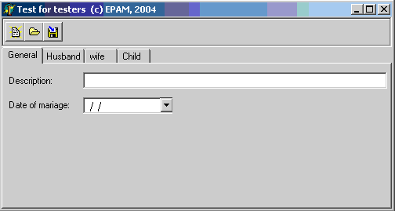

**Sketch 2**

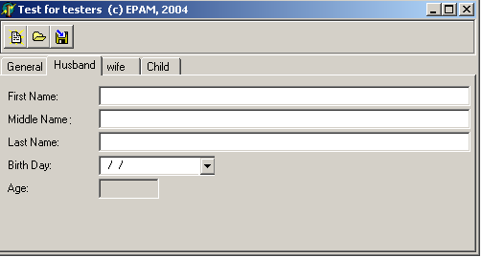

**Sketch 3**

