Atmosphere Shader

Sept. 2020 Changes
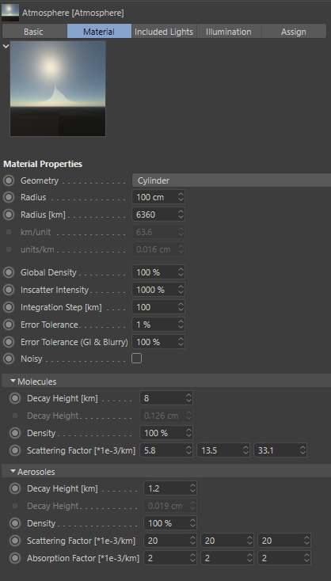
Geometry: With this you can make flat earths, ring worlds or cylindrical habitats. Note: Cylinder type renders much slower. This is an unfortunate limitation.

Integrator: The numerical integration routine responsible for accumulating the in-scattered light along the viewing ray was rewritten.

* Now, the view ray is divided into segments of length “Integration Step” as shown in the sketch below. On every segment the light that reaches the eye is computed for a couple of scattering locations (i.e. sample points). Their sum gives the total contribution across the ray.
* There is an error estimation. Errors inevitably occur due to the finite number of samples. If the estimated relative error goes above the “Error Tolerance” setting, then the segment with the largest error is subdivided into two, the error is reevaluated and the process repeats. This is illustrated by the different levels in the sketch.
* For GI or blurry reflections/refractions we don’t need much precision so there is an extra setting.
* The “Noisy” checkbox randomly varies the location of the scattering points, trading systematic errors for noise. Good for the physical render mode when you take many samples per pixel.

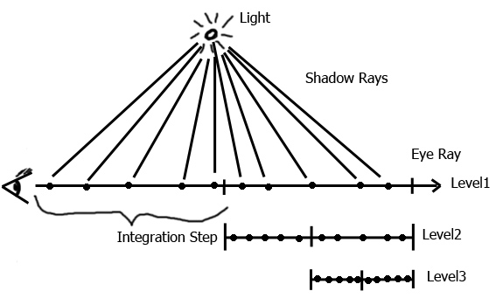

Center Setting: Removed. Instead, you can position the texture coordinate system accordingly.
Material Preview: New custom scenes for the new geometries were added. Right click on the preview image, go to the Atmosphere sub menu. You’ll find different options there.
Location in the Cinema 4D UI: It can be found next to the other “special” materials, Banji, Banzi, Cheen, etc. Normally in the Material Manager menu: Create→Extension or Shader → Atmosphere (depending on C4d version).

Known Issues
With Irradiance Caching some spots on the borders don’t get any indirect illumination.
Here it is shown in the prepass visualization. In the final image you’d see splotchy artifacts. There is nothing I can do about that.
