Writing Task 1 C4T1T1

You should spend about 20 minutes on this task.

The table below shows the proportion of different categories of families living in poverty in Australia in 1999.
Summarize the information by selecting and reporting the main features, and make comparisons where relevant.

Write at least 150 words.

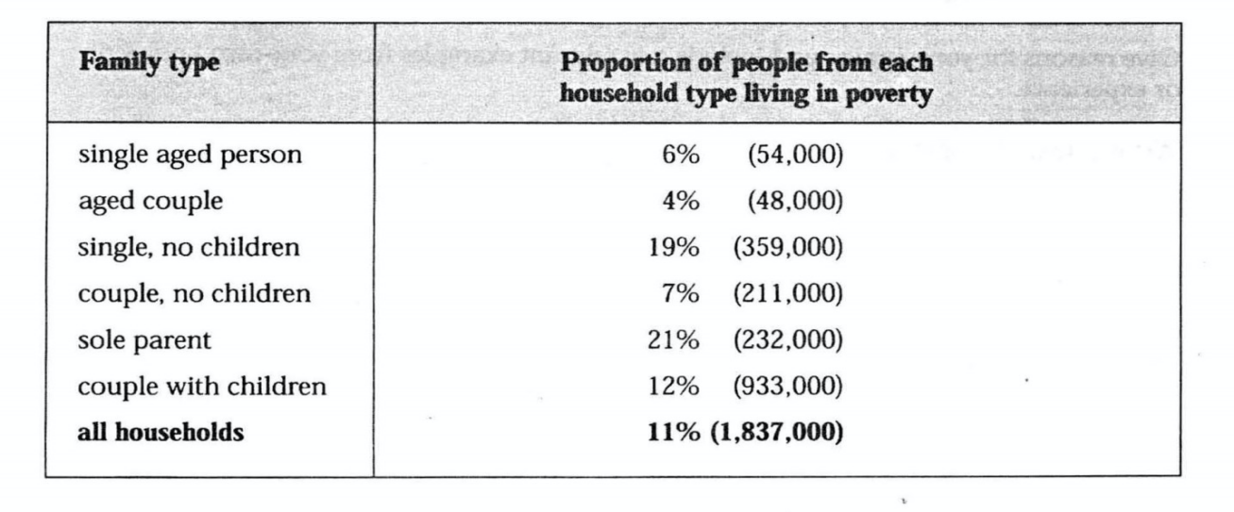
The table gives a breakdown of the different types of family who were living in poverty in Australia in 1999.

On average, 11% of all households, comprising almost two million people, were in this position. However, those consisting of only one parent or a single adult had almost double this proportion of poor people, with 21% and 19% respectively.

Couples generally tended to be better off, with lower poverty levels for couples without children(7%) than those with children(12%). It is noticeable that for both types of household with children, a higher than average proportion were living in poverty at this time.

Older people were generally less likely to be poor, though once again the trend favoured elderly couples(only 4%) rather than single elderly people(6%).

Overall the table suggests that households of single adults and those with children were more likely to be living in poverty than those consisting of couples.

(考官范文 150 words)
Writing Task 1 C5T1T1

You should spend about 20 minutes on this task.

The graph below shows the proportion of population aged 65 and over between 1940 and 2004 in three different countries.
Summarize the information by selecting and reporting the main features, and make comparisons where relevant.

Write at least 150 words.

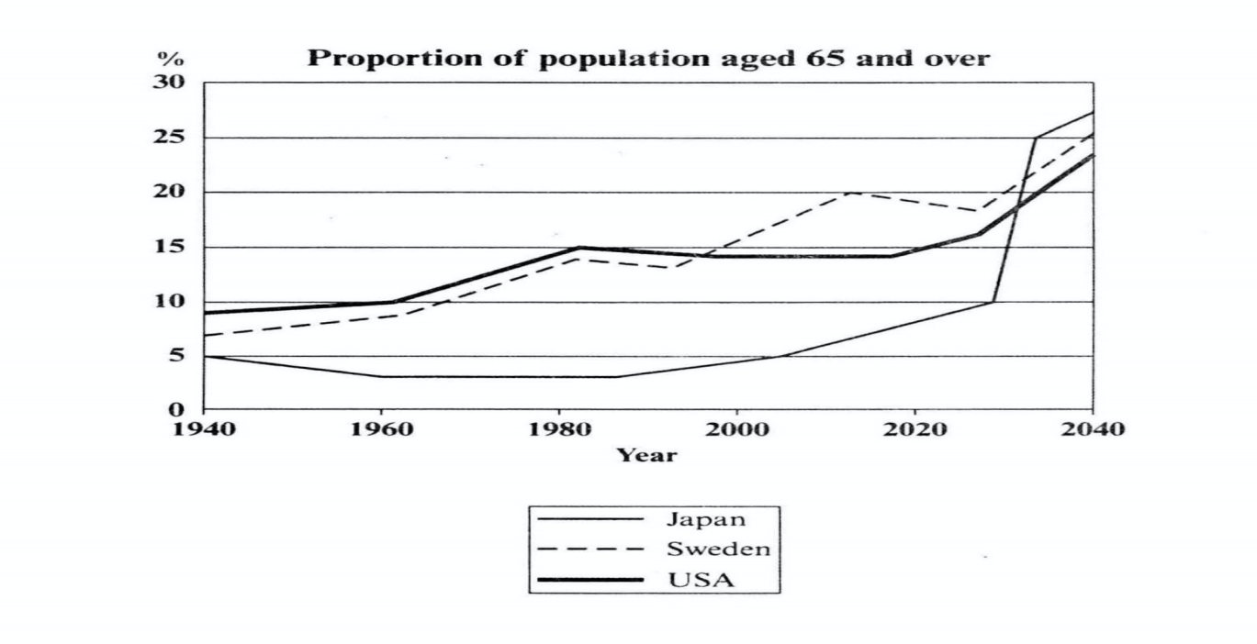

The line graph displays the increase in the ageing population in Japan, Sweden and the USA since 1940 and predicts the percentage of elder people in these three countries by the year 2040. It indicates that the percentage of elderly people in all three countries is expected to increase to almost 25% of the respective populations in 2040.

In 1940, the proportion of people aged 65 or more stood at only 5% in Japan, approximately 7% in Sweden and 9% in the US. After this, the figures for the Western countries grew to about 15% in around 1990, while the figure for Japan dipped to only 2.5% for much of this period, before rising to almost 5% again after 2000.

In spite of some fluctuation in the expected percentages, the proportion of older people will probably continue to increase in the next two decades in the three countries. A more dramatic rise is predicted between 2030 and 2040 in Japan, by which time it is thought that the proportion of elder people will be similar in the three countries.
(考官范文179 words)
Writing Task 1 C4TBT1（general training）
You should spend about 20 minutes on this task.

You want to sell some of your furniture. You think a friend of yours might like to buy it from you.

Write a letter to your neighbours. In your letter

- Explain why you are selling
- Describe the furniture
- Suggest a date when your friend can come and see the furniture

Write at least 150 words.

Dear Jan,
As you know, we'll be moving to a new house soon and there are a few things that I won't be able to take with me. The new house is a bit smaller so I have to sell some furniture and I was wondering if you might be interested?

In particular I want to sell my big dining table. Do you remember it - the one in the living room? It has wooden legs and a grey glass top and it's big enough for six people. There are six matching chairs to go with it.

I know you've always like this furniture so I could let you have it at a good price. I'd rather sell it to you than to a stranger!

Why don't you come around and take another look at them on Saturday?We'll be here all day, so maybe we could have some lunch together?
Give me a ring and let me know.
Love,
Shanda.

(考官范文 160 words)

Writing Task 1 C5T3T1
You should spend about 20 minutes on this task.

The map below is of the town of Garlsdon. A new supermarket (S) is planned for the town. The map shows two possible sites for the supermarket.

Write at least 150 words.
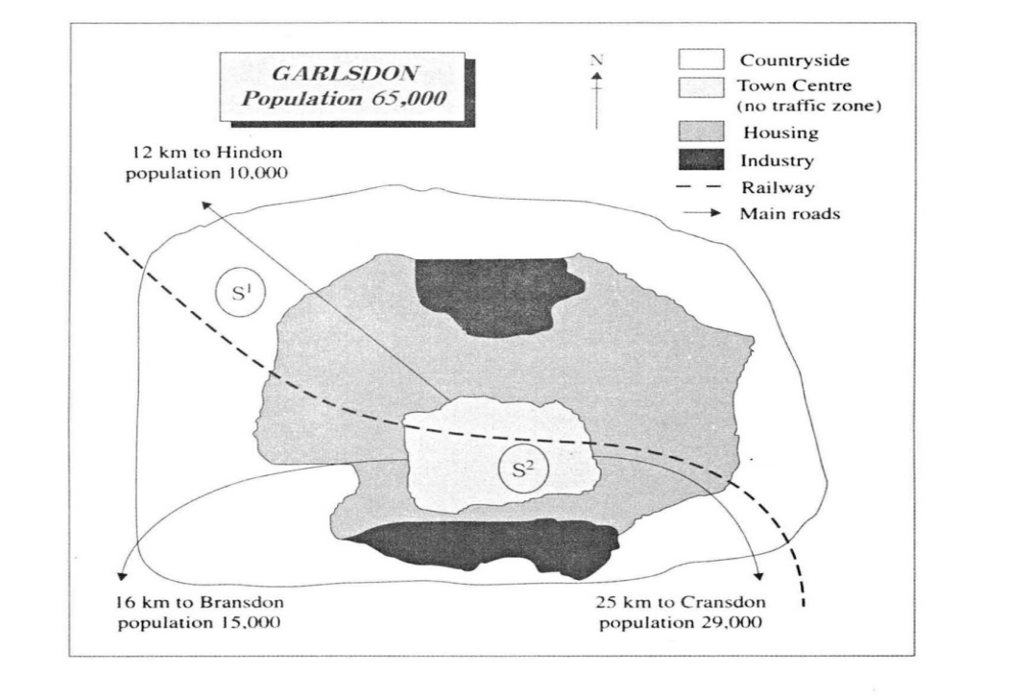
The map shows two proposed locations for a new supermarket for the town of Garlsdon.
The first potential location (S1) is outside the town itself, and is sited just off the main road to the town of Hindon, lying 12 kms to the north-west. This site is in the countryside and so would be able to accommodate a lot of car parking. This would make it accessible to shoppers from both Hindon and Garlsdon who could travel by car. As it is close to the railway line linking the two towns of Cransdon (25 kms to the south-east), a large number of shoppers would also be able to travel by train.
In contrast, the suggested location, S2, is right in the town centre, which would be good for local residents. Theoretically the store could be accessed by road or rail from the surrounding towns, including Bransdon, but as the central area is a no-traffic zone, cars would be unable to park and access would be difficult.

Overall, neither site is appropriate for all the towns, but for customers in Cransdon, Hindon and Garlsdon, the out-of-town site (S1) would probably offer more advantages.
(考官范文192 words)
Writing Task 1 C5TAT1（general training）

You should spend about 20 minutes on this task.

Your neighbors have recently written to you to complain about the noise from your house/flat.
Write a letter to your neighbours. In your letter
- Explain the reasons for the noise
- Apologise
- Describe what action you will take

Write at least 150 words.

Dear James,
I was very shocked to get your letter saying that the noise from my flat has been spoiling your evenings and causing you some distress. I am really, really sorry about that. I had no idea that you would be able to hear so much, so I hope you will accept my apologies.
As you may have guessed, I am trying to refit my kitchen in the evenings when I get home from work. Unfortunately it is all getting longer than expected and I have been having problems with getting things to fit properly. This has meant to a lot of banging and hammering.
As the kitchen is still not finished, I have decided to call in a professional builder who will finish the work in the next day or two. He'll work only during daytime hours, so you won't be disturbed in the evenings again, I promise.
Sorry to have caused these problems,
Bill.
(考官范文 157 words)

Writing Task 1 C6T1T1
You should spend about 20 minutes on this task.

The graph and table below give information about water use worldwide and water consumption in two different countries.

Write at least 150 words.
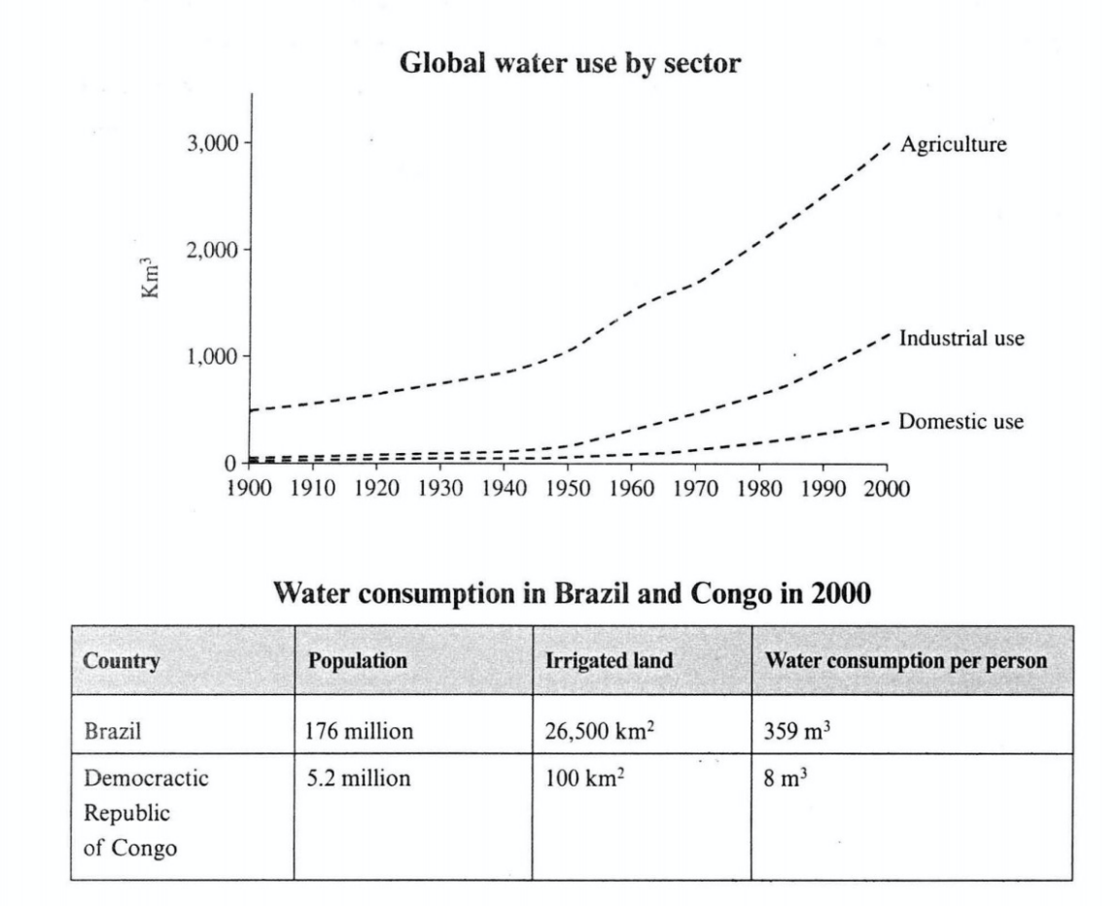

The graph shows how the amount of water used worldwide changed between 1900 and 2000.

Throughout the century, the largest quantity of water was used for agricultural purposes, and this increased dramatically from about 500 km3 to around 3000 km3 in the year 2000.Water used in the industrial and domestic sectors also increased, but consumption was minimal until mid-century. From 1950 onwards, industrial use grew steadily to just over 1000 km3, while domestic use rose more slowly to only 300 km3, both far below the levels of consumption by agriculture.

The table illustrates the differences in agricultural consumption in some areas of the world by contrasting the amount of irrigated land in Brazil (26500 km2) with that in the D.R.C (100 km2). This means that a huge amount of water is used in agriculture in Brazil, and this is reflected in the figures for water consumption per person: 359 m3 compared with only 8 m3 in the Congo. With a population of 176 million, the figures for Brazil indicate how high agricultural water consumption can be in some countries.

(考官范文179 words)

Writing Task 1 C6T3T1
You should spend about 20 minutes on this task.

The diagrams below show the life cycle of the silkworm and the stages in the production of silk cloth.

Write at least 150 words.

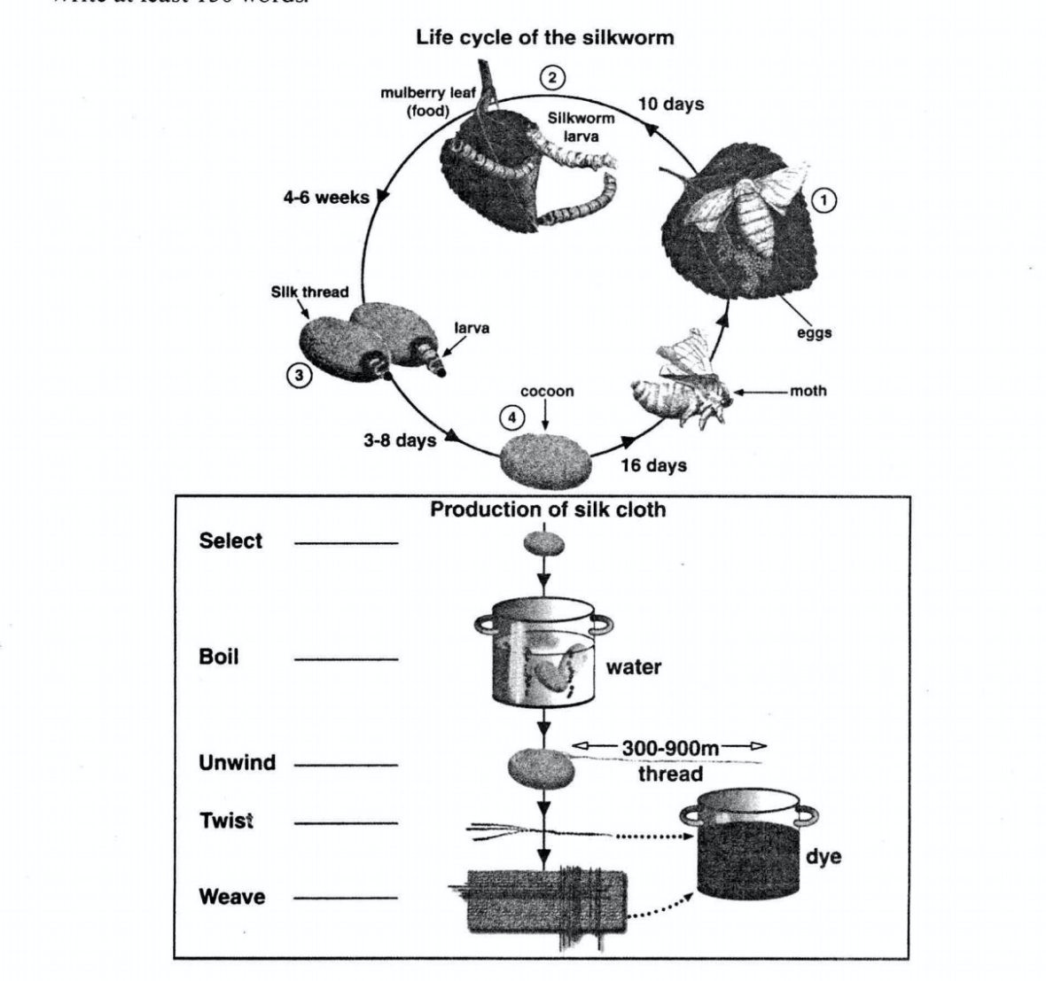
The diagrams show that the cocoon stage of the silkworm can be used to produce silk cloth through a very simple process.

The first diagram shows that there are four main stages in the life of the silk worm.First of all, eggs are produced by the moth and it takes ten days for each egg to become a silkworm larva that feeds on mulberry leaves. This stage lasts for up to six weeks until the larva produces a cocoon of silk thread around itself. After a period of about three weeks, the adult moths eventually emerge from these cocoons and the life cycle begins again.

The cocoons are the raw material used for the production of silk cloth. Once selected, they are boiled in water and the threads can be separated in the unwinding stage. Each thread is between 300 and 900 metres long, which means they can be twisted together, dyed and then used to produce cloth in the weaving stage.

(考官范文 163 words)

Writing Task 1 C6TAT1(General training)

You should spend about 20 minutes on this task.

You and your family are living in rented accommodation in an English-speaking country. You are not satisfied with the condition of some of the furniture.

Write a letter to the landlord. In your letter
- Introduce yourself
- Explain what is wrong with the furniture
- Say what action you would like the landlord to take

Write at least 150 words.

Dear Mr Smith，

I am your tenant from Flat 3 on Riverside Street. We met each other when I signed the rental agreement in your office.

I have lived here for 6 months now and I am writing to complain about some of the furniture. As you may remember.the dining table is in very poor condition and has uneven legs. It also does not match the dining chairs as these are too low to be comfortable for a table of that height. When I first pointed this out to you.you agreed to provide a brand new dining set.However，you have not done so and I would really like to resolve this matter as soon as possible.

If it is more convenient for you，perhaps you could simply replace the table by finding one of a suitable height for the chairs. This would solve the problems without too much cost，so I hope you agree to this proposed solution.

Looking forward to hearing from you，

Yours sincerely,
- M.Egil

(考官范文 172 words)

Writing Task 1 C7T2T1
You should spend about 20 minutes on this task.

The graph below shows the consumption of fish and some different kinds of meat in a European country between 1979 and 2004.

Write at least 150 words.
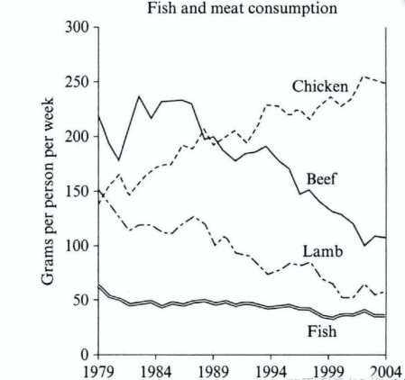

The line chart illustrates the changes in the amounts of beef, lamb, chicken and fish consumed in a particularly European country between 1979 and 2004.

Overall, the graph shows how the consumption of chicken increased dramatically while the popularity of these other foods decreased over the period.

In 1979, beef was by far the most popular of these foods,with about 225 grams consumed person per week. Lamb and chicken were eaten in similar quantities(around 150 grams), while much less fish was consumed at just over 50 grams.

However, during this 25-year period, the consumption of beef and lamb fell dramatically to approximately 100 grams and 55 grams respectively. The consumption of fish also declined, but much less significantly to just below 50 grams, so although it remained the least popular food, consumption levels were the most stable.

The consumption of chicken, on the other hand, showed an upward trend, overtaking that of lamb in 1980 and that of beef in 1989. By 2004 it had soared to almost 250 grams per person per week.

(考官范文 192 words)

Writing Task 1 C7T4T1
You should spend about 20 minutes on this task.

The pie chart below show units of electricity production by fuel source in Australia and France in 1980 and 2000.

Write at least 150 words.

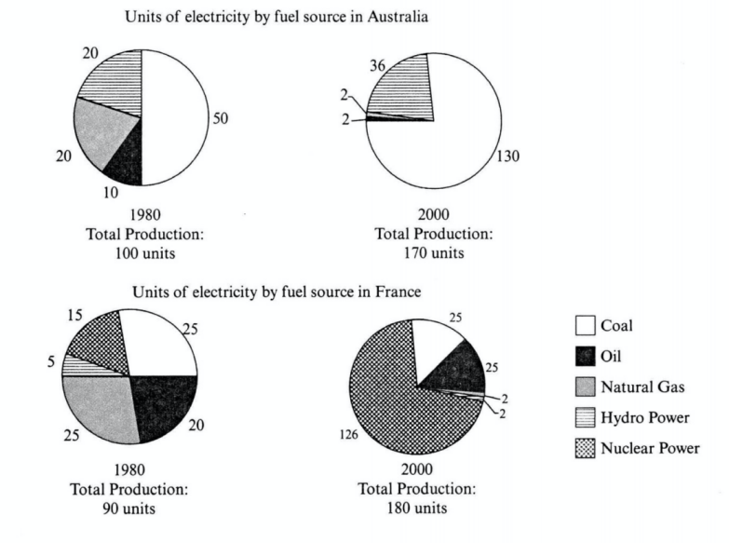

The charts compare the sources of electricity in Australia and France in the years 1980 and 2000.

Overall, between these years electricity production almost doubled, rising from 100 units to 170 in Australia, and from 90 to 180 units in France.However, by 2000 these two countries relied different principal fuel sources: Australia relied on coal and France on nuclear power.
In 1980 Australia used coal as the main electricity source (50 units) and the remainder was produced from natural gas, hydro power (each producing 20 units) and oil (which produced only 10 units). However, by 2000, coal had become the fuel for more than 75% of electricity produced and only hydro continued to be another significant source supplying approximately 20%.
In contrast, France used coal as a source for only 25 units of electricity in 1980, which was matched by natural gas. The remaining 40 units were produced largely from oil and nuclear power, with hydro contributing only 5 units. But by 2000 nuclear power, which was not used at all in Australia, had developed into the main source, producing almost 75% of electricity, at 126 units, while coal and oil together produced only 50 units. Other sources were no longer significant.
(考官范文 205 words)

Writing Task 1 C7TAT1(General training)

You should spend about 20 minutes on this task.

You have recently started work in a new company.

Write a letter to an English-speaking friend. In your letter
- Explain why you changed jobs
- Describe your new job
- Tell him/her your other news

Write at least 150 words.

Dear Jenny,

I hope this finds you and your family well, and I am sorry I have not been in touch recently. I am writing now to let you know about my new job.

You remember that I was working for that construction company a few miles outside the city? Well, I just got so fed up with it- I was working really long hours and, to be honest, the pay was not great. So basically I applied for a job at a new international company that was looking for admin staff for a new branch in the city centre.

I was a bit nervous in the interview, but in the end I got a job as one of the senior administrators. I am so happy! The pay is better, the working conditions are great and I do not have to drive to work anymore.

Anyway, I have to stop now because my sister is staying with me and has brought my baby nephew to meet me. She sends you lots of love and is asking when we can all meet up. Soon, I hope.

With love,
Tina

(考官范文 188 words)

Writing Task 1 C8T1T1
You should spend about 20 minutes on this task.

The pie chart below shows the main reasons why agricultural land becomes less productive. The table shows how these causes affected three regions of the world during the 1990s.

Write at least 150 words.

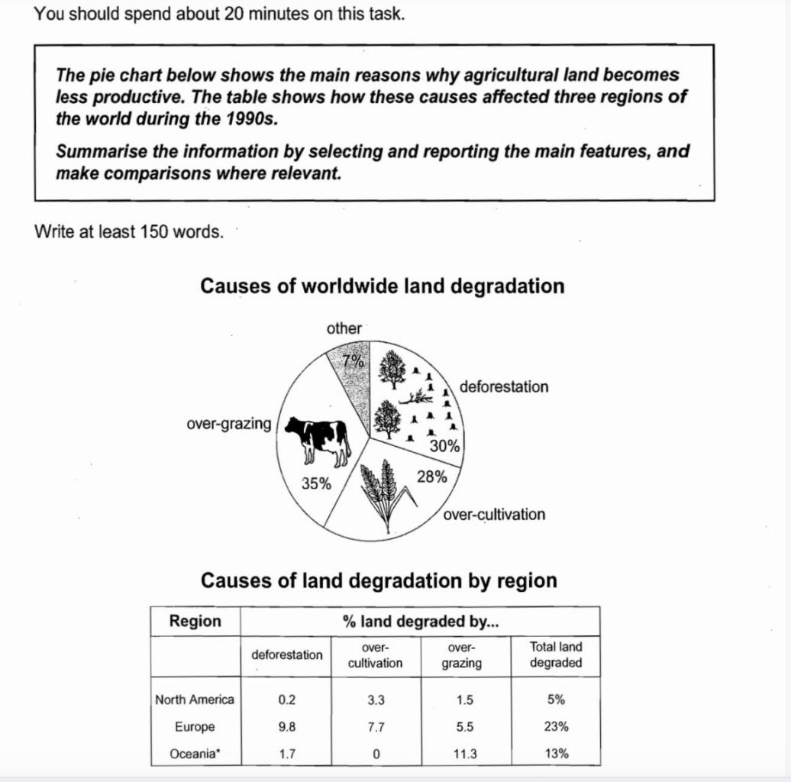

The pie chart shows that there are four main causes of farmland becoming degraded in the world today. Globally, 65% of degradation is caused by too much animal grazing and tree clearance, constituting 35% and 30% respectively. A further 28% of global degradation is due to over-cultivation of crops. Other causes account for only 7% collectively.
These causes affected different regions differently in the 1990s, with Europe having as much as 9.8% of degradation due to deforestation, while the impact of this on Oceania and North America was minimal, with only 1.7% and 0.2% of land affected respectively. Europe, with the highest overall percentage of land degraded (23%), also suffered from over-cultivation (7.7%) and over-grazing (5.5%). In contrast, Oceania had 13% of degraded farmland and this was mainly due to over-grazing (11.3%). North America had a lower proportion of degraded land at only 5%, and the main causes of this were over-cultivation (3.3%) and, to a lesser extent, over-grazing (1.5%).
Overall, it is clear that Europe suffered more from farmland degradation than the other regions, and the main causes there were deforestation and over-cultivation.

(考官范文 185words)

Writing Task 1 C8T2T1
You should spend about 20 minutes on this task.

The three charts below show the changes in annual spending by a particular UK school in 1981, 1991 and 2001.

Write at least 150 words.

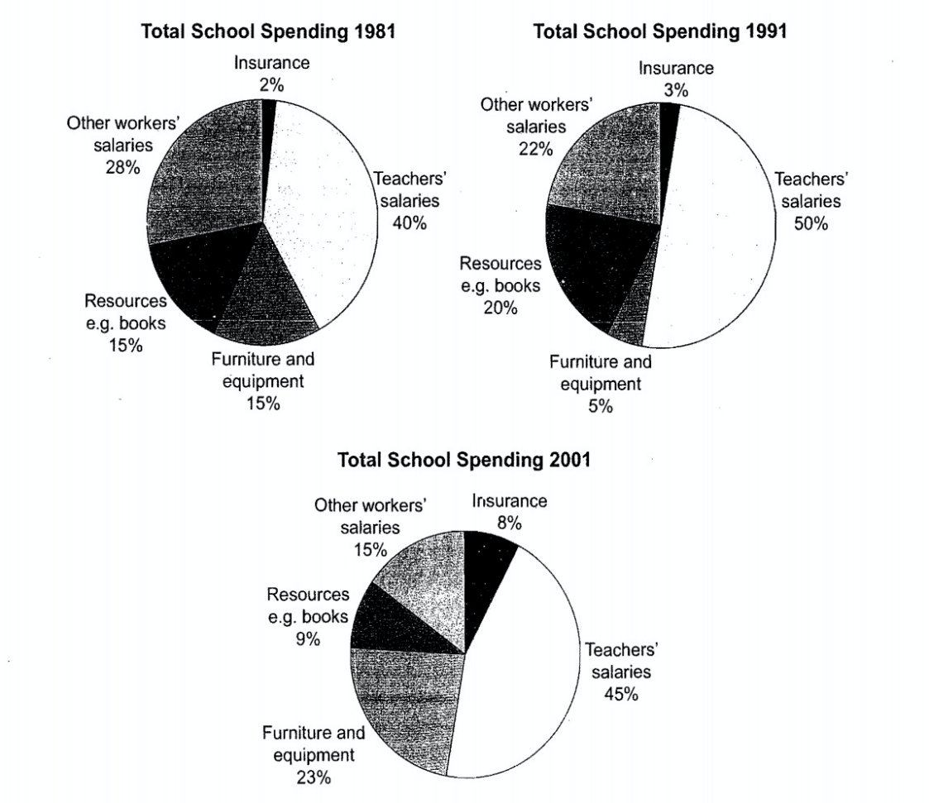
The charts show how much a UK school spent on different running costs in three separate years: 1981, 1991 and 2001.

In all three years, the greatest expenditure was on staff salaries. But while other workers’ salaries saw a fall from 28% in 1981 to only 15% of spending in 2001, teachers’ pay remained the biggest cost, reaching 50% of total spending in 1991 and ending at 45% in 2001.

Expenditure on resources such as books had increased to 20% by 1991 before decreasing to only 9% by the end of the period. In contrast, the cost of furniture and equipment saw an opposite trend. This article is from Laokaoya website. This cost decreased to only 5% of total expenditure in 1991 but rose dramatically in 2001 when it represented 23% of the school budget. Similarly, the cost of insurance saw a rising trend, growing from only 2% to 8% by 2001.

Overall, teachers’ salaries constituted the largest cost to the school, and while spending increased dramatically for equipment and insurance, there were corresponding drops in expenditure on things such as books and on other workers’ salaries.

(考官范文 187 words)

Writing Task 1 C8T4T1
You should spend about 20 minutes on this task.

The graph below shows the quantities of goods transported in the UK between 1974 and 2002 by four different modes of transport.

Write at least 150 words.

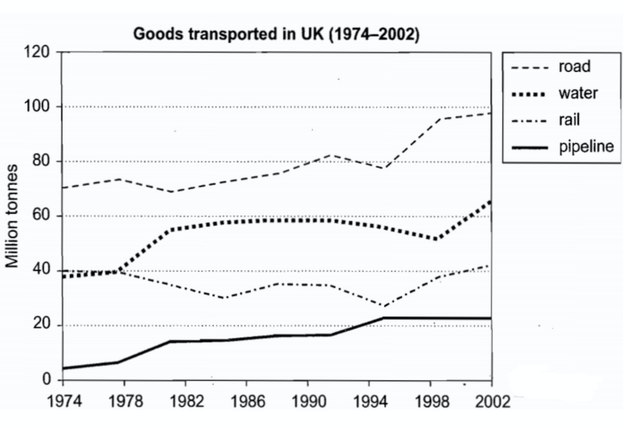
The graph illustrates the quantities of goods transported in the United Kingdom by four different modes of transport between the time period of 1974 and 2002.Over this span of 28 years, the quantities of goods transported by road, water and pipeline all increased while the quantity transported by rail remained almost constant at about 40 million tonnes.

The largest quantity of goods transported both in 1974 and 2002 was by road (70 million tonnes and 2002 million tonnes respectively) while the lowest both in 1974 and 2002 was by pipeline (about 5 million tonnes and 22 million tonnes respectively). The amount of goods transported by water was constant from 1974 to 1978, after which it showed an exponential growth, rising to almost 60 million tonnes after which it plateaued for about 20 years before starting to rise gradually again.

The amount of goods transported by rail was almost constant at 40 million tonnes in 1974 and 2002, with decreases in quantity between the years. It is also interesting to note that almost all showed a decrease in 1994 in amount of goods transported except for the pipeline, which actually peaked in that year.

Overall, the road remained the most popular method of transporting goods in the UK while water and pipelines were becoming increasingly used, while had not become more popular as a method of transport.

(八分范文 226 words)

Writing Task 1 C8TAT1(General training)

You should spend about 20 minutes on this task.

You have recently moved to a different house.
Write a letter to an English-speaking friend. I your letter

- Explain why you have moved
- Describe your new house
- Invite your friend to come and visit

Write at least 150 words.

Dear Dave，
I am writing to let you know that we have moved to a bigger house. We just could not go to living in the two-bedroom bungalow now that the twins are growing up and the new baby has arrived. So we started looking-and one thing led to another and finally here we are in our new home.

I am sure you will like it. We have three bedrooms now，and a very modern bathroom and kitchen. The kids are happy because there is much more space with the living room and the garden outside. But Michel is the happiest of all because he does not need to do much decorating.

Why don’t you come round this weekend and see what you think of our new place？We would all love to see you and if the weather is good we can have a barbecue in the garden.

Our new address and phone number are below, so give us a call and let us know when to expect you.

Lots of love，
Francoise

Writing Task 1 C9T1T1

You should spend about 20 minutes on this task.

The two maps below show an island, before and after the construction of some tourist facilities.

Write at least 150 words.

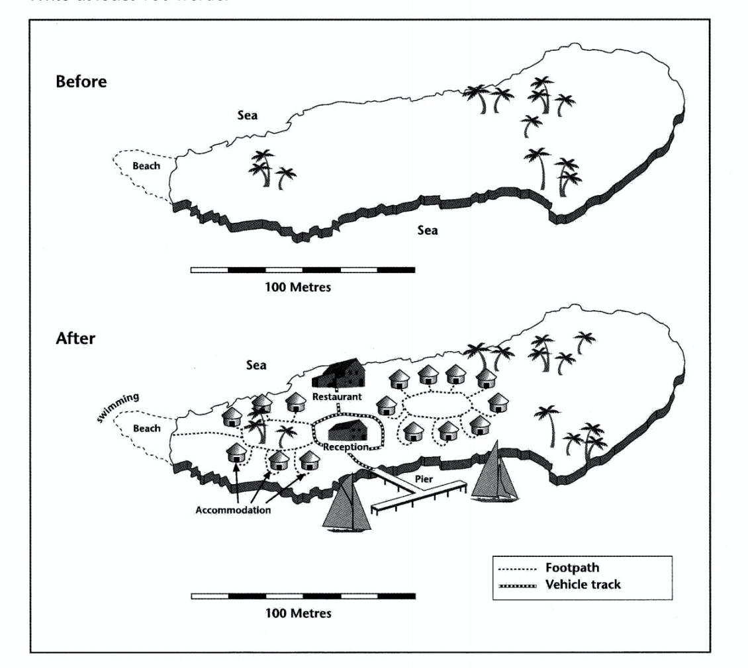
The two maps show the same island while first one is before and the second one is after the construction for tourism.

Looking first at the one before construction, we can see a huge island with a beach in the west. The total length of the island is approximately 250 meters.

Moving on to the second map, we can see that there are lots of buildings on the island. There are two maps of accommodation. One is in the west near the beach while the other one is in the centre of the island. Between them, there is a restaurant in the north and a reception block, which is surrounded by a vehicle track. The track also goes down to the pier where people can go sailing in the south sea of the island. Furthermore, tourists can swim near the beach in the west. A footpath connecting the western accommodation units also leads to the beach.

Overall, comparing the two maps, there are significant changes after this development. Not only lots of facilities are built on the island, but also the sea is used for activities. The new island has become a good place for tourism.

(考生七分范文 196 words)

Writing Task 1 C9T4T1

You should spend about 20 minutes on this task.

The graph below gives information from a 2008 report about consumption of energy in the USA since 1980 with projections until 2030.

Summarise the information by selecting and reporting the main features, and make comparisons where relevant.

Write at least 150 words.

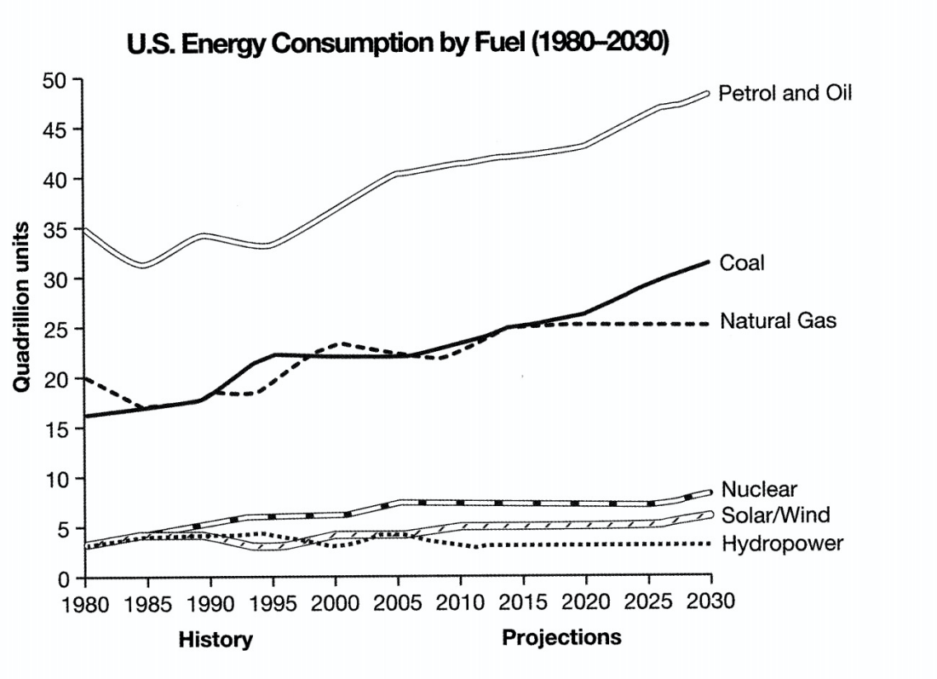

The graph shows energy consumption in the US from 1980 to 2012, and projected consumption to 2030.

Petrol and oil are the dominant fuel sources throughout this period, with 35 quadrillion (35q) units used in 1980, rising 42q in 2012. Despite some initial fluctuation, from 1995 there was a steady increase. This is expected to continue, reaching 47q in 2030.

Consumption of energy derived from natural gas and coal is similar over the period. From 20q and 15q respectively in 1980, gas showed an initial fail and coal a gradual increase, with the two fuels equal between 1985 and 1990. Consumption has fluctuated since 1990 but both now provide 24q. Coal is predicted to increase steadily to 31q in 2030, whereas after 2014, gas will remain stable at 25q.

1n 1980, energy from nuclear, hydro- and solar/wind power was equal at only 4q. Nuclear has risen by 3q, and solar/wind by 2. After slight increases, hydropower has fallen back to the 1980 figure. It is expected to maintain this level until 2030, while the others should rise slightly after 2025.

Overall, the US will continue to rely on fossil fuels, with sustainable and nuclear energy sources remaining relatively insignificant.

(考官范文 199 words)

Writing Task 1 C9TAT1(General training)

You should spend about 20 minutes on this task.

You are working for a company. You need to take some time off work and want to ask your manager about this.

Write a letter to your manager. In your letter

- Explain why you want to take time off work
- Give details of the amount of time you need
- Suggest how your work could be covered while you are away

Write at least 150 words.

Dear Jennifer

I am writing to request some unpaid leave next month.

My parents’ 60th wedding anniversary is on March 21^{st,} and they are planning to celebrate this significant achievement with all their children and grandchildren. To do this, they have rented a house big enough to accommodate all the family.

To participate in this special occasion, I would need to be away from work for four days, from Monday 19th to Thursday 23^{rd.} My schedule for that week is relatively light, apart from two meetings with clients. Netta would be able to attend these in my place, as she has had previous dealings with both companies and knows the relevant staff there. I have no urgent work commitments at that time.

I would be very grateful if you could allow me this time. These few days are very important to my parents and the whole family, and it would be a way to thank them for all the support they have given me.

Best wishes.

Writing Task 1 C10T2T1
You should spend about 20 minutes on this task.

The tables give information about sales of Fairtrade-labelled coffee and bananas in 1999 and 2004 in five European countries.

Summarise the information by selecting and reporting the main features, and make comparisons where relevant.

Write at least 150 words.

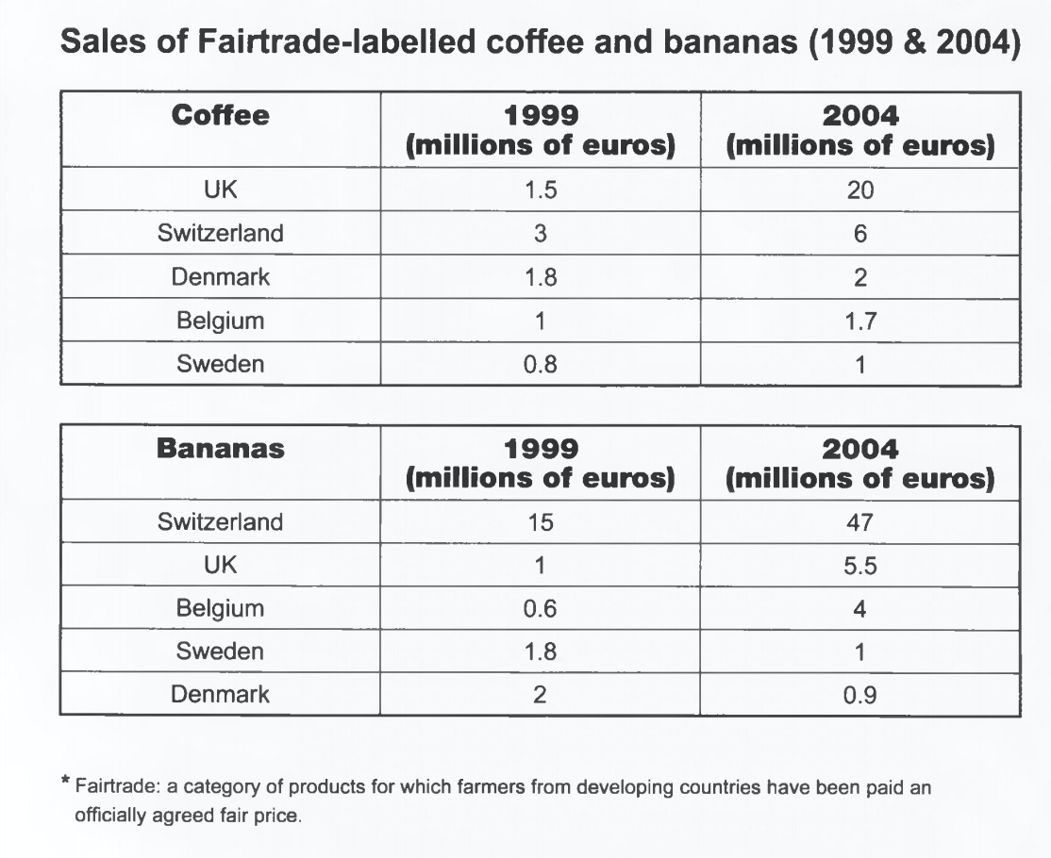
The two tables contain sales data for Fairtrade coffee and bananas in 1999 and 2004, in five nations of Europe.
The first table shows low-level coffee sales increasing in all five countries, albeit to widely varying degrees. In two places sales increased by the same small amount:1.8-2 million euros in Denmark, and 0.8-1 million in Sweden. The increment was slightly larger in Belgium, from 1-1.7 million euros. Meanwhile, in Switzerland sales doubled from 3-6 million euros. Finally, in the UK there was an enormous increase,from 1.5-20 million euros.
In the second table, it is Switzerland which stands out as buying far more Fairtrade bananas than the other four countries. Swiss sales figures jumped from 15-47million euros across these five years, while in the UK and Belgium sales only grew from 1-5.5 and from 0.6-4 million euros respectively. Sweden and Denmark showed a different pattern, with falls in banana sales from 1.8-1 and 2-0.9 million euros.

Comparing the two tables, it is clear that in 1999 Fairtrade coffee sales ranged from 0.8-3 million euros in these five countries, while banana sales also mostly clustered between 0.6 and 2 million euros, with Switzerland the outlier at a huge 15 million euros. By 2004, sales figures for both products had risen across the board, except for Sweden and Denmark which recorded drops in banana sales.

(考官范文 222words)

Writing Task 1 C10T4T1

You should spend about 20 minutes on this task.

The diagrams below show the life cycle of a species of large fish called the salmon.

Summarise the information by selecting and reporting the main features, and make comparisons where relevant.

Write at least 150 words.

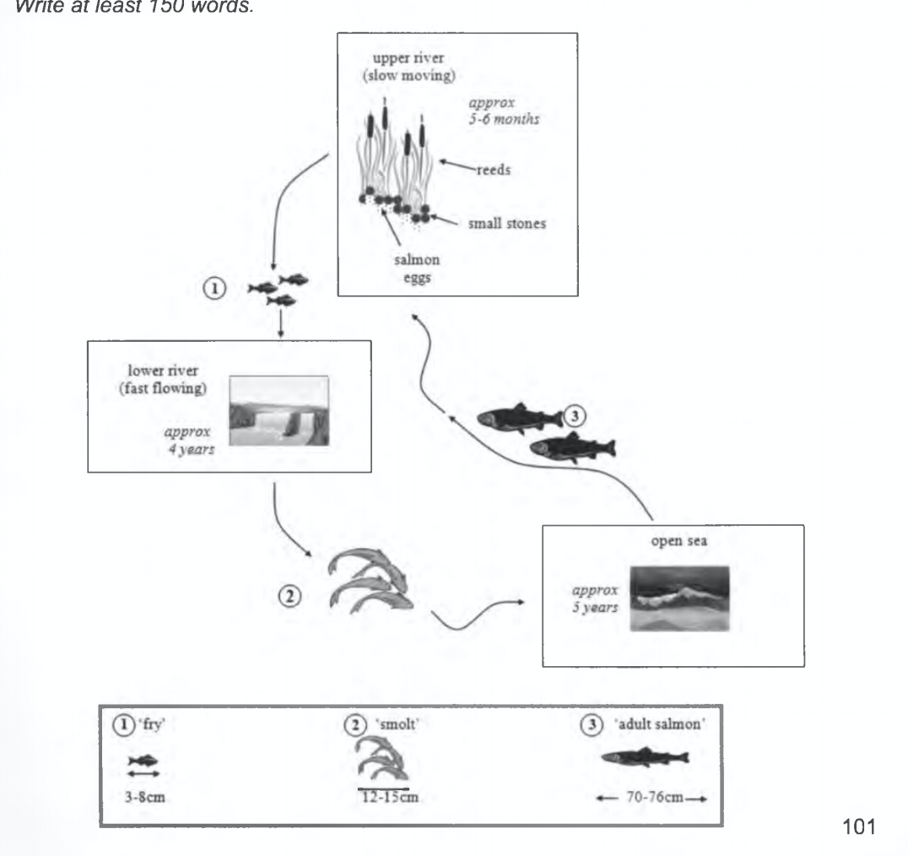

Salmon begin life as eggs on a pebbly riverbed, hidden among reeds in the slow-moving upper reaches of a river. After five to six months the eggs hatch into ‘fry’. For approximately the next four years, these baby salmon will live in the lower, faster-flowing waters of their river. During this time they measure between three and eight centimetres in length.

By the time salmon reach twelve to fifteen centimetres, they are termed ‘smolt’, and at this time they migrate further downriver into the open sea. After five years at sea, the salmon will have grown to adult size, which is between seventy and seventy-six centimetres. They then begin swimming back to their birthplace, where they will lay their eggs, and the cycle starts anew.

In summary, the salmon passes through three distinct physical stages as it grows to maturity.Each of these stages takes place in a very different aquatic location. It is noteworthy that the first two stages of this fish’s life occur in a fresh water environment, while the third stage is lived in saltwater.

(考官范文 177words)

Writing Task 1 C10TAT1

You should spend about 20 minutes on this task.

You are going to another country to study. You would like to do a part-time job while you are studying, so you want to ask a friend who lives there for some help.

Write a letter to this friend. In your letter

- Give details of your study plans
- Explain why you want to get a part time job
- Suggest how your friend could help you find a job

Write at least 150 words.

Dear Sally,

My departure date for New Zealand is drawing near, and I am busy with preparations. I have enrolled at an institution called 'IDT English' in Ottawa, full-time. It is quite expensive but I am hopeful of improving my pronunciation, especially.

To assist in covering the costs of my study, I aim to find a part-time job. Not only are the college fees rather high, but also I know that rental accommodation in the capital city will not be cheap, to say nothing of food and heating expenses! So I would very much like to arrange some temporary employmentbefore I arrive.

I was wondering if you could ask around among your friends and colleagues to see if anyone wants a house-cleaner, gardener, or nanny for their children. I know you have a wide social network in Ottawa which you could canvas for me, if you wouldn't mind. I'd be so grateful.

I look forward to seeing you soon.

Best wishes,

Margot

(考官范文 162 words)

Writing Task 1 C14T4T1
You should spend about 20 minutes on this task.

The plans below show a public park when it first opened in 1920 and the same park today.

Summarise the information by selecting and reporting the main features, and make comparisons where relevant.

Write at least 150 words.

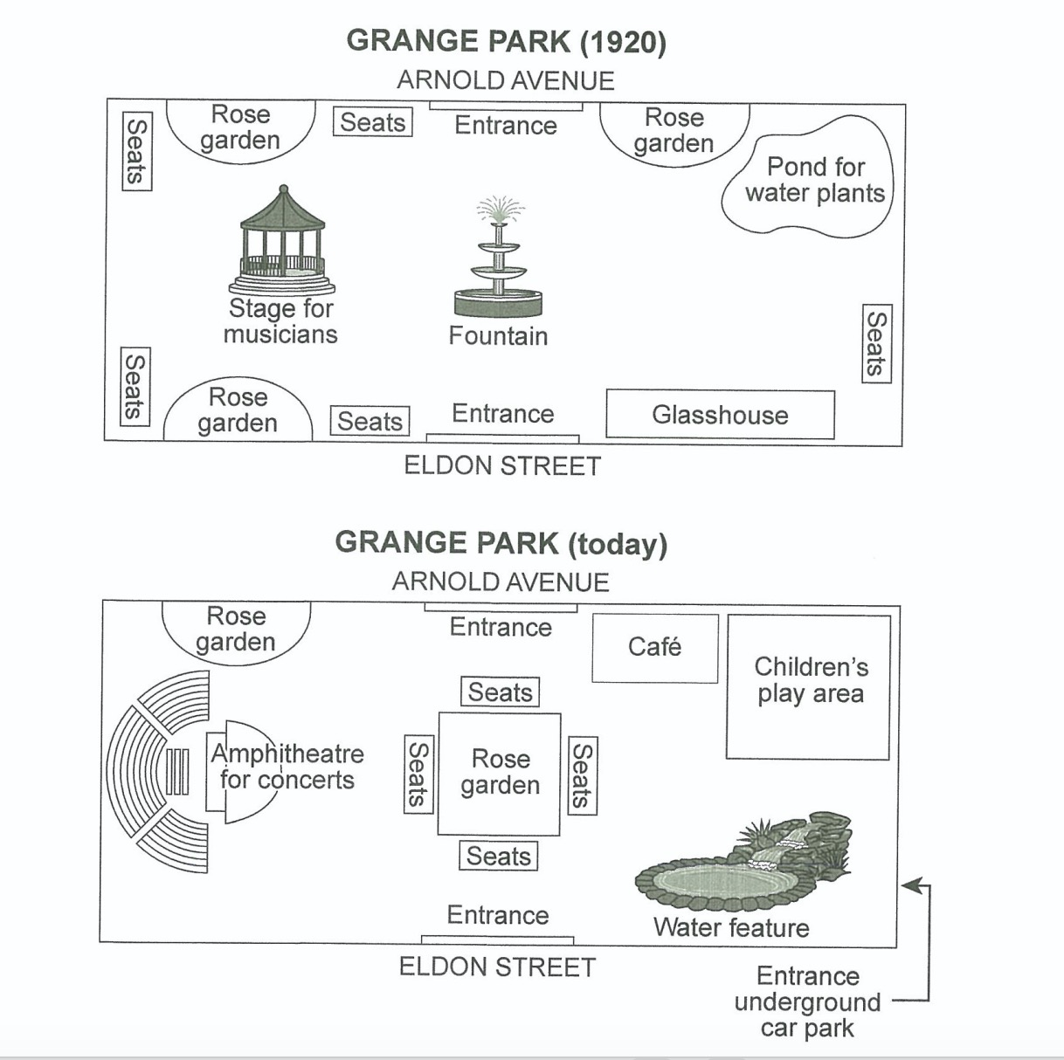

Grange Park was opened in 1920, a rectangular area with access from Arnold Avenue on the north side and from Eldon Street on the south side. There was a fountain in the centre, with a stage for musicians situated centre left, a glasshouse to the right of the Eldon Street entrance and a pond for water plants in the north east corner opposite. Around the edges of the park there were rose gardens, with seats nearby for people to smell the flowers and listen to music.

The park has altered considerably since then. Now there is one large-ish rose garden, occupying the central area where the fountain stood, and with seats all around it. One of the smaller rose gardens remains on the north side of the park. The bandstand (stage for musicians) has also been replaced, by an amphitheatre for concerts and associated seating. The glasshouse has gone and in its places is a water feature; similarly, where the pond for water plants stood there is now a children’s play area with a cafe nearby. Access to the park is still via the two original entrances, but there is now a third entrance near the water feature from an underground car park.

Despite the apparently significant changes, the park retains the basic elements of flowers, water, seating and music, with the addition of a cafe and a children’s play area.

(考官范文 231 words)

Writing Task 1 C17T2T1
You should spend about 20 minutes on this task.

The table and charts below give information on the police budget for 2017 and 2018 in one area of Britain. The table shows where the money came from and the charts show how it was distributed.

Summarise the information by selecting and reporting the main features, and make comparisons where relevant.

Write at least 150 words.

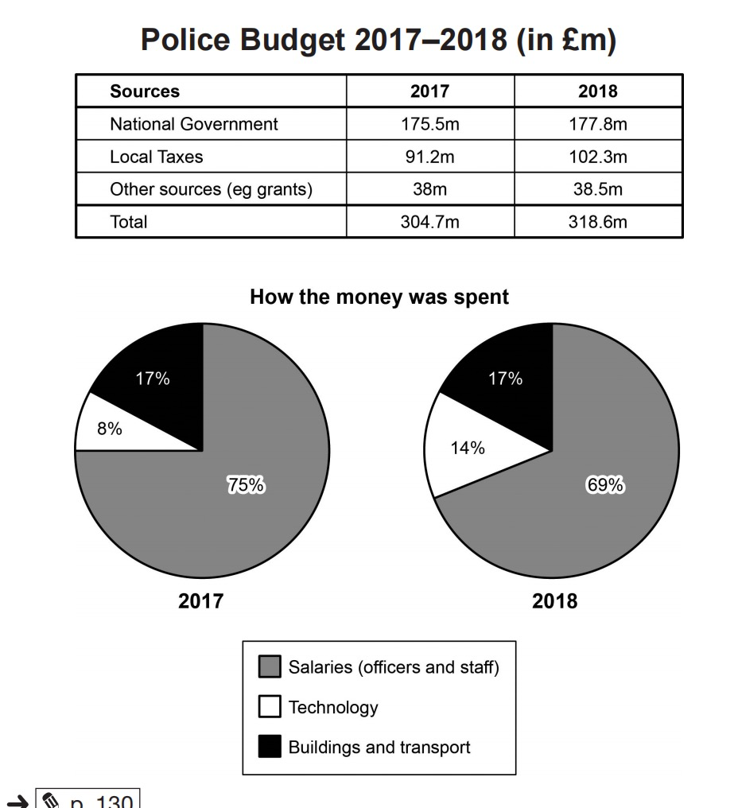

The table illustrates the data on the police budget in which the money came from and the two pie charts describe the distribution of the amount of money in the two of year 2017 and 2018 in an area of Britain.

Overall, there was an upward trend in all three different sources while the money spent on salaries was always the majority of contribution.

Looking into more details, the highest amount of money on the police budget belonged to ‘National Government’, 175.5 million pounds in 2017 and it kept rising to 177.8 million pounds. This was followed by ‘Local Taxes’, at 91.2 million pounds in 2017. After one year, it increased significantly to 102.3 million pounds.

In terms of how the money was spent, the majority of police budget goes to salaries which was for officers and staff, dropping slightly from 75% in 2017 to 69% in 2018. Meanwhile, the proportion of ‘Buildings and transport’ remained constantly, at 17% each year. An opposite pattern can be seen in the category of technology, whose figure rose sharply from 8% in 2017 to 14% in 2018, which was always the lowest rate during the given period.

(7.5范文 194 words)

Writing Task 1 C17T4T1
You should spend about 20 minutes on this task.

The graph below shows the number of shops that closed and the number of new shops that opened in one country between 2011 and 2018.

Summarise the information by selecting and reporting the main features, and make comparisons where relevant.

Write at least 150 words.

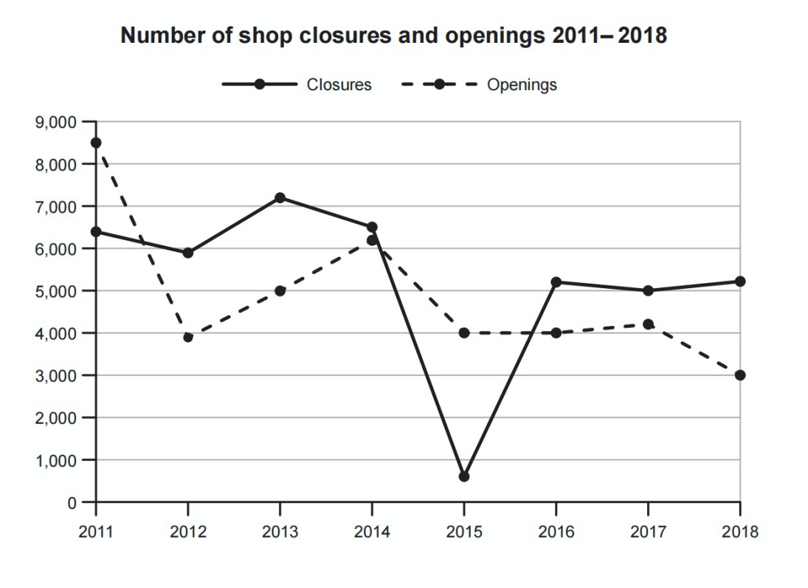

The line graph shows trends in shop closures and openings of new shops in a particular country between the years 2011 and 2018.

In 2011 approximately 6400 shops closed. The number of closures fluctuated over the next four years until 2015, when there was a dramatic fall in closures to roughly 700 shops. The following year the number of shops closing their doors rose sharply, reaching over 5000. The figures remained steady for the next two years, with just over 5000 closures in 2018.

The number of new shops opening decreased dramatically between 2011(approximately 8500) and 2012(just under 4000) but rebounded by roughly 50% by 2014. In 2015, the number of openings then fell to the 2012 level, but remained stable for the next two years. The last recorded year, 2018, saw a further fall to 3000 new openings, the lowest point in this seven year period.

Overall, the number of shop closures has remained within 5000 to 7000 range (with the exception of 2015). In contrast, new shop openings have shown a wider range of figures, but generally indicate a downward trend over the same period.

(7.5范文 187 words)

Writing Task 1 C18T3T1
You should spend about 20 minutes on this task.

The diagram below shows the floor plan of a public library 20 years ago and how it looks now.

Summarise the information by selecting and reporting the main features, and make comparisons where relevant.

Write at least 150 words.

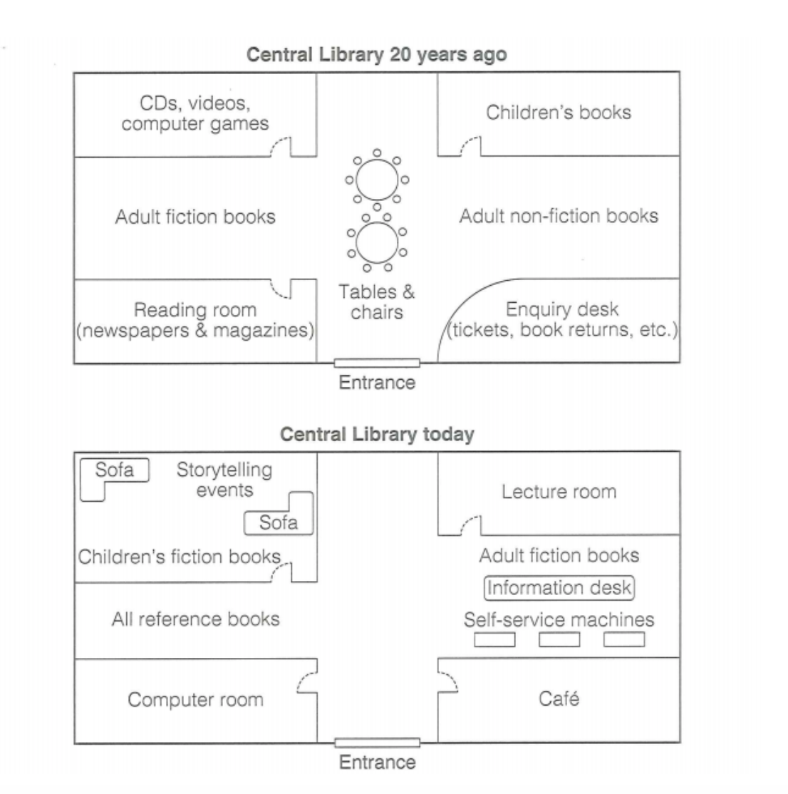
The diagrams show Central Library before and after changes were made to its layout.

Clearly, the library has been updated to include dedicated spaces for events and now has an open space in the centre.

Twenty years ago, to the left of the entrance there was a reading room with newspapers and magazines and to the right there was an enquiry desk. Now there’s a computer room on the left and a cafe where the information desk once was. Adult fiction has moved to the right-hand side of the room and all reference books are now on the left. There is a smaller information desk with self-service machines in what once was the adult non-fiction section.

There was a room at the back left-hand corner that had computer games, CDs and videos that have since been enlarged and houses children’s fiction. It has a space with two sofas where storytelling events are held. There is a lecture room in the back right-hand corner where children’s books used to be.

(考官范文 169 words)

Writing Task 1 C18T4T1
You should spend about 20 minutes on this task.

The graph below shows the average monthly change in the prices of three metals during 2014.

Summarise the information by selecting and reporting the main features, and make comparisons where relevant.

Write at least 150 words.

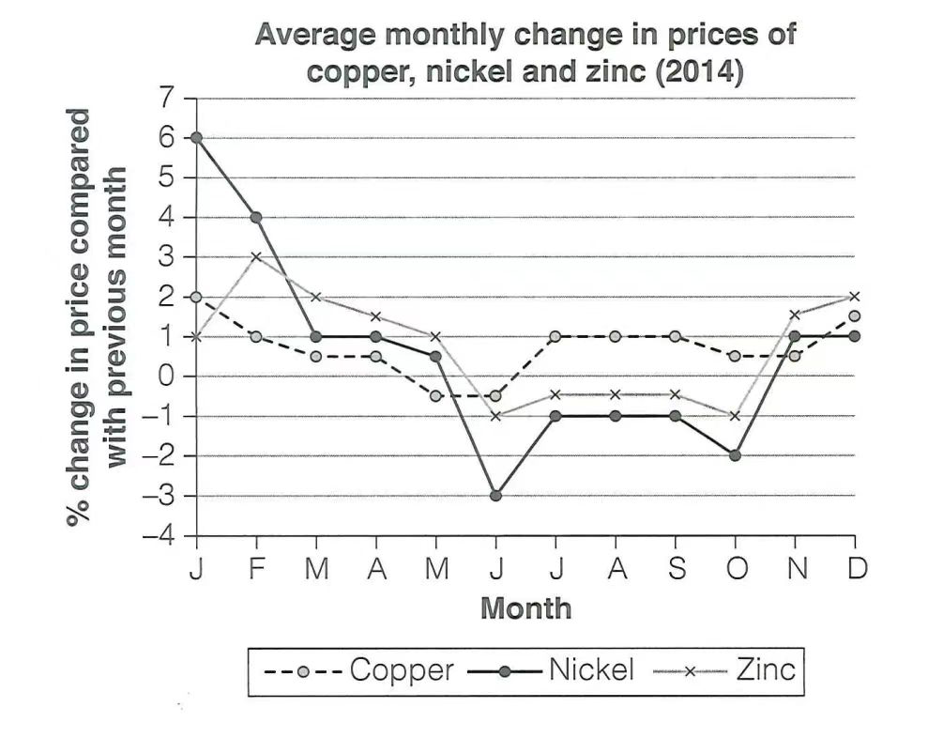
From the line graph, we can see the average monthly rise or fall in how much copper, nickle and zinc cost throughout 2014.

Overall, nickle started with the highest percentage change of the three but ended with the lowest. Zinc started with the smallest change and ended with the highest, and copper prices fluctuated. Prices for all three metals dipped in June.

In January the price of nickel was up six percent, but this dropped to negative three percent in June, ending the year with a one percent increase in both November and December. Copper began the year with an increase of two percent and by May, the price was dropping (by slightly less than one percent). It rose again, increasing by a percentage point in July, August and September. Zinc saw its most dramatic increase in February, with three percent and the price fell in June(a one percent decrease). The change was negative until October/November when it began to rise.

(考官范文 161 words)

2015年真题

You should spend about 20 minutes on this task.

The line graph shows the sales of children’s books, adult’s fictions and educational books between 2002 and 2006 in one country.

Summarise the information by selecting and reporting the main features, and make comparisons where relevant.

Write at least 150 words.

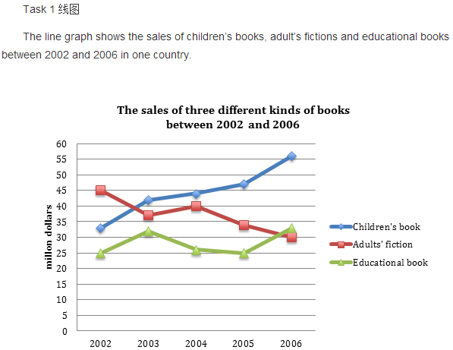

The line chart illustrates changes in the sales of children’s book, adults’ fiction and educational book respectively from 2002 to 2006 in one country.

It is clear the the sales of children’s book exceeded those of adults’ fiction, and it had become the most popular book since about 2003.

In 2002, adults’ fiction was by far the most sold book, with its sales standing at about 45 million dollars. The figure for children’s book was relatively smaller at 32 million dollars, while educational book was much less sold(just 25 million dollars).

However, during the four-year period,the sales of children’s book increased dramatically to approximately 55 million dollars in the end. The figure for educational book also increased, but much less significantly to just about 32 million dollars, so although its sales was almost the smallest all the time except for in the end, the levels were the most stable.

The sales of adults’ fiction, on the other hand, showed a downward trend despite a slight increase from 2003 to 2004, being overtaken by those of children’s book in about 2003 and those of educational book in 2006. By 2006, it had plunged to only 30 million dollars, which was the lowest among three types.

(老师范文 181 words)

Writing Task 1 C8T4T1
You should spend about 20 minutes on this task.

The graph below shows the quantities of goods transported in the UK between 1974 and 2002 by four different modes of transport.

Summarise the information by selecting and reporting the main features, and make comparisons where relevant.

Write at least 150 words.

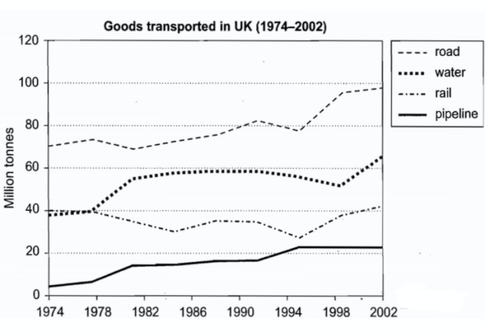

The graph illustrates the quantities of goods transported in the United Kingdom by four different modes of transport between the time period of 1974 and 2002

It is clear that over this span of 28 years, the quantities of goods transported by road, water and pipeline all increased while the quantity transported by rail remained almost constant at about 40 million tonnes. Meanwhile, the road remained the most popular method of transporting goods in the UK while water and pipelines were becoming increasingly used. However, rail had not become more popular as a method of transport.

The largest quantity of goods transported both in 1974 and 2002 was by road (70 million tonnes and 2002 million tonnes respectively) while the lowest both in 1974 and 2002 was by pipeline (about 5 million tonnes and 22 million tonnes respectively). The amount of goods transported by water was constant from 1974 to 1978, after which it showed an exponential growth, rising to almost 60 million tonnes after which it plateaued for about 20 years before starting to rise gradually again.

The amount of goods transported by rail was almost constant at 40 million tonnes in 1974 and 2002, with decreases in quantity between the years. It is also interesting to note that almost all showed a decrease in 1994 in amount of goods transported except for the pipeline, which actually peaked in that year.

(8分范文 232 words）
The graph below shows the proportion of population aged 65 and over between 1940 and 2004 in three different countries.
Summarise the information by selecting and reporting the main features, and make comparisons where relevant.
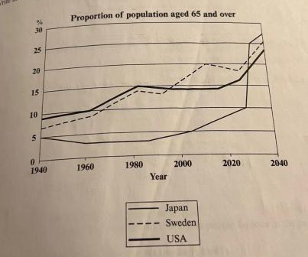
The line graph displays the increase in the ageing population in Japan, Sweden and the USA since 1940 and predicts the percentage of elder people in these three countries by the year 2040. It indicates that the percentage of elderly people in all three countries is expected to increase to almost 25% of the respective populations in 2040.

In 1940, the proportion of people aged 65 or more stood at only 5% in Japan, approximately 7% in Sweden and 9% in the US. After this, the figures for the Western countries grew to about 15% in around 1990, while the figure for Japan dipped to only 2.5% for much of this period, before rising to almost 5% again after 2000.

In spite of some fluctuation in the expected percentages, the proportion of older people will probably continue to increase in the next two decades in the three countries. A more dramatic rise is predicted between 2030 and 2040 in Japan, by which time it is thought that the proportion of elder people will be similar in the three countries.

(179 words)

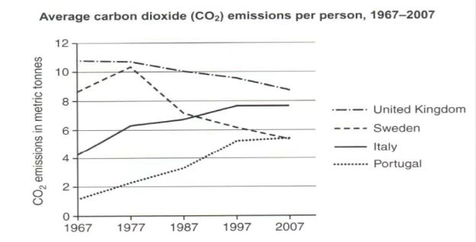
版本一
The line chart illustrates the changes in the amount of carbon dioxide emissions per person in four different countries from 1967 to 2007.

As is shown in the chart, the amount of CO2 emissions in UK was always the largest among four countries, standing at about 11 metric tonnes in the beginning, however slowly decreasing to about 9 metric tonnes. Likewise, the figure for Sweden also witnessed a decreasing trend, but much more significant. Despite a minor increase in the first decade, it decreased to about 5.5 metric tonnes, being exceeded by the figure for Italy in about 1987.

Obviously, in Italy and Portugal, the trends of the CO2 emissions were similar, both increasing over the 40-year-long period. However, the figure for Italy, from 4 metric tonnes to 7.8 metric tonnes in 2007, was always larger than that for Portugal by about 3 metric tonnes, which was from only 1 metric tonnes to about 5 metric tonnes in the end, making Portugal the smallest country emitting CO2.

Overall, the graph shows how the amount of carbon dioxide emission in Sweden and UK dropped constantly, while the figure for the other two countries increased dramatically over the period.

(194 words)

版本二
This line chart illustrates the changes in the average carbon dioxide emissions per person from 1967 to 2007 in different countries.

It is clear that the emissions of carbon dioxide both increased significantly in Portugal and Italy. However, for Sweden and United Kingdom, the emissions saw downward trends in general.

In 1967, the emissions of carbon dioxide in United Kingdom stood at about 11 metric tonnes in the beginning, which was far more than other country. And the emissions of Sweden was relatively smaller at 9 metric tonnes, while Italy and Portugal were much less, at only 4 and 1.7 metric tonnes.

During 40-year period, the emissions of United Kingdom slowly decreased to about 9 metric tonnes in the end. Similarly the emissions of Sweden also saw a constant decrease despite a minor increase to the peak at about 10.5 metric tonnes in 1977, dropping at only about 5 metric tonnes in 2007.

By contrast, this is not the case for the other two countries. The emissions of Portugal increased significantly, which reached the similar amount as Sweden at about 5 metric tonnes in 2007. And the emissions of Italy, also showed a similarly increasing trend,to nearly 8 metric tonnes in the end, surpassing that of Sweden and becoming the second largest country emitting carbon dioxide after 1987.

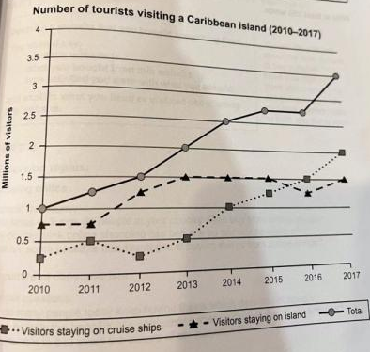
This line chart demonstrates how the figure of visitors travelling a certain Caribbean island changed from 2010 to 2017.

Overall, there was an marked increase in the total number of visitors during the whole period, while the preference of the most visitors changed in later years.

In the graph, we can clearly see that the number of visitor staying on cruise ships and island showed different patterns. Form 2010 to 2013, the figure for tourists on ships fluctuated within the range of 0.25 to 0.5 million, whereas there was a dramatic increase in that of people on islands, growing from 0.75 to 1.5 million. However, the number of people on islands remained relatively stable in later, while the the figure for people on island saw a significant increase and exceeded those of people on ships in the 2015, ending at 2 million.

In terms of total number of visitors, we can see the figure was larger than every former year, while there was an exception from 2015 to 2016 due to the similar number of people on ships deceasing and those of on island increasing.

(185 words)

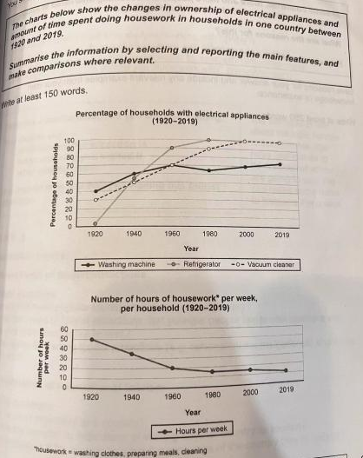

These line charts illustrate the changes of percentage of households with electrical appliances and number of hours spent on housework per week from 1920 to 2019 in one country.

It is clear that the percentage of households with electrical appliances all increased significantly. and correspondingly, the number of hours of housework per week saw a downward trend in general.

In 1920, the percentages of households with washing machine and vacuum cleaner were relatively small, at about 40% and 30% respectively, while refrigerator was almost hardly used by the people in this country. However,, the figure for households with refrigerator increased significantly, surpassing those for the other two tools in around 1940 and becoming the first appliance that was used by 100% of households. This was followed by washing machine, with its figure stably increasing to 100% in 2000. By contrast, the figure for households with vacuum cleaner barely changed, remaining stable at 70% after 1960.

Correspondingly, in the second chart, the number of hours of housework per week decreased significantly from 1920 to 1960. However, after 1960, although the figure continued a decreasing trend, it decreased at a much lower rate because the popularizing rate of appliances almost did not increase at all.

(203 words)

C9T4T1
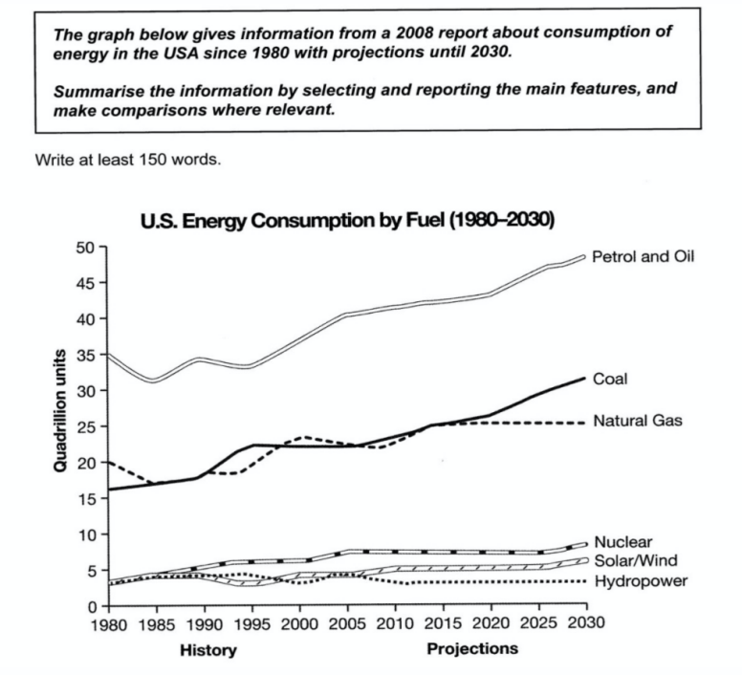

考官范文
The graph shows energy consumption in the US from 1980 to 2012, and projected consumption to 2030.

Petrol and oil are the dominant fuel sources throughout this period, with 35 quadrillion (35q) units used in 1980,rising to 42q in 2012. Despite some initial fluctuation, from 1995 there was a steady increase. This is expected to continue, reaching 47q in 2030.

Consumption of energy derived from natural gas and coal is similar over the period. From 20q and 15q respectively in 1980, gas showed an initial fall and coal a gradual increase, with the two fuels equal between 1985 and 1990. Consumption has fluctuated since 1990 but now provide 24q. Coal is predicted to increase steadily to 31q in 2030, whereas after 2014, gas will remain stable at 25q.

In 1980, energy from nuclear, hydro-and solar/wind power was equal at only 4q. Nuclear has risen by 3q, and solar/wind by 2. After slight increase, hydro power has fallen back to the 1980 figure. It is expected to maintain this level until 2030, while the others should rise slightly after 2025.

Overall, the US will continue to rely on fossil fuels, with sustainable and nuclear energy sources remaining relatively insignificant.

The chart shows the distribution of the overseas travel from India and the age profiles of Indian tourists.
Summarize the information by selecting and reporting the main features, and makes comparisons where relevant.
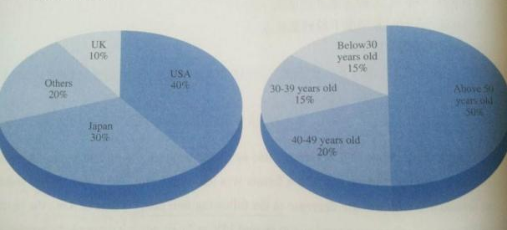
The two pie charts illustrate the situation of travelling in India in terms of destination and age groups respectively in 1992.

It is clear that most Indian tourists were fond of going to America, and a half of them were over 50 years old.

As is shown in the first pie chart, we can clearly see that USA was the most popular destination for Indian travelers, 40% of whom chose to go there, while UK was the least popular country, with only 10% of whole visiting there. We can also see that those traveling to Japan accounted for 30% of whole, which was 10% smaller than the figure for USA, whereas the other 20% chose the rest places to go.

In terms of age groups, it is noticeable that those over 50 years old occupied a half of whole, being the largest group of travelling people, which was 2.5 times as large as the figure for the group between 40 and 49(20%). Coincidentally, the proportion of the people below 30 was equal to that from 30 to 39 years old, both taking up 15% respectively.
(185 words)

The charts below show the average percentages in typical meals of three types of nutrients, all of which may be unhealthy if eaten too much.
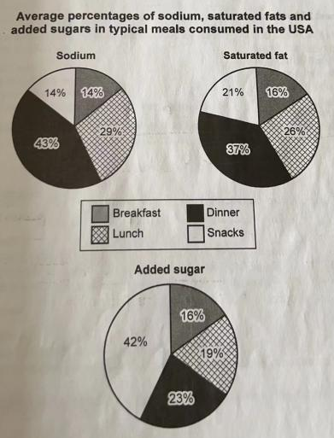
The pie charts illustrate the proportion of three different types of nutrients contained in four main meals in America.
It is clear that dinner is the main meal that almost provides the largest proportion of sodium and saturated fat, while snacks offer the largest percentage of added sugar.
As is shown in three pie charts, the figures for dinner in the fist two nutrients are relatively larger than other meals, accounting for 43% in Sodium and 37% in Saturated fat, while in added sugar, the figure for snacks is the largest , occupying 42%, which is 19% larger than the figure for dinner(23%). The proportions of Sodium and Saturated fat are relatively smaller, making up only 14% and 21%.
As for breakfast and lunch, we can clearly see that the proportions of those nutrients provided by breakfast are always the lowest, taking up 14% in sodium, 16% in Saturated fat and 16% again in added sugar. The figures for lunch are relatively larger in three domains, representing 29%, 26% and 19% respectively.
(173 words)

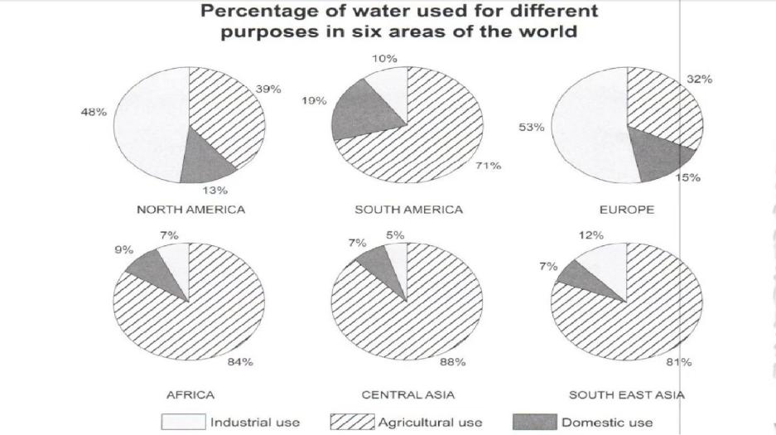
The pie chart illustrates the proportion of water used for industrial, agricultural and domestic purposes respectively in six regions around the world.

It can be clearly observed that in the developed areas like Europe and north America, industry is the biggest consumer of water, accounting for 53% in Europe and 48% in North America respectively. As for the other two uses, a third is used in agriculture in Europe, while the water used in households is the least, accounting for only 15%. In North America, water used for agriculture makes up 39% of the total, which is slightly higher than the figure for Europe,whereas domestic use represents merely 13%.

By contrast, the other four developing regions saw a great use of water in the agricultural sector. The percentage of water used for agriculture in central Asia is the largest (88%), while South America is the region which uses the least water (71%). In addition, there are two regions, namely Africa and Southeast Asia, which share a similar percentage of water for agriculture, with 84% and 81% respectively. It can be clearly seen that the proportion of water used for industrial in south east Asia is the largest (12%), while. the water used for households is the most in South America, constituting 19%.

Overall, in developed regions, the water is mostly used in industries, while agriculture is the main domain consuing water in developing countris.

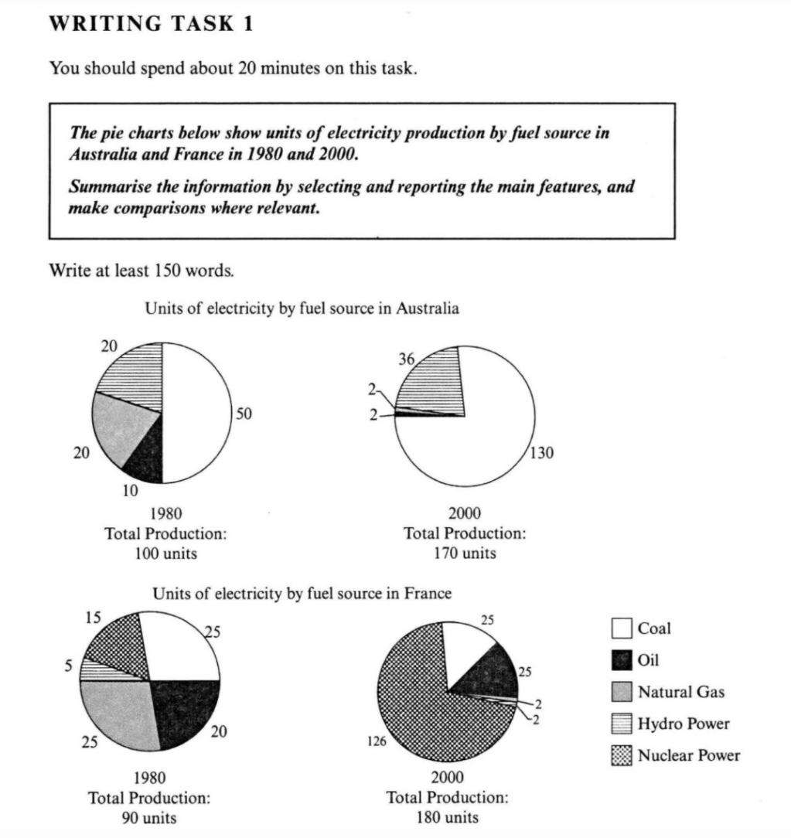
The pie charts illustrate the proportion of five different types of units of electricity by fuel source in Australia and France.

It is clear that coal is the main source that produced the largest proportion of electricity in Australia in 2000, while nuclear power offered the largest portion in France. Meanwhile, the total amount of electricity of two countries almost both doubled.

In Australia,,we can clearly see that coal and hydro power were the main raw materials to produce electricity. The figure for coal increased dramatically from 50 units to 130 units, accounting for almost three quarters in 2000. By contrast, although the amount of electricity produced by Hydro power also increased a bit, its proportion arely changed at about one quarter. As for natural gas and oil, they were no longer used in 2000, whereas the unites of nuclear power was always 0.

In terms of France, in 1980, the amount of electricity generated by natural gas, coal, oil, nuclear power were similar, at 25, 25, 20, 15 units respectively. On the contrary, Hydro power was hardly used at only 5 units. During 20-year period, the nuclear power increased from 15 units to 126 units, making up about three quarters and becoming the dominant source. the oil increased 5 unites, and the figures for oil and coal barely changed, while natural gas and hydropower were much less used at only 2units.

考官范文

The charts compare the sources of electricity in Australia and France in the years 1980 and 2000.

Overall, between these years electricity production almost doubled, rising from 100 units to 170 in Australia, and from 90 to 180 units in France. However, in 2000, these two countries relied on different principal fuel sources: Australia relied on coal and France on nuclear power.
In 1980 Australia used coal as the main electricity source (50 units) and the remainder was produced from natural gas, hydro power (each producing 20 units) and oil (which produced only 10 units). By 2000, coal had become the fuel for more than 75% of electricity produced by it, and only hydro continued to be another significant source supplying approximately 20%.
In contrast, France used coal as a source for only 25 units of electricity in 1980, which was matched by natural gas. The remaining 40 units were produced largely from oil and nuclear power, with hydro contributing only 5 units. But by 2000 nuclear power, which was not used at all in Australia, had developed into the main source, producing almost 75% of electricity, at 126 units, while coal and oil together produced only 50 units. Other sources were no longer significant.
Overall, it is clear that by 2000
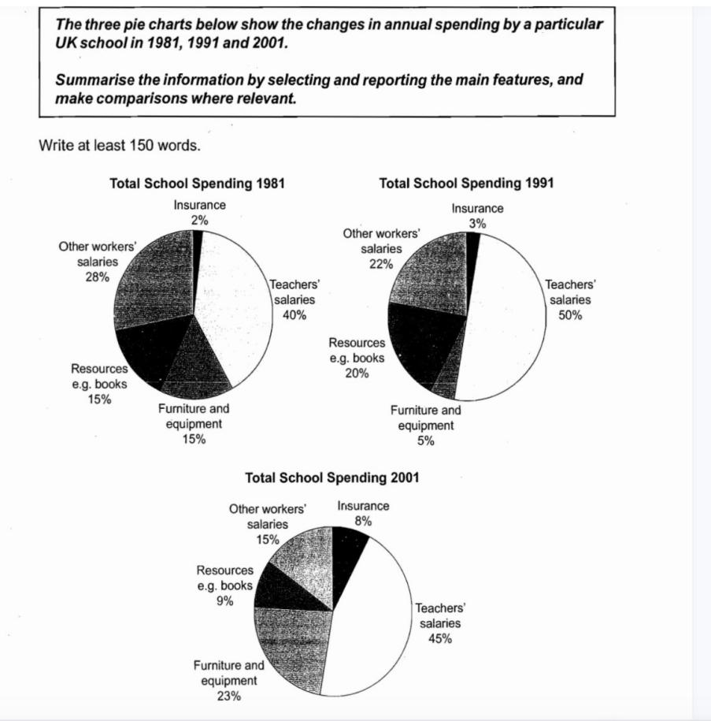
考官范文

The charts show how much a UK school spent on different running costs in three separate years: 1981, 1991 and 2001.
In all three years, the greatest expenditure was on staff salaries. But while other workers’ salaries saw a fall from 28% in 1981 to only 15% of spending in 2001, teachers’ pay remained the biggest cost, reaching 50% of total spending in 1991 and ending at 45% in 2001.
Expenditure on resources such as books had increased to 20% by 1991 before decreasing to only 9% by the end of the period. In contrast, the cost of furniture and equipment saw an opposite trend. This cost decreased to only 5% of total expenditure in 1991 but rose dramatically in 2001 when it represented 23% of the school budget. Similarly, the cost of insurance also saw a rising trend, growing from only 2% to 8% by 2001.
Overall, teachers’ salaries constituted the largest cost to the school, and while spending increased dramatically for equipment and insurance, there were corresponding drops in expenditure on things such as books and on other workers’ salaries.

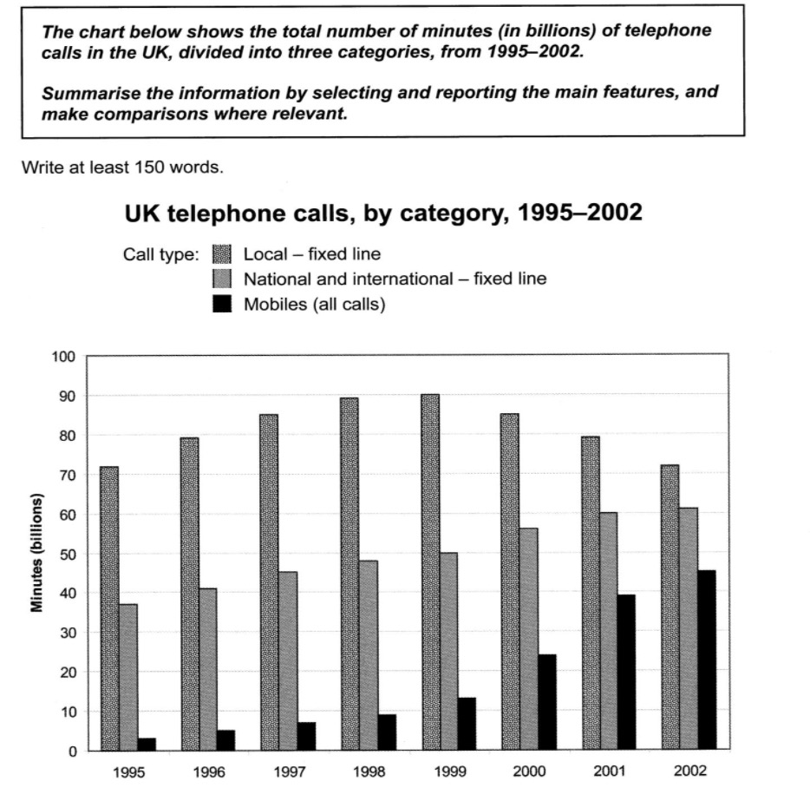
The bar chart demonstrates how long the British people spent on making different calls including telephoning local citizens through fixed lines, domestic or international calls through fixed line and mobiles respectively from 1995 to 2002.

As is shown in the chart, the most adopted pattern was to call local people through fixed lines. The time range for this type had increased gradually from roughly 70 billion minutes to the peak at approximately 90 billion minutes in 1999, before decreasing to the bottom at approximately 70 billion minutes again.

The trends shown/illustrated by the rest of the categories were similar, both rising. The statistic for making phone calls domestically or internationally increased modestly from around 40 billion to about 60 billion minutes during these 7 years. By contrast, a much more significant growth could be witnessed in the time spent on mobiles, which ranged from almost 0 to approximately 40 million minutes.

Overall, local fixed line was the only means that underwent a decreasing trend while the other two all increased. However, the figures in all three aspects reached the similar number. Still, the former was mostly used in 2002

考官范文

The chart shows the time spent by UK residents on different types of telephone calls between 1995 and 2002.

Local fixed line calls were the highest throughout the period, rising from 72 billion minutes in 1995 to just under 90 billion in 1998. After peaking at 90 billion the following year, these calls had fallen back to the 1995 figure by 2002.

National and international fixed line calls grew steadily from 38 billion to 61 billion at the end of the period in question, though the growth slowed over the last two years.

There was a dramatic increase in mobile calls from 2 billion to 46 billion minutes. This rise was particularly noticeable between 1999 and 2002, during which time the use of mobile phones tripled.

Overall, although local fixed line calls were still the most popular in 2002, the gap between the three categories had narrowed considerably over the second half of the period in question.

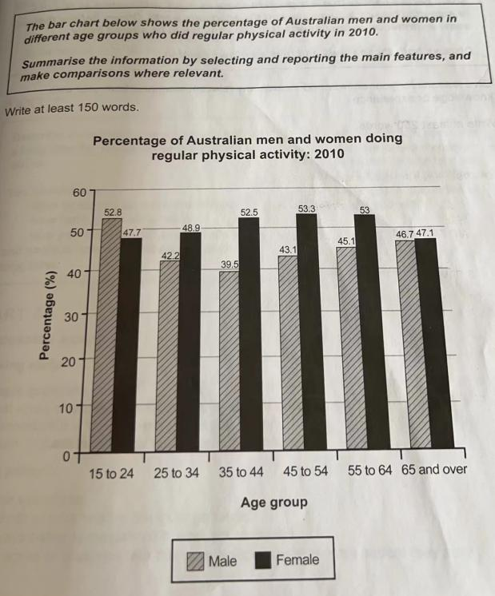
The bar chart demonstrates the proportion of males and females who exercised regularly in different age groups in 2010.

It is clear that females were more likely to do regular physical activity than males in almost all age groups except the group from 15 to 24.

As is shown in the chart, we can see that in the age groups from 15 to 44, as the age got older, the proportion of exercising men decreased correspondingly, while that of women saw a dramatic increase. The percentage of men in the age group from 15 to 24 was the largest at 52.8%, which was quiet larger than than the figure for females(47.7%), while it decreased to the lowest at only 39.5% in the age group from 35 to 44, which was far lower than the figure for women(52.5%)

In the next age group between 45 and 54 years old, the figure for women continued to rise to the peak at 53.3%. Similarly, the proportion of males doing exercises began to grow as age comes up, from 43.1% in this group to 46.7% in the group 65 and over. By contrast, the figure for females saw a slight decrease to 47.1% in the age groups of 65 to over, which was only 0.4% higher than that for males.

(216 words)

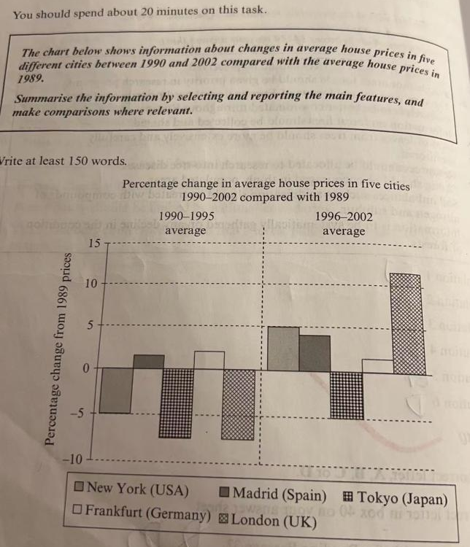
The bar chart illustrates the changes in prices of five different cities between 1990 and 2002 compared with the average house prices in 1989.

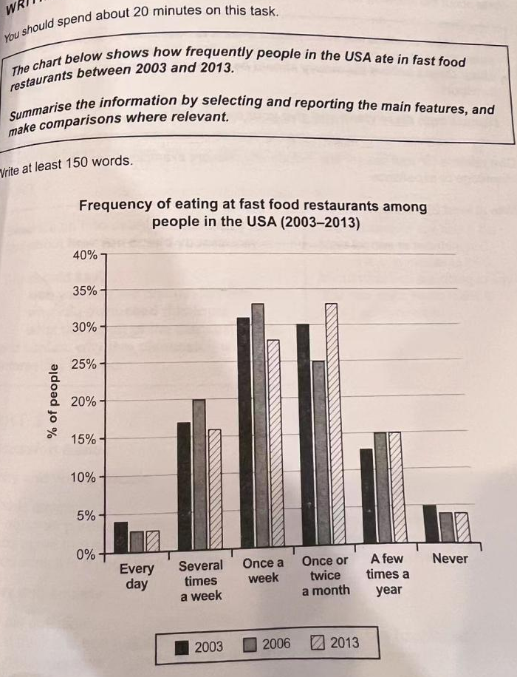

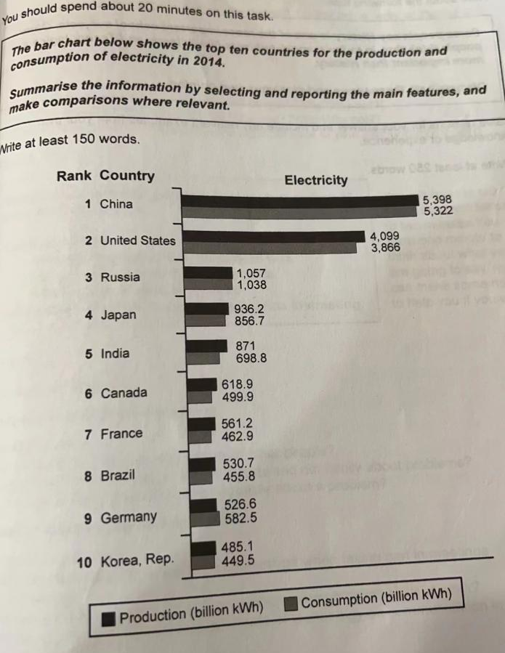
The graph demonstrates the situation where top ten countries produced and consumed the electricity in 2014.

Overall, China was the largest countries for production and consumption whereas korea was the smallest spender and consumer.

As is shown in the bar chart, we can clearly see that there was a huge gap of using and generating electricity between the top two countries and the rest of countries. The figures for china production and consumption of electricity were 5398 and 5322 billion kWh respectively, while there was a similar situation in US, with 4099 and 3866 billion kWh.

In terms of the last eight countries, the figure for Russia was the largest among them, at 1057 and 1038 billion kWh, which was approximately twice larger than the lowest countries, korea,rep. There was similar situations for eastern countries and the European countries respectively. The figures for generating and using electricity in Japan and India were between 1000 and 500 billion kWh, while those of Canada, France, Brazil and Germany were in the range between 700 and 400 billion kWh.

You should spend about 20 minutes on this task.
The table below shows the proportion of different categories of families living in poverty in Australia in 1999.
Summarize the information by selecting and reporting the main features, and make comparison where relevant.
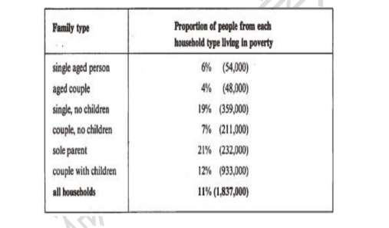
The table gives a breakdown of the different types of families who were living in poverty in Australia in 1999.

On average, 11% of all house holds, comprising almost two million people, were in this position. However, those consisting of only parent or a single adult had almost double this proportion of poor people, with 21% and 19% respectively.

Couples generally tended to be better off, with lower poverty levels for couples without children(7%) than those with children(12%). It is noticeable that for types of house hold with children, they were higher than average proportion living in poverty at this time.

Older people were generally less likely to be poor, though once again the trend favored elder couples , which was 4%, rather than single elderly people(6%).

Overall the table suggests that households of single adults and those with children were more likely to be living in poverty than other family types.

(152 words)

C10T2T1
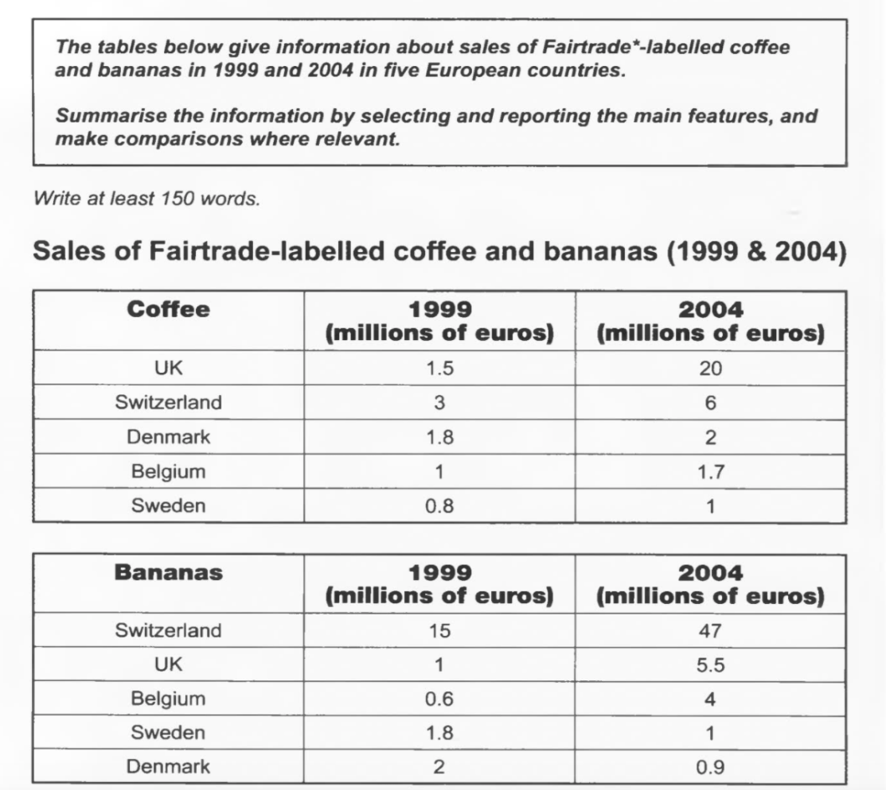

The two tables contain sales data for Fairtrade coffee and bananas in 1999 and 2004, in five nations of Europe.

The first table shows low-level coffee sales increasing in all five countries, albeit to widely varying degrees. In two places sales increased by the same small amount: 1.8-2 million euros in Denmark, and 0.8-1 million in Sweden. The increment was slightly larger in Belgium, from 1-1.7 million euros. Meanwhile, in Switzerland sales doubled from 3-6 million euros. Finally, in the UK there was an enormous increase, from 1.5-20 million euros.

In the second table, it is Switzerland which stands out as buying far more Fairtrade bananas than the other four countries. Swiss sales figures jumped from 15-47 million euros across these years, while in the UK and Belgium sales only grew from 1-5.5 and from 0.6-4 million euros respectively. Sweden and Denmark showed a different pattern, with falls in banana sales from 1.8-1 and 2-0.9 million euros.

Comparing the two tables, it is clear that in 1999 Fairtrade coffee sales ranged from 0.8-3 million euros in these five countries, while banana sales also mostly clustered between 0.6 and 2 million euros, with Switzerland the outlier at a huge 15 million euros. By 2004, sales figures for both products had risen across the board, except for Sweden and Denmark which recorded drops in banana sales.

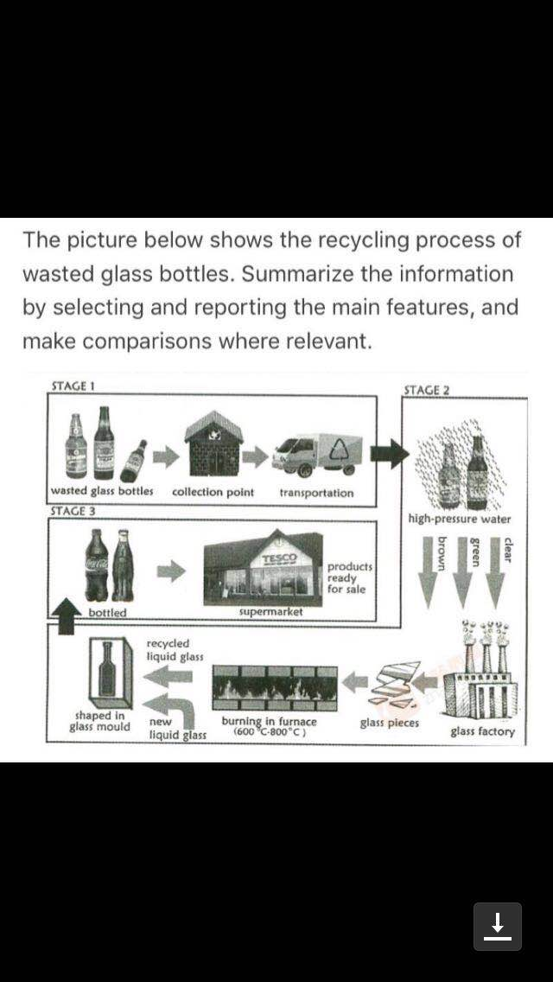
The flow chart illustrates how glass bottles are recycled mainly divided into three steps including collecting, reproducing and selling respectively.

As is shown in the flow chart, the first step is to collect bottles which have been used by customers at the collection point, and then they will be transported to the plant by a truck. After arriving at the destination, those bottles are washed by high-pressure water until they are totally clean. Once washing is finished, they will be classified into three groups by color including brown ones, clear ones and green ones, which are then put into glass factory where they are cut into pieces.

Subsequently, those glass pieces are heated in the furnace at the temperature between 600 degrees and 800 degrees until they are completely melted into liquid, which is then mixed with new liquid glass, after which the mixture is shaped in the mould and new bottles are made in this process. The final step is to sell those bottles to the supermarket where they are again picked by customers, and a new circle restarts once more.
(172 words)

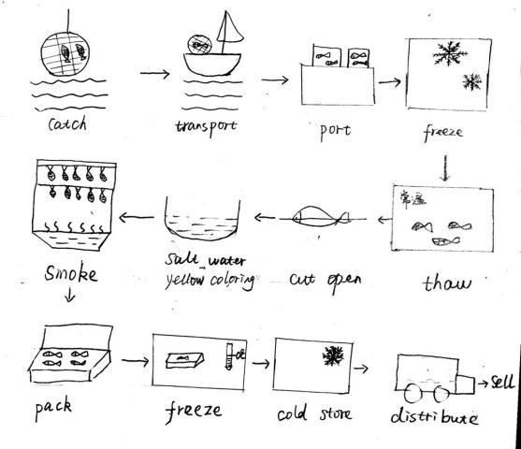
The flow chart illustrates how the smoked fish are produced mainly divided into three steps including catching, processing and selling respectively.

As is shown in the flow chart, the first step is to catch the fish from the sea, and then they will be transported to the port by several ships. After arriving at the destination, those fish will be placed into a freezer where they are frozen. Subsequently, the frozen fish are transferred into a place at the normal temperature for a while, during which the fish begin to thaw. Once thawing is finished, they will be cut open, before being soaked in the salty water with yellow coloring until turning yellow completely.

The next step is to smoke the fish until ready for sale, after which they are packed into boxes, which are then frozen in the freezer and stored in a cold place for certain period of time. Finally, those fish products are delivered to supermarket where they are sold to the customers.
(165)

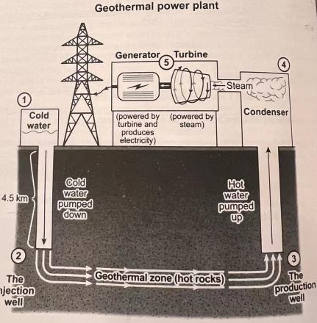
The flow chart illustrates how the electricity is produced by geothermal energy, mainly divided into four steps including heating, condensing, producing and selling respectively.

As is shown in the diagram, the first step is to pump down the cold water from the surface of the ground into the injection well through a 4.5-kilometer-long passage. After arriving at he injection well, they will be delivered to a horizontal geothermal zone where there are many hot rocks, which means that the cold water from the surface will be heated by those rocks. Once heating is finished, the hot water will be transferred into the production well where it will be pumped up and return to the surface again for processing.

After being pumped up, the hot water is condensed in the condenser into the steam, which is then used to drive the turbine to rotate, and therefore the turbine is powered. Subsequently, the next equipment called generator is also powered by the turbine, during which the electricity is produced, which is then delivered to towers and sold to various residents.
(178words)

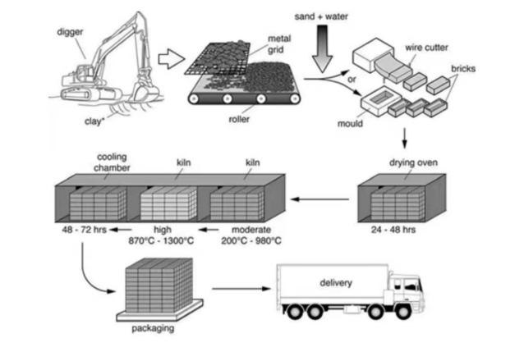
The flow chart illustrates how the bricks are produced mainly divided into three steps including digging,processing and selling respectively.

As is shown in the diagram, the first step is to use the digger to dig the clay from certain places of the ground, and then it is sifted on the mental grid. After sifting is finished, the smaller pieces of clay are placed on the roller, which are then mixed with sand and water for raw material of making solid bricks. It is worth-noticing that, there are two methods of shaping the mixture into cuboid bricks, including cutting them with wire cutter and placing them into the mould respectively.

Once shaping is finished, bricks will be put in drying oven for 24 to 48 hours first to remove the moisture. Subsequently, those dry bricks are firstly heated in kiln at the temperature between 200 degrees to 980 degrees, before being again burned between 870 degrees and 1300 degrees. Finally, they are cooled in the cool chamber from 48 to 72 hours, after which they are packed and delivered to the market where they are sold to various customers.
The diagrams below show the stage and equipment used in cement-making process, and how cement is used to produce concrete for building purposes.
Summarize the information by selecting and reporting the main features, and make comparisons where relevant.
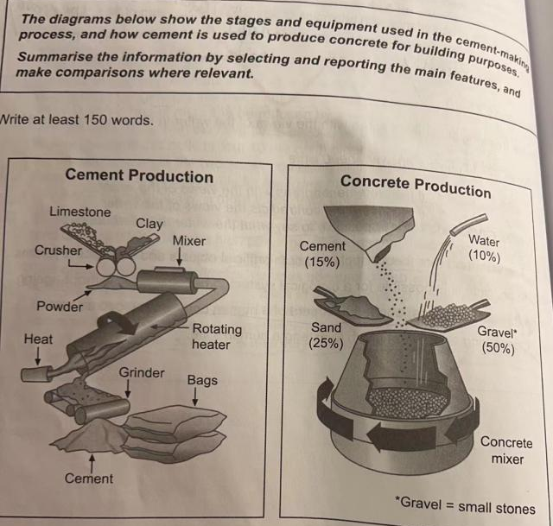
The process charts demonstrate the production of cement and that of concrete.

As can be seen in the first chart, four pieces of equipment (the crusher, the mixer, the rotating heater, and the grinder are involved in making the cement. Initially, the crusher is used to turn limestone and clay into powder, which then goes through the mixer and is heated in the rotating heater. As this is done, what is got in the former step is processed into the cement by the grinder. In the end, the product of the entire process is sent to users in bags.

In the second picture, we can see that it needs a concrete mixer to produce the concrete. It rotates and mixes 50% of gravel, 25% of sand, 15% of cement, and 10% of water together to form the concrete.

Thus, the two diagrams give us a vivid description of how the cement is made and how it is turned into concrete for building purposes. It shows that the production of cement is much more complicated than that of concrete.

The diagram shows the process of recycling glass bottles.
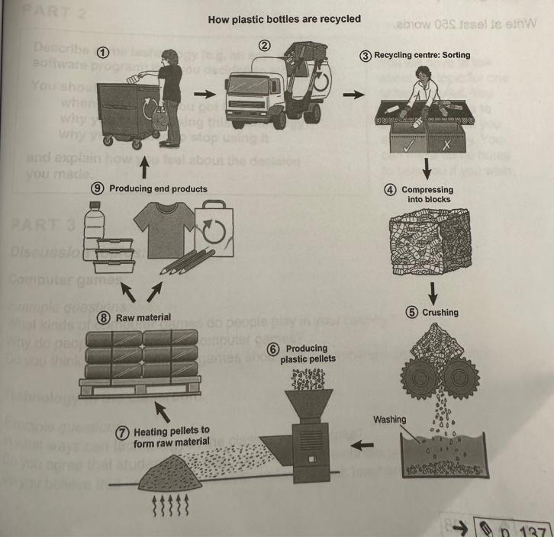

This flow chart provides an overview of how the plastic bottles are recycled, which can be mainly divided into three steps, including sorting, processing and producing end products respectively.

As is shown in the diagram, the first step is to sort out the plastic bottles from other garbage, and then they are transported to the recycling center by a truck. After that, the plastic bottles are sorted for picking up qualified bottles to be recycled while the others will be thrown away.Once sorting is finished, plastic bottles are compressed into blocks, which will then be crushed by wheels into small pieces of glass and washed by water, which are then transferred into a piece of equipment where plastic pellets are formed.

Subsequently, the plastic pellets are heated to form raw material which can be used in producing end products. It is worth-noticing that there are two types of end products, including new plastic bottles and relative products such as pencils, T-shirts and recycled bags respectively. At this stage, the process is completed, and a new circle restarts once more.

(179 words)

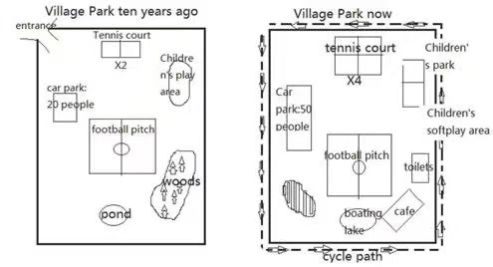
The two pictures compare how the village park was rebuilt in the past ten years.

Overall, we can clearly see that many new facilities have been built here, and old facilities renovated, while the woods were cut down to make place for the changes.

As is shown in the maps, many new facilities can be found in the present layout. Obviously, the entrance located in the northwest of the map has disappeared, with a rectangular cycle path established around the four sides of the park. It is also apparent that the woods lying in the east have been cut down to make place for cafe and toilets, to the west of which there has been a new lake used for boating, which was rebuilt from a small pond. Further to the west, a new picnic area was established for tourists resting and eating.

Apart from those newly-built ones, some old facilities were also updated. Firstly, the car park lying in the west of the map has been expanded greatly, which used to accommodate 20 people, while now accommodate 50 people, to the east of which the size of tennis court has also doubled. Further to the east, we can see that the children’s area was also enriched and divided into two parts, including children’s park and children’s soft play area respectively. However, the football pitch is the only part that remains unchanged.

(老师范文238words）
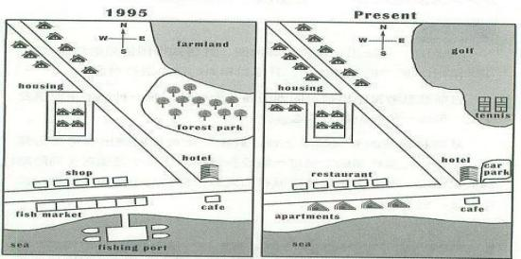
The two maps compare how the community has been rebuilt in the past years.

It is clear that the accommodation areas and facilities have both been developed greatly, whereas farming and fishing industries have been decreased.

As is shown in the maps, the housing located around the road has been expanded dramatically in the northwestern part of the community, and a new eastbound branch of road has also been added in the west. We can also clearly see that the shops and fishing markets situated on both sides of the eastbound main road have been replaced by restaurants and apartments. Along with the disappearance of fish market, the fishing port stretching into the sea has also been demolished.

In the east of the community, it can be obviously preserved that the farmland and forest park lying in the northeastern have been taken place of by a tennis court and golf. Further to the south, a new car park has been constructed next to the hotel, while the cafe on the south of the road is almost the only part that remains unchanged.
(183 words)

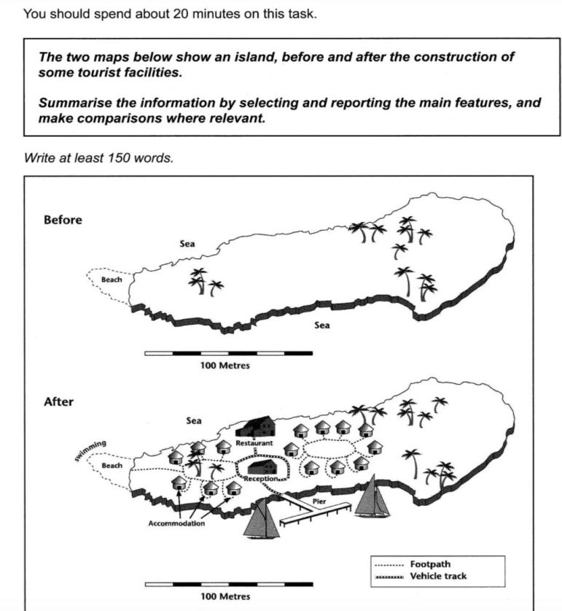

范文

The two maps compare how an island has been rebuilt in an effort to boost local tourism.
Overall, many facilities have been established, while trees, the beach and the eastern part of the island are left untouched.
The most noticeable additions are the houses. A circle of accommodation buildings, surrounding some trees, have been built in the west of the island, with each of them linked by a circular football path and one branch leading to the beach, which is now used for swimming. In the centre of the island, a larger circle of buildings have been constructed , which are also linked by football path.
Between the two accommodation areas, a reception building and a restaurant has been developed, linked by a vehicle track, which further stretches to the south to the pier, which allows yachts to access to the resort now.

七分范文

The two maps show the same island while first one is before and the second one is after the construction for tourism.

Looking first at the one before construction, we can see a hug island with a beach in the west. The total length of the island is approximately 250 meters.

Moving on to the second map, we can see that there are lots of buildings on the island. There are two areas of accommodation. One is in the west near the beach while the other one is in the center of the island. Between them, there is a restaurant in the north and a central reception block, which is surrounded by a vehicle track. This track also goes down to the pier where people can go sailing in the south sea of the island. Furthermore, tourists can swim near the beach in the west. A foot path connecting the western accommodation unites also leads to the beach.

Overall, comparing the two maps, there are significant changes after this development. Not only lots of facilities are built on the island, but also the sea is used for activities. The new island has become a good place for tourism.

The two maps below show road access to a city hospital in 2007 and in 2010.
Summarize the information by selecting and reporting the main features, and make comparisons where relevant.
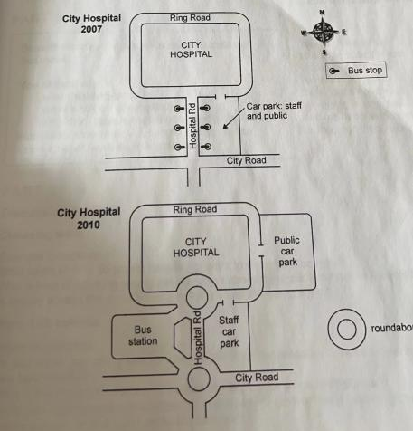
The two maps compare how the road access of a city hospital had been rebuilt between 2007 and 2010, and it is clear that there were two roundabouts built respectively in both sides of Hospital Road.

As is shown in the east part of the map, the car park which was on the east of Hospital Rd for both stuff and public in 2007 had been separated into two different parts in 2010. The original one was only used for the staff of the hospital, while the new public car park was located in the east of the main building of the hospital, which could be entered from the Ring Road around the building.

Further to the west, the bus stops near the Hospital Rd had been replaced by a isolate bus stop in the west of the Hospital Rd, which was connected by two roundabouts, which had been newly added in both ends of the Hospital road to release traffic jam

The maps below show the village of Stokeford in 1930 and 2010.
Summarise the information by selecting and reporting the main features, and make comparisons where relevant.
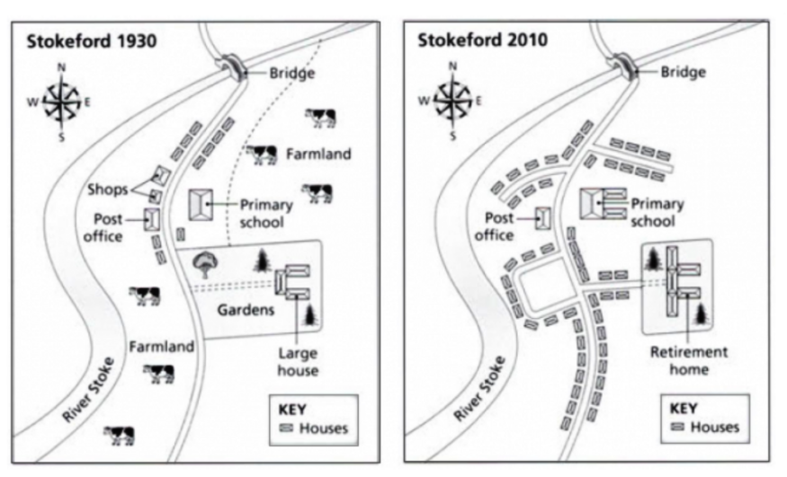
版本一
These two pictures illustrate how a village named Stokefod had been rebuilt by the year of 2010 since 1930.

In the first map, this area was mainly used for farming, with shops and post office on the west side of road, as well as a primary school and gardens with large house on the opposite side. However, there were some houses located on both sides of the northern part of the road. Further to the west, a bridge was situated in the north across the River Stoke, which completely lay in the west of the village.

However, over the 80-year-long period, a great number of changes had been achieved. An obvious one is that two pieces of farmland and shops had been replaced by housing areas, some of which were located around two newly-built branches of road in the north of the school and post office respectively. Another square-shaped branch had been added on the west side of the main road while on the east a branch had been added to connect the newly-built retirement room. Apart from the large house being enlarged into a new retirement home, taking place of the original garden in the east, the primary school had also been expanded by constructing two new buildings in the north.

(212 words)

版本二
These two pictures illustrate how a village named Stokefod had been rebuilt by the year of 2010 since 1930. It is clear that the accommodation areas and facilities had both been developed greatly, whereas farmland had been decreased.

As is shown in the maps, the housing located around the road had been expanded dramatically in the central of the map, and new branch of roads had also been added on both sides of road. We can also clearly see that the shops, farmland and gardens had been replaced by apartments. All the farmland and a footpath had been replaced by apartment, while the bridge and the river stoke were preserved.

It can be obvious that the primary school doubled in size, and large house lying in the northeastern had been taken place of by a retirement home.However, the post office located in the centre and the key house situated in the southeast remained unchanged.

(154 words)

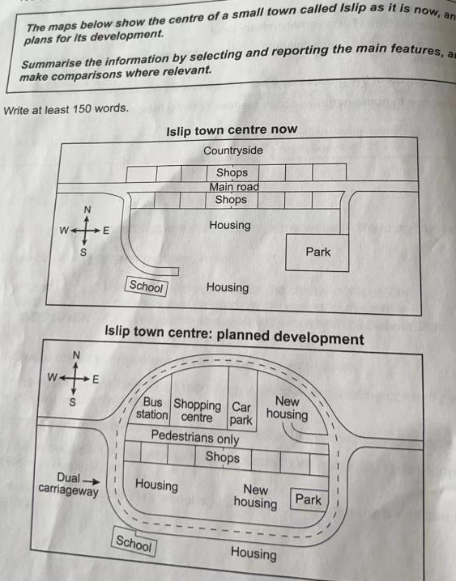
The two maps compare how lslip town centre will be changed in the future.

It is clear that the Dual carriageway will be built as a replacement of the current main road around the centre of the small town, which is a loop containing most of the town center's facilities. There will be a straight eastbound way going through the town center, which will be only used for pedestrians.

Changes will also happen to the core of the town center. It is noteworthy that the shops located on the north side of the present main road will be removed, and the land will be redeveloped with a bus station, a shopping center, a car park and a new housing area built as replacements for the shops.

Also, the plan does not affect the location and the number of the shops on the south side of the main road, while the eastern part of the current housing area will be revamped. In addition, the park will remain in its original location, but will be reduced in size. Further to the south, the school and housing on the south of the road will be remained.
The plans below show the site of an airport now and how it will look after redevelopment next year.

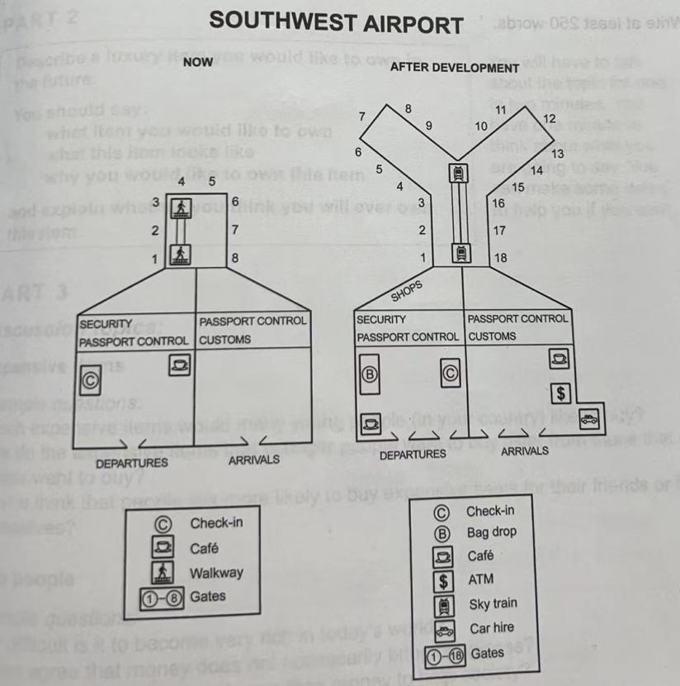

The two maps compare how the Southwest Airport will be rebuilt in the future.It is clear that both facilities and gates of the air port are predicted to be increased dramatically next year.

According to the present layout, which provides an overview of the Southwest Airport, the airport has the check-in module and café in the departures. On the same time, there is no special service in arrivals. To its north, behind the security passport control and the passport control customs, there are eight gates which is connected to security passport control by the walkway.

The future map highlights the planned changes to be completed after development.Both the café and the check-in module will be removed to the south and the east respectively to make room for the bag drop, which is located on the west of the departures. After going through security passport control, passengers can buy some souvenirs at the newly-built shops. Additionally, there will be more equipped facilities, including the café, ATM and the car hire service at the arrivals. In addition, there will be 18 gates which is expected to be connected by sky train.

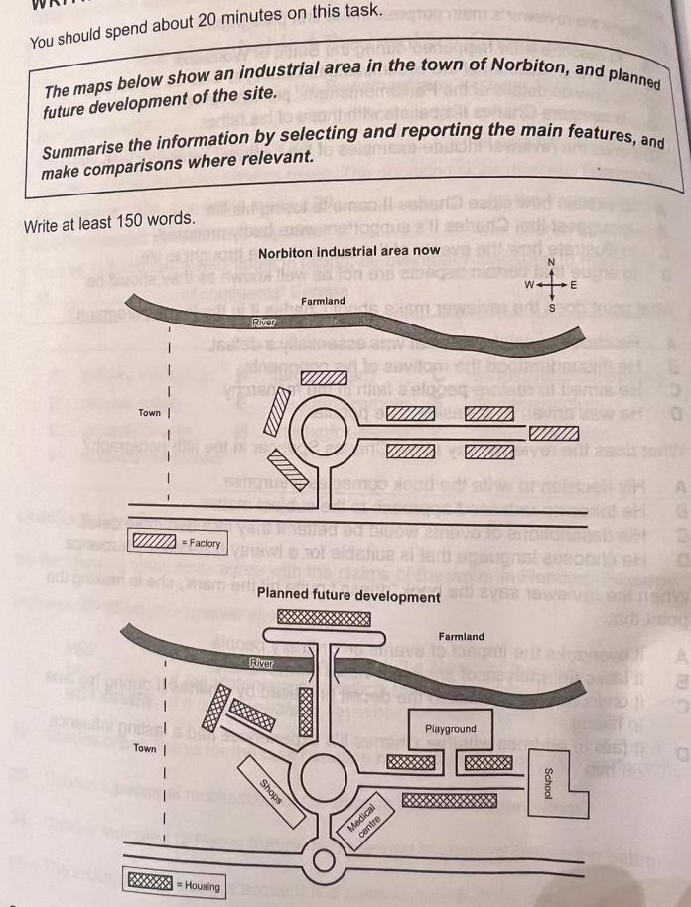

The pie chart shows that there are four main causes of farmland becoming degraded in the world today. Globally, 65% of degradation is caused by too much animal grazing and tree clearance, constituting 35% and 30% respectively. A further 28% of global degradation is due to over-cultivation of crops. Other causes account for only 7% collectively.
These causes affected different regions differently in the 1990s, with Europe having as much as 9. 8% of degradation due to deforestation, while the impact of this on Oceania and North America was minimal, with only 1. 7% and 0. 2% of land affected respectively. Europe, with the highest overall percentage of land degraded (23%), also suffered from over-cultivation (7.7%) and over-grazing (5.5%). In contrast, Oceania had 13% of degraded farmland and this was mainly due to over-grazing (11.3%). North America had a lower proportion of degraded land at only 5%, and the main causes of this were over-cultivation (3. 3%) and, to a lesser extent, over-grazing (1.5%).
Overall, it is clear that Europe suffered more from farmland degradation than the other regions, and the main causes there were deforestation and over-cultivation.

