Writing Task 1 C7T2T1
You should spend about 20 minutes on this task.

The graph below shows the consumption of fish and some different kinds of meat in a European country between 1979 and 2004.

Write at least 150 words.
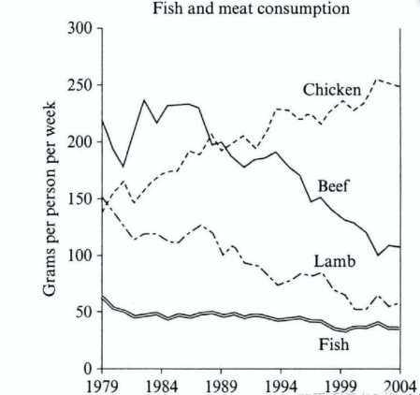

The line chart illustrates the changes in the amounts of beef, lamb, chicken and fish consumed in a particularly European country between 1979 and 2004.

Overall, the consumption of chicken increased dramatically while the popularity of these other foods decreased over the period.

In 1979, beef was by far the most popular of these foods,with about 225 grams consumed person per week. Lamb and chicken were eaten in similar quantities(around 150 grams), while much less fish was consumed at just over 50 grams.

However, during this 25-year period, the consumption of beef and lamb fell dramatically to approximately 100 grams and 55 grams respectively. The consumption of fish also declined, but much less significantly to just below 50 grams, so although it remained the least popular food, consumption levels were the most stable.

The consumption of chicken, on the other hand, showed an upward trend, overtaking that of lamb in 1980 and that of beef in 1989. By 2004 it had soared to almost 250 grams per person per week.

2015年真题

You should spend about 20 minutes on this task.

The line graph shows the sales of children’s books, adult’s fictions and educational books between 2002 and 2006 in one country.

Summarise the information by selecting and reporting the main features, and make comparisons where relevant.

Write at least 150 words.

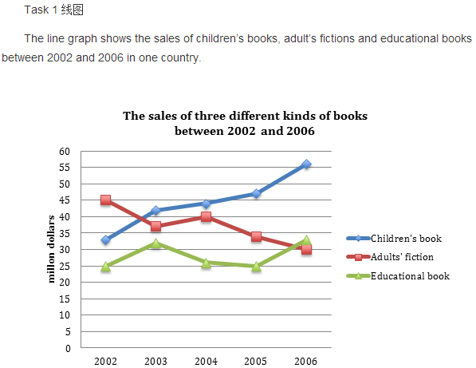

The line chart illustrates changes in the sales of children’s book, adults’ fiction and educational book respectively from 2002 to 2006 in one country.

It is clear the the sales of children’s book exceeded those of adults’ fiction, and it had become the most popular book since about 2003.

In 2002, adults’ fiction was by far the most sold book, with its sales standing at about 45 million dollars. The figure for children’s book was relatively smaller at 32 million dollars, while educational book was much less sold(just 25 million dollars).

However, during the four-year period,the sales of children’s book increased dramatically to approximately 55 million dollars in the end. The figure for educational book also increased, but much less significantly to just about 32 million dollars, so although its sales was almost the smallest all the time except for in the end, the levels were the most stable.

The sales of adults’ fiction, on the other hand, showed a downward trend despite a slight increase from 2003 to 2004, being overtaken by those of children’s book in about 2003 and those of educational book in 2006. By 2006, it had plunged to only 30 million dollars, which was the lowest among three types.

Writing Task 1 C9T4T1

You should spend about 20 minutes on this task.

The graph below gives information from a 2008 report about consumption of energy in the USA since 1980 with projections until 2030.

Summarise the information by selecting and reporting the main features, and make comparisons where relevant.

Write at least 150 words.

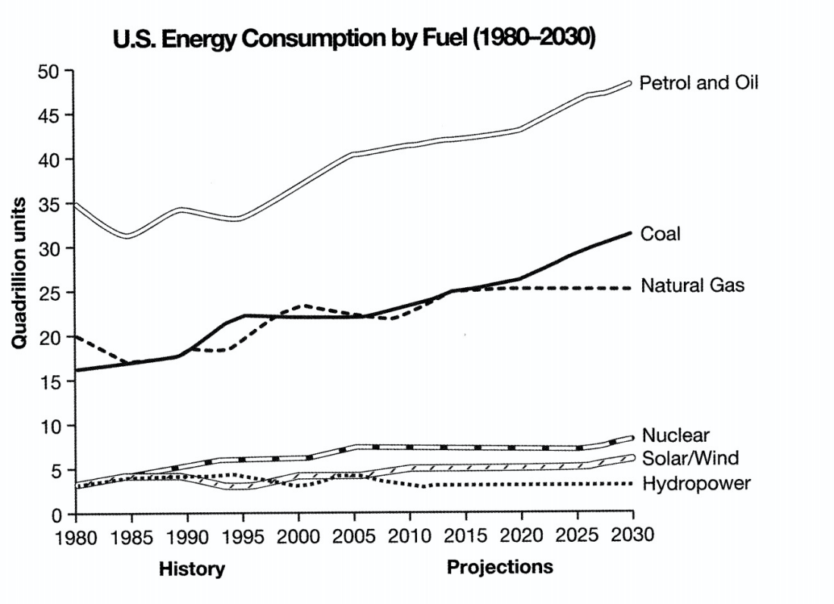

The graph shows energy consumption in the US from 1980 to 2012, and projected consumption to 2030.

Overall, the US will continue to rely on fossil fuels, with sustainable and nuclear energy sources remaining relatively insignificant.

Petrol and oil are the dominant fuel sources throughout this period, with 35 quadrillion (35q) units used in 1980, rising 42q in 2012. Despite some initial fluctuation, from 1995 there was a steady increase. This is expected to continue, reaching 47q in 2030.

Consumption of energy derived from natural gas and coal is similar over the period. From 20q and 15q respectively in 1980, gas showed an initial fail and coal a gradual increase, with the two fuels equal between 1985 and 1990. Consumption has fluctuated since 1990 but both now provide 24q. Coal is predicted to increase steadily to 31q in 2030, whereas after 2014, gas will remain stable at 25q.

1n 1980, energy from nuclear, hydro- and solar/wind power was equal at only 4q. Nuclear has risen by 3q, and solar/wind by 2. After slight increases, hydropower has fallen back to the 1980 figure. It is expected to maintain this level until 2030, while the others should rise slightly after 2025.

(考官范文 199 words)

Writing Task 1 C8T4T1
You should spend about 20 minutes on this task.

The graph below shows the quantities of goods transported in the UK between 1974 and 2002 by four different modes of transport.

Summarise the information by selecting and reporting the main features, and make comparisons where relevant.

Write at least 150 words.

