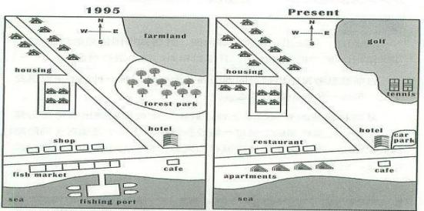

The two maps compare how the community has been rebuilt in the past years.

It is clear that many new facilities have both been established here, whereas farming and fishing industries are reduced.

As is shown in the maps, the housing located around the road has been expanded dramatically in the northwestern part of the community, and a new eastbound branch of road has also been added in the west. We can also clearly see that the shops and fishing markets situated on both sides of the eastbound main road have been replaced by restaurants and apartments. Along with the disappearance of fish market, the fishing port stretching into the sea has also been demolished.

In the east of the community, it can be obviously preserved that the farmland and forest park lying in the northeastern have been taken place of by a tennis court and golf. Further to the south, a new car park is constructed next to the hotel, while the cafe on the south of the road and hotel are almost the only two parts that remain unchanged.
(183 words)

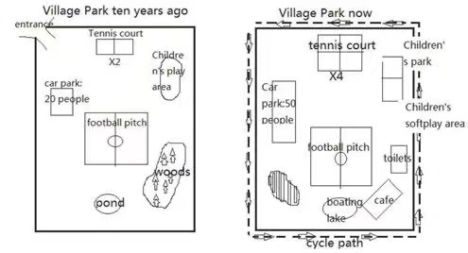
The two pictures compare how the village park was rebuilt in the past ten years.

Overall, we can clearly see that many new facilities have been built here, and old facilities renovated, while the woods were cut down to make place for the changes.

As is shown in the maps, many new facilities can be found in the present layout. Obviously, the entrance located in the northwest of the map has disappeared, with a rectangular cycle path established around the four sides of the park. It is also apparent that the woods lying in the east have been cut down to make place for cafe and toilets, to the west of which there has been a new lake used for boating, which was rebuilt from a small pond. Further to the west, a new picnic area was established for tourists resting and eating.

Apart from those newly-built ones, some old facilities were also updated. Firstly, the car park lying in the west of the map has been expanded greatly, which used to accommodate 20 people, while now accommodate 50 people, to the east of which the size of tennis court has also doubled. Further to the east, we can see that the children’s area was also enriched and divided into two parts, including children’s park and children’s soft play area respectively. However, the football pitch is the only part that remains unchanged.

(老师范文238words）

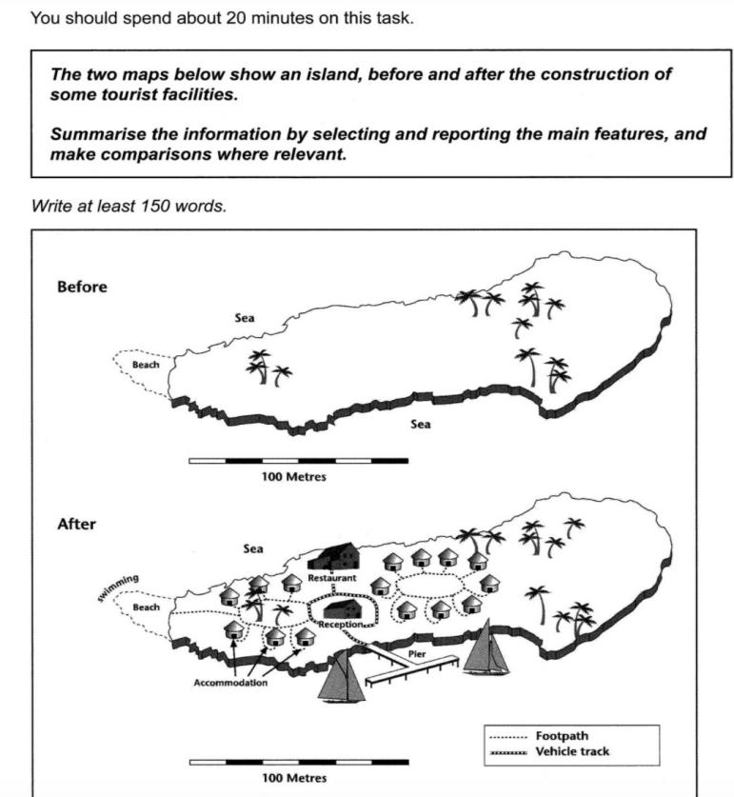
The two maps show the same island while first one is before and the second one is after the construction for tourism.

Looking first at the one before construction, we can see a hug island with a beach in the west. The total length of the island is approximately 250 meters.

Moving on to the second map, we can see that there are lots of buildings on the island. There are two areas of accommodation. One is in the west near the beach while the other one is in the center of the island. Between them, there is a restaurant in the north and a central reception block, which is surrounded by a vehicle track. This track also goes down to the pier where people can go sailing in the south sea of the island. Furthermore, tourists can swim near the beach in the west. A foot path connecting the western accommodation unites also leads to the beach.

Overall, comparing the two maps, there are significant changes after this development. Not only lots of facilities are built on the island, but also the sea is used for activities. The new island has become a good place for tourism.

Writing Task 1 C14T4T1
You should spend about 20 minutes on this task.

The plans below show a public park when it first opened in 1920 and the same park today.

Summarise the information by selecting and reporting the main features, and make comparisons where relevant.

Write at least 150 words.

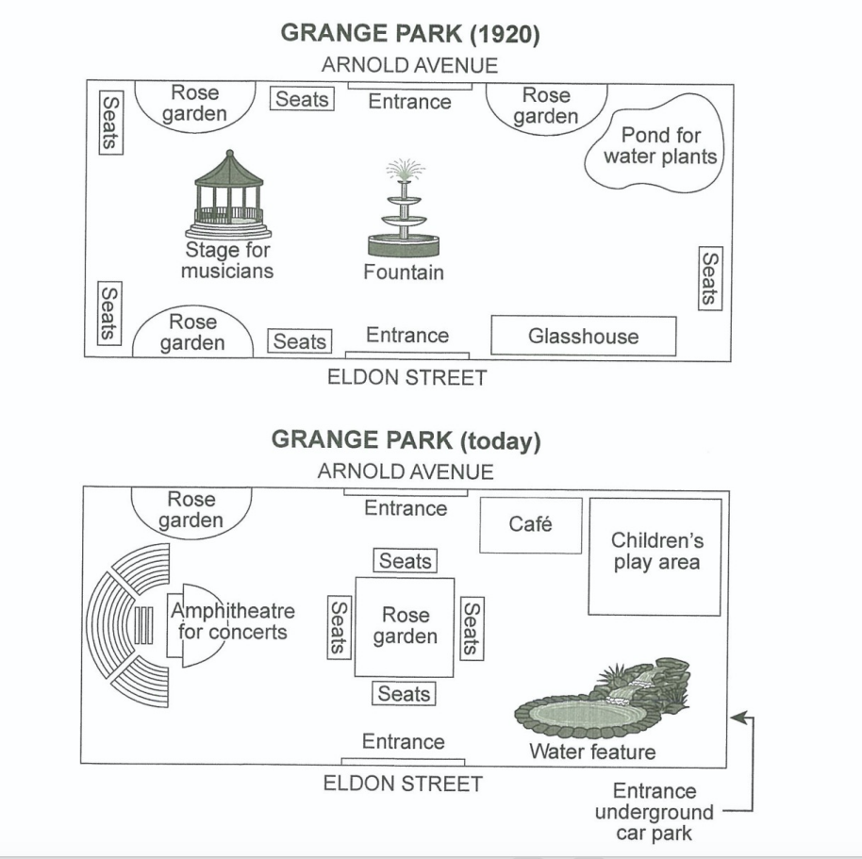

Grange Park was opened in 1920, a rectangular area with access from Arnold Avenue on the north side and from Eldon Street on the south side. There was a fountain in the centre, with a stage for musicians situated centre left, a glasshouse to the right of the Eldon Street entrance and a pond for water plants in the north east corner opposite. Around the edges of the park there were rose gardens, with seats nearby for people to smell the flowers and listen to music.

The park has altered considerably since then. Now there is one large-ish rose garden, occupying the central area where the fountain stood, and with seats all around it. One of the smaller rose gardens remains on the north side of the park. The bandstand (stage for musicians) has also been replaced, by an amphitheatre for concerts and associated seating. The glasshouse has gone and in its places is a water feature; similarly, where the pond for water plants stood there is now a children’s play area with a cafe nearby. Access to the park is still via the two original entrances, but there is now a third entrance near the water feature from an underground car park.

Despite the apparently significant changes, the park retains the basic elements of flowers, water, seating and music, with the addition of a cafe and a children’s play area.

(考官范文 231 words)

Writing Task 1 C18T3T1
You should spend about 20 minutes on this task.

The diagram below shows the floor plan of a public library 20 years ago and how it looks now.

Summarise the information by selecting and reporting the main features, and make comparisons where relevant.

Write at least 150 words.

