Home Page

Lessons

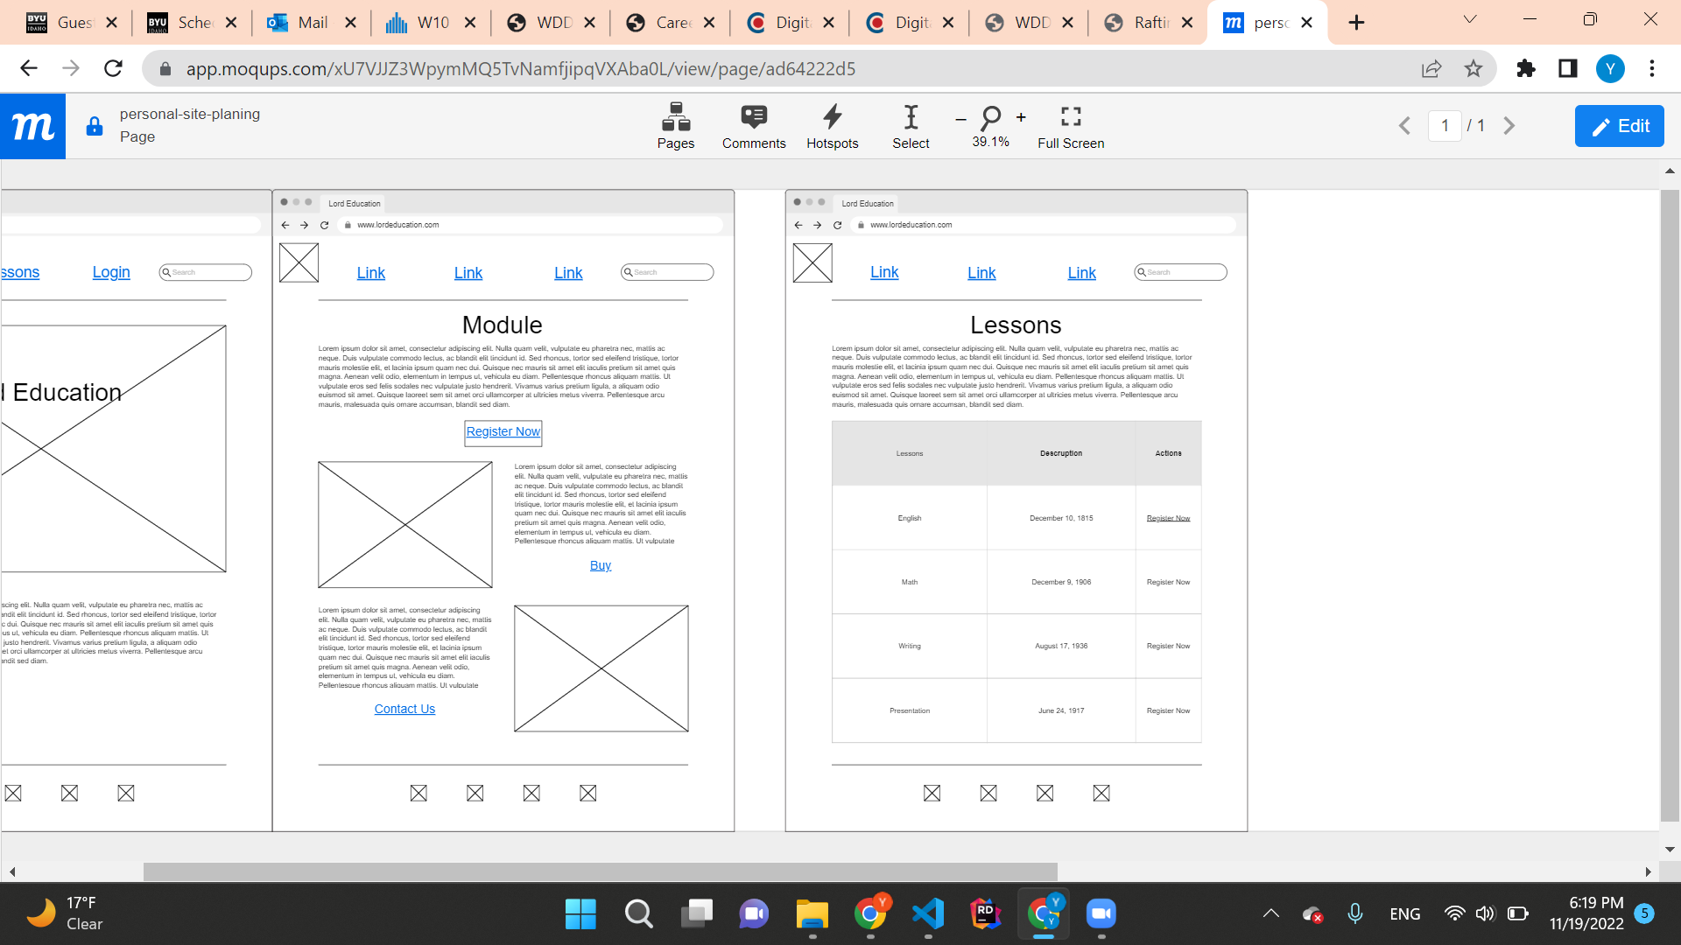

Register

