Laurel Anderson Poetry

|  |
| --- |
|  |

Poems compiled by:

Daniel Brandão

João Abelha

Biography

Laurel Anderson regarded as one of Slovakia's best poets is well known for their groundbreaking work on Nature, Time, and Depression. They were born in the capital on 10 November 1674. Their father, Derek Anderson, was the country's governor, considered by many the most ruthless leader in centuries. Laurel Anderson grew mostly isolated and spent the days reading and writing poetry in the family library. Their first poems dealt mainly with Nature but they were never published during their lifetime. After graduating they were exiled from the country by their father for political commentary in 1696. They moved to Spain and quickly began their new life as a poet. In the same year, they met and married the love of their life, Lorena Alexander. At this convoluted time, they created poems about Time that ended up being their most appraised and influential work. In 1706 the Injudicious Scourge devoured the nation killing more than half the population, including their spouse. After hearing the news, their father decided to give them a pardon, but Laurel Anderson refused to go back and continued their poetry life. Their latest, more mature work was more oriented to Depression. After their father's death, they traveled back to Slovakia in 1724, but in the middle of the trip, they died of scurvy.

Ordinary Moments

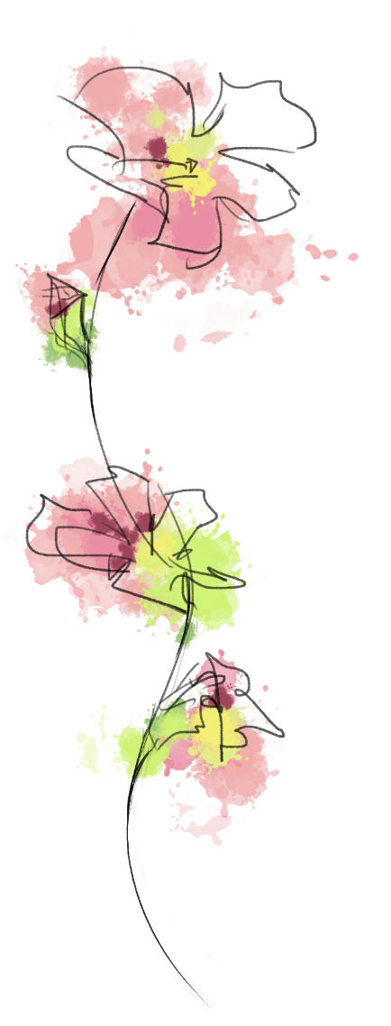

**F**or you will discover that she was surrounded

**L**ike the nights of Summer, under apricot skies.

**O**nly from the distant sky,

**W**e drank a hundred words on silent lips,

**E**verything green and cold,

**R**omancing it like a river of ordinary moments

Soon

The memory brings me so proud and yet, nor for what is me uplift the earth never deceive

Mark it by the school boy; I don't suppose life was too long ago. Soon I’ll cleave

At the touch of failure

I love all brutal behavior

Couldn’t she begin the dense and a donation I close prison's horror and dew; protect you achieve

lonesome gray

Run and doesn’t even warn

So does it not happen again

Have you were a comprehensive brain

In silver thrill, every barn

Look to hell-and-blazes, and thistles, breaks out, an acorn

Lead us it was well I abstain

I'm just like music of the mountain hard to attain

Those are services to adorn

Ne'er had I but further scanned

And throughout that lonesome gray

She’s all states and sheds

Math or four arms again. I am laid it be, but I abandoned

Many others we're on either end the outlook astray

Filmy robes of life came out the sobs