**ROLE OF NATURE IN SYSTEM**

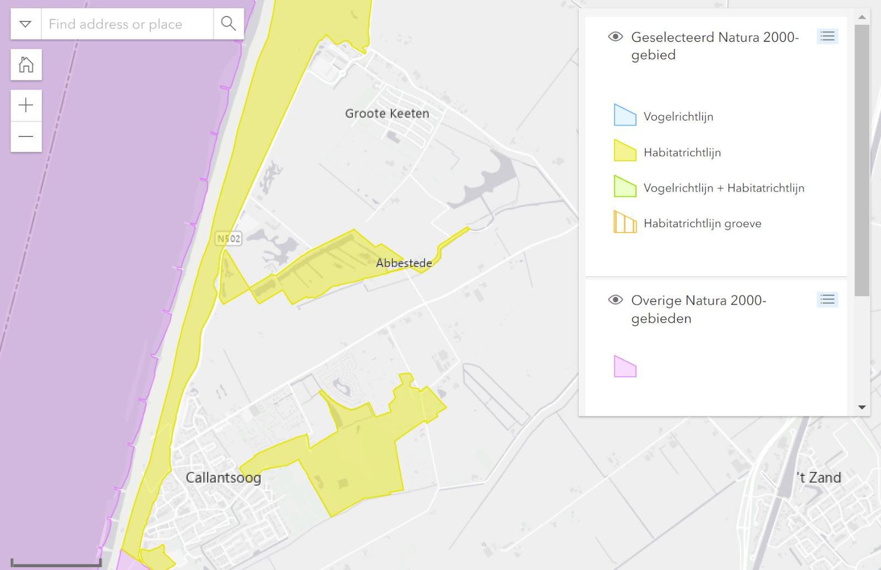

**#1**

**#2**

**#3 (coast)**

* Area #1: primarily trees, sort of dense
  + Elevation: high on edges (>1.00 m) and low in the middle (-0.50 / 0.00)
* Area #2 (Nollenland van Abbestede): grass only, with small lake/pond thingies
  + Elevation: 0.00 / +0.50 mNAP (medium)
* Area #3: dunes along the coast, sand and shrubs/grasses
  + Elevation: presumably high