Odoo backup and recovery lab
Technical completion and evidence report
Germain Daakpo Amouzou
Lab session 31 October 2026

Purpose and result
This lab demonstrates deployment of Odoo 18 and PostgreSQL in Docker on Ubuntu, a coordinated database and filestore backup, and recovery into an independent Compose project. The restored database and Odoo quotation list establish the manual application recovery result.
The Veeam work establishes Agent installation and Windows SMB access. A full-machine attempt failed under guest storage pressure. The user subsequently reported completing the instructed follow-up steps, but no later successful Veeam session or recovered-file result was supplied for this report.
Area | Recorded result
Odoo deployment | Running application and healthy PostgreSQL
Business record | S00001, Northstart Demo Ltd, total $250
Manual backup | 7.5 MB bundle and four passing checksums
Manual recovery | Separate volumes, restored SQL record and Odoo UI
Veeam integration | SMB write access and Agent modules verified
Remaining evidence | Final Veeam backup success and recovered-bundle hashes

Supporting material
The repository package includes the full technical guides, sanitized Compose references, a bundle verification script, a presentation and all 118 supplied lab screenshots. Six stage galleries place historical captures beside their workflow context. Visible password and cookie values have been redacted from publication copies.

Platform and container deployment
The Windows host runs Oracle VirtualBox. The Ubuntu 22.04 amd64 guest has approximately 4 GB RAM and a 24 GB root filesystem. Initial disk exhaustion prevented normal desktop use. Targeted journal and disabled Snap cleanup, followed by user-confirmed removal of an unused virtual disk, recovered space.
Docker Engine and the Compose plugin came from Docker's official Ubuntu repository. The hello-world container and Compose validation completed. Administration commands used sudo.
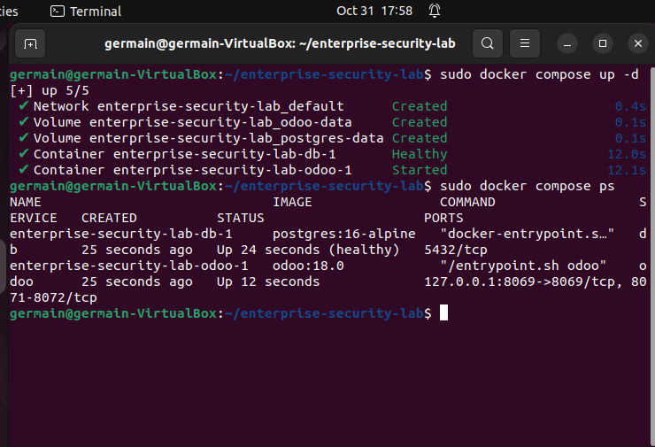
E032 Healthy PostgreSQL and running Odoo

Service controls
PostgreSQL and Odoo use separate named volumes. PostgreSQL has a health check and no published host port. Odoo binds to 127.0.0.1:8069 inside Ubuntu. The addons mount is read only. Rotated container logs limit routine log growth. A private .env holds the database password outside Git.
Named volumes provide persistence across container replacement. Backup and restore tests provide separate protection and validation.

Business records and attachment baseline
The enterprise_lab database uses English US and Canada, without demo data. The customer is Northstart Demo Ltd. The service product IT Support Package appears on quotation S00001 at quantity 1, unit price $250 and final tax 0%. The saved quotation state is draft.
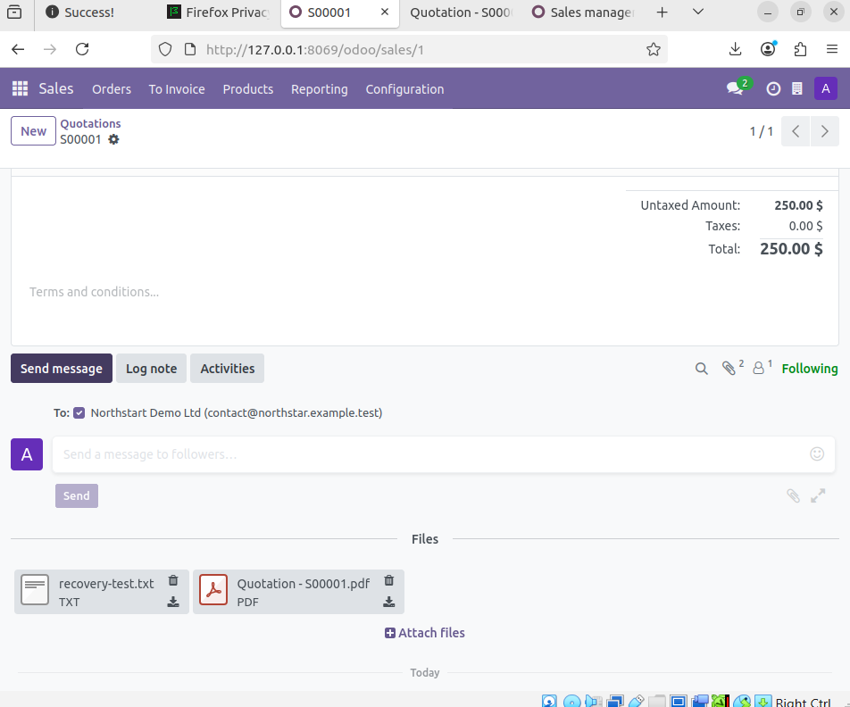
E050 Text and PDF attachments in Odoo

Recovery test attachment
S00001 contains a quotation PDF and recovery-test.txt. The text records the lab name, recovery test, quotation identifier and customer. These give the recovery exercise a recognizable business record and attachment baseline.
The original and downloaded text comparison produced the same SHA-256 value. The detailed recovery guide distinguishes direct restored-instance evidence from later attachment views whose browser context points to the original instance or is incomplete.

Coordinated manual backup
The Windows directory E:\Enterprise-Lab-Backups\Odoo maps into Ubuntu through the permanent VirtualBox share OdooBackups. A cross-system write test verified access. The observed bundle directory is odoo-backup-SzPMZ85w.
Component | Purpose
database.dump | Custom-format PostgreSQL logical export
odoo-data.tar.gz | Odoo data including the attachment filestore
odoo.conf and project.tar.gz | Effective application configuration and project files
SHA256SUMS | Hashes for the four primary backup files

Odoo paused while PostgreSQL stayed online. The database export and stopped-container data archive capture the application recovery unit. Restore catalog and compressed archive checks completed. The initial exit trap lost its Compose working directory. Returning to the original project and restarting Odoo corrected that issue.
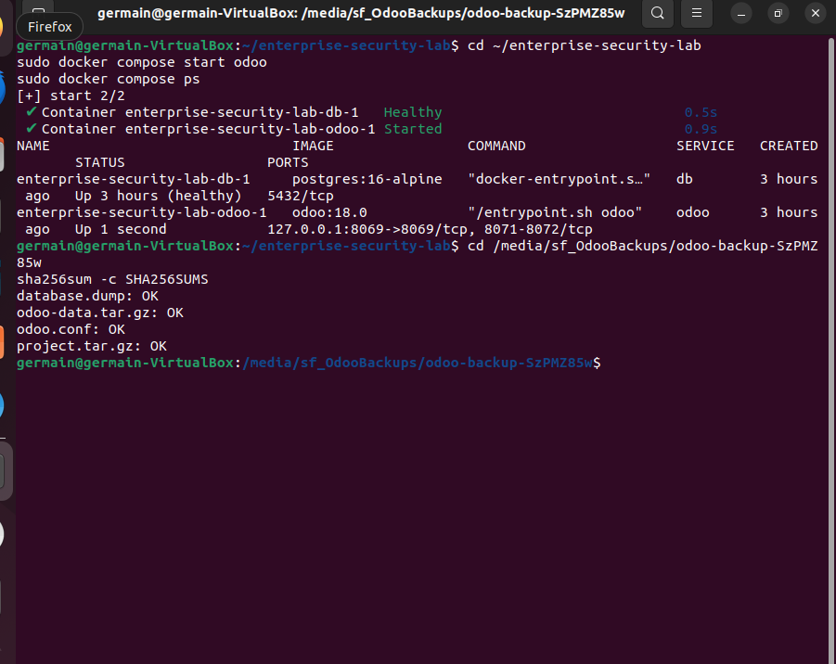
E062 Original service restarted and four checksums passed
All four manifest checks passed. The complete bundle occupies about 7.5 MB and includes private configuration. The actual recovery files are excluded from the public repository.

Isolated database restoration
The restore project uses enterprise-security-lab-restore and distinct named volumes, preserving the original application. The recovery network is internal and Odoo scheduled workers are disabled with --max-cron-threads=0.
The database import created enterprise_lab from template0 and used pg_restore with --exit-on-error and --no-owner. The restored sale_order query returned S00001, draft and 250.00.
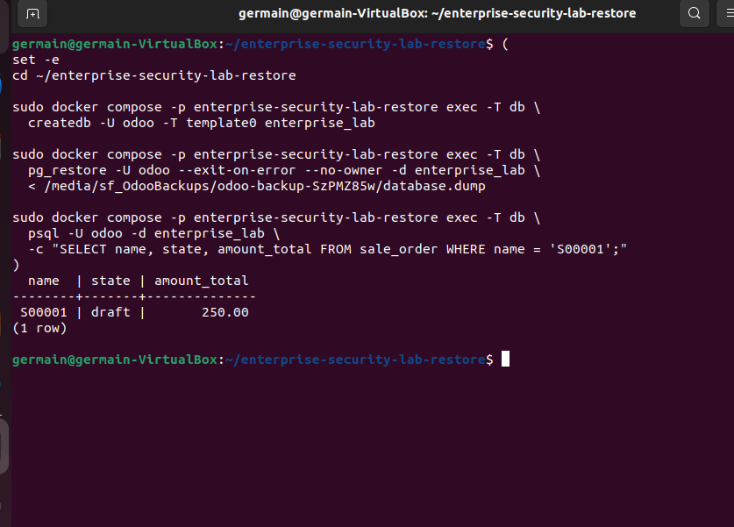
E065 Restored database query confirms S00001

Filestore and configuration
A one-off container extracted the odoo/filestore subtree into the recovery application volume and assigned Odoo ownership. The effective backed-up odoo.conf was mounted read only. Separate database and filestore recovery prevents a database-only restore from omitting attachment content.

Recovered Odoo application
The recovery services started with PostgreSQL healthy. The intended 127.0.0.1:8070 mapping did not respond in this internal-network setup. Container inspection identified 172.19.0.3 and Ubuntu reached Odoo directly at port 8069. This address is session-specific.
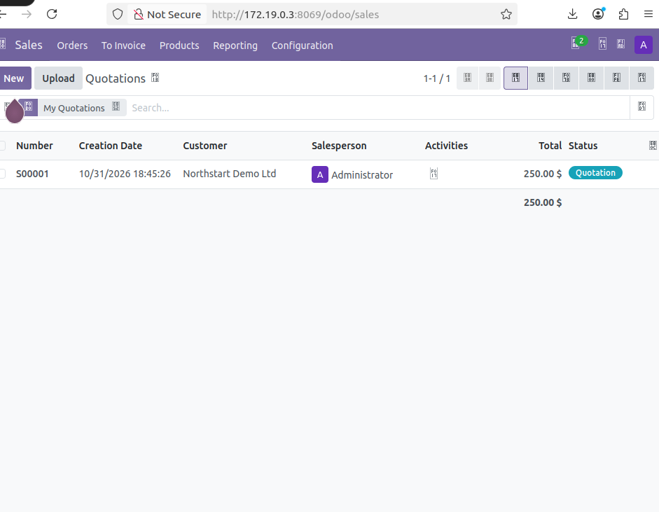
E070 Restored Odoo quotation list at container IP
The recovery browser shows S00001 and Northstart Demo Ltd with total 250.00. The original application remains separate. The user confirmed that the restored instance exists and works.

Recovery measurements
No formal RTO or RPO was measured. The test demonstrates manual application recovery. It does not establish a completed bare-metal recovery, offsite protection or production high availability.

Windows SMB destination for Veeam
A dedicated local account, GM-PC\veeambackup, receives Change access to the VeeamBackups share and Modify access to the underlying directory. The directory is E:\Enterprise-Lab-Backups\Veeam. A scoped TCP 445 rule supports the observed VirtualBox network path while leaving the Windows profile Public.
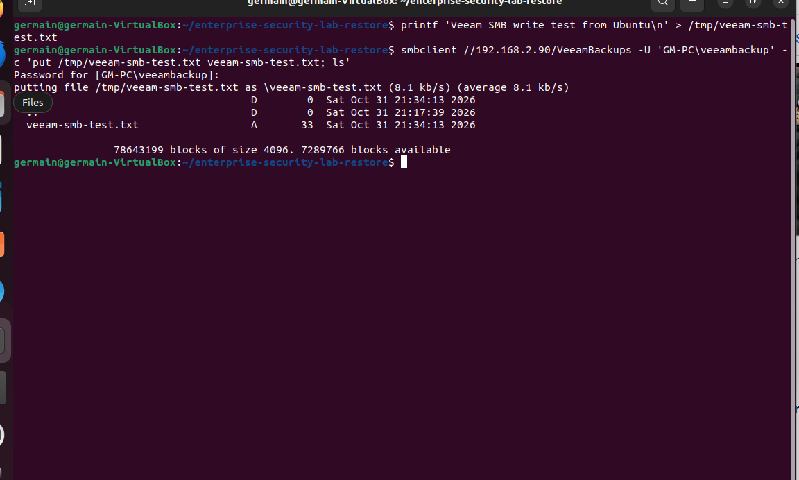
E085 SMB upload test succeeds
Ubuntu successfully uploaded and listed a 33-byte test file through //192.168.2.90/VeeamBackups. Veeam later reported Repository_1 as SMB and accessible. The password stayed in private prompts.

Storage independence
Both the manual shared folder and SMB destination reside on the Windows host. The lab has not established their physical independence from the host disk or an offsite copy. Repository accessibility confirms access, while a completed backup and restore must establish recoverability separately.

Veeam Agent and module repair
The repository package veeam-release-deb_13.0.2_amd64.deb configured APT. The installed Agent version was 13.1.2.11. DKMS work targeted kernel 6.8.0-85-generic.
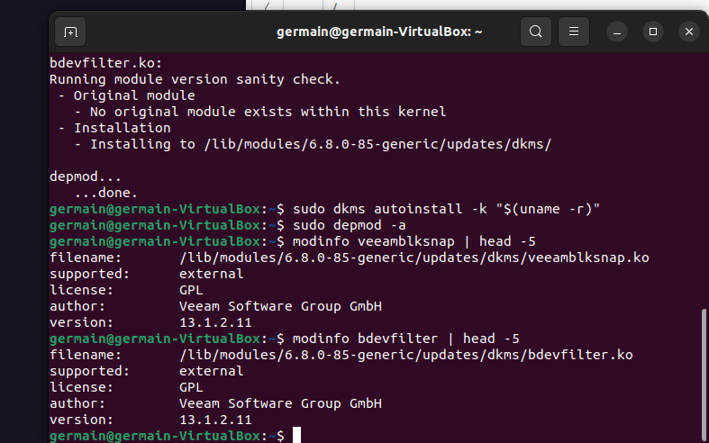
E102 Veeam modules rebuilt successfully
A temporary-workspace cleanup incident affected paths exposed through bind mounts. Repair included reinstalling firmware and kernel-module packages, checking package integrity and restoring the current kernel headers. The DKMS rebuild then restored veeamblksnap and bdevfilter. modinfo identified both module files and version 13.1.2.11.
The recorded module and package checks do not constitute a documented reboot or a complete system integrity assessment. The troubleshooting guide preserves the incident and its cause.

Storage incidents and backup interruption
Download and patch ISO failed with No space left on device. The temporary workspace occupied about 4.8 GB. A prior i386 download also did not match the amd64 guest. Bootable recovery media was not completed.
The saved BackupJob1 remained All System. It created a snapshot, processed about 1.9 GB and stayed visibly at 8%. Root usage reached 99%. Veeam logs identified low snapshot free space and a request to grow its snapshot storage.
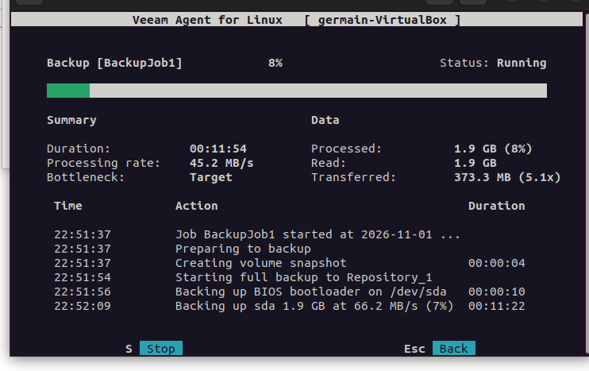
E113 Backup remains at 8 percent
A normal stop left the job in Stopping. A forced stop ended it as Failed and recovered root free space to approximately 2.7 GB. This attempt does not prove a successful restore point.

Cleanup lesson
Recursive cleanup with a filesystem boundary flag did not protect host paths behind same-filesystem bind mounts. Mount inspection and application-managed cleanup must precede deletion of a temporary recovery workspace. Historical diagnostic screenshots are not instructions to repeat those commands.

File backup source and Veeam verification
The existing manual recovery bundle was copied to /home/germain/odoo-veeam-source. A shared-folder permission error required an elevated copy followed by ownership assignment only on the local destination. Four hashes passed and the staged copy remained 7.5 MB.
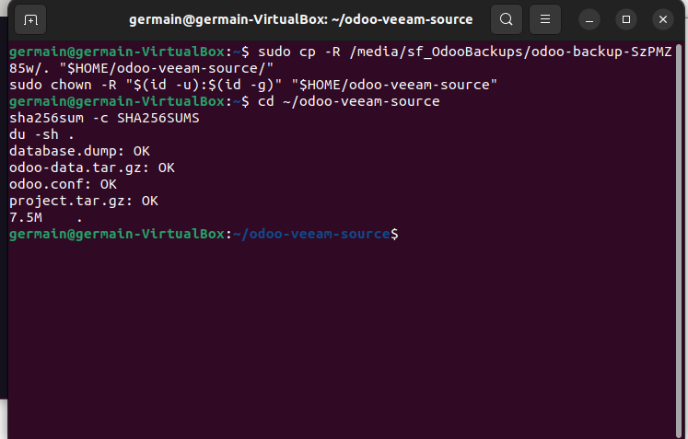
E117 Local recovery bundle four checksums pass
The instructed follow-up configuration selects File level backup, enables Disable snapshot, protects only the staged source and keeps the SMB destination. This static bundle preserves the earlier manual recovery point. It is not a new export of current application data.

Evidence required to close the Veeam exercise
Record the saved file-level scope and disabled snapshot, a completed successful backup session, recovery through Veeam into a separate directory, and four passing checksum checks on that recovered copy. The user reported the steps done after the last screenshot, but these final results remain unverified in the supplied evidence.

Further work
Measure recovery timing, provision adequate space for a future machine-level exercise, complete compatible recovery media and add independent backup storage. The complete screenshot galleries and technical guides accompany this report.

Findings and recovery roadmap
The lab demonstrates manual application recovery and identifies the operational controls needed before expanding the exercise. The following findings separate established results from the remaining recovery risks.
Finding | Risk | Next control
24 GB guest root | ISO workspace and snapshot growth compete for free space. | Provision temporary workspace and snapshot capacity.
Copies on Windows host | Host failure can affect source and backup destinations. | Add independent storage and an offsite copy.
Incomplete recovery media | Machine recovery remains untested. | Create amd64 media and verify that it boots.
Veeam results unverified | Final restore-point usability is unproven. | Capture Success and verify recovered-file hashes.
No measured RTO or RPO | Recovery objectives remain unknown. | Time a repeatable recovery and record backup age.

Recovery sequence
- Close the Veeam file-backup exercise with a successful session, a separate recovery directory and four passing hashes.
- Expand available workspace and complete a compatible recovery-media boot test. External output media alone does not provide the temporary workspace needed during ISO generation.
- Restore from a copy outside the Windows host failure domain.
- Repeat the recovery with recorded start, service-ready and business-validation times. Record the protected backup timestamp to evaluate RPO.

Publication and privacy
Business records are synthetic. Machine configuration and observed network details describe the actual lab. Publication screenshots redact visible password and cookie values. E085 uses a private SMB password prompt and echoes no password. The checksum command in E117 is sha256sum -c SHA256SUMS.
GitHub repository publication remains pending. The deck links to the existing GitHub profile until the project repository is available.

