# Driver State

The main function of the driver module is estimation of the time to driver (un)fitness and time to driver (dis)comfort which are used to determine who is fittest to drive. Within the MEDIATOR project scope, driver (un)fitness is estimated from levels of driver fatigue and distraction.

## TTDU

The ***time to driver unfitness*** (TTDU) is defined as the estimated time until the driver is no longer able to safely perform the manual driving task and is most relevant while driving manually or in CM, where the driver is expected to continuously be involved in the driving task. The *shortest* TTDU is selected and serve as output to the decision logic and also require a *worst, likely* and *best* case of that value, which is deduced from the *reliability* of the estimates.

### Fatigue

*Karolinska Sleepiness Scale (KSS) score* was obtained during the experiment, ranging from 1 (extremely alert) to 9 (very sleepy).

0, 1, 2, 3

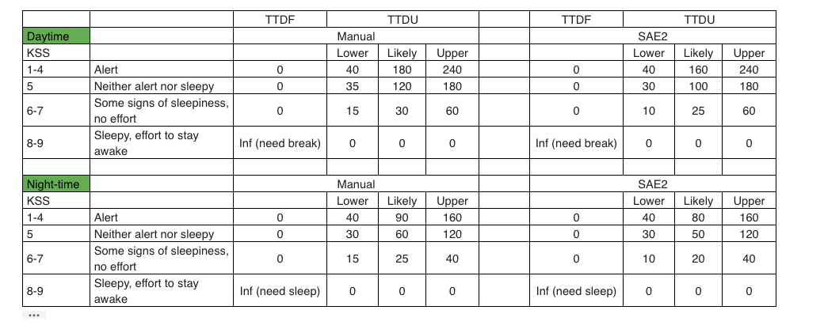

### Distraction

The AttenD algorithm makes use of a time buffer that runs empty when the driver looks away from the road and fills while the driver looks on the road. The driver is assumed to be closer to a distracted state and thus have less situation awareness when the buffer is closer to zero. The **binary state** of being distracted or not is computed. The estimation of TTDU due to distraction can instead be based on the expected loss of situation awareness due to distraction. Similar as it was proposed for fatigue related TTDU (but with a much shorter time scale), the distraction severity can be linked to the expected time to driver unfitness.

|  |  |  |  |
| --- | --- | --- | --- |
| Distraction severity level | Meaning | Calculation | TTDU [s] |
| 1 | Sufficient SA | AttenD Time buffer close to max | 300 |
| 2 | Long term loss of SA | AttenD time buffer zero for long period | 0 |

## TTDF

The time to driver fitness (TTDF) is defined as the estimated time before a driver is able to safely perform the manual driving task and is most relevant in SB or TtS where the driver is not expected to be involved in the driving task at all times.

While driving in SB or TtS, the driver is not expected to maintain a high level of situation awareness all the time. Instead, the driver is expected to be fit enough for the current automation functioning. This means that the time to driver fitness (TTDF) should always be smaller than the time to automation unfitness (TTAU). Research has shown that non-driving related tasks (NDRTs) can affect the required takeover time in varying degrees, e.g., task modality influences take over time. Detecting which NDRT is being performed can therefore aid in estimating the TTDF with respect to distraction.

|  |  |  |
| --- | --- | --- |
| NDRT type | TTDF | NDRT examples |
| Messaging | 5 seconds | Short messages via phone or tablet where driver intermittently looks at the road |
| Obstruction | 10 seconds | Working on a laptop |
| Immersion | 10 seconds | Watching a movie on a fixed screen |
| Obstruction and immersion | 20 seconds | Watching a movie on a laptop |

The maximumTTDF among distraction and fatigue related TTDF is selected and serves as output to the decision logic. Besides, w*orst, likely* and *best* case of that value, is deduced from the *reliability* of the estimates.

## TTDD

The main focus in the MEDIATOR project related to comfort is to initiate takeovers to improve driver comfort when uncomfortable events occur. An offline approach where typical driving situations are assigned average comfort values is used to *detect* and *predict driver comfort*. The table below covers two types of uncomfortable situations: 1) potentially uncomfortable situations in manual driving and 2) potentially uncomfortable situations in automated driving. A brief description of the situation and the time span within which this situation can be detected in advance is shown in the table.

As each situation shown in the table is potentially uncomfortable and should thus evoke a suggestion from the Mediator system for taking over control. Therefore, **TTDD can simply be calculated as the *time until such an event is expected* to take place**.

The probability of discomfort in the offline comfort table can be adjusted based on *historical data* regarding the acceptance or rejection of Mediator system suggestions to transfer control for each situation.

|  |  |  |
| --- | --- | --- |
| Situation | | Average time span for the premature  detection of the situations |
|
| Manual driving | Car following scenarios | several minutes |
| Situations with poor visibility | several minutes |
| Situations with high complexity | several seconds or minutes |
| Challenging driving manoeuvres | several seconds |
| Situations causing high levels of uncertainty | several minutes |
| Demanding or highly prioritized NDRTs | several seconds |
| Impaired driver state | several seconds or minutes |
| Longer and monotonous trips | several seconds or minutes |
| Optimise fuel or energy efficiency | several seconds or minutes |
| Automated driving | Situations with higher risks of motion sickness | several seconds |
| Situations with high demands on communication with other road users | several seconds or minutes |
| Driving under time pressure | several seconds or minutes |
| Purpose of the trip (e.g., driving for pleasure) | several seconds or minutes |
| Situations that cannot be handled by the automated system | several seconds or minutes |

# Automation State

The time to automation (un)fitness describes how much time is left before an automation level will no longer be available (unfitness) or become available (fitness). The time to automation (un)fitness should be calculated *continuously* for each automation functionality, which in the MEDIATOR project refers to automation levels CM, SB and TtS. Within the MEDIATOR project three estimations with different certainty levels are requested: worst case, likely case, best case.

* Estimate worst case based on mainly on-board sensors
* Estimate likely case using HD map and more variable information such as traffic and weather predictions
* Estimate best case using HD map and optimal traffic and weather assumptions

## TTAF

The *time to automation fitness* refers to the time until the automation function performance is high enough to be switched on, including worst case, likely case, best case estimations.

## TTAU

The *time to automation unfitness* (TTAU) refers to how much time is left before an automation level will no longer be available, including worst case, likely case, best case estimations.

## Automation Unfit Reasons

This variable describes the reasons for upcoming automation unfitness, which is important for the HMI to, for example, indicate to the driver why control will need to be taken over as to increase system transparency and thus improve the driver’s understanding of the system.

* Leave ODD
* Sensor failures
* Unclear Lane marking

## Current Automation Mode

* L0
* L2 (CM)
* L3 (SB)
* L4 (TtS)

# Context

## Uncomfortable Events

Driver module will require context information to identify the uncomfortable situations. For instance, traffic jam is detected based on traffic data and on-board vehicle sensors.

## Road Marking Quality

* Clear
* Unclear

## Road Type

* Highway
* Urban
* City

# HMI

An HMI is defined as a device that enables humans to engage and interact with machines. The main HMI functions are:

* Facilitating negotiations between driver and automation
* Guiding control transfers between driver and automation (takeovers)
* Informing transparency
* Executing corrective actions to increase driver fitness,
* Detecting and facilitating driver preferences and momentary inputs

For decision logic, action with different levels of necessity is represented with:

* Moderate preference

A **seductive** negotiation between HMI and human is applied.

* Strong preference

A **persuasive** negotiation between HMI and human is applied.

* Enforced control

A forced takeover is conducted without negotiation with the user

## Driver Request

Driver initiates take over through HMI about hand over or take over.

## Driver Response

HMI collects the driver’s response toward the decision logic action, including: no response, accept and reject.

## Procedure Status

HMI should send the procedure status of the decision logic action within a given time

# Actions

## Corrective Actions

Corrective actions are designed to improve driver fitness after **early stage** degraded performance is detected. Three corrective action groups were found: 1) warnings, 2) advises and 3) blocking actions.

Corrective actions should be effective and not decrease driver comfort. For instance, their *frequency* should not be too high and the *urgency* should be communicated appropriately. If the driver does not respond well to warnings or advices, another corrective action can be to block the usage of distracting advices or force a fatigued driver to rest by dimming lights. However, such more invasive corrective actions can significantly reduce driver acceptance of the system and should be implemented with care.