**Taking a step back**

**Introduction**

Me and my stakeholders of this project thought it was a good idea to take a step back, as we were going in a pretty smooth line momentarily. We found it a good idea to scope out a little bit more and take a look at other programs again and get to know how they work, we thought this was a good idea because we didn’t want to follow one line and we still wanted to keep our possibilities broad. I wanted to see how other applications worked and if I could take some inspiration from it, and maybe changing the way how I see things. I’m starting this research thinking I know how I should make my prototype a certain way but I hope that after this research I get more knowledge on other applications and know how they go to work so I can keep that in mind when working on my own application.

**Methods I used for this research**

For this research I used the library method, and the literature study. As I needed to find contextual information, guidance and best practices, this was the best way to find out more about other applications. I will also be using the Design Pattern Search method as I need to find common solutions for ‘recurring problems’ and a description of the context in which these solutions work best, I don’t have a problem but I do need to find common solutions and find out how they work.

**IFTTT**

IFTTT, also known as ‘If this then that’ is a software platform that can connect apps, devices and services from other developers in order to automate certain services that can be seen as very predictable and repeatable. IFTTT is an application with more than 25 million users and thousands of developers with more than 700 services. You can for example automatically turn your lights on at sunset with Philips Hue, or Automatically sync your Soundcloud likes to your Spotify or even keep your Facebook and Twitter profile pictures in sync. As you can see it is very broad and some big companies work together with IFTTT to automate processes, but how does the application work? IFTTT provides a web application and an app that you can use on several kind of devices, the application you is very self-explanatory. When you click on the explore button you see some pre-made tasks from other people or IFTTT. When pressing on it you can see what the certain automation does and what other application it is used on. It gives you a big button which says ‘click to connect’ and this redirects you to a page where you need to give IFTTT permission to use the applications that are needed. When pressing agree it is done and the specific automation will be done when it is triggered.

You can also make create your own so called ‘applets’ , when going to my applets you can press a button called ‘create your own’ and you get redirected to a page where you can create your own. The page looks a little like this;

When pressing add you get a huge list of applications you can use and automate together, the options are endless. As you can see you can connect two applications, the first will be used as a ‘trigger’ and it will activate a specific automation.   
IFTTT uses the a sort of macro to connect multiple applications to run automated tasks, this means they are the middle man for certain tasks that you normally do your self and could save you a lot of time when done automatically. This is similar to my project as they grab functionalities from an external application and link them together, except I take it from the ThingsDB backend and they take it from other applications. It is possible with IFTTT to connect more than two applets with eachother.   
Not everything is possible with IFTTT though, for every application they have a set of ‘applets’ that could be automated so they do limit you with what can be automated as seen for the YouTube applets down below;

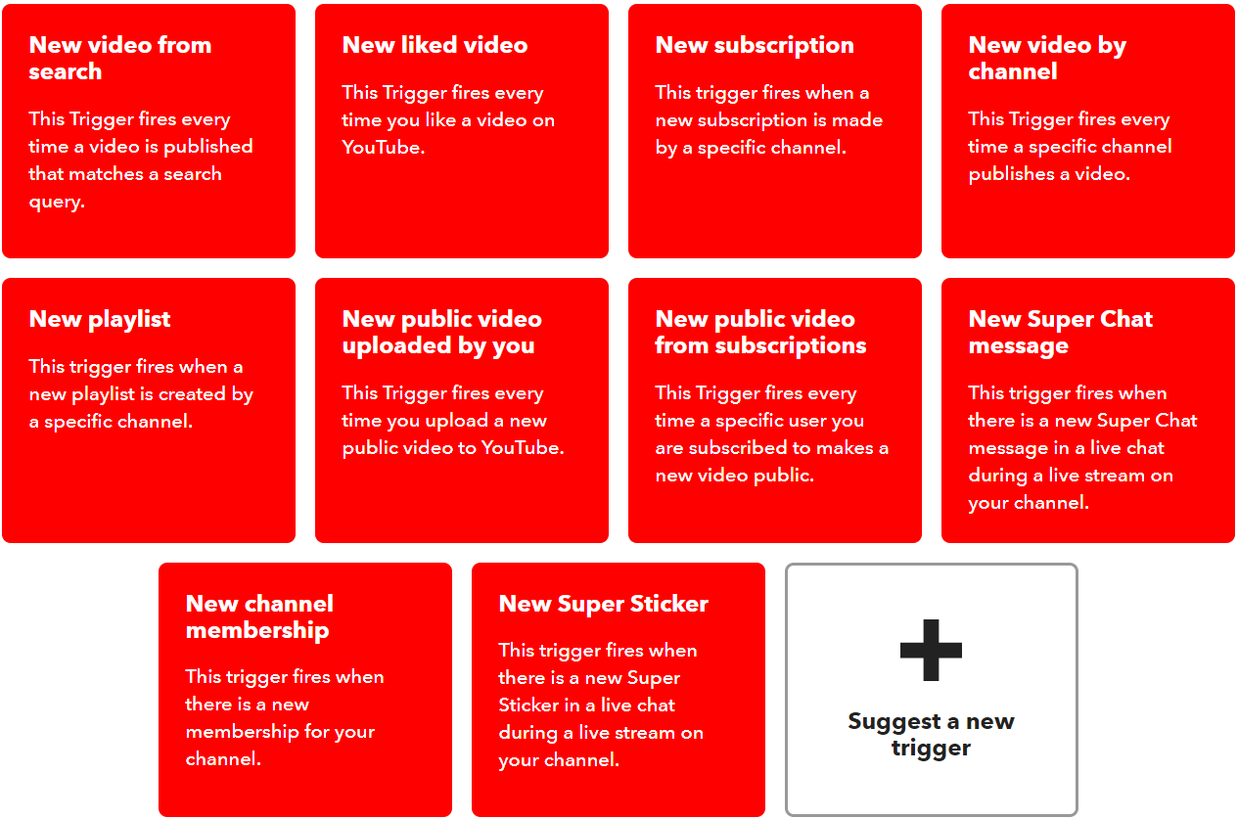

If we start looking at the design of this web application you immediately notice how bold and simplified it is. They give you the necessary components on the page that are needed and don’t add a lot of useless accessories to the page. It is very obvious which purpose everything has and you can not overlook an important step.

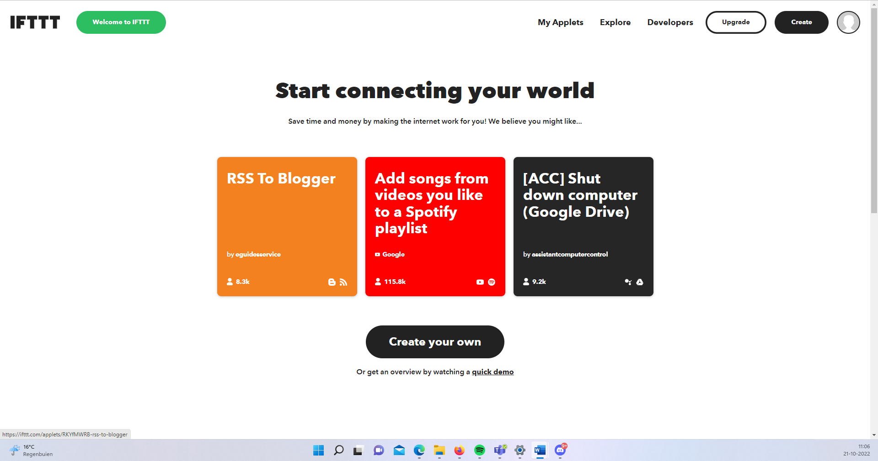

As you can see IFTTT doesn’t make use of a sidebar or anything, they just have the two buttons that you can press and when pressed you get the options which you want to choose. This causes for the page to be very simple and doesn’t cause any distraction from the functionality that is most important.

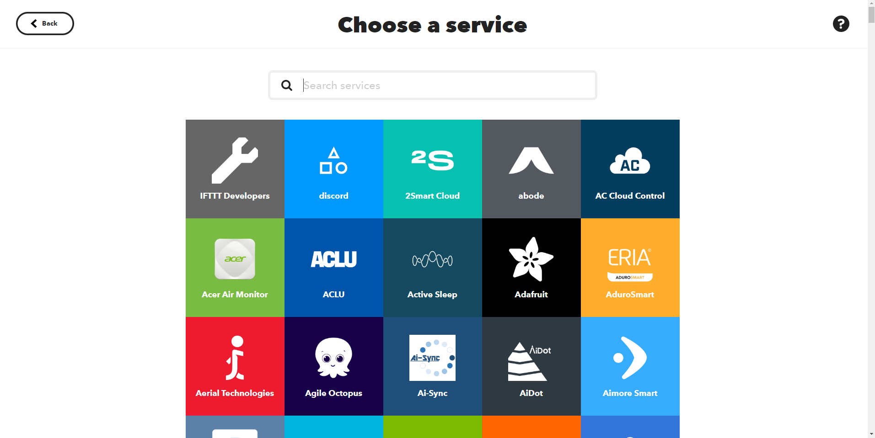

**Zapier**  
Another application I took a look at was Zapier, it´s an automated platform that connects your work applications and does tasks for you that are repetitive. It connects your apps and moves the information between them based on the rules that you set yourself. It is mostly used when there is a time consuming manual process that can be automated such as sending a notification to Slack when you posted something on Twitter. With more than 5 million users it´s a very popular application and used all over the world by companies that need to automate specific functionalities.   
Zapier works with so called ´zaps´ which are the automatization of their software, when creating a zap you need a trigger for an action to be activated. Similarly to IFTTT it gives you a lot of choices that you can select for certain things to be automated in your company. This application immediately gives off that it is very company based, when trying to make an account they start off with asking you how many members you have in your company and what kind of functionality you have. They make clear from the start that this is their target group, the page itself is a little less simple than and organized than IFTTT´s page but it still is pretty straightforward how everything is supposed to work;

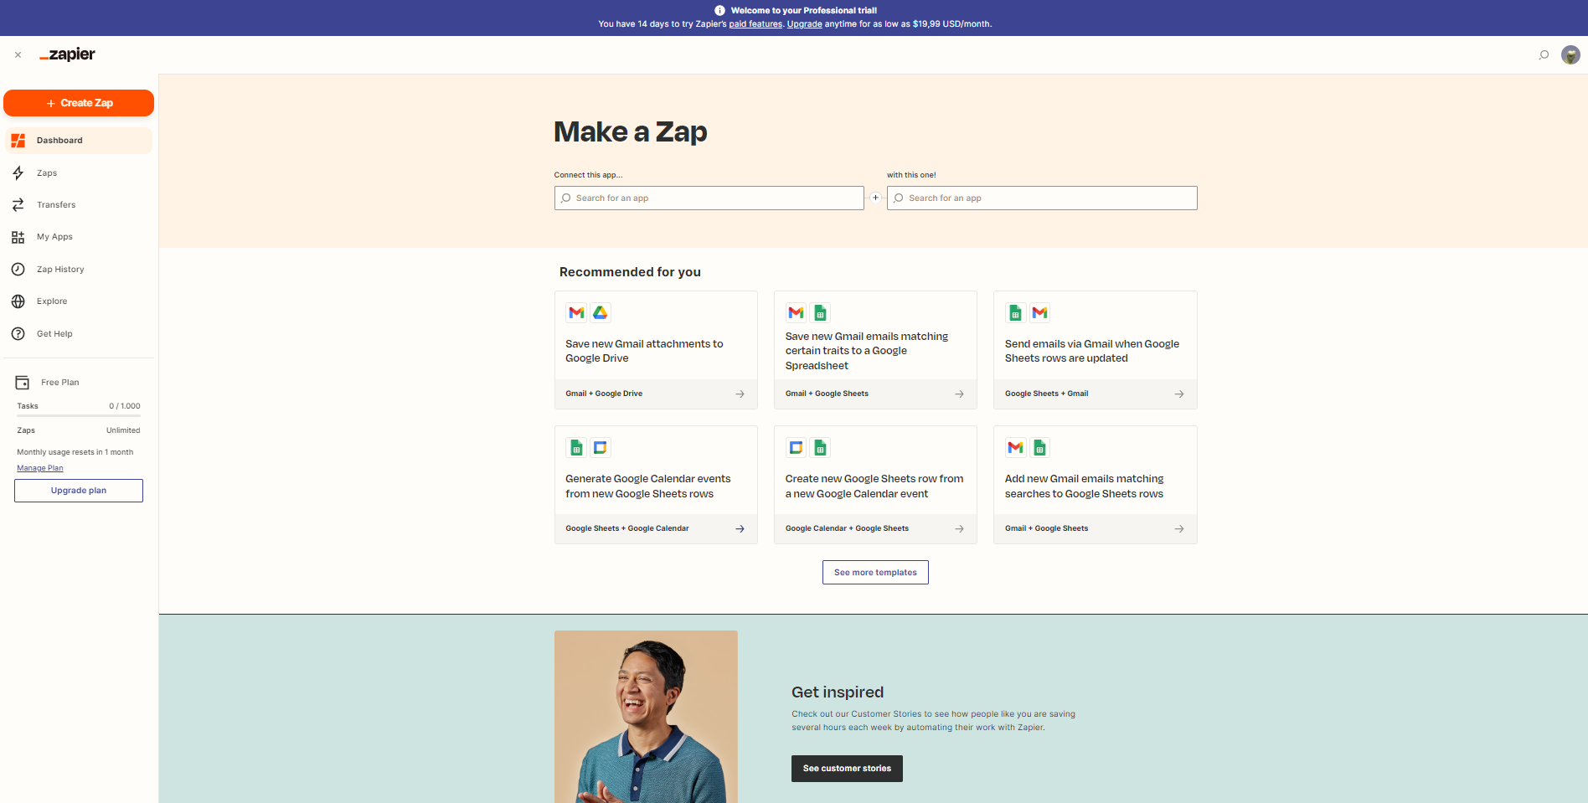

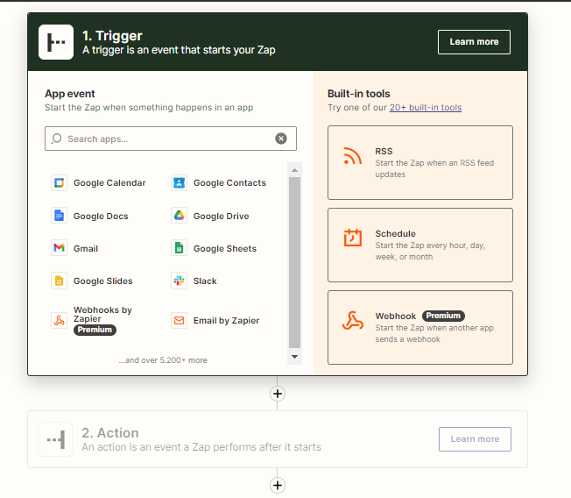When going to the zaps folder you can add your own zap, it gives you a list of choices such as google calendar, google drive, or slack. When pressing these you also get a list of functionalities that could happen that will be used as a trigger for your zap.

When setting up everything for the trigger you can choose what you want the action to do, for example create an e-mail as shown below;

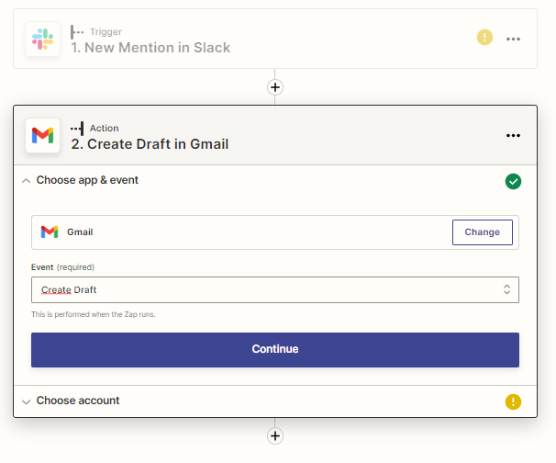

You can also choose to add another action after this one by pressing the little plus sign underneath, but that goes without saying. When you save your zap you can see them and look through them on a separate page called zaps, it showcases the name, owner, warnings, last edit and if it’s running or not.

The application also gives loads of other information like transfers and zap history, that can be very helpful for a business. When looking at the layout of the application you can see that it is quite similar to IFTTT, as it has a page where you can make your own automatization and you have a place where you can see and monitor your saved and made ones. One thing I found different about Zapier is that it has a much more professional look to it than IFTTT, it has a much tighter look. I prefer the overview page of the saved automatizations more than the IFTTT one, as it is much clearer to see which ones you have and to see more about the specific details about it. Overall, you can really see that it is meant for businesses and it gives of that vibe. It doesn’t really have anything special to it but there are a few elements on the page that I do really like. This page has a whole different way of working than I had in mind for my own workflow and this could be a possibility to make it in this kind of style as well, though it would be more difficult as both these pages are working with other applications and companies that already have a specific automatization ready for this.

**Conclusion**