rmAgro Guideline
  - The domain reference model for agricultural production.
Document type: Draft
Date: October 27, 2017.
Background: This document is an explication of the domain reference model rmAgro.
Editor: Dr. Ir. D. Goense, daan@pragmaas.com
Sponsors: Het Programma Precisielandbouw (PPL)
PPS AgroConnect.
EU research project FIspace.
Farm Digital project

Table of Contents
1 Introduction. 5
1.1 Version 1 of rmAgro 5
1.2 Developments in reference models for agricultural production 5
1.2.1 crop production. 5
1.3 Why drmCrop 6
1.4 Objective 6
2 Materials and Methods. 7
3 Structure of the rmCrop Model. 7
3.1 General. 8
3.2 BPMN 2.0 Business Process View. 8
3.3 Use case model 8
3.4 Domain model 8
3.4.1 drmCrop 8
3.4.2 DrmCropNL 9
3.4.3 FIspaceShortTermSolutions. 9
3.5 Dynamic view 9
3.6 External models 9
3.6.1 Models as reference 10
3.6.2 Models that are or can be used. 10
3.7 External XSD schemas 10
3.7.1 Schema’s for reference. 10
3.7.6 Used schema’s 11
3.8 Java model Crop. 11
3.9 Mapping drmCrop 11
3.10 MySQL model Crop. 12
3.11 XSD model crop. 12
3.12 Deployment Model. 12
3.12.1 Platforms 12
3.12.2 Other Sub Packages. 12
4 Modelling and naming conventions. 12
1. Modelling and naming conventions for the domain model drmCrop. 12
4.1.1 General 12
4.1.2 Specification and typographical conventions 13
4.1.3 Naming of classes and attributes 13
4.2 Name versus Designator 13
4.3 Identifiers 13
4.4 DataTypes. 14
4.5 Geometry types and or classes. 14
4.6 Code. 14
4.7 Enumeration or coding list. 14
4.8 A Type enumeration or a Subclass. 14
5 ToDo 15
5.1 Issues to be solved. 15
5.2 Work still to be done. 16
6 Abbreviations 17
7 Definitions 17
8 Literature. 17
9 Appendix I. Background on some design patterns. 18
9.1 Allocations 18
9.1.1 Harvesting from plots. 18
9.1.2 Applications on Crops. 20
9.1.3 Aggregating Lots 23
9.1.4 Sorting Lots 23
9.1.5 Application of Products on BatchLot’s of Produce. 24
9.2 Analyses and sampling 25
9.2.1 Sampling 25
9.2.2 Analyses of Samples. 27
9.3 BatchLot and Delivery 29
9.4 Certificates 29
9.5 Composition and Substance 31
9.6 CropProductionUnit 31
9.7 Geometries. 32
9.7.1 Background 32
9.7.2 Basic geometry classes. 33
9.8 Guidance and Tracks. 34
9.8.1 TrackPlan based on GuidanceReferences. 34
9.8.2 TrackPlan based on Tracks. 34
9.8.3 Additional information on TrackPlans 34
9.9 Job Task Operation 36
9.9.1 Operation 36
9.9.2 CulturalPractice 36
9.9.3 OperationTechnique 37
9.9.4 Task. 37
9.9.5 TaskCategory 38
9.9.6 Job 39
9.10 Organizations 40
9.11 Party, Organization and Person with addressing and contact info. 45
9.12 Party, Farm, GreenhouseComplex and AnimalHolding. 46
9.13 Party and its subclasses. 47
9.14 Plots and Fields. 48
9.15 Products and Produce 50
9.16 52
9.17 Values and Units 52
9.18 Zones 52
10 Appendix II. Some use cases. 52
10.1 Potato chain. 52
10.1.1 From harvest onwards. 52

Introduction.

Version 1 of rmAgro
Version 1 of rmCrop was developed from the perspective of arable farming with emphasis on precision agriculture.
Version 2 of rmCrop is developed in cooperation with stakeholders from the horticulture and flower production chains where focus is on tracking and tracing up to the retail market. The result is that a number of classes are added to cover the additional requirements and that some classes have name changes to become acceptable in a wider context. Also some definitions are sharpened or changed.
Version 1 of rmAgro is an extension of rmCrop version 2 which will cover the whole of primary agricultural production including those parts of the processing and retail chain which are relevant for the primary production. The main change is that the domain reference model is restructured in a main package which cover those objects which are generic for all branches of agriculture and specific sub packages for crop production, greenhouses, animal production etc.

Developments in reference models for agricultural production

crop production.
During the years several agricultural reference models are developed as basis for standardised information exchange. For crop production these include:
- Informatie Model Open Teelten", IMOT
- EDI-Teelt 1-3
- Computer Integrated farming, CIA
- ISO11783-part10
- AgroXML
- EDAPLOS
- UN-CEFACT
- EDI-Teelt plus
- EDI-Teelt++
- rmCrop 1 and 2
- AgroRDF
- rmAgro
- ADAPT
An important bases for many of the listed models is the "Informatie Model Open Teelten", IMOT, (1984-1987) which is the first reference model developed for arable farming in the Netherlands.
EDI-Teelt version 1 to 3 is used for standardised data exchange between parties in the Netherlands. The messages are based on the IMOT model, though the entities and its mutual relations of IMOT were neglected and only a flat model with attributes from IMOT was left. In the version 3, some of the entities with their hierarchy were reintroduced. Format for data exchange started with the Agricultural Data Interchange Syntax, ADIS, changed to Edifact and later to XML.
Computer Integrated Farming, CIA. This model developed during an EU research project had IMOT as a basis, but the classical relational entity model was converted to an object oriented model, with extensions for precision Agriculture. It also took animal husbandry into account, resulting in some abstract classes covering both branches of agriculture.
ISO11783 Part 10. Part 10 of ISO11783 started as a subset of the CIA model, but developed itself under WG1 of ISO/TC23/SC19.
AgroXML is a German reference model which clearly shows characteristics from IMOT and ISO11783.
EDAPLOS is a French reference model, which has clear signs of inheritance of IMOT, but also some very pragmatic solutions based on messages between parties in France that were used at the moment of development.
UN-CEFACT. EDAPLOS was the start of the arable farming part for core components in UN-CEFACT. More recently changes and additions are proposed and accepted which are based on the rmCrop and rmAgro reference model
EDI-Teelt plus was an initiative in the Netherlands under the umbrella of the GEO-Boer project. It is characterised by very abstract classes. It also introduced the geometry classes required for precision agriculture. This model was the basis for data exchange on agricultural fields between farm management systems and the Dutch government.
The reference model EDI-Teelt++ was an initiative from the Program Precision Agriculture (PPL) of the Dutch Ministry of Economic Affairs, Agriculture and Innovation (EL&I, now EZ). PPL promoted the development and introduction of Precision Agriculture in the Netherlands. EDI_Teelt++ is intended as a reference model for all data that is handled in Precision Agricultural applications. Data is defined and the structure of the data is made visible in UML class diagrams. EDI-Teelt++ was clearly focussed on the use of XML messages between farm management systems and services.
rmCrop. When looking at the mentioned models, there is a large communality in the classes and attributes of the different classes. This is not surprising as all applications in crop production that are computerised require sooner or later the same information to perform properly. The main differences in the above mentioned models is in the way the information is structured in classes and the applied abstraction level. The different reference models also reflect the requirements of the time they were developed. During development of IMOT it was expected that everything would soon be computerised, so the model took all available knowledge of agricultural research into account. Much attention was paid to strategic, tactical and operational planning, based on models developed in academia. This proved to be too optimistic, and later models restricted themselves in the number of applications that were covered. At the moment rmCrop started (2013) we saw, apart from the introduction of geographical aspects, applications in development which require again more types of data.
rmAgro. In 2015 there was a wish from the horticultural sector to bring their data model from Frugicom in line with the rmCrop data model as quite some arable farmers grow legumes in the open air and use the horticultural sales chains. Parallel to that it was realised that other sectors of agriculture, especially animal husbandry has a lot in common with arable farming, so have a lot of classes in common. Therefore it was decided to extend rmCrop to rmAgro to cover all branches of primary agricultural production.
AgroRDF. With the developement of the OWL – RDF technology it was decided to convert AgroXML to AgroRDF. New developments are specified in this newer technology.
ADAPT is a software core developed in C# and is intended as a basis for exchange of data between different agricultural software systems. The implemented classes are also specified in UML and is intended as the common data model. Developers can write plugins to convert their own data in the common classes. ADAPT started to cover ISO11783 part 10 and messages that contain an advice from service bureaus.

Technologies
A characteristic is that the reference models reflect their time of origin and the main technology used at that time. IMOT used entity relationship diagrams and was focussed on relational data bases as means of data storage. CIA introduced object orientation while ISO11783-part10 had an ERD approach. Mentioned models used initially a proprietary exchange format (ADIS), which was soon shifted to the use of XML. AgroXML had, as the name indicates, from the beginning onward XML in mind. The technology which is used in the different models is reflected in some attributes and the way in which relations between classes are modelled.
Now newer technologies for data communication like JSON and RDF come along, it is realised that a reference model should restrict itself to a domain model which is implementation and platform independent. That is the reason why drmCrop was started as a further development of EDI_Teelt++. The latter had clear characteristics of XML. It used data types which were based on XML; ID and sometimes IDREFS were modelled. It held also some characteristics of relational databases by the use of Id’s and modelling junction tables for many to many relations. It is the intention to remove or change all those implementation specific characteristics from the domain reference model.
drmAgro is the basis for standardized messages that will be used in data exchange between applications and between parties in the Netherlands. Messages will now, 2013-2017, be based on XML, but drmAgro is also intended as the reference for other methods of data exchange like JSON and RDF. On the longer term it should also be possible to generate messages for bandwidth efficient protocols like that used on the CAN bus by ISO11783, or on message hopping wireless sensor networks from the reference model. The data elements that are relevant for specific messages are made visible in message specific diagram(s).

Objective
The objective is to provide a reference model for agricultural production which can be used as a basis for different means of standardised data exchange in agriculture.
The reference model reflects the classes of objects which are relevant in agriculturl production, gives clear definitions of those classes, specifies the relevant attributes and shows the mutual relations between classes.
Different methods of data exchange will be specified by a well-defined transformation from the domain reference model to the implementation/platform specific model. This will take care that data types and attributes that are specific for the means of communication will be inserted by the transformation. An example is an attribute defined as Real in the reference model will be converted to gml:decimal in an XSD model. For different purposes, also different subsets of the reference model can be used. Though, the name and definition of transposed classes and attributes will not be changed, and for their meaning the domain reference model is the only source.
It is the intention to use as much as possible already existing standards. For geometries the classes will be used as defined by the OGC consortium (ISO19107) and the transformation of those classes to XML is based on GML. Data types are in the reference model limited to the basic, implementation independent data types like Boolean, Integer, Real and String. Some data types for attributes might require a further specification by their nature. Examples are URI’s or designators with restrictions in allowed characters. In that case as much as possible XSD types are used. ( Examples are anyURI or token).

Materials and Methods.
UML is used as the modelling language, Enterprise Architect (EA) is used as the tool to document the domain reference model. EA is also used to transform the domain model in platform specific models.

Structure of the rmAgro reference Model.
The Enterprise Architect model rmAgro.eap is divided in a number of packages and sub packages.
- BPMN 2.0 Business Process View (e)
- Owl Ontology
- Use case model (e)
- Domain model Agro, drmAgro
  - Generic agricultural classes
  - SWE types
  - XSD types
  - drmAgroDataTypes
  - drmAgroEnumerations
  - drmAgroGeometies
  - drmAnimal
  - drmCrop
    - drmCropNL
    - FIspaceShortTermSolutions (e)
    - ISO
  - drmGreenHouse
  - drmInfrastructure
  - drmStylGuide
- Dynamic view (e)
- DDL model Agro
- External models (e)
  - DataDictionaryPlantProtectionProducts
  - Fertilizers
  - ISO 00639 Language Codes
  - ISO 19107 Spatial schema
  - ISO 19111 ReferencingByCoordinates
  - ISO 19123 Coverage Geometry and functions.
  - ISO 19130 Sensor Data
  - AgroXML
- External Informative XSDs (e)
  - AgroXML
  - EDI_Crop crop recording
  - Frugicom
  - ISO11783
  - YGG model
  - eLab
- External used XSD’s
  - GML
  - CMLCOV
  - SWE
  - UNCEFACT Unqualified data Types.
  - XSD dataTypes
- Java model Crop
  - Java interface model
  - Java implementation model
- Mapping drmAgro
- WSDLs
- XSD model agro
- Deployment Model.

General.
rmAgro is a model in development. It does not claim to be complete and not all classes, attributes and relations are checked yet in respect of modelling guidelines defined hereafter.
Classes which are relevant for sending a complete cropping scheme from a farm to other parties are, as far as foreseen yet, complete. This is also the case for classes which are used in a fertilizer advise coming form an advisory service to a farmer. These classes can also be used for a crop protection advise.
All other classes originate from historical models and mapping against other models or reflect requirements from projects in which drmAgro is used as a reference. A number of choices which are made must be seen as proposal, open for discussion.
A number of items still to be completed are:
- Definitions of attributes are not complete.
- Minimum and maximum values for those attributes which represent a value are not specified yet.
- A check on national classes or attributes that should belong in a national sub model like drmCrop_NL is not complete, so there might still be attributes which are typical for the Netherlands.
- Mapping on ISO11783 is not complete
- Mapping on AgroXML is not complete
- For classes with geometry aspects the most suited OGC standards must be selected. This is done for Point, Linestring, Polygon, MultiPoint and MultiSurface, but Grid has to worked out in more detail.
- The patterns for units and measures (Rate, Value, etc.) can be improved by (partly) adopting the QUDT ontology of NASA.
- The templates to generate XML, Java and DDL models need changes and the generated models have to be actualized. At this moment still manual changes in the transformed models must be made.
- Etc.

BPMN 2.0 Business Process View.
This package holds the description of some business processes which are realised in the FIspace trial “Crop Protection Information Sharing”. This trial implements a system for Phytophthora control in potatoes.
There is some redundancy in the components.
A check has to be done on the correct message / data flows.
The “Total View Crop Protection” diagram is rather complete.

OWL Ontology.
It is intended to realise a transformation from the domain reference model drmAgro to an OWL model from which in a succeeding step ad RDF model can be generated.
THIS PACKAGE IS AT THIS MOMENT EMPTY. An investigation will made whether EA will come with an transformation template, before starting to implement our own.

Use case model
The use case model shows some use cases as defined in the ISO/TC23/SC19/WG5 working group for wireless communication in Agriculture. It describes some aspects of fleet management, task update and job control.

Domain model

drmAgro
This is the core of the model. drmAgro describes classes of objects and their attributes which are generic for all branches of agricultural production. These classes are listed and also some diagrams are part of this packages which some aspects of the model.
SWE types. A limited number of classes from Software Enablement which are used for compact data transfer are specified in this package.
XSD types. Here some data types from the XML data types as published by W3C are listed, which are used as data type in drmCrop.
DrmAgroDataTypes defines data types which are specific for drmAgro. At this moment they cover mainly requirements from crop production. (See "DataTypes" under "Some Modeling and naming conventions used")
drmAgroEnumerations specifies enumeration tables that are specific for drmAgro. At this moment they cover mainly requirements from crop production. (See "Enumerations versus Code Listst" under "Some Modeling and naming conventions used")

drmAgroGeometies. Specified geometries are based on ISO19107 and GML. As the ISO 19107 specification includes methods as part of its class specifications, this model should be seen as a platform specific implementation model, which in analogy to the approach in rmAgro should result from a transformation from a platform independent domain model. GML is the XML representation of ISO19107 and as such also a platform specific model. This package Geometries is a reverse engineering from both ISO19107 and GML and should be able to act as platform independent model. There is no transformation template specified for the Geometry package, as the results are already well published by ISO19107 and as GML schema’s. The difficulty is that GML is not a one to one transformation from ISO19107. (see footnote 1 on one of the previous pages.)
drmAnimal is just an onset to cover the specifications in different animal data models. SO IT IS STILL TO BE WORKED OUT.
drmCrop. All identified classes specific for crop production are listed in the drmCrop package. Also a number of diagrams are specified. Each diagram has a name which indicates a particular aspect of crop production and shows the classes which are relevant for that aspect. Several aspects have a further explanation in the Appendices with examples.
The drmCrop domain model has three sub packages.
drmCop IS AT THIS MOMENT NOT COMPLETELY CHECKED ON COMMON CLASSES THAT BELONG TO drmAgro.
drmCropNL. There are some attributes of classes which are specific for the Netherlands. Most have to do with national legislation. It is assumed that they are not used in other countries. Those specific national attributes, or eventually classes are specified as subclass of classes in the drmCrop package.
The same procedure can be used for other countries. A clear example is the “Ackerzahl” for Fields in Germany (and some other countries in Europe?), which should be specified in a drmCrop_DE package.
FIspaceShortTermSolutions. A short term solution is chosen in the FIspace project to represent some essential growth stages of a CropField. Emergence date and the date of start of tuber formation in potatoes are made attributes. A correct solution is a reference to a growth stage coding table, but this complicates the data structure and processing considerable.
ISO. ISO11783 has the classes Device and DeviceElement which represents implements and components of implements like bins, sections valves, etc. Mapping to ISO11783 requires that the numbering of especially the DeviceElements must be specified and maintained constant. For that reason these classes are added in a separate sub package.
drmGreenHouse has a lot in common with crop production which is specified in the drmCrop packages. A number of Greenhous specific classes is specified in this package.
drmInfrastructure contains those classes that are not specific for agriculture, but are of relevance for agriculture. Examples are public roads, utility poles, trees, etc.
drmStylGuide. In ISO11783 and ADAPT it is possible to specify color and line coding such that the user interface on different platforms ( Farm management system and Task controller) is the same. This is not part of an agricultural reference model, but is required for mapping to those systems. A separate package is used to keep this aspect separate.
------------ UPDATED UP TO HERE ------------------2017-10-27-----------------------------

Dynamic view
A start is made to model the dynamics of some classes which can change their state based on events.
In this package there is also The Phytophthora Control Sequence Diagram, which shows the messages exchanged so far in the FIspace trial for Crop Protection Information Sharing.

External models
External models are specifications defined as class models. Some specifications are specified as XSD schema’s. See 3.6.
The whole model contains two types of external models:
- External reference models which are only used as a reference, something to look at or to provide ideas. These can be models describing the same domain (crop production) or related domains. There is an external model for Fertilizers and Crop protection material. (See also external XSD schema’s)
- Models which are used in the standards based on drmCrop. It is not intended to (re)model entities already well defined by other organisations. A clear example is ISO19107 which describes geographic objects.

Models as reference

Data dictionary plant protection products.
This is a UML model representation of a data dictionary for plant protection products. This is formulated by the European Commission, DG SANCO.

Fertilizers.
UML model for fertilizers as formulated by AgroConnect, with consultation of the fertilizer industry.

ISO 1930 Sensor Data
The OGC model for sensor data. This is only used as a reference yet. It can be considered to use classes from this standard.

Left overs of EDI-Teelt plus.
Classes which were in the predecessor model EDI_Teelt++ and are not used in drmCrop. (Mostly junction tables in many to many relations) This package can be deleted when a complete check is made.

Models that are or can be used.

ISO 00639 Language codes.
This is a code list which can be relevant for data exchange in crop production.

ISO 19107 Spatial schema.
This is the basic class model on which GML is based. This model also specifies methods and can be seen as a basis for implementing geometries.

ISO 19111 Referencing by coordinates
This model specifies classes around coordinate reference systems, datums and conversions between systems.

ISO 19123 Coverage’s
This model specifies Grid.

External XSD schemas
Some specifications are given in the form of xsd schema’s They can in analogy to external models be separated in
- External reference schema’s which are only used as a reference, something to look at, to provide ideas. These can be models describing the same domain (crop production) or related domains.
Important external schema’s for reference are AgroXML and ISO11783. Both cover the same domain. The first one is used as reference. The same is true for ISO11783, but this schema is also essential in crop production as it is the standard to exchange data with task controllers on farm machinery. The possibility to map drmCrop on ISO11783 as specified in 3.8 is therefore a requirement.
- Schema’s which are used in the standards based on drmCrop. It is not intended to define entities already well defined by other organisations. The most basic schema is the basic schema of XML. Another important schema is GML, the XML specification of ISO19107.

Schema’s for reference.

AgroXML
German XML model drafted in several German precision agriculture projects (PreAgro). Maintained by KTBL.

ISO11783.
ISO11783 part 10 is specified as xsd, but as its entities are identified by three character names and its attributes are in the XML schema specified as A, B, C, etc., a model reverse engineered from the schema is useless. For that reason an XML model of ISO11783 part 10 is drafted on basis of the entity relationship diagram in the most recent version of the FDIS of part 10.
This is not complete yet.

ISO11783_TaskFile_20050104.
This is the reverse engineered XML model representation forom the xsd’s as published in 2005.

EDI_Crop version 4.
In the Netherlands EDI_Crop version 4 is the present standard for data exchange in crop production. For different types of messages, different schema’s are generated, which holds only the mandatory and optional classes and attributes for those messages.
EDI_Crop V4.0 is based on drmCrop, though in some cases UNCEFACT constructs are preferred, and sometimes short term solutions are chosen by using constructs of EDI_Teelt version 3.
At present the schema for the crop recording is specified.

Used schema’s
The following schema’s are used in drmCrop:

XSDDatatypes.
A schema defined by W3C. It is the basis xsd of xml, defining a number of basic data types like "float", "int" and "string", but also subset of "string" like "token and "NCName". Also identifiers to use in XML files like "ID" are defined in this Schema. The XSD data types are used when generating a XML model from drmCrop.

GML version 3.2.1.
Contains different xsd''s as defined by OGC (Open Gis Consortium). They define the geometry objects, which are used to describe geometries in the context of drmCrop.
THE SCHEMA’S OF gml WHICH ARE OF RELEVANCE FOR drmCrop ARE IMPORTED AS MODEL IN THIS PACKAGE, THE CLASSES USED BY drmCrop ARE SPECIFIED IN THE SUB-PACKAGE “Geometries” OF drmCrop. IN A LATER STAGE A CROP PRODUCTION SPECIFIC GML PROFILE WILL BE SPECIFIED.

Java model Crop.
In principle it is possible to transform the domain model in an implementation model in java (or C++ or any other computer language). This is not the goal of the reference model rmCrop, but done for a limited number of classes to check whether the domain model is specified in such a way that this transformation is possible.

Mapping drmCrop
The package “Mapping drmCrop” holds two types of mapping:
            - Mapping Geometries of drmCrop on ISO19107 and GML.

ISO19107 and GML are already specified by OGC, so no XML and java models are generated from drmCrop’s sub package Geometries. To show how the classes specified in Geometries are mapped on on ISO19107 and GML this overview is made.
2. Mapping as a reference.
As check whether classes and attributes that are specified in drmCrop cover the whole domain of crop production, a start is made to compare drmCrop with other models or schema’s as specified in the packages “External Models” and “External Schema’s”. There are mappings made by visualizing the different classes near each other.
As it is not possible to draw lines in EA diagrams, these overviews are not always very clear. A better method to make the mapping visible must be looked after.

MySQL model Crop.
Generating of database tables from a DDL model which is generated from a domain model is possible, but not the goal of rmCrop. To check whether the domain model is specified in such a way that this is possible at all, this is done for a limited number of classes.

XSD model crop.
As XML is foreseen now (2013) as the main protocol to exchange information between parties, an xsd model is generated from the domain model. Typical XML elements are added to the classes of the domain model like an ID for root classes and an IDREF when there is a relation to one instance of another class. (IDREF IS NOT REALISED YET).
The generic data types are converted to xsd data types as follows:
- Boolean --> xsd:boolean
- Integer --> xsd:int (which limits it to 32 bits). WHEN MAXIMUM AND MINIMUM VALUES ARE SPECIFIED FOR THE RELEVANT ATTRIBUTES, A MORE SPECIFIC DATATYPE CAN BE GENERATED.)
- Real --> xsd:decimal
- String --> xsd:string
Separate packages DataTypes and Enumerations are generated for the data types and enumerations specified in drmCrop.
There is no XML model generated for Geometries, as this is already published as GML models and schema’s.
There is also no XML schema generated for XSD_Types, as this is available from W3C.

Deployment Model.
This will represent the devices and environments used to implement Crop productrion, but are in fact not part of the Crop Production Domain.

Platforms
At this moment only used to identify different types of (computer) platforms, which are used in the context of crop production.

Other Sub Packages.
Some devices are already represented in the other sub packages, but this must still be completed.

Modelling and naming conventions.

Modelling and naming conventions for the domain model drmCrop.

General
The domain model is kept as much as possible independent from all types of implementation characteristics. This means that:
- No identifiers are modelled, with exception of a Global Unique IDentifier (GUID), which is seen as an attribute of the object. (not strict an attribute because it has a complex nature)
- The model is not based on any computer language, which means that only a limited set of data types is used. (for example “Real”)
- There are no association classes modelled for many-to-many relations, except when they hold attributes.
- There are no foreign keys modelled as attributes.

Specification and typographical conventions
For each Class a Definition is given and in most cases a Remark is made which contains further explanation. In some cases examples are given. When there are discussion points, those are printed in CAPITALS. When in the definition or remark a reference is made to other classes in the domain model, the class name is printed in bold. To stay strict to the class name, multiples are written with a ‘s, in spite of the fact that this in most cases is grammatically not correct. When the name of an attribute is used, that name is given in cursive bold.
The classes with their attributes are shown in the diagrams and have the default color of EA (light crème) Enumerations have a dark yellow background colour and data types defined in EDI_Teelt++ a light yellow colour. Geometries as specified for drmCrop have a light rose colour. Geometries that are data types following the criteria mentioned in

Naming of classes and attributes
For both, Classes and Attributes, the principle of "Upper Camel Case" is used. (THSI IS THE CONVENTION ALSO USED IN ISO11783. ONE CAN QUESTION WHETHER THIS IS CORRECT FOR ATTRIBUTES)
When a class is defined as a data type, the expression Type is always used at the end of the class name. When the class is not a data type the expression Type at the end is not used. In most cases, where there is a natural tendency to use the expression type, but not a data type as defined under 4.4 is intended, the expression Category is used. Examples are ProductCategory, TaskCategory or CropClass instead of ProductType, TaskType and CropType. (CropClass is used instead of CropCategory to stay conform FAO terminology)
Enumerations have always the expression 'Enumeration" at the end of their name. The values of the enumerations are written in CAPITALS.

Name versus Designator
In analogy to ISO11783 part 10, the expression "Designator" is used for the identification which is used when people talk or write about a specific instance of an object. ( Following a language purist in the early ISO WG1 meetings, the expression "name" should be reserved for natural persons. (and I (DG) guess that some animals might also have a Name).
As a Party has a Designator, and Person inherits from Party, a Person has, apart from a first name and a last name also a Designator by inheritance, which could for example be used for a less formal name used in daily communication.

Identifiers
Identifiers and references are not specified in the domain reference model drmCrop. The only Exception is XxxGUID, where Xxx stands for the name of the class. GUID is seen as an attribute of the type GlobalUniqueIdentifier and must guarantee that the object is worldwide unique identified. The XxxGUID is given by the Organisation which is the creator of the object.
ThirdPartyxxxGUID is an optional additional attribute which is also of the the GlobalUniqueIdentifierType that is assigned by another Organisation then the "creator” of the object.
The name of the class, Xxxx is not used in case the identifier(s) are defined in a superclass with subclasses that inherit the identifier.

DataTypes.
A data type is a special kind of classifier, similar to a class. It differs from a class in that instances of a data type are identified only by their value.
So, when a class can have an identifier for identification of an instance (whether that is a GUID or a key in a database table), it is a class. A clear example is Party. As super class of Organization, Person and Equipment it has an identifier for identification of instances. An Address is an example of a data type. The value of the different attributes of the Address identifies the address. A decimal is also a very clear example of a data type.

Geometry types and or classes.
It is not the intention to model geometries as classes or data types in drmCrop. Classes from OGC models or schema’s should be used. The sub package Geometries is only used to specify the OGC classes which are relevant for drmCrop. There are a few classes which can be called geometry, like for example a FieldBorder. This is done when they have a particular meaning in crop production. In general they inherit the characteristics of OGC geometries, or have relations with OGC geometries.

Code.
In the DataTypes package of drmCrop the data type CodeType is defined. The CodeType has a Code as attribute which is from the data type xsd:token. A Code is part of a CodeList, which is specified as CodeListType, so in implementing CodeType in a data base, a foreign key to CodeList can be specified, while in an XML file an IDREF can be given as reference to the CodeList.
The use of two data types; CodeType and CodeListType, deviates from "code" as defined in UN CEFACT. In UN CEFACT the "code" is not de-normalized, as all attributes of CodeListType as defined here, are made attribute of "code" in UN CEFACT.
In the description of the attributes which are of the data type CodeType, is specified in which CodeList the codes can be found. The value of the attributes of CodeListType are given in the attribute description. The CodeList specified there is either mandatory or default. In case of a mandatory or default CodeList, it is only required to specify the Code attribute. The CodeList can also be as "free", which means that it is left open to the user, or parties of users, to choose a CodeList. When a non default or free CodeList is used, the attributes of CodeList must be specified.
THIS MIGHT BE TOO MUCH FOCUSSED ON THE DUTCH IMPLEMENTATION.

Enumeration or coding list.
An enumeration is a data type with a limited number of possible items. The name represents the meaning of that item. A coding List is a list of objects of which the unique code is one of the attributes.
The enumeration becomes part of the software for implementation. The consequence is that enumerations should be restricted for those items who are expected to be stable over time. Addition of an item of an enumeration list requires a change in the specification of the standard and also a change and recompilation of the implementation software.
Items that change regularly must be specified in coding lists. The class of objects, with its attributes, in the coding list, is specified in the standard. The objects themselves are items in a database or communication file.

A Type enumeration or a Subclass.
Often a choice must be made whether a specific type of class can be indicated by an enumeration indicating the type/castegory of that class, or whether it should be modelled as a subclass. An example of the difference in approach is LineString as used in ISO11783 with enumeration values of 1 through 9 for different classes of object formed by the LineString. In drmCrop the different classes are modelled as for example GuidanceReferenceLine and Track which are sub classes of LineString. The consequence of the use of a subclass is that the software to implement the applications must be recompiled as soon as a new subclass is required. A comparable situation is described by Johnsons and Woolfe, 1996. The conclusion is that subclasses should be used when:
- The subclass has attributes which are relevant/specific for the subclass and not for other subclasses
- The subclass has different behaviour which should be taken care of by subclass specific procedures.
- The number of subclasses is known and expected to be stable over time.

ToDo

Issues to be solved.
  - All the data types of type "string" are to be checked whether they can stay as "string" (which seldom will be the case) or should be replaced by : normalizedString, token, Name or NCName. The "UN CEFACT Text . Type" allows strings, normalized strings and tokens, so this will leave too much freedom in cases where the allowed characters should be restricted.
  - Designator is now typed as String. Proposal: make it a token, which means that all the occurrences of #x9 (tab), #xA (linefeed), or #xD (carriage return) are replaced by an occurrence of #x20 (space) and contiguous occurrences of spaces are replaced by a single space. Leading and trailing spaces are removed. The use of Name adds the restriction that the Designator should start with a letter, underscore or colon. The use of NCName adds the restriction that no colon should be used.
  - Pal and Pw are now attributes from a Field. Proposal is to leave it as it is but make it in future versions a normal PropertyValue of a PropertyZone. (This is specific for the situation in the Netherlands)
  - Phosphate status is left as a separate class, connected to Farm. A change should be made toward a class QuotaTransfer which can be used to specify transfer between years for all categories of inputs. The phosphate status of arable land and grassland can be calculated from the PropertyValue's that refer to P₂O₅ for the PropertyZone's distinguished in the Farm. In that case point 3 should be adopted accordingly. (This is specific for the situation in the Netherlands)
  - Should we remove all attributes which are a reference to a Designators (or Name) of a coded item? The Designator is already specified in the coding list. (See for example apart from VarietyCode also VarietyName as attribute in CropField.
  - RegulatorySoilType is now an attribute of CropField. The Dutch government assigns those SoilTypes to what they call an AAN perceel, which means that it becomes an attribute of a "Field". Leave it for now to CropField or replace it to "Field"? See also issue 8) in the next paragraph to be solved later. (This is specific for the situation in the Netherlands)
  - When should we use different sub-classes and when use only one (upper) class with a type attribute defined in a coding list, which differentiates the meaning and role of the upper class?
  - Naming of attributes. For both, Classes and Attributes, the principe of "Upper Camel Case" is used. (There are modeling guidelines (DatexII) where for attributes the principle of "Lower Camel Case" is used.)
  - The relations between the classes qualified as Associations, Compositions or Aggregations are not checked on their correctness and consistency and require a further check. The relations drawn are found valid, and the multiplicities are specified as they are intended. The exact form of these relations, Associations, Compositions or Aggregations, might be changed.
  - There are in respect of converting XML schemes to UML diagrams two possibilities: 1) A DataType is an attribute of the Class 2) A DataType is drawn as a Class which has an association (Composition) with the Class that "Owns" the dataType. We must decide whether we model DataType in XML models as attribute or as composition.
  - Definitions of attributes must be completed.
  - Minimum and maximum values for those attributes which represent a value or quantity must be specified.
  - A check on national classes or attributes that should belong in a national sub model like drmCrop_NL is not complete.
  - Mapping on ISO11783 is not complete
  - Mapping on AgroXML is not complete
  - For classes with geometry aspects the most suited OGC standards must be selected.
  - Mapping of geometries on GML respectively ISO19107 must be validated.
  - The patterns for units and measures (Rate, Value, etc.) can be improved by (partly) adopting the QUDT ontology of NASA.
  - A Customer can also be a Person. How to deal with multiple inheritance?

Work still to be done.
- The generated XML, Java and DDL models are not in line with the domain model drmCrop version 2. The templates need updates and the generated models have to be actualized whith changes from version 2.
- Add attributes to Order and Delivery.
- Look for a construct to specify between which possibilities an PROPOSED_CHOICE must be made.

Abbreviations
EA Enterprise Architect UML case tool.
OGC Open GIS Consortium

Definitions
Leaf class. A leaf class is a class which is a subclass of another class. This is relevant, as it is not required to generate an ID when transforming the domain model to an XML model.
Root class. A root class is a class which has sub-classes.

Literature.

Biesalski, E. 1954. Landarbeit und Technik. Heft 32. Eine schriftreihe des Max-Planck-Institutes für Landarbeit und Landtechnik. Herausgegeben von Prof. Dr. G Preuschen, bad Kreuznach. Fünfte, erweiterte Auflage. Verlag Paul Parey, Hamburg und Berlin. 1954.
Goense, D. and J. W. Hofstee. 1995. Deliverable Report 1.2.c, Information Model, Annex 2.3.9. ESPRIT III project 7318. Computer Integrated Agriculture.
Johnson, R. and B. Woolf. 1996. The Type Object Pattern. http://www.cs.ox.ac.uk/jeremy.gibbons/dpa/typeobject.pdf

Appendix I. Background on some design patterns.

Allocations
Allocation has subclasses: ProductAllocation and ProduceAllocation, which deal with product and produce respectively, and a Delivery. ProductAllocation has a subclass ProductFieldApplication which specifically describes application of products on a field surface, while ProductAllocation can be used for Application of a Product on a batch of Produce or Product and mixing of products.
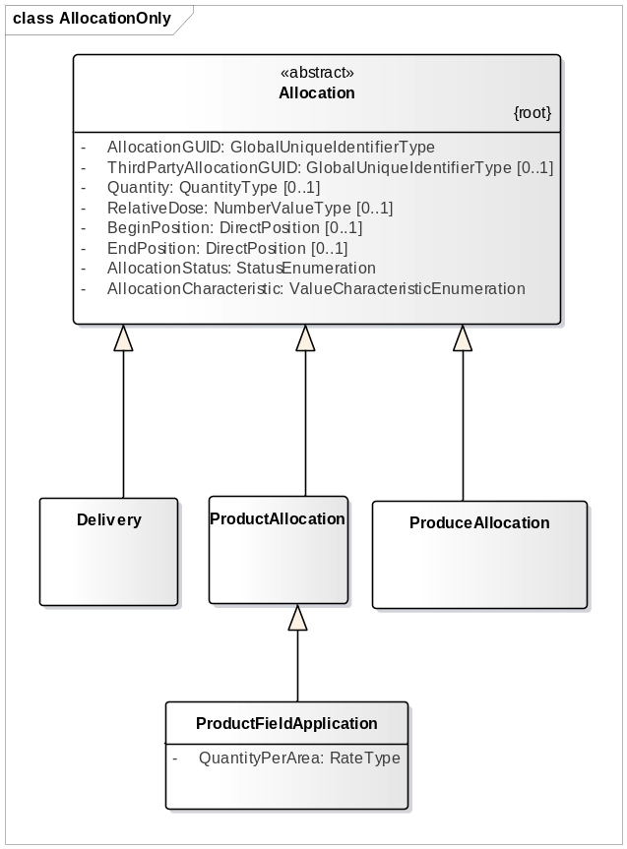
Figure 1. Allocation with subclasses
Allocation is used to describe the application of products on field surfaces, application of (protecting) products on produce, sorting produce, mixing products or produce, etc. These activities in respect of allocations are specified hereafter.

Harvesting from plots.

Harvesting is an Operation which results in one or more ProduceAllocations. The farm business process determines on which level of detail the ProduceAllocations will be recorded.
In case of global registration only one ProduceAllocation and one HarvestingZone exists for the whole CropField. The BatchLot will be collected in one or more storages, but holds one BatchLot identifier pointing to that HarvestingZone.
In case of detailed registration, a harvesting machine will keep track of the surface which is harvested when a particular container is being filled. This container can be located on the harvesting machine like on grain combines, but can also be a tipping trailer driving near the harvester like most choppers. The surface is a HarvestingZone and will be the part of strips harvested for one particular filling of the container. After emptying the container a new BatchLot is created.
When implementing detailed registration, it will for example be the combine harvester which records the harvesting zones and the ProduceAllocation when unloading. The time and geographic position of this allocation can be recorded. When a trailer is equipped with loadcells for weighing, it could also record a loading action around the same time and very close to the position recorded by the combine. So there is a redundant recording of the allocation possible with slightly different quantities, time and location.

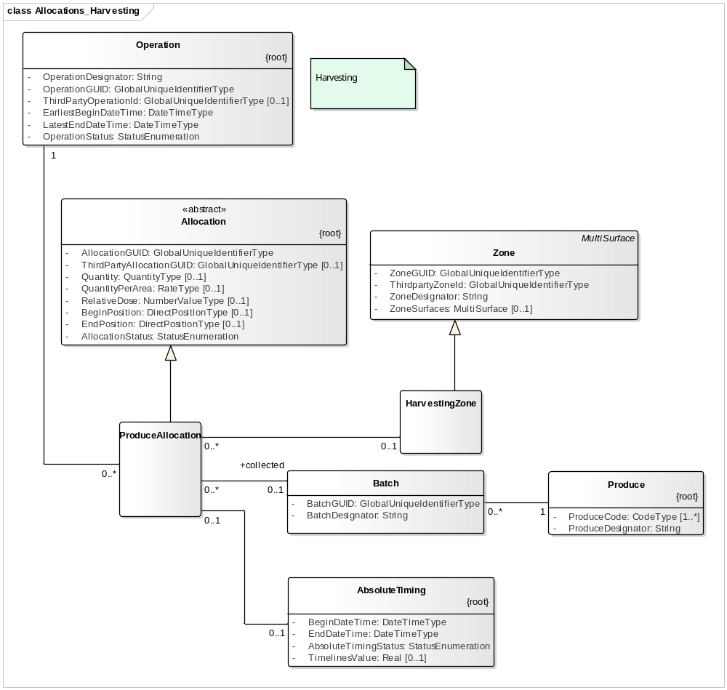
Figure 2. ProduceAllocation in the context of harvesting.

Applications on Crops.
An Operation which applies products (fertlizers, seed, plant protection products, etc.) is specified for a CropField and after planning for an ActivityField.
An Operation of this type has one or more time windows, AbsoluteTiming, for which the amount of product to apply is specified for each treatment zone, the ProductFieldApplications. Each AbsoluteTiming can have a specific ProductFieldApplication. In case of precision Agriculture there are different TreatmentZones for which a different ProductFieldApplication can be specified. (A CropField and ActivityField has always at least one TreatmentZone).
The ProductFieldApplication specifies the QuantityPerArea and refers to either a Product or to a particular (source) Batch of a Product. (Realize that the Quantity attribute of the super class Allocation is in this case a derived variable which must be calculated from each QuantityPerArea for each TreatmentZone and the amount of overlap which depends on the capabilities of the application equipment) A Batch will often be the case when applying manure, such that the mineral content of that Batch can be accounted for. (It is possible to specify which BatchLot of a Plant Protection product is used).
An Operation can also have more ProductAllocations to account for differences in rate depending on the time of application. A clear case is Phytophthora control in potatoes, where the type of product to apply differs for the timing of the application, but also in the case of irrigation and to a lesser extend fertilizer application, the quantities to apply might differ for the time of application. In AbsoluteTiming, the AbsoluteTimingStatus attribute with the value PROPOSED_CHOICE can be used for that.
TODO Look for a construct to specify between which possibilities a PROPOSED_CHOICE must be made.

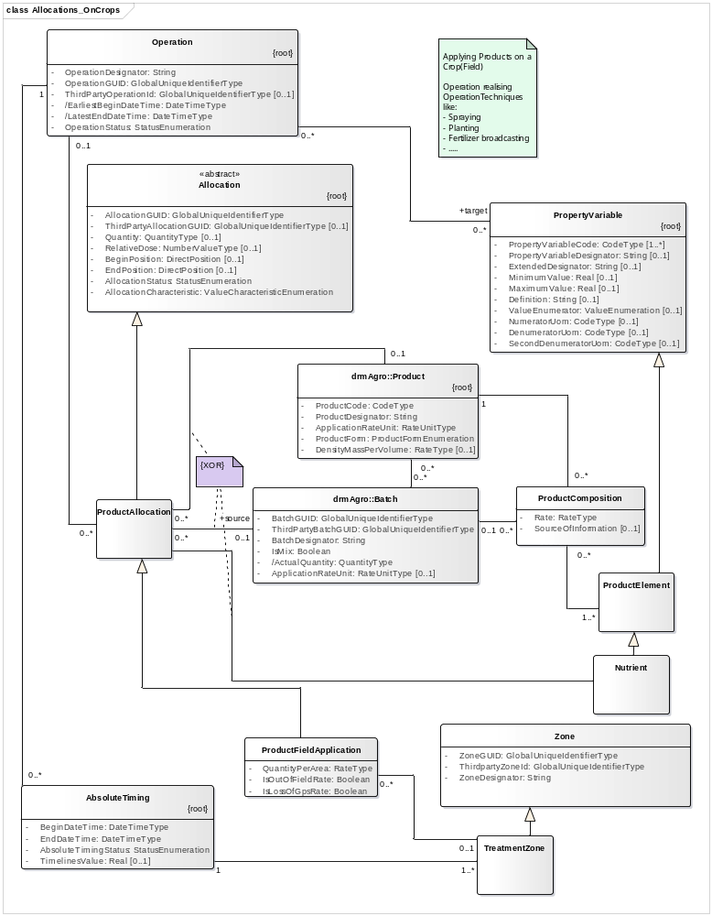
Figure 3. ProductAllocation in the context of application of products on a CropField or an ActivityField.

Aggregating Lots
There are products for the retail market which can only be produced by assembling from different sources. An example are the packages with three colors paprika and mixed bouquets of flowers. Another clear example are farmers or cooperatives that blend fertilizers to a specific specification. Another example is that a trader can only deliver an order when he combines products from two different sources. In all these cases products or produce is used from a Batch, i.e. the source Batch. The result is the aggregated Batch.
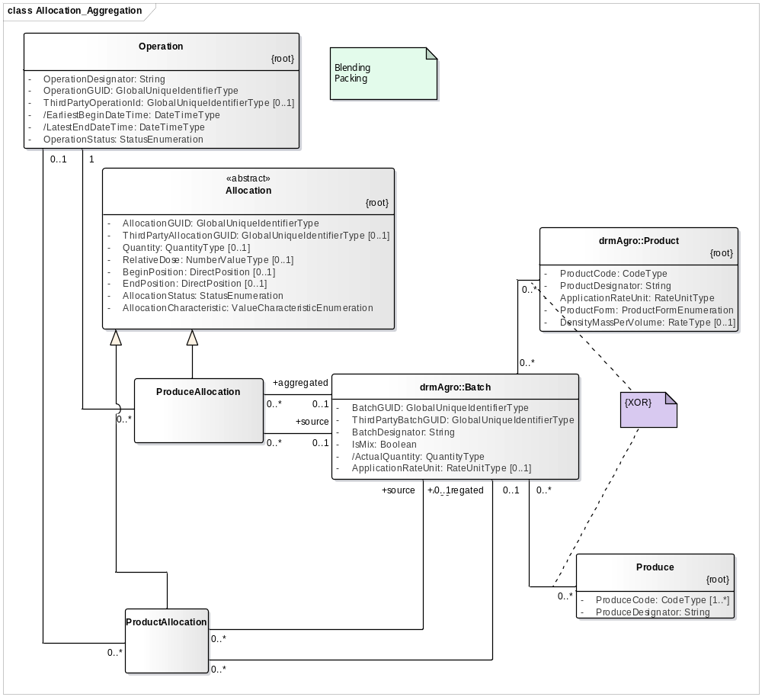
Figure 4. Poduce- and ProductAllocation when assembling new Batch’s.

Sorting Produce
Batches of produce can be sorted in different ProduceQualityClass’es. In such a case each ProduceAllocation defines one source BatchLot and one splitted BatchLot. Sorting leads to at least two different BatchLots, and a sorting operation has therefore at least two ProduceAllocations.
It looks logical to have a multiplicity of 2..* on the splitted BatchLot side, but when we want to keep track of the quantities coming from a source and going to a particular splitted BatchLot, we need for each splitted BatchLot a ProduceAllocation, as this class specifies the quantity.

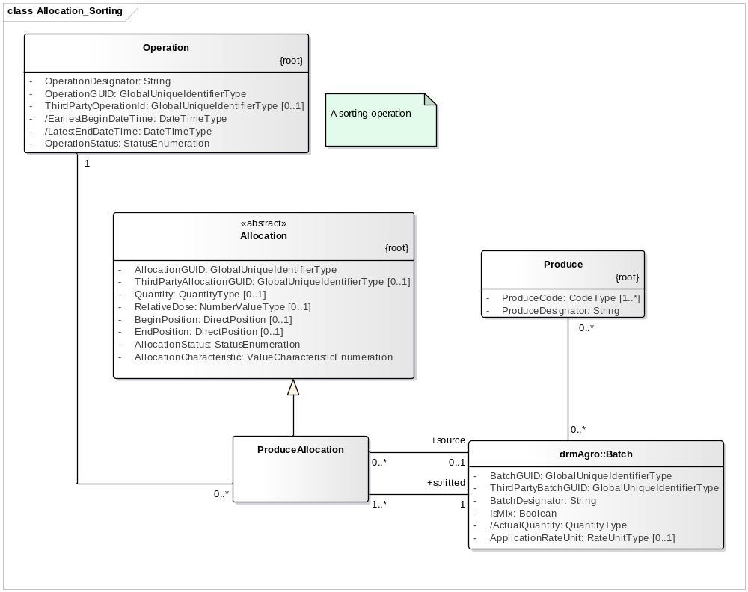
Figure 5. ProduceAllocation when sorting or splitting batches.

Application of Products on Batch’es of Produce.
When products are stored, operations are carried out on the storage facilities (or containers) which hold the BatchLot’s. These operations can control environmental variables like temperature and humidity, but there are also operations which add products to the Produce. An example is germination retarding products in potatoes, but also pesticides can be added to prevent pests. Another example is adding a conservation product to grass because it is too wet during harvest.
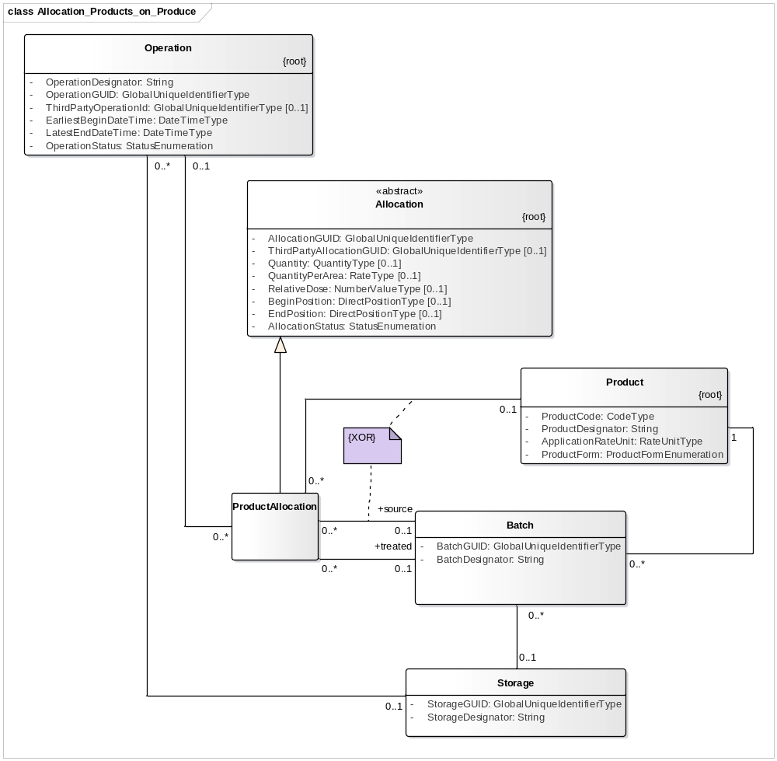
Figure 6. Application of Products on a Batch.

Analyses and sampling

Sampling
There are four types of samples recognized; soil samples, tissue samples, produce samples and product samples. Soil samples are collected from a particular vertical layer. One or more vertical layers form a profile. The profile has a position in space.
Tissue samples can be taken from growing crops (the possibility to take them from animals is not considered yet for this reference model). Also Produce samples can be taken from crops when it is intended to have a pre harvest analyses from those parts that will become Produce. Produce samples can also be taken from BatchLots of produce and ProductSamples only from BatchLots. An example of the latter is a sample from manure.
Samples on crops or on vertical layers as part of profiles can be taken either from one point, or from a collection of points or from a TreatmentZone. As an ActivityField and a CropField have always at least one TreatmentZone, this covers also sampling whole fields.
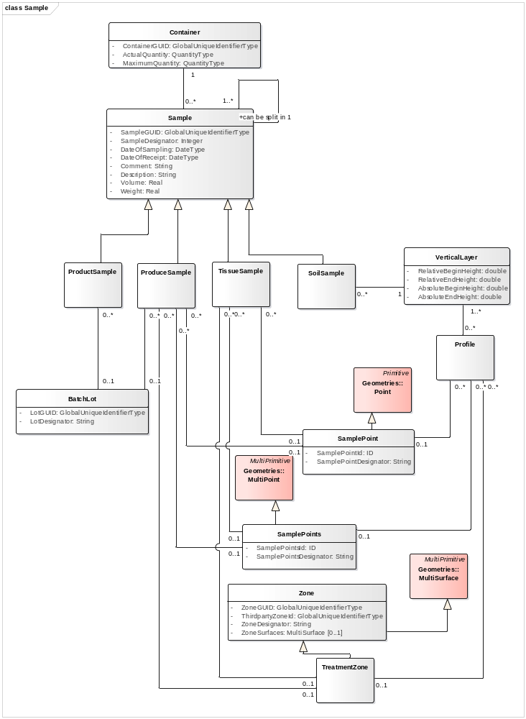
Figure 7. Different categories of samples and where they can be taken from.
Samples are collected in containers, which apart from conditioning of the sample and keeping it together plays an important role in identification of the sample. It is either the place to hold a sample id, or it has its own id which in the latter case must have a time indication to connect it to a particular sample.
Collection of samples is an Operation and has like other Operations also OperationTechniques. Manual sampling can for example be distinguished from sampling with a quad. By assigning the sampling operation to a Task it is possible to specify the Worker and participating equipment.
Samples can also be split. It is not uncommon to separate a part of a sample for biological soil analyses (nematodes) and send it to another laboratory for chemical analyses.

Analyses of Samples.
Samples are analysed and in this reference model it is assumed that this is done by a laboratory which has an accreditation (certificate).
The result of an analyses is a propertyvalue of a particular PropertyVariable. A number of specific PropertyVariables are shown as subclasses from PropertyVariable in Figure 7. In tracking and tracing the substance which is a generic expression used for active ingredients of PlasntProtectionProducts, plays an important role as Produce is restricted to certain levels of residue.

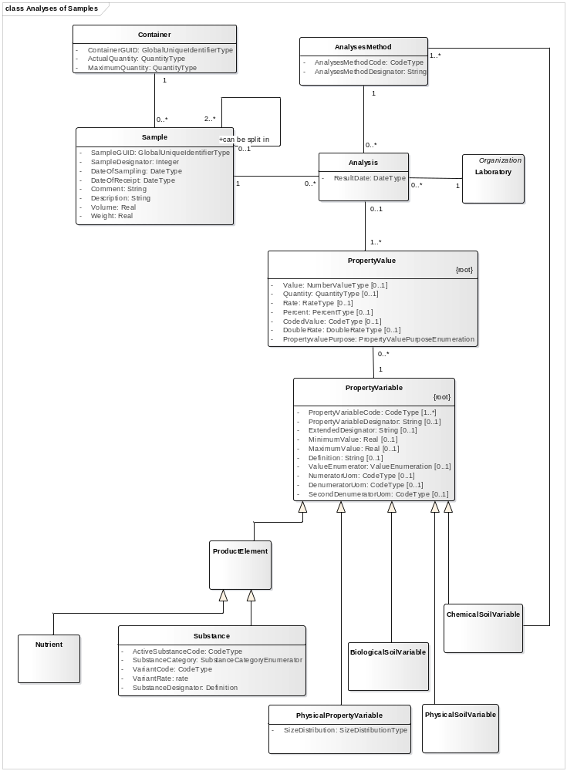
Figure 8. Analyses of samples.

BatchLot and Delivery
The class BatchLot is essential in tracking and tracing. When products are delivered to a retailers it is a requirement that the Lot is identified on a specific category of packages.
The difference between Batch and Lot in the agricultural production chain is not clear defined and as long as that is not the case there is no difference made between Batch and Lot. The class BatchLot is used. It is defined as a specific identified number or quantity of a Product or Produce.
When products are delivered to a customer which can be an intermediary (trader, processor, and packer) or a retailer, one or more BatchLots are delivered conform the order of the customer.
The pattern is shown in Figure 1.
TODO Add attributes to Order issue: A Customer can also be a Person. How to deal with multiple inheritance?d Delivery.

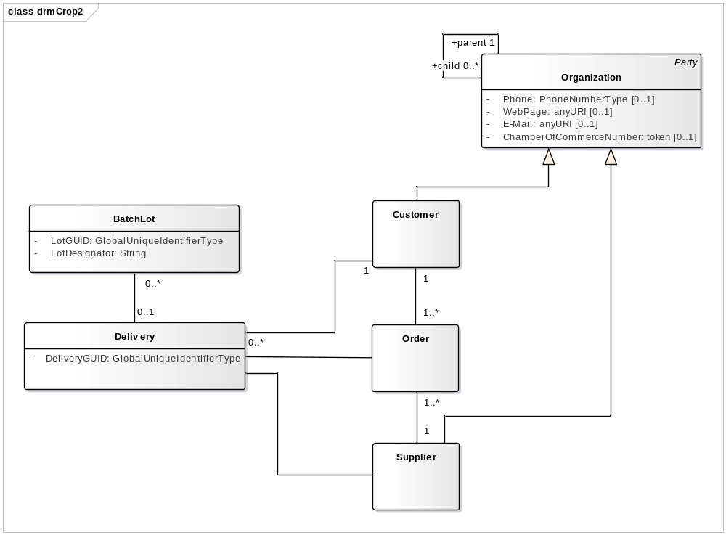
Figure 9. Pattern for Delivery and BatchLot.
Tracing back to the source of a Product is possible by defining allocations. See 9.1 for further details.

Certificates
An analyses is made of a number of certificates that are used in Agriculture. Up to now those certificates are explicitly modelled in the reference model as they have a quit different structure. The only attribute in common is the Designator, and likely the number can also be brought to a common attribute.
TODO: Issuing and reviewing of certificates must be worked out.
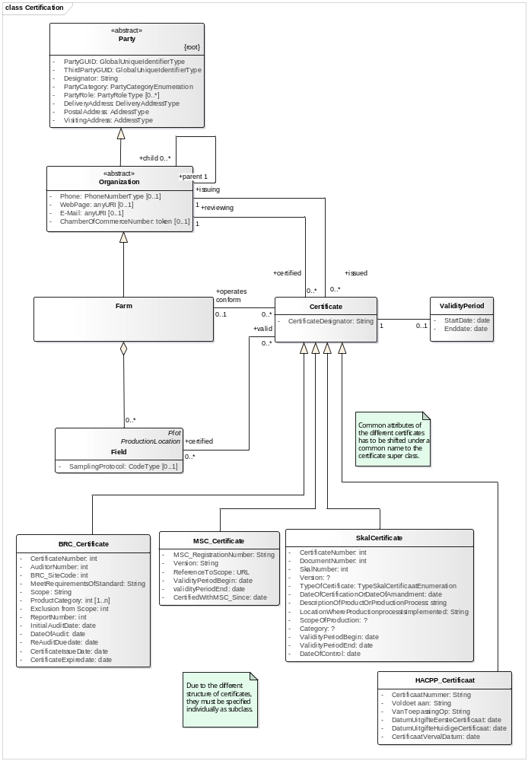

Composition and Substance
For a number of products or Produce it is required that their composition is specified. At this moment two Patterns are developed. ProductElement is developed in drmCrop, while Substance comes from the Plant Protection Product data dictionary.
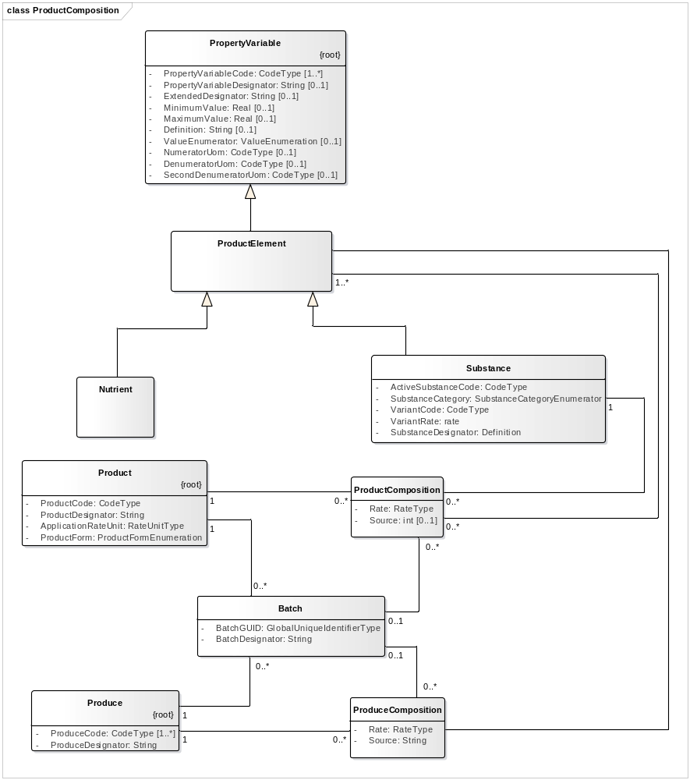

CropProductionUnit

Crop Production unit is still in the reference model as a heritance of “Teelt” from IMOT. There are two arguments to maintain it in the reference model.
- There are farmers who want to aggregate different fields so they can use the same prescriptions for the different fields as they have properties in common. The definition of CropField, in line with rules from the EU does not allow to treat surfaces which are not continuous, i.e. more then one Polygon, as one CropField. CropProductionUnit facilitates to group more CropFields together.
- Activities on a CropProductionUnit can extend the time that it is grown on a field. Sometimes work on a BatchLot of planting material is for a particular CropProductionUnit, and after harvesting also storage, drying, sorting on BatchLot’s of Produce can be assigned to a particular CropProductionUnit.

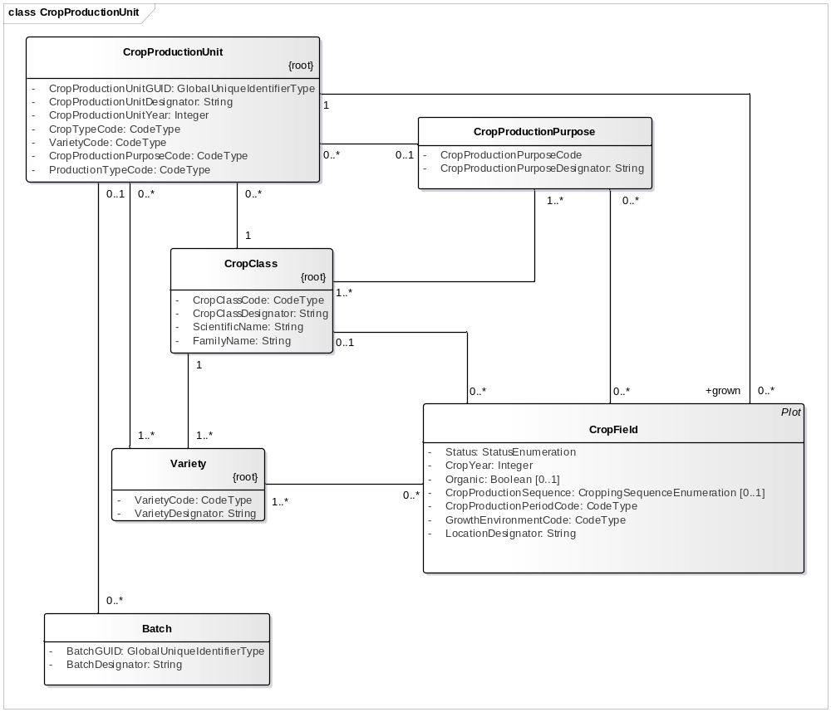
Figure 10. CropProductionUnit

Geometries.

Background
Geometries used in rmAgro reflect as much as possible the set of ISO standards defined by TC211. The most important one is ISO19107, describing basic geometries. ISO19107 is described as an interface model. GML is claimed to be the XML representation of ISO19107, but a more detailed comparison shows some differences, which makes it complicated to establish a common, platform independent model.
The Geometry described in rmAgro reflects ISO19107, and the mapping to GML is specified separately. The Geometry package in rmAgro is not transformed to an Java interface and an XML model. As java interface the ISO19107 interfaces can be used. Geotools or GeotoolKit provide implementation code for thos interfaces. As XML the GML specification can be used.

Basic geometry classes.

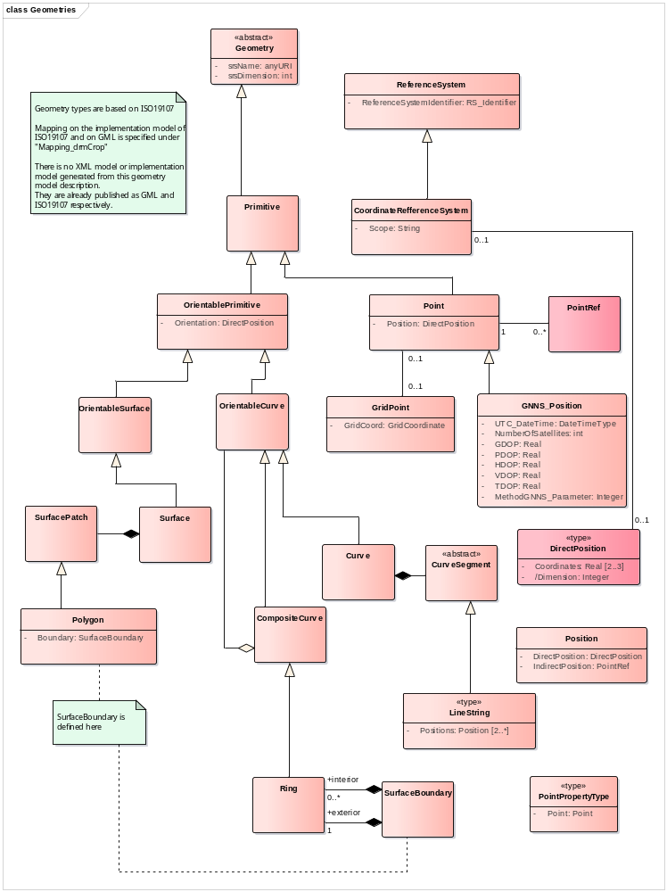
Point (LOS PROBLEEM MET 4E KOP OP)
The most basic geometry is Point, which is described by a DirectPosition with either two or three coordinates. A subclass of Point specified for rmAgro is GNNS_Position. These are Points, which positions are measured with a GNNS receiver and hold attributes which provide information on the time and conditions under which this position is determined.
LineString
A LineString is described by a series of Positions, with linear interpolation between the succeeding Positions. A Position is either described by a DirectPosition (see Point) or by a reference to a Point, PointRef. The latter possibility is important to guarantee consistency when a particular Point is used in more than one LineStrings which shares the Point. This is for example the case where the PlotSurface of a Field is divided in two or more CropFields. Two adjacent CropFields will share at least two Points.

Guidance and Tracks.
Tractor and or implement guidance on agricultural fields is by nearly all implementations based on guidance reference lines, often called AB lines. ISO11783 distinguishes five different types of guidance reference lines; AB, Curve, A+, Pivot and Spiral. In drmAgro they are GuidanceAB_Line, GuidanceCurve, GuidanceA_PlusLine, GuidancePivot and GuidanceSpiral.
Each TaskCategory has for a particular ActivityField a TrackPlan (GuidanceGroup in ISO11783). This TrackPlan can be shared by different TaskCategories which have an identical working width. As TaskCategory is not supported by most TaskControllers, a TrackPlan must be connected to a Task itself.
A TrackPlan can be based on two different approaches: 1) based on a number of GuidanceReferences or 2) based on a number of tracks.

TrackPlan based on GuidanceReferences.
A TrackPlan based on GuidanceReferences has a TrackPattern for each GuidanceReference.
The TrackPattern can have an offset to the left or to the right for the first/nearest Track. This offset will be 0.0 m. when the first Track itself is used as AB line. When the AB line corresponds with a FieldSide, the offset will be half of the EffectiveWorkingWidth of the used Equipment. (DG 2017: I am not sure whether an offset is supported by all guidance systems on the market). A TrackPlan is valid for a particular ManMachineSystem, as that determines the EffectiveWorkingWidth. As ISO11783 does not support ManMachineSystem up to version 4, the TrackPlan has to be connected to the Task in mapping drmAgro on ISO11783. The extent to which a TrackPattern will continue from the GuidanceReference onwards is either defined by the number of tracks to drive, or by a BoundingSurface

TrackPlan based on Tracks.
A TrackPlan can also be based on a collection of Tracks, which are either computed by an application, or logged during a previous Task. In that case each Track is described by the Curve. An ActivityField can also have a TrackPlan with Tracks that have no geographical specification. This can be the case in situations where more than one ManMachineSystem work on the same ActivityField and wants to communicate to each other which Track is already worked by one ManMachineSystem, such that the other knows it should not be worked twice. It can also be useful in case of a single ManMachineSystem when work is interrupted, so it is known when work is continued which tracks are already covered.

Additional information on TrackPlans
Both, TrackPlan (based on Tracks) as a GuidanceReference can have a GuidanceShift, which can be caused by continental drift and/or eventual other factors. This Shift will be determined at a certain moment and one can eventually specify a period for which the shift is assumed to be a correct estimate.
It is assumed that a TrackPlan is based on one GNNS_BaseStation to correct the GNNS receivers on the equipment. The GNNS_BaseStation is identified and Designated and has a Position (There can be different Positions in different coordinate Systems).
Both, GuidanceReference’s and Track’s are part of a GeometrySet for which an estimation of the PositioningQuality can be determined.
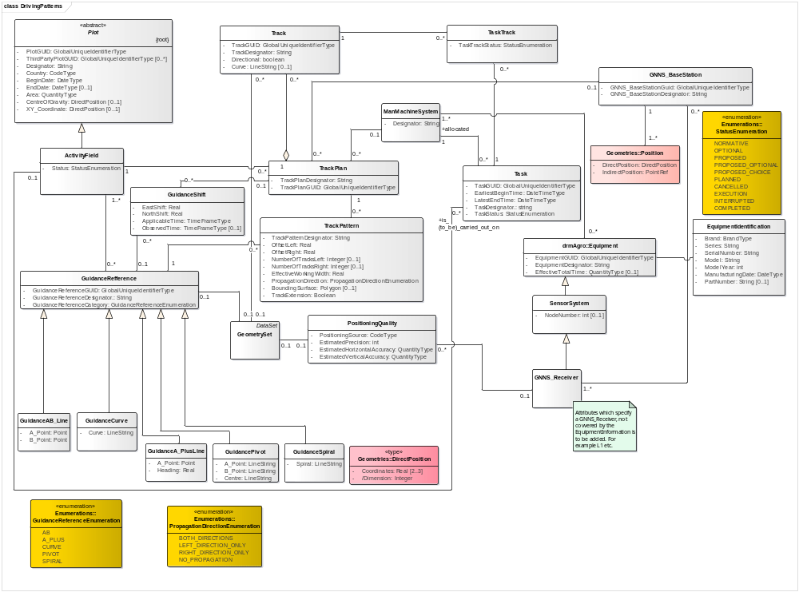

Job Task Operation

Operation
From an agronomical point of view, certain activities are to be performed on crops growing on a field, or sometimes also on batches or Lots of product (for example seed potatoes) or stored produce (grain in a silo). Also repair and maintenance activities on equipment and buildings are Operation’s.
Such an activity with an agronomical purpose to be performed on a certain object (Field, Batch, ) in a certain time period is called an Operation.
Definition.
An Operation performs a particular OperationTechnique on a particular CropField, ActivityField, CropProductionUnit or BatchLot to realize a certain CulturalPractise.
REMARK. Repair and maintenance activities of machinery and buildings and activities around animal husbandry can also be called operations. In that sense the definition will be extended to more objects and more purposes apart from CulturalPractise.

CulturalPractice
The agronomical purpose (objective) of the Operation is called a CulturalPractise.

It is not sure whether CulturalPractise’s can be standardized internationally. From one side they are quite common for arable farming and forage production all over the world, on the other side it is difficult to foresee all different regional situations and especially the level of required detail might differ. AgroConnect CodeLists CL291 and CL293 are an effort to standardise CulturalPractises on two levels of detail.
The need for a relatively short list of standardized CulturalPractice’s might come from processors that need information on how the crop is grown for evaluation or for a certification authority. A solution could be that a farm management system leaves it open for the farm manager to define the CulturalPractice’s. The farmer specifies the code and the coding list of the CulturalPractice’s which are required by his processors or certification authorities. In that way it can be adapted on the local situation. (A problem might arise when different party’s require a different structuring/categorization of CulturalPractices.) Maybe it is possible to come to a national standard list for CulturalPractices.
Operations are even much more region-, farm-, crop-, season- and time- specific. The CulturalPractice “Stubble tillage” can for example be realized by two operations “Chisel ploughing” (in Dutch “vaste tand cultivateren”) followed by “stubble ploughing”. (In Dutch “stoppel ploegen”). Operations that realize the Cultural Practice “Fertilizer application” can be: “phosphate fertilization”, “first nitrogen application”, “second nitrogen application”,” third nitrogen application”, “potassium application”, etc. The Cultural practice “disease control” in potatoes will have such a large number of operations called “phytophthora spraying” that a farmer might even not take the effort to give them a distinguished Designator, while they are all different Operations, with a different time period (and have therefore a different Id).
It is impossible to have a standardized coding list for Operations. They are instances of an activity following an OperationTechnique with a certain purpose (CulturalPractise) on a certain object in a certain time period. The consequence is that a farm management system should give the farm manager (or advisor) the possibility to define Operations, which are linked to an eventually standardized “CulturalPractice” and performed following a standardized OperationTechnique. (See further on.) A TaskController on a tractor can show the designator for the Operation, which has a meaning for the driver, but has no meaning for the TaskController itself. (For the TaskController it gets a meaning by the link to the standardized OperationTechnique)

OperationTechnique
CulturalPractices, and as a consequence Operations, can be performed by different OperationTechniques. As example: fertilizers can be broadcasted or side banded. Planting of seeds can be done as broadcasting, drilling or precession planting. The OperationTechnique’s must be internationally coded and well defined because it must be known which implements are able to perform these OperationTechnique’s, and TaskControllers commanding those implements must know which implement are able to perform that technique. A proposed standard list of OperationTechniques is CL292 from AgroConnect.
The farm manager is responsible that he has each of his CulturalPractice’s connected to one or more OperationTechnique’s. This is the list OperationTechniqueCulturalPractice, which is part of his Farm management System. (That can be his selection of the junction table of Appendix I) When specifying an Operation he will first choose the CulturalPractice to fulfill and then he can choose the OperationTechnique to specify how this Operation should be carried out. The part of the decision support system that is responsible for resource scheduling has the information on which implements are able to perform the Operation following the specified OperationTechnique, as Implements must have a list of one or more supported OperationTechniques. This requires a junction table Implement (Device in ISO11783) - OperationTechnique. An example of a list of Implements is provided in Appendix III and the junction table of the implements with the OperationTechniques in Appendix IV. Some Decision Support Systems that advise on the amount of inputs to use might also want information on the OperationTechnique, as the efficiency of an input can differ due to the chosen technique. Side banding of phosphate for corn is for example more efficient then broadcasting phosphate and an advice might differ in the amount depending of the applied OperationTechnique. A possible list of OperationTechnique’s which can realize certain CulturalPractices is given by AgroConnect.

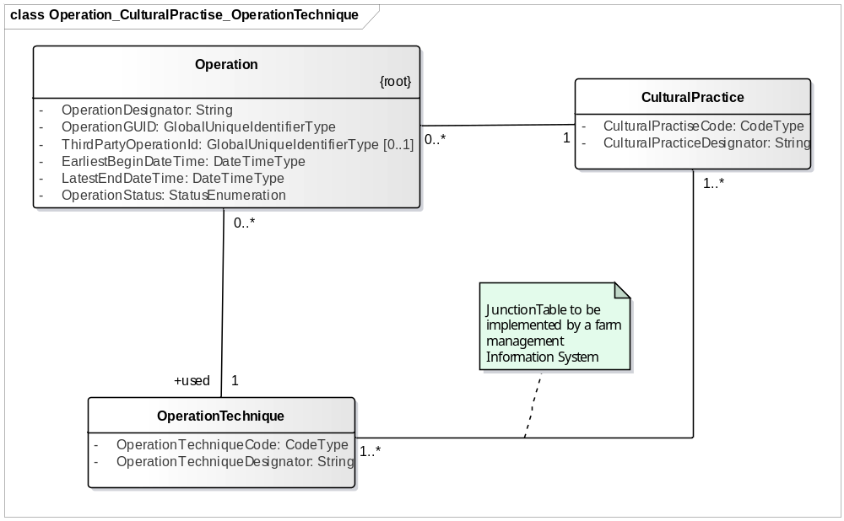
Figure 11.

Task.
Operations are seen from an agronomical point of view. Those Operations are to be performed by man and/or machinery. The execution of an Operation by man and/or machinery is called a Task.
Definition.
A Task is the execution of one or more Operation's.

Remark.
An Operation can be executed by more Tasks.(See example below). Therefore, there is a many to many relation between Task and Operation.

Example.
There is one Task "Harrowing and Drilling", which performs two Operation's; one is "Harrowing" and the other is "Drilling".
On the other hand, there can be two Task's that realize one Operation. For example two combines harvesting on one ActivityField.
It is possible that one Operation is realized by two different combinations of man and machinery. An example is combine harvesting, where one Operation called “Combine harvesting of wheat behind the barn” must be realized within a certain time period by two combines, each with a driver.
Another situation is where two different Operation’s, which realize different CulturalPractise’s are realized at the same time with one combination of men and machinery. An example is the Operation “seedbedpreparation on Over de Weg” which is combined with the Operation “wheat drilling on Over de Weg”, by a combination of a driver, a tractor, a rotary harrow and a drill mounted on the rotary harrow.

The consequence is that an Operation can be performed by two Task’s (the combine example) and that a Task can perform two Operation’s (the harrowing drilling example). The drmCrop reference model specifies this as a many to many relation, which will require that the farm management System has a junction table.
Problems that arise by creating yield maps when two combines worked on the same field can be caused by not realizing that there is one Operation, harvesting, performed by two Tasks. When there is defined that the Operation is performed by two Task’s, in the junction table TaskOperation, there is a control that yield maps logged under those two tasks must be combined to realize the complete map for the Operation.
A combination of man and machine executing a Task is called a ManMachineSystem. A ManMachineSystem can be defined as man and machinery which are “physically connected”. An example is a tractor with an implement and a driver. The practical reason to distinguish a ManMachineSystem is that it, normally speaking, will be controlled by one TaskController.

TaskCategory
As a Task is (part of) one or more Operations performed on a particular ActivityField in a particular time period, there is a need for a TaskCategory class to define the kind/type of Tasks which can be performed by the available equipment and that are relevant for the farm. As there is a large number of combination of implements possible and farmers will be very inventive in new efficient ways of working, it makes little sense to compile a standardized list of coded TaskCategories. There should be a possibility for a farmer to define his TaskCategories. An example of a list of Taskcategories is given below.
TODO Check example with latest version of CL292.
TaskCategory OperationTechnique(s)
Stubble ploughing Stubble moldboard plowing
Ploughing Moldboard ploughing
Seedbed preparation Rotary harrowing
Grain Drilling Drilling
Drill combination Rotary harrowing + Drilling
Granulate application Drilling
Planter combination Rotary harrowing + Potato planting + Full field granulate application + Band granulate application
Spraying full field spraying
Spraying and transport Full field spraying + water transport by sprayer
Potato ridging ridging
Fertilizer application Broadcasting
Manure application Injection
Baling Square baling
Combining Combining
Forage chopping Forage chopping
Sugar beet harvesting sugar beet lifting + Sugar beet topping + Sugar beet loading
Potato harvesting Potato leaf chopping + Potato lifting + Potato loading
Water transport water transport by tankwagon.
Grain Transport Transporting grain
Sugar beet Transport Transporting rootcrops
Potato Transport Transporting rootcrops
Bale loading Loading bales
Bale transport Transporting bales

Job
A job is the work executed by one ManMachineSystem, or a number of ManMachineSystem’s which work organisationally together. An example is one ManMachineSystem consisting of one combine harvester and a driver, working together with a number of other transport ManMachineSystem’s who each exist of a driver, a tractor and a trailer (grain cart).
In resource planning it is relevant to formulate Job’s, as it must be guaranteed that the resources (men, tractors and implements) required to perform the Job are available in the same time period and are not assigned to other Job’s in that period. Formulation of JobCategories, which specify the TaskCategories that can be combined in a Job and the resources which can form a Job is required for efficient Job formulation. Estimation of the required time to execute a Job is determined by the resources which form the ManMachineSystem’s that realize the Job and their way of operating (as example the size of grain carts and unloading during combining or unloading at the headland). Some examples of JobCategories based on the available resources are given below.
During execution of a Job it might be relevant to have a form of Job control. In a case of silage maize harvesting it is relevant to adjust the number of transport units, based on idle time of either the chopper or of the transport units.
The relation between Job and Task is quit straightforward; A Job exists of one or more Task’s.
Example of Job Categories. TODO Formulate task categories in this example.

JobCategory Resource.
Grain drilling Worker 1
Green tractor
Grain drill
Wagon 6 m old
Potato harvesting with two transport units Worker 1
Worker 2
Worker3
Worker4
Big Green tractor
Blue tractor
Green tractor
Potato harvester
Tipping trailer 7 ton
Tipping trailer 9 ton
Potato Hopper
Conveyer

Potato harvesting with one transport units Worker 1
Worker 2
Worker3
Big Green tractor
Blue tractor
Potato harvester
Tipping trailer 9 ton
Potato Hopper
Conveyer

Organizations

An Organization is a group of people, a company (enterprise) or a group of companies (Enterprises), which, as subclass of Party has a legal connotation.
Organization is an abstract class which requires other classes for implementation. In drmCrop a number of classes are defined which implement an organization. These classes are shown in Figure 11 and the definitions of those classes are shown in the textbox below.
The defined organizations represent the roles which organizations can fulfil. Roles like buyer, seller, client, etc. are implicit for the defined organization and eventually mentioned in the relation they have with other organizations. In Figure 11 it is specified that a contractor is hired by a farmer and the farmer is a customer for the contractor. All possible relations between the different organisations will be further specified in further versions.

AdvisoryService.
Definition.
An Organization or department of an Organization which has as its activity to advise farmers.

AuditingOrganization.
Definition
An organization which acts as a third party and audits an organization whether it handles conform a certain certificate.
DISCUSSION.
IS THIS THE CORRECT EXPRESSION?

AgriculturalProductionOrganization? or Producer?
Definition.
An Organization which realizes agricultural production activities.

AnimalHolding
Definition.
An Animal Holding is part of an AgriculturalProductionOrganization located at a distinct geographic location, where animals are housed for production purposes.
Remark.
The location/complex is seen as one object from a phytosanitary point of view.
An AgriculturalProductionOrganization can have one or more AnimalHoldings.
An AnimalHolding is assumed to be operated as an independent unit and is as such also an Organization.
An AgriculturalProductionOrganization can have also other agricultural production activities like Farm or a GreenhouseComplex.
An animal Holding can, like a Farm, have Plots (Fields, CropFields. ActivityFields) to grow feed and graze animals.

Broker
Definition.
A Broker is an Organization which arranges a transaction between a seller and a buyer and receives a commission when the transaction is executed.
Remark.
A Broker is not the owner of the product, produce or equipment that is sold.

Contractor.
Definition.
An Organization that is hired to execute activities, i.e. Operation's and Task's and eventually Job's in behalf of another Organization.

Department.
Definition.
A group within an Organization which is responsible for specific businesses.

Farm
Description.
A Farm is part of an AgriculturalProductionOrganization located at a distinct geographic location with the objective to produce crops.
Remark.
An AgriculturalProductionOrganization can have one or more Farms.
A farm is assumed to be operated as an independent unit and is as such also an Organization.
An AgriculturalProductionOrganization can have also other agricultural production activities like greenhouse crop production or an animal holding.

GreenHouseComplex
Definition.
A GreenHouseComplex is one or a collection of more GreenHouses within a distinct geographic location.
Remark.
The GreenHouses of a GreenHouseComplex will in most cases share facilities like heating.
A GreenHouseComplex is assumed to be operated as an independent unit and is as such also an Organization.
An AgriculturalProductionOrganization can have one or more GreenHouseComplexes.
An AgriculturalProductionOrganization can have also other agricultural production activities like a farm or an animal holding.

IssuingAuthority
Definition.
An organization which issues certificates.
DISCUSSION.
IS THIS THE CORRECT EXPRESSION?

Laboratory
Definition.
An organization which analyses samples to determine the value of property variables of those samples.

Manufacturer.
Definition.
An organization which manufacturers products or equipment.

Processor.
Description.
A Processor is an Organization which processes Produce from a Farm.
Example:
Sugar factory.

Retailer.
Definition.
An organization which sells directly to the end consumer.

ServiceProvider
Description.
A ServiceProvider is ( a Department of ) an Organization which provides services around agricultural production processes.
Remark.
An enterprise which performs Operation 's for a Farm is a Contractor and not a ServiceProvider.
An activity of a service provider on an ActivityField, like for example measuring crop reflection, is still called an Operation.
Example.
A general agricultural advisory service
an accountant
a soil surveying company
an advisory service (is specifically defined as subclass)
a laboratory (is specifically defined as subclass)
a provider of remote sensing data.

StandardizationAgency.
Description.
An Organization which is responsible for the establishment, maintenance and publication of standards and standard coding lists.
Remark.
The standardization Organization should be specified up to the level where responsible persons, Department's or working groups can be identified. For example not ISO, but ISO/TC23/SC19/WG1)

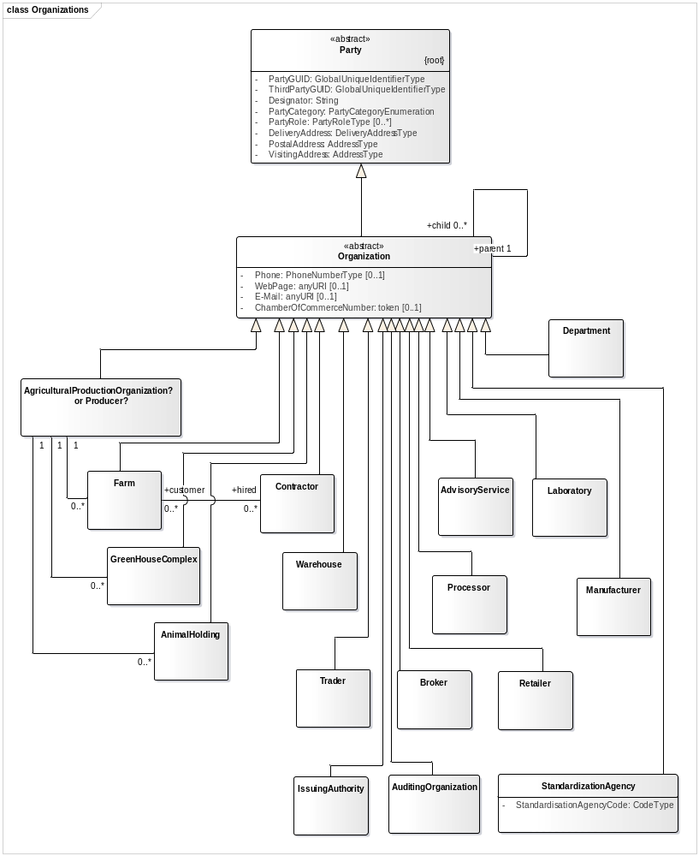
Trader.
Definition.
A Trader is an organization which buys and sells products, produce or equipment.
Remark.
This means that the trader owns the products, produce or equipment during a certain time period.
A trader deals with other businesses, BB, not with the end consumer. In the latter case it is a retailer.

Warehouse
Definition.
A warehouse is a complex that pro vides the service to store products and associated logistic activities like loading and unloading. Also cleaning, sorting and drying are activities that can be provided by a Warehouse.
Remark.
In the context of this reference model a Warehouse is seen as an organization that provides the service for third parties.
Figure 12. Organization and its defined subclasses.

Party, Organization and Person with addressing and contact info.

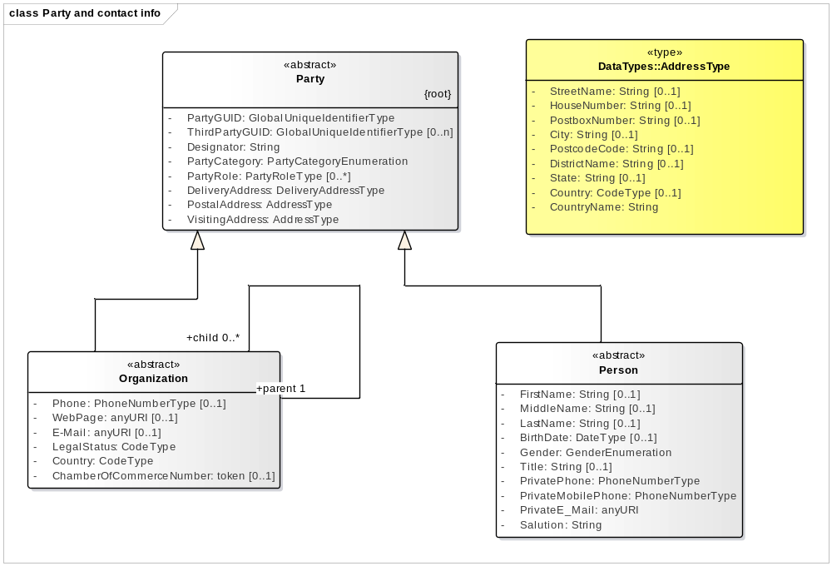

Party, Farm, GreenhouseComplex and AnimalHolding.

Party is the abstract root class of all entities that have a legal connotation in Business activities. drmAgro distinguishes two abstract subclasses; Organization and Person.
In analogy of Inspire, there is a Producer (Inspire’s Holding, ADAPTs Grower), which can realise its activities on one or more sites. The sites are represented by Farm, GreenhouseComplex, AnimalHolding in drmAgro. (More categories of sites may follow when the scope will be broadened ). Farm, GreenhouseComplex and AnimalHolding are subclass of Organization. Organization has a LegalStatus, so the status of the Producer, Farm, etc. can be specified. The reciprocal association of Organization allows for all kind of constructions to split risk. Country defines the country under which law the Legal status is registered.
Apart from Farm, GreenhouseComplex and AnimalHolding, operated by a Producer, some entities are specified like Contractor and Department. Different classes of service providers are discussed in ???? .
Each organisation or Department of an Organisation can have a Contact, which is a Person, that should be contacted in respect of specific activities.

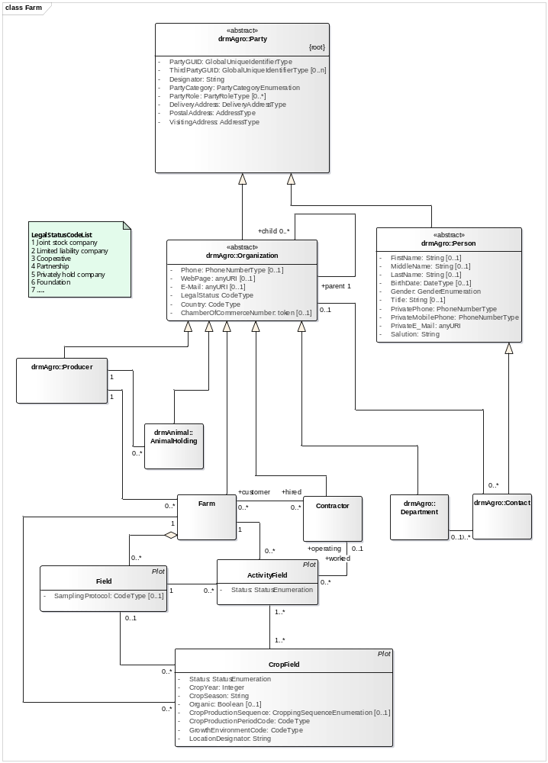
Figure 13. Party and some subclasses active in agricultural production.

Party and its subclasses.

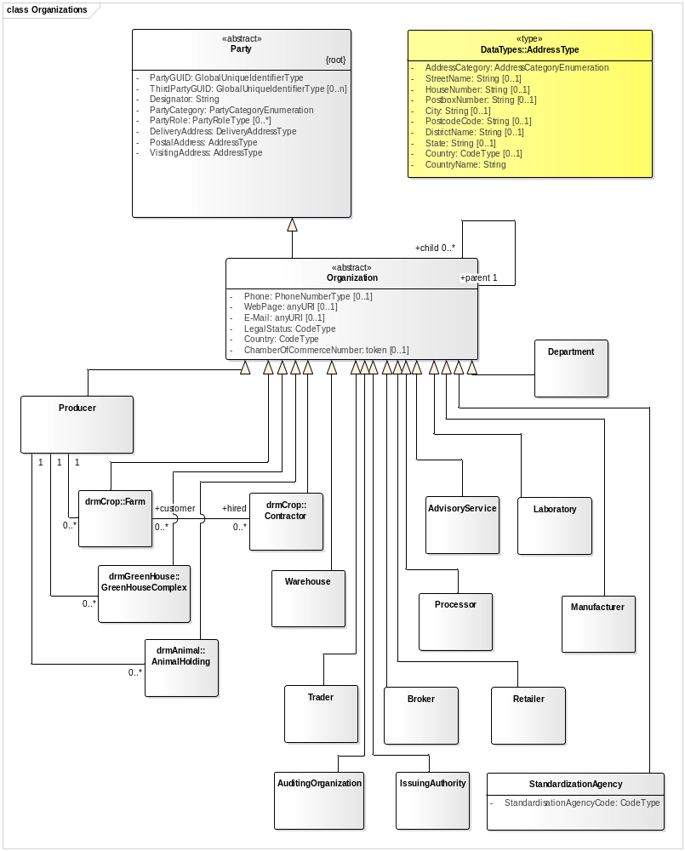

Plots and Fields.
Inspire refers to Plots which can be situated in other Plots. This allows for a lot of freedom to define different areas for CropProduction. In drmCrop is chosen to distinguish plots that have specific characteristics or have different purposes. All variables that the different categories of Plot have in common are specified in an abstract Object “Plot”, but this has to be implemented by a specific subclass. In Inspire, there is a reciprocating relation, but this is not implemented in drmAgro/drmCrop, as the relations are made specific for the different categories of plots.
All categories of plots in drmCrop are continuous surfaces, which means they are described by a single PlotSurface (which is a Polygon). The fact that PlotSurface and Plot have a many to many relation should not be misinterpreted as that it is allowed to describe it with more than one Polygon. The reason there can be two Polygons is that at a certain moment a more exact or more correct PlotSurface is determined. The old surface should be closed by defining an EndDate, which is not defined for the actual PlotSurface to use.
The same PlotSurface can be used for more Plot’s. When a complete Field is used for a single CropClass, the CropField for that season has the identical PlotSurface as the Field and also the ActivityFueld will share that PlotSurface. (see descriptions of Field, CropField and ActivityField below)
Field’s are the more or less permanent Plots which stay the same over more years, up to a moment that structural changes occur, like for example a road which is widened and making the Field smaller. Fields are bound by topographical objects like roads, ditches, stone walls, wooded banks, farm yards, etc. and by land of another owner or operator of that land.
From season to season one or more CropFields can be situated within a Field. A CropField is grown with one single CropClass and has a BeginDate and an EndDate. CropClass has CropYear as attribute and an optional CropSeason. In regions where more crops can be grown in one year it can for example be indicated with “small rainy season” or “large rainy season”.
An ActivityField is the continuous surface at which an Operation will be executed. In most cases that will be the exact surface of a corresponding CropField, but it can be that two adjacent CropFields, which are identified separately (for example because a difference in the QualityClass of seed potatoes) will in executing Operations be operated as one unit. It is also possible that an order is given to a contractor to operate only a part of a CropField. (For example sugarbeet harvesting in two separate periods of time)
A special category of Plot is a Greenhouse. It is equivalent to a Field in that sense that its surface will stay constant for a longer period of time. Like a Field, it is possible to locate one or more CropFields during the growing season in the Greenhouse. In the situation of CropFields in a Greenhouse, the restriction on a CropField of a continuous surface should be handled not too restrictive, as paths might separate surfaces, but it is left to the grower to neglect this. The requirement of one CropClass must be maintained, so surfaces separated by a path must be of the same CropClass when they are assigned to one CropField.
CadastralField is corresponding to the National registration systems and might have country specific subclasses. The border between cadastral fields will in many cases not be identical of that of Field’s.

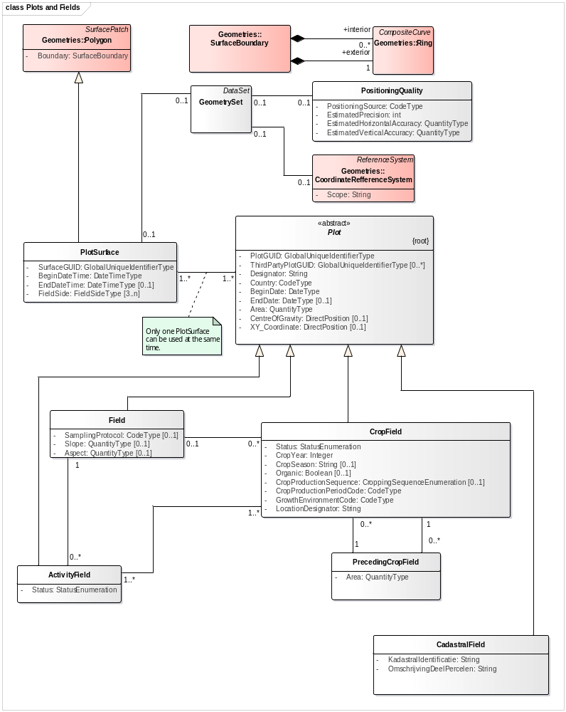
Figure 14. The different categories of Plot

Products and Produce
Products are the inputs for agricultural Production and Produce is the result.
Fertilizers, seed, planting material, irrigation water are among the products. Crops can produce one or more types of produce. A maize (corn) crop for example can produce whole crop silage, corn cob mix, kernels and fresh cobs. Tomatoes can be delivered in different grades and on a bunch or loose, wheat produces grain and straw.
Products can be worked out in more detail by subclasses, as can be seen by the example of Phytophthora fungicides.
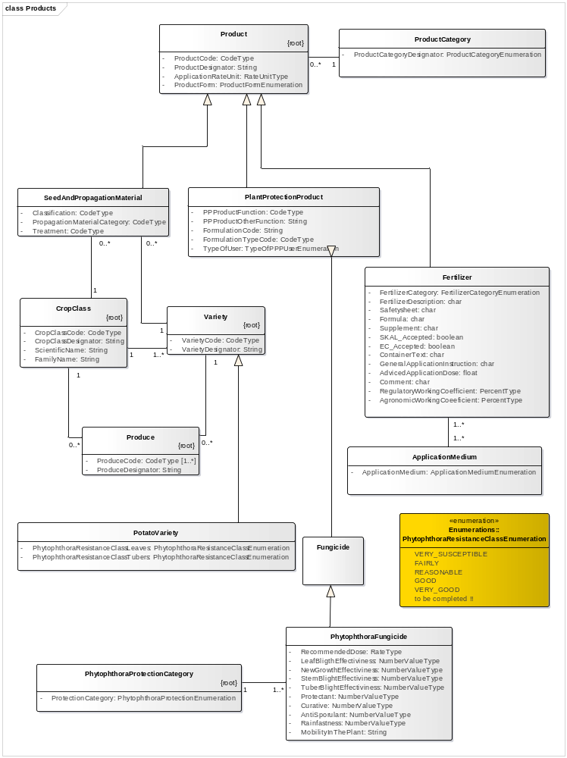
Figure 15. Products and Produce.

Values and Units
Will be worked out later

Zones

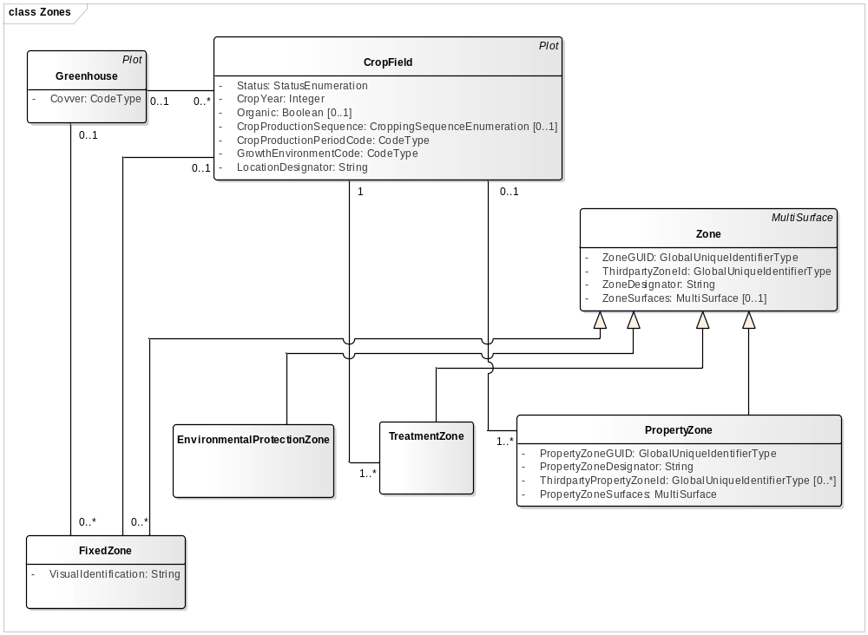
In a Greenhous it is possible to use a number of fixed zones to specify the surfaces of a CropField (or of a TreatmentZone. Ps the association is to be added)

Appendix II. Some use cases.

Potato chain.

From harvest onwards.
This part of the use case description starts at the moment of harvesting.

This proved to be difficult, as GML is not a one-to-one representation of ISO19107. See for example a SurfaceBoundary as element of a Polygon in ISO19107, which is not used in gml:Polygon.
This is a combination with a rotary harrow in the front, a full field granulate applicator which disposes in front of the harrow, a potato planter in the rear hitch with a granulate applicator mounted in the planter for application in the plant row (banding). This is a challenging combination; in one ActivityField two different operation techniques (full field and banding) are applied for one CulturalPractise (nematode control). So apart from an application rate, also an application method must be specified in treatment zones. This situation needs to be worked out. (a solution could be to define two different Operations, one for banding and one for full field application).

