**Real-Time Motion Tracking with IMU and Blender  
Project Template**

### **Objective**

Make a cannon in blender that can move around a sphere that uses the Arduino and the IMU circuit to provide real time motion tracking.

**Circuit Design**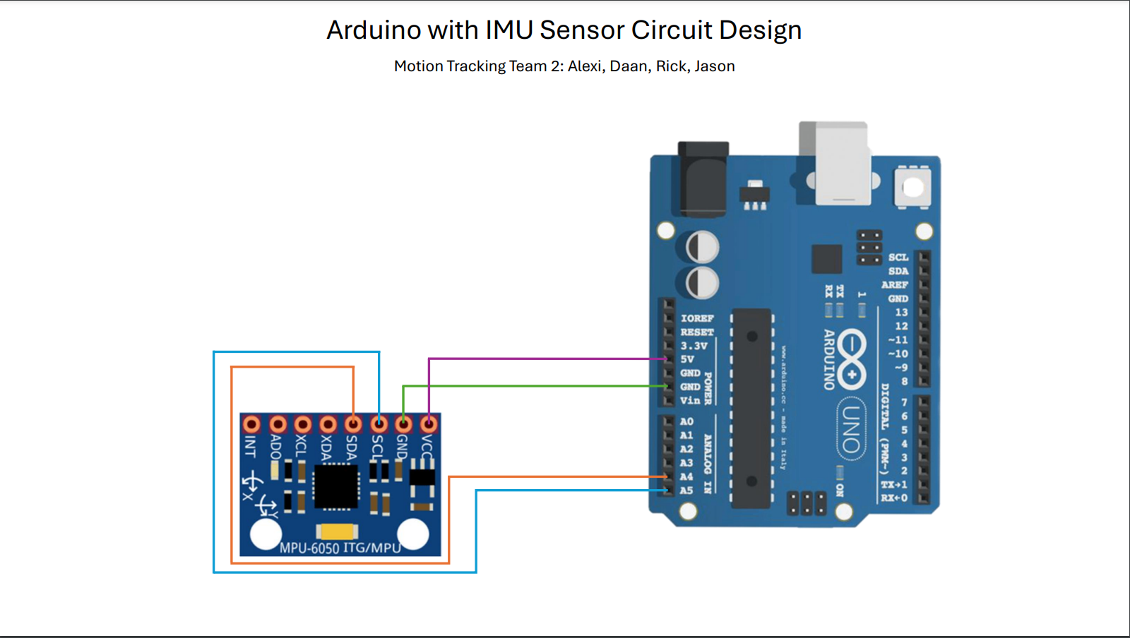

### **Timeline**

1. **Setup**
   * Created Arduino and IMU circuit, design shown above.
   * Creation of code for receiving understandable output (roll/pitch/yaw readings).
2. **Blender Integration**
   * Integrated IMU readings into Blender.
   * **Pipeline/Methodology**: A loop starts that catches the roll/pitch/yaw readings and turns them into radians to ensure that Blender can use this data correctly, after this they are assigned to the Euler angles and updates every 0.1 second, thus ensuring that movement is smooth and without much lag. This will keep going until you close blender or run a new code.
3. **3D Model Selection**
   * Started with basic models for testing.
   * Transitioned to a more complex idea of moving a cannon on an airship.
   * Model used: <https://sketchfab.com/3d-models/bowsers-airship-ed2c106a85c14ec69d18e5f9343ec83c>**.** Cannon was assembled using a simple rocket.

### **Reflection**

### **Rick:**

I got an error, so i could not import a package. I watched and helped Jason work on the real time tracking, and learned how to make the model move with the sensor.

### **Jason:**

### I learnt about the usage of Blender and IMU sensors. I already have some experience with designing a circuit so started with that, afterwards our group started with trying out some model movements with simple models. The main challenge was to actually get the code to work within blender, as I have no previous Blender experience and code integration first brought the problem of missing packages that are hard to install and then moved towards actually getting the model to move properly. If our group had more time, we would’ve focussed on getting a better model for the cannon and also giving the movement a limit so it can’t clip into the airship model in any way.

### **Daan:**

What I found interesting about this project is the fact we used Blender. I have never used it in my life and found it interesting the moment we began to work with it. I learned how to make a simple temple, a minecraft sword, how to make a pokeball and began practicing with it. I helped the team mostly with the Blender part of modeling and texturing. apart from that I did have a lot of challenges with the use of Blender, since I am still a beginner. Harder models are still really hard to make and I think I will need to improve on this part. I also learned a lot about our project. from the circuit board to the movement, even though it was really hard, it was fun to do nonetheless.

### **Alexi:**

I found this project really interesting, I learnt about how to use c++ to read input from an IMU sensor as well as how to setup the IMU sensor board. I also learnt some basics of lender su as how to import and rig a model to the sensor which was really interesting. I did experience some challenges with the packages, leading me to reinstall my python environment altogether and migrate my code into Blender(The code which receives input from the IMU sensor, with which Jason and Rick used to further improve it and make it work correctly with the 3D blender model Dan had designed. Overall I am happy with the results of what we have produced in this challenge!

### **Video Demonstration**

**Short Video**<https://edubuas-my.sharepoint.com/:v:/g/personal/232567_buas_nl/EfbfxXrGmnxGiFzSbrAy9mYBPth1hfSLHc5DFlP4_qZC2A?e=kZbsUT&nav=eyJyZWZlcnJhbEluZm8iOnsicmVmZXJyYWxBcHAiOiJTdHJlYW1XZWJBcHAiLCJyZWZlcnJhbFZpZXciOiJTaGFyZURpYWxvZy1MaW5rIiwicmVmZXJyYWxBcHBQbGF0Zm9ybSI6IldlYiIsInJlZmVycmFsTW9kZSI6InZpZXcifX0%3D>