IKPHBV – CoFight-19 Ideeën

Gezichtsmasker detecteren

Spel waarbij je ‘corona’s’ / bacteriën moet ontwijken & vaccins moet oppakken met je masker

Kleur van het masker detecteren en hier iets mee doen (kleur van levensbalk / levens)

Iets met ogen, knipperen = aanvallen?

Vaccinatie is ammunitie

5G zenders zijn eindbazen

Vaccinaties van Bill Gates maken je dood NIET OPPAKKEN

Muziek & soundeffects

Bacteriën slechte pngs lol iksdee

EyeToys (<https://www.youtube.com/watch?v=WAftpiUNY0E>)

Expressie ogen veranderen als je geraakt wordt (traantjes ☹)

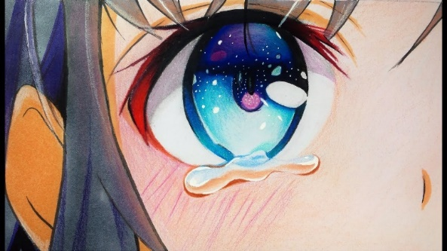

Pygame zero uitvogelen

<https://www.pygame.org/project/1111>

Mask detection linkies:

<https://towardsdatascience.com/my-quarantine-project-a-real-time-face-mask-detector-using-tensorflow-3e7c61a42c40>

<https://towardsdatascience.com/part-2-yet-another-face-mask-detector-opencv-spatial-ai-competition-journey-91dfaf96c6e8>

<https://github.com/ibaiGorordo/Social-Distance-Feedback-For-The-Blind/tree/master/Part%202%20-%20Mask%20Detection/Face%20Mask%20Detection%20Inference%20Comparison>

<https://towardsdatascience.com/covid-19-face-mask-detection-using-tensorflow-and-opencv-702dd833515b>

<https://www.pyimagesearch.com/2020/05/04/covid-19-face-mask-detector-with-opencv-keras-tensorflow-and-deep-learning/>

<https://www.mygreatlearning.com/blog/real-time-face-detection/#sh2>

**Bronnen**

SPACE INVADERS  
<https://github.com/russs123/space_invaders>

FACE DETECTOR & TRAINER  
<https://www.pyimagesearch.com/2020/05/04/covid-19-face-mask-detector-with-opencv-keras-tensorflow-and-deep-learning/>

PYGAME  
<https://www.pygame.org/docs/>

PYGAME-MENU  
<https://pygame-menu.readthedocs.io/en/3.5.5/>

EYE DROPPER COLOR PICKER  
<https://blog.electroica.com/eye-dropper-color-picker-tool-in-python-using-opencv/>

GRAPHICS  
<http://pixelatorapp.com/>  
<https://www.clipstudio.net/en/>  
<https://images.google.nl/>

MUZIEK

8-Bit March by Twin Musicom (Title screen)   
Powerup! by Jermey Blake (In-game music)