#CAOS – ASSIGNMENT -2
#SAAD AHMAD - 2018409

IPC MECHANISM USED:

UNIX Domain Socket – I have implemented the chat program using unix domain sockets. It allows bi-directional flow of data among processes on the same machine. To listen to multiple clients at once I have used the select() command to which I have passed an fd_set type which holds all the file descriptors which are currently connected to the server including the connection acception fd.
select() monitors all fd’s for read, this allows multiple clients to be handled on one server.

DIFFERENTIATING BETWWEN PUBLIC AND PRIVATE MESSAGES:

To differentiate between public and private messages, the client has to use @ symbol. For example, user0 sending a private to user1 would be “Hello there! @user1” (without the quotes). Every message that does not follow the above mentioned convention is considered to be a public message.
Whenever a public message is sent to the server, it loops through all the active socket descriptors to find the open ones except the one sending the message and sends the messages to them using the send() system call. The fds of open sockets is passed as a parameter to send().

ON THE CLIENT SIDE:

On the client side, I have created a thread (using pthread library) which keeps listening for incoming messages and the main process is used for writing messages. This program works as an echo server if the client sends private messages to itself.

ERRORS HANDLED:

1) Client trying to connect when server is not active – An error message is printed using perror and program exits.

2) Trying to send a message to a non-existing user throws and error.

HOW TO USE:

1) cd into the directory
2) run make
3) type ./startServer
4) open other terminals and cd into the directory and type ./startClient

REFERENCES:

http://beej.us/guide/bgipc/pdf/bgipc_USLetter.pdf

https://www.geeksforgeeks.org/socket-programming-in-cc-handling-multiple-clients-on-server-without-multi-threading/

SAMPLE TEST RUNS:

1) using make command and starting server on upper-left terminal

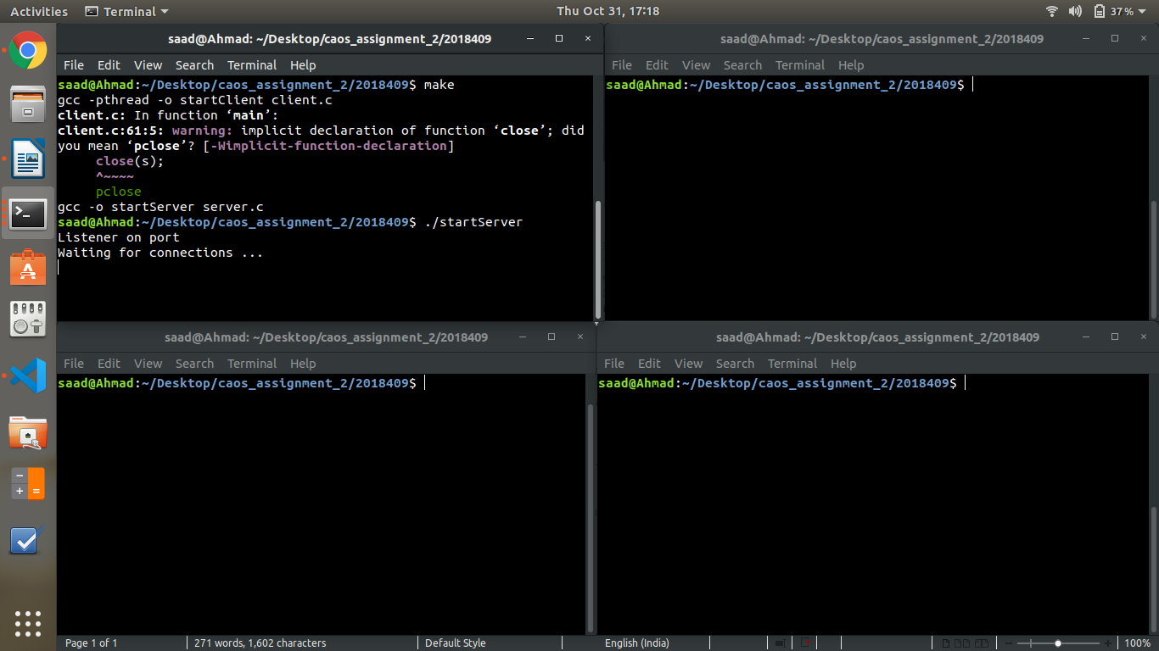
2) running ./startClient on the other 3 terminals which would serve as clients and sending various public and private messages

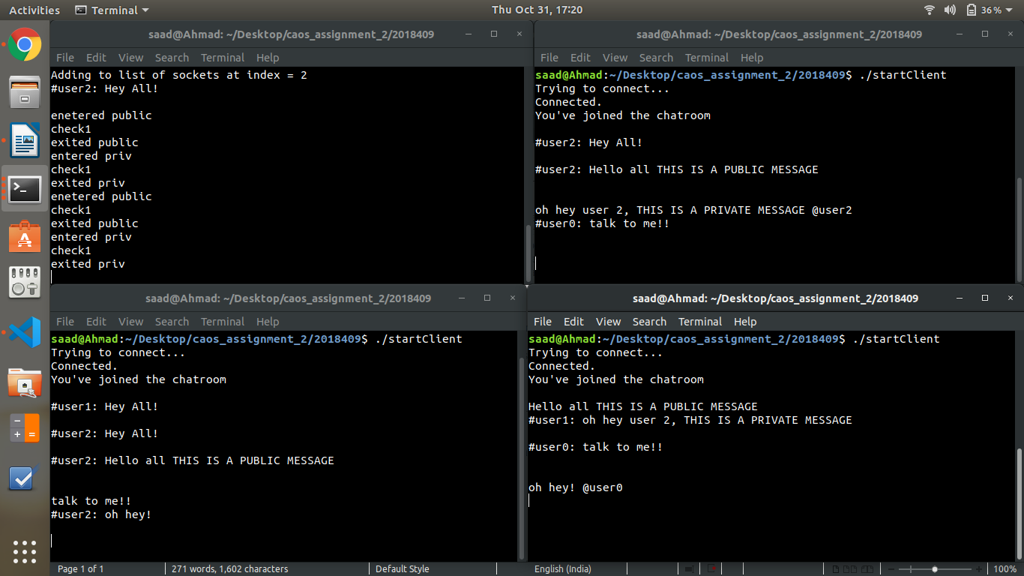

3) Error handling on upper-right terminal, user3 does not exist

