

Self-Supervised Few-Shot Reinforcement Learning for Scalable and Adaptive Anomaly Detection in Edge-Based Industrial IoT Systems

Ng Kien Loong
TP078627

Master of science in artificial intelligence
Research Methodology in Computing and Engineering (RMCE)

Asia Pacific University of Technology & Innovation (APU)
School of Computing and Technology

Assoc. Prof. Dr. Raja Rajeswari (Supervisor)
Assoc. Prof. Dr V. Sivakumar (Co-supervisor)

September 2025

ABSTRACT

IIoT systems are becoming more complicated and larger, necessitating reliable and efficient anomaly detection techniques, especially in edge-based settings with decentralized data and constrained resources. Conventional anomaly detection methods frequently struggle to adjust to changing data patterns and require enough labeled data for training, which is no longer feasible in IIoT applications. This research presents a method to overcome these obstacles by combining self-supervised learning, few-shot learning, and reinforcement learning. The framework can produce high-quality data representations on its own by using self-supervised learning, which makes it possible to detect anomalies effectively with little labeled data. With fewer training samples, few-shot learning enables the model to adjust to novel, previously undiscovered anomalies, which makes it appropriate for dynamic industrial settings. To ensure scalability and adaptability in edge-based systems, reinforcement learning is also integrated to continuously enhance the model's performance. Experiments conducted in actual IIoT environments are used to assess the suggested framework, showing that it can effectively detect anomalies while reducing computing overhead. The findings demonstrate its potential to improve edge-based IIoT systems' operational effectiveness, security, and dependability in a range of industrial applications.

Keywords: Self-supervised learning, Few-shot learning, Reinforcement learning, Anomaly detection, Edge computing, Industrial IoT, Scalable and Adaptive systems.

CHAPTER 1

INTRODUCTION

1.1 Introduction
Manufacturing and industrial operations have been transformed by the quick spread of Industrial Internet of Things (IIoT) devices, which allow for real-time data collecting, monitoring, and edge decision-making. But this growth also raises the possibility of anomalies like equipment breakdowns, sensor issues, or cybersecurity threats, which can seriously impair operations and drive-up expenses. Conventional anomaly detection techniques frequently depend on huge, labeled datasets and centralized systems, which are computationally demanding and unsuitable for edge-based, low-latency environments.
A novel solution to this problem is provided by the combination of few-shot reinforcement learning (FSRL) and self-supervised learning (SSL). These methods preserve the scalability and efficiency required for edge computing while allowing systems to dynamically adjust to novel and uncommon anomalies without the requirement for extensive labeled data. The possibility of integrating SSL and FSRL to create an adaptive anomaly detection framework that satisfies IIoT system requirements is investigated in this research.

1.2 Problem Statement
The Industrial Internet of Things' (IIoT) rapid growth has revealed significant weaknesses in the frameworks now in use for anomaly detection. One of the main challenges is their strong reliance on large quantities of labeled data. Zhang et al. (2020) emphasized that labelling industrial anomalies is both expensive and impractical due to their rarity and contextual variability. Similarly, Pang et al. (2021) argued that the dependence on labeled data severely limits the scalability and generalization of anomaly detection systems, particularly in real-world IIoT environments.
Furthermore, when applied to edge environments, many existing models encounter scalability issues because they were originally designed for centralized cloud-based infrastructures. Chen et al. (2022) highlighted that edge-based IIoT systems require real-time and low-latency responses, which are difficult to achieve with cloud-centric models. Li et al. (2021) further pointed out that traditional algorithms struggle with real-time inference on distributed, resource-constrained edge devices, limiting their use in dynamic manufacturing scenarios.
The static nature of traditional anomaly detection techniques is another critical limitation. Ahmed et al. (2016) observed that many anomaly detection models rely on offline training using historical data, making them unsuitable for evolving industrial processes. Wu et al. (2022) echoed this concern, noting that such models often fail to adapt to new patterns or conditions, resulting in reduced reliability and detection performance over time.
These challenges underscore the importance of developing a data-efficient, scalable, and adaptable anomaly detection framework. Wang et al. (2023) proposed that self-supervised approaches offer promising benefits for learning from unlabeled data in real-time. In a related study, Zhang and Liu (2021) demonstrated that few-shot reinforcement learning can enhance anomaly detection by enabling rapid adaptation to new anomalies with minimal supervision, particularly in edge computing environments.

1.3 Research Questions
- What is the role of self-supervised learning and few-shot reinforcement learning in detecting anomalies in edge-based IIoT systems?
- How can this method accurately identify outliers and changing anomalies while minimizing the requirement for large and labeled datasets?
- How does the proposed framework adapt to changing industrial environments with fluctuating data and operational conditions?
- What approaches ensure the scalability and efficiency of the anomaly detection system in edge environments with limited resources?
- How does this new method compare to conventional anomaly detection techniques in terms of accuracy, latency, and flexibility?
- Why is a scalable and adaptable system necessary for reducing reliance on labeled datasets and improving anomaly detection in dynamic settings?
- Who benefits the most from implementing this framework in resource-constrained edge systems, and how does it enhance its performance?

1.4 Aim & Objectives
- To investigate at the way self-supervised learning and few-shot reinforcement learning can improve edge-based IIoT systems' ability to detect anomalies, especially in situations when labeled data is hard to come by or unavailable.
- To solve the data efficiency issue in industrial anomaly detection by creating and putting into practice a technique that can precisely detect outliers and dynamic anomalies while reducing the reliance on sizable, labeled datasets.
- To develop the hybrid SSL-FSRL framework's flexibility in changing industrial settings, allowing the model to react to shifting operational circumstances, data patterns, and IIoT infrastructure modifications.
- To examine the framework's capacity for self-improvement and adaptation by providing it the flexibility to learn from fresh data without the requirement for intensive retraining or human intervention. As a result, the system will be able to dynamically adjust to evolving anomaly patterns and changing industrial environments.
- To create and evaluate resource-efficient and scalable methods that preserve anomaly detection capabilities in edge environments with constrained amounts of memory, processing power, and energy.
- To support the need for a flexible and scalable system that enhances detection quality, dynamic industrial situations while lowering dependency on labeled data.
- To evaluate the application and advantages of the suggested framework, such as greater value delivery in resource-constrained edge deployments, less system interruptions, and better performance.

1.5 Scope of Research
A scalable anomaly detection system designed for edge computing in IIoT contexts is the objective of this research effort. The main goal is to create a SSL-FSRL model that can operate effectively on edge devices with constrained processing power. The model will prioritize lowering resource consumption while retaining good detection performance, considering the limitations of edge devices. By continuously adjusting to fresh data, the framework lessens the requirement for large, labeled datasets and improves anomaly detection in IIoT systems. Early testing will simulate edge conditions on a local computer, allowing for early validation of the model's capabilities even though the system is intended for deployment on edge devices. By assessing the framework's scalability and flexibility over a variety of IIoT system complexities, data availability scenarios, and changing operating conditions, its applicability will be ensured.
The research has several significant limitations despite its encouraging promise. Network heterogeneity in industrial settings, where different communication protocols and fluctuating network latencies may impact the model's performance, may present difficulties for the practical implementation of the suggested framework. Furthermore, the smooth functioning of the model in practical situations may be impeded by hardware-specific limits including processor power, memory capacity, and energy limitations of edge devices. Moreover, more research is required to examine the framework's generalizability across additional IIoT domains, such as manufacturing, smart grids, and predictive maintenance applications, even though it will be tested using a variety of industrial datasets. Additionally, even though the reinforcement learning component was created to function well on edge devices, more optimizations may be needed to handle complex and dynamic settings, especially in configurations with limited resources. Finally, to overcome issues like data sparsity, class imbalance, and the changing nature of industrial contexts, the integration of SSL and FSRL approaches might need more fine-tuning.

1.6 Significance of Research
The potential of this research to reduce unplanned downtime and facilitate predictive maintenance in industrial settings makes it significant. To ensure continuous production in smart manufacturing environments, the suggested framework uses self-supervised few-shot reinforcement learning to detect sensor failures, equipment faults, and operational anomalies in real time. Since the method does not depend on sizable, labeled datasets, it can be easily applied to real-world situations where data labeling is frequently costly and time-consuming. By identifying uncommon and changing dangers like illegal access or strange network behavior, the model can also improve industrial cybersecurity and further protect vital infrastructure.
Moreover, by identifying anomalies in resource distribution, logistics, or delivery timetables, the framework can improve supply chain operations. It is especially well-suited for scalable and adaptive anomaly detection in IIoT systems due to its capacity to operate in limited resources edge locations. This research offers a workable and effective answer to the urgent problems faced by businesses while implementing edge-based IIoT systems by tackling concerns like constrained computational capacity and processing needs. The results may lead to IIoT installations that are more dependable and secure, which would ultimately increase operational effectiveness and lower expenses in a variety of industrial sectors.

CHAPTER 2

LITERATURE REVIEW

2.1 Anomaly Detection in IIoT
IIoT includes the network of sensors, devices, instruments, and data analytics into industrial applications. Anomaly detection is crucial in IIoT systems while addressing challenges such as equipment failure or malfunction, cyber-attacks, and operational inefficiencies.

2.1.1 Temporal Anomaly Detection
Manufacturing processes can be managed in real time with temporal anomaly detection. For detecting anomalies in IIoT-enabled manufacturing systems, Zhan et al. (2021) suggested a hierarchical temporal representation technique based on time series. By examining the sequential nature of sensor data, their method showed exceptional accuracy and efficiency in identifying anomalies, which is crucial in smart manufacturing settings.

2.1.2 Machine Learning Techniques
Machine learning has emerged as a popular technology for IIoT anomaly identification due to its capacity to handle large and diverse datasets. Bhupal Naik D. S. et al. (2022) compared machine learning algorithms such as Random Forest, LightGBM, and K-Nearest Neighbors, and discovered that Random Forest consistently beat other models in anomaly detection accuracy. This study showed the significance of algorithmic selection based on the complexity and amount of IIoT data.
W. Hore & Wakde (2022) conducted a similar study in which they assessed sensor data from industrial systems using unsupervised learning methods such as density-based clustering and fuzzy c-means. Their method worked well for identifying irregularities without the need for labeled information, which allowed for real-time IIoT applications to perform outstandingly.

2.1.3 Network Security
The dependence of IIoT systems on interconnected networks makes them particularly susceptible to cyberattacks. Using deterministic physical properties, Zhou and Guo (2018) investigated anomaly detection techniques designed for IIoT networks. According to Zhou and Guo (2018), this research provided a thorough analysis of network-based anomaly detection techniques that protect against intrusions and guarantee system availability.
IIoT systems are especially vulnerable to assaults due to their reliance on interconnected networks. Zhou and Guo (2018) examined anomaly detection methods intended for IIoT networks using deterministic physical features. Zhou and Guo (2018) claim that this study offered a comprehensive examination of network-based anomaly detection methods that ensure system availability and prevent intrusions.

2.1.4 Deep Learning
Deep learning models have been used to enhance IIoT systems' anomaly detection capabilities. To successfully detect abnormalities and remove sensor noise, Han et al. (2021) created a multidimensional data-processing framework based on autoregressive models. With high-dimensional datasets and demanding industrial settings, this method proved.
For real-time anomaly identification in IIoT time-series data, Nizam et al. (2022) suggested a hybrid architecture that combines Long Short-Term Memory (LSTM) autoencoders with Convolutional Neural Networks (CNN). Their methodology demonstrated its applicability for dynamic industrial environments by capturing both short- and long-term dependencies, which allowed it to excel in identifying unusual events.

2.1.5 Applications in Predictive Maintenance
Predictive maintenance, a crucial component of IIoT systems, has made substantial use of anomaly detection. To identify irregularities in sensor data, such as fuel consumption and oil pressure, Shah and Tiwari (2018) concentrated on engine-based machinery and employed multivariate regression and Gaussian mixture models. Their approach reduced downtime and operational inefficiencies by enabling timely maintenance.

2.1.6 Summary
Machine learning, deep learning, and network-specific approaches are being used in the quickly developing field of anomaly detection in IIoT systems to tackle a variety of problems. From manufacturing processes to network security and predictive maintenance, techniques including Random Forest, unsupervised clustering, and hybrid deep learning frameworks show strong performance in anomaly detection across a range of contexts. The importance of data-driven techniques in guaranteeing the dependability and effectiveness of IIoT systems is highlighted by these developments.

2.2 Reinforcement Learning for Adaptive Systems
Reinforcement learning (RL) has become a potent tool for adaptive systems, allowing agents to learn the best course of action. The main developments in reinforcement learning techniques and their use in adaptive systems are highlighted in this research.

2.2.1 Adaptive Control and Reinforcement Learning Intersection
To better manage uncertain systems, the combination of RL and adaptive control has been investigated. According to Annaswamy's (2023) comparison of RL with classical adaptive control techniques, RL provides near-optimal solutions for complicated tasks and greater applicability, while adaptive control excels in real-time system management with stability guarantees. Using the advantages of both strategies, the author suggested a single framework.
Similarly, Wong and Lee (2008) showed how RL algorithms may improve control policies and adaptively handle uncertainty by extending them to stochastic systems. Their research filled the void in reinforcement learning applications for continuous-variable systems, highlighting the value of adaptive techniques in managing unpredictability in the real world.

2.2.2 Deep Reinforcement Learning for Adaptive Systems
New possibilities for adaptive systems have been made possible by recent developments in deep reinforcement learning (DRL). In their assessment of DRL's use in control engineering, Buşoniu et al. (2018) concentrated on how deep neural networks can be used to approximate solutions for high-dimensional state spaces. Although stability is still a major obstacle, they highlighted DRL's potential in handling nonlinear and stochastic.

2.2.3 Application for Complex Adaptive Systems
An online reinforcement learning framework for self-adaptive information systems was presented by Palm et al. (2020), tackling issues like scalability and design-time uncertainty. Their method greatly improved the flexibility and effectiveness of information systems in dynamic environments by automating the tweaking of exploration rates and quantifying environment states.

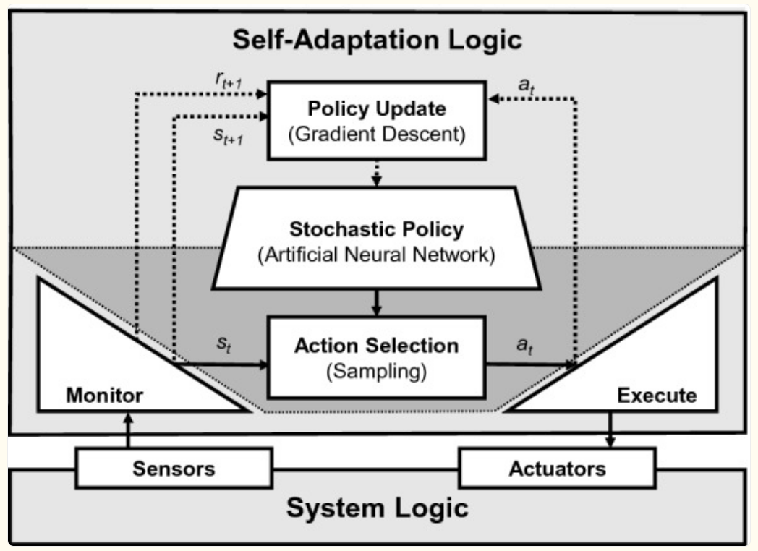
Figure 2.1: At runtime, the self-adaptation logic uses the policy to choose an adaptation action based on the current state, which is determined by monitoring. This process decides if adaptation is needed and selects the appropriate action to execute. The policy is updated using the history of actions, states, and rewards.

Ran and Xie (2022) created an observation-based RL methodology. Their concurrent learning observer demonstrated its efficacy in controlling large adaptive systems by combining experience-based simulation with data-driven parameter estimates to produce near-optimal control rules.

2.2.4 Summary
By allowing agents to learn the best rules in unpredictable and changing contexts, reinforcement learning has revolutionized the study of adaptive systems. The adaptability of reinforcement learning (RL) has been shown in a variety of applications, ranging from deep reinforcement learning and its integration with adaptive control to traditional adaptive dynamic programming. These developments have solidified reinforcement learning as a foundation for creating intelligent, self-governing systems that can instantly adjust to changing obstacles.

2.3 Few-Shot and Self-Supervised Learning
Two machine learning techniques that try to overcome the dependence on large, labeled datasets are few-shot learning (FSL) and self-supervised learning (SSL). SSL uses its own supervisory signals to exploit unlabeled data, whereas FSL focuses on learning from a small number of annotated samples. To get state-of-the-art outcomes in classification, object detection, and other tasks, recent research investigates the synergy between these paradigms.

2.3.1 Theoretical and Practical Foundations
The objective of a few-shot learning is to make it possible for models to generalize to new classes using a few samples. Large dataset pretraining is a key component of traditional FSL techniques. In contrast, self-supervised learning reduces this reliance by generating supervisory signals directly from the data. SSL can be used as an auxiliary task to enhance visual representations for FSL, as Gidaris et al. (2019) showed. Their approach produced better feature representations and notable performance benefits across several datasets by integrating self-supervised tasks, such as picture rotations, into an FSL pipeline.
Su et al. (2020) made a significant further contribution to this synergy by methodically examining the ways in which SSL can improve FSL in various scenarios. Even with tiny datasets, they discovered that SSL dramatically lowers error rates in few-shot jobs. Given that domain shifts could offset the advantages, the study underlined the significance of dataset similarity across self-supervised and downstream tasks.

2.3.2 Advances in Self-Supervised Objectives for FSL
To enhance few-shot learning, a few research have put forward creative self-supervised objectives. Chen et al. (2022) bridged the gap between pretraining and few-shot adaptation by introducing intermediate self-supervised training stages. When compared to conventional techniques, their methodology performed better on benchmarks by customizing SSL objectives to instruct models to undertake in-context learning. Interestingly, they showed how SSL and datasets with human annotations complement each other.
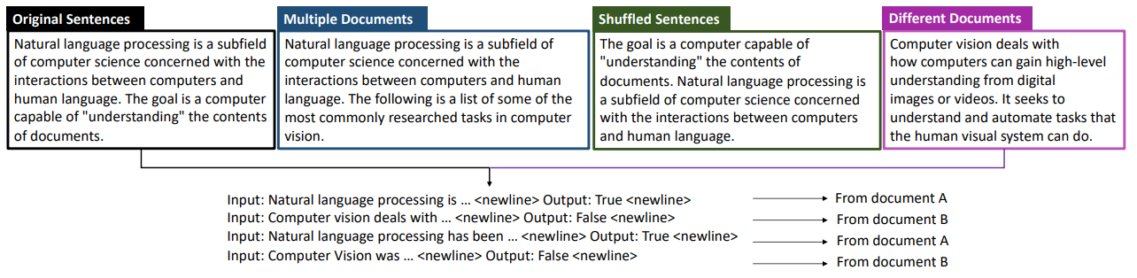
Figure 1.4: 4 types of training instances, each resembles the next sentence prediction task to instruct the model to compare topical similarities.

The trade-offs between FSL and SSL aims were also addressed by Chen et al. (2021) with their introduction of Pareto Self-Supervised Training (PSST). They successfully balanced these goals by identifying preference regions in the loss landscape using a multi-objective optimization technique. By resolving task conflicts dynamically, this technique achieved state-of-the-art performance across multiple public benchmarks.

2.3.3 Combining SSL with Advanced FSL Frameworks
To extract more significant representations, a few studies investigated incorporating SSL into intricate few-shot frameworks. Simard and Lagrange (2021) created a multi-task framework that integrated FSL with SSL. To increase the generalizability of learnt representations, they employed self-supervised auxiliary tasks such as contrastive learning to serve as regularizers. In domains with little labeled data, the method worked especially well.
Lu et al. (2022) made another significant contribution by putting out a novel SSL strategy that optimizes mutual information (MI) between instances and representations. Their MI-based self-supervised pretraining promoted generalization to unseen categories, in contrast to supervised pretraining, which frequently biases the model towards observed classes. On FSL benchmarks, this approach was on par with or better than supervised approaches.

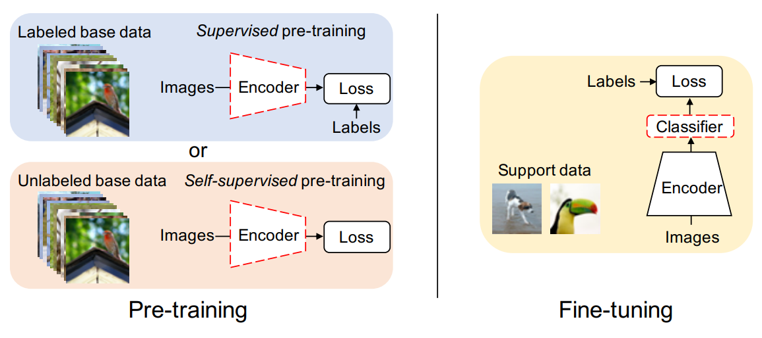
Figure 2.2: During pre-training, an encoder network is trained with labeled and unlabeled datasets with supervised and self-supervised loss respectively. During fine-tuning, a linear classifier is trained on embeddings of a few samples using frozen pre-trained encoder.

2.3.4 Applications in Cross-Domain Learning
Further challenges arise with cross-domain few-shot learning (CDFSL), since models need to generalize across domain shifts. SSL techniques were tested in CDFSL conditions by Zhang et al. (2022), who discovered that they were resilient to domain changes. In cross-domain tasks, they pointed out that SSL-derived features frequently perform better than supervised ones, indicating their potential use in real-world situations with less labeled data.
Ji et al. (2019) presented an unsupervised few-shot learner for person re-identification tasks in another domain-specific application. They demonstrated the adaptability of SSL in low-data regimes by combining episodic training with SSL to produce competitive results even in the absence of labeled datasets.

2.3.5 Novel Architectures Leveraging SSL
FSL has been further enhanced by creative architectures that include SSL principles. To supplement few-shot objectives, Rong et al. (2023) developed a self-supervised episodic spatial pretext task (ESPT). Their method achieved state-of-the-art outcomes in picture classification benchmarks by learning transferable features by capturing local spatial correlations inside episodic tasks.
Moreover, Medina et al. (2020) presented a model transfer learning system that learned robust metric embeddings by clustering unlabeled data. Their SSL-enhanced strategy fared better than unsupervised meta-learning techniques, demonstrating SSL's ability to lower annotation needs without sacrificing accuracy.

2.3.6 Summary
Self-supervised learning and few-shot learning are complimentary approaches that tackle the problems of sparse labeled data. While SSL improves feature representations with unlabeled data, FSL allows for quick generalization with less supervision. Learning robust and generalizable models has advanced significantly because of the integration of these methods, whether through novel architecture, multi-objective optimization, or auxiliary activities. SSL has demonstrated its capacity to expand the applicability of FSL to real-world tasks, particularly in low-data settings and cross-domain applications. Together, these results demonstrate SSL's adaptability as a basis method for next few-shot learning developments.

2.4 Industrial IoT and Edge Computing
Industries have been transformed by the convergence of edge computing and the IIoT, which has made real-time processing, low latency, and improved security possible. By combining knowledge from current research, this review of the literature investigates the convergence of these two technologies, their uses, and their difficulties.

2.4.1 Edge Computing in Industrial IoT
For IIoT systems, edge computing is essential because it allows computation to be done closer to data sources, lowering latency and bandwidth needs. To improve production efficiency, Chen et al. (2018) suggested architecture that blends edge computing with IoT. As demonstrated by active maintenance systems, this design combines edge devices, network connection, and cloud cooperation to process data in real time.
Qiu et al. (2020) highlighted how edge computing may optimize IIoT operations by tackling issues like privacy concerns and latency in decision-making. According to Qiu et al. (2020), their research examined methods for routing, task scheduling, and data storage and suggested architecture designed for industrial uses like manufacturing, logistics, and smart grids.

2.4.2 Enhancing IIoT Through AI-Driven Edge Solutions
Edge computing and artificial intelligence (AI) are being increasingly combined to enhance resource management and decision-making in IIoT settings. AI-driven strategies to maximize power consumption and prolong the battery life of IoT devices in industrial environments were put out by Sodhro et al. (2019). By using predictive transmission power regulation and dynamic task scheduling, their methodology showed notable gains in data dependability and energy efficiency.
Mai et al. (2021) investigated edge architectures in conjunction with in-network computing (INC) paradigms. Their method provided high throughput and low-latency processing by shifting light-duty activities to programmable network devices, satisfying the requirements of industrial systems operating in real-time.

2.4.3 Edge Computing Frameworks for IIoT
Frameworks for edge computing are essential for enabling IIoT applications. A multi-access edge computing (MEC) framework was presented by Borsatti et al. (2021) to convert IIoT applications into scalable, service-based architectures. Real-time industrial process monitoring and control were made possible by this framework's quick deployment capabilities.
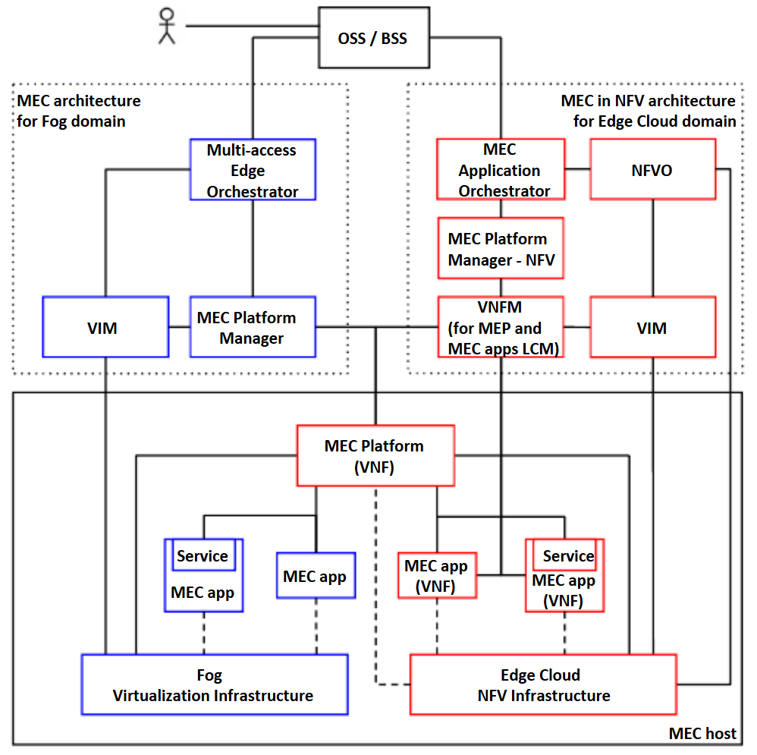
Figure 2.3: MEC-compliant architecture that integrates components from edge computing environments (highlighted in red) and fog computing environments (highlighted in blue).

A dynamic edge-cloud integration paradigm was also created by Hästbacka et al. (2022), which allowed for the smooth orchestration of IIoT data across various hardware platforms. This concept improved the adaptability of industrial cyber-physical systems by enabling variable application and service composition.

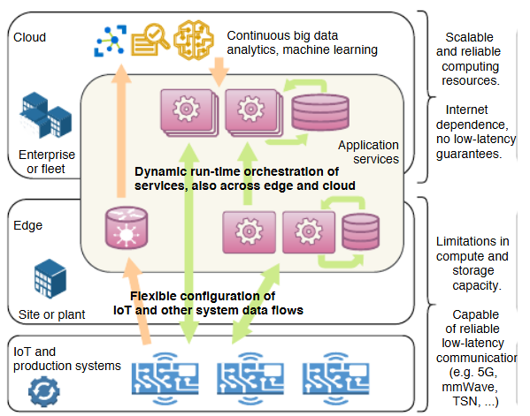
Figure 2.4: The architectural concept for building data-driven applications, where data flows from IoT devices and other plant floor systems are configured and dynamically orchestrated with application services across edge and cloud environments.

2.4.4 Security and Trust in Edge-Based IIoT
As IIoT devices proliferate, security and trust have emerged as critical issues. A unified trust framework that uses edge computing to identify malicious activity and improve service dependability was proposed by Wang et al. (2020). To ensure safe and effective IIoT operations, their system used trust evaluations to suggest reliable service providers.
Rafique et al. (2020) examined how software-defined networking (SDN) and edge computing can be combined to address security flaws in IIoT ecosystems. Their study cleared the path for strong security measures by identifying multiple attack scenarios and suggesting mitigation techniques.

2.4.5 Challenges and Future Directions
Despite the enormous advantages of edge computing, there are also a few difficulties. Dai et al. (2019) highlighted the necessity for enhanced interoperability and defined protocols to overcome the constraints of present edge platforms in managing intricate industrial operations. They emphasized how edge computing nodes serve as entry points for clever applications, connecting the digital and real worlds.
Premsankar et al. (2018) investigated bandwidth and latency issues in edge-enabled IIoT applications and suggested sophisticated architectures to satisfy the needs of systems of the future. The significance of optimizing data processing and resource allocation at the edge to support new use cases like predictive maintenance and augmented reality was highlighted by their findings.

2.4.6 Summary
By facilitating real-time data processing, improved security, and effective resource management, industrial IoT and edge computing are revolutionizing various industries. To handle the difficulties of IIoT contexts, recent developments emphasize the integration of AI, dynamic frameworks, and trust mechanisms. To fully realize the potential of edge computing in industrial contexts, further research must concentrate on scalability, standardization, and better resource optimization.

2.5 Integrative Frameworks
Given the complexity and importance of industrial operations, anomaly detection in Industrial Internet of Things (IIoT) systems has grown in importance. Conventional approaches frequently lack the flexibility to accommodate new abnormalities or are constrained by the requirement for sizable, labeled datasets. A promising answer to these problems is provided by hybrid strategies that combine reinforcement learning (RL), few-shot learning (FSL), and self-supervised learning (SSL). We examine these intersections and how they are used in IIoT anomaly detection below.

2.5.1 Few-Shot Learning and Self-Supervised Techniques for Limited Data Scenarios
Due to the frequent scarcity of identified abnormalities, few-shot learning is especially pertinent to anomaly identification in IIoT. Huang et al. (2020) presented a gated few-shot anomaly detection model that uses few labeled samples to learn new anomaly categories. Their method provides state-of-the-art results on the NSL-KDD dataset by utilizing gated network architectures, which effectively bridge the gap between known and unknown anomaly types.
By using unlabeled data to improve feature representations, self-supervised approaches can be used in conjunction with few-shot methods. A contrastive self-supervised learning framework called CoLA was presented by Liu et al. (2021) for anomaly detection on attributed networks. Their method showed better anomaly identification accuracy across several datasets by using graph neural networks (GNNs) to learn useful embeddings. For the IIoT, where networked devices generate high-dimensional data, this SSL and FSL combination is extremely pertinent.

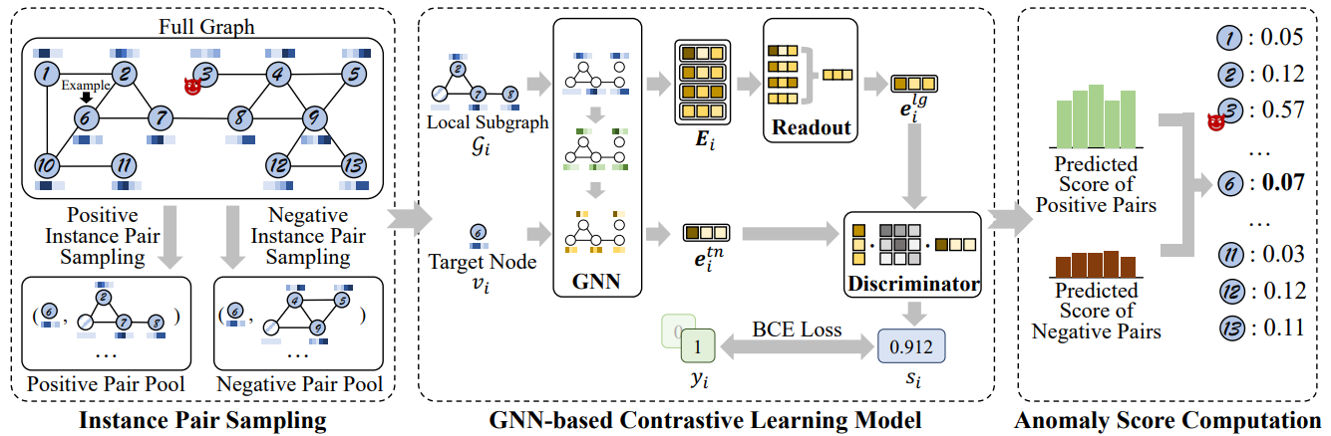
Figure 2.5: The CoLA framework consists of three parts: instance pair sampling, a GNN-based contrastive learning model, and anomaly score computation. For example, if node 𝑣6 is the target, positive and negative instance pairs are sampled. The GNN model predicts scores for these pairs, and the anomaly score for 𝑣6 is calculated using statistical estimates of these scores. Node 𝑣3, with corrupted attributes, serves as an example of an anomaly, while the other nodes are normal.

2.5.2 Reinforcement Learning for Dynamic Adaptation
Adaptive anomaly detection in IIoT systems is a good fit for reinforcement learning since it performs very well in dynamic contexts. In their hierarchical federated learning strategy, Wang et al. (2022) used deep reinforcement learning (DRL) to train local models. Through local data processing, this configuration not only improves detection accuracy but also addresses privacy concerns. By integrating RL, models can maintain low latency and high throughput while dynamically adapting to new anomalies.
Likewise, for the detection of motor anomalies, Cen et al. (2023) integrated reinforcement learning with temporal convolutional networks (TCNs). The difficulties of temporal and spatial variability in IIoT systems were addressed by their approach, which enhanced feature extraction and attained good generalization performance.

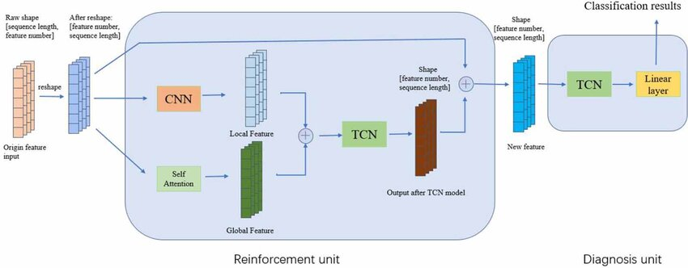
Figure 2.6: The architecture structure of models, as the TCN models provide a great parallel computation and more extended memory rather than RNNs, which improves the efficiency of the model eventually.

2.5.3 Practical Applications and Future Directions
Applications for hybrid models in IIoT include cyberattack detection and predictive maintenance. To address the misclassification of novel classes, Qi et al. (2024) created a few-shot object detection framework that incorporates self-supervised learning. Using cooperative classifiers and double ROI heads, their method significantly increased detection accuracy on industrial datasets.
Using SSL for domain adaptation, Sun et al. (2021) presented a cross-domain few-shot learning paradigm for video anomaly detection. For IIoT setups with diverse operating contexts, such several manufacturing facilities or machinery kinds, this approach is very beneficial.
These developments are encouraging, but there are still issues with interpretability, scalability, and real-time processing. Santos et al. (2023) emphasized the possibility of improving on current techniques for few-shot anomaly identification, such as PatchCore. Their results highlight the need for better integration of SSL approaches with feature extractors with strong inductive biases.

2.5.4 Summary
Self-supervised, few-shot, and reinforcement learning hybrid techniques provide a robust toolkit for IIoT anomaly identification. Self-supervised learning makes use of unlabeled data, reinforcement learning guarantees flexibility in changing contexts, and few-shot techniques deal with data scarcity. Together, these methods improve detection accuracy, lessen the need for labeled data, and allow for real-time anomaly detection, which makes them crucial for IIoT applications in the future.

CHAPTER 3

RESEARCH METHODOLOGY

3.1 Overview
A self-supervised few-shot reinforcement learning framework for scalable and adaptive anomaly detection in IIoT systems is designed, implemented, and evaluated in this research using a multi-phase technique. With a focus on tackling the difficulties of anomaly detection in resource-constrained situations, the process combines data collection, model construction, experimentation, and evaluation. Docker containers with memory and resource limitations are employed as a stand-in for edge computing devices due to the practical limitations of this research, offering an implementation platform that is both accessible and efficient. To guarantee feasibility and reproducibility, all computational operations—including model training and evaluation—are carried out locally using consumer-grade GPUs and CPUs.

3.2 Data Acquisition and Preprocessing
The SOLDEF AI PCB Dataset for Defect Detection is a publicly available dataset designed for automated defect detection on Printed Circuit Boards (PCBs) (Calabrese et al., 2022). It allows researchers to train and assess machine learning models for tasks like classification, segmentation, or anomaly detection by providing high-resolution photos of PCBs with annotated defect labels. The information is particularly helpful for creating AI systems that improve electronics manufacturing quality control procedures by spotting flaws like scratches, misalignments, or missing parts. It is a useful tool for comparing AI algorithms in industrial defect detection applications because of its varied content and carefully chosen comments.
Python-based simulation libraries, like SimPy or OpenAI Gym, are used to create synthetic data that models IIoT systems with a variety of operational scenarios and failure modes. Publicly accessible IIoT datasets are used to gather real-world data, guaranteeing that the collection encompasses a wide variety of use cases. To assure its quality, the data goes through preprocessing procedures like standardization, normalization, and noise filtering. Anomaly labels are assigned using semi-automated labeling methods, such as clustering algorithms with manual validation. Few-shot subsets of the data are created to evaluate the model’s capability to generalize effectively with limited labeled examples, an important feature for real-world deployment.


Figure 3.1: Good Solder


Figure 3.2: Excess Solder


Figure 3.3: Poor Solder


Figure 3.4: Spike Solder

3.3 Model Design and Development
To satisfy the requirements of IIoT applications, the anomaly detection framework combines resource-efficient deployment techniques, self-supervised learning, and few-shot reinforcement learning.
A component for self-supervised learning is created to improve the ability to extract features. This entails pre-training the model using contrastive learning approaches, which create positive and negative pairs by augmenting the data. The self-supervised method improves the quality of learned representations while addressing the lack of labeled datasets by taking advantage of the wealth of unlabeled data.
The implementation of few-shot reinforcement learning facilitates quick adaptation to novel anomaly detection tasks. The model is ideal for dynamic industrial situations because it uses meta-learning concepts to generalize across jobs with little labeled input. To find a compromise between performance and computational economy, a model-based reinforcement learning approach is selected.
The research simulates edge environments using Docker containers with limited memory and processing power rather than implementing the model on actual edge devices. To guarantee effective operation within these limitations, optimization strategies like model trimming and quantization are used. To maintain accessibility and prevent dependence on cloud-based resources, all training and assessment tasks are carried out locally utilizing consumer-grade GPUs and CPUs.
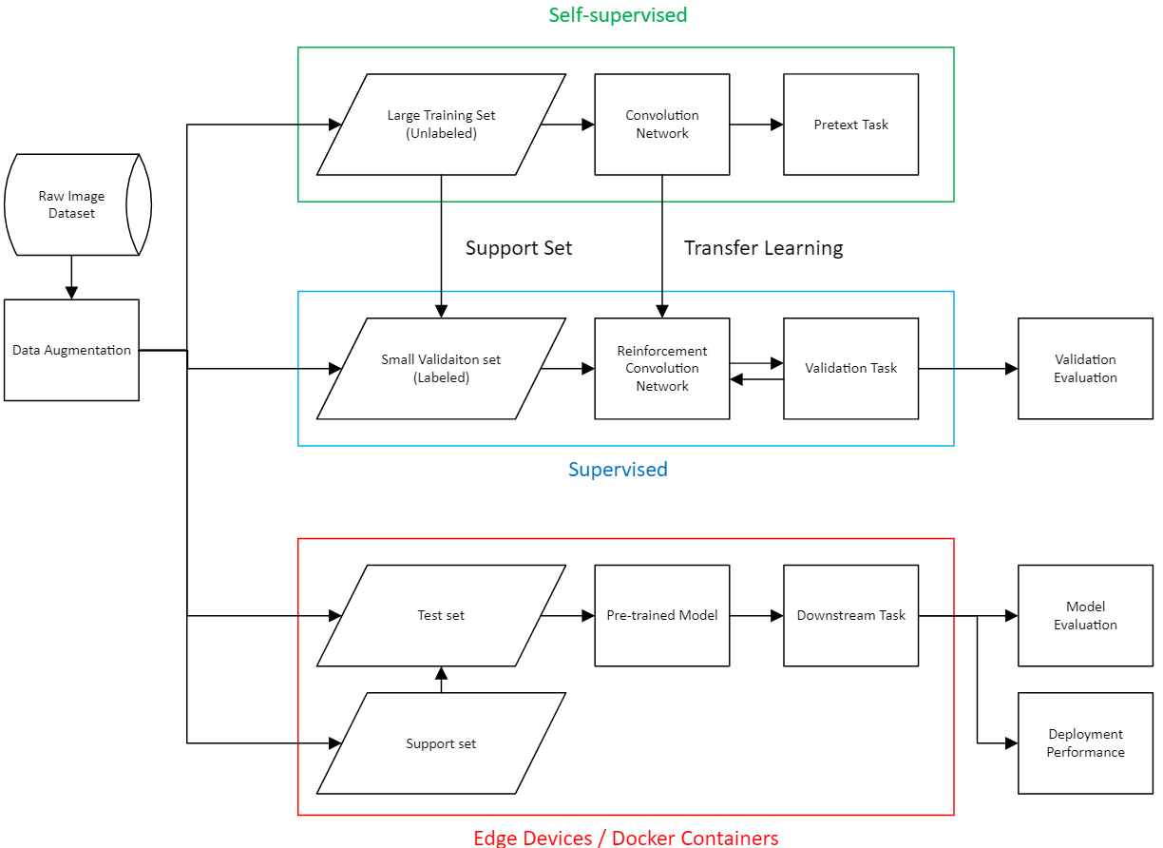
Figure 3.5: Flowchart of research methodology

3.3.1 Self-Supervised Learning
In the first stage of the anomaly detection framework, a Self-Supervised Learning (SSL) encoder is designed to learn high-quality feature representations from unlabeled PCB defect images. This approach is essential in Industrial IoT (IIoT) environments where obtaining large volumes of labeled data is costly and impractical. Instead of relying on manual annotations, SSL leverages the inherent structure of the data itself to create supervisory signals.
The encoder is based on a lightweight MobileNetV2 backbone, pretrained on ImageNet for efficiency, with most layers frozen to reduce computational demand. A custom projection head is added, consisting of a Global Average Pooling layer, fully connected layers, and an L2 normalization step to produce robust 64-dimensional embeddings. The design of this encoder is illustrated in Figure 3.6.

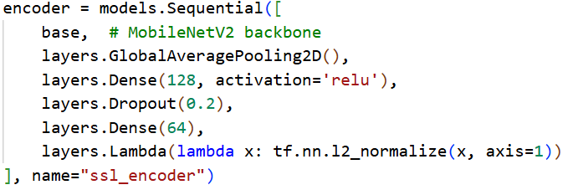
Figure 3.6: Encoder

To train this encoder without labels, a contrastive learning strategy is employed. The dataset is used to automatically construct positive and negative image pairs:
- Positive pairs consist of two images belonging to the same defect class.
- Negative pairs consist of images sampled from different classes.

The encoder processes both inputs, and the embeddings are compared using a distance function. The model is trained with a contrastive loss function, which minimizes the distance between embeddings of positive pairs while maximizing the distance for negative pairs.

$$L=y⋅D^{2}+(1-y)⋅max{\left(0,m-D\right)}^{2}$$

where $y∈\{0,1\}$ indicates whether a pair is positive or negative, $D$ is the embedding distance, and mmm is the margin parameter.

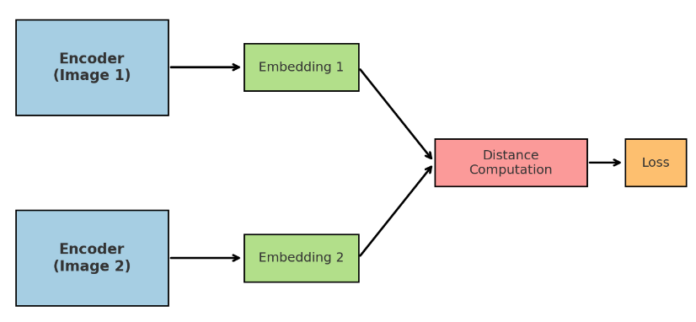
Figure 3.7: Self-Supervised Learning Siamese Architecture

Figure 3.7 shows the simplified Siamese architecture applied in SSL training, where two identical encoders process paired images and the resulting embeddings are compared. This enables the model to extract discriminative features of solder defects without requiring explicit class labels.
By applying SSL, the encoder learns transferable feature embeddings that serve as the foundation for the subsequent Few-Shot Learning (FSL) stage, where only a small number of labeled examples are required for classification. This significantly reduces dependence on annotated datasets while maintaining high adaptability to unseen defect types.

3.3.2 Few-Shot Learning
Following the self-supervised learning stage, the second component of the framework applies FSL to enable classification with only a small number of labeled samples per class. This step is crucial in IIoT environments where annotated defect data is scarce and costly to acquire. By leveraging the representations learned during SSL, the model can quickly generalize to new or rare defect types with minimal supervision.
In the implementation, a support set is constructed by randomly sampling a limited number of examples (n-shots) from each defect class. For this research, the default configuration uses 8 shots per class. To ensure class balance, the system either randomly undersamples or oversamples data where needed. The support set is then used to compute class prototypes, which are vector representations that summarize each class by averaging the embeddings of its support samples. The code snippet below demonstrates how prototypes are created from the SSL encoder outputs:

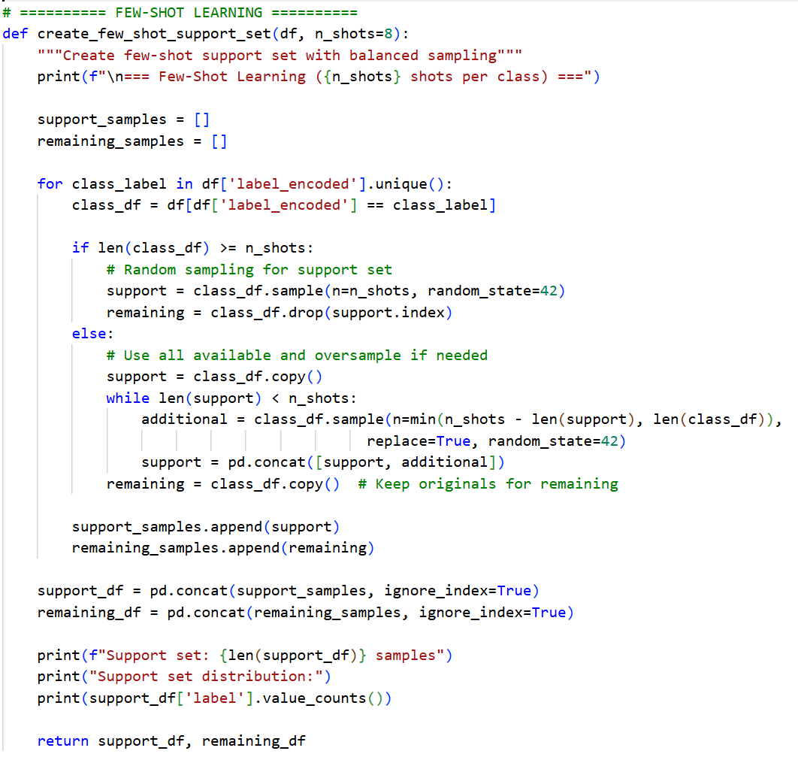
Figure 3.8: Few-shot Learning

During inference, a query image is encoded using the same SSL encoder, and its embedding is compared to the prototypes using cosine similarity. The class with the highest similarity score is assigned as the predicted label. This process aligns with the prototypical network’s paradigm, which is well-suited for FSL tasks in computer vision.

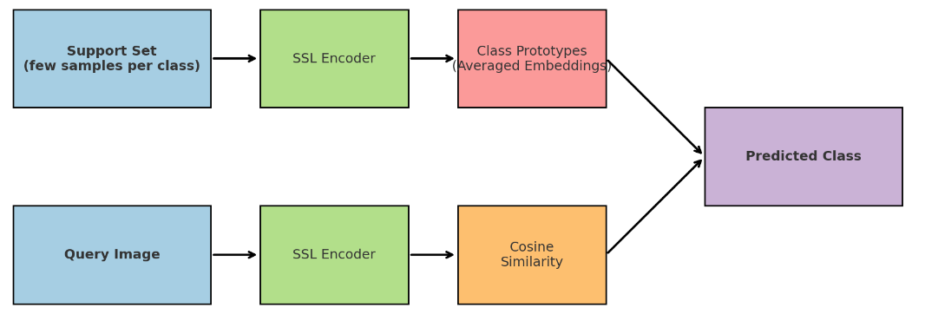
Figure 3.9: Few-Shot Learning Prototypes and Query Classification

Figure 3.9 illustrates the FSL process: a small support set is sampled from each class, and the embeddings are computed through the SSL encoder and averaged to form prototypes. Query images are then classified by measuring their similarity to these prototypes.
By combining SSL with FSL, the framework effectively addresses the dual challenge of limited labeled data and high variability in defect patterns, making it highly adaptable for real-world IIoT anomaly detection scenarios.

3.3.3 Reinforcement Learning
The third stage of the proposed methodology integrates Reinforcement Learning (RL) to enable continuous adaptation and long-term improvement of the anomaly detection system. While SSL and FSL provide strong initial representations and classification from limited data, they do not inherently support online learning or dynamic adaptation to evolving industrial environments. To address this, an adaptive RL Agent is introduced, leveraging Q-Learning to refine decision-making during real-time classification.
The RL agent operates across three major decision spaces. First, it manages prototype update decisions, determining how much weight to assign new samples when updating class prototypes. Second, it focuses on human feedback optimization, deciding when to seek operator feedback versus making autonomous predictions. Finally, it addresses new class discovery, handling cases where a query sample may represent an unseen defect category by deciding whether to create a new prototype, merge it with existing classes, or disregard the anomaly.
The agent represents each state as a set of features, including prediction confidence, uncertainty, class balance, and recent performance trends. States are discretized into keys for efficient lookup in Q-tables. For each state, the RL agent selects an action according to an ε-greedy policy, balancing exploration of new strategies with exploitation of known effective policies. The reward function is defined in relation to the outcomes of the agent’s actions. Correct prototype updates and appropriately timed feedback requests are incentivized through positive rewards, whereas over-aggressive updates, redundant feedback queries, and failures to detect novel classes incur penalties.

The Q-learning update rule is then applied:

Figure 3.10: Q-learning rule equation

where $α$ is the learning rate, γ the discount factor, r the reward, and s′ the next state.
The interactive RL cycle using SSL and FSL prototypes, and the RL agent evaluates whether to accept the prediction, request feedback, or update prototypes. Based on the decision outcome and user feedback, the agent receives a reward, updates its Q-tables, and gradually reduces its exploration rate to favor reliable policies.
This RL integration enables the system to continuously improve with each interaction, adapt to new defect types, and optimize the trade-off between human involvement and autonomous decision-making. The persistence of Q-tables, experience replay buffer, and learning statistics ensures that improvements are retained across sessions, making the model increasingly robust in long-term industrial deployments.

3.4 Experimentation and Deployment
Using Python-based simulation tools, the anomaly detection framework is tested in a mock industrial setting to start the exploration phase. The framework's performance may be assessed in a variety of scenarios, encompassing both typical operation and various anomalies, effective to this controlled environment.
The framework is then set up within Docker containers that are set up to simulate edge environments. To determine whether the strategy is feasible, important parameters including memory utilization, computing efficiency, and response times are tracked. To demonstrate the benefits of the suggested framework in terms of detection accuracy, adaptability, and resource efficiency, comparisons are made with standard machine learning and deep learning models.
Performance measures are used to assess the framework thoroughly. Precision, recall, and F1-score are used to gauge detection accuracy. The amount of time needed for the framework to pick up additional anomaly detection duties is used to gauge adaptability. While resource efficiency is measured by tracking memory and compute requirements within Docker containers, scalability is examined by increasing data volumes and emulating larger IIoT networks.

3.5 Ethical and Safety Considerations
In this research, ethical considerations are crucial. All real-world datasets are hidden to preserve data privacy, guaranteeing the security of sensitive information. To assure equitable and trustworthy anomaly detection, the model is assessed for biases, especially in crucial industrial applications where false positives or negatives could have serious repercussions.
By setting in place procedures to deal with inaccurate anomaly detections, safety concerns are also addressed. The framework, for example, has automated alerts that prompt human operators to confirm before acting. The system won't cause instability in the IIoT environments it monitors because of this fail-safe design.

3.6 Justification
The selected approach emphasizes the necessity of tackling important anomaly detection issues for IIoT systems, specifically the lack of labeled data, resource limitations, and scalability requirements. A new and efficient approach to adaptive anomaly detection is offered by the framework, which combines self-supervised learning with few-shot reinforcement learning.
While optimization approaches further increase the research's applicability, the utilization of Docker containers to simulate edge environments guarantees that the research stays realistic and repeatable. By eliminating reliance on expensive or unavailable cloud resources, the choice to carry out all calculations locally guarantees that the research will continue to be available to a large audience.
This methodology is exciting, fills in the gaps in existing anomaly detection techniques, and supports the goals of the research. It prioritizes practicality in the real world while utilizing cutting-edge AI techniques, producing a significant contribution to the field.

3.7 Resources Required
Both software and physical resources are used in the research. Docker containers are used to simulate edge devices, offering a versatile and affordable testing environment. Consumer-grade GPUs and CPUs are used locally for all computing operations, including model evaluation and training. Model construction and training are done using Python-based machine learning tools like PyTorch and TensorFlow. To create artificial datasets and simulate IIoT environments, Python libraries for IIoT simulation are utilized, such as SimPy or OpenAI Gym.

3.8 Evaluation and Validation
Real-world testing and cross-validation methods are used to validate the framework. While deployment in simulated and emulated contexts evaluates the model's practical viability, K-fold cross-validation guarantees the model's durability over a range of circumstances. To ensure the model's long-term adaptability, continuous learning processes are put in place to update it as new data becomes available.

3.9 Summary
For the objective of developing and evaluating a self-supervised few-shot reinforcement learning framework for anomaly detection in IIoT systems, it offers a thorough and convincing approach. The research addresses important issues in scalability and flexibility while maintaining practicality by simulating edge situations with Docker containers and carrying out all computations locally. The suggested system makes a substantial contribution to the field of industrial anomaly detection by combining optimization techniques, few-shot reinforcement learning, and self-supervised learning to ensure that it is both creative and efficient.

3.10 Research Plan
The research timeline in Table 3.1 is divided into eight primary stages as follows.

Table 3.1: Gantt chart of research
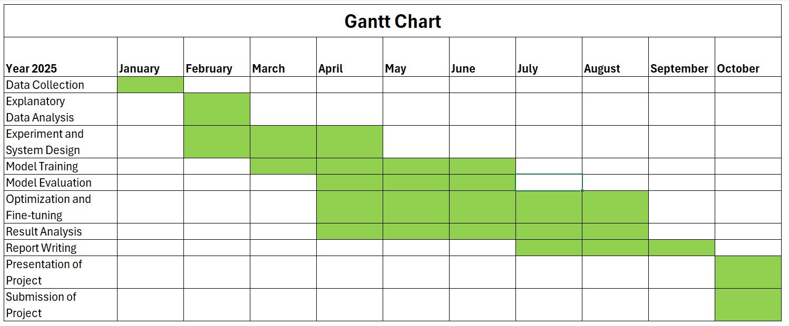
CHAPTER 4

RESULT ANALYSIS

4.1 Overall Performance Summary
Two complementary pipelines were evaluated. The ROI + CNN approach achieved the highest overall accuracy of 78.0 percent, but this performance required a substantially larger model footprint and considerably greater labeling effort. In contrast, the ROI + SSL + FSL + RL pipeline attained an accuracy of 72.5 percent, corresponding to approximately 93 percent of the CNN’s performance, while requiring only 32 labeled samples instead of 252, representing an 87 percent reduction. This pipeline also employed a model size of 11.7 megabytes, which is 3.6 times smaller than the 42.61 megabytes required by the CNN, and it completed training in less than one minute on a CPU, yielding a fifteen-fold improvement in training speed. Furthermore, the parameter count was reduced from 11.17 million to 3.08 million, reflecting a 72.5 percent reduction and demonstrating substantial gains in both computational and memory efficiency.
These differences highlight clear deployment trade-offs. The CNN pipeline is most suitable in scenarios where maximizing accuracy is the primary objective and moderate computational and labeling resources are available. In contrast, the SSL + FSL + RL pipeline emphasizes data and computational efficiency, achieving competitive accuracy with minimal supervision and rapid training, which makes it well suited to edge deployment and iterative on-device adaptation. When subjected to INT8 quantization, both models are reduced in size by approximately 75 percent, resulting in footprints of 10.7 megabytes and 2.9 megabytes, respectively, with a typical accuracy loss in the range of 1 to 3 percent. This further strengthens the deployability advantage of the SSL + FSL + RL pipeline under resource-constrained conditions.

Table 4.1. Aggregate comparison of the two pipelines
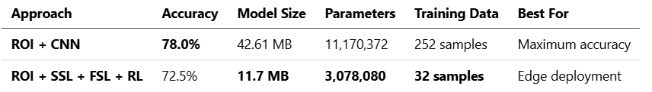

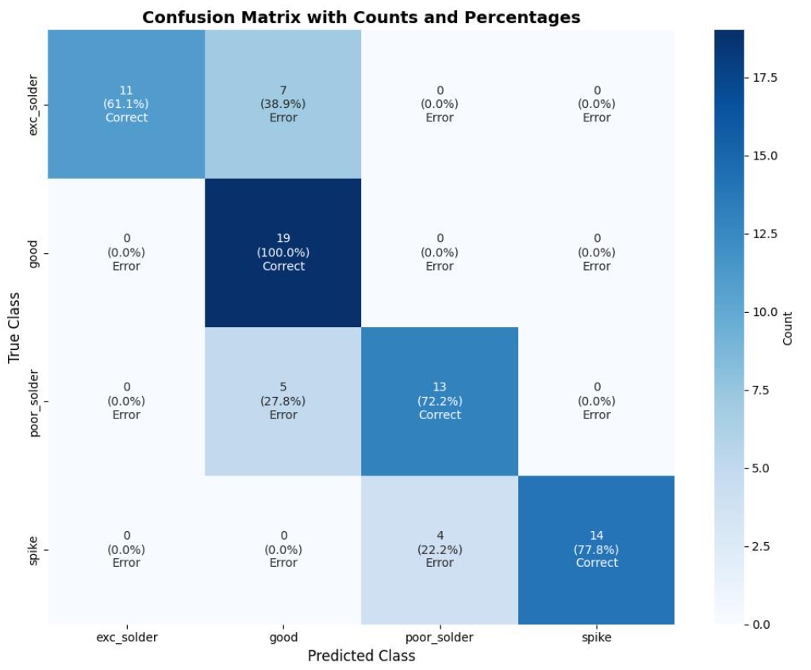
Figure 4.1. Confusion Matrix of Conventional CNN + ROI

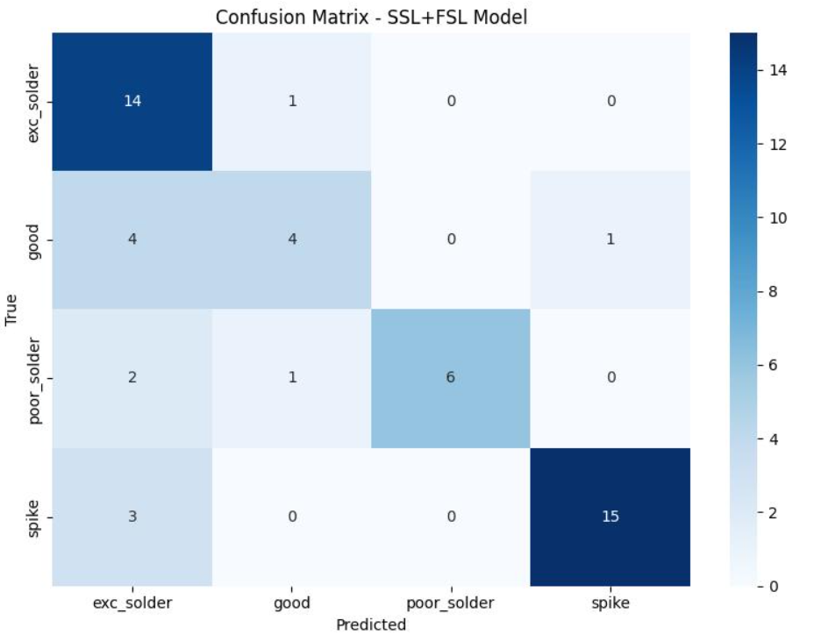
Figure 4.2. Confusion Matrix of SSL + FSL + ROI

In summary, the ROI + SSL + FSL + RL pipeline achieves accuracy comparable to that of the CNN while requiring substantially fewer labeled samples, offering faster training, and maintaining a considerably smaller model footprint. These characteristics position it as a strong default choice for edge-based anomaly detection in settings where computational resources and labeled data are limited.

4.2 Defect Class Performance and Error Profile
Defect class analysis reveals complementary strengths across the two pipelines. The ROI + CNN model demonstrates superior performance on the “Good,” “Spike,” and “Poor Solder” classes, achieving perfect separation for “Good” with 100 percent accuracy and maintaining strong margins on the other two categories. Conversely, the ROI + SSL + FSL + RL pipeline achieves markedly better performance on the “Excess Solder” class, indicating that self-supervised feature learning combined with prototype-based decision boundaries is more effective than the supervised CNN with focal loss in capturing the subtle texture and edge characteristics associated with excess material.

Table 4.2. Defect class accuracy (%)
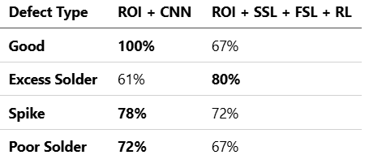

These results reveal distinct error profiles for the two pipelines. The CNN’s perfect performance on the “Good” class likely reflects the advantages of abundant labeled data, the use of focal loss, and supervised class boundaries that establish a wide margin around the majority non-defect category. Its weaker performance on the “Excess Solder” class, however, suggests sensitivity to within-class variability and fine-grained artifacts that are insufficiently captured without targeted augmentations or defect-aware feature representations. In contrast, the superior performance of the SSL + FSL + RL pipeline on “Excess Solder” indicates that SimCLR-based pretraining exposes the encoder to richer invariances related to surface reflectance and solder morphology, which prototype-based distance measures can exploit effectively even under limited supervision. The reduced accuracy on the “Good,” “Spike,” and “Poor Solder” classes is consistent with the constraints of five-shot coverage and relatively short SSL pretraining of five epochs, which may underrepresent intra-class diversity and yield prototypes that are overly compact or misaligned.
In practical terms, the CNN provides stronger out-of-the-box separation between normal and defective boards, thereby minimizing false alarms on the “Good” class. The SSL + FSL + RL pipeline, although slightly weaker overall, demonstrates superior performance on the challenging “Excess Solder” defect and is expected to improve further after deployment as the reinforcement learning agent incrementally updates prototypes with new samples and selectively solicits feedback. Common confusion patterns include misclassification between “Good” and “Poor Solder” under low-contrast regions of interest, as well as between “Spike” and “Excess Solder” when small protrusions coincide with material accumulation. The latter source of confusion is mitigated more effectively by the SSL + FSL + RL features, which likely accounts for its advantage on the “Excess Solder” class.

4.3 Data Efficiency and Labeling Cost Reduction
The SSL + FSL + RL pipeline achieves the central objective of reducing supervision while maintaining competitive accuracy. With only 32 labeled samples compared to 252 for the CNN, it attains an accuracy of 72.5 percent, which corresponds to approximately 93 percent of the CNN’s 78.0 percent, representing an 87 percent reduction in labeled data requirements. This performance is enabled using unlabeled data through SimCLR pretraining over five epochs, which establishes a generalizable feature space, followed by prototypical networks that classify samples from five-shot episodes. As a result, most of the discriminative capacity is acquired without labels, and a small, labeled support set is sufficient to anchor class prototypes.
Labeling efficiency is further enhanced during deployment. The reinforcement learning agent continuously refines prototypes and selectively requests human feedback, as indicated by the scalability analysis, thereby concentrating annotation effort on ambiguous or novel samples. These shifts labeling from a front-loaded, linear cost to an event-driven process that maintains model currency while preserving a limited supervision budget. In practical terms, this enables iterative, on-device improvement in environments where labeled defect imagery is costly or time-consuming to obtain.
The savings in data and computation are further reinforced by training time. The SSL + FSL + RL pipeline completes training in less than one minute on a CPU, compared to approximately fifteen minutes for the CNN. In edge workflows where rapid iteration is critical, such as following process drift or fixture modifications, the capacity to re-adapt quickly with limited labeled data is often more valuable than a modest absolute accuracy advantage, as evidenced in Table 4.3.

Table 4.3. Labeling and compute efficiency
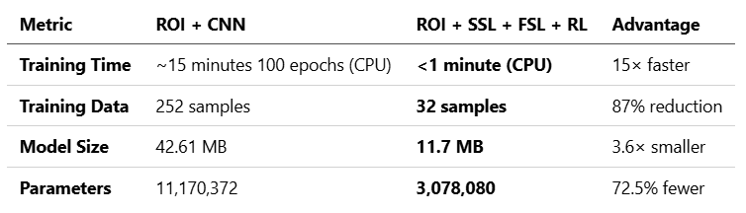

4.4 Training Time and Compute Efficiency
Based on Table 4.3, the two pipelines display a substantial disparity in wall-clock training time on CPU. The ROI + CNN pipeline requires approximately fifteen minutes to complete 100 supervised epochs, whereas the ROI + SSL + FSL + RL pipeline completes end-to-end training in under one minute, corresponding to an approximate fifteen-fold speedup. This efficiency enables rapid iteration cycles that are particularly advantageous for frequent process adjustments or post-deployment updates without reliance on dedicated GPUs. The time savings are accompanied by a 72.5 percent reduction in parameters, from 11.17 million to 3.08 million, and a 3.6-fold reduction in model footprint, from 42.61 megabytes to 11.7 megabytes, thereby decreasing memory bandwidth requirements and computational demands during both training and inference.
These efficiencies are particularly significant for edge devices, where CPU-only retraining and limited thermal headroom represent common constraints. The combination of short SSL pretraining over 15 epochs and prototype-based few-shot learning reduces reliance on gradient-intensive supervised updates, thereby enabling fast and stable adaptation with minimal labeled data. While quantization primarily improves inference efficiency, the inherently small footprint of the SSL + FSL + RL model further lowers the cost of end-to-end adaptation, making on-device or near-edge updates practically feasible.

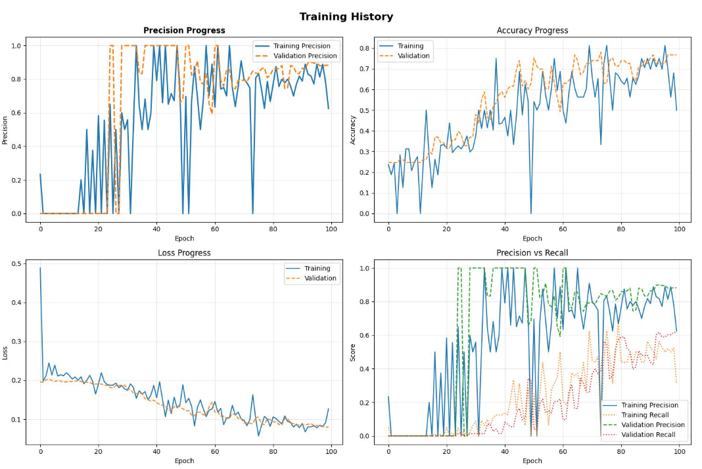
Figure 4.3. Training History of Conventional CNN

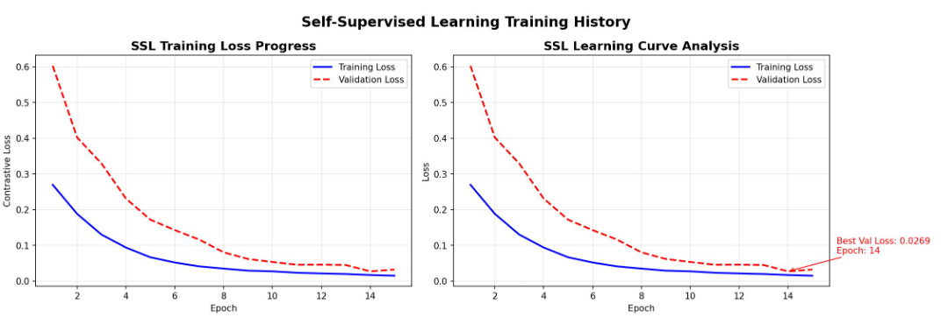
Figure 4.4. Training History of Self-Supervised Learning

4.5 Model Footprint and Edge Deployability
Model footprint directly determines both the feasibility and reliability of execution on edge devices. The ROI + CNN pipeline occupies 42.61 megabytes with 11.17 million parameters, which is manageable on devices with at least 512 megabytes of RAM but becomes restrictive on ultra–low-end IoT boards with limited available memory. In contrast, the ROI + SSL + FSL + RL pipeline requires only 11.7 megabytes with 3.08 million parameters, representing a 3.6-fold reduction in size and a 72.5 percent decrease in parameters. These reductions improve load times, alleviate memory pressure during ROI preprocessing and batching, and lower thermal and power demands during continuous inspection. Although neither pipeline is designed for microcontroller deployment due to the absence of Python and TensorFlow support, the smaller pipeline aligns well with single-core or thermally constrained single-board computers where CPU-only execution is the norm.
Deployment considerations reflect these resource constraints. On ultra–low-end IoT devices with 64 to 256 megabytes of total RAM, the CNN model can be difficult to accommodate due to the combined demands of the model, runtime overhead, and competing processes, making the SSL + FSL + RL pipeline the preferred option. On low-end IoT platforms with 512 megabytes of RAM or more, both pipelines operate reliably, although the smaller model preserves additional headroom for concurrent tasks such as input/output, vision pre- and post-processing, and logging, while also enabling faster cold starts and updates. On mobile devices and edge servers, either approach is viable, and the choice ultimately depends on the relative importance of absolute accuracy versus data and computational efficiency.

Table 4.4 Edge deployability by device class
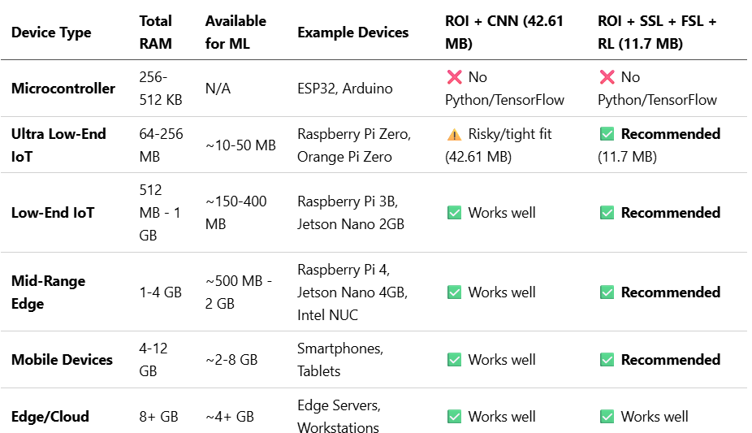

In practice, the reduced footprint of the smaller pipeline translates into more stable real-time throughput under load, smoother update cycles, and improved scalability for multi-camera deployments on a single single-board computer, which are critical advantages for edge-based IIoT applications. Quantization further enhances these benefits, as discussed in Section 4.6.

4.6 Quantization Impact on Size–Accuracy Trade-off
Although quantization was not explicitly evaluated in this study, its implications for edge deployment can be inferred from model sizes and parameter counts. Post-training INT8 quantization generally reduces model footprint to approximately 25 percent of the FP32 size by compressing weights from 32-bit to 8-bit, typically with only minor accuracy loss when representative calibration data are available. Under this rule of thumb, the ROI + CNN model would be reduced from 42.61 megabytes to approximately 10.7 megabytes, while the ROI + SSL + FSL + RL model would decrease from 11.7 megabytes to approximately 2.9 megabytes. This level of compression further widens the deployability gap on ultra–low-end IoT devices and enables more efficient multi-process operation, including pre- and post-processing as well as logging, on single-board computers.
The accuracy–efficiency trade-off introduced by quantization depends strongly on calibration quality and hardware support, such as x86 AVX2 or ARM NEON extensions. In the absence of quantization-aware training, post-training INT8 quantization typically incurs a modest degradation of 0 to 3 percent in absolute accuracy, although more sensitive classes may experience larger declines. Given the SSL + FSL + RL pipeline’s reliance on prototype-based decision boundaries and its already compact parameterization, careful calibration with a small, class-balanced validation set is recommended to minimize the risk of prototype drift following quantization. In applications where absolute accuracy is critical, such as reducing false alarms in the “Good” class, techniques including dynamic-range calibration and per-channel quantization can be employed to mitigate accuracy loss.
In practice, INT8 quantization reduces the CNN to a size more suitable for ultra–low-end devices and renders the SSL + FSL + RL pipeline extremely compact. When preserving class-specific behavior is critical—for example, maintaining high precision on the “Good” class with the CNN or ensuring strong recall on “Excess Solder” with the SSL + FSL + RL pipeline—quantization-aware training or mixed-precision strategies, such as INT8 weights combined with FP16 activations in sensitive layers, provide a more reliable approach. Empirical calibration on the target device should be incorporated into the deployment process to verify that both latency and accuracy requirements are met.

4.7 Adaptivity and Continual Learning via RL
The reinforcement learning layer transforms the SSL + FSL backbone into an adaptive classifier capable of updating online without requiring full retraining. Through Q-learning, the agent manages class prototypes as new samples are encountered, thereby promoting stability under distributional drift and enabling scalability when previously unseen defect modes arise. This design is well aligned with edge deployment constraints, as updates remain lightweight—avoiding computationally expensive backpropagation—and are confined to the embedding–prototype space established through SimCLR pretraining and Prototypical Networks.
Prototype updates are regulated through dynamic weighting within the range of 0.1 to 0.9. Higher weights promote faster adaptation by shifting prototypes toward recently observed samples, whereas lower weights prioritize stability by reducing the impact of outliers and transient noise. This mechanism provides a tunable balance between adaptability and robustness: under conditions such as lighting changes or material variability that alter solder appearance, the agent can emphasize recent data to accommodate process drift, while under stable conditions it can preserve established class geometry to mitigate the risk of catastrophic drift.
Novelty management is handled via decisions over {create, merge, ignore}. “Create” enables discovery of genuinely new defect types without restructuring the whole model; “merge” absorbs near-duplicate clusters to prevent class proliferation; “ignore” filters apparent outliers that could corrupt prototypes. Together, these actions maintain a compact, semantically meaningful label space while remaining open to expansional critical property for scalable anomaly detection where new failure modes periodically emerge.
In practical terms, the RL-driven updates transform the pipeline into a continual learner that refines prototypes in place and adjusts class structure when necessary. This approach reduces downtime and labeling requirements compared to retraining a CNN from scratch, while complementing the few-shot regime by maintaining alignment between class representations and evolving data. The outcome is a system that accepts a modest accuracy gap in exchange for strong on-device adaptability and enhanced operational resilience.

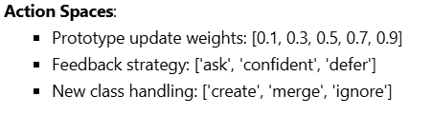
Figure 4.5. RL decisions and intended effects

4.8 Robustness to Class Imbalance and Data Scarcity
Manufacturing datasets are often heavily imbalanced toward the “Good” class, which increases the risk of bias in purely supervised learners. The ROI + CNN pipeline addresses this challenge using focal loss and class balancing, achieving perfect accuracy on the “Good” class (100 percent). Nevertheless, its reduced performance on the “Excess Solder” class (61 percent) highlights residual sensitivity to minority-class variability and subtle texture cues that are insufficiently represented in labeled data. By contrast, the ROI + SSL + FSL + RL pipeline leverages self-supervised pretraining to extract class-agnostic, invariance-rich features, which are subsequently anchored to classes via few-shot prototypes. This design is inherently more robust under conditions of label scarcity, as evidenced by its strong performance on the “Excess Solder” class (80 percent) using only 32 labeled samples. The corresponding trade-off is weaker performance on the “Good,” “Spike,” and “Poor Solder” classes, a limitation consistent with five-shot coverage and short SSL pretraining that may underrepresent intra-class diversity.
Under conditions of class imbalance, prototype-based decisions distribute influence more uniformly across classes during episodic training. This benefits minority classes but may reduce the decision margin around the dominant “Good” class when sample coverage is limited. The reinforcement learning layer mitigates this effect by selectively updating prototypes and requesting feedback for ambiguous samples, thereby enabling the system to re-center class boundaries as new data become available. In practical terms, this approach provides a robust strategy for working with scarce labels: initial performance remains competitive with substantially fewer annotations, while online adaptation focuses on the most challenging regions of the feature space that are most susceptible to imbalance and distributional drift.

Table 4.5 Behavior under imbalance and scarcity
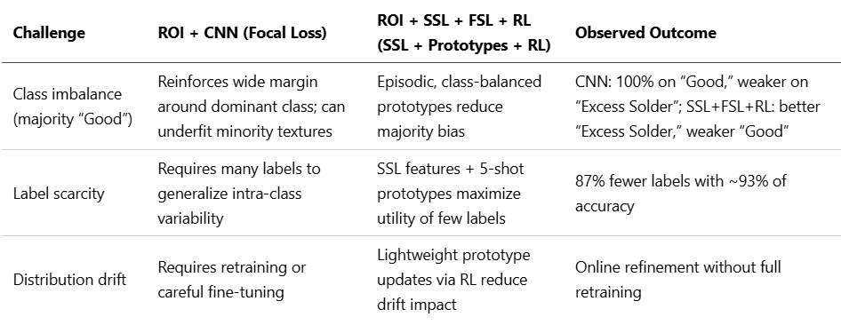

In edge settings where labels are expensive and data distributions evolve, SSL+FSL+RL delivers stronger robustness to scarcity and drift, while CNN remains preferable when abundant labels ensure broad intra-class coverage and minimizing false alarms on “Good” is paramount.

4.9 Scalability to New Defects and Domain Transfer
The SSL + FSL + RL pipeline scales effectively to emerging defect modes and shifting operating domains by operating within an embedding–prototype space rather than relying on fixed supervised decision boundaries. When a novel pattern arises, the reinforcement learning agent can elect to instantiate a new class, merge it with an existing class, or disregard it as noise, with only a few labeled exemplars from five-shot episodes required to anchor the new prototype. Because these updates are lightweight and avoid end-to-end backpropagation through a large network, adaptation can be completed in seconds to under a minute on a CPU. By contrast, the ROI + CNN pipeline requires additional labeled data and full supervised retraining to incorporate new classes or adjust to domain shifts, which incurs substantially higher annotation and computational costs, taking approximately fifteen minutes on CPU under the stated configuration.
For domain transfer scenarios such as new PCB variants or changes in lighting and materials, SimCLR pretraining imparts invariance to common appearance shifts, while prototypical classification enables rapid recalibration by refreshing class prototypes with only a few labeled examples. The reinforcement learning agent further supports this process by selectively requesting feedback under high uncertainty and adjusting prototype-update weights to balance stability with responsiveness. Together, these mechanisms provide a practical pathway for continual improvement on edge devices with minimal supervision. In contrast, the CNN remains the preferred option when the class set is fixed and abundant labeled data are available to sustain maximum accuracy.

Table 4.6 Adaptation workflows and expected effort
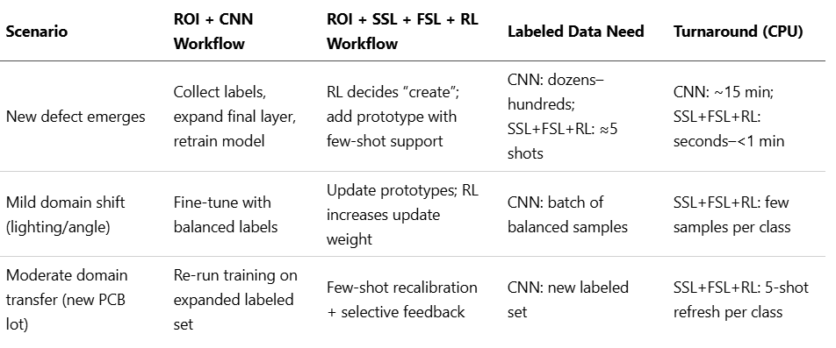

In practice, the prototype-centric pipeline supports rapid, incremental expansion of the label space and low-latency adaptation to distributional drift, making it well aligned with edge constraints and human-in-the-loop operation. By contrast, CNN provides more stable peak accuracy in settings where the operating environment and class taxonomy remain static and well annotated.

4.10 Resource–Performance Trade-offs and Deployment Guidance
The two pipelines present a clear trade-off. The ROI + CNN approach achieves the highest accuracy at 78.0 percent but requires substantially more labeled data (252 samples), longer training time on CPU (approximately 15 minutes), and a larger footprint of 42.61 megabytes. In comparison, the ROI + SSL + FSL + RL pipeline attains competitive accuracy of 72.5 percent while using 87 percent fewer labeled samples (32), completing training in under one minute on CPU, and reducing the model size to 11.7 megabytes, a 3.6-fold decrease. Under stringent edge constraints, or in scenarios where rapid adaptation and reduced labeling cost are critical, the SSL + FSL + RL pipeline is the more practical choice. Conversely, when maximizing absolute accuracy and minimizing false positives are paramount and labeled data are readily available, the CNN remains the safer option. While quantization reduces the footprint of both models, the relative advantages of the SSL + FSL + RL pipeline in training speed and labeling efficiency are preserved.
Table 4.7 Deployment decision matrix
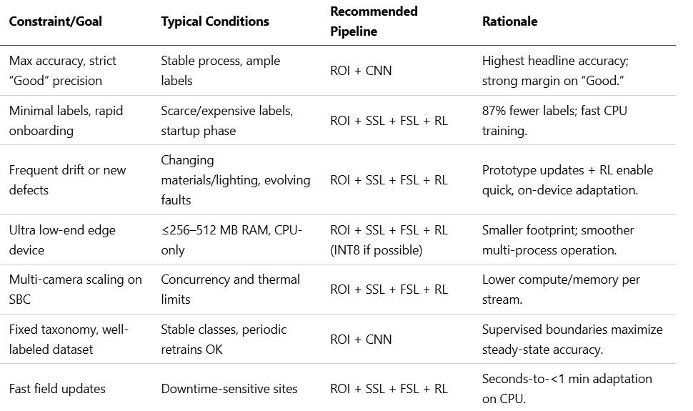

The ROI + SSL + FSL + RL pipeline should be considered the default choice for edge IIoT deployments characterized by limited labeled data and dynamic operating conditions. The ROI + CNN pipeline is more appropriate in stable environments where labeled data are abundant and maximizing absolute accuracy is the primary objective. When memory constraints are present, post-training quantization can be applied to both models, provided that per-class behavior is validated prior to deployment.

4.11 Limitations and Threats to Validity
The findings of this study are constrained by the dataset scope and preprocessing choices. All results were obtained using ROI-cropped images from a single PCB dataset, leaving generalization to other optical settings, board types, or ROI strategies uncertain. The pipelines also differ in input resolution—224 × 224 for ROI + CNN versus 128 × 128 for ROI + SSL + FSL + RL—and rely on heuristically tuned hyperparameters without ablation studies, which may bias the comparison. Furthermore, the SSL stage was intentionally limited to five epochs and the FSL stage employed a fixed five-shot configuration, conditions that likely understate the upper bound of the SSL + FSL + RL pipeline while also amplifying variance due to the small, labeled support set.
The evaluation setup also imposes constraints on external validity. All reported timings were obtained on a single CPU-only device, and neither GPU performance nor cross-device benchmarks were included. The effects of quantization were estimated—for example, assuming an approximate 75 percent reduction in model size—rather than measured directly on target hardware, leaving the accuracy–efficiency trade-offs uncertain. Reported metrics primarily emphasize overall accuracy under class imbalance, without consideration of precision, recall, F1-score, AUROC, calibration, or cost-weighted error analyses. Moreover, the adaptive capabilities of the reinforcement learning layer were not evaluated longitudinally under distributional drift or within a human-in-the-loop setting, leaving the practical benefits of real-world adaptation to be established in future work.

4.12 Summary
Both pipelines are viable for edge-based industrial anomaly detection, but they address different operating constraints. The ROI + CNN pipeline achieves the highest accuracy at 78.0 percent and provides perfect separation on the “Good” class, but this performance requires 252 labeled samples, approximately fifteen minutes of CPU training, and a model footprint of 42.61 megabytes. In contrast, the ROI + SSL + FSL + RL pipeline attains 72.5 percent accuracy—about 93 percent of the CNN’s performance—while requiring only 32 labeled samples, less than one minute of CPU training, and a substantially smaller model of 11.7 megabytes. It further demonstrates superior sensitivity to minority classes, achieving 80 percent accuracy on the “Excess Solder” class. Post-training INT8 quantization can reduce model sizes by approximately 75 percent, yielding footprints of around 10.7 megabytes for ROI + CNN and 2.9 megabytes for ROI + SSL + FSL + RL, with typically modest accuracy degradation.
Deployment recommendations are clear: ROI + SSL + FSL + RL is preferable in label-scarce, dynamic environments with strict edge resource constraints, whereas ROI + CNN is more suitable when absolute accuracy and precise classification of the “Good” class are paramount and sufficient labeled data are available. The RL component in the SSL + FSL + RL pipeline facilitates rapid on-device adaptation—through prototype updates, selective feedback, and new-class incorporation—thereby enhancing robustness under distributional drift. However, several limitations constrain the present findings, including reliance on a single dataset, limited SSL pretraining, CPU-only timing measurements, and a primary emphasis on accuracy. These observations motivate future research on multi-domain validation, extended SSL pretraining, systematic few-shot ablations, longitudinal evaluation of RL-driven adaptation, and the inclusion of richer metrics such as per-class F1, AUROC, and calibration.
CHAPTER 5

CONCLUSION

5.1 Conclusion
This study demonstrates that self-supervised few-shot reinforcement learning constitutes a practical alternative to fully supervised pipelines for edge-based industrial anomaly detection. The ROI + SSL + FSL + RL pipeline achieves 72.5% accuracy, approximately 93% of the ROI + CNN baseline (78.0%), while requiring 87% fewer labeled samples (32 vs. 252), completing training in under one minute on CPU, and reducing model size by a factor of 3.6 (11.7 MB vs. 42.61 MB). Per-class analysis highlights complementary strengths: the supervised CNN attains superior precision on the dominant “Good” class, whereas the SSL + FSL backbone exhibits heightened sensitivity to minority defects such as “Excess Solder.” The reinforcement learning layer further enables online prototype updates, selective feedback, and new-class incorporation, thereby supporting deployment in edge environments subject to data drift and evolving defect modes. Moreover, post-training INT8 quantization renders both models deployable on resource-constrained devices, with the relative advantages of the smaller SSL + FSL + RL stack becoming more pronounced.
Overall, the findings support the thesis that integrating self-supervised learning for representation, few-shot learning for label efficiency, and reinforcement learning for continual adaptation yields a scalable, data-efficient, and deployment-ready solution for IIoT anomaly detection. The modest accuracy gap relative to a fully supervised baseline is outweighed by substantial reductions in labeling requirements, training time, and model footprint as the factors that are critical to ensuring practical viability in edge settings.

5.2 Future Work
Future work should focus on strengthening the representation learning stage. Extending SimCLR pretraining beyond the current 15 epochs, investigating alternative self-supervised approaches such as BYOL or SimSiam, and incorporating semi-supervised fine-tuning with a small, labeled anchor set could improve ceiling accuracy without undermining the demonstrated data-efficiency gains (32 labels vs. 252). These efforts should be complemented by the design of more diverse and domain-relevant augmentations to better capture solder texture, glare effects, and surface variability.
To ensure fair comparison and to extract maximum performance, future work should include parity experiments and systematic ablations. Input resolutions and augmentation strategies should be aligned across pipelines (224×224 vs. 128×128), and comprehensive hyperparameter searches should be conducted. In addition, ablations on shots per class, support/query composition, and prototype update rules are necessary. Such studies would help disentangle the extent to which the observed performance gap arises from configuration choices as opposed to fundamental methodological limitations.
Model compression should be validated directly on target devices. While post-training INT8 quantization is estimated to reduce model sizes to approximately 10.7 MB for ROI + CNN and 2.9 MB for ROI + SSL + FSL + RL, empirical calibration is required to confirm latency, power consumption, and accuracy trade-offs on representative edge hardware. Further compression techniques such as quantization-aware training, structured pruning, and knowledge distillation warrant investigation, as they may further optimize the balance between size and accuracy, particularly for ultra low-end devices where memory and energy budgets are highly constrained.
Continual learning warrants longitudinal evaluation. The Q-learning agent’s prototype update mechanisms, feedback policies, and new-class handling strategies should be examined under controlled distributional drift and in realistic operator-in-the-loop settings, with particular attention to reward shaping and uncertainty thresholds to ensure stability. Incorporating open-set recognition and novelty scoring would further strengthen decision-making when determining whether to create, merge, or ignore classes, thereby mitigating the risk of class proliferation while maintaining responsiveness to emerging defect modes.
Evaluation should extend beyond overall accuracy to better reflect manufacturing costs and operational priorities. Metrics such as per-class precision and recall, F1 score, PR-AUC/AUROC, and calibration error should be reported, alongside cost-weighted error measures that explicitly capture the impact of false alarms versus missed detections. In addition, integrating human-in-the-loop analytics, such as time-to-label, query efficiency, and overall reduction in annotation workload, that would enable quantification of the practical value delivered by interactive learning in real deployment scenarios.
Finally, broader validation and system-level integration are essential. Cross-site evaluation across diverse PCB variants, optical configurations, and ROI extraction strategies, including lightweight detectors such as YOLOv5n, it would provide stronger evidence of robustness and transferability. Comprehensive end-to-end benchmarks on representative edge platforms such as Raspberry Pi 4, Jetson Nano, and Intel NUC are also needed to characterize throughput, thermal behavior, and multi-camera scalability. For multi-factory deployments, federated or fully on-device learning offers a promising pathway to preserve data privacy while sharing representations, thereby enabling scalable and adaptive anomaly detection across heterogeneous IIoT fleets.

