

Self-Supervised Few-Shot Reinforcement Learning for Scalable and Adaptive Anomaly Detection in Edge-Based Industrial IoT Systems

Ng Kien Loong
TP078627

Master of science in artificial intelligence
Research Methodology in Computing and Engineering (RMCE)

Asia Pacific University of Technology & Innovation (APU)
School of Computing and Technology

Assoc. Prof. Dr V. Sivakumar (Module Lecturer & Co-supervisor)
Assoc. Prof. Dr. Raja Rajeswari (Supervisor)

December 2024

ABSTRACT

IIoT systems are becoming more complicated and larger, necessitating reliable and efficient anomaly detection techniques, especially in edge-based settings with decentralized data and constrained resources. Conventional anomaly detection methods frequently struggle to adjust to changing data patterns and require enough labeled data for training, which no longer feasible in real-time IIoT applications. This research presents a method to overcome these obstacles by combining reinforcement learning, few-shot learning, and self-supervised learning. The framework can produce high-quality data representations on its own by using self-supervised learning, which makes it possible to detect anomalies effectively with little labeled data. With fewer training samples, few-shot learning enables the model to adjust to novel, previously undiscovered anomalies, which makes it appropriate for dynamic industrial settings. To ensure scalability and adaptability in edge-based systems, reinforcement learning is also integrated to continuously enhance the model's performance. Experiments conducted in actual IIoT environments are used to assess the suggested framework, showing that it can effectively detect anomalies while reducing computing overhead. The findings demonstrate its potential to improve edge-based IIoT systems' operational effectiveness, security, and dependability in a range of industrial applications.

Keywords: Self-supervised learning, Few-shot learning, Reinforcement learning, Anomaly detection, Edge computing, Industrial IoT, Scalable and Adaptive systems.

TABLE OF CONTENTS

ABSTRACT ii
TABLE OF CONTENTS iii
LIST OF TABLES iv
LIST OF FIGURES v
LIST OF ABBREVIATIONS vi
CHAPTER 1: INTRODUCTION 1
1.1 Introduction 1
1.2 Research Background 1
1.3 Problem Statement 3
1.4 Research Questions 3
1.5 Aim & Objectives 4
1.6 Scope of the Research 5
1.7 Significance of the Research 5
CHAPTER 3: RESEARCH METHODOLOGY 7
2.1 Overview 7
2.2 Data Acquisition and Preprocessing 7
2.3 Model Design and Development 7
2.4 Experimentation and Deployment 8
2.5 Ethical and Safety Considerations 9
2.6 Justification 9
2.7 Resources Required 9
2.8 Evaluation and Validation 10
2.9 Summary 10
2.10 Research Plan 11
REFERENCES 12

LIST OF TABLES

LIST OF FIGURES

Figure 1.1: The CoLA framework 1
Figure 1.2: The architecture structure of the TCN models 15
Figure 2.1: Flowchart of research methodology 22
Figure 2.2: Gantt chart of research 26

LIST OF ABBREVIATIONS

AI Artificial Intelligence
CoLA Contrastive Self-Supervised Learning
CPU Central Processing Unit
FSL Few-shot Learning
FSRL Few-shot Reinforcement Learning
GNN Hraph Neural Networks
GPU Hraphics Processing Unit
IIoT Industrial Internet of Things
PCB Printed Circuit Board
RL Reinforcement Learning
RNN Recurrent Neural Network
SSL Self-supervised Learning
SSL-FSRL Self-supervised Few-shot Reinforcement Learning
TCN Temporal Convolutional Network

CHAPTER 1

INTRODUCTION

1.1 Introduction
Manufacturing and industrial operations have been transformed by the quick spread of Industrial Internet of Things (IIoT) devices, which allow for real-time data collecting, monitoring, and edge decision-making. But this growth also raises the possibility of anomalies like equipment breakdowns, sensor issues, or cybersecurity threats, which can seriously impair operations and drive-up expenses. Conventional anomaly detection techniques frequently depend on huge, labeled datasets and centralized systems, which are computationally demanding and unsuitable for edge-based, low-latency environments.
A novel solution to this problem is provided by the combination of few-shot reinforcement learning (FSRL) and self-supervised learning (SSL). These methods preserve the scalability and efficiency required for edge computing while allowing systems to dynamically adjust to novel and uncommon anomalies without the requirement for extensive labeled data. The possibility of integrating SSL and FSRL to create an adaptive anomaly detection framework that satisfies IIoT system requirements is investigated in this research.

1.2 Research Background
Given the complexity and importance of industrial operations, anomaly detection in IIoT systems has grown in importance. Conventional approaches frequently lack the flexibility to accommodate new anomalies or are constrained by the requirement for sizable, labeled datasets. A promising answer to these problems is provided by hybrid strategies that combine RL, few-shot learning (FSL), and SSL. We examine these intersections and how they are used in IIoT anomaly detection below.
Self-supervised methods and few-shot learning are essential for dealing with data scarcity in IIoT anomaly detection. The CoLA framework by Liu et al. (2021) and gated few-shot approach by Huang et al. (2020) efficiently leverage graph neural networks for improved accuracy in high-dimensional IIoT data by enhancing feature representation through limited labeled data and SSL. Figure 1.1 shows the CoLA framework consists of three parts: instance pair sampling, a GNN-based contrastive learning model, and anomaly score computation. For example, if node 𝑣6 is the target, positive and negative instance pairs are sampled. The GNN model predicts scores for these pairs, and the anomaly score for 𝑣6 is calculated using statistical estimates of these scores. Node 𝑣3, with corrupted attributes, serves as an example of an anomaly, while the other nodes are normal.
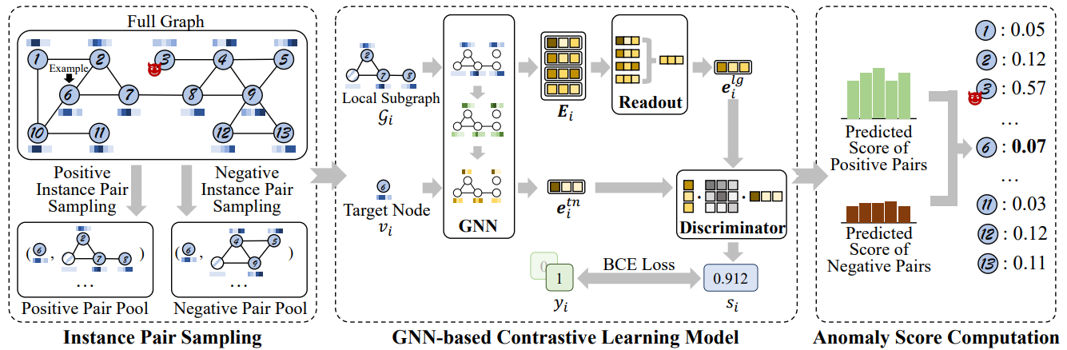
Figure 1.1: The CoLA framework

As demonstrated by Cen et al. (2023), the RL-integrated temporal convolutional networks and Wang et al. (2022) used hierarchical federated learning, which handle temporal and spatial variability, RL further enhances this by facilitating dynamic adaptability. Figure 1.2 demonstrates the architecture structure of model, as the TCN models provide a great parallel computation and more extended memory rather than RNNs, which improves the efficiency of the model eventually.
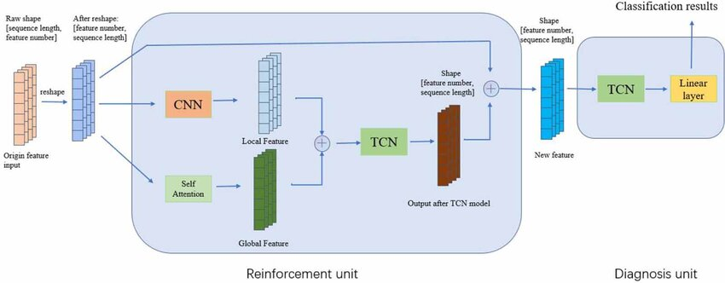
Figure 7: The architecture structure of the TCN models

Sun et al. (2021) presented the hybrid models cross-domain learning for varied IIoT contexts and Qi et al. (2024) created few-shot framework are useful for practical applications, such as cyberattack detection and predictive maintenance. Although these methods have potential, issues with scalability, interpretability, and real-time processing still exist, highlighting the necessity of more SSL, few-shot, and RL technique integration to increase detection precision and flexibility in IIoT systems.

1.3 Problem Statement
The Industrial Internet of Things' (IIoT) rapid growth has revealed significant weaknesses in the frameworks now in use for anomaly detection. One of the main challenges is their strong reliance on large quantities of labeled data. Zhang et al. (2020) emphasized that labeling industrial anomalies is both expensive and impractical due to their rarity and contextual variability. Similarly, Pang et al. (2021) argued that the dependence on labeled data severely limits the scalability and generalization of anomaly detection systems, particularly in real-world IIoT environments.
Furthermore, when applied to edge environments, many existing models encounter scalability issues because they were originally designed for centralized cloud-based infrastructures. Chen et al. (2022) highlighted that edge-based IIoT systems require real-time and low-latency responses, which are difficult to achieve with cloud-centric models. Li et al. (2021) further pointed out that traditional algorithms struggle with real-time inference on distributed, resource-constrained edge devices, limiting their use in dynamic manufacturing scenarios.
The static nature of traditional anomaly detection techniques is another critical limitation. Ahmed et al. (2016) observed that many anomaly detection models rely on offline training using historical data, making them unsuitable for evolving industrial processes. Wu et al. (2022) echoed this concern, noting that such models often fail to adapt to new patterns or conditions, resulting in reduced reliability and detection performance over time.
These challenges underscore the importance of developing a data-efficient, scalable, and adaptable anomaly detection framework. Wang et al. (2023) proposed that self-supervised approaches offer promising benefits for learning from unlabeled data in real-time. In a related study, Zhang and Liu (2021) demonstrated that few-shot reinforcement learning can enhance anomaly detection by enabling rapid adaptation to new anomalies with minimal supervision, particularly in edge computing environments.

1.4 Research Questions
- What is the role of self-supervised learning and few-shot reinforcement learning in detecting anomalies in edge-based IIoT systems?
- How can this method accurately identify outliers and changing anomalies while minimizing the requirement for large and labeled datasets?
- How does the proposed framework adapt to changing industrial environments with fluctuating data and operational conditions?
- What approaches ensure the scalability and efficiency of the anomaly detection system in edge environments with limited resources?
- How does this new method compare to conventional anomaly detection techniques in terms of accuracy, latency, and flexibility?
- Why is a scalable and adaptable system necessary for reducing reliance on labeled datasets and improving anomaly detection in dynamic settings?
- Who benefits the most from implementing this framework in resource-constrained edge systems, and how does it enhance real-time performance?

1.5 Aim & Objectives
- To investigate at the way self-supervised learning and few-shot reinforcement learning can improve edge-based IIoT systems' ability to detect anomalies, especially in situations when labeled data is hard to come by or unavailable.
- To solve the data efficiency issue in industrial anomaly detection by creating and putting into practice a technique that can precisely detect outliers and dynamic anomalies while reducing the reliance on sizable, labeled datasets.
- To develop the hybrid SSL-FSRL framework's flexibility in changing industrial settings, allowing the model to react to shifting operational circumstances, data patterns, and IIoT infrastructure modifications.
- To examine the framework's capacity for self-improvement and adaptation by providing it the flexibility to learn from fresh data without the requirement for intensive retraining or human intervention. As a result, the system will be able to dynamically adjust to evolving anomaly patterns and changing industrial environments.
- To create and evaluate resource-efficient and scalable methods that preserve anomaly detection capabilities in edge environments with constrained amounts of memory, processing power, and energy.
- To support the need for a flexible and scalable system that enhances detection quality in real-time, dynamic industrial situations while lowering dependency on labeled data.
- To evaluate the application and advantages of the suggested framework, such as greater value delivery in resource-constrained edge deployments, less system interruptions, and better real-time performance.

1.6 Scope of Research
A scalable anomaly detection system designed for edge computing in IIoT contexts is the objective of this research effort. The main goal is to create a SSL-FSRL model that can operate effectively on edge devices with constrained processing power. The model will prioritize lowering resource consumption while retaining good detection performance, considering the limitations of edge devices. By continuously adjusting to fresh data, the framework lessens the requirement for large, labeled datasets and improves real-time anomaly detection in IIoT systems. Early testing will simulate edge conditions on a local computer, allowing for early validation of the model's capabilities even though the system is intended for deployment on edge devices. By assessing the framework's scalability and flexibility over a variety of IIoT system complexities, data availability scenarios, and changing operating conditions, its applicability will be ensured.
The research has several significant limitations despite its encouraging promise. Network heterogeneity in industrial settings, where different communication protocols and fluctuating network latencies may impact the model's performance, may present difficulties for the practical implementation of the suggested framework. Furthermore, the smooth functioning of the model in practical situations may be impeded by hardware-specific limits including processor power, memory capacity, and energy limitations of edge devices. Moreover, more research is required to examine the framework's generalizability across additional IIoT domains, such as manufacturing, smart grids, and predictive maintenance applications, even though it will be tested using a variety of industrial datasets. Additionally, even though the reinforcement learning component was created to function well on edge devices, more optimizations may be needed to handle complex and dynamic settings, especially in configurations with limited resources. Finally, to overcome issues like data sparsity, class imbalance, and the changing nature of industrial contexts, the integration of SSL and FSRL approaches might need more fine-tuning.

1.7 Significance of Research
The potential of this research to reduce unplanned downtime and facilitate predictive maintenance in industrial settings makes it significant. To ensure continuous production in smart manufacturing environments, the suggested framework uses self-supervised few-shot reinforcement learning to detect sensor failures, equipment faults, and operational anomalies in real time. Since the method does not depend on sizable, labeled datasets, it can be easily applied to real-world situations where data labeling is frequently costly and time-consuming. By identifying uncommon and changing dangers like illegal access or strange network behavior, the model can also improve industrial cybersecurity and further protect vital infrastructure.
Moreover, by identifying anomalies in resource distribution, logistics, or delivery timetables, the framework can improve supply chain operations. It is especially well-suited for scalable and adaptive anomaly detection in IIoT systems due to its capacity to operate in limited resources edge locations. This research offers a workable and effective answer to the urgent problems faced by businesses while implementing edge-based IIoT systems by tackling concerns like constrained computational capacity and real-time processing needs. The results may lead to IIoT installations that are more dependable and secure, which would ultimately increase operational effectiveness and lower expenses in a variety of industrial sectors.

CHAPTER 2

LITERATURE REVIEW

2.1 Anomaly Detection in IIoT
IIoT includes the network of sensors, devices, instruments, and data analytics into industrial applications. Anomaly detection is crucial in IIoT systems while addressing challenges such as equipment failure or malfunction, cyber-attacks, and operational inefficiencies.

2.1.1 Temporal Anomaly Detection
Manufacturing processes can be managed in real time with temporal anomaly detection. For detecting anomalies in IIoT-enabled manufacturing systems, Zhan et al. (2021) suggested a hierarchical temporal representation technique based on time series. By examining the sequential nature of sensor data, their method showed exceptional accuracy and efficiency in identifying anomalies, which is crucial in smart manufacturing settings.

2.1.2 Machine Learning Techniques
Machine learning has emerged as a popular technology for IIoT anomaly identification due to its capacity to handle large and diverse datasets. Bhupal Naik D. S. et al. (2022) compared machine learning algorithms such as Random Forest, LightGBM, and K-Nearest Neighbors, and discovered that Random Forest consistently beat other models in anomaly detection accuracy. This study showed the significance of algorithmic selection based on the complexity and amount of IIoT data.
W. Hore & Wakde (2022) conducted a similar study in which they assessed sensor data from industrial systems using unsupervised learning methods such as density-based clustering and fuzzy c-means. Their method worked well for identifying irregularities without the need for labeled information, which allowed for real-time IIoT applications to perform outstandingly.

2.1.3 Network Security
The dependence of IIoT systems on interconnected networks makes them particularly susceptible to cyberattacks. Using deterministic physical properties, Zhou and Guo (2018) investigated anomaly detection techniques designed for IIoT networks. According to Zhou and Guo (2018), this research provided a thorough analysis of network-based anomaly detection techniques that protect against intrusions and guarantee system availability.
IIoT systems are especially vulnerable to assaults due to their reliance on interconnected networks. Zhou and Guo (2018) examined anomaly detection methods intended for IIoT networks using deterministic physical features. Zhou and Guo (2018) claim that this study offered a comprehensive examination of network-based anomaly detection methods that ensure system availability and prevent intrusions.

2.1.4 Deep Learning
Deep learning models have been used to enhance IIoT systems' anomaly detection capabilities. To successfully detect abnormalities and remove sensor noise, Han et al. (2021) created a multidimensional data-processing framework based on autoregressive models. With high-dimensional datasets and demanding industrial settings, this method proved.
For real-time anomaly identification in IIoT time-series data, Nizam et al. (2022) suggested a hybrid architecture that combines Long Short-Term Memory (LSTM) autoencoders with Convolutional Neural Networks (CNN). Their methodology demonstrated its applicability for dynamic industrial environments by capturing both short- and long-term dependencies, which allowed it to excel in identifying unusual events.

2.1.5 Applications in Predictive Maintenance
Predictive maintenance, a crucial component of IIoT systems, has made substantial use of anomaly detection. To identify irregularities in sensor data, such as fuel consumption and oil pressure, Shah and Tiwari (2018) concentrated on engine-based machinery and employed multivariate regression and Gaussian mixture models. Their approach reduced downtime and operational inefficiencies by enabling timely maintenance.

2.1.6 Summary
Machine learning, deep learning, and network-specific approaches are being used in the quickly developing field of anomaly detection in IIoT systems to tackle a variety of problems. From manufacturing processes to network security and predictive maintenance, techniques including Random Forest, unsupervised clustering, and hybrid deep learning frameworks show strong performance in anomaly detection across a range of contexts. The importance of data-driven techniques in guaranteeing the dependability and effectiveness of IIoT systems is highlighted by these developments.

2.2 Reinforcement Learning for Adaptive Systems
Reinforcement learning (RL) has become a potent tool for adaptive systems, allowing agents to learn the best course of action. The main developments in reinforcement learning techniques and their use in adaptive systems are highlighted in this research.

2.2.1 Adaptive Control and Reinforcement Learning Intersection
To better manage uncertain systems, the combination of RL and adaptive control has been investigated. According to Annaswamy's (2023) comparison of RL with classical adaptive control techniques, RL provides near-optimal solutions for complicated tasks and greater applicability, while adaptive control excels in real-time system management with stability guarantees. Using the advantages of both strategies, the author suggested a single framework.
Similarly, Wong and Lee (2008) showed how RL algorithms may improve control policies and adaptively handle uncertainty by extending them to stochastic systems. Their research filled the void in reinforcement learning applications for continuous-variable systems, highlighting the value of adaptive techniques in managing unpredictability in the real world.

2.2.2 Deep Reinforcement Learning for Adaptive Systems
New possibilities for adaptive systems have been made possible by recent developments in deep reinforcement learning (DRL). In their assessment of DRL's use in control engineering, Buşoniu et al. (2018) concentrated on how deep neural networks can be used to approximate solutions for high-dimensional state spaces. Although stability is still a major obstacle, they highlighted DRL's potential in handling nonlinear and stochastic.

2.2.2 Application for Complex Adaptive Systems
An online reinforcement learning framework for self-adaptive information systems was presented by Palm et al. (2020), tackling issues like scalability and design-time uncertainty. Their method greatly improved the flexibility and effectiveness of information systems in dynamic environments by automating the tweaking of exploration rates and quantifying environment states.

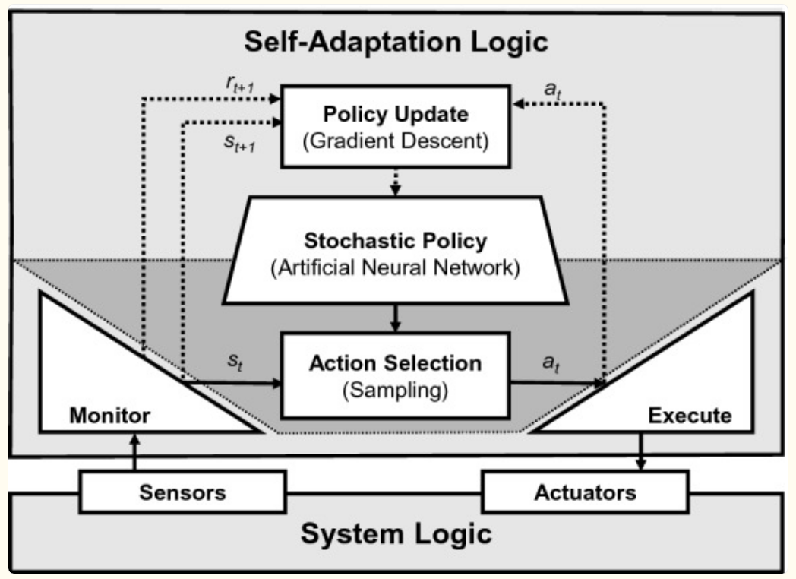
Figure 1: At runtime, the self-adaptation logic uses the policy to choose an adaptation action based on the current state, which is determined by monitoring. This process decides if adaptation is needed and selects the appropriate action to execute. The policy is updated using the history of actions, states, and rewards.

Ran and Xie (2022) created an observation-based RL methodology. Their concurrent learning observer demonstrated its efficacy in controlling large adaptive systems by combining experience-based simulation with data-driven parameter estimates to produce near-optimal control rules.

2.2.3 Summary
By allowing agents to learn the best rules in unpredictable and changing contexts, reinforcement learning has revolutionized the study of adaptive systems. The adaptability of reinforcement learning (RL) has been shown in a variety of applications, ranging from deep reinforcement learning and its integration with adaptive control to traditional adaptive dynamic programming. These developments have solidified reinforcement learning as a foundation for creating intelligent, self-governing systems that can instantly adjust to changing obstacles.

2.3 Few-Shot and Self-Supervised Learning
Two machine learning techniques that try to overcome the dependence on large, labeled datasets are few-shot learning (FSL) and self-supervised learning (SSL). SSL uses its own supervisory signals to exploit unlabeled data, whereas FSL focuses on learning from a small number of annotated samples. To get state-of-the-art outcomes in classification, object detection, and other tasks, recent research investigates the synergy between these paradigms.

2.3.1 Theoretical and Practical Foundations
The objective of a few-shot learning is to make it possible for models to generalize to new classes using a few samples. Large dataset pretraining is a key component of traditional FSL techniques. In contrast, self-supervised learning reduces this reliance by generating supervisory signals directly from the data. SSL can be used as an auxiliary task to enhance visual representations for FSL, as Gidaris et al. (2019) showed. Their approach produced better feature representations and notable performance benefits across several datasets by integrating self-supervised tasks, such as picture rotations, into an FSL pipeline.
Su et al. (2020) made a significant further contribution to this synergy by methodically examining the ways in which SSL can improve FSL in various scenarios. Even with tiny datasets, they discovered that SSL dramatically lowers error rates in few-shot jobs. Given that domain shifts could offset the advantages, the study underlined the significance of dataset similarity across self-supervised and downstream tasks.

2.3.2 Advances in Self-Supervised Objectives for FSL
To enhance few-shot learning, a few research have put forward creative self-supervised objectives. Chen et al. (2022) bridged the gap between pretraining and few-shot adaptation by introducing intermediate self-supervised training stages. When compared to conventional techniques, their methodology performed better on benchmarks by customizing SSL objectives to instruct models to undertake in-context learning. Interestingly, they showed how SSL and datasets with human annotations complement each other.
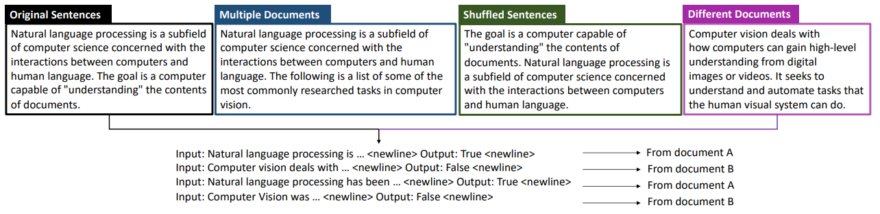
Figure 2: 4 types of training instances, each resembles the next sentence prediction task to instruct the model to compare topical similarities.

The trade-offs between FSL and SSL aims were also addressed by Chen et al. (2021) with their introduction of Pareto Self-Supervised Training (PSST). They successfully balanced these goals by identifying preference regions in the loss landscape using a multi-objective optimization technique. By resolving task conflicts dynamically, this technique achieved state-of-the-art performance across multiple public benchmarks.

2.3.3 Combining SSL with Advanced FSL Frameworks
To extract more significant representations, a few studies investigated incorporating SSL into intricate few-shot frameworks. Simard and Lagrange (2021) created a multi-task framework that integrated FSL with SSL. To increase the generalizability of learnt representations, they employed self-supervised auxiliary tasks such as contrastive learning to serve as regularizers. In domains with little labeled data, the method worked especially well.
Lu et al. (2022) made another significant contribution by putting out a novel SSL strategy that optimizes mutual information (MI) between instances and representations. Their MI-based self-supervised pretraining promoted generalization to unseen categories, in contrast to supervised pretraining, which frequently biases the model towards observed classes. On FSL benchmarks, this approach was on par with or better than supervised approaches.

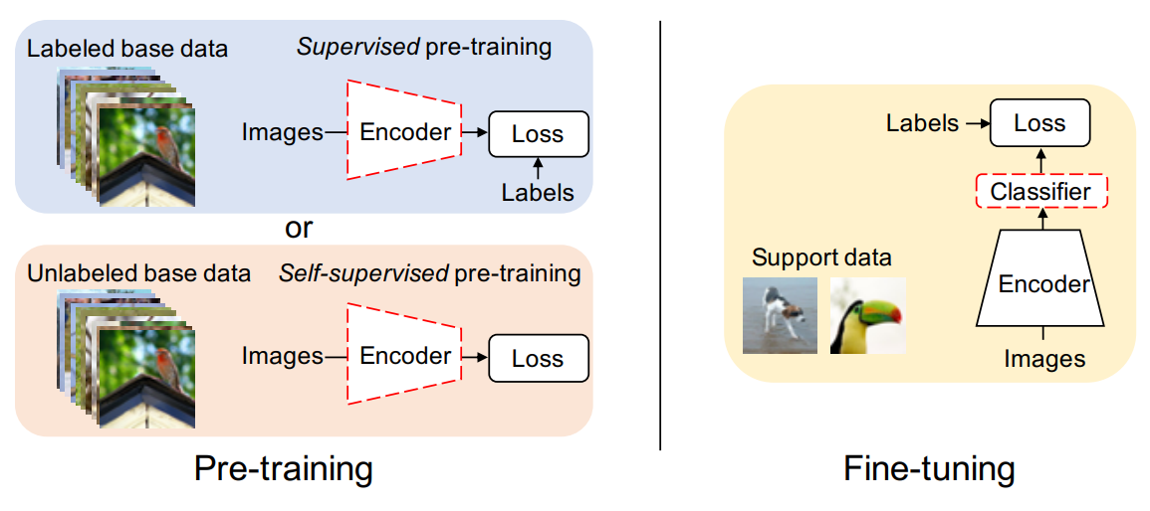
Figure 3: During pre-training, an encoder network is trained with labeled and unlabeled dataset with supervised and self-supervised loss respectively. During fine-tuning, a linear classifier is trained on embeddings of a few samples using frozen pre-trained encoder.

2.3.4 Applications in Cross-Domain Learning
Further challenges arise with cross-domain few-shot learning (CDFSL), since models need to generalize across domain shifts. SSL techniques were tested in CDFSL conditions by Zhang et al. (2022), who discovered that they were resilient to domain changes. In cross-domain tasks, they pointed out that SSL-derived features frequently perform better than supervised ones, indicating their potential use in real-world situations with less labeled data.
Ji et al. (2019) presented an unsupervised few-shot learner for person re-identification tasks in another domain-specific application. They demonstrated the adaptability of SSL in low-data regimes by combining episodic training with SSL to produce competitive results even in the absence of labeled datasets.

2.3.5 Novel Architectures Leveraging SSL
FSL has been further enhanced by creative architectures that include SSL principles. To supplement few-shot objectives, Rong et al. (2023) developed a self-supervised episodic spatial pretext task (ESPT). Their method achieved state-of-the-art outcomes in picture classification benchmarks by learning transferable features by capturing local spatial correlations inside episodic tasks.
Moreover, Medina et al. (2020) presented a model transfer learning system that learned robust metric embeddings by clustering unlabeled data. Their SSL-enhanced strategy fared better than unsupervised meta-learning techniques, demonstrating SSL's ability to lower annotation needs without sacrificing accuracy.

2.3.6 Summary
Self-supervised learning and few-shot learning are complimentary approaches that tackle the problems of sparse labeled data. While SSL improves feature representations with unlabeled data, FSL allows for quick generalization with less supervision. Learning robust and generalizable models has advanced significantly because of the integration of these methods, whether through novel architecture, multi-objective optimization, or auxiliary activities. SSL has demonstrated its capacity to expand the applicability of FSL to real-world tasks, particularly in low-data settings and cross-domain applications. Together, these results demonstrate SSL's adaptability as a basis method for next few-shot learning developments.

2.4 Industrial IoT and Edge Computing
Industries have been transformed by the convergence of edge computing and the IIoT, which has made real-time processing, low latency, and improved security possible. By combining knowledge from current research, this review of the literature investigates the convergence of these two technologies, their uses, and their difficulties.

2.4.1 Edge Computing in Industrial IoT
For IIoT systems, edge computing is essential because it allows computation to be done closer to data sources, lowering latency and bandwidth needs. To improve production efficiency, Chen et al. (2018) suggested architecture that blends edge computing with IoT. As demonstrated by active maintenance systems, this design combines edge devices, network connection, and cloud cooperation to process data in real time.
Qiu et al. (2020) highlighted how edge computing may optimize IIoT operations by tackling issues like privacy concerns and latency in decision-making. According to Qiu et al. (2020), their research examined methods for routing, task scheduling, and data storage and suggested architecture designed for industrial uses like manufacturing, logistics, and smart grids.

2.4.2 Enhancing IIoT Through AI-Driven Edge Solutions
Edge computing and artificial intelligence (AI) are being combined more and more to enhance resource management and decision-making in IIoT settings. AI-driven strategies to maximize power consumption and prolong the battery life of IoT devices in industrial environments were put out by Sodhro et al. (2019). By using predictive transmission power regulation and dynamic task scheduling, their methodology showed notable gains in data dependability and energy efficiency.
Mai et al. (2021) investigated edge architectures in conjunction with in-network computing (INC) paradigms. Their method provided high throughput and low-latency processing by shifting light-duty activities to programmable network devices, satisfying the requirements of industrial systems operating in real-time.

2.4.3 Edge Computing Frameworks for IIoT
Frameworks for edge computing are essential for enabling IIoT applications. A multi-access edge computing (MEC) framework was presented by Borsatti et al. (2021) to convert IIoT applications into scalable, service-based architectures. Real-time industrial process monitoring and control were made possible by this framework's quick deployment capabilities.
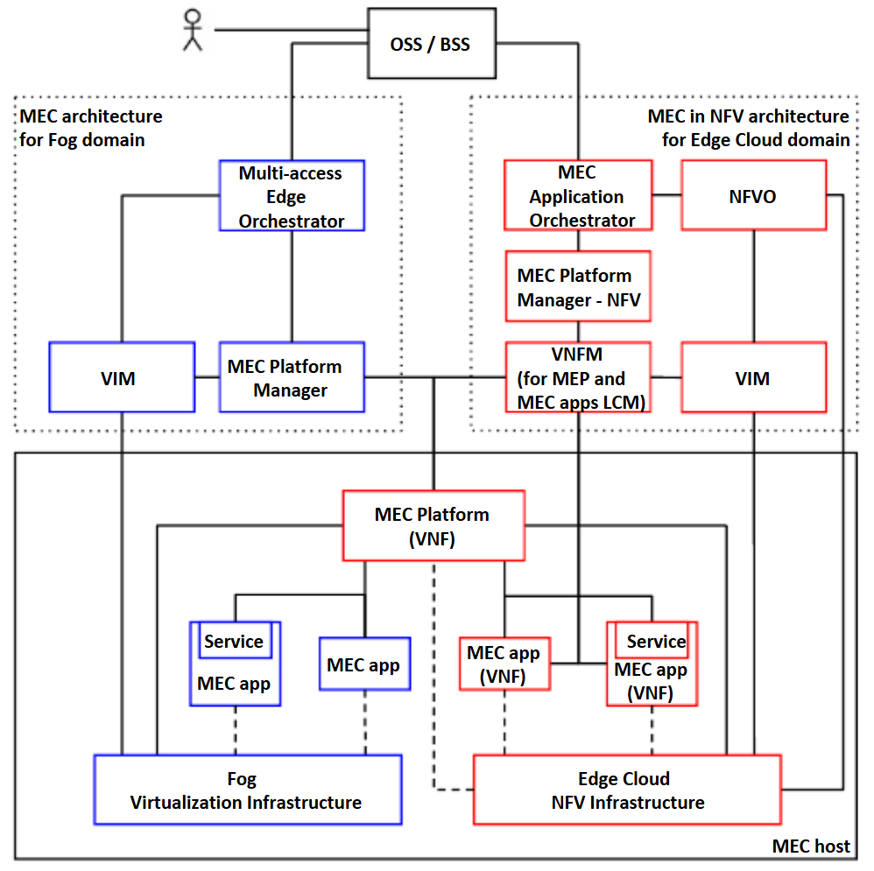
Figure 4: MEC-compliant architecture that integrates components from edge computing environments (highlighted in red) and fog computing environments (highlighted in blue).

A dynamic edge-cloud integration paradigm was also created by Hästbacka et al. (2022), which allowed for the smooth orchestration of IIoT data across various hardware platforms. This concept improved the adaptability of industrial cyber-physical systems by enabling variable application and service composition.

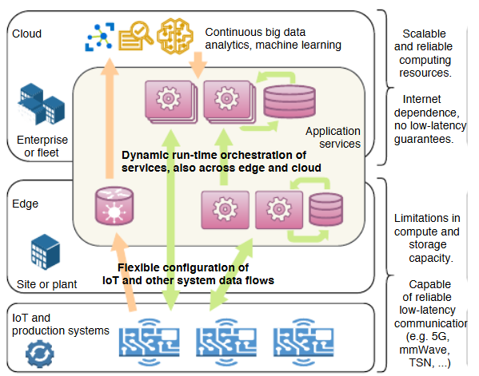
Figure 5: The architectural concept for building data-driven applications, where data flows from IoT devices and other plant floor systems are configured and dynamically orchestrated with application services across edge and cloud environments.

2.4.4 Security and Trust in Edge-Based IIoT
As IIoT devices proliferate, security and trust have emerged as critical issues. A unified trust framework that uses edge computing to identify malicious activity and improve service dependability was proposed by Wang et al. (2020). To ensure safe and effective IIoT operations, their system used trust evaluations to suggest reliable service providers.
Rafique et al. (2020) examined how software-defined networking (SDN) and edge computing can be combined to address security flaws in IIoT ecosystems. Their study cleared the path for strong security measures by identifying multiple attack scenarios and suggesting mitigation techniques.

2.4.5 Challenges and Future Directions
Despite the enormous advantages of edge computing, there are also a few difficulties. Dai et al. (2019) highlighted the necessity for enhanced interoperability and defined protocols to overcome the constraints of present edge platforms in managing intricate industrial operations. They emphasized how edge computing nodes serve as entry points for clever applications, connecting the digital and real worlds.
Premsankar et al. (2018) investigated bandwidth and latency issues in edge-enabled IIoT applications and suggested sophisticated architectures to satisfy the needs of systems of the future. The significance of optimizing data processing and resource allocation at the edge to support new use cases like predictive maintenance and augmented reality was highlighted by their findings.

2.4.6 Summary
By facilitating real-time data processing, improved security, and effective resource management, industrial IoT and edge computing are revolutionizing various industries. To handle the difficulties of IIoT contexts, recent developments emphasize the integration of AI, dynamic frameworks, and trust mechanisms. To fully realize the potential of edge computing in industrial contexts, further research must concentrate on scalability, standardization, and better resource optimization.

2.5 Integrative Frameworks
Given the complexity and importance of industrial operations, anomaly detection in Industrial Internet of Things (IIoT) systems has grown in importance. Conventional approaches frequently lack the flexibility to accommodate new abnormalities or are constrained by the requirement for sizable, labeled datasets. A promising answer to these problems is provided by hybrid strategies that combine reinforcement learning (RL), few-shot learning (FSL), and self-supervised learning (SSL). We examine these intersections and how they are used in IIoT anomaly detection below.

2.5.1 Few-Shot Learning and Self-Supervised Techniques for Limited Data Scenarios
Due to the frequent scarcity of identified abnormalities, few-shot learning is especially pertinent to anomaly identification in IIoT. Huang et al. (2020) presented a gated few-shot anomaly detection model that uses few labeled samples to learn new anomaly categories. Their method provides state-of-the-art results on the NSL-KDD dataset by utilizing gated network architectures, which effectively bridge the gap between known and unknown anomaly types.
By using unlabeled data to improve feature representations, self-supervised approaches can be used in conjunction with few-shot methods. A contrastive self-supervised learning framework called CoLA was presented by Liu et al. (2021) for anomaly detection on attributed networks. Their method showed better anomaly identification accuracy across several datasets by using graph neural networks (GNNs) to learn useful embeddings. For the IIoT, where networked devices generate high-dimensional data, this SSL and FSL combination is extremely pertinent.


Figure 6: The CoLA framework consists of three parts: instance pair sampling, a GNN-based contrastive learning model, and anomaly score computation. For example, if node 𝑣6 is the target, positive and negative instance pairs are sampled. The GNN model predicts scores for these pairs, and the anomaly score for 𝑣6 is calculated using statistical estimates of these scores. Node 𝑣3, with corrupted attributes, serves as an example of an anomaly, while the other nodes are normal.

2.5.2 Reinforcement Learning for Dynamic Adaptation
Adaptive anomaly detection in IIoT systems is a good fit for reinforcement learning since it performs very well in dynamic contexts. In their hierarchical federated learning strategy, Wang et al. (2022) used deep reinforcement learning (DRL) to train local models. Through local data processing, this configuration not only improves detection accuracy but also addresses privacy concerns. By integrating RL, models can maintain low latency and high throughput while dynamically adapting to new anomalies.
Likewise, for the detection of motor anomalies, Cen et al. (2023) integrated reinforcement learning with temporal convolutional networks (TCNs). The difficulties of temporal and spatial variability in IIoT systems were addressed by their approach, which enhanced feature extraction and attained good generalization performance.


Figure 7: The architecture structure of models, as the TCN models provide a great parallel computation and more extended memory rather than RNNs, which improves the efficiency of the model eventually.

2.5.3 Practical Applications and Future Directions
Applications for hybrid models in IIoT include cyberattack detection and predictive maintenance. To address the misclassification of novel classes, Qi et al. (2024) created a few-shot object detection framework that incorporates self-supervised learning. Using cooperative classifiers and double ROI heads, their method significantly increased detection accuracy on industrial datasets.
Using SSL for domain adaptation, Sun et al. (2021) presented a cross-domain few-shot learning paradigm for video anomaly detection. For IIoT setups with diverse operating contexts, such several manufacturing facilities or machinery kinds, this approach is very beneficial.
These developments are encouraging, but there are still issues with interpretability, scalability, and real-time processing. Santos et al. (2023) emphasized the possibility of improving on current techniques for few-shot anomaly identification, such as PatchCore. Their results highlight the need for better integration of SSL approaches with feature extractors with strong inductive biases.

2.5.4 Summary
Self-supervised, few-shot, and reinforcement learning hybrid techniques provide a robust toolkit for IIoT anomaly identification. Self-supervised learning makes use of unlabeled data, reinforcement learning guarantees flexibility in changing contexts, and few-shot techniques deal with data scarcity. Together, these methods improve detection accuracy, lessen the need for labeled data, and allow for real-time anomaly detection, which makes them crucial for IIoT applications in the future.
CHAPTER 3

RESEARCH METHODOLOGY

3.1 Overview
A self-supervised few-shot reinforcement learning framework for scalable and adaptive anomaly detection in IIoT systems is designed, implemented, and evaluated in this research using a multi-phase technique. With a focus on tackling the difficulties of anomaly detection in resource-constrained situations, the process combines data collection, model construction, experimentation, and evaluation. Docker containers with memory and resource limitations are employed as a stand-in for edge computing devices due to the practical limitations of this research, offering an implementation platform that is both accessible and efficient. To guarantee feasibility and reproducibility, all computational operations—including model training and evaluation—are carried out locally using consumer-grade GPUs and CPUs.

3.2 Data Acquisition and Preprocessing
The SOLDEF AI PCB Dataset for Defect Detection is a publicly available dataset designed for automated defect detection on Printed Circuit Boards (PCBs) (Calabrese et al., 2022). It allows researchers to train and assess machine learning models for tasks like classification, segmentation, or anomaly detection by providing high-resolution photos of PCBs with annotated defect labels. The information is particularly helpful for creating AI systems that improve electronics manufacturing quality control procedures by spotting flaws like scratches, misalignments, or missing parts. It is a useful tool for comparing AI algorithms in industrial defect detection applications because of its varied content and carefully chosen comments.
Python-based simulation libraries, like SimPy or OpenAI Gym, are used to create synthetic data that models IIoT systems with a variety of operational scenarios and failure modes. Publicly accessible IIoT datasets are used to gather real-world data, guaranteeing that the collection encompasses a wide variety of use cases. To assure its quality, the data goes through preprocessing procedures like standardization, normalization, and noise filtering. Anomaly labels are assigned using semi-automated labeling methods, such as clustering algorithms with manual validation. Few-shot subsets of the data are created to evaluate the model’s capability to generalize effectively with limited labeled examples, an important feature for real-world deployment.

3.3 Model Design and Development
To satisfy the requirements of IIoT applications, the anomaly detection framework combines resource-efficient deployment techniques, self-supervised learning, and few-shot reinforcement learning.
A component for self-supervised learning is created to improve the ability to extract features. This entails pre-training the model using contrastive learning approaches, which create positive and negative pairs by augmenting the data. The self-supervised method improves the quality of learned representations while addressing the lack of labeled datasets by taking advantage of the wealth of unlabeled data.
The implementation of few-shot reinforcement learning facilitates quick adaptation to novel anomaly detection tasks. The model is ideal for dynamic industrial situations because it uses meta-learning concepts to generalize across jobs with little labeled input. To find a compromise between performance and computational economy, a model-based reinforcement learning approach is selected.
The research simulates edge environments using Docker containers with limited memory and processing power rather than implementing the model on actual edge devices. To guarantee effective operation within these limitations, optimization strategies like model trimming and quantization are used. To maintain accessibility and prevent dependence on cloud-based resources, all training and assessment tasks are carried out locally utilizing consumer-grade GPUs and CPUs.
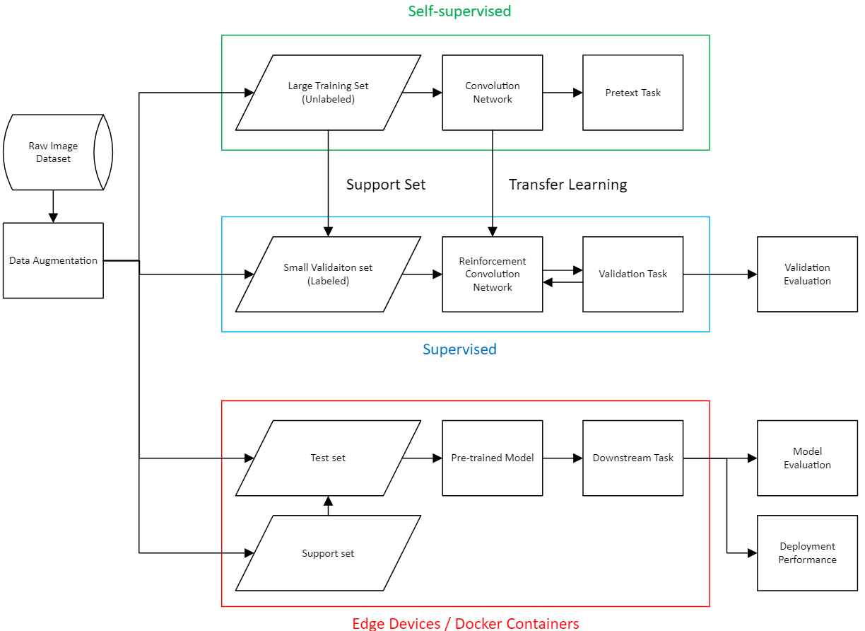
Figure 2.1: Flowchart of research methodology

3.3.1 SSL
Todo

3.3.2 FS
Todo

3.3.3 RL
Todo

3.4 Experimentation and Deployment
Using Python-based simulation tools, the anomaly detection framework is tested in a mock industrial setting to start the exploration phase. The framework's performance may be assessed in a variety of scenarios, encompassing both typical operation and various anomalies, effective to this controlled environment.
The framework is then set up within Docker containers that are set up to simulate edge environments. To determine whether the strategy is feasible, important parameters including memory utilization, computing efficiency, and response times are tracked. To demonstrate the benefits of the suggested framework in terms of detection accuracy, adaptability, and resource efficiency, comparisons are made with standard machine learning and deep learning models.
Performance measures are used to assess the framework thoroughly. Precision, recall, and F1-score are used to gauge detection accuracy. The amount of time needed for the framework to pick up additional anomaly detection duties is used to gauge adaptability. While resource efficiency is measured by tracking memory and compute requirements within Docker containers, scalability is examined by increasing data volumes and emulating larger IIoT networks.

3.5 Ethical and Safety Considerations
In this research, ethical considerations are crucial. All real-world datasets are hidden to preserve data privacy, guaranteeing the security of sensitive information. To assure equitable and trustworthy anomaly detection, the model is assessed for biases, especially in crucial industrial applications where false positives or negatives could have serious repercussions.
By setting in place procedures to deal with inaccurate anomaly detections, safety concerns are also addressed. The framework, for example, has automated alerts that prompt human operators to confirm before acting. The system won't cause instability in the IIoT environments it monitors because of this fail-safe design.

3.6 Justification
The selected approach emphasizes the necessity of tackling important anomaly detection issues for IIoT systems, specifically the lack of labeled data, resource limitations, and scalability requirements. A new and efficient approach to adaptive anomaly detection is offered by the framework, which combines self-supervised learning with few-shot reinforcement learning.
While optimization approaches further increase the research's applicability, the utilization of Docker containers to simulate edge environments guarantees that the research stays realistic and repeatable. By eliminating reliance on expensive or unavailable cloud resources, the choice to carry out all calculations locally guarantees that the research will continue to be available to a large audience.
This methodology is exciting, fills in the gaps in existing anomaly detection techniques, and supports the goals of the research. It prioritizes practicality in the real world while utilizing cutting-edge AI techniques, producing a significant contribution to the field.

3.7 Resources Required
Both software and physical resources are used in the research. Docker containers are used to simulate edge devices, offering a versatile and affordable testing environment. Consumer-grade GPUs and CPUs are used locally for all computing operations, including model evaluation and training. Model construction and training are done using Python-based machine learning tools like PyTorch and TensorFlow. To create artificial datasets and simulate IIoT environments, Python libraries for IIoT simulation are utilized, such as SimPy or OpenAI Gym.

3.8 Evaluation and Validation
Real-world testing and cross-validation methods are used to validate the framework. While deployment in simulated and emulated contexts evaluates the model's practical viability, K-fold cross-validation guarantees the model's durability over a range of circumstances. To ensure the model's long-term adaptability, continuous learning processes are put in place to update it as new data becomes available.

3.9 Summary
For the objective of developing and evaluating a self-supervised few-shot reinforcement learning framework for anomaly detection in IIoT systems, it offers a thorough and convincing approach. The research addresses important issues in scalability and flexibility while maintaining practicality by simulating edge situations with Docker containers and carrying out all computations locally. The suggested system makes a substantial contribution to the field of industrial anomaly detection by combining optimization techniques, few-shot reinforcement learning, and self-supervised learning to ensure that it is both creative and efficient.

3.10 Research Plan
The research timeline in Figure 2.1 is divided into eight primary stages, beginning with data collection, cleaning, and analysis in January, to guarantee high-quality data for model building. After that, it is anticipated that algorithms and frameworks will be designed and configured in February. Self-supervised and few-shot reinforcement learning models will be developed and assessed in Dockerized simulated environments starting in March and ending in May to lay the foundation for the model implementation. The validation and benchmarking phase, which is to be completed by June, compares the model's performance to benchmarks. In July, the model will be optimized and fine-tuned for greater accuracy and efficiency. After the supervisor reviews the results in August to obtain a better understanding, the research is put together into a draft for completion and assessment. The research concludes in August with the presentation and submission of the research findings, ensuring a comprehensive and well-structured approach to achieving the research goal.

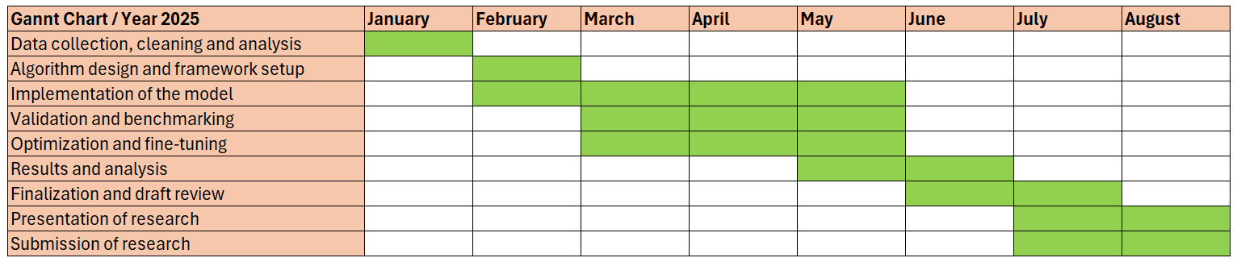
Figure 2.2: Gantt chart of research
CHAPTER 4

RESULT ANALYSIS

4.1 Overview
todo
todo

REFERENCES

Ahmed, M., Mahmood, A. N., & Hu, J. (2016). A survey of network anomaly detection techniques. Journal of Network and Computer Applications, 60, 19–31. https://doi.org/10.1016/j.jnca.2015.11.016
Annaswamy, A. M. (2023). Adaptive control and intersections with reinforcement learning. Annual Review of Control, Robotics, and Autonomous Systems, 6(1), 65–93. https://doi.org/10.1146/annurev-control-062922-090153
Bhupal Naik D. S., Dondeti, V., & Balakrishna, S. (2022). Comparative analysis of machine learning-based algorithms for detection of anomalies in Iiot. International Journal of Information Retrieval Research, 12(1), 1–55. https://doi.org/10.4018/ijirr.298647
Borsatti, D., Davoli, G., Cerroni, W., & Raffaelli, C. (2021). Enabling industrial IOT as a service with Multi-Access Edge Computing. IEEE Communications Magazine, 59(8), 21–27. https://doi.org/10.1109/mcom.001.2100006
Buşoniu, L., de Bruin, T., Tolić, D., Kober, J., & Palunko, I. (2018). Reinforcement learning for control: Performance, stability, and deep approximators. Annual Reviews in Control, 46, 8–28. https://doi.org/10.1016/j.arcontrol.2018.09.005
Calabrese, M., Di Bono, M. G., & Pascucci, P. (2022). SOLDEF AI PCB dataset for defective detection [Dataset]. Kaggle. https://doi.org/10.3390/jmmp8030117
Cen, Y., Li, X., Cen, G., & Cheng, Z. (2023). Anomaly detection of industrial motors under few-shot feature conditions based on causality. Measurement Science and Technology, 34(12), 125004. https://doi.org/10.1088/1361-6501/aced5d
Chen, B., Wan, J., Celesti, A., Li, D., Abbas, H., & Zhang, Q. (2018). Edge computing in IOT-based manufacturing. IEEE Communications Magazine, 56(9), 103–109. https://doi.org/10.1109/mcom.2018.1701231
Chen, M., Yang, J., Zhao, Y., Sun, X., & Leung, V. C. M. (2022). Edge intelligence for anomaly detection in IIoT: Architecture, challenges, and future directions. IEEE Network, 36(3), 122–128. https://doi.org/10.1109/MNET.011.2100434
Chen, Z., Ge, J., Zhan, H., Huang, S., & Wang, D. (2021). Pareto self-supervised training for few-shot learning. 2021 IEEE/CVF Conference on Computer Vision and Pattern Recognition (CVPR), 13658–13667. https://doi.org/10.1109/cvpr46437.2021.01345
Dai, W., Nishi, H., Vyatkin, V., Huang, V., Shi, Y., & Guan, X. (2019). Industrial Edge Computing: Enabling Embedded Intelligence. IEEE Industrial Electronics Magazine, 13(4), 48–56. https://doi.org/10.1109/mie.2019.2943283
Gidaris, S., Bursuc, A., Komodakis, N., Perez, P. P., & Cord, M. (2019). Boosting few-shot visual learning with self-supervision. 2019 IEEE/CVF International Conference on Computer Vision (ICCV), 8058–8067. https://doi.org/10.1109/iccv.2019.00815
Han, G., Tu, J., Liu, L., Martinez-Garcia, M., & Peng, Y. (2021). Anomaly detection based on multidimensional data processing for protecting vital devices in 6G-enabled massive IIoT. IEEE Internet of Things Journal, 8(7), 5219–5229. https://doi.org/10.1109/jiot.2021.3051935
Hastbacka, D., Halme, J., Barna, L., Hoikka, H., Pettinen, H., Larranaga, M., Bjorkbom, M., Mesia, H., Jaatinen, A., & Elo, M. (2022). Dynamic edge and cloud service integration for industrial IOT and production monitoring applications of industrial cyber-physical systems. IEEE Transactions on Industrial Informatics, 18(1), 498–508. https://doi.org/10.1109/tii.2021.3071509
Huang, S., Liu, Y., Fung, C., An, W., He, R., Zhao, Y., Yang, H., & Luan, Z. (2020). A gated few-shot learning model for anomaly detection. 2020 International Conference on Information Networking (ICOIN), 505–509. https://doi.org/10.1109/icoin48656.2020.9016599
Ji, Z., Zou, X., Huang, T., & Wu, S. (2019). Unsupervised Few-shot Learning via Self-supervised Training. ArXiv, abs/1912.12178.
Li, Y., Shu, L., Wan, J., Mukherjee, M., & Wang, K. (2021). Adaptive edge computing for IIoT: A review. IEEE Transactions on Industrial Informatics, 17(9), 6306–6319. https://doi.org/10.1109/TII.2020.3015504
Liu, Y., Li, Z., Pan, S., Gong, C., Zhou, C., & Karypis, G. (2022). Anomaly detection on attributed networks via contrastive self-supervised learning. IEEE Transactions on Neural Networks and Learning Systems, 33(6), 2378–2392. https://doi.org/10.1109/tnnls.2021.3068344
Lu, Y., Wen, L., Liu, J., Liu, Y., & Tian, X. (2022). Self-supervision can be a good few-shot learner. Lecture Notes in Computer Science, 740–758. https://doi.org/10.1007/978-3-031-19800-7_43
Mai, T., Yao, H., Guo, S., & Liu, Y. (2021). In-network computing powered mobile edge: Toward high performance industrial iot. IEEE Network, 35(1), 289–295. https://doi.org/10.1109/mnet.021.2000318
Medina, C., Devos, A., & Grossglauser, M. (2020). Self-Supervised Prototypical Transfer Learning for Few-Shot Classification. ArXiv, abs/2006.11325.
Nizam, H., Zafar, S., Lv, Z., Wang, F., & Hu, X. (2022). Real-time deep anomaly detection framework for multivariate time-series data in industrial IOT. IEEE Sensors Journal, 22(23), 22836–22849. https://doi.org/10.1109/jsen.2022.3211874
Palm, A., Metzger, A., & Pohl, K. (2020). Online reinforcement learning for self-adaptive information systems. Lecture Notes in Computer Science, 169–184. https://doi.org/10.1007/978-3-030-49435-3_11
Pang, G., Shen, C., Cao, L., & Hengel, A. v. d. (2021). Deep learning for anomaly detection: A review. ACM Computing Surveys, 54(2), 1–38. https://doi.org/10.1145/3439950
Premsankar, G., Di Francesco, M., & Taleb, T. (2018). Edge computing for the internet of things: A case study. IEEE Internet of Things Journal, 5(2), 1275–1284. https://doi.org/10.1109/jiot.2018.2805263
Qi, D., Hu, J., & Shen, J. (2024). Few-shot object detection with self-supervising and cooperative classifier. IEEE Transactions on Neural Networks and Learning Systems, 35(4), 5435–5446. https://doi.org/10.1109/tnnls.2022.3204597
Qiu, T., Chi, J., Zhou, X., Ning, Z., Atiquzzaman, M., & Wu, D. O. (2020). Edge computing in industrial internet of things: Architecture, advances and challenges. IEEE Communications Surveys &amp; Tutorials, 22(4), 2462–2488. https://doi.org/10.1109/comst.2020.3009103
Rafique, W., Qi, L., Yaqoob, I., Imran, M., Rasool, R. U., & Dou, W. (2020). Complementing IOT services through software defined networking and edge computing: A comprehensive survey. IEEE Communications Surveys &amp; Tutorials, 22(3), 1761–1804. https://doi.org/10.1109/comst.2020.2997475
Ran, M., & Xie, L. (2022). Adaptive observation-based efficient reinforcement learning for uncertain systems. IEEE Transactions on Neural Networks and Learning Systems, 33(10), 5492–5503. https://doi.org/10.1109/tnnls.2021.3070852
Rong, Y., Lu, X., Sun, Z., Chen, Y., & Xiong, S. (2023). ESPT: A self-supervised episodic spatial pretext task for improving few-shot learning. Proceedings of the AAAI Conference on Artificial Intelligence, 37(8), 9596–9605. https://doi.org/10.1609/aaai.v37i8.26148
Santos, J., Tran, T., & Rippel, O. (2023). Optimizing PatchCore for Few/many-shot Anomaly Detection. ArXiv, abs/2307.10792. https://doi.org/10.48550/arXiv.2307.10792.
Shah, G., & Tiwari, A. (2018). Anomaly detection in Iiot. Proceedings of the ACM India Joint International Conference on Data Science and Management of Data. https://doi.org/10.1145/3152494.3156816
Simard, N., & Lagrange, G. (2021). Improving Few-Shot Learning with Auxiliary Self-Supervised Pretext Tasks. ArXiv, abs/2101.09825.
Sodhro, A. H., Pirbhulal, S., & de Albuquerque, V. H. (2019). Artificial intelligence-driven mechanism for edge computing-based industrial applications. IEEE Transactions on Industrial Informatics, 15(7), 4235–4243. https://doi.org/10.1109/tii.2019.2902878
Su, J.-C., Maji, S., & Hariharan, B. (2020). When does self-supervision improve few-shot learning? Lecture Notes in Computer Science, 645–666. https://doi.org/10.1007/978-3-030-58571-6_38
Sun, G., Liu, Z., Wen, L., Shi, J., & Xu, C. (2021). Anomaly Crossing: A New Method for Video Anomaly Detection as Cross-domain Few-shot Learning. ArXiv, abs/2112.06320.
W. Hore, U., & Wakde, D. G. (2022). An effective approach of IIOT for anomaly detection using unsupervised machine learning approach. Journal of ISMAC, 4(3), 184–197. https://irojournals.com/iroismac/article/view/4/3/5
Wang, H., Wang, Y., & Jin, C. (2023). Self-supervised learning for anomaly detection in edge computing: Challenges and methods. IEEE Transactions on Industrial Informatics, 19(1), 78–87. https://doi.org/10.1109/TII.2022.3185643
Wang, X., Garg, S., Lin, H., Hu, J., Kaddoum, G., Jalil Piran, Md., & Hossain, M. S. (2022). Toward accurate anomaly detection in industrial internet of things using hierarchical federated learning. IEEE Internet of Things Journal, 9(10), 7110–7119. https://doi.org/10.1109/jiot.2021.3074382
Wang, T., Wang, P., Cai, S., Ma, Y., Liu, A., & Xie, M. (2020). A unified trustworthy environment establishment based on Edge Computing in industrial IOT. IEEE Transactions on Industrial Informatics, 16(9), 6083–6091. https://doi.org/10.1109/tii.2019.2955152
Wang, X., Garg, S., Lin, H., Hu, J., Kaddoum, G., Jalil Piran, Md., & Hossain, M. S. (2022). Toward accurate anomaly detection in industrial internet of things using hierarchical federated learning. IEEE Internet of Things Journal, 9(10), 7110–7119. https://doi.org/10.1109/jiot.2021.3074382
Wong, W., & Lee, J. (2008). A reinforcement learning-based scheme for adaptive optimal control of linear stochastic systems. 2008 American Control Conference, 57-62. https://doi.org/10.1109/ACC.2008.4586466.
Wu, X., Zhang, Y., & Zhao, H. (2022). Real-time anomaly detection in smart manufacturing using continual learning. Journal of Manufacturing Systems, 63, 323–335. https://doi.org/10.1016/j.jmsy.2022.04.011
Zhan, P., Wang, S., Wang, J., Qu, L., Wang, K., Hu, Y., & Li, X. (2021). Temporal anomaly detection on IIOT-enabled manufacturing. Journal of Intelligent Manufacturing, 32(6), 1669–1678. https://doi.org/10.1007/s10845-021-01768-1
Zhang, C., Song, D., Chen, Y., & Wang, H. (2020). A deep learning-based approach for detecting anomalies in industrial control systems. IEEE Transactions on Systems, Man, and Cybernetics: Systems, 50(1), 161–172. https://doi.org/10.1109/TSMC.2018.2871452
Zhang, Y., & Liu, X. (2021). Few-shot anomaly detection for IIoT: A reinforcement learning perspective. IEEE Internet of Things Journal, 8(5), 3412–3423. https://doi.org/10.1109/JIOT.2020.3009434
Zhang, Y., Zheng, Y., Xu, X., & Wang, J. (2022). How Well Do Self-Supervised Methods Perform in Cross-Domain Few-Shot Learning?. ArXiv, abs/2202.09014.
Zhou, L., & Guo, H. (2018). Anomaly detection methods for IIOT Networks. 2018 IEEE International Conference on Service Operations and Logistics, and Informatics (SOLI), 214–219. https://doi.org/10.1109/soli.2018.8476769

Literature Review Matrix

Table 1: Literature Review Matrix
Author/  Article title,  journal title,  and  publication  details | Research  Question(s)/  Hypotheses | Methodology | Analysis and Results | Conclusions | Implications for Future research/practice
Annaswamy, A. M. (2023). Adaptive control and intersections with reinforcement learning. Annual Review of Control, Robotics, and Autonomous Systems, 6(1), 65–93. https://doi.org/10.1146/annurev-control-062922-090153 | Investigates how adaptive control and reinforcement learning can be integrated to address challenges in dynamic and uncertain systems | Theoretical review of adaptive control principles and RL, with case studies to demonstrate the integration in real-world applications | Combining adaptive control’s stability and RL’s adaptability offers a powerful approach for complex systems, though challenges in computational complexity and interpretability remain | The integration of adaptive control and RL can enhance performance in systems requiring both theoretical guarantees and real-time adaptability | Further research is needed to develop scalable algorithms and improve the computational efficiency and interpretability of hybrid models
Bhupal Naik D. S., Dondeti, V., & Balakrishna, S. (2022). Comparative analysis of machine learning-based algorithms for detection of anomalies in Iiot. International Journal of Information Retrieval Research, 12(1), 1–55. https://doi.org/10.4018/ijirr.298647 | Compares various machine learning algorithms for anomaly detection in Industrial IoT (IIoT) systems | Experimental analysis of algorithms like SVM, Random Forest, and k-NN on IIoT datasets, evaluating metrics such as accuracy, precision, and computational efficiency | Ensemble methods and deep learning models outperform traditional algorithms in detecting anomalies in complex IIoT data but require more computational resources | Advanced models are more effective for complex anomaly detection in IIoT environments than traditional algorithms | Develop hybrid models that combine the scalability of traditional methods with the performance of deep learning for real-time anomaly detection
Borsatti, D., Davoli, G., Cerroni, W., & Raffaelli, C. (2021). Enabling industrial IOT as a service with Multi-Access Edge Computing. IEEE Communications Magazine, 59(8), 21–27. https://doi.org/10.1109/mcom.001.2100006 | Multi-access Edge Computing (MEC) enables IIoT as a service by improving latency, scalability, and resource efficiency | Analyzes MEC integration with IIoT via use cases and prototypes | MEC enhances real-time processing and supports large-scale industrial systems | MEC is essential for scalable and reliable IIoT services | Explore MEC-cloud interoperability, security, and adaptive resource management
Buşoniu, L., de Bruin, T., Tolić, D., Kober, J., & Palunko, I. (2018). Reinforcement learning for control: Performance, stability, and deep approximators. Annual Reviews in Control, 46, 8–28. https://doi.org/10.1016/j.arcontrol.2018.09.005 | Explores reinforcement learning (RL) for control systems, focusing on performance, stability, and deep approximators | Reviews RL methods (model-based and model-free) and analyzes deep learning’s role in policy/value function approximation | Deep approximators improve scalability and performance but create challenges with stability, convergence, and sample inefficiency | RL is promising for control systems but requires careful tuning for stability and reliability | Enhance stability guarantees, reduce sample complexity, and develop hybrid RL-control approaches
Cen, Y., Li, X., Cen, G., & Cheng, Z. (2023). Anomaly detection of industrial motors under few-shot feature conditions based on causality. Measurement Science and Technology, 34(12), 125004. https://doi.org/10.1088/1361-6501/aced5d | Proposes a few-shot anomaly detection method for industrial motors using causality-based features | Utilizes causal relationships in sensor data to detect anomalies under few-shot learning conditions, minimizing the need for large datasets | The approach effectively detects anomalies with limited labeled data by leveraging causal inference, offering high accuracy with fewer training samples | Causality-based anomaly detection is promising for scenarios with limited data, such as industrial motor monitoring | Improve the robustness of the model in more complex industrial environments and to explore integration with other diagnostic tools
Chen, B., Wan, J., Celesti, A., Li, D., Abbas, H., & Zhang, Q. (2018). Edge computing in IOT-based manufacturing. IEEE Communications Magazine, 56(9), 103–109. https://doi.org/10.1109/mcom.2018.1701231 | Explores the role of edge computing in IoT-based manufacturing systems, aiming to improve processing efficiency and reduce latency in industrial applications | Reviews edge computing architecture, applications in manufacturing, and its integration with IoT for real-time data processing and decision-making | Edge computing helps reduce latency, enhance scalability, and optimize resource allocation in IoT-based manufacturing systems | Edge computing is essential for improving the efficiency and reliability of IoT-based manufacturing systems, enabling real-time analysis and decision-making | More efficient edge computing architectures and addressing security, scalability, and interoperability challenges in industrial IoT applications
Chen, M., Du, J., Pasunuru, R., Mihaylov, T., Iyer, S., Stoyanov, V., & Kozareva, Z. (2022). Improving in-context few-shot learning via self-supervised training. Proceedings of the 2022 Conference of the North American Chapter of the Association for Computational Linguistics: Human Language Technologies. https://doi.org/10.18653/v1/2022.naacl-main.260 | Investigates improving in-context few-shot learning using self-supervised training methods | Proposes a self-supervised approach to enhance the ability of few-shot learning models to generalize from limited data by leveraging pretext tasks | The self-supervised training improves performance in few-shot learning scenarios by allowing the model to learn useful representations without requiring large labeled datasets | Self-supervised learning enhances the effectiveness of few-shot learning models, making them more capable of handling tasks with limited data | Further refinement of self-supervised methods and exploration of their application in other domains with few-shot learning challenges, such as anomaly detection and language processing
Chen, Z., Ge, J., Zhan, H., Huang, S., & Wang, D. (2021). Pareto self-supervised training for few-shot learning. 2021 IEEE/CVF Conference on Computer Vision and Pattern Recognition (CVPR), 13658–13667. https://doi.org/10.1109/cvpr46437.2021.01345 | Proposes Pareto self-supervised training to improve few-shot learning by balancing multiple objectives during the learning process | Introduces a Pareto optimization framework that simultaneously optimizes for multiple tasks, improving the model's generalization ability in few-shot scenarios | Pareto self-supervised training enhances model performance by providing better feature representations without the need for large, labeled datasets, enabling more efficient learning from fewer samples | The Pareto optimization approach is effective in improving few-shot learning, especially in complex scenarios where data is scarce | Extending Pareto self-supervised methods to other domains, as well as exploring multi-task learning and its integration with few-shot learning for more robust performance
Dai, W., Nishi, H., Vyatkin, V., Huang, V., Shi, Y., & Guan, X. (2019). Industrial Edge Computing: Enabling Embedded Intelligence. IEEE Industrial Electronics Magazine, 13(4), 48–56. https://doi.org/10.1109/mie.2019.2943283 | Industrial edge computing with embedded intelligence can enhance system efficiency by reducing latency and optimizing resource allocation | The study proposes an edge computing architecture integrating embedded intelligence for real-time processing | Edge computing with embedded intelligence reduces latency and optimizes resource allocation | Industrial edge computing enhances system efficiency, autonomy, and scalability | Machine learning, energy efficiency, and security in edge computing
Gidaris, S., Bursuc, A., Komodakis, N., Perez, P. P., & Cord, M. (2019). Boosting few-shot visual learning with self-supervision. 2019 IEEE/CVF International Conference on Computer Vision (ICCV), 8058–8067. https://doi.org/10.1109/iccv.2019.00815 | Self-supervision can significantly improve the performance of few-shot learning models in visual recognition tasks | The authors introduce a self-supervised pretraining approach to boost few-shot visual learning, utilizing self-generated labels to improve feature representations | The approach achieves state-of-the-art performance on several few-shot learning benchmarks, outperforming existing methods | Self-supervised learning is a powerful strategy for boosting few-shot visual learning, enhancing model generalization with limited labeled data | Explore the combination of self-supervision with other advanced learning paradigms and evaluate its scalability in real-world applications
Han, G., Tu, J., Liu, L., Martinez-Garcia, M., & Peng, Y. (2021). Anomaly detection based on multidimensional data processing for protecting vital devices in 6G-enabled massive IIoT. IEEE Internet of Things Journal, 8(7), 5219–5229. https://doi.org/10.1109/jiot.2021.3051935 | Multidimensional data processing can improve anomaly detection for protecting vital devices in 6G-enabled massive IIoT systems | The study proposes an anomaly detection framework based on multidimensional data processing techniques, leveraging 6G-enabled IIoT for enhanced device protection | The proposed approach effectively detects anomalies with high accuracy, demonstrating its capability to safeguard critical devices in IIoT systems | Multidimensional data processing improves anomaly detection performance, ensuring better protection of vital devices in 6G-enabled IIoT environments | Optimizing anomaly detection algorithms and exploring their integration with other 6G technologies for broader IIoT applications
Hastbacka, D., Halme, J., Barna, L., Hoikka, H., Pettinen, H., Larranaga, M., Bjorkbom, M., Mesia, H., Jaatinen, A., & Elo, M. (2022). Dynamic edge and cloud service integration for industrial IOT and production monitoring applications of industrial cyber-physical systems. IEEE Transactions on Industrial Informatics, 18(1), 498–508. https://doi.org/10.1109/tii.2021.3071509 | Dynamic integration of edge and cloud services can enhance industrial IoT and production monitoring in cyber-physical systems | The study presents a dynamic edge-cloud integration framework to support real-time monitoring and data processing for industrial IoT applications | The integration framework improves system responsiveness, reduces latency, and optimizes resource allocation for industrial cyber-physical systems | Dynamic edge and cloud service integration is crucial for efficient monitoring and management of industrial IoT systems | Further optimization of edge-cloud interactions and security challenges in industrial IoT systems
Huang, S., Liu, Y., Fung, C., An, W., He, R., Zhao, Y., Yang, H., & Luan, Z. (2020). A gated few-shot learning model for anomaly detection. 2020 International Conference on Information Networking (ICOIN), 505–509. https://doi.org/10.1109/icoin48656.2020.9016599 | A gated few-shot learning model can effectively improve anomaly detection performance with limited labeled data | The authors propose a gated few-shot learning model that combines a gating mechanism with few-shot learning techniques to enhance anomaly detection in diverse scenarios | The gated model outperforms traditional methods in detecting anomalies with minimal labeled samples, showing its potential in real-world applications | The gated few-shot learning model is an effective approach for anomaly detection, especially when labeled data is scarce | Further integration of gating mechanisms with other learning paradigms and test the model on larger, more complex datasets
Ji, Z., Zou, X., Huang, T., & Wu, S. (2019). Unsupervised Few-shot Learning via Self-supervised Training. ArXiv, abs/1912.12178. | Unsupervised few-shot learning can be improved through self-supervised training techniques | The authors propose a self-supervised training framework to enhance unsupervised few-shot learning, using self-generated labels to pretrain models and improve their performance on novel tasks | The self-supervised approach significantly improves performance on few-shot learning tasks, outperforming traditional unsupervised methods | Self-supervised training is an effective strategy for improving unsupervised few-shot learning, even with limited labeled data | Explore combining self-supervised learning with other advanced few-shot learning techniques for more robust and scalable models
Liu, Y., Li, Z., Pan, S., Gong, C., Zhou, C., & Karypis, G. (2022). Anomaly detection on attributed networks via contrastive self-supervised learning. IEEE Transactions on Neural Networks and Learning Systems, 33(6), 2378–2392. https://doi.org/10.1109/tnnls.2021.3068344 | Contrastive self-supervised learning can effectively enhance anomaly detection in attributed networks | The authors propose a contrastive self-supervised learning framework to detect anomalies in attributed networks by learning informative representations without relying on labeled data | The contrastive self-supervised approach improves anomaly detection performance, showing better results compared to traditional methods on attributed network datasets | Contrastive self-supervised learning is a promising technique for anomaly detection in attributed networks, providing strong performance with limited supervision | Investigate the scalability of contrastive self-supervised learning for large-scale networks and its integration with other anomaly detection methods
Lu, Y., Wen, L., Liu, J., Liu, Y., & Tian, X. (2022). Self-supervision can be a good few-shot learner. Lecture Notes in Computer Science, 740–758. https://doi.org/10.1007/978-3-031-19800-7_43 | Self-supervision can enhance few-shot learning performance by providing effective feature representations with minimal labeled data | The authors explore self-supervised learning techniques to improve few-shot learning by leveraging self-generated labels for pretraining models before applying them to few-shot tasks | The self-supervised approach shows competitive performance in few-shot learning tasks, outperforming traditional few-shot methods that rely heavily on labeled data | Self-supervision is a promising approach for few-shot learning, improving model generalization with limited labeled data | Enhancing self-supervised learning methods and exploring their combination with other few-shot learning techniques for more robust models
Mai, T., Yao, H., Guo, S., & Liu, Y. (2021). In-network computing powered mobile edge: Toward high performance industrial iot. IEEE Network, 35(1), 289–295. https://doi.org/10.1109/mnet.021.2000318 | In-network computing powered by mobile edge computing can significantly enhance the performance of industrial IoT systems | The authors propose an in-network computing architecture, leveraging mobile edge computing to process data closer to the source and improve performance in industrial IoT applications | The proposed architecture improves system efficiency, reduces latency, and enhances real-time processing capabilities for industrial IoT devices | Mobile edge computing with in-network computing is a key enabler for high-performance industrial IoT applications | Explore scalability, energy efficiency, and security challenges in deploying in-network computing for industrial IoT
Medina, C., Devos, A., & Grossglauser, M. (2020). Self-Supervised Prototypical Transfer Learning for Few-Shot Classification. ArXiv, abs/2006.11325. | Self-supervised prototypical transfer learning can enhance few-shot classification performance by leveraging self-generated representations for better generalization | The authors propose a self-supervised prototypical transfer learning framework that combines self-supervised learning for pretraining with prototypical networks for few-shot classification tasks | The method shows improved performance in few-shot classification tasks, outperforming traditional few-shot learning models by effectively transferring knowledge across domains | Self-supervised prototypical transfer learning is an effective approach for improving few-shot classification, utilizing both self-supervision and transfer learning for better generalization with minimal labeled data | Integrating this method with other advanced learning paradigms, such as meta-learning and domain adaptation, to further enhance its applicability in real-world scenarios
Nizam, H., Zafar, S., Lv, Z., Wang, F., & Hu, X. (2022). Real-time deep anomaly detection framework for multivariate time-series data in industrial IOT. IEEE Sensors Journal, 22(23), 22836–22849. https://doi.org/10.1109/jsen.2022.3211874 | A real-time deep anomaly detection framework can effectively identify anomalies in multivariate time-series data within Industrial IoT (IIoT) systems | The authors propose a deep learning-based framework for real-time anomaly detection, specifically designed to process multivariate time-series data from IIoT devices and detect abnormal patterns | The framework successfully detects anomalies in real-time with high accuracy, outperforming traditional methods in terms of both detection rate and computational efficiency | The proposed real-time deep anomaly detection framework is a highly effective solution for monitoring and ensuring the reliability of IIoT systems | Improving the scalability and adaptability of the framework to handle larger datasets and more complex IIoT environments with varying sensor data characteristics
Palm, A., Metzger, A., & Pohl, K. (2020). Online reinforcement learning for self-adaptive information systems. Lecture Notes in Computer Science, 169–184. https://doi.org/10.1007/978-3-030-49435-3_11 | Online reinforcement learning can enable self-adaptive behavior in information systems by dynamically adjusting to changing conditions | The authors propose an online reinforcement learning approach to create self-adaptive information systems that continuously learn and optimize their behavior based on real-time feedback | The online reinforcement learning framework successfully adapts the information system's actions in real-time, showing improved performance in dynamic environments compared to traditional methods | Online reinforcement learning is an effective strategy for building self-adaptive information systems that can autonomously adjust to evolving conditions | Enhancing the scalability of the proposed approach and exploring its integration with other adaptive techniques to handle more complex, real-world applications
Premsankar, G., Di Francesco, M., & Taleb, T. (2018). Edge computing for the internet of things: A case study. IEEE Internet of Things Journal, 5(2), 1275–1284. https://doi.org/10.1109/jiot.2018.2805263 | Edge computing can significantly improve the performance of IoT applications by processing data closer to the source, reducing latency and bandwidth usage | The authors conduct a case study to evaluate the effectiveness of edge computing in IoT applications, focusing on how edge nodes process data locally and interact with cloud systems for enhanced performance | The case study demonstrates that edge computing improves response times, reduces network congestion, and enhances the scalability of IoT systems by offloading computation to edge nodes | Edge computing is a promising solution for IoT systems, providing faster processing and more efficient use of resources compared to cloud-based approaches | Optimizing edge computing architectures for IoT, addressing challenges such as security, energy consumption, and seamless integration with cloud services
Qi, D., Hu, J., & Shen, J. (2024). Few-shot object detection with self-supervising and cooperative classifier. IEEE Transactions on Neural Networks and Learning Systems, 35(4), 5435–5446. https://doi.org/10.1109/tnnls.2022.3204597 | Few-shot object detection performance can be improved using self-supervision and a cooperative classifier for enhanced feature representation | The authors propose a few-shot object detection model that integrates self-supervised learning and a cooperative classifier to leverage both self-generated features and collaboration between classifiers. | The proposed method outperforms traditional few-shot detection models, showing improved detection accuracy with limited labeled samples through better feature learning and classifier cooperation | Self-supervision combined with cooperative classifiers enhances few-shot object detection, making it more effective with minimal labeled data | Further refining cooperative classification techniques and exploring their application in other areas of computer vision with limited labeled data
Qiu, T., Chi, J., Zhou, X., Ning, Z., Atiquzzaman, M., & Wu, D. O. (2020). Edge computing in industrial internet of things: Architecture, advances and challenges. IEEE Communications Surveys &amp; Tutorials, 22(4), 2462–2488. https://doi.org/10.1109/comst.2020.3009103 | Edge computing can significantly enhance the performance of Industrial Internet of Things (IIoT) systems by addressing challenges like latency, bandwidth, and real-time data processing | The authors review the architecture, advancements, and challenges of applying edge computing in IIoT, analyzing various edge computing models and their role in IIoT systems | The paper identifies key benefits of edge computing, including reduced latency and efficient data processing, but also highlights challenges such as security, scalability, and integration with existing systems | Edge computing is a critical enabler for IIoT, offering improved system performance but requiring further advancements in security, interoperability, and infrastructure | Addressing the challenges of security, scalability, and seamless integration of edge computing in large-scale IIoT applications
Rafique, W., Qi, L., Yaqoob, I., Imran, M., Rasool, R. U., & Dou, W. (2020). Complementing IOT services through software defined networking and edge computing: A comprehensive survey. IEEE Communications Surveys &amp; Tutorials, 22(3), 1761–1804. https://doi.org/10.1109/comst.2020.2997475 | The integration of Software Defined Networking (SDN) and edge computing can enhance IoT services by improving flexibility, scalability, and resource management | The authors provide a comprehensive survey on how SDN and edge computing complement IoT services, reviewing the architecture, benefits, and challenges of combining these technologies | The survey highlights the synergy between SDN and edge computing, showing that together they can improve IoT network management, reduce latency, and optimize resource usage. However, challenges related to security, interoperability, and network complexity remain | SDN and edge computing are promising technologies for enhancing IoT services, offering better management, efficiency, and performance, but further work is needed to overcome integration and security challenges | Developing secure, scalable architectures that combine SDN and edge computing, addressing the remaining challenges in real-world IoT deployments
Ran, M., & Xie, L. (2022). Adaptive observation-based efficient reinforcement learning for uncertain systems. IEEE Transactions on Neural Networks and Learning Systems, 33(10), 5492–5503. https://doi.org/10.1109/tnnls.2021.3070852 | Adaptive observation-based efficient reinforcement learning can improve decision-making in uncertain systems by optimizing observation strategies and learning efficiency | The authors propose an adaptive observation-based reinforcement learning framework that adjusts the observation strategy during the learning process to maximize the efficiency of decision-making in uncertain environments | The proposed approach demonstrates superior performance in uncertain systems, with faster convergence and more efficient learning compared to traditional reinforcement learning methods that do not adapt observations | Adaptive observation-based reinforcement learning enhances decision-making efficiency in uncertain systems, enabling faster learning and better handling of uncertainty | Further applications of adaptive observation strategies in real-world systems, and investigate scalability and robustness across various uncertain environments
Rong, Y., Lu, X., Sun, Z., Chen, Y., & Xiong, S. (2023). ESPT: A self-supervised episodic spatial pretext task for improving few-shot learning. Proceedings of the AAAI Conference on Artificial Intelligence, 37(8), 9596–9605. https://doi.org/10.1609/aaai.v37i8.26148 | The ESPT (Episodic Spatial Pretext Task) can improve few-shot learning by leveraging self-supervised learning to enhance feature extraction and representation | The authors propose ESPT, a self-supervised episodic pretext task that learns spatial representations to aid in few-shot learning tasks, focusing on improving the model's ability to generalize from limited labeled data | The ESPT method significantly improves performance in few-shot learning tasks, demonstrating better feature representations and generalization compared to traditional few-shot learning approaches | ESPT is an effective self-supervised approach for enhancing few-shot learning by generating useful spatial features from limited labeled data | Explore the integration of ESPT with other self-supervised learning methods and its application in more complex few-shot learning scenarios across various domains
Santos, J., Tran, T., & Rippel, O. (2023). Optimizing PatchCore for Few/many-shot Anomaly Detection. ArXiv, abs/2307.10792. https://doi.org/10.48550/arXiv.2307.10792. | Optimizing PatchCore can improve its performance for few-shot and many-shot anomaly detection by enhancing feature extraction and the representation learning process | The authors propose optimizations to the PatchCore method, focusing on fine-tuning its ability to detect anomalies with few or many labeled samples by refining its patch-based learning approach and leveraging more robust feature representations | The optimized PatchCore method achieves improved anomaly detection accuracy, particularly in few-shot and many-shot settings, by leveraging stronger feature representations and better use of available labeled data | Optimizing PatchCore enhances its efficacy for anomaly detection in scenarios with limited or abundant labeled data, making it a more versatile tool for real-world applications | Extending the optimized PatchCore approach to other anomaly detection tasks and further improving its scalability and generalization across different domains
Shah, G., & Tiwari, A. (2018). Anomaly detection in Iiot. Proceedings of the ACM India Joint International Conference on Data Science and Management of Data. https://doi.org/10.1145/3152494.3156816 | Anomaly detection techniques can effectively identify irregular patterns in Industrial Internet of Things (IIoT) data to ensure system reliability and performance | The authors discuss various anomaly detection methods applied to IIoT systems, focusing on statistical, machine learning, and deep learning techniques for identifying anomalies in time-series and sensor data | The study compares the effectiveness of different anomaly detection approaches, highlighting that machine learning-based methods, especially those using time-series data, perform better in detecting complex anomalies in IIoT systems | Machine learning-based anomaly detection is crucial for ensuring the security and efficiency of IIoT systems, with several techniques proving effective in identifying anomalies in real-time | Explore hybrid anomaly detection models and the integration of real-time data processing to improve detection accuracy and reduce false positives in IIoT environments
Simard, N., & Lagrange, G. (2021). Improving Few-Shot Learning with Auxiliary Self-Supervised Pretext Tasks. ArXiv, abs/2101.09825. | Auxiliary self-supervised pretext tasks can improve few-shot learning by enhancing feature learning and representation, even with limited labeled data | The authors introduce auxiliary self-supervised pretext tasks designed to complement few-shot learning, aiming to improve the model's ability to generalize by learning additional self-supervised tasks alongside the main few-shot task | The incorporation of auxiliary pretext tasks leads to better performance in few-shot learning settings by improving feature extraction and the model's generalization capabilities, particularly in challenging scenarios with sparse labeled data | Self-supervised pretext tasks can effectively enhance few-shot learning by improving the model's ability to learn robust representations from limited labeled data | Explore a broader range of self-supervised tasks and their integration with few-shot learning in various domains to further improve generalization and performance across tasks with limited labeled data
Sodhro, A. H., Pirbhulal, S., & de Albuquerque, V. H. (2019). Artificial intelligence-driven mechanism for edge computing-based industrial applications. IEEE Transactions on Industrial Informatics, 15(7), 4235–4243. https://doi.org/10.1109/tii.2019.2902878 | Artificial intelligence (AI)-driven mechanisms can enhance the performance of edge computing for industrial applications by optimizing data processing, decision-making, and resource allocation | The authors propose an AI-driven framework for edge computing in industrial applications, focusing on integrating AI techniques for real-time data processing, anomaly detection, and adaptive resource management at the edge | The proposed AI-driven mechanism improves the efficiency of edge computing in industrial environments, offering faster data processing, reduced latency, and more effective resource utilization in industrial IoT applications | AI-driven mechanisms significantly enhance edge computing performance for industrial applications, enabling real-time processing and decision-making in resource-constrained environments | Refining AI algorithms for edge computing, improving scalability and integration with existing industrial systems, and exploring security concerns in AI-driven edge computing frameworks
Su, J.-C., Maji, S., & Hariharan, B. (2020). When does self-supervision improve few-shot learning? Lecture Notes in Computer Science, 645–666. https://doi.org/10.1007/978-3-030-58571-6_38 | Self-supervision can improve few-shot learning by enhancing feature representations and aiding generalization when combined with few-shot learning tasks | The authors investigate the conditions under which self-supervised learning techniques benefit few-shot learning, analyzing various self-supervised methods and their impact on learning performance across different datasets and tasks | The study finds that self-supervision improves few-shot learning in scenarios where the self-supervised task is closely aligned with the target task, leading to better feature learning and faster convergence with limited labeled data | Self-supervised learning can enhance few-shot learning performance when the pretext tasks are carefully selected to be relevant to the target task, improving generalization and feature representation | Identifying optimal self-supervised tasks for different few-shot learning scenarios and investigate how these tasks can be adapted for diverse domains and datasets
Sun, G., Liu, Z., Wen, L., Shi, J., & Xu, C. (2021). Anomaly Crossing: A New Method for Video Anomaly Detection as Cross-domain Few-shot Learning. ArXiv, abs/2112.06320. | Anomaly Crossing, a cross-domain few-shot learning method, can effectively detect anomalies in video data with minimal labeled samples | The authors introduce the Anomaly Crossing method, which uses a cross-domain few-shot learning approach to detect video anomalies by transferring knowledge from related domains with few labeled examples | The Anomaly Crossing method outperforms traditional video anomaly detection methods, achieving better results with fewer labeled samples and improved generalization across domains | Cross-domain few-shot learning, as demonstrated by Anomaly Crossing, is a powerful technique for video anomaly detection, requiring minimal supervision and enhancing model flexibility | Explore further applications of cross-domain few-shot learning in other areas of anomaly detection, as well as techniques to improve the method's robustness in diverse real-world scenarios
W. Hore, U., & Wakde, D. G. (2022). An effective approach of IIOT for anomaly detection using unsupervised machine learning approach. Journal of ISMAC, 4(3), 184–197. https://irojournals.com/iroismac/article/view/4/3/5 | Unsupervised machine learning methods can effectively detect anomalies in Industrial Internet of Things (IIoT) systems without relying on labeled data | The authors propose an unsupervised machine learning approach for anomaly detection in IIoT systems, utilizing clustering and dimensionality reduction techniques to identify abnormal patterns | The approach successfully detects anomalies in IIoT data, demonstrating high accuracy and efficiency compared to traditional methods that require labeled data | Unsupervised machine learning is a promising solution for anomaly detection in IIoT systems, offering scalability and flexibility in handling unlabeled data | Explore the integration of unsupervised methods with other anomaly detection techniques and evaluate their performance in larger, more complex IIoT environments
Wang, T., Wang, P., Cai, S., Ma, Y., Liu, A., & Xie, M. (2020). A unified trustworthy environment establishment based on Edge Computing in industrial IOT. IEEE Transactions on Industrial Informatics, 16(9), 6083–6091. https://doi.org/10.1109/tii.2019.2955152 | Edge computing can establish a trustworthy environment for Industrial IoT (IIoT) systems by improving security, privacy, and data integrity | The authors propose a unified framework that integrates edge computing to enhance trustworthiness in IIoT by ensuring secure data processing, storage, and transmission across devices | The proposed framework effectively improves data security and integrity, ensuring a trustworthy environment for IIoT applications, with reduced latency and better real-time processing capabilities | Edge computing plays a critical role in establishing a secure and trustworthy environment for IIoT, enhancing the reliability of industrial applications | Optimizing the scalability, efficiency, and robustness of edge computing in IIoT environments, particularly in the context of real-time monitoring and security
Wang, X., Garg, S., Lin, H., Hu, J., Kaddoum, G., Jalil Piran, Md., & Hossain, M. S. (2022). Toward accurate anomaly detection in industrial internet of things using hierarchical federated learning. IEEE Internet of Things Journal, 9(10), 7110–7119. https://doi.org/10.1109/jiot.2021.3074382 | Hierarchical federated learning can improve the accuracy of anomaly detection in Industrial Internet of Things (IIoT) systems | The authors propose a hierarchical federated learning approach, which enables distributed learning across IIoT devices to collaboratively detect anomalies without sharing raw data | The hierarchical federated learning model outperforms traditional centralized and federated learning methods in terms of anomaly detection accuracy and efficiency in IIoT environments | Hierarchical federated learning is an effective technique for anomaly detection in IIoT, providing improved accuracy while ensuring data privacy | Optimizing hierarchical federated learning models for scalability, security, and real-time anomaly detection in large-scale IIoT systems
Wong, W., & Lee, J. (2008). A reinforcement learning-based scheme for adaptive optimal control of linear stochastic systems. 2008 American Control Conference, 57-62. https://doi.org/10.1109/ACC.2008.4586466. | A reinforcement learning-based scheme can achieve adaptive optimal control for linear stochastic systems | The authors propose a reinforcement learning algorithm to adaptively optimize the control strategy for linear stochastic systems, balancing exploration and exploitation for optimal decision-making | The proposed scheme demonstrates improved performance in controlling linear stochastic systems compared to traditional methods, with the ability to adapt to changing system dynamics | Reinforcement learning is an effective approach for adaptive optimal control in linear stochastic systems, offering enhanced performance over conventional methods | Explore extending the scheme to non-linear systems and investigating its applicability in real-world control scenarios with more complex dynamics
Zhan, P., Wang, S., Wang, J., Qu, L., Wang, K., Hu, Y., & Li, X. (2021). Temporal anomaly detection on IIOT-enabled manufacturing. Journal of Intelligent Manufacturing, 32(6), 1669–1678. https://doi.org/10.1007/s10845-021-01768-1 | Temporal anomaly detection techniques can improve the detection of abnormal patterns in IIoT-enabled manufacturing systems | The authors propose a temporal anomaly detection framework for IIoT-enabled manufacturing, utilizing time-series data from sensors to identify anomalies in manufacturing processes | The framework effectively detects temporal anomalies, improving the detection of issues in manufacturing systems, with better accuracy compared to traditional methods | Temporal anomaly detection is crucial for enhancing the reliability and efficiency of IIoT-enabled manufacturing systems | Refining anomaly detection algorithms to handle large-scale sensor data and exploring their integration with predictive maintenance systems
Zhang, Y., Zheng, Y., Xu, X., & Wang, J. (2022). How Well Do Self-Supervised Methods Perform in Cross-Domain Few-Shot Learning?. ArXiv, abs/2202.09014. | Self-supervised methods can achieve strong performance in cross-domain few-shot learning tasks | The authors evaluate the performance of self-supervised learning techniques on cross-domain few-shot learning benchmarks to assess their ability to generalize across different domains | The self-supervised methods show competitive performance, outperforming traditional few-shot learning approaches in certain cross-domain scenarios | Self-supervised methods are effective in cross-domain few-shot learning, offering a promising approach for tasks with limited labeled data across different domains | Investigate how to further improve the generalization of self-supervised learning across more diverse domains and integrate it with other learning paradigms
Zhou, L., & Guo, H. (2018). Anomaly detection methods for IIOT Networks. 2018 IEEE International Conference on Service Operations and Logistics, and Informatics (SOLI), 214–219. https://doi.org/10.1109/soli.2018.8476769 | Effective anomaly detection methods can improve the security and reliability of Industrial Internet of Things (IIoT) networks | The authors review and compare various anomaly detection techniques, including statistical, machine learning, and hybrid approaches, for IIoT networks | The analysis shows that machine learning-based methods, particularly supervised and unsupervised learning, outperform traditional statistical techniques in detecting anomalies in IIoT networks | Machine learning-based anomaly detection methods are more effective for IIoT networks, offering improved detection accuracy and scalability | Optimizing anomaly detection algorithms for real-time performance, handling high-dimensional data, and ensuring robustness in IIoT environments

