Machine Learning Assignment 2
Final Submission Report
Bank Marketing Term Deposit Classification Pipeline

1. Problem Statement
The objective of this project is to build and evaluate multiple machine learning classification models for predicting whether a bank customer will subscribe to a term deposit based on bank marketing campaign attributes. The project demonstrates an end-to-end workflow including data preprocessing, model training, evaluation, comparison, deployment and interactive prediction using Streamlit.

2. Dataset Description
The project uses the Bank Marketing classification dataset for a binary classification problem. The target variable is deposit, indicating whether a customer subscribed to a term deposit. The dataset satisfies the assignment requirement for a classification dataset with at least 12 features and at least 500 instances. The workflow includes preprocessing of categorical variables, train-test splitting, feature scaling and conditional SMOTE applied to the training data.

3. Submission Links
GitHub Repository: https://github.com/Daawood-Sheikh-M/bank-marketing-ml-pipeline
Live Streamlit Application: https://bank-marketing-ml-pipeline-c5ejb8gn6gpucbrmyhivow.streamlit.app/

4. Models Used and Evaluation Metrics
The assignment explicitly lists five classification algorithms. All five have been implemented and evaluated on the same dataset using Accuracy, AUC Score, Precision, Recall, F1 Score and Matthews Correlation Coefficient (MCC).
Model | Accuracy | AUC | Precision | Recall | F1 | MCC
Logistic Regression | 0.7962 | 0.8729 | 0.7831 | 0.7883 | 0.7857 | 0.5915
Decision Tree | 0.7676 | 0.7662 | 0.7624 | 0.7401 | 0.7511 | 0.5334
KNN | 0.7913 | 0.8503 | 0.7863 | 0.7684 | 0.7772 | 0.5811
Gaussian Naive Bayes | 0.7497 | 0.8077 | 0.7014 | 0.8214 | 0.7566 | 0.5088
Random Forest | 0.8495 | 0.9133 | 0.8195 | 0.8752 | 0.8464 | 0.7007

5. Observations on Model Performance
Model | Observation
Logistic Regression | Provides a strong and interpretable baseline with good ROC-AUC and balanced precision and recall.
Decision Tree | Captures non-linear patterns but shows lower overall performance than the stronger models.
KNN | Performs competitively after feature scaling, with balanced results across the evaluation metrics.
Gaussian Naive Bayes | Provides strong recall and captures a high proportion of positive cases, although its overall precision and MCC are lower than the best-performing model.
Random Forest | Best overall performer, achieving the highest Accuracy, AUC, Recall, F1 Score and MCC among the evaluated models.
Overall Winner | Random Forest, selected based on the strongest overall performance and the highest MCC score of 0.7007.

6. Repository and Implementation Review
The project repository contains the core components required for the assignment, including the Streamlit application, requirements file, README documentation, test data, saved model artifacts and the model training implementation.
The implementation evaluates all five required models using the six required evaluation metrics. The trained preprocessing and model artifacts are saved and reused by the Streamlit application, enabling consistent deployment and prediction.

7. Streamlit Application Features
The Streamlit application satisfies the required interactive deployment objective and provides functionality beyond the minimum assignment requirements.
Feature | Description
CSV Upload and Batch Prediction | Users can upload a CSV dataset and obtain predictions for multiple customer records in a batch. This directly satisfies the assignment requirement for a CSV dataset upload option.
Real-Time Individual Prediction | Users can manually provide customer feature values and obtain a prediction for an individual customer. This is an additional feature beyond the minimum assignment requirement.
Model Comparison | Performance of all five classification models can be compared using the required evaluation metrics.
Model Selection | Users can select a model for detailed evaluation and visualization.
Confusion Matrix | A confusion matrix is provided for evaluating classification results.
Additional Visualizations | The application includes EDA, ROC curves, Precision-Recall curves and feature importance visualizations, providing additional analytical value.

8. Final Review Findings
Status | Review Finding
Verified | Five explicitly listed classification models are implemented. Although the assignment contains an inconsistent reference to '6 ML models', the actual list of required algorithms and example comparison table contain five models. Therefore, no sixth model is required.
Verified | All six required evaluation metrics are included for the five models.
Verified | The application includes a CSV upload feature through batch prediction, satisfying the dataset upload requirement.
Additional Strength | The application also provides real-time individual customer prediction, which is beyond the minimum assignment requirement.
Verified | The project includes model comparison and a confusion matrix, satisfying the required evaluation functionality.
Correction Recommended | Update the README setup instructions so that the git clone command uses the actual repository URL and the Windows virtual-environment activation command is correctly formatted.
To Attach | Include the BITS Virtual Lab training notebook execution screenshot as proof of execution.
To Attach | Include the Streamlit CSV upload / batch prediction screenshot as evidence of the interactive application functionality.

9. Screenshot Evidence
The following two screenshots are sufficient and directly relevant to the assignment requirements:

Figure 1: BITS Virtual Lab – Training Notebook Execution. This demonstrates that the assignment was executed on the BITS Virtual Lab environment.
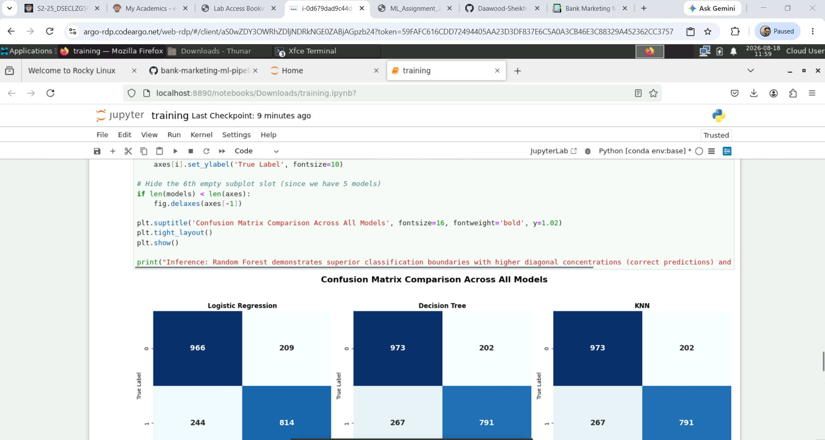

Figure 2: Streamlit Application – CSV Upload and Batch Prediction. This demonstrates the interactive application, CSV upload capability and prediction functionality.

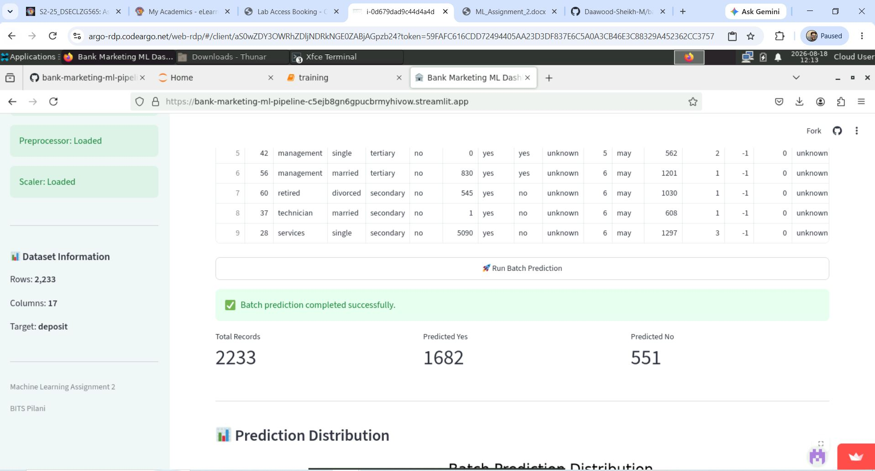

10. README Setup Command
Use the following repository clone command:
git clone https://github.com/Daawood-Sheikh-M/bank-marketing-ml-pipeline.git
cd bank-marketing-ml-pipeline
For Windows Command Prompt:
.venv\Scripts\activate
For Windows PowerShell:
.\.venv\Scripts\Activate.ps1
Then:
pip install -r requirements.txt
streamlit run app.py

11. Conclusion
The Bank Marketing ML Pipeline is complete and well aligned with the assignment requirements. It implements all five explicitly required classification models, evaluates them using all six required metrics and identifies Random Forest as the best overall model. The deployed Streamlit application meets the mandatory interactive requirements through CSV upload, model evaluation, model selection and confusion matrix functionality. The additional real-time individual prediction and analytical visualizations further strengthen the project. The final steps are to correct the README setup commands and insert the two available screenshots before converting the document to PDF.

