Full Name: Azeez Adedayo ADEBAYO
Student Registration Number: 22073702
MSc Study Route: Computer Science (Pure)
University Email Address: aa24anw@herts.ac.uk
Contact Number: +974 66714891
Repository: https://github.com/Daazee/fraud-detection-models

Completed Work
This report documents interim progress on the project titled "An Explainable Machine Learning-Based Framework for Fraud Detection in Digital Banking Transfers." This project does not involve human subjects or primary data collection. As stated in the Extended Project Proposal (EPP), it relies exclusively on a publicly available and anonymised dataset; formal ethics approval is therefore not required.

1.1 Data Collection and Understanding
The EPP originally identified the IEEE-CIS Fraud Detection Dataset as the primary data source. This dataset was downloaded from Kaggle and loaded into the project development environment in Visual Studio Code for exploratory data analysis (EDA). However, EDA revealed a fundamental misalignment with the project scope: the IEEE-CIS dataset comprises card-based payment transactions rather than inter-account banking transfers. Since the project is explicitly focused on fraud detection in digital banking transfers, this dataset was deemed unsuitable.
Following a comprehensive evaluation of alternative datasets, including the PaySim Synthetic Financial Dataset, the Bank Transaction Dataset for Fraud Detection, and the IBM AMLSim Example Transactions Dataset, the IEEE-CIS dataset was replaced with the IBM AMLSim Example Transactions Dataset obtained from Kaggle. This dataset was selected due to its closer alignment with the project's focus on fraud detection in digital banking transfers. The proposed change was communicated to and approved by the project supervisor.
This synthetic banking transaction dataset contains sender-receiver account relationships, transaction types (including wire transfers, deposits, and credits), transaction amounts, timestamps, and labelled suspicious activity flags.
The dataset was loaded programmatically via a dedicated ingestion module (src/ingestion/loaders.py), which resolves the file path relative to the project root using python-dotenv for environment-variable-based configuration, supporting both CSV and Excel formats.
The dataset comprises 1,048,575 transaction records across eight columns: a transaction identifier (TX_ID), sender and receiver account identifiers, transaction type (TX_TYPE), transaction amount (TX_AMOUNT), a simulation time step (TIMESTAMP), a fraud label (IS_FRAUD), and an alert identifier (ALERT_ID). No missing values were present across any column.
Initial exploration revealed a severe class imbalance: only 1,329 of 1,048,575 transactions are labelled as fraudulent, a fraud rate of approximately 0.13%. This makes standard accuracy an unreliable metric and motivates the use of SMOTE during training and PR-AUC as the primary evaluation criterion.

Several columns were identified as unsuitable for modelling. TX_ID is a unique row identifier carrying no predictive signal. ALERT_ID is a post-hoc flag derived from the fraud detection process itself, making its inclusion a source of data leakage; it was therefore removed. TX_TYPE contained a single constant value (TRANSFER) across all records, offering no discriminative information, and was also excluded.

Pairwise correlation analysis was conducted across all numeric features; where any pair exceeded a coefficient of 0.8, the feature with the lower absolute correlation to the target was dropped. A chi-squared test was further applied to determine whether outliers in each feature were disproportionately associated with fraud. Features where outliers were fraud-correlated were preserved intact, while the remaining features were winsorised at the 1st and 99th percentiles to suppress extreme values without discarding genuine fraud signals.

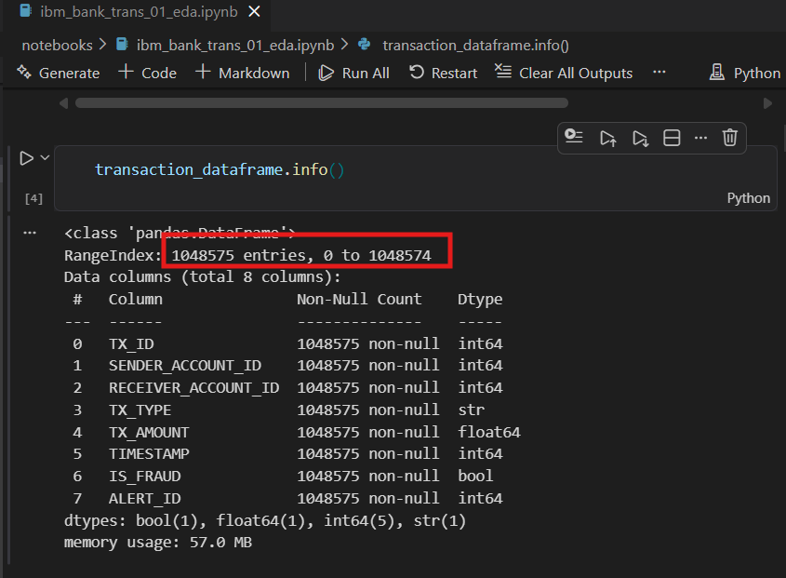
Figure 1.0: Dataset overview containing 1,048,575 total records.

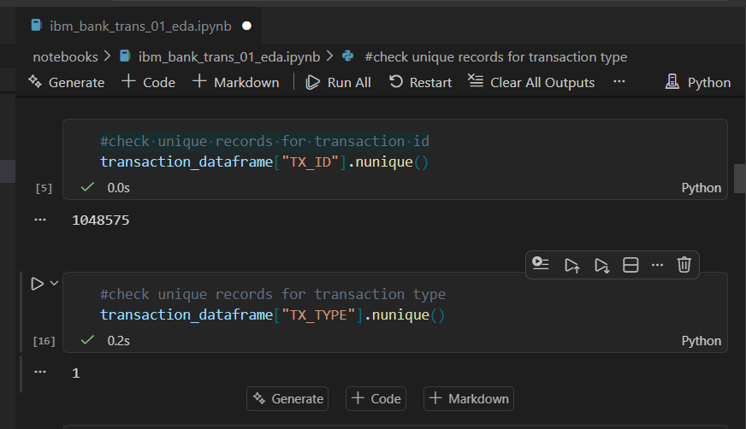
Figure 1.1: Evaluation of unique values per feature in the dataset.

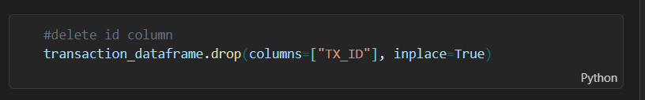
Figure 1.1: Deletion of dataset ID column

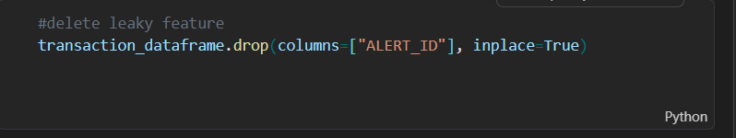
Figure 1.1: Deletion of dataset leaky feature

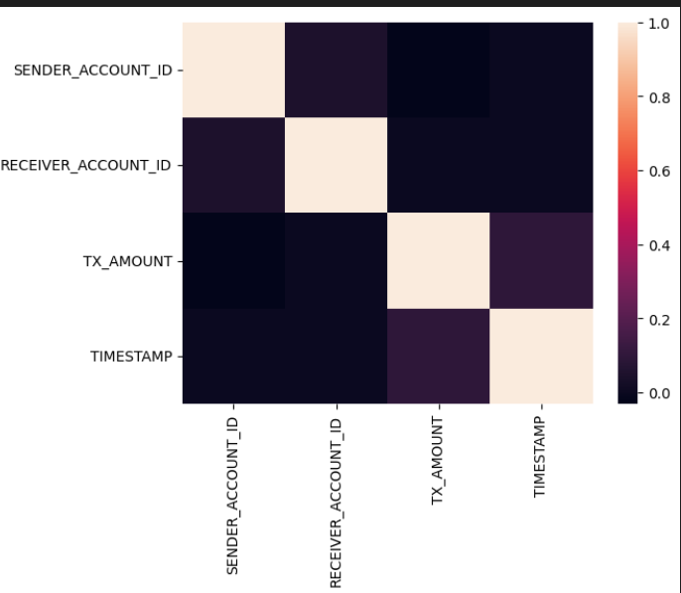
Figure 1.1: Indicating weak or no correlations among the features.

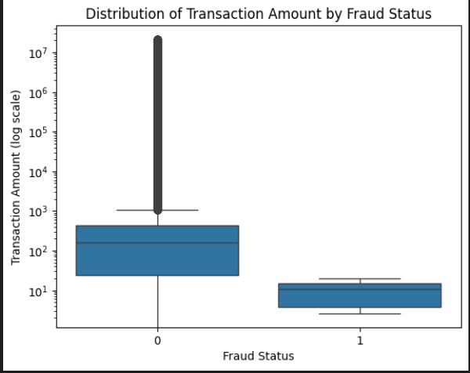
Figure 1.1: Showing the distribution of Transaction Amount by Fraud Status

1.2 Data Preprocessing
Preprocessing was conducted using Python with Pandas, NumPy, and Scikit-learn. Identifier and leaky columns (TX_ID, ALERT_ID) were removed, along with TX_TYPE, which held a single constant value. Pairwise correlation analysis was applied across numeric features, dropping any feature exceeding a threshold of 0.8 with a weaker absolute correlation to the target.
Outlier treatment was guided by a chi-squared test: features whose outliers were disproportionately associated with fraud were preserved, while the remainder were winsorised at the 1st and 99th percentiles. A log1p transformation was applied to features with absolute skewness exceeding 1.0, including TX_AMOUNT which carried a skewness of 23.0. Categorical variables were one-hot encoded using pd.get_dummies with drop_first=True, and the boolean IS_FRAUD target was cast to integer.
The dataset was split 80/20 using stratified sampling to preserve the 0.13% fraud rate across both sets. SMOTE was applied exclusively within each supervised model's training pipeline to address class imbalance without contaminating the test set. StandardScaler was included only in the Logistic Regression pipeline, as tree-based models are scale-invariant.

Three behavioural features were engineered from sender, receiver, and timestamp data. SENDER_STEP_COUNT captures the number of transactions a sender makes within a time step; exactly two transactions corresponded to a 6.0% fraud rate, 46 times the dataset baseline, indicating potential test-then-transfer behaviour. SENDER_RECEIVER_PAIR_COUNT measures interactions between sender–receiver pairs; first-time transfers showed an 8.2% fraud rate (63 times the baseline), while repeat transfers were rarely fraudulent. SENDER_TOTAL_COUNT reflects overall sender activity and showed a weak negative correlation with fraud. Added as integer count features after log transformation, they improved XGBoost performance, increasing PR-AUC from 0.89 to 0.99 and F1-score from 0.72 to 0.99.

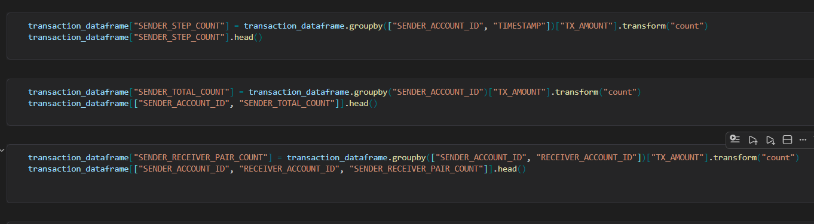
Figure 1.1: Engineered velocity features

1.3 Model Development
Four models were implemented for fraud detection: Logistic Regression, Random Forest, XGBoost, and Isolation Forest. Each supervised model was encapsulated within an imblearn.pipeline.Pipeline, ensuring that SMOTE oversampling is applied exclusively to training data during fitting and never applied to the test set, preventing synthetic samples from influencing evaluation.
Logistic Regression was configured with a maximum of 1,000 iterations to ensure convergence on the high-dimensional processed dataset. Its pipeline includes a StandardScaler step prior to the classifier, as Logistic Regression is sensitive to feature scale. Random Forest was trained with 100 estimators with parallelisation enabled (n_jobs=-1). XGBoost was configured with eval_metric="logloss", appropriate for binary classification under class imbalance. Neither tree-based model includes a scaling step, as they are invariant to feature magnitude.
Isolation Forest was implemented as an unsupervised anomaly detection model trained solely on X_train without access to labels, consistent with its role in detecting anomalous patterns rather than learning from labelled fraud examples. The contamination parameter was set to 0.0013, reflecting the empirically observed fraud rate of 0.13% in the dataset, rather than the Scikit-learn default of 0.1, ensuring the anomaly threshold aligns with the actual class distribution. During evaluation, the model's output of −1 (anomaly) and 1 (normal) was mapped to 1 and 0 respectively, and the decision function scores were negated so that higher values correspond to greater fraud likelihood.

1.4 Challenges Encountered
Dataset Unsuitability. The most significant challenge was discovering, through EDA, that the IEEE-CIS dataset was structurally unsuitable for the project’s focus on banking transfers. This required evaluating alternative datasets, selecting the IBM AMLSim dataset, and restarting the data preparation pipeline. Whilst this introduced additional effort, it strengthened the methodological alignment between the dataset and the research questions.
Class Imbalance. Suspicious transactions represent a small proportion of total records in the IBM AMLSim dataset. Naive model training produced biased classifiers favouring the majority class. This was addressed through stratified splitting and SMOTE applied exclusively to the training set. Alternative strategies (class-weight adjustment and random oversampling) are retained as fallbacks.
Contamination Parameter Configuration. The Scikit-learn default contamination of 0.1 would overestimate anomalies relative to the actual suspicious transaction rate. This was proactively corrected by setting the parameter to match the empirical class distribution.

1.5 Initial Evaluation
Model evaluation was performed on a held-out test set comprising 20% of the dataset (209,715 transactions). Stratified sampling was applied during the train-test split to preserve the original fraud prevalence of 0.13% across both subsets.
To establish a performance benchmark, a dummy baseline classifier was first evaluated. This classifier predicts every transaction as legitimate, irrespective of its attributes. Consequently, it achieved Precision, Recall, and F1-Score values of 0.0, a ROC-AUC of 0.5, a PR-AUC of 0.0013, a False Positive Rate (FPR) of 0.0, and a False Negative Rate (FNR) of 1.0. These results confirm that the baseline model fails to identify any fraudulent transactions and provide a minimum threshold that all candidate models must exceed to demonstrate meaningful predictive capability.
The supervised models—Logistic Regression, Random Forest, and XGBoost—were evaluated using predicted fraud probabilities obtained through “predict_proba”, enabling the computation of threshold-independent metrics such as ROC-AUC and PR-AUC. As an unsupervised anomaly detection approach, Isolation Forest generates anomaly labels of −1 and +1, which were mapped to fraud (1) and legitimate (0) respectively. Its decision function scores were inverted so that higher values indicate a greater likelihood of fraud, ensuring consistency in metric calculation across all models.
Model performance was assessed using seven evaluation metrics: Precision, Recall, F1-Score, ROC-AUC, PR-AUC, False Positive Rate, and False Negative Rate. Due to the severe class imbalance, PR-AUC was selected as the primary evaluation metric because it focuses on performance for the minority fraud class and is less influenced by the large volume of legitimate transactions. False Negative Rate was also considered particularly important, as failing to detect fraudulent transactions carries a greater operational risk than generating false alarms.
The final model was selected using a combined ranking based on PR-AUC and F1-Score. Models were ranked separately on each metric, and the rankings were summed to produce an overall score. The model with the lowest combined rank was identified as the best-performing model, ensuring that both precision-recall performance and overall classification effectiveness were considered during model selection.

2.0 Work to be Done

2.1 Model Training and Hyperparameter Tuning (Weeks 11-13)
Random Forest and XGBoost will be fully trained on the preprocessed, SMOTE-balanced training set. Randomised search cross-validation will be used for hyperparameter tuning, prioritising parameters with the greatest empirical impact on F1-score and PR-AUC: the number of estimators, maximum tree depth, learning rate (XGBoost), and class weight settings. A consistent evaluation pipeline will be applied across all models to ensure fair comparison.

2.2 Hybrid Model Development (Weeks 11-13)
A hybrid model will be developed by combining the probability outputs of the best-performing supervised model with the anomaly scores produced by Isolation Forest. The primary fusion strategy is a weighted average, where the supervised probability and normalised anomaly score are blended using empirically determined weights validated on a held-out development set. If this approach underperforms individual models, two alternatives will be evaluated: threshold-based stacking (classifying as fraud if either model exceeds its respective threshold) and score-as-feature concatenation (appending the Isolation Forest score as an additional input feature to the supervised model). The hybrid model’s performance will be compared directly against individual models using the same evaluation metrics.

2.3 Evaluation (Weeks 14-16)
Logistic Regression, Random Forest, XGBoost, Isolation Forest, and the hybrid model will be evaluated on the held-out test set using Precision, Recall, F1-score, PR-AUC, ROC-AUC, False Positive Rate, and False Negative Rate. These metrics are appropriate for imbalanced classification tasks where accuracy alone is insufficient. Threshold analysis will also be conducted to examine the precision-recall trade-off across decision boundaries, which is particularly relevant in a fraud detection context where the relative cost of false negatives (missed fraud) versus false positives (wrongly blocked transactions) is asymmetric.

2.4 SHAP Explainability (Weeks 14-16)
SHAP will be applied to the best-performing model using the TreeExplainer for tree-based models, which is computationally efficient at scale. Both global and local interpretability will be produced: SHAP summary plots will identify the features with the greatest aggregate influence on fraud predictions across the test set, whilst waterfall and force plots will explain individual transaction predictions. To manage compute time, SHAP analysis will be conducted on a stratified sample of approximately 5,000 test records. If the hybrid model is the best performer, SHAP will be applied to its supervised component, with the Isolation Forest anomaly score treated as an additional explanatory feature.

2.5 Write-up and Submission (Weeks 17-18)
The Final Project Report will document the full experimental pipeline, results, SHAP analysis, and critical evaluation of the framework against the three research questions stated in the EPP. The Final Demonstration Video will present the working system and key results. The code repository will be finalized with a comprehensive README, requirements file, and inline documentation.
Feasibility note: The remaining work builds directly on the completed preprocessing and baseline implementation. All tools (Scikit-learn, XGBoost, SHAP) are already integrated into the project environment. The 18-week timeline has sufficient capacity to accommodate the planned work, and clearly defined fallback positions exist for the hybrid model and SHAP integration should computational constraints arise.

