Your company is ready to move forward with using Docker to run their applications. However, they have some complex container apps that can take advantage of the cluster management and orchestration features of Docker swarm. You have been asked to stand up a simple Docker swarm cluster to be used for some initial testing. A set of servers has already been provisioned for this purpose. The swarm cluster should meet the following criteria:

One Swarm manager.

Two worker nodes.

All nodes should use Docker CE version 5:18.09.5~3-0~ubuntu-bionic.

Both worker nodes should be joined to the cluster.

Any non-root user should be able to run docker commands on all three servers.

[NOTE: Write the series of commands to achieve above in this file below the question scenario with documentation]

Good luck!

ans:-

Install Docker in all the 3 machines using below

• command.

curl -fsSL get.docksal.io | bash

Additional Network Checks

The following ports must be available. On some systems, these ports are open bydefault.

• **TCP port 2377** for cluster managementcommunications

• **TCP** and **UDP port 7946** forcommunication among

nodes

• **UDP port 4789** foroverlay network traffic

• If you are planning on creating an overlay network with encryption (--opt encrypted), you will also need to ensure **ip protocol 50** (**ESP**) trafficis allowed.

• Enable all the ports in AWS security groups.

Create Swarm Manager

Make sure the Docker Engine daemon is started on

• the hostmachines.

• Open a terminal and ssh into the machine where you want to run your manager node.

docker swarm init --listen-addr=eth0 --advertise-addr 52.15.74.121

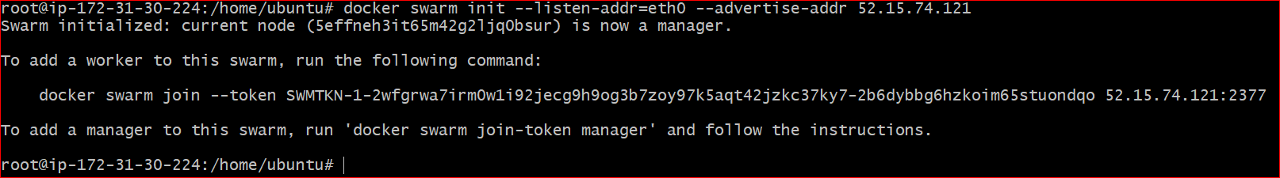

Run the docker node ls command to view information about nodes:

Docker node ls



Addnodes to swarm

Open the worker node

Run the command produced by the docker swarm init output from the create a swarm step 2 to create a worker node joined to the existing swarm:

docker swarm join --token SWMTKN-1-2wfgrwa7irm0w1i92jecg9h9og3b7zoy97k5aqt42jzkc37ky7-2b6dybbg6hzkoim65stuondqo 52.15.74.121:2377

. If you don’t have the command available, you can run the following command on a manager node to retrieve the join command for a worker:

docker swarm join-token worker

